Supplementary Material:
The HAADF image in Fig S1 shows a comparative contrast across the Q-carbon and the diamond phase, where contrast is directly proportional to number density of atoms. From the ratio of scattering intensity, and number density of atoms in diamond, we directly estimate the density of Q-carbon to be 5.0 gcm⁻³. The electron diffraction pattern shows the presence of tetrahedra in Q-carbon.

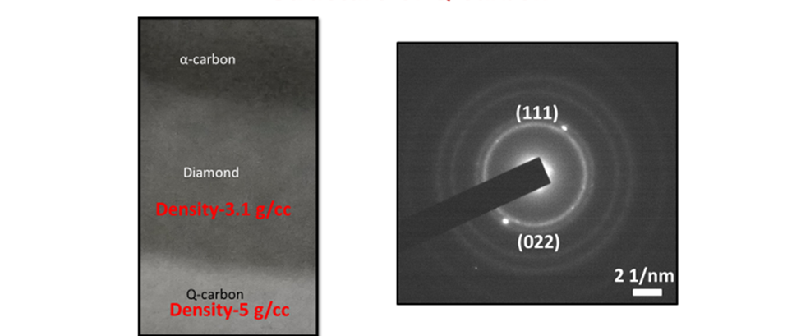Fig. S1: (a) HAADF image of Q2 and diamond, showing the density of C atoms in Q phases higher than diamond by >60%; and (b) Electron diffraction pattern from Q-carbon.
The ELNES characteristics of B-K (Figure S2(a)) and C–K (Figure S2(b)) are drastically different and energetically shifted in the QB3 phase. As shown in Figure S2(a), the EEL spectrum of B–K in QB3 exhibits a characteristic excited state of π* and σ* at 192.9 and 200 eV (peak maxima), respectively. While σ* energy position in Q-carbon phases (Figure S2(b)) remains almost unchanged, a significant energy-shift is observed in the π* energy peak from 188.6 eV in QB2 to 192.9 eV in QB3. Similarly, an overall intensity of π* and σ* peaks in C-K of the QB3 phase is distinctly decreased as compared to that of the QB2 phase, while having no peak energy-shift. This significant shift in the π* peak in B suggests that B is present only in the sp3 state occupying centers of tetrahedra.
QB3 phase, and it clearly reflects a cumulative change in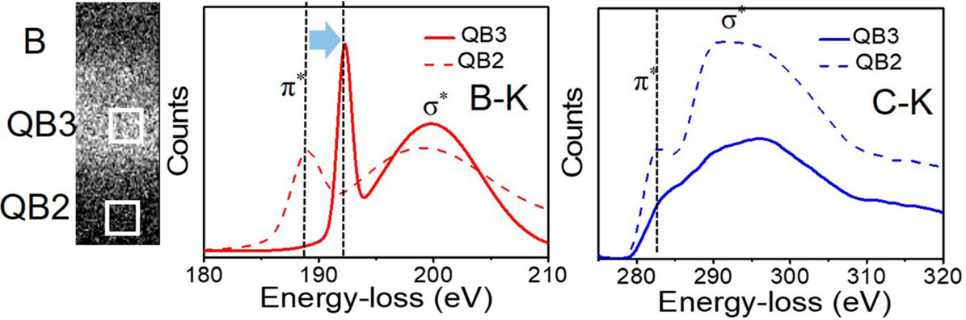
Fig. S2: This figure shows energy loss near edge structure (ELNES) of B–K edge and C–K edge for QB2 and QB3 phases

