Iron-containing nickel cobalt sulfides, selenides and a sulfoselenide as active and stable electrocatalysts for the oxygen evolution reaction in alkaline solution

Soheil Abdpour ª, Lars Rademacher ª, Marcus. N. A. Fetzer ª, Thi Hai Yen Beglauª, Christoph Janiak ^{a*}
ª Institut für Anorganische Chemie und Strukturchemie, Heinrich-Heine-Universität Düsseldorf, 40204 Düsseldorf, Germany

Emails:
soheil.abdpour@hhu.de, larad101@hhu.de,marcus.fetzer@uni-duesseldorf.de
beglau@uni-duesseldorf.de, Janiak@hhu.de

Table of Contents

Section S1 Preparation of Ni_{1.0}Co_{2.1}(S_{0.9}O_{0.1})₄ and Ni_{0.7}Co_{1.4}(Se_{0.85}O_{0.15})₄ 2
Section S2 Sample preparation for atomic absorption spectroscopy 2
Section S3 Scanning electron microscopy and energy dispersive X-ray spectroscopy (SEM/EDX) and TEM/EDX 3
Section S4 Elemental analysis and atomic absorption spectroscopy measurements 8
Section S5 Nitrogen sorption measurement 12
Section S6 X-ray photoelectron spectroscopy 13
Section S7 Electrochemical characterization 18

Preparation of Ni_{1.0}Co_{2.1}(S_{0.9}O_{0.1})₄ and Ni_{0.7}Co_{1.4}(Se_{0.85}O_{0.15})₄

The nickel cobalt sulfide sample Ni_{1.0}Co_{2.1}(S_{0.9}O_{0.1})₄ was prepared through the hydrothermal sulfidation of the precursor (NiCoCH). An amount of 125 mg of the NiCoCH precursor was dispersed in 40 mL of ultrapure water within an 80 mL Teflon-lined autoclave and stirred for 20 minutes. Subsequently, 750 mg (3.125 mmol) of Na₂S·9H₂O was added. The resulting suspension was transferred to an oven and maintained at 160 °C for 12 hours. The obtained product was washed five times with ultrapure water (50 mL each) and twice with ethanol (20 mL each), followed by drying in a vacuum oven at 60 °C overnight. The yield was approximately 95 mg.
Nickel cobalt selenide sample Ni_{0.7}Co_{1.4}(Se_{0.85}O_{0.15})₄: The amount of 125 mg of NiCoCH was dispersed in 30 mL of ultrapure water, followed by addition of 100 mg (0.9 mmol) of SeO₂ and stirring for 10 min. Then 10 mL of N₂H₄ was added to the suspension and stirred for another 10 min. The resulting suspension was transferred to a stainless-steel autoclave and heated at 160 ^{ₒ}C for 12 h. The obtained black powder was washed five times with ultrapure water (50 mL each) and three times with absolute ethanol (20 mL each), then dried at 60 ^{ₒ}C in the vacuum oven overnight. Yield 105 mg.

Sample preparation for atomic absorption spectroscopy

A precisely weighted dried sample of approx. 5 mg was suspended in 10 mL of aqua regia solution (3:1 conc. HCl and HNO₃ mixture) and the liquid was slowly boiled under stirring under the fume-hood until evaporation of the liquid. The treatment by 10 mL aqua regia solution was repeated two times, which yielded a clear solution prior to the final evaporation. Finally, the obtained residue was dissolved in a fresh portion of aqua regia solution (5 mL aqua regia + 10 mL ultrapure water) and stirred overnight. The solution was filtered, the filter was carefully washed multiple times with ultrapure water, and the filtrate was diluted precisely to 50 mL in a volumetric flask to yield the solution used for the determination of the Fe, Ni, and Co content in the samples.

Scanning electron microscopy and energy dispersive X-ray spectroscopy (SEM/EDX) and TEM/EDX

The print-out data of the SEM-EDX analysis, which were used to calculate the chemical formula of as-prepared catalysts, are provided in Figures S1–S8.
Because of overlapping sulfur and gold peaks, no gold sputtering was applied to the samples, except for Ni_{0.7}Co_{1.4}(Se_{0.85}O_{0.15})₄ which was Au-sputtered.
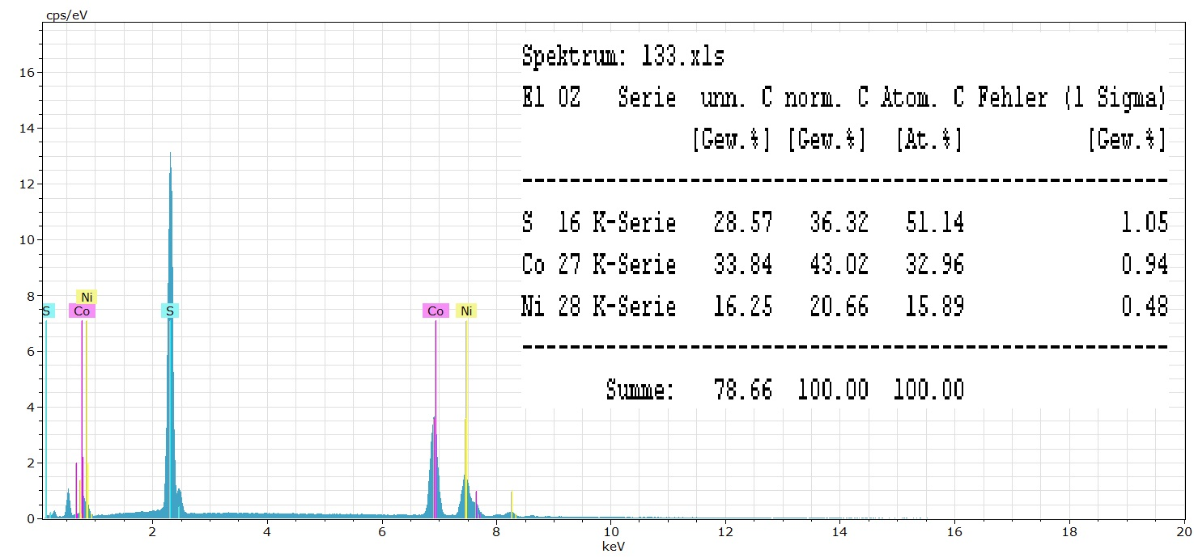
Figure S1. Energy dispersive X-ray analysis of Ni_{1.0}Co_{2.1}(S_{0.9}O_{0.1})₄.

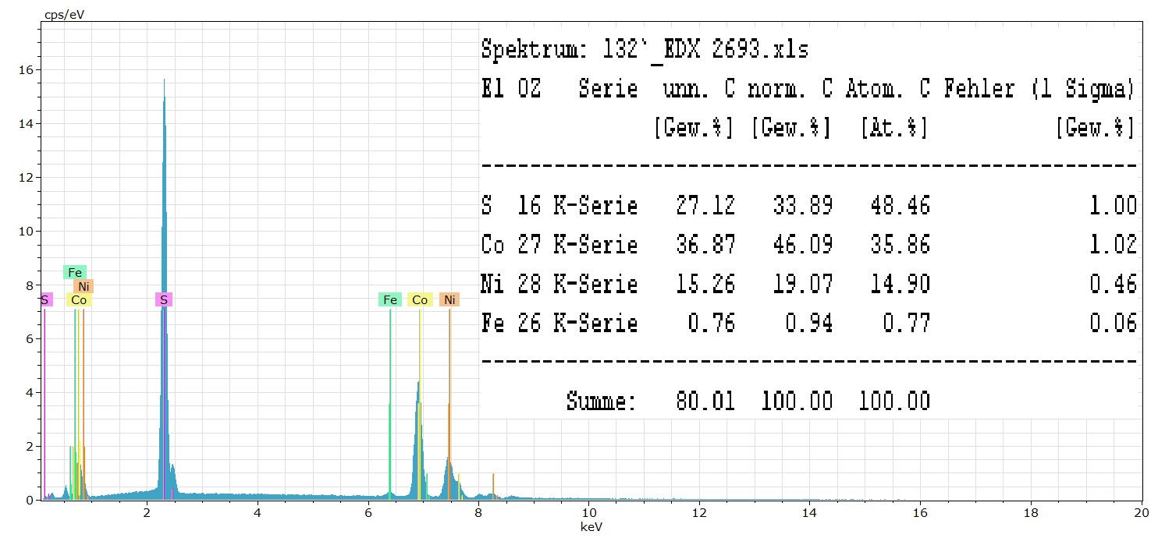
Figure S2. Energy dispersive X-ray analysis of Fe_{0.1}Ni_{1.4}Co_{2.9}(S_{0.87}O_{0.13})₄.
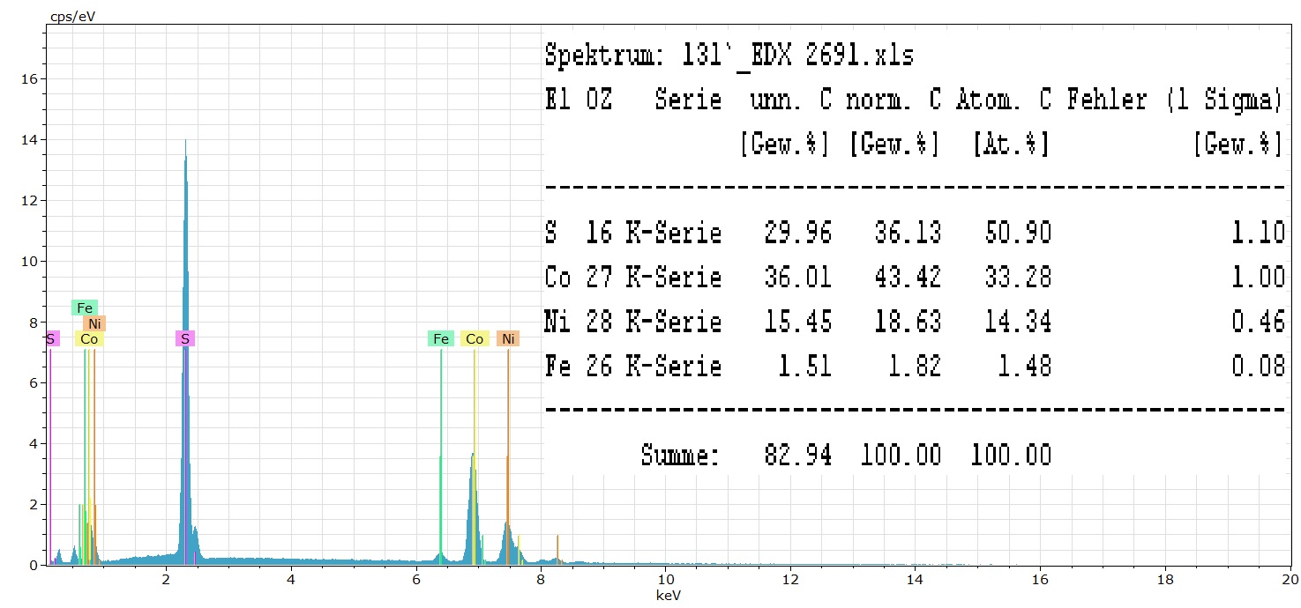
Figure S3. Energy dispersive X-ray analysis of Fe_{0.2}Ni_{1.5}Co_{2.8}(S_{0.9}O_{0.1})_{4.}

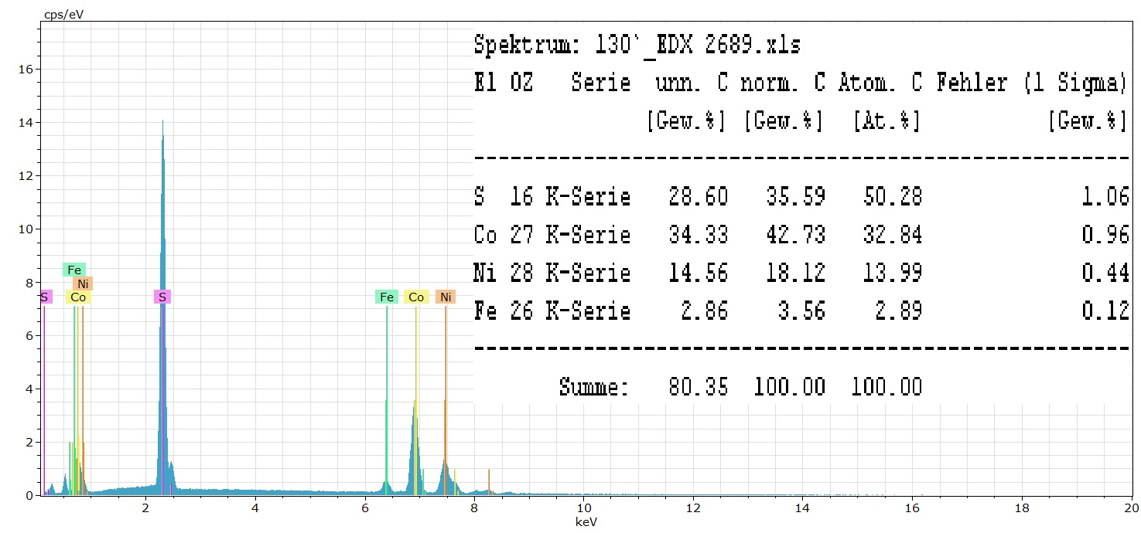
Figure S4. Energy dispersive X-ray analysis of Fe_{0.3}Ni_{1.2}Co_{2.5}(S_{0.9}O_{0.1})₄.

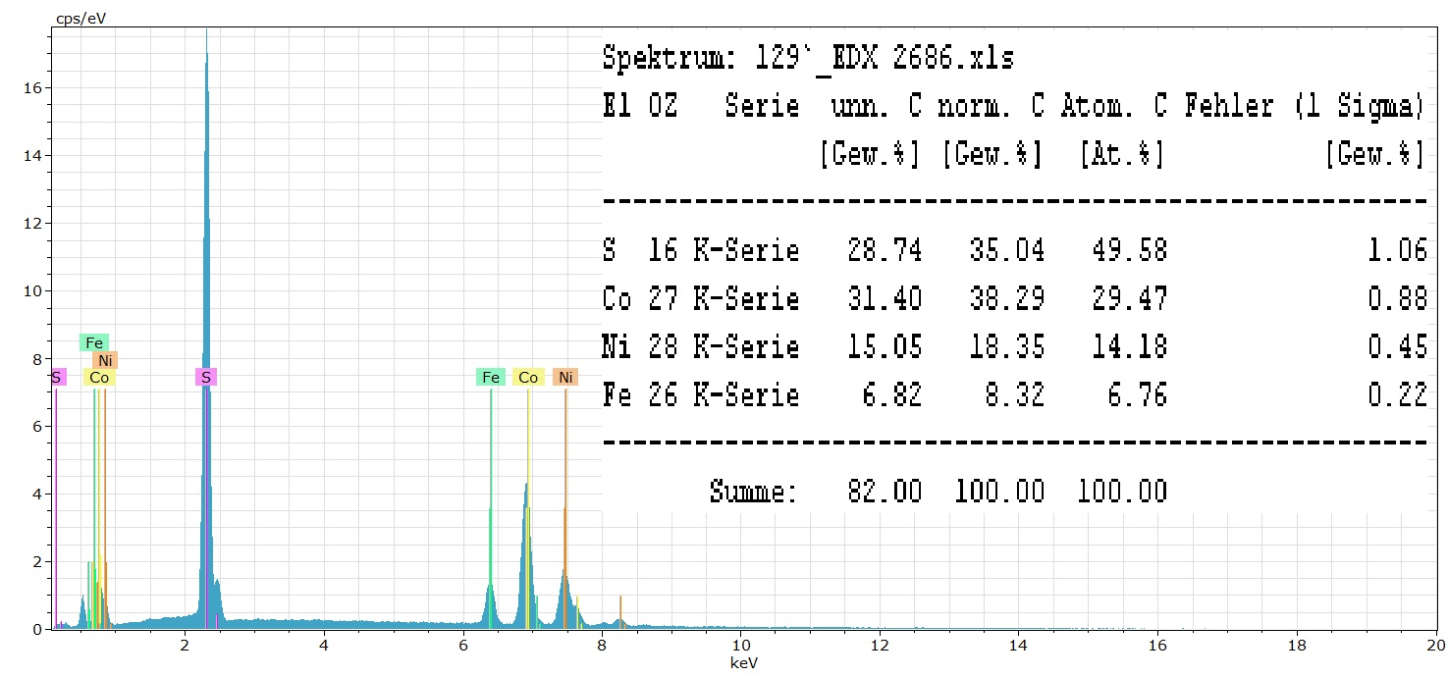
Figure S5. Energy dispersive X-ray analysis of Fe_{0.6}Ni_{1.2}Co_{2.5}(S_{0.83}O_{0.17})₄.

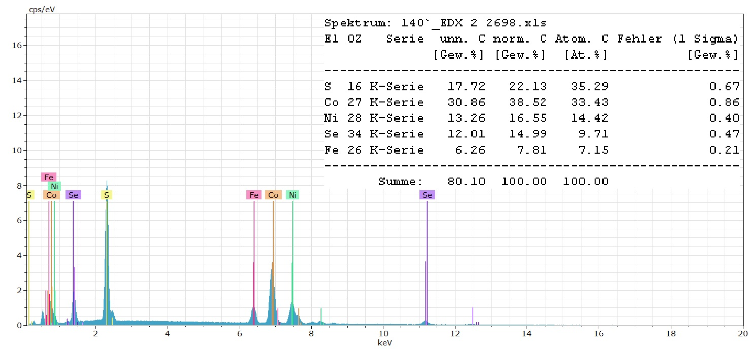
Figure S6. Energy dispersive X-ray analysis of Fe_{0.5}Ni_{1.0}Co_{2.0}(S_{0.57}Se_{0.25}O_{0.18})₄.

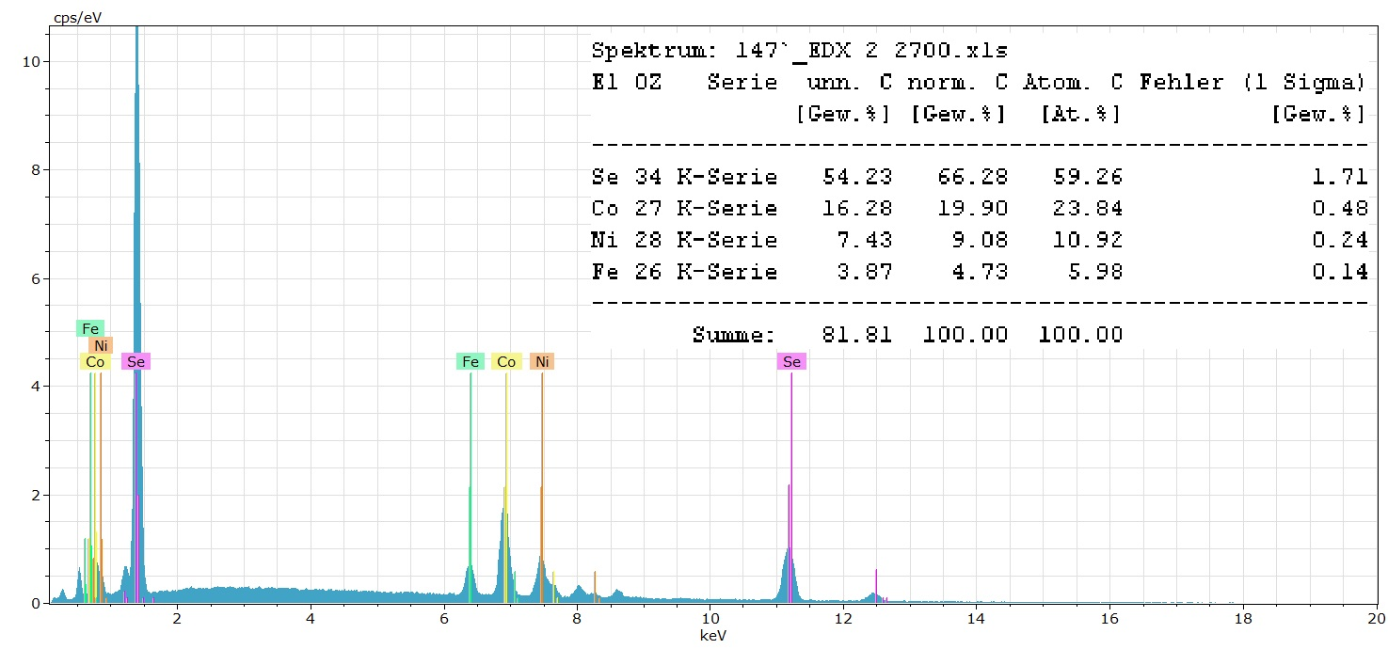
Figure S7. Energy dispersive X-ray analysis of Fe_{0.4}Ni_{0.7}Co_{1.6}(Se_{0.81}O_{0.19})₄.

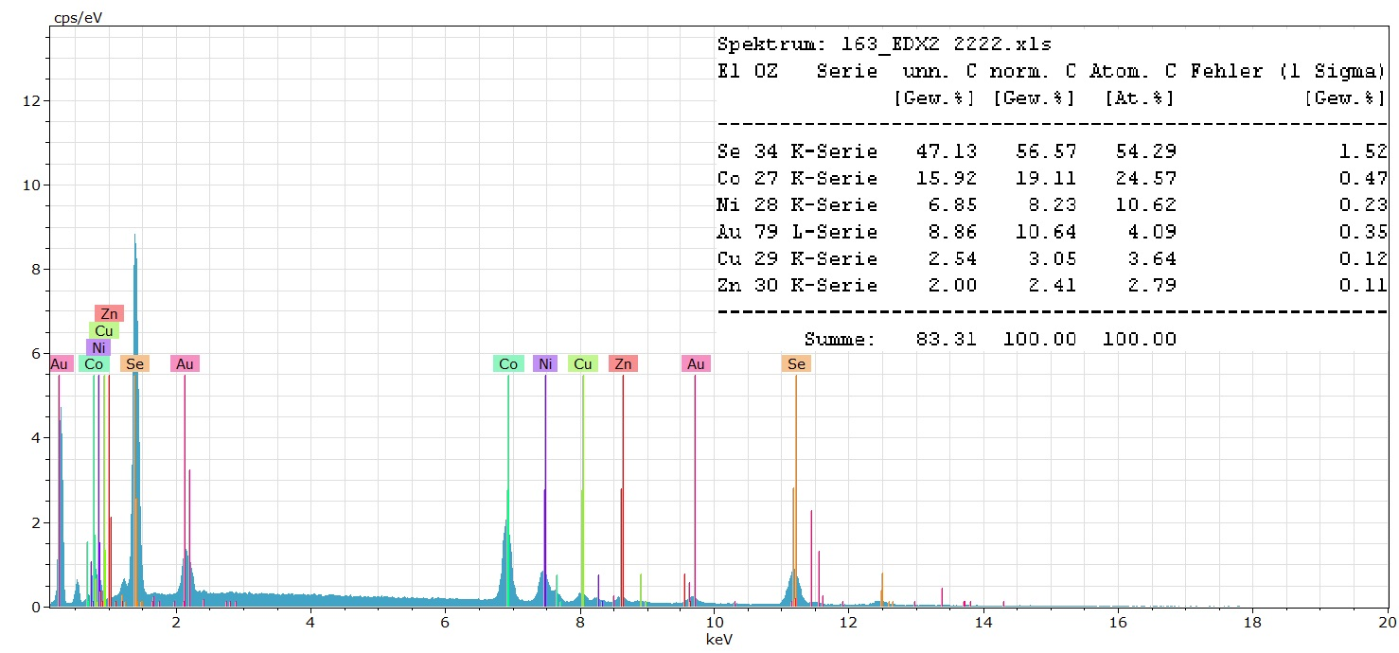
Figure S8. Energy dispersive X-ray analysis of Ni_{0.7}Co_{1.4}(Se_{0.85}O_{0.15})₄. The Se and Au peaks do not overlap. Hence, EDX analysis with Au sputtering was not performed for this specific sample.

Figure S9 shows the EDX-mapping of Fe_{0.5}Ni_{1.0}Co_{2.0}(S_{0.57}Se_{0.25}O_{0.18})₄ and indicates the uniform distribution of the elements.
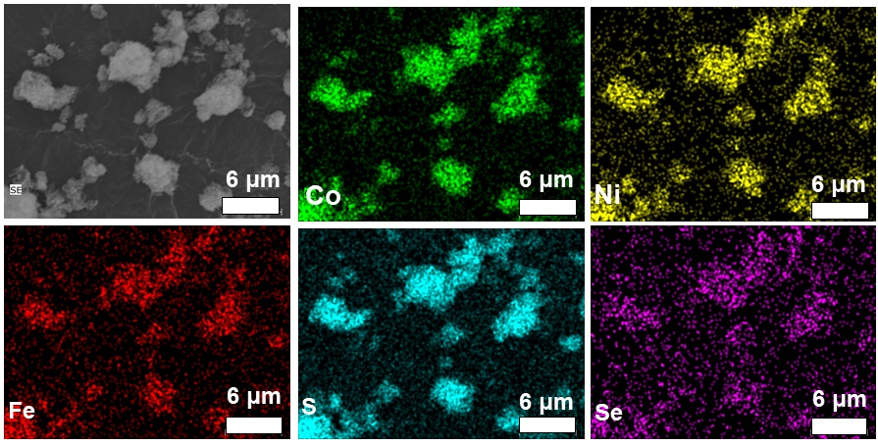
Figure S9. SEM and EDX mapping images of the Fe_{0.5}Ni_{1.0}Co_{2.0}(S_{0.57}Se_{0.25}O_{0.18})₄.

Table S1. TEM-EDX analysis of Fe_{0.5}Ni_{1.0}Co_{2.0}(S_{0.57}Se_{0.25}O_{0.18})₄.^{a)}
Element | Weight% | Atom%
S (K) | 14.0 | 11.9
Fe (K) | 4.6 | 2.3
Co (K) | 20.8 | 9.6
Ni (K) | 9.2 | 4.3
Se (K) | 9.3 | 3.2
^{a)} Values for C, O and Cu which stem from the sample holder are not given, hence the values do not add up to 100%.

Elemental analysis and atomic absorption spectroscopy measurements

Table S2. Metal concentration derived from AAS and sample mass used for AAS analysis.^{a)}
Sample | Fe conc. (mg/L) | Ni conc. (mg/L) | Co conc. (mg/L) | Sample mass (mg)
Ni_{1.0}Co_{2.1}(S_{0.9}O_{0.1})₄ | -------- | 13.17 | 28.5 | 3.5
Fe_{0.1}Ni_{1.4}Co_{2.9}(S_{0.87}O_{0.13})₄ | 1.196 | 16.04 | 34.3 | 3.8
Fe_{0.2}Ni_{1.5}Co_{2.8}(S_{0.9}O_{0.1})₄ | 1.980 | 18.10 | 33.4 | 3.9
Fe_{0.3}Ni_{1.2}Co_{2.5}(S_{0.9}O_{0.1})₄ | 3.371 | 14.59 | 30.8 | 3.7
Fe_{0.6}Ni_{1.2}Co_{2.5}(S_{0.83}O_{0.17})₄ | 6.728 | 13.63 | 29.5 | 3.7
Fe_{0.5}Ni_{1.0}Co_{2.0}(S_{0.57}Se_{0.25}O_{0.18})₄ | 5.506 | 11.40 | 23.9 | 3.8
Fe_{0.4}Ni_{0.7}Co_{1.6}(Se_{0.81}O_{0.19})₄ | 4.302 | 8.57 | 20.2 | 4.5
Ni_{0.7}Co_{1.4}(Se_{0.85}O_{0.15})₄ | ------- | 9.19 | 20.8 | 5.0
^{a)} Sample volume 50 mL (0.05 L).

Table S3. Weight percent (wt%) of the elements based on AAS for Fe, Ni, and Co, CHNS for S, and EDX.
Sample | Fe  wt% | Ni  wt% | Co  wt% | Fe+Ni+Co  wt% | S  wt% | Se  wt% | Sum of Fe,Co,Ni,S,Se  wt% ª | O  wt ª
Ni_{1.0}Co_{2.1}(S_{0.9}O_{0.1})₄  (304.81 g/mol)  (theor.) | …. | 18.8  (19.25) | 40.71  (38.67) | 59.51  (57.92) | 38.08  (42.08) |  | 97.53 | 2.47
Fe_{0.1}Ni_{1.4}Co_{2.9}(S_{0.87}O_{0.13})₄ | 1.57 | 21.10 | 45.13 | 67.80 | 30.88 |  | 98.81 | 1.19
Fe_{0.2}Ni_{1.5}Co_{2.8}(S_{0.9}O_{0.1})₄ | 2.53 | 23.20 | 42.82 | 68.55 | 29.79 |  | 98.60 | 1.40
Fe_{0.3}Ni_{1.2}Co_{2.5}(S_{0.9}O_{0.1})₄ | 4.55 | 19.70 | 41.62 | 65.87 | 32.22 |  | 97.90 | 2.10
Fe_{0.6}Ni_{1.2}Co_{2.5}(S_{0.83}O_{0.17})₄ | 9.10 | 19.47 | 39.86 | 68.43 | 28.46 |  | 96.50 | 3.50
Fe_{0.5}Ni_{1.0}Co_{2.0}(S_{0.57}Se_{0.25}O_{0.18})₄ | 7.24 | 16.28 | 31.45 | 54.97 | 19.80 | 22 | 97.00 | 3.0
Fe_{0.4}Ni_{0.7}Co_{1.6}(Se_{0.81}O_{0.19})₄ | 4.78 | 9.96 | 22.44 | 37.18 | …. | 60 | 97.20 | 2.80
Ni_{0.7}Co_{1.4}(Se_{0.85}O_{0.15})₄  (492.39 g/mol)  (theor.) |  | 9.77  (11.92) | 20.80  (23.94) | 30.57  (35.86) | ….. | 67  (64.14) | 97.60 | 2.40
ª The difference to 100% is assumed to be oxygen weight percent.

It is noteworthy that the AAS, CHNS determination and EDX(Se) for metal, S and Se, respectively, add up to almost 100%, which also indicates that the determinations, even from different methods seem to be reliable.
If we divide the wt% values in Table S3 by the relative atomic weight, we get the atom content in mol/g. These values are given in Table S4:

Table S4. Weight percent (wt%) and atom content (mol/g) of the elements based on AAS for Fe, Ni, and Co, CHNS for S, and EDX for Se.
Sample  wt%:A_{r} | Fe  wt%  (mol/g) | Ni  wt%  (mol/g) | Co  wt%  (mol/g) | S  wt%  (mol/g) | Se  wt%  (mol/g) | O  wt ª  (mol/g) | S+Se+O
Ni_{1.0}Co_{2.1}(S_{0.9}O_{0.1})₄  (theor.)  wt% : A_{r} | …. | 18.8  (19.25)  0.32 | 40.71  (38.67)  0.69 | 38.08  (42.08)  1.185 |  | 2.47  0.15 | 1.335
Fe_{0.1}Ni_{1.4}Co_{2.9}(S_{0.87}O_{0.13})₄  wt% : A_{r} | 1.57  0.028 | 21.10  0.36 | 45.13  0.766 | 30.88  0.967 |  | 1.19  0.074 | 1.041
Fe_{0.2}Ni_{1.5}Co_{2.8}(S_{0.9}O_{0.1})₄  wt% : A_{r} | 2.53  0.045 | 23.20  0.395 | 42.82  0.727 | 29.79  0.936 |  | 1.40  0.087 | 1.023
Fe_{0.3}Ni_{1.2}Co_{2.5}(S_{0.9}O_{0.1})₄  wt% : A_{r} | 4.55  0.081 | 19.70  0.336 | 41.62  0.706 | 32.22  0.998 |  | 2.10  0.13 | 1.128
Fe_{0.6}Ni_{1.2}Co_{2.5}(S_{0.83}O_{0.17})₄  wt% : A_{r} | 9.10  0.163 | 19.47  0.332 | 39.86  0.676 | 28.46  0.873 |  | 3.50  0.22 | 1.093
Fe_{0.5}Ni_{1.0}Co_{2.0}(S_{0.57}Se_{0.25}O_{0.18})₄  wt% : A_{r} | 7.24  0.129 | 16.28  0.277 | 31.45  0.534 | 19.80  0.624 | 22  0.279 | 3.0  0.187 | 1.09
 |  |  |  |  |  |  | Se+O
Fe_{0.4}Ni_{0.7}Co_{1.6}(Se_{0.81}O_{0.19})₄  wt% : A_{r} | 4.78  0.086 | 9.96  0.170 | 22.44  0.381 | …. | 60  0.760 | 2.80  0.175 | 0.935
Ni_{0.7}Co_{1.4}(Se_{0.85}O_{0.15})₄  (theor.)  wt% : A_{r} |  | 9.77  (11.92)  0.166 | 20.80  (23.94)  0.353 | ….. | 67  (64.14)  0.848 | 2.40  0.15 | 0.998
ª The difference to 100% is assumed to be oxygen weight percent.

From the atom content in mol/g the atom ratio per gram, that is the formula unit is derived. The combined S, Se and O content is set to 4, the metal content referenced accordingly and rounded to one decimal digit – these formula units are summarized in Table S5.

Table S5. AAS, CHNS and EDX (for Se) derived formula units.
Atom ratio | Atom ratio with (S,Se,O) set to 4 | Atom ratio rounded to one decimal digit
Ni_{0.32}Co_{0.69}(S,O)_{1.33} | Ni_{0.96}Co_{2.07}(S,O)₄ | Ni_{1.0}Co_{2.1}(S,O)₄
Fe_{0.028}Ni_{0.36}Co_{0.766}(S,O)_{1.04} | Fe_{0.11}Ni_{1.4}Co_{2.9}(S,O)₄ | Fe_{0.1}Ni_{1.4}Co_{2.9}(S,O)₄
Fe_{0.045}Ni_{0.395}Co_{0.727}(S,O)_{1.02} | Fe_{0.17}Ni_{1.5}Co_{2.8}(S,O)₄ | Fe_{0.2}Ni_{1.5}Co_{2.8}(S,O)₄
Fe_{0.081}Ni_{0.336}Co_{0.706}(S,O)_{1.13} | Fe_{0.29}Ni_{1.2}Co_{2.5}(S,O)₄ | Fe_{0.3}Ni_{1.2}Co_{2.5}(S,O)₄
Fe_{0.163}Ni_{0.332}Co_{0.676}(S,O)_{1.09} | Fe_{0.60}Ni_{1.2}Co_{2.5}(S,O)₄ | Fe_{0.6}Ni_{1.2}Co_{2.5}(S,O)₄
Fe_{0.129}Ni_{0.277}Co_{0.534}(S,Se,O)_{1.09} | Fe_{0.47}Ni_{1.0}Co_{2.0}(S,Se,O)₄ | Fe_{0.5}Ni_{1.0}Co_{2.0}(S,Se,O)₄
Fe_{0.086}Ni_{0.170}Co_{0.381}(Se,O)_{0.935} | Fe_{0.37}Ni_{0.73}Co_{1.6}(Se,O)₄ | Fe_{0.4}Ni_{0.7}Co_{1.6}(Se,O)₄
Ni_{0.166}Co_{0.353}(Se,O)_{0.998} | Ni_{0.67}Co_{1.4}(Se,O)₄ | Ni_{0.7}Co_{1.4}(Se,O)₄

A comparison between the AAS, CHNS and EDX (for Se) derived formula units and the formula unit from EDX alone is given in Table S6.
We note that in the literature on mixed-metal sulfides almost no metal analyses seem to be carried out by AAS and no sulfur weight percent analyses by CHNS. We did not find any literature which used a combination of AAS and CHNS to derive at the formula units of mixed-metal sulfides.
Instead, the mostly used method to determine the atomic ratios in mixed-metal sulfides is SEM-EDX. In rare cases, ICP-Mass MS or ICP-OES has been used to determine the Ni:Co ratios between Ni and Co
However, one has to keep in mind that X-ray spectroscopy needs standards for peak identification and quantification. Due to matrix effects a combination of elements can give different emission intensities compared to the individual constituent elements in neat form. Such matrix effects originate because the other elements in the sample can absorb the emitted X-rays. This then enhances the X-ray emission of these other elements. These matrix effects of X-ray spectroscopies are well-known but are often not taken into account. Hence, a quantification by EDX has always the risk that the composition of the sample is different than expected and different when compared to other methods. Consequently, the sample composition from EDX analysis will not be very accurate without certified standards and atom percent values from EDX should be given with at the most one decimal digit.
Further, it should be considered that in EDX the emitted X-rays derive from a 1-2 µm surface layer of the sample which can be different due to oxidation from the bulk of the sample.
It is also important to note that EDX gives only the element ratio but not the absolute content of an element because the lighter elements (atomic number smaller 9 (fluorine)) are not quantified well. The absolute metal content and also the metal atom ratio is given by AAS where a concentration in mmol/g (or mg/g) of the element is measured from the solution of a exactly weighed sample.
Table S6. Comparison between chemical formula derived from SEM-EDX and AAS +CHNS.
Chemical formula based on SEM-EDX analysis | AAS-CHNS-EDX(Se) derived formula unit  from Table S5
Ni_{1.2}Co_{2.5}S₄ | Ni_{1.0}Co_{2.1}(S_{0.9}O_{0.1})₄
Fe_{0.06}Ni_{1.2}Co_{3.0}S₄ ª | Fe_{0.1}Ni_{1.4}Co_{2.9}(S_{0.87}O_{0.13})₄
Fe_{0.12}Ni_{1.1}Co_{2.6}S₄ ª | Fe_{0.2}Ni_{1.5}Co_{2.8}(S_{0.9}O_{0.1})₄
Fe_{0.2}Ni_{1.1}Co_{2.6}S₄ | Fe_{0.3}Ni_{1.2}Co_{2.5}(S_{0.9}O_{0.1})₄
Fe_{0.5}Ni_{1.1}Co_{2.4}S₄ | Fe_{0.6}Ni_{1.2}Co_{2.5}(S_{0.83}O_{0.17})₄
Fe_{0.6}Ni_{1.3}Co₃(S_{0.78}Se_{0.22})₄ | Fe_{0.5}Ni_{1.0}Co_{2.0}(S_{0.57}Se_{0.25}O_{0.18})₄
Fe_{0.4}Ni_{0.7}Co_{1.6}Se₄ | Fe_{0.4}Ni_{0.7}Co_{1.6}(Se_{0.81}O_{0.19})₄
Ni_{0.9}Co_{1.9}Se₄ | Ni_{0.7}Co_{1.4}(Se_{0.85}O_{0.15})₄
ª In EDX analysis the element stoichiometric values should be rounded to only one decimal digit. Here we kept two digits for Fe in two of the samples as rounding would otherwise make the values identical.

From Table S6 it is evident that the chemical formulae from SEM-EDX and from AAS-CHNS-EDX(Se) analysis are not very far off. The trend is the same. For reasons given above AAS was taken as the more reliable analysis and combined with CHNS and EDX for Se.

Nitrogen sorption measurement

Potential porosities of the samples were checked by nitrogen sorption measurements (Figure S10). The specific surface area (BET) of the samples is listed in Table S7. The BET surface areas are slightly above the outer surface area of 20-50 m² g^{–1}, which would be expected for a fine powder, and reached 71 m² g^{–1} in Fe_{0.6}Ni_{1.2}Co_{2.5}(S_{0.83}O_{0.17})₄.
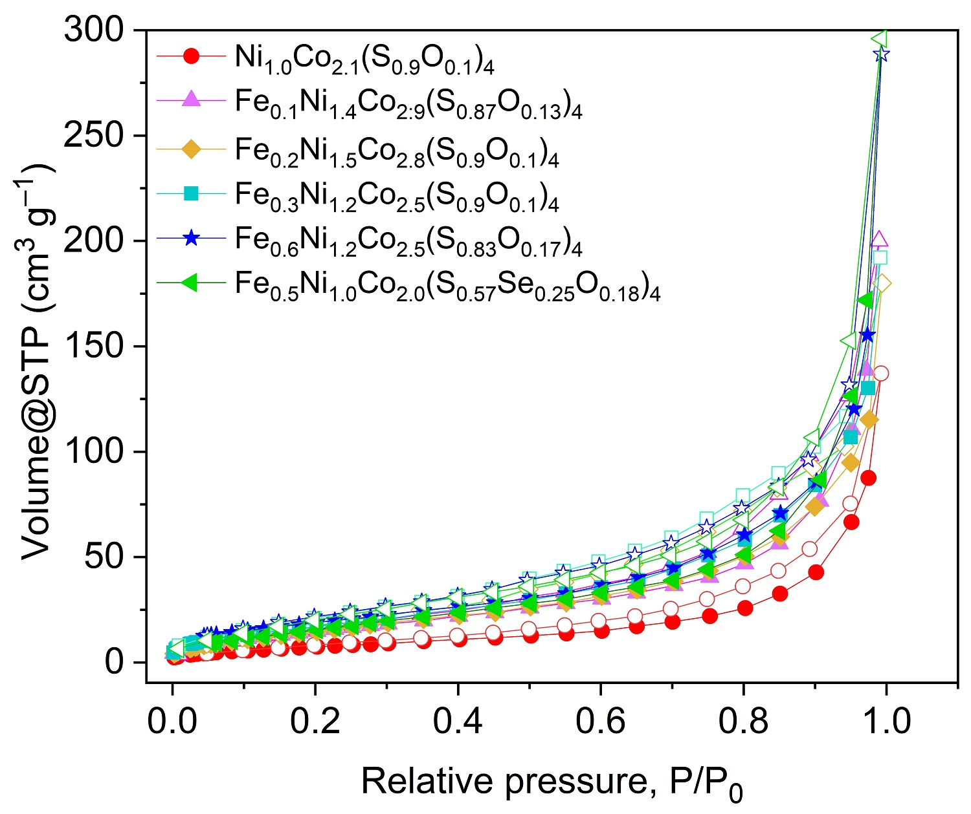
Figure S10. Nitrogen adsorption-desorption isotherms (adsorption: filled symbols; desorption: empty symbols of the sulfide and sulfoselenide samples.

Table S7. Specific surface area (BET) of as-prepared samples.
Sample | BET ª (m² g^{–1})
Ni_{1.0}Co_{2.1}(S_{0.9}O_{0.1})₄ | 31
Fe_{0.1}Ni_{1.4}Co_{2.9}(S_{0.87}O_{0.13})₄ | 58
Fe_{0.2}Ni_{1.5}Co_{2.8}(S_{0.9}O_{0.1})₄ | 60
Fe_{0.3}Ni_{1.2}Co_{2.5}(S_{0.9}O_{0.1})₄ | 67
Fe_{0.6}Ni_{1.2}Co_{2.5}(S_{0.83}O_{0.17})₄ | 71
Fe_{0.5}Ni_{1.0}Co_{2.0}(S_{0.57} Se_{0.25} O_{0.18} )₄ | 63
Fe_{0.4}Ni_{0.7}Co_{1.6}(Se_{0.81} O_{0.19})₄ | 56
Ni_{0.7}Co_{1.4}(Se_{0.85} O_{0.15})₄ | 21
ª Brunauer, Emmett, and Teller

X-ray photoelectron spectroscopy

The survey spectra of the compounds (Figure S11) confirmed the presence of Ni, Co, S, and O for Ni_{1.0}Co_{2.1}(S_{0.9}O_{0.1})₄ and Fe, Ni, Co, S, Se, and O for Fe_{0.5}Ni_{1.0}Co_{2.0}(S_{0.57’}Se_{0.25}O_{0.18})₄ with also oxygen. The oxygen content can both derive from the synthesis using metal carbonate hydroxides as precursors and from surface oxidation. Note that in XPS analysis the detected photoelectrons can only escape from a 70-110 Å thin surface layer of the sample, rendering XPS a surface analysis technique.
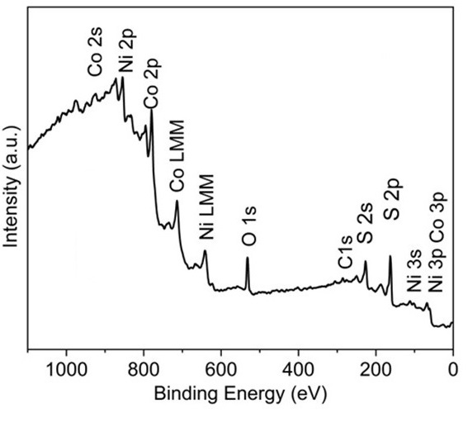 | 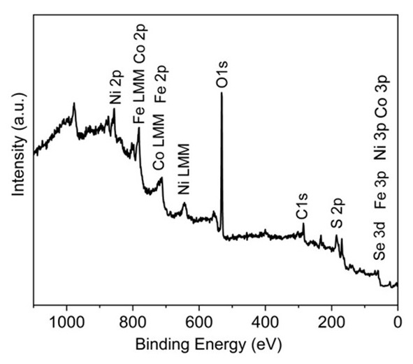
(a) | (b)
Figure S11. XPS survey spectrum of (a) Ni_{1.0}Co_{2.1}(S_{0.9}O_{0.1})₄ (b) Fe_{0.5}Ni_{1.0}Co_{2.0}(S_{0.57}Se_{0.25}O_{0.18})₄.

Ni_{1.0}Co_{2.1}(S_{0.9}O_{0.1})₄:
The deconvolution of the Ni 2p_{3/2} band resulted in two peaks at 853.3 and 856.0 eV, ascribed to Ni²⁺ and Ni³⁺. The Ni 2p_{1/2} region is comprised of two peaks centered at 871.8 and 875.4 eV corresponding to Ni²⁺ and Ni³⁺ respectively [1]. The Co 2p_{3/2} signal consists of two peaks centered at 778.7 and 780.3 eV, which can be attributed to Co³⁺ and Co^{2+,} respectively, and Co 2p_{1/2} is comprised of two peaks at 793.6 and 796.5 eV, which can be ascribed to Co³⁺ and Co²⁺, respectively [2,3].
Fe_{0.5}Ni_{1.0}Co_{2.0}(S_{0.57}Se_{0.25}O_{0.18})₄:
The Ni 2p_{3/2} region can be deconvoluted into two peaks, a prominent one at 856.5 eV and a small one at 854.5 eV, which can be assigned to Ni³⁺ and Ni²⁺, respectively. The binding energy of the Ni 2p_{1/2} region can be deconvoluted into two peaks, the main one at 875.0 eV and a small one at 871.3 eV, corresponding to Ni³⁺ and Ni²⁺, respectively [4]. The Co 2p_{3/2} region consists of two peaks, the more prominent one centered at 782eV is attributed to Co²⁺, while a smaller peak located at 779.1 can be ascribed to Co³⁺ [5]. Two fitted peaks at 798.0 and 795.2 eV in the Co 2p_{1/2} signal region can be ascribed to Co²⁺ and Co³⁺ respectively [6].

S 2p XPS spectrum of Ni_{1.0}Co_{2.1}(S_{0.9}O_{0.1})₄ and Fe_{0.5}Ni_{1.0}Co_{2.0}(S_{0.57}Se_{0.25}O_{0.18})₄:
The binding energies of S 2p in Ni_{1.0}Co_{2.1}(S_{0.9}O_{0.1})₄ (Figure S12a) located at 161.5 eV and 162.7 eV can be assigned to S 2p_{3/2,} and S 2p_{1/2} from to metal-bound sulfur while the peak located at 169 eV can be ascribed to oxidized sulfur species (SO₄^{2–}, HSO₄–) on the surface [7].
The S 2p region overlaps with the Se 3p region. As illustrated in Figure S12b for Fe_{0.5}Ni_{1.0}Co_{2.0}(S_{0.57}Se_{0.25}O_{0.18})₄, the S 2p bands are deconvoluted into peaks located at 160.7 and 166.3 eV, which can be attributed to the Se 3p_{3/2} and Se 3p_{1/2} binding energies, respectively. Additionally, two peaks observed at 162.5 and 164.8 eV correspond to the S 2p_{3/2} and S 2p_{1/2} binding energies [8–10]. The broad peak at 169 eV can be attributed to oxidized sulfur species (SO₄^{2–}, HSO₄–) on the surface [7]. A certain amount of oxidized sulfur species is always observed in the XPS spectra of metal sulfides and selenides [11].
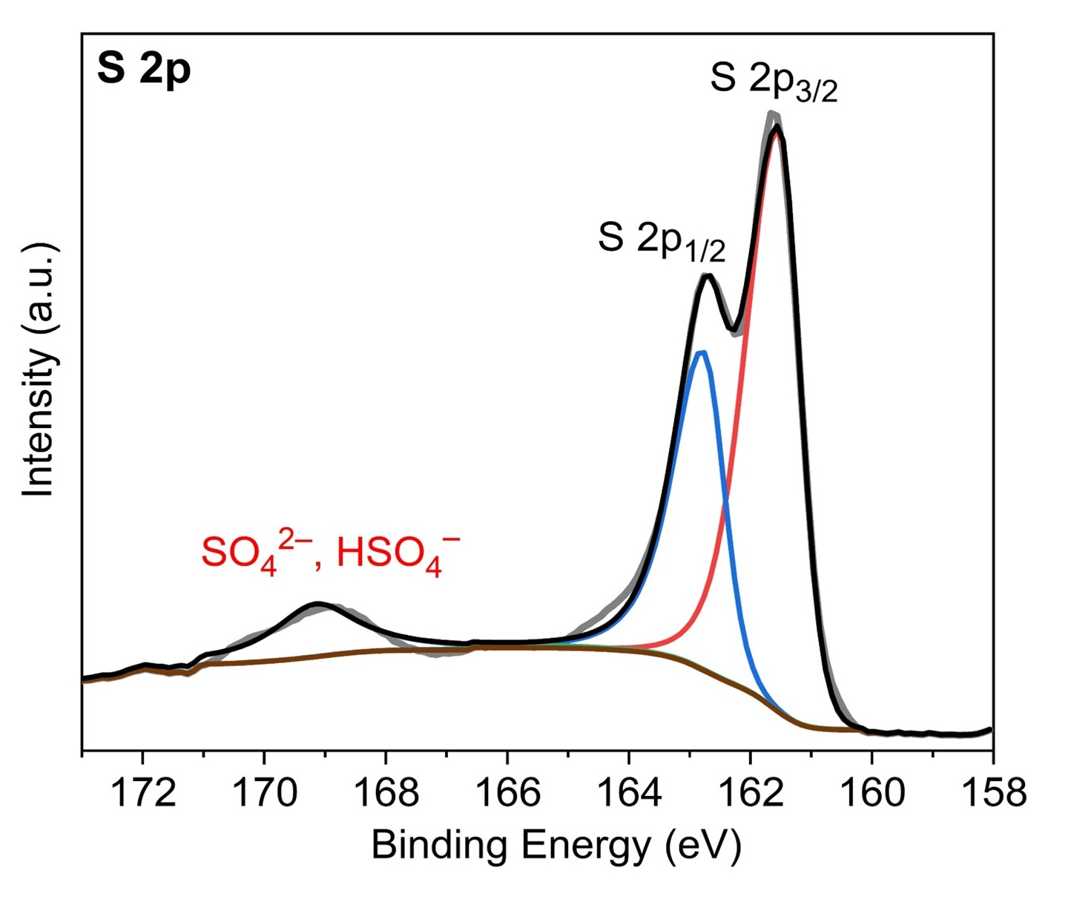 | 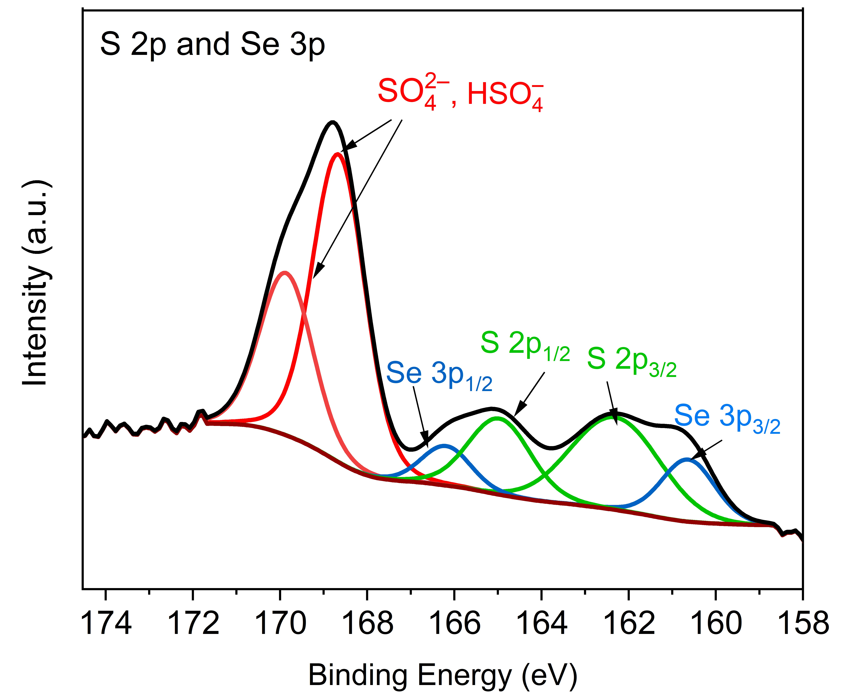
(a) | (b)
Figure S12. X-ray photoelectron spectrum of S 2p in (a) Ni_{1.0}Co_{2.1}(S_{0.9}O_{0.1})₄, and (b) Fe_{0.5}Ni_{1.0}Co_{2.0}(S_{0.57}Se_{0.25}O_{0.18})₄ (overlapping with Se 3p)

O 1s spectra of Ni_{1.0}Co_{2.1}(S_{0.9}O_{0.1})₄ and Fe_{0.5}Ni_{1.0}Co_{2.0}(S_{0.57}Se_{0.25}O_{0.18})₄:
To further evaluate the presence of oxygen in the samples of Ni_{1.0}Co_{2.1}(S_{0.9}O_{0.1})₄ and Fe_{0.5}Ni_{1.0}Co_{2.0}(S_{0.57}Se_{0.25}O_{0.18})₄ the O 1s spectra have been deconvoluted in two peaks (Figure S13). The prominent peaks observed at 531.8 eV for Ni_{1.0}Co_{2.1}(S_{0.9}O_{0.1})₄ and 531.7 eV for Fe_{0.5}Ni_{1.0}Co_{2.0}(S_{0.57}Se_{0.25}O_{0.18})₄ are attributed to the presence of OH– groups. These groups may arise from surface hydroxylation or the substitution of S²⁻ by OH–. Additionally, these peaks can also be attributed to the presence of defective oxides [12,13]. In addition, the O 1s spectrum shows small signal contributions at 533.4 eV for Ni_{1.0}Co_{2.1}(S_{0.9}O_{0.1})₄ and 532.9 eV for Fe_{0.5}Ni_{1.0}Co_{2.0}(S_{0.57}Se_{0.25}O_{0.18})₄, which can be assigned to oxygen from SO₄^{2–} on the surface of samples [13,14].
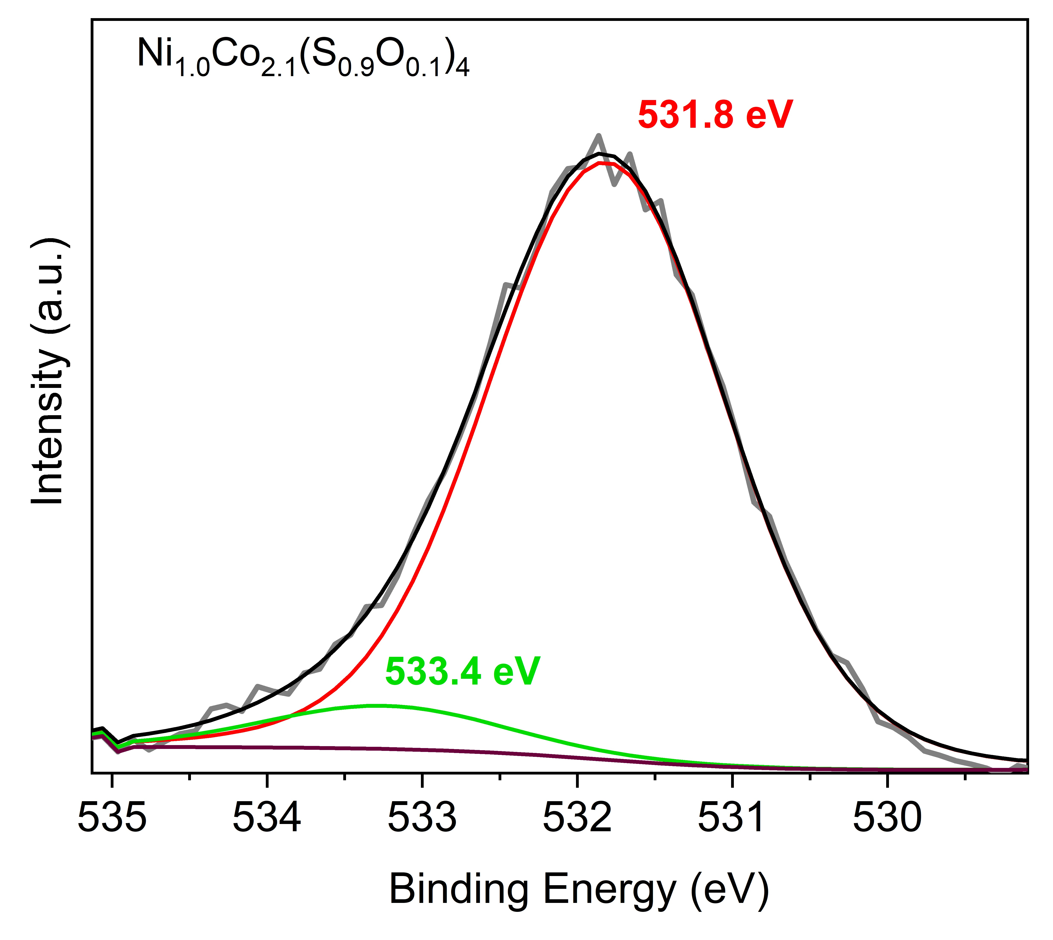 | 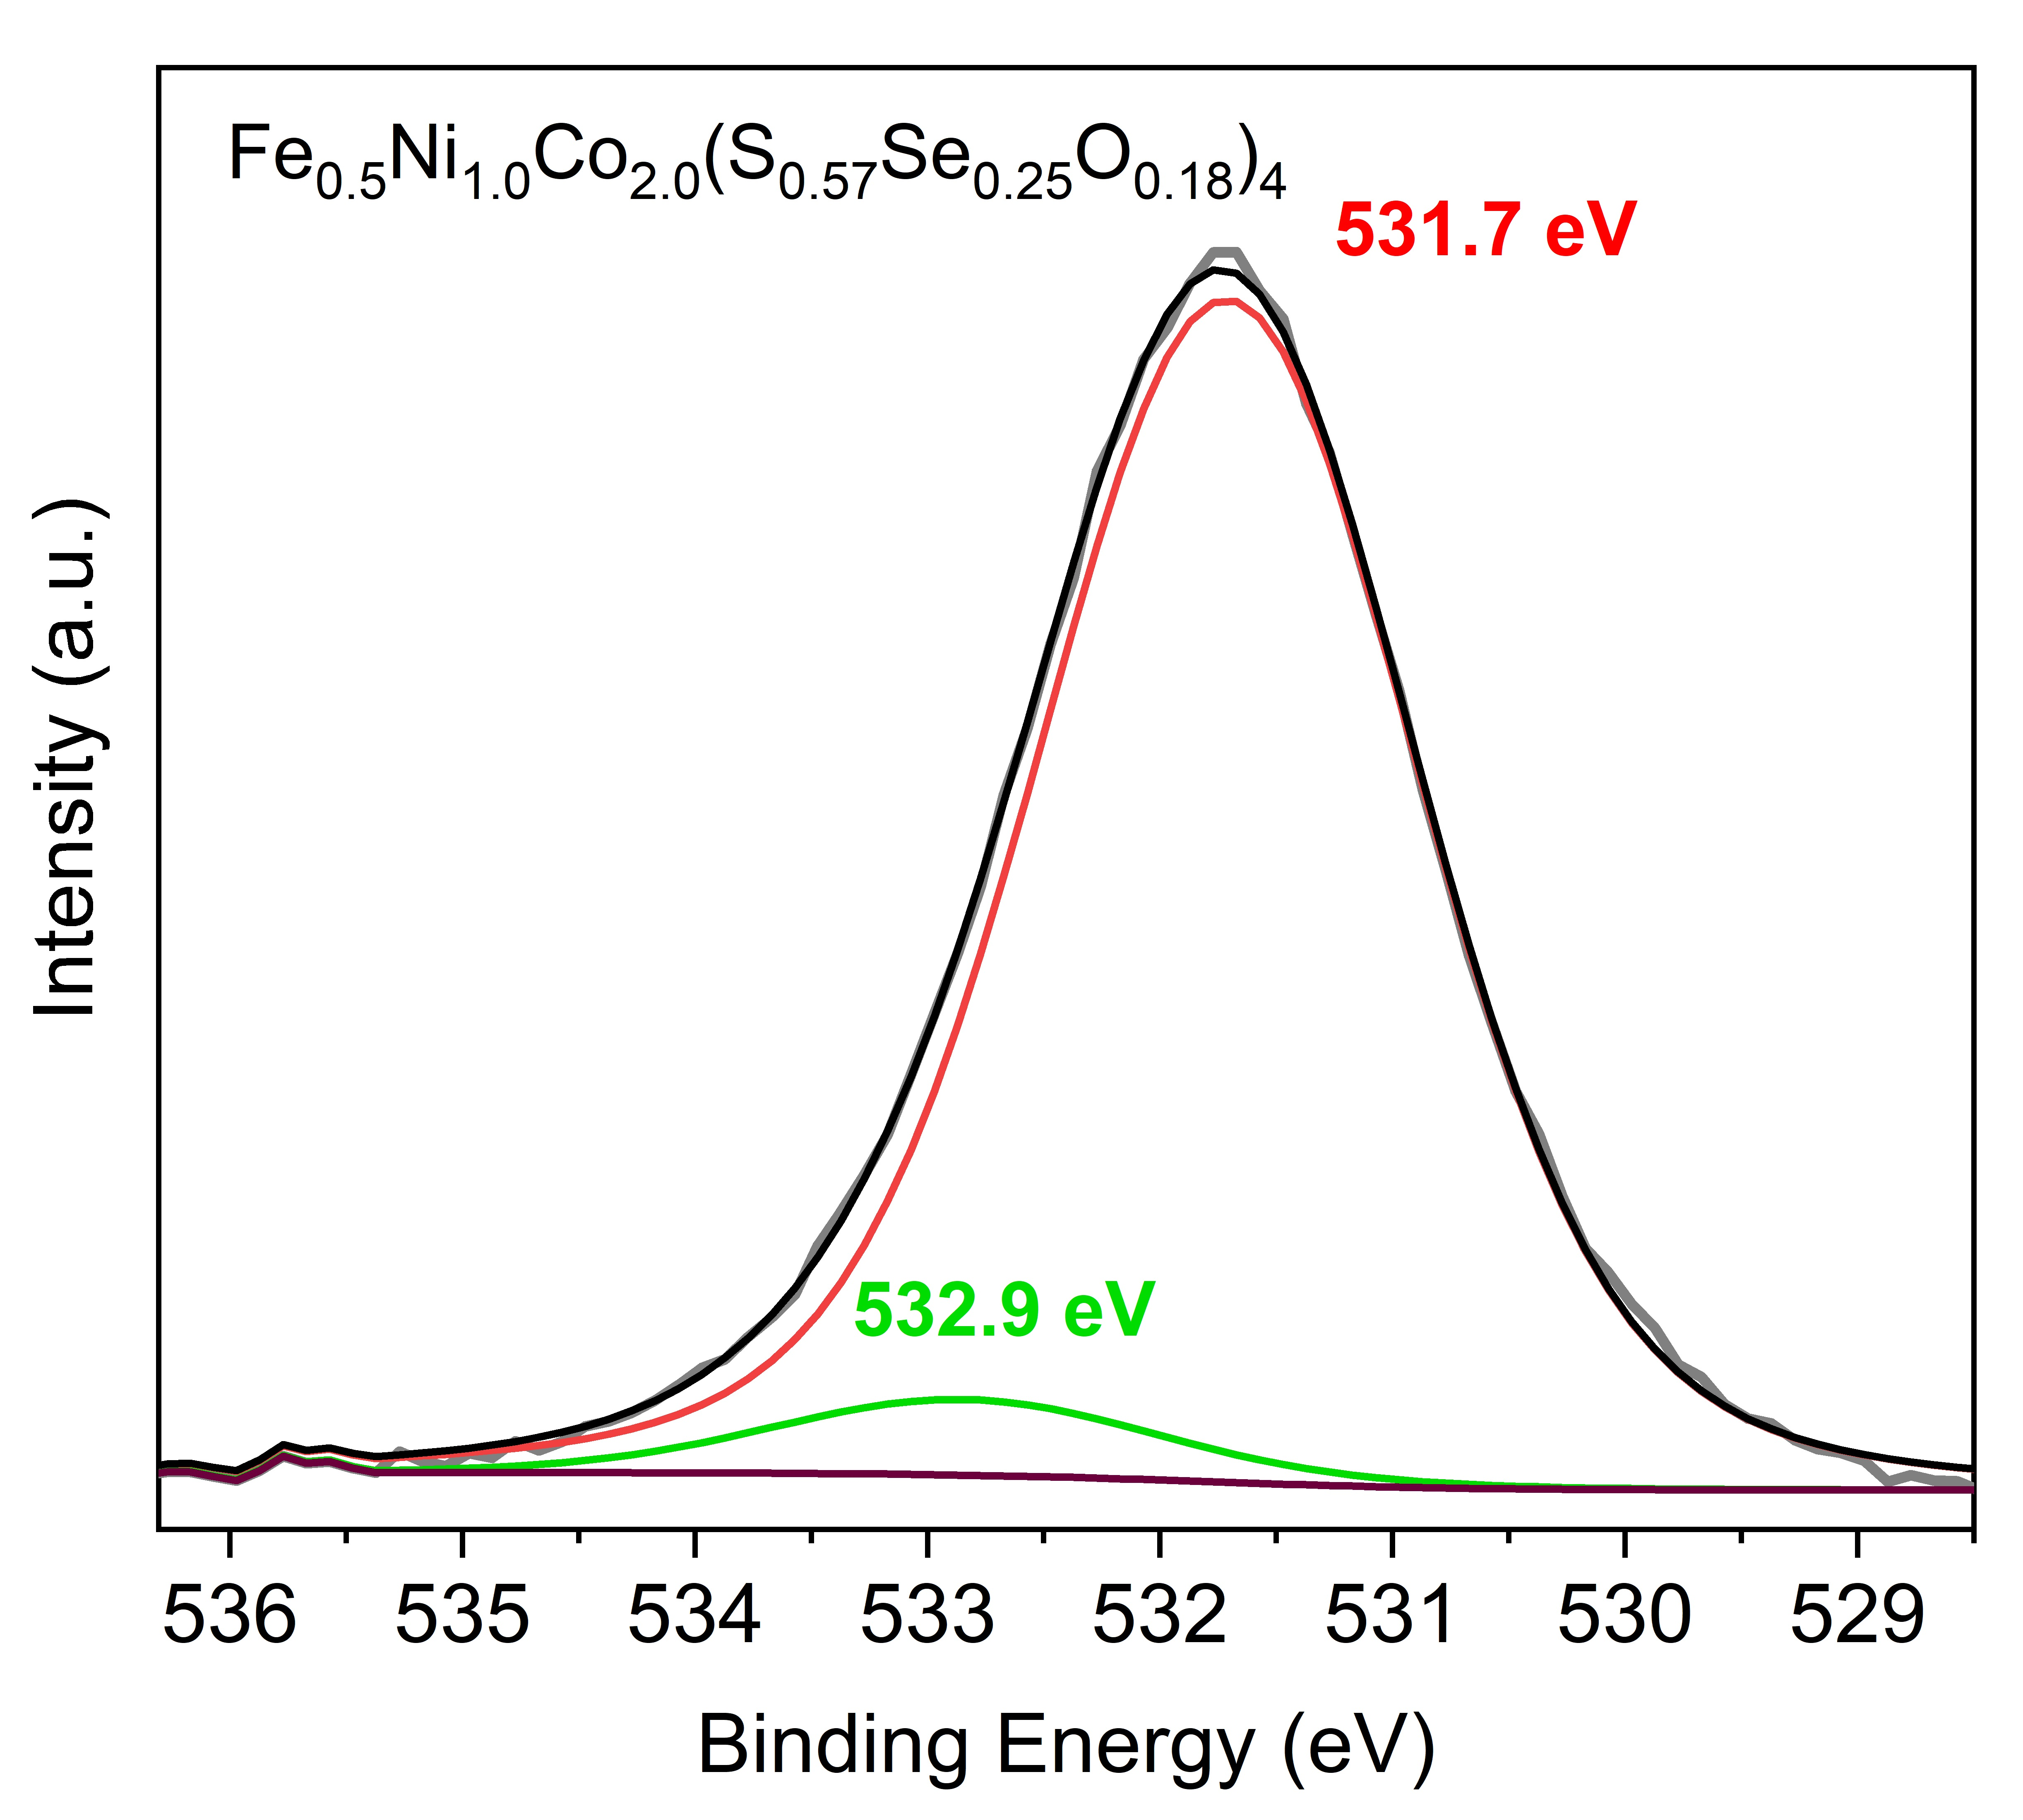
(a) | (b)
Figure S13. XPS O 1s spectrum of (a) Ni_{1.0}Co_{2.1}(S_{0.9}O_{0.1})₄, (b) Fe_{0.5}Ni_{1.0}Co_{2.0}(S_{0.57}Se_{0.25}O_{0.18})₄.

Table S8 and S9 summarize the binding energies in the XPS spectra of Ni_{1.0}Co_{2.1}(S_{0.9}O_{0.1})₄ and Fe_{0.5}Ni_{1.0}Co_{2.0}(S_{0.57}Se_{0.25}O_{0.18})₄.

Table S8. Binding energies of the element components in Ni_{1.0}Co_{2.1}(S_{0.9}O_{0.1})₄.^{a)}
Sample
Ni_{1.0}Co_{2.1}(S_{0.9}O_{0.1})₄ | Ni 2p_{3/2} |  |  | Ni 2p_{1/2}
 | Peak | Binding energy/eV | Sat. | Peak | Binding energy/eV | Sat.
 | Ni²⁺ | 853.3 | 860.5 | Ni²⁺ | 871.8 | 880.2
 | Ni³⁺ | 856.0 |  | Ni³⁺ | 875.4
 | Co 2p_{3/2} |  |  | Co 2_{1/2}
 | Peak | Binding energy/eV | Sat. | Peak | Binding energy/eV | Sat.
 | Co²⁺ | 780.3 | 784.5 | Co²⁺ | 796.5 | 801.5
 | Co³⁺ | 778.7 |  | Co³⁺ | 793.6
 | O 1s |  |  | S 2p
 | Peak | Binding energy/eV |  | Peak | Binding energy/eV
 | OH– or  defective oxides | 531.8 |  | S^{2–}, 2p_{3/2} | 161.5
 | O from SO₄^{2–} | 533.4 |  | S^{2–}, 2p_{1/2} | 162.7
 |  |  |  | SO₄^{2–},  HSO₄– | 169
^{a)} Sat. = satellite peak.

Table S9. Binding energies of the elements components in Fe_{0.5}Ni_{1.0}Co_{2.0}(S_{0.57} Se_{0.25}O_{0.18})₄.^{a)}
Sample
Fe_{0.5}Ni_{1.0}Co_{2.0}(S_{0.57}Se_{0.25}O_{0.18})₄ | Ni 2p_{3/2} |  |  | Ni 2p_{1/2}
 | Peak | Binding energy/eV | Sat. | Peak | Binding energy/eV | Sat.
 | Ni²⁺ | 854.5 | 864 | Ni²⁺ | 871.3 | 882.4
 | Ni³⁺ | 856.5 |  | Ni³⁺ | 875.0
 | Co 2p_{3/2} |  |  | Co 2p_{1/2}
 | Peak | Binding energy/eV | Sat. | Peak | Binding energy/eV | Sat.
 | Co²⁺ | 782.0 | 787.1 | Co²⁺ | 798.0 | 803.30
 | Co³⁺ | 779.1 |  | Co³⁺ | 795.2
 | Fe 2p_{3/2} |  |  | Fe 2p_{1/2}
 | Peak | Binding energy/eV | Sat. | Peak | Binding energy/eV | Sat.
 | Fe³⁺ | 712.5 | 717.5 | Fe³⁺ | 725.0 | 734.5
 | Se 3d_{5/2} |  |  | Se 3d_{3/2}
 | Peak | Binding energy/eV | Sat. |  | Binding energy/eV | Sat
 | Se^{2–} | 55.0 | ---- | Se^{2–} | 57.0 | 59.5
 | O1s |  | S 2p |  | Se 3p
 | Peak | Binding energy/eV | Peak | Binding energy/eV | Peak | Binding energy/eV
 | OH– or  defective oxides | 531.7 | S^{2–}, 2p_{3/2} | 162.5 | Se 3p3/2 | 160.7
 | O from adventitious carbon  or O from SO₄^{2–} | 532.9 | S^{2–}, 2p_{1/2} | 164.8 | Se 3p1/2 | 166.3
 |  |  | SO₄^{2–},  HSO₄– | 169
^{a)} Sat. = satellite peak.

Electrochemical characterization

The linear sweep voltammetry polarization curve and Tafel curve of (Fe_{x}Ni_{1–x})CoCH-(1.0) were shown in Figures S 14a and S 14b, respectively. The overpotential for generating 50 mA.cm^{–2} was 330 mV, and the calculated Tafel slope was 98 mV dec^{–2}. (Fe_{x}Ni_{1–x})CoCH-(1.0) showed lower OER performance compared to Fe_{0.6}Ni_{1.2}Co_{2.5}(S_{0.83}O_{0.17})₄ (ƞ₅₀ = 294 mV, Tafel slope = 87 mV dec^{–2}), Fe_{0.4}Ni_{0.7}Co_{1.6}(Se_{0.81} O_{0.19})₄ (ƞ₅₀ = 306 mV, Tafel slope = 84 mV dec^{–2}) and Fe_{0.4}Ni_{0.7}Co_{1.6}(Se_{0.81} O_{0.19})₄ (ƞ₅₀ = 277 mV, Tafel slope = 75 mV dec^{–2}) at the same condition. This result indicates that, although (Fe_{x}Ni_{1–x})CoCH-(1.0) was used as the precursor for the synthesis Fe_{0.6}Ni_{1.2}Co_{2.5}(S_{0.83}O_{0.17})₄, Fe_{0.4}Ni_{0.7}Co_{1.6}(Se_{0.81}O_{0.19})₄, and Fe_{0.5}Ni_{1.0}Co_{2.0}(S_{0.57}Se_{0.25}O_{0.18})₄ with the same transition metal content, the absence of chalcogens (S, Se) in its structure dramatically reduces its OER performance compared to related sulfide, selenide, and sulfoselenides.
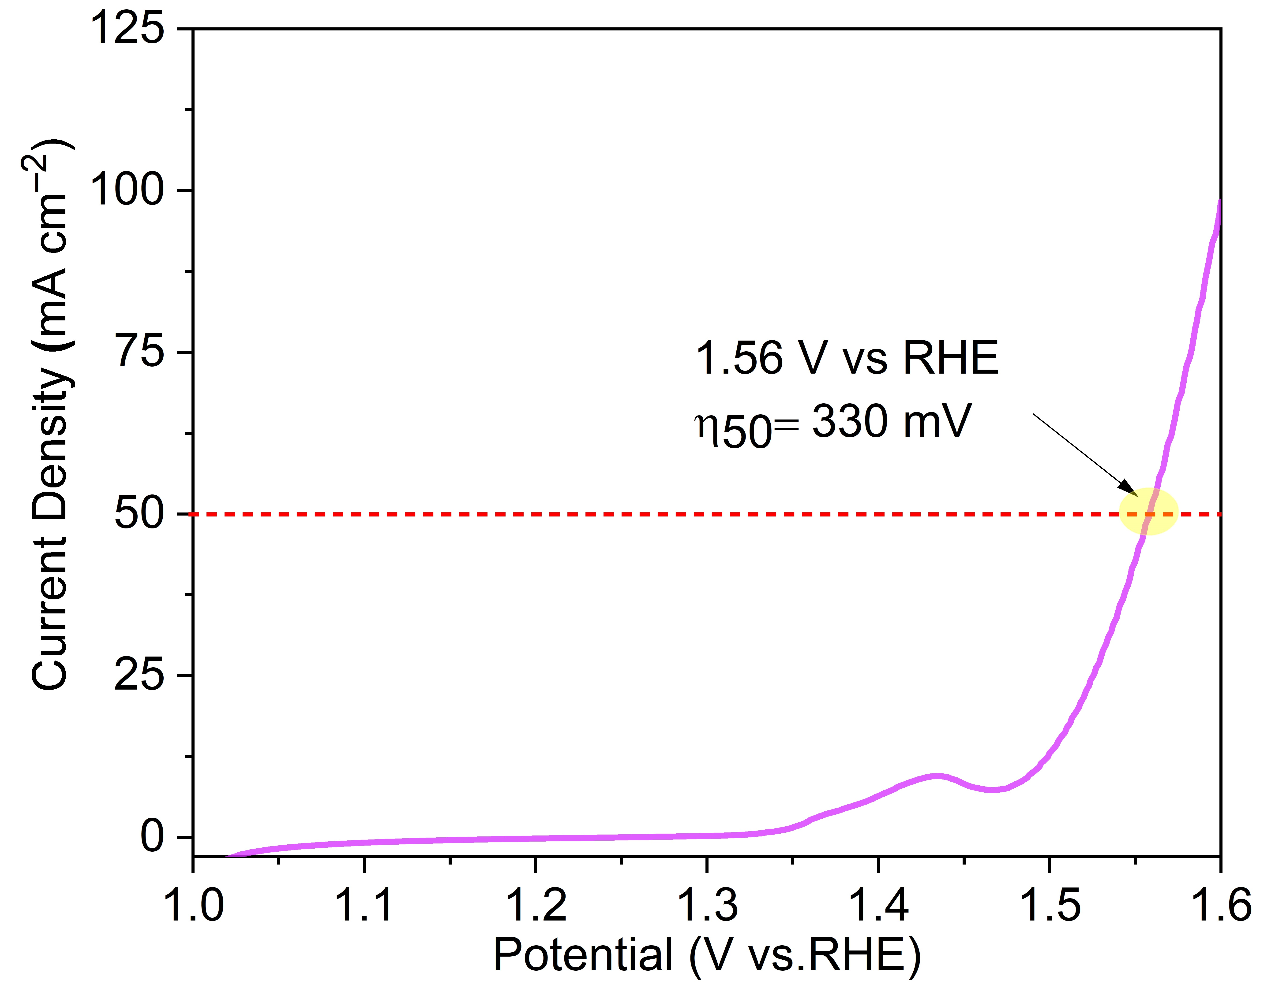 | 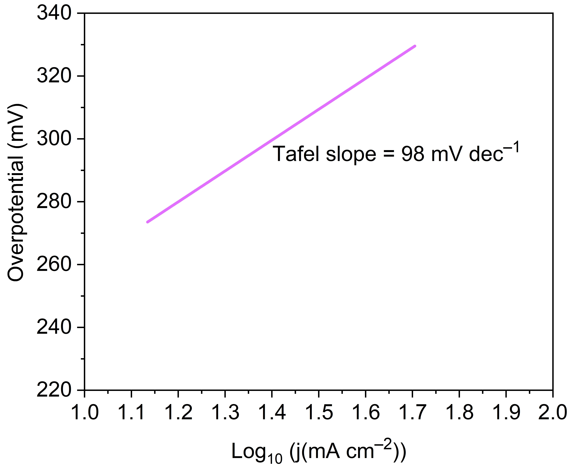
(a) | (b)
Figure S14. (a) LSV polarization curve of and (b) Tafel slope of (Fe_{x}Ni_{1–x})CoCH-(1.0).

The Nyquist plots of (Fe_{x}Ni_{1–x})CoCH-(1.0) in Figure S15 also showed a bigger semicircle radius than for Fe_{0.6}Ni_{1.2}Co_{2.5}(S_{0.83}O_{0.17})₄, Fe_{0.4}Ni_{0.7}Co_{1.6}(Se_{0.81}O_{0.19})₄ and Fe_{0.5}Ni_{1.0}Co_{2.0}(S_{0.57}Se_{0.25}O_{0.18})₄ which indicates higher charge transfer resistance during the OER process.
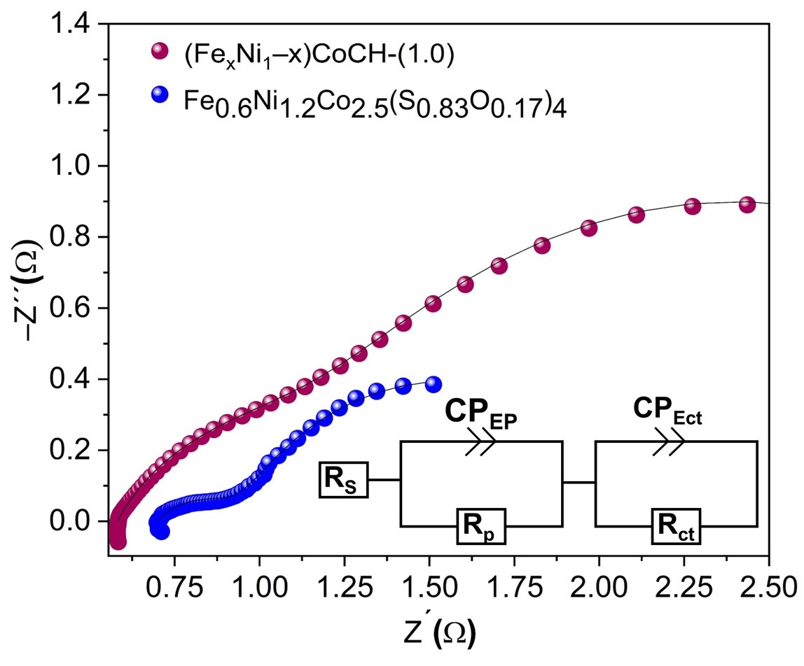
Figure S15. Nyquist plots of selected samples and Voigt circuit model of (Fe_{x}Ni_{1–x})CoCH-(1.0) and Fe_{0.6}Ni_{1.2}Co_{2.5}(S_{0.83}O_{0.17})₄.

References
1. Mohamed, S.G.; Hussain, I.; Shim, J.-J. One-Step Synthesis of Hollow C-NiCo₂S₄ Nanostructures for High-Performance Supercapacitor Electrodes. Nanoscale 2018, 10, 6620–6628, doi:10.1039/C7NR07338K.
2. Pu, J.; Cui, F.; Chu, S.; Wang, T.; Sheng, E.; Wang, Z. Preparation and Electrochemical Characterization of Hollow Hexagonal NiCo₂S₄ Nanoplates as Pseudocapacitor Materials. ACS Sustain. Chem. Eng. 2014, 2, 809–815, doi:10.1021/sc400472z.
3. Zou, J.; Xie, D.; Zhao, F.; Wu, H.; Niu, Y.; Li, Z.; Zou, Q.; Deng, F.; Zhang, Q.; Zeng, X. Microwave Rapid Synthesis of Nickel Cobalt Sulfides/CNTs Composites as Superior Cycling Ability Electrode Materials for Supercapacitors. J. Mater. Sci. 2021, 56, 1561–1576, doi:10.1007/s10853-020-05257-3.
4. Bao, Y.; Zhang, W.; Yun, T.; Dai, J.; Li, G.; Mao, W.; Guan, M.; Zhuang, Y. The Application of Transition Metal Sulfide Ni₃S₄/CNFs in Rechargeable Ni–Zn Batteries. New J. Chem. 2021, 45, 22491–22496, doi:10.1039/D1NJ03768D.
5. Min, K.; Yoo, R.; Kim, S.; Kim, H.; Shim, S.E.; Lim, D.; Baeck, S.-H. Facile Synthesis of P-Doped NiCo2S4 Nanoneedles Supported on Ni Foam as Highly Efficient Electrocatalysts for Alkaline Oxygen Evolution Reaction. Electrochim. Acta 2021, 396, 139236, doi:10.1016/j.electacta.2021.139236.
6. Kung, C.-W.; Chen, H.-W.; Lin, C.-Y.; Huang, K.-C.; Vittal, R.; Ho, K.-C. CoS Acicular Nanorod Arrays for the Counter Electrode of an Efficient Dye-Sensitized Solar Cell. ACS Nano 2012, 6, 7016–7025, doi:10.1021/nn302063s.
7. Khani, H.; Wipf, D.O. Iron Oxide Nanosheets and Pulse-Electrodeposited Ni–Co–S Nanoflake Arrays for High-Performance Charge Storage. ACS Appl. Mater. Interfaces 2017, 9, 6967–6978, doi:10.1021/acsami.6b11498.
8. Matoba, M.; Anzai, S.; Fujimori, A. Thermal Expansion, Thermoelectric Power, and XPS Study of the Nonmetal-Metal Transition in Ni_{1-x}S_{1-y}Se_{y}. J. Phys. Soc. Jpn. 1991, 60, 4230–4244, doi:10.1143/JPSJ.60.4230.
9. Shi, Z.-T.; Kang, W.; Xu, J.; Sun, L.-L.; Wu, C.; Wang, L.; Yu, Y.-Q.; Yu, D.Y.W.; Zhang, W.; Lee, C.-S. In Situ Carbon-Doped Mo(Se_{0.85}S_{0.15})₂ Hierarchical Nanotubes as Stable Anodes for High-Performance Sodium-Ion Batteries. Small 2015, 11, 5667–5674, doi:10.1002/smll.201501360.
10. Danilson, M.; Altosaar, M.; Kauk, M.; Katerski, A.; Krustok, J.; Raudoja, J. XPS Study of CZTSSe Monograin Powders. Thin Solid Films 2011, 519, 7407–7411, doi:10.1016/j.tsf.2010.12.165.
11. Zou, X.; Wu, Y.; Liu, Y.; Liu, D.; Li, W.; Gu, L.; Liu, H.; Wang, P.; Sun, L.; Zhang, Y. In Situ Generation of Bifunctional, Efficient Fe-Based Catalysts from Mackinawite Iron Sulfide for Water Splitting. Chem 2018, 4, 1139–1152, doi:10.1016/j.chempr.2018.02.023.
12. Sahoo, M.K.; Samantara, A.K.; Behera, J.N. In Situ Transformed Cobalt Metal–Organic Framework Electrocatalysts for the Electrochemical Oxygen Evolution Reaction. Inorg. Chem. 2020, 59, 12252–12262, doi:10.1021/acs.inorgchem.0c01300.
13. Biesinger, M.C.; Payne, B.P.; Grosvenor, A.P.; Lau, L.W.M.; Gerson, A.R.; Smart, R.St.C. Resolving Surface Chemical States in XPS Analysis of First Row Transition Metals, Oxides and Hydroxides: Cr, Mn, Fe, Co and Ni. Appl. Surf. Sci. 2011, 257, 2717–2730, doi:10.1016/j.apsusc.2010.10.051.
14. High Resolution XPS of Organic Polymers: The Scienta ESCA300 Database (Beamson, G.; Briggs, D.). J. Chem. Educ. 1993, 70, A25, doi:10.1021/ed070pA25.5.

