Supporting information

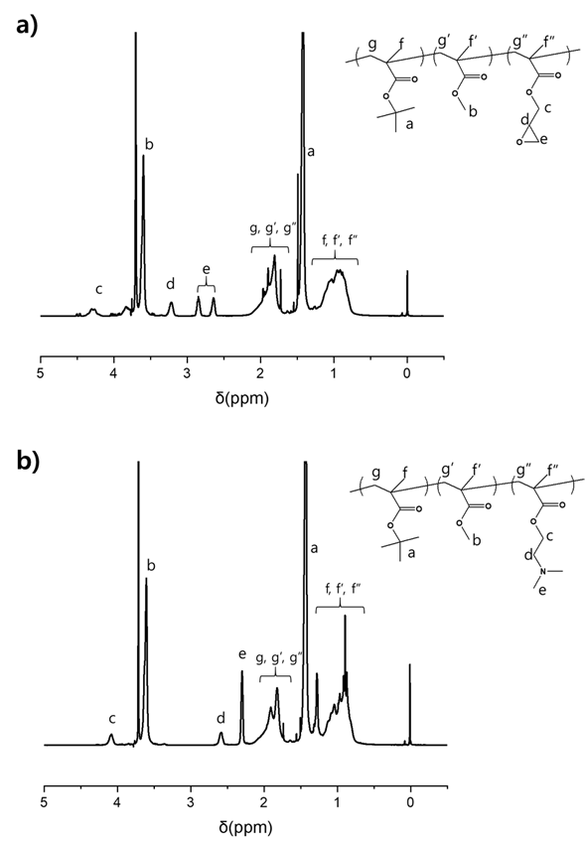
Figure S1. Chemical structure analysis of synthesized covalent a) and non-covalent b) chain extenders.

Table S1. Melt flow index (MFI) results of PGA/PCL blending plastics according to blending ratio and introducing with covalent or non-covalent chain extenders.
Sample name | PGA  (g) | PCL  (g) | G-CE*ª (g) | D-CE*^{b} (g) | ADR-4368*^{c} (g) | Time (min) | MFI (g/10min)
PGA_0 | 150 | - | - | - | - | 0 | 24.50
PGA_4 | 150 | - | - | - | - | 4 | 25.92
PGA | 150 | - | - | - | - | 6 | 26.94
PGA_8 | 150 | - | - | - | - | 8 | 30.58
PGA_10 | 150 | - | - | - | - | 10 | 31.45
PGA_12 | 150 | - | - | - | - | 12 | 32.86
10 | 135 | 15 | - | - | - | 6 | 37.02
10G | 135 | 15 | 0.75 | - | - | 6 | 15.56
10D | 135 | 15 | - | 0.3 | - | 6 | 22.66
10GD | 135 | 15 | 0.75 | 0.3 | - | 6 | 21.1
10J | 135 | 15 | - | - | 1.5 | 6 | 38.92
30 | 105 | 45 | - | - | - | 6 | 63.42
30G | 105 | 45 | 0.75 | - | - | 6 | 18.25
30D | 105 | 45 | - | 0.3 | - | 6 | 24.69
30GD | 105 | 45 | 0.75 | 0.3 | - | 6 | 24.75
50 | 75 | 75 | - | - | - | 6 | 44.07
50G | 75 | 75 | 0.75 | - | - | 6 | 17.91
50D | 75 | 75 | - | 0.3 | - | 6 | 32.36
50GD | 75 | 75 | 0.75 | 0.3 | - | 6 | 27.76
10G_0.2 | 135 | 15 | 0.3 | - | - | 6 | 18.39
10G_0.5 (10G) | 135 | 15 | 0.75 | - | - | 6 | 15.56
10G_1.0 | 135 | 15 | 1.5 | - | - | 6 | 16.28
10D_0.2 | 135 | 15 | - | 0.3 | - | 6 | 22.66
10D_0.5 (10D) | 135 | 15 | - | 0.75 | - | 6 | 44.66
10D_1.0 | 135 | 15 | - | 1.5 | - | 6 | 52.82
*ª ; Ionic chain extender (D-CE)
*^{b} ; Covalent chain extender (G-CE)
*^{c} ; Joncryl® chain extender purchased from BASF Co. Ltd

Table S2. Differential scanning calorimetry (DSC) of PGA and PGA/PCL blending plastics with or without chain extenders.
Sample name | T_{c1 at PCL}  (℃) | area  (mJ) | T_{c2 at PGA}  (℃) | area  (mJ) | T_{m1 at PGA}  (℃) | T_{m2 at PGA}  (℃)
PGA | - | - | 193.46 | 536.24 | 210.76 | 221.67
10 | 13.75 | 16.53 | 193.13 | 281.21 | 214.83 | 222.24
10G | 14.71 | 32.34 | 190.91 | 389.86 | 215.24 | 221.32
10D | 11.60 | 19.08 | 192.39 | 283.32 | 214.01 | 221.33
10GD | 11.37 | 10.06 | 193.05 | 172.94 | 215.61 | 222.60

Table S3. Mechanical properties of PGA/PCL blending plastics according to blending ratio and introducing with or without chain extenders.
Sample name | Tensile strength (kgf/mm2) |  | Elongation (%)
PGA |  | 8.22 | 4.80
10 |  | 11.60 | 7.20
30 |  | 5.67 | 6.20
50 |  | 3.45 | 5.15
10G |  | 8.99 | 18.45
30G |  | 4.65 | 11.15
50G |  | 2.15 | 7.20
10D |  | 9.31 | 26.60
30D |  | 5.69 | 13.60
50D |  | 2.41 | 11.20
10J |  | 9.03 | 14.35

