Supplementary Material

A.
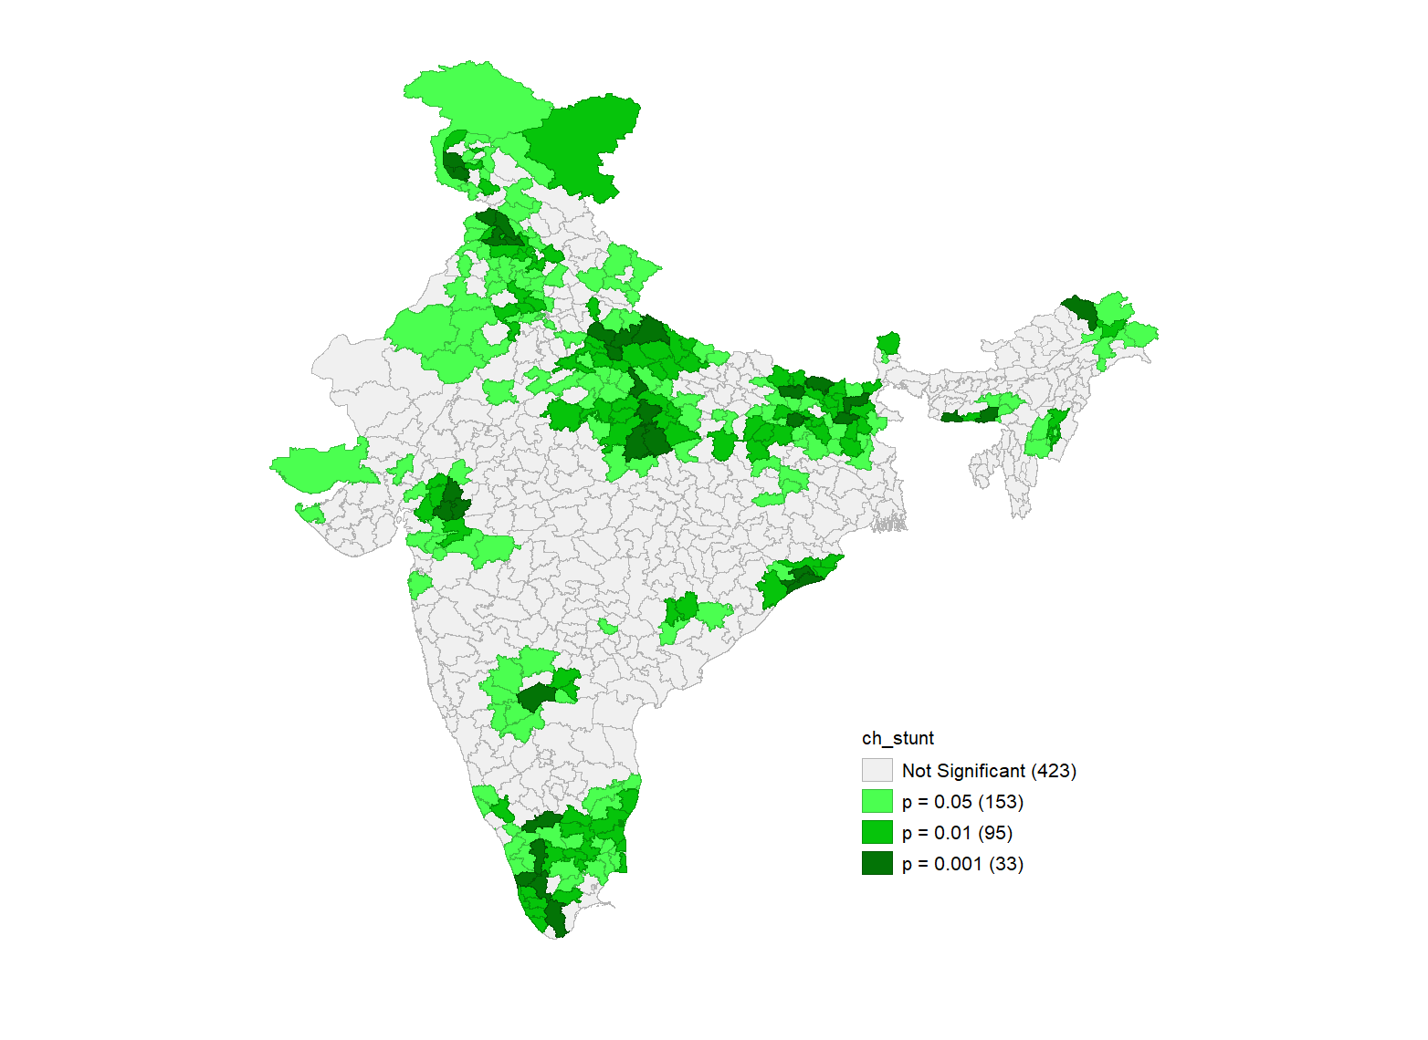

B.
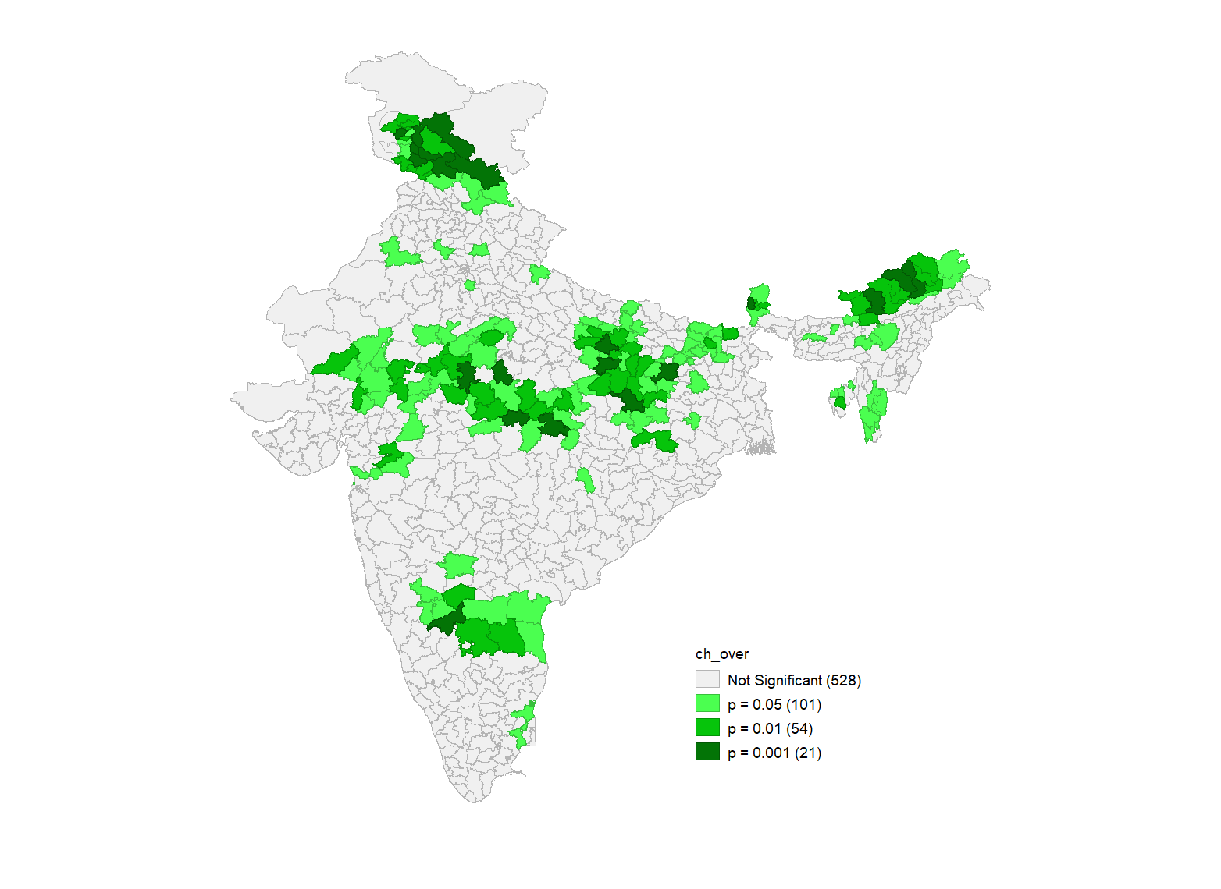

C.
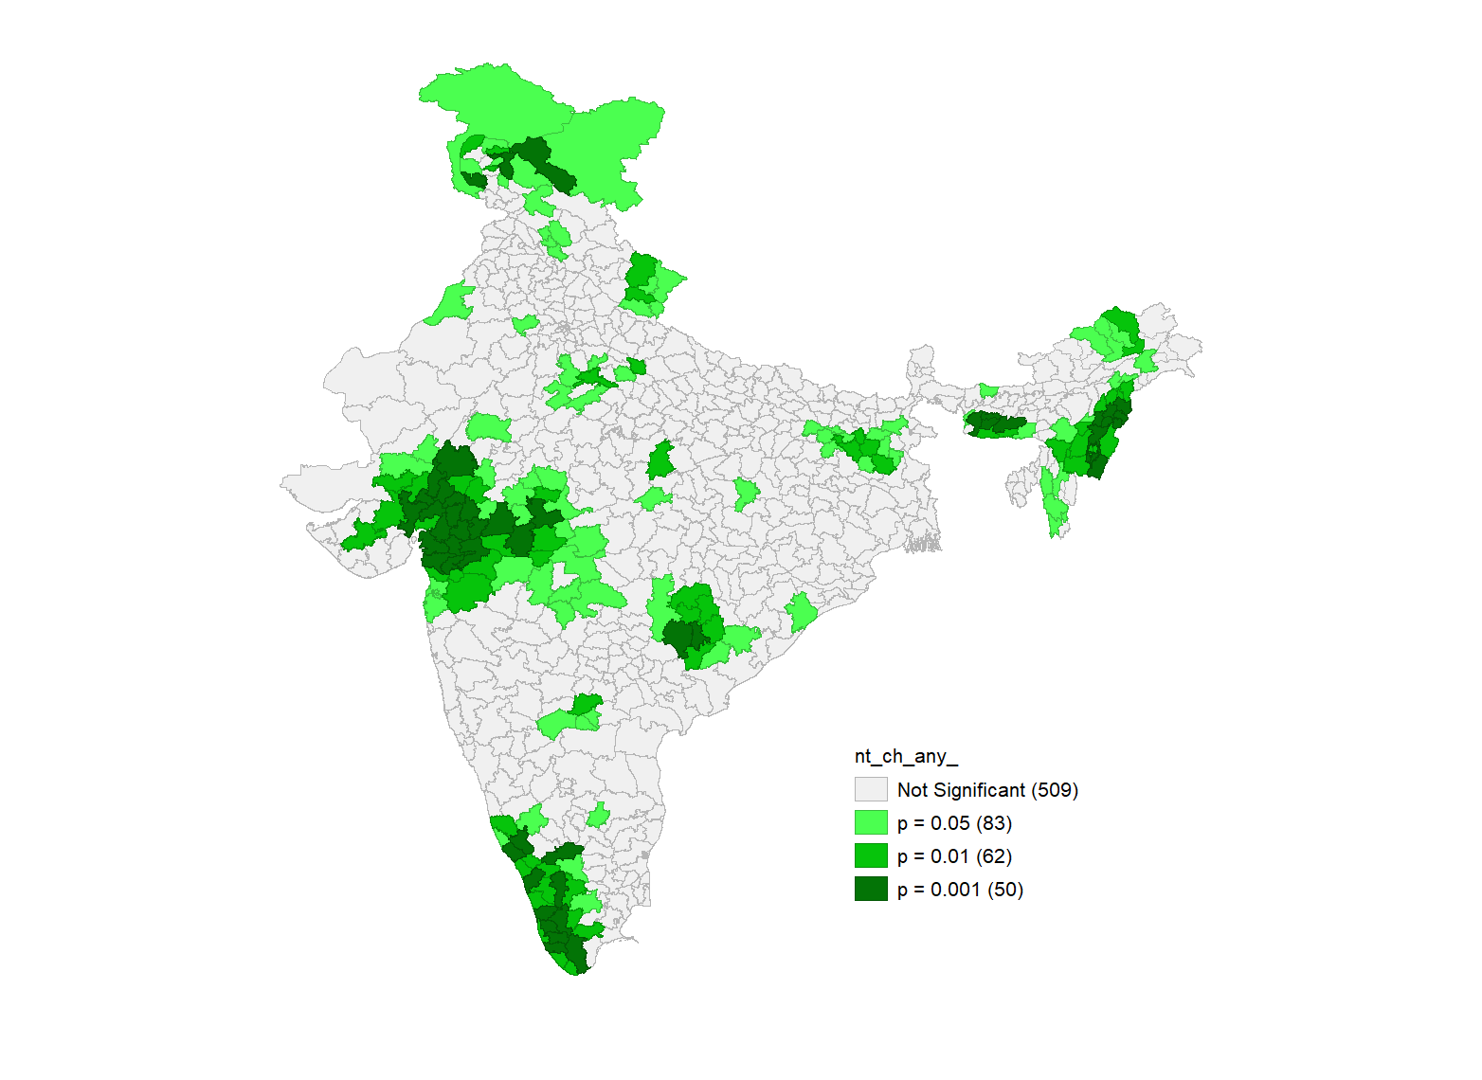

Figure S 1. Univariate LISA significance map of (a) stunting (b) overweight and (c) anaemia among children aged 6-59 months across 707 districts in India, National Family Health Survey (NFHS-5), 2019-21.

Table S2. Ordinary Least Square and Spatial Auto Regressive (SAR) models for malnutrition outcomes (a) stunting (b) overweight and (c) anaemia among children aged 6-59 months across 707 districts, India, National Family Health Survey (NFHS-5), 2019-21.
Predictors | Coefficient (p-value)
 | Ordinary Least Square (OLS) | Spatial Lag Model (SLM) | Spatial Error Model (SEM)
Stunting
Rural | -0.029 (0.029) | -0.019 (0.145) | -0.026 (0.059)
Poorest | 0.046 (0.063) | 0.037 (0.118) | 0.066 (0.058)
Scheduled Castes/Tribes | -0.013 (0.379) | 0.002 (0.914) | 0.001 (0.951)
Ten or more years of Schooling | 0.013 (0.527) | 0.018 (0.313) | 0.005 (0.827)
Exposure to Mass Media | 0.004 (0.893) | 0.020 (0.463) | 0.024 (0.432)
Muslim | 0.009 (0.521) | 0.025 (0.084) | 0.015 (0.390)
Female Child | 0.171 (0.011) | 0.142 (0.023) | 0.132 (0.032)
Three or more Birth Order | 0.364 (0.000) | 0.290 (0.000) | 0.327 (0.000)
Children under 6 months exclusively breastfed | 0.009 (0.333) | 0.008 (0.362) | 0.009 (0.253)
Children 6-23 months receiving an adequate diet | -0.028 (0.443) | -0.010 (0.767) | -0.044 (0.238)
Women with Body Mass Index<18.5 kg/m2 | 0.353 (0.000) | 0.277 (0.000) | 0.310 (0.000)
Household with Improved Sanitation | -0.061 (0.004) | -0.052 (0.009) | -0.064 (0.008)
Constant | 15.90 (0.000) | 6.01 (0.122) | 17.38 (0.000)
Number of Observations | 707 | 707 | 707
Log likelihood | -2299.98 | -2267.47 | -2267.66
AIC | 4625.97 | 4562.95 | 4561.32
Adjusted R square | 0.53 | 0.595 | 0.597
Lag (Rho) Coefficient |  | 0.317
Error (Lambda) Coefficient |  |  | 0.406
Overweight
Urban | 0.004 (0.597) | 0.007 (0.227) | 0.005 (0.022)
Richest | -0.018 (0.057) | -0.012 (0.162) | -0.011 (0.379)
Scheduled Castes/Tribes | 0.035 (0.000) | 0.023 (0.000) | 0.026 (0.000)
Ten or more years of Schooling | 0.002 (0.805) | 0.005 (0.589) | 0.0097 (0.414)
Exposure to Mass Media | -0.015 (0.141) | -0.014 (0.135) | -0.019 (0.104)
Muslim | 0.031 (0.000) | 0.019 (0.003) | 0.029 (0.001)
Female Child | 0.072 (0.011) | 0.059 (0.026) | 0.049 (0.057)
Three or more Birth Order | -0.049 (0.000) | -0.028 (0.034) | -0.021 (0.218)
Children under 6 months exclusively breastfed | 0.003 (0.371) | 0.004 (0.322) | 0.003 (0.460)
Children 6-23 months receiving an adequate diet | -0.009 (0.572) | -0.009 (0.507) | 0.000 (0.999)
Women with Body Mass Index<18.5 kg/m2 | -0.149 (0.000) | -0.103 (0.000) | -0.127 (0.000)
Births delivered by Caesarean Section | 0.011 (0.304) | 0.008 (0.369) | 0.022 (0.079)
Constant | 3.55 (0.027) | 1.58 (0.284) | 3.41 (0.022)
Number of Observations | 707 | 707 | 707
Log likelihood | -1724.98 | -1682.25 | -1685
AIC | 3475.96 | 3392.5 | 3396.01
Adjusted R square | 0.26 | 0.378 | 0.38
Lag (Rho) Coefficient |  | 0.41
Error (Lambda) Coefficient |  |  | 0.46
Anaemia
Rural | -0.018 (0.287) | -0.007 (0.674) | -0.013 (0.484)
Poorest | -0.271 (0.000) | 0174 (0.000) | -0.109 (0.005)
Scheduled Castes/Tribes | 0.034 (00.106) | 0.023 (0.162) | 0.001 (0.951)
Ten or more years of Schooling | -0.124 (0.000) | -0.060 (0.011) | -0.068 (0.057)
Exposure to Mass Media | -0.060 (0.116) | -0.017 (0.618) | 0.021 (0.605)
Muslim | 0.035 (0.084) | 0.038 (0.036) | 0.046 (0.069)
Female Child | 0.248 (0.005) | 0.282 (0.000) | 0.199 (0.011)
Three or more Birth Order | 0.000 (0.991) | 0.031 (0.400) | 0.064 (0.191)
Children under 6 months exclusively breastfed | 0.033 (0.004) | 0.028 (0.006) | 0.023 (0.024)
Children 6-23 months receiving an adequate diet | -0.215 (0.000) | -0.135 (0.002) | -0.059 (0.219)
Women with Body Mass Index<18.5 kg/m2 | 0.195 (0.000) | 0.084 (0.0611) | 0.060 (0.291)
Household with Improved Sanitation | 0.110 (0.000) | 0.083 (0.001) | -0.085 (0.009)
Anaemic Mothers | 0.566 (0.000) | 0.465 (0.000) | 0.583 (0.000)
Constant | 43.69 (0.000) | 13.51 (0.012) | 30.22 (0.000)
Number of Observations | 707 | 707 | 707
Log likelihood | -2491.62 | -2438.06 | -2449.29
AIC | 5011.25 | 4906.12 | 4926.59
Adjusted R square | 0.57 | 0.64 | 0.64
Lag (Rho) Coefficient |  | 0.36
Error (Lambda) Coefficient |  |  | 0.55

Table S3. Result of quantile regression with proportion of children who were stunted, underweight and anaemia by some selected characteristics in 707 districts of India, NFHS-5 (2019-21)
Childhood Stunting | q25 | q50 | q75 | q90
Rural | -0.0437*** | -0.0213 | -0.0222 | -0.00588
Poorest | -0.000407 | -0.00157 | 0.0377 | 0.0205
Scheduled Castes/Tribes | 0.0154 | 0.0128 | -0.0086 | -0.0169
Ten or more years of Schooling | 0.029 | -0.0109 | -0.017 | -0.0224
Exposure to Mass Media | -0.0805 | -0.0375 | -0.0111 | 0.0117
Muslim | 0.0206 | 0.0274 | 0.0165 | 0.0213
Female Child | -0.0206 | 0.0977 | 0.0909 | 0.0947
Three or more Birth Order | 0.252*** | 0.295*** | 0.372*** | 0.389***
Children under 6 months exclusively breastfed | 0.0153 | 0.0105 | 0.0148 | -0.0129
Children 6-23 months receiving an adequate diet | -0.0947 | -0.0278 | -0.0157 | -0.0312
Women with Body Mass Index<18.5 kg/m2 | 0.305*** | 0.390*** | 0.342*** | 0.310***
Household with Improved Sanitation | -0.122*** | -0.0708** | -0.0422 | -0.0491
Constant | 36.28*** | 24.40** | 23.91*** | 27.30***
Childhood Overweight | q25 | q50 | q75 | q90
Urban | 0.00565 | 0.00683 | 0.0137 | 0.00905
Richest | -0.0132 | -0.0194** | -0.0341** | -0.0506*
Scheduled Castes/Tribes | 0.00878 | 0.0261*** | 0.0513*** | 0.0514***
Ten or more years of Schooling | -0.00245 | 0.0196* | 0.0299* | 0.000993
Exposure to Mass Media | -0.00213 | -0.0116 | -0.0136 | 0.000273
Muslim | 0.0101 | 0.0281* | 0.0411*** | 0.0247*
Female Child | 0.0173 | 0.0487 | 0.0990* | 0.155*
Three or more Birth Order | -0.00903 | -0.0236 | -0.0635* | -0.102**
Children under 6 months exclusively Breastfed | -0.00264 | -0.000952 | -0.000321 | 0.00437
Children 6-23 months receiving an adequate diet | 0.0238 | 0.00363 | 0.0195 | 0.0038
Women with Body Mass Index<18.5 kg/m2 | -0.0870*** | -0.123*** | -0.192*** | -0.266***
Births delivered by Caesarean Section | 0.0161 | 0.0125 | -0.00922 | -0.0107
Constant | 0.328 | -0.459 | -1.687 | 0.506
Childhood Anaemia | q25 | q50 | q75 | q90
Rural | -0.0118 | -0.0563 | -0.0509* | -0.0225
Poorest | -0.351*** | -0.260*** | -0.233*** | -0.259***
Scheduled Castes/Tribes | 0.0184 | 0.0278 | 0.0488 | 0.0702**
Ten or more years of Schooling | -0.195*** | -0.146*** | -0.181*** | -0.174***
Exposure to Mass Media | -0.140* | -0.0896 | -0.0756 | -0.064
Muslim | 0.029 | 0.0231 | 0.0144 | 0.0249
Female Child | -0.0029 | 0.148 | 0.0804 | -0.0445
Three or more Birth Order | -0.114 | -0.0930* | -0.147** | -0.122*
Children under 6 months exclusively Breastfed | 0.0451** | 0.0392** | 0.0286 | 0.0258
Children 6-23 months receiving an adequate diet | -0.191* | -0.164** | -0.257*** | -0.221***
Women with Body Mass Index<18.5 kg/m2 | 0.217** | 0.109 | 0.0646 | 0.0638
Household with Improved Sanitation | -0.155*** | -0.175*** | -0.152*** | -0.145***
Anaemic Mothers | 0.485*** | 0.528*** | 0.472*** | 0.469***
Constant | 71.29*** | 65.26*** | 77.62*** | 82.85***

