Supplementary Materials
Quantifying the Potential Contribution of Submerged Aquatic Vegetation to Coastal Carbon Capture in a Delta System from Field and Landsat 8/9-OLI data with Deep Convolutional Neural Network

Bingqing Liu¹*, Tom Sevick¹, Hoonshin Jung¹, Erin Kiskaddon¹, Tim Carruthers¹
Citation: To be added by editorial staff during production.
Academic Editor: Firstname Lastname
Received: date
Revised: date
Accepted: date
Published: date
Copyright: © 2023 by the authors. Submitted for possible open access publication under the terms and conditions of the Creative Commons Attribution (CC BY) license (https://creativecommons.org/licenses/by/4.0/).
¹ The Water Institute, 1110 S. River Road, Baton Rouge, LA, 70802, USA
* Correspondence: bliu@thewaterinstitute.org; Tel.: +1-225-916-8089

Supplementary Materials

Supplement 1. Accuracy Metrics of WSAV-Net
For accurate analysis of image classification, four evaluation indices were used in this study including probability of false detection ($P_{f}$), Precision, Recall, and F₁ score. The F₁ score, is a measure of a model’s accuracy on a dataset, which is a way of combining the precision and recall of the model and is defined as the harmonic mean of the model’s precision and recall [1]. The model reports summary information per epoch while the tool is running. The Precision, Recall, and F₁ scores are averaged for all classes using a macro-average method (an equal weight per class).
The probability of false classification $P_{f}$ was calculated as (Eq. 1):
$P_{f}= \frac{FP}{TP+FP}$ (1)
where, TP is the number of pixels classified correctly, and FP is the number of pixels incorrectly classified.
Precision refers to the fraction of correct predictions for a class, with respect to all the points predicted to be in that class, both correct and incorrect and calculated based on $P_{f}$
$Precision= \frac{TP}{TP+FP}=1-P_{f}$ (2)
Recall is the fraction of correct predictions for a class with respect to all the points that truly belong in the class (Eq. 3):
$Recall= \frac{TP}{TP+FN}$ (3)
where, FN is the number of pixels unclassified but which belong to one specific class.
Further, $F_{1} score$ was calculated as a harmonic mean between Precision and Recall (Eq. 4):
$F_{1} score= \frac{2Precision ×Recall}{Presicion+Recall}$ (4)
where, an F₁ score attains its best value at one (perfect precision and recall) and worst at zero.

Supplement 2. Look-up Table for Carbon Flux Values from Literature Review
Table S2. Look-up table used to represent the carbon fluxes that were used to calculate the estimated net ecosystem carbon balance (NECB) of eight dominant coastal habitats including floating aquatic vegetation (FAV), fresh forested wetland, fresh marsh, intermediate marsh, brackish marsh, SAV, bare ground, and open waters (fresh/intermediate).
Existing Habitat | Carbon Flux (mean ± 95% SE, tonne CO₂e ha⁻¹ year⁻¹) |  |  |  | References
 | ANPP  (± SE) | Sed./Soil Accum.  (± SE) | GHG emission (± SE) | NECB (± combined uncertainty)
Fresh Forested Wetland | -16.4 ± 1.2 | -8.9 ± 2.0 | 24.6 ± 12.2 | -0.7 ± 0.4 | [2–23]
Fresh Marsh | -22.2 ± 3.8 | -7.4 ± 1.2 | 44.6 ± 15.2 | 15.0 ± 6.2 | [9,24–46]
Intermediate Marsh | -24.1 ± 2.3 | -6.2 ± 1.1 | 44.6 ± 15.2 | 14.3 ± 5.7 | [9,26,30,31,41,43,44,47–55]
Brackish Marsh | -46.5 ± 5.5 | -9.2 ± 1.1 | 8.1 ± 3.2 | -47.6 ± 20.4 | [25–32,34–41,43,44,47–50,54–65]
SAV | -5.1 ± 0.31 | -11.7 ± 6.1 | 3.2 ± 0.79 | -13.6 ± 7.9 | [66–68,68–78]
Open Water | -3.7 ± 0.0 | -5.2 ± 1.8 | 0.28 ± 0.18 | -8.6 ± 6.3 | [3,18,25,27–29,68,79]
Notes: * (1) FAV habitat area was combined into fresh marsh for NECB and net flux analysis as limited information available for FAV habitat. (2) Bare ground was considered as not modeled area with carbon fluxes (e.g., ANNP, Sed/Soil accmu., and GHG) as zero in this study.

Supplement 3. Hurricane Tracks for Barry 2019 and Ida 2021.
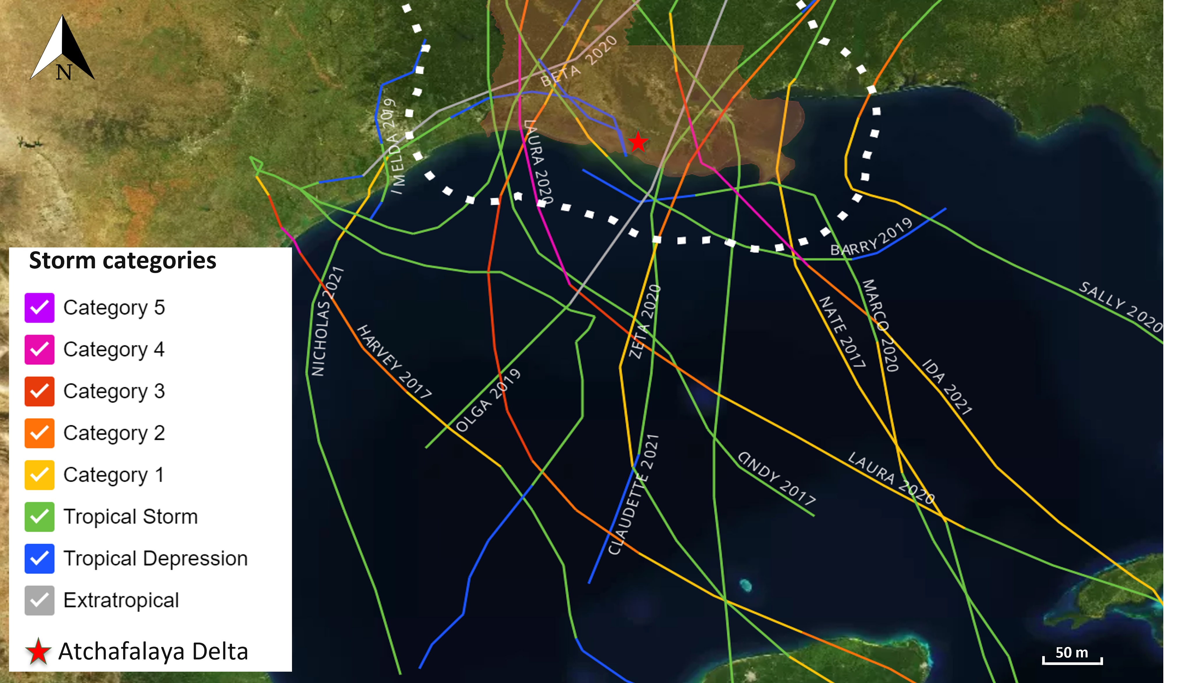
Figure S3-1. Tracks of major hurricanes that made landfall near the Louisiana Coast during the study period of 2015-2022. The colored lines indicate the different categories of the hurricanes.

Supplement 4. Percent Habitat Changes at Targeted Years
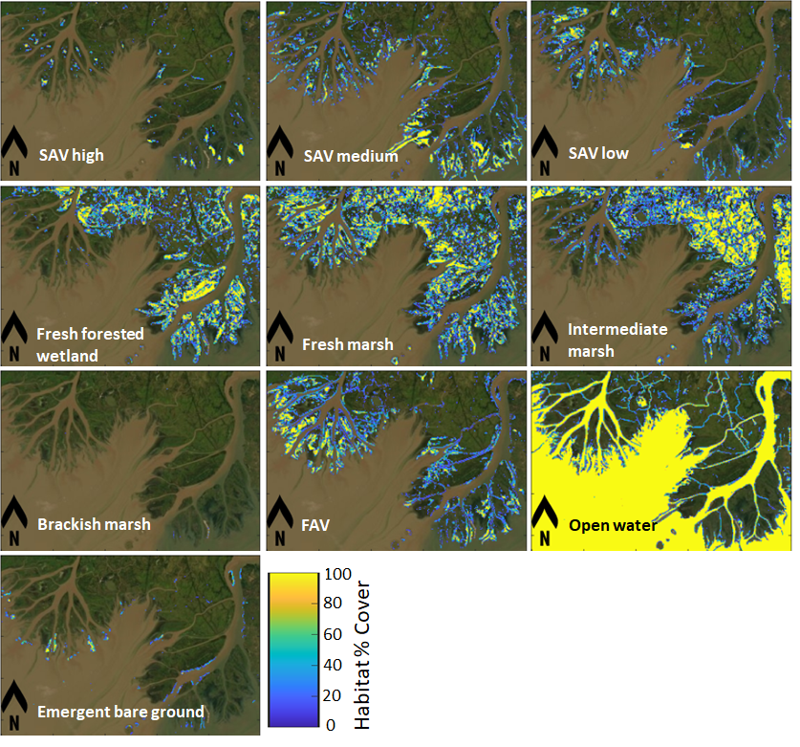
Figure S4-1. Vegetation % cover for eight habitats converted from the 2016 habitat map produced WSAV-Net using Landsat 8-OLI imagery acquired on 30 October 2016. SAV = submerged aquatic vegetation. FAV = floating aquatic vegetation.
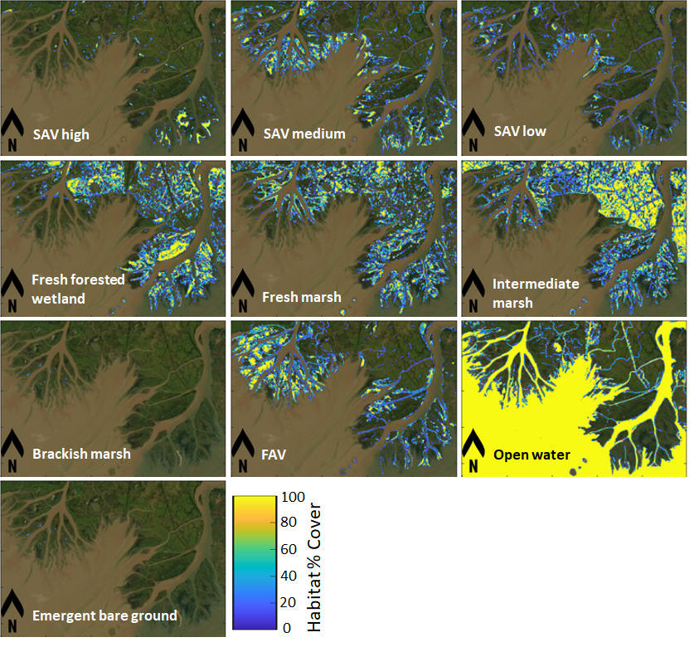
Figure S4-2. Vegetation % cover for eight habitats converted from the 2017 habitat map produced WSAV-Net using Landsat 8-OLI imagery acquired on 17 October 2017. SAV = submerged aquatic vegetation. FAV = floating aquatic vegetation.
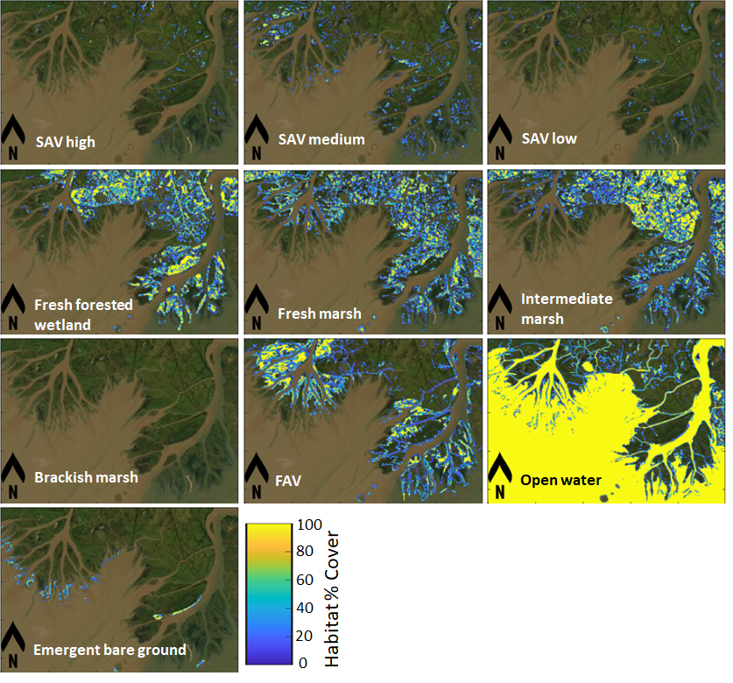
Figure S4-3. Vegetation % cover for eight habitats converted from the 2019 habitat map produced WSAV-Net using Landsat 8-OLI imagery acquired on 05 September 2019. SAV = submerged aquatic vegetation. FAV = floating aquatic vegetation.
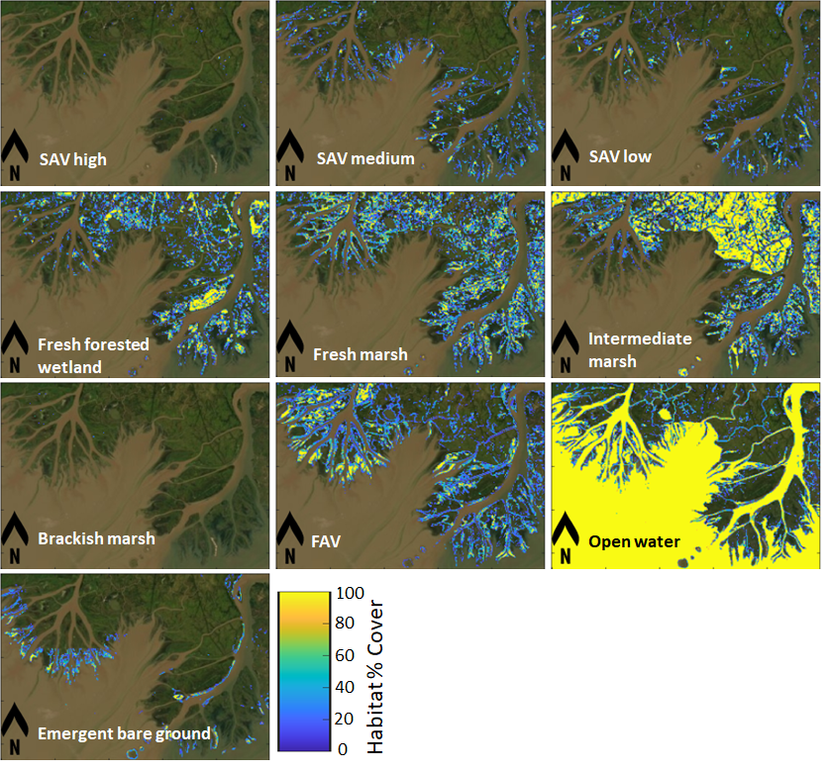
Figure S4-4. Vegetation % cover for eight habitats converted from the 2021 habitat map produced WSAV-Net using Landsat 8-OLI imagery acquired on 10 September 2021. SAV = submerged aquatic vegetation. FAV = floating aquatic vegetation.
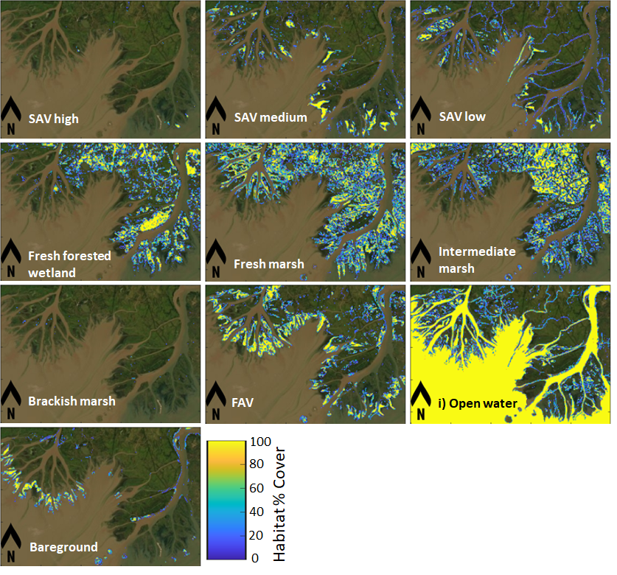
Figure S4-5. Vegetation % cover for eight habitats converted from the 2022 habitat map produced WSAV-Net using Landsat 8-OLI imagery acquired on 15 October 2022. SAV = submerged aquatic vegetation. FAV = floating aquatic vegetation.
Table S4. Areas (in ha) of eight habitats in target years
Habitat (ha) | 2015 | 2016 | 2017 | 2019 | 2021 | 2022
Fresh Forested Wetland | 4,830 | 3,864 | 3,826 | 3,667 | 2,759 | 3,552
Fresh Marsh | 5,625 | 5,401 | 3,501 | 3,473 | 3,764 | 5,832
Intermediate Marsh | 4,172 | 5,301 | 5,965 | 4,377 | 6,320 | 4,763
Brackish Marsh | 2 | 0 | 7 | 0 | 2 | 10
Floating Aquatic Vegetation (FAV) | 1,248 | 2,479 | 2,624 | 3,188 | 3,169 | 3,359
SAV | 3,255 | 3,361 | 3,125 | 688 | 1,380 | 2,432
Open Water | 24,067 | 22,842 | 23,592 | 27,824 | 25,466 | 22,661
Bareground | 262 | 211 | 821 | 243 | 599 | 850
Total | 43,460 | 43,460 | 43,460 | 43,460 | 43,460 | 43,460

Supplement 5. Net GHG fluxes
Table S5-1. Net GHG fluxes (with uncertainty) for scenario without SAV habitat in target years
Net GHG emissions  (×10⁵ tonne CO₂e yr⁻¹) | 2015 | 2016 | 2017 | 2019 | 2021 | 2022
Net | -0.76 ± 0.33 | -0.35 ± 0.15 | -0.56 ± 0.25 | -0.86 ± 0.37 | -0.39 ± 0.17 | -0.13 ± 0.06
Fresh Forested Wetland | -0.03 ± 0.01 | -0.03 ± 0.01 | -0.03 ± 0.01 | -0.03 ± 0.01 | -0.02 ± 0.01 | -0.02 ± 0.01
Fresh Marsh | 0.84 ± 0.37 | 0.81 ± 0.35 | 0.53 ± 0.23 | 0.52 ± 0.23 | 0.56 ± 0.25 | 0.87 ± 0.38
Intermediate Marsh | 0.60 ± 0.26 | 0.76 ± 0.33 | 0.85 ± 0.37 | 0.63 ± 0.27 | 0.90 ± 0.39 | 0.68 ± 0.30
Brackish Marsh | 0.00 ± 0.00 | 0.00 ± 0.00 | 0.00 ± 0.00 | 0.00 ± 0.00 | 0.00 ± 0.00 | 0.00 ± 0.00
Floating Aquatic Vegetation (FAV) | 0.19 ± 0.08 | 0.37 ± 0.02 | 0.39 ± 0.17 | 0.48 ± 0.21 | 0.48 ± 0.21 | 0.50 ± 0.22
SAV | 0.00 ± 0.00 | 0.00 ± 0.00 | 0.00 ± 0.00 | 0.00 ± 0.00 | 0.00 ± 0.00 | 0.00 ± 0.00
Open Water | -2.36 ± 1.03 | -2.26 ± 0.99 | -2.30 ± 1.01 | -2.46 ± 1.07 | -2.31 ± 1.01 | -2.16 ± 0.09
Bareground | 0.00 ± 0.00 | 0.00 ± 0.00 | 0.00 ± 0.00 | 0.00 ± 0.00 | 0.00 ± 0.00 | 0.00 ± 0.00
Table S5-2. Net GHG fluxes (with uncertainty) for scenario with SAV habitat in target years
Net GHG emissions  (×10⁵ tonne CO₂e yr⁻¹) | 2015 | 2016 | 2017 | 2019 | 2021 | 2022
Net | -0.90 ± 0.39 | -0.49 ± 0.21 | -0.70 ± 0.30 | -0.89 ± 0.38 | -0.45 ± 0.19 | -0.23 ± 0.10
Fresh Forested Wetland | -0.03 ± 0.01 | -0.03 ± 0.01 | -0.03 ± 0.01 | -0.03 ± 0.01 | -0.02 ± 0.01 | -0.02 ± 0.01
Fresh Marsh | 0.84 ± 0.36 | 0.81 ± 0.35 | 0.53 ± 0.23 | 0.52 ± 0.23 | 0.56 ± 0.25 | 0.87 ± 0.38
Intermediate Marsh | 0.60 ± 0.26 | 0.76 ± 0.33 | 0.85 ±0.37 | 0.63 ± 0.27 | 0.90 ± 0.39 | 0.68 ± 0.30
Brackish Marsh | 0.00 ± 0.00 | 0.00 ± 0.00 | 0.00 ± 0.00 | 0.00 ± 0.00 | 0.00 ± 0.00 | 0.00 ± 0.00
Floating Aquatic Vegetation (FAV) | 0.19 ± 0.08 | 0.37 ± 0.16 | 0.39 ± 0.17 | 0.48 ± 0.21 | 0.48 ± 0.21 | 0.50 ± 0.22
SAV | -0.42 ± 0.18 | -0.43 ± 0.19 | -0.40 ± 0.17 | -0.09 ± 0.04 | -0.18 ± 0.08 | -0.31 ± 0.13
Open Water | -2.07 ± 0.91 | -1.97 ± 0.86 | -2.03 ± 0.89 | -2.40 ± 1.05 | -2.20 ± 0.96 | -1.95 ± 0.85
Bareground | 0.00 ± 0.00 | 0.00 ± 0.00 | 0.00 ± 0.00 | 0.00 ± 0.00 | 0.00 ± 0.00 | 0.00 ± 0.00

Supplement 6. Spatial Distribution of Net GHG Flux for Scenarios With/Without SAV
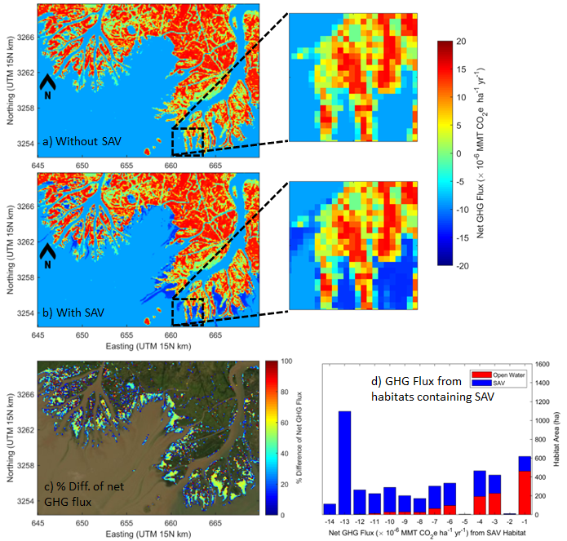
Figure S6-1. Comparison of spatial distribution of the net GHG fluxes in 2016: (a) without SAV and (b) with SAV, c) difference between with SAV and without SAV, and d) distribution of SAV net GHG flux.
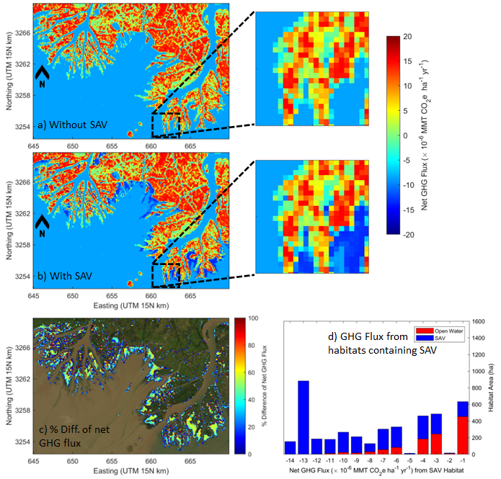
Figure S6-2. Comparison of spatial distribution of the net GHG fluxes in 2017: (a) without SAV and (b) with SAV, c) difference between with SAV and without SAV, and d) distribution of SAV net GHG flux.
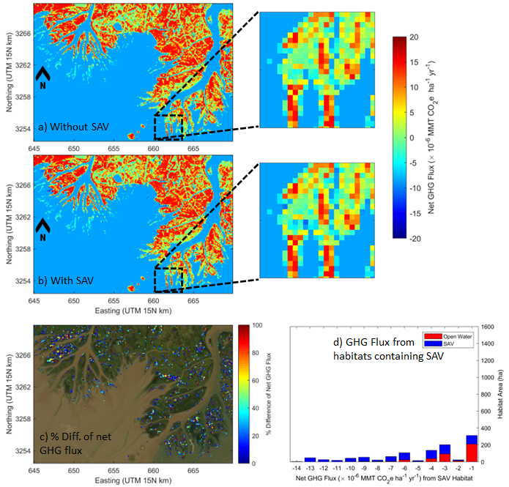
Figure S6-3. Comparison of spatial distribution of the net GHG fluxes in 2019: (a) without SAV and (b) with SAV, c) difference between with SAV and without SAV, and d) distribution of SAV net GHG flux.
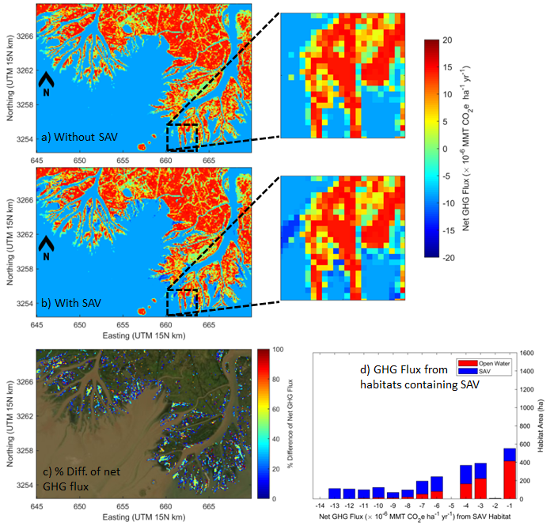
Figure S6-4. Comparison of spatial distribution of the net GHG fluxes in 2021: (a) without SAV and (b) with SAV, c) difference between with SAV and without SAV, and d) distribution of SAV net GHG flux.
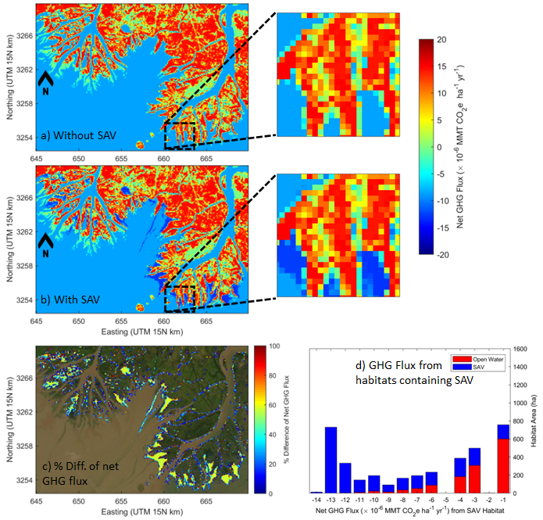
Figure S6-5. Comparison of spatial distribution of the net GHG fluxes in 2022: (a) without SAV and (b) with SAV, c) difference between with SAV and without SAV, and d) distribution of SAV net GHG flux.

