Supporting Information
Unlocking Gel-powers: Exploring Rheological Marvels of Acrylamide/Sodium Alginate Double-Network Hydrogels
Shi-Chang Wang,¹ Shu-Tong Du², Saud Hashmi³, Shu-Ming Cui^{1,4}, Ling Li¹, Stephan Handschuh-Wang^{2,4}, Xuechang Zhou², Florian J. Stadler^{1*}
¹ College of Materials Science and Engineering, Shenzhen Key Laboratory of Polymer Science and Technology, Guangdong Research Center for Interfacial Engineering of Functional Materials, Shenzhen University, Shenzhen, 518055, PR China
² College of Chemistry and Environmental Engineering, Shenzhen University, Shenzhen, P. R. China
³ Department of Polymer & Petrochemical Engineering NED University of Engineering & Technology, Pakistan
⁴ The International School of Advanced Materials, School of Emergent Soft Matter, South China University of Technology, Guangzhou, 511442, People’s Republic of China
* fjstadler@szu.edu.cn
Figure S1 (a and b) Frequency scan curves for sample S2 (SA=2.667 wt%), (c) relationship between loss coefficient and angular frequency in the frequency scan, (d) modulus of sample S2 versus calcium ion concentration
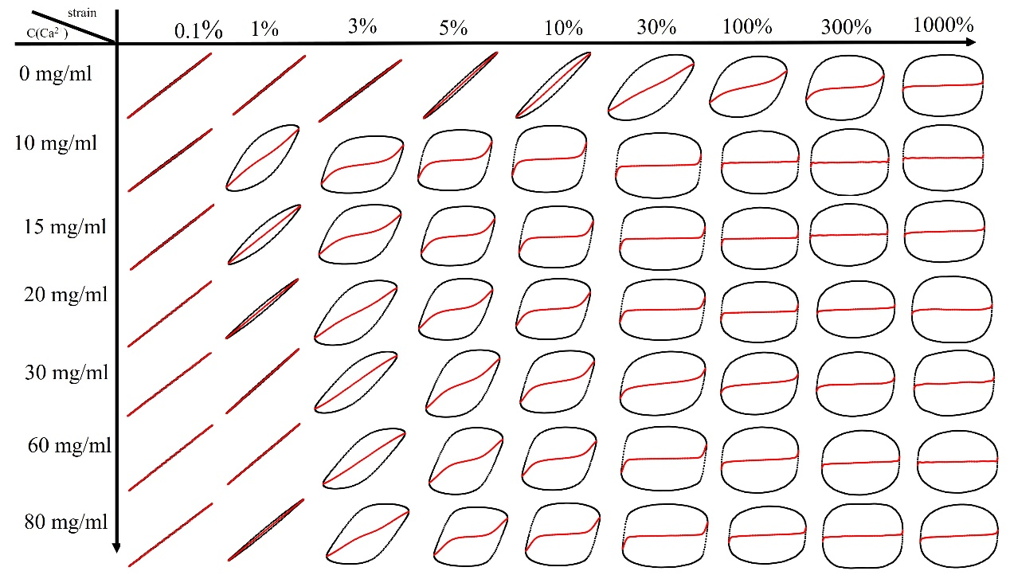
Figure S2 Elastic Lissajous curves of sample S1 at different calcium ion concentrations with different γ₀
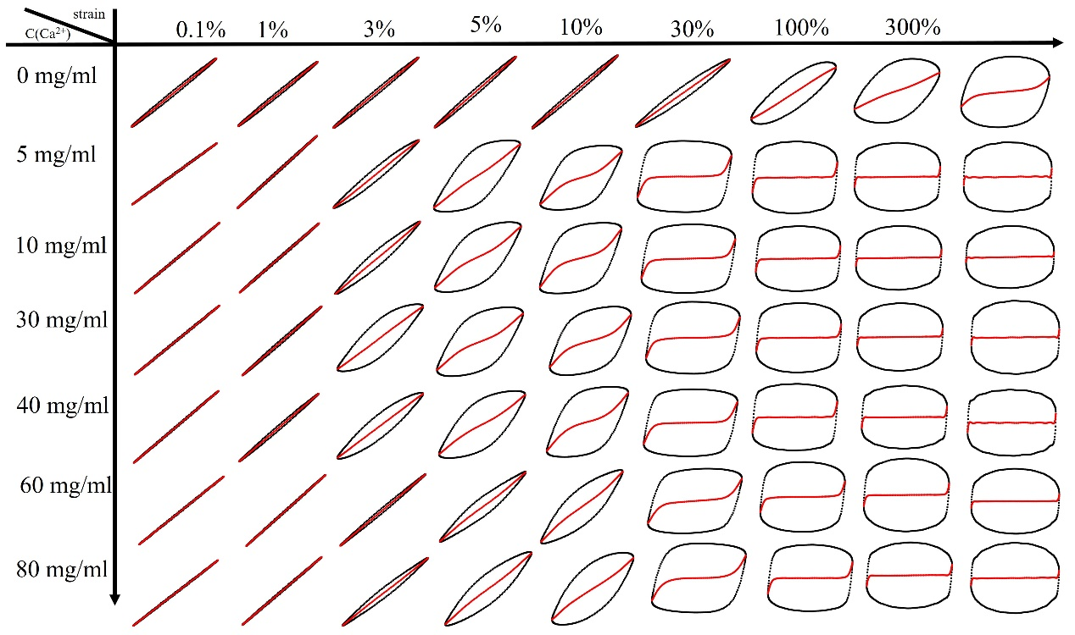
Figure S3 Elastic Lissajous curves of sample S2 at different calcium ion concentrations and different γ₀
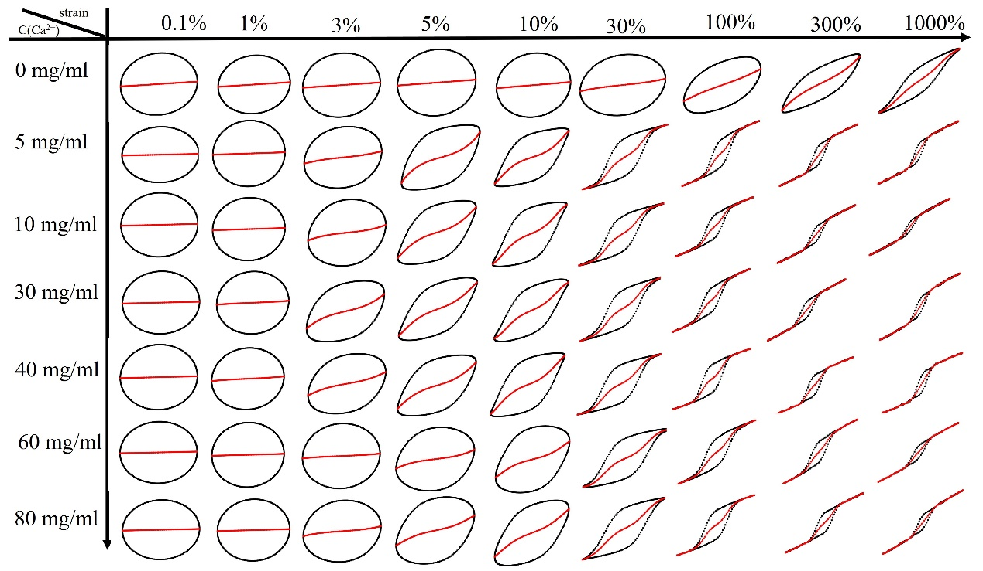
Figure S4 Viscosity Lissajous curves of sample S2 at different calcium ion concentrations with different γ₀
Figure S5 sample S2: (a and b) Chebyshev coefficient (e₃/e₁, and v₃/v₁) versus strain

