Supplementary figures

Figure S1: The (normal) growth inhibitory effect of celecoxib (a) and indomethacin (b) on the Hep G2 cell line.
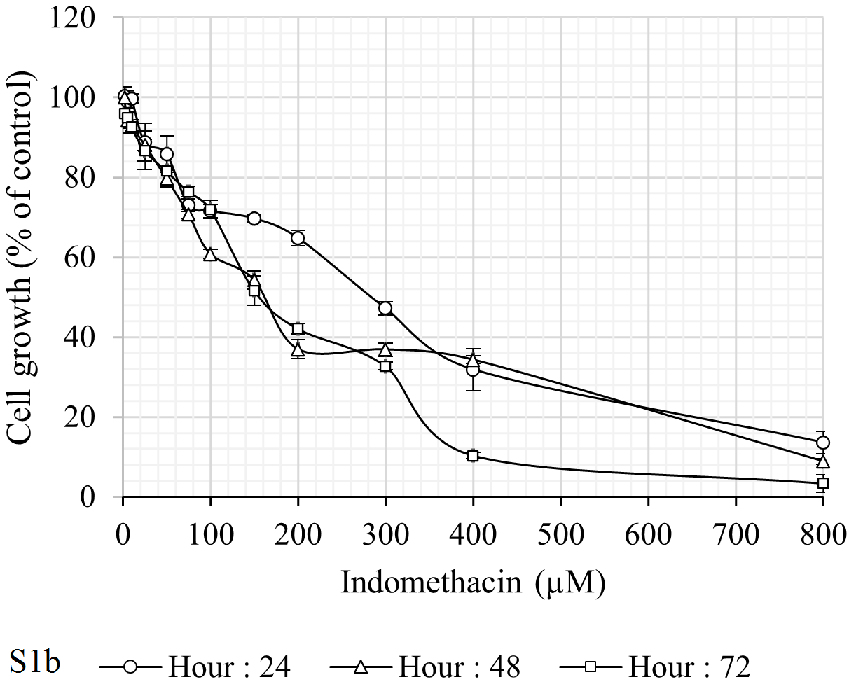
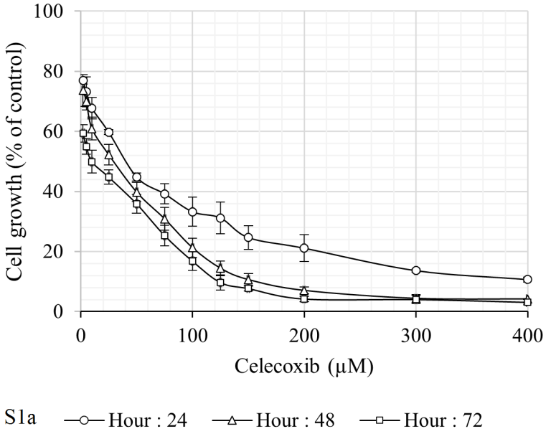

Figure S2: The (logarithmic) growth inhibitory effect of celecoxib in combination with DDWs and DEWs for 24 (a), 48 (b), and 72 (c) hours on the Hep G2 cell line.
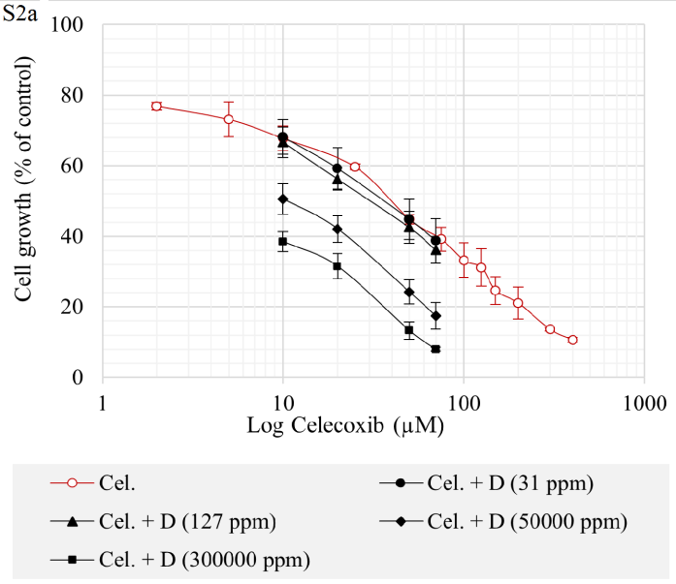
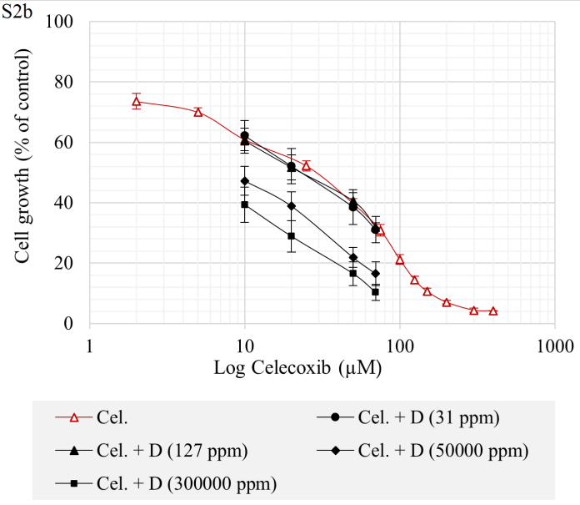
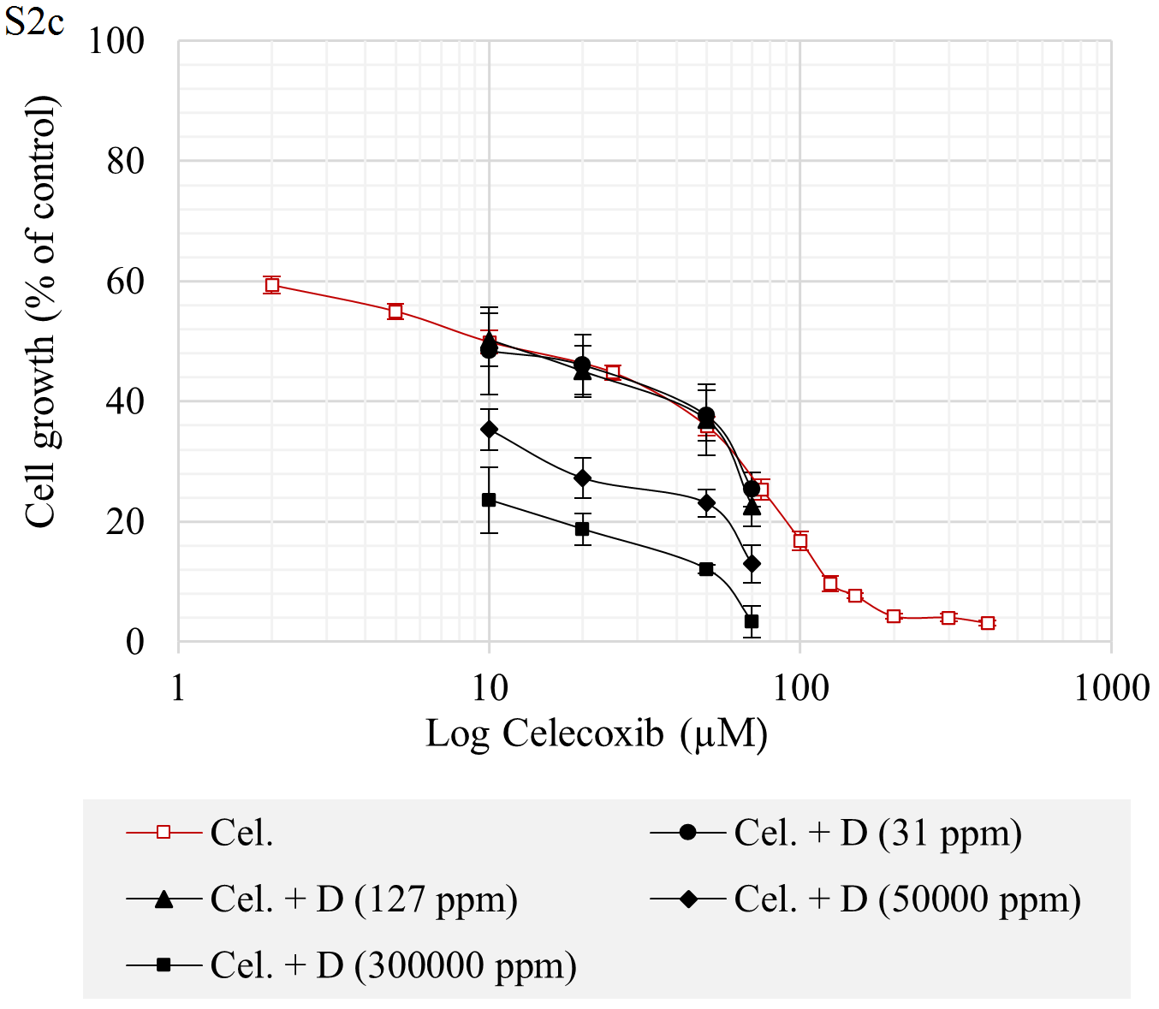

Figure 3: The (logarithmic) growth inhibitory effect of indomethacin in combination with DDWs and DEWs for 24 (a), 48 (b), and 72 (c) hours on the Hep G2 cell line.
