Figure S1. The interactive dialogue tool, the family wheel

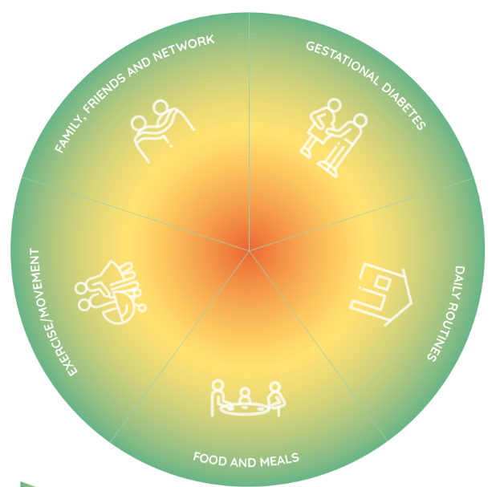

Table S1. Key questions in the interview guide for couple interviews

Transition to parenthood
- Can you tell me what it was like for you to become women and partners?
Health concept
- Can you tell me what health is to you and your family and how this may have changed after becoming women and partners?
- When do you feel healthy as a family?
Face-it intervention (prompt: family wheel and overview of intervention activities)
- What were your considerations on participating in the Face-it intervention?
- Can you describe what happened during the home visits?
- What were your thoughts about the home visits being delivered by a health visitor?
- What is your relationship to health technology, e.g., apps, activity trackers etc.?
- Can you tell me about your experiences with the LIVA app?
- Are there any parts of the interventions which you have seen as particularly useful or less useful?
- Can you tell me what you think you have gained from participating in the Face-it intervention?
- What were your thoughts on the intervention including both woman and partner?
Exercise
I would like you to think about aspects of the intervention which have been good and less good according to you throughout the intervention. To ensure that your views do not affect each other’s replies, you should write down key words individually on post-its, after which we will discuss them together. You have five minutes.
Cue: Address the individual, who said the least.
What have you written on your notes and why?
Queue: Address the other individual
What do you think about the other’s notes? Do you recognise it? Why? Why not?
Perspectives
- Can you tell me what you would have wanted to be different in the intervention?

