Table S1. Predictive models from machine learning (FDA), regression (GAM and GLM) and their performance evaluation of sdms using different statistical parameters. Sensitivity and specificity describe the rate of true positive and negative respectively.

Model | AUC | TSS | Deviance | Sensitivity | Specificity | Threshold | Prevalence
Albacore
GAM | 0.48 | 0.40 | 0.21 | 0.66 | 0.54 | 0.24 | 0.71
GLM | 0.48 | 0.41 | 0.19 | 0.60 | 0.63 | 0.22 | 0.62
FDA | 0.48 | 0.42 | 0.19 | 0.60 | 0.62 | 0.22 | 0.63
Bigeye
GAM | 0.47 | 0.43 | 5.47 | 0.55 | 0.69 | 0.25 | 0.56
GLM | 0.48 | 0.42 | 0.40 | 0.55 | 0.70 | 0.24 | 0.55
FDA | 0.48 | 0.41 | 0.40 | 0.55 | 0.71 | 0.24 | 0.54
Skipjack
GAM | 0.43 | 0.42 | 0.25 | 0.55 | 0.68 | 0.26 | 0.55
GLM | 0.44 | 0.42 | 0.25 | 0.53 | 0.73 | 0.26 | 0.52
FDA | 0.44 | 0.42 | 0.25 | 0.52 | 0.72 | 0.24 | 0.52
Yellowfin
GAM | 0.46 | 0.42 | 0.24 | 0.50 | 0.77 | 0.24 | 0.48
GLM | 0.45 | 0.44 | 0.25 | 0.46 | 0.80 | 0.26 | 0.45
FDA | 0.44 | 0.43 | 0.25 | 0.45 | 0.81 | 0.25 | 0.44

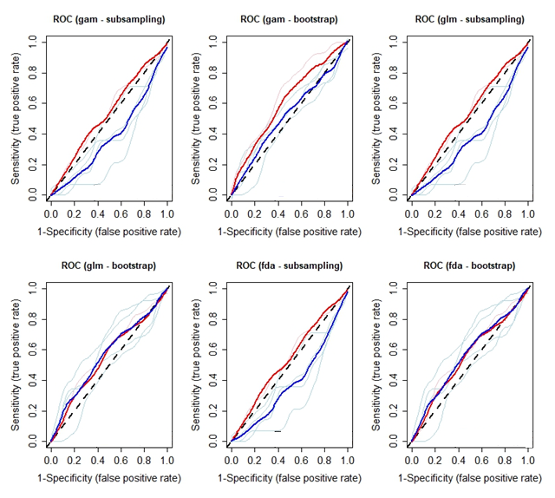
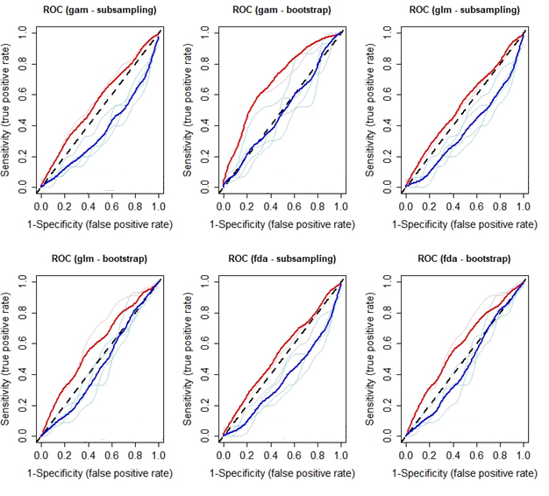
- Albacore
(b) Bigeye

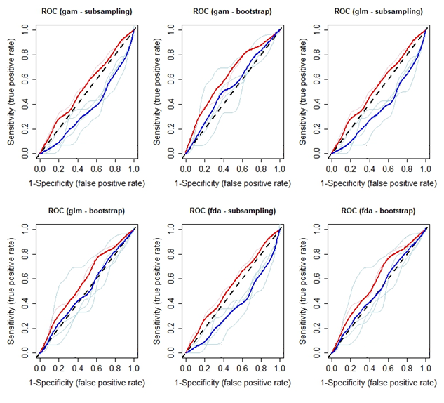
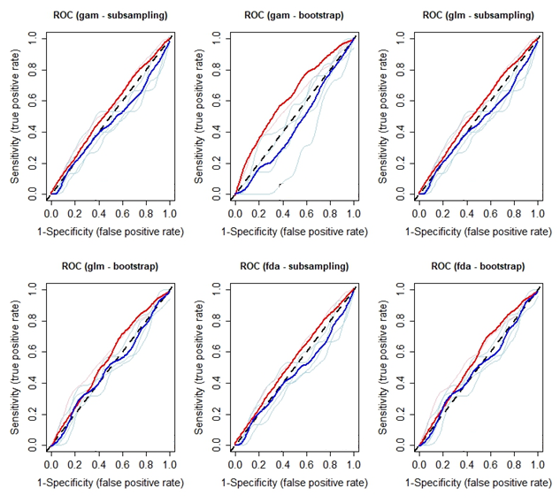
(c) Skipjack
(d) Yellowfin

Figure S1. Receiver operator characteristics (ROC) curve using bootstrap and subsampling replication methods for different sdms for (a) Albacore, (b) Bigeye, (c) Skipjack and (d) Yellowfin. Sensitivity (true positive rate) of the vertical line and 1-specificity (false positive rate) of the horizontal line describe the proportion of correctly and incorrectly classified samples. The red and blue curves represent the mean of AUC using training and test data respectively.

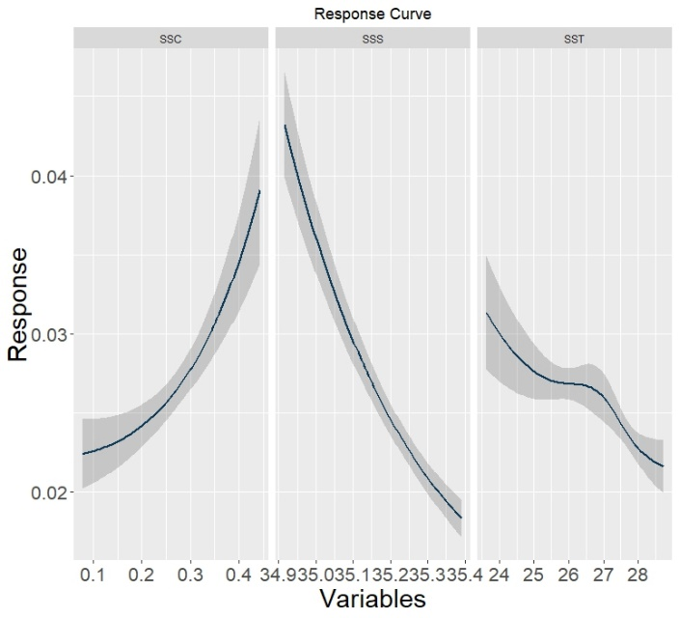
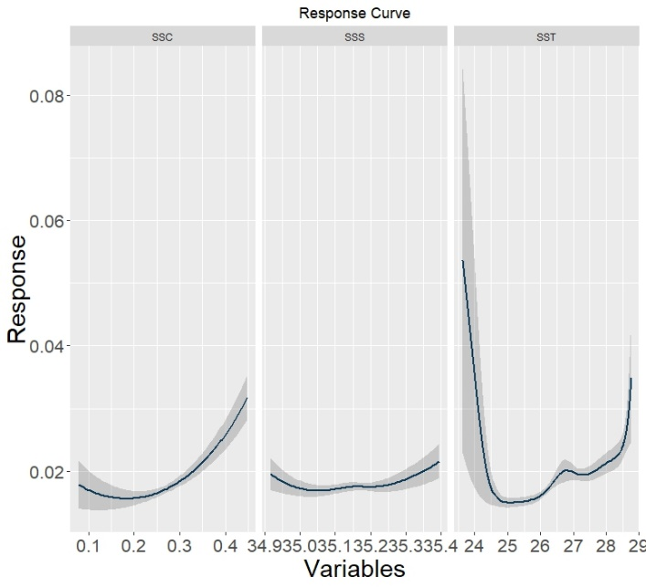
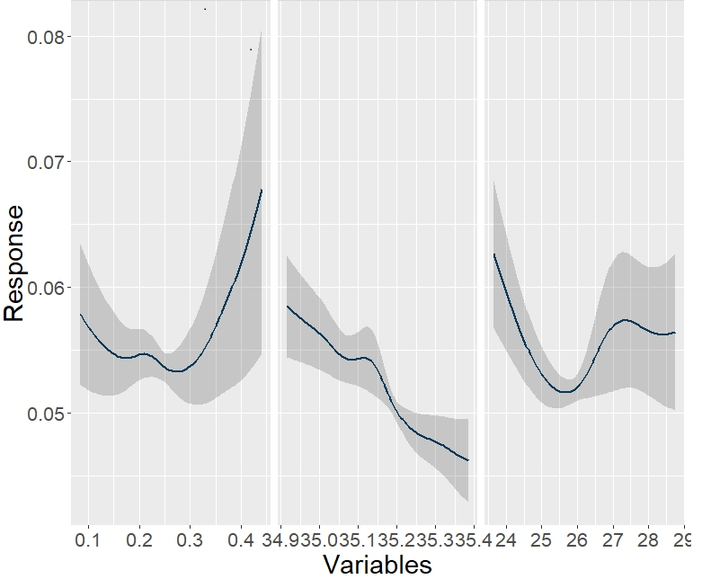
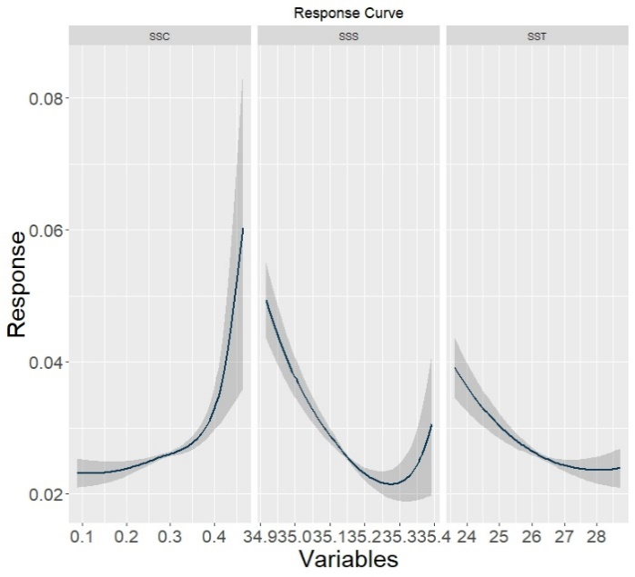
(d) Yellowfin
(c) Skipjack
(b) Bigeye
- Albacore
SSC
SSS
SST
SSC
SSC
SSC
SSS
SSS
SSS
SST
SST
SST
Figure S2. Response curves from the ensemble models to the three selected environmental variables for Albacore, Bigeye, Skipjack and Yellowfin in panels (a), (b), (c) and (d) respectively. Response curves were fitted through locally estimated scatterplot smoothing (LOESS). SSC = sea surface current, SSS = sea surface salinity and SST = sea surface temperature.

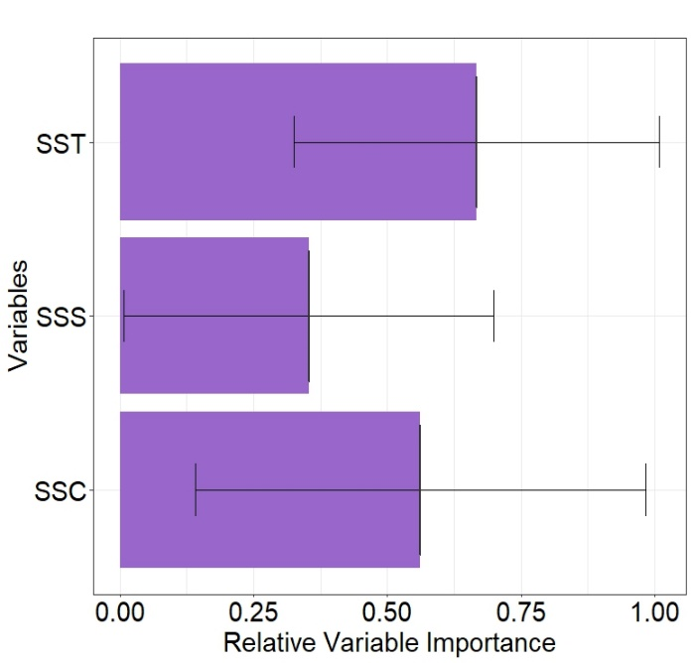
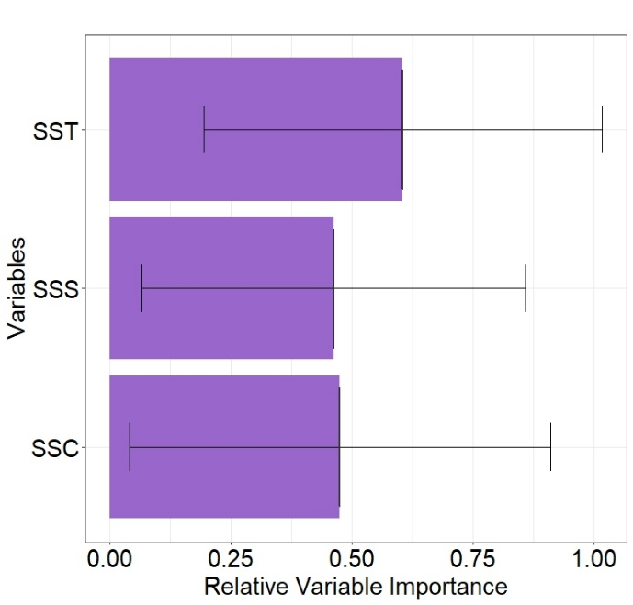
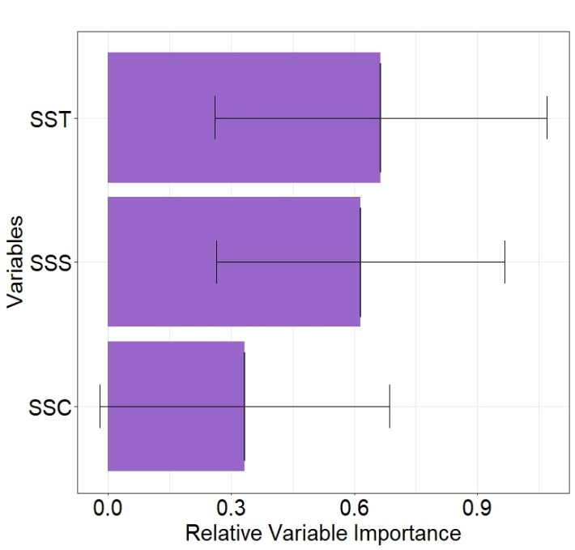
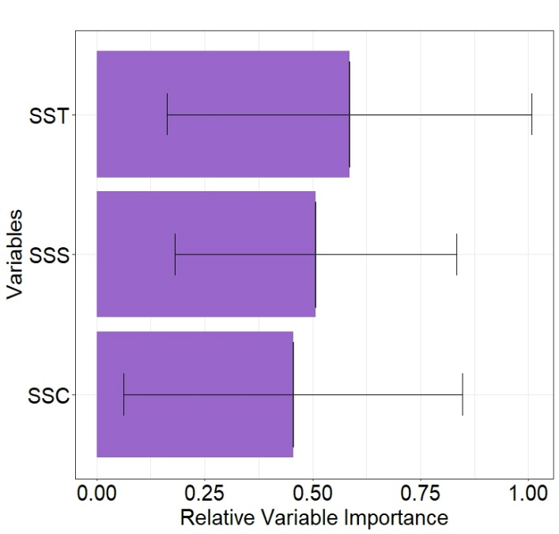
Figure S3. Variable importance for three less correlated environmental variables of the ensemble species distribution model for Albacore, Bigeye, Skipjack and Yellowfin in panels (a), (b), (c) and (d) respectively. SSC = sea surface current, SSS = sea surface salinity and SST = sea surface temperature.
- Albacore
(b) Bigeye
(c) Skipjack
(d) Yellowfin

