Supplementary Materials:
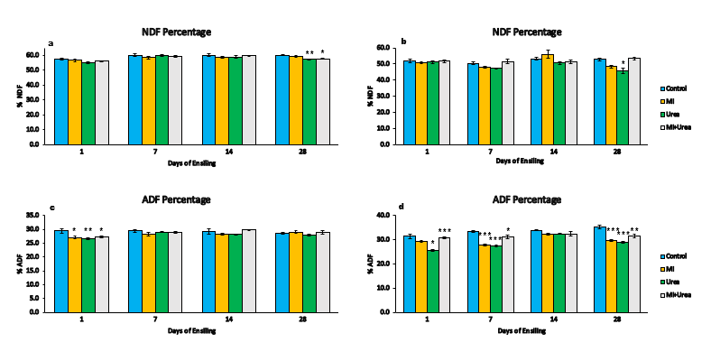
Figure S1. a. The NDF content of wheat silage with additives treatment at various days of ensiling; b. The NDF content of corn silage with additives treatment at various days of ensiling; c. The ADF content of wheat silage with additives treatment at various days of ensiling; d. The ADF content of corn silage with additives treatment at various days of ensiling. *0.05, **0.01 and ***0.001 Statistical significance at P < 0.05 after LSMeans Dunnett test.

Table S 1. The effect of additives and ensiling days on Hemicellulose content of wheat and corn silage
Wheat silage
Days | Treatment |  |  |  |  | Main Effect (P-Value)
 | Control | MI | Urea | MI+Urea | SEM | Trt | Day | Trt*Day
1 | 29.4 | 29.5 | 28.5 | 28.9 | 0.258 | 0.0691 | 0.0029 | 0.4047
7 | 29.5 | 30.2 | 31.0 | 30.4 | 0.233
14 | 29.1 | 30.7 | 30.6 | 29.9 | 0.354
28 | 28.6 | 30.0* | 29.4 | 28.9 | 0.205
Corn silage
Days | Treatment |  |  |  |  | Main Effect (P-Value)
 | Control | MI | Urea | MI+Urea | SEM | Trt | Day | Trt*Day
1 | 20.5 | 21.6 | 25.4** | 20.9 | 0.604 | 0.0063 | <.0001 | 0.0001
7 | 16.9 | 20.2** | 20.0** | 20.1** | 0.436
14 | 19.3 | 23.8 | 18.2 | 19.1 | 0.816
28 | 17.6 | 18.6 | 16.8 | 21.9 | 0.726
*0.05 and **0.01: Statistical significance at p< 0.05 after LSMeans Dunnett test, SEM: Standard error of the mean.

Table S 2: The effect of additives and ensiling days on DM content of wheat and corn silage
Wheat silage
Days | Treatment |  |  |  |  | Main Effect (P-Value)
 | Control | MI | Urea | MI+Urea | SEM | Trt | Day | Trt*Day
1 | 43.8 | 45.0* | 45.4* | 43.2 | 0.346 | <.0001 | <.0001 | 0.0048
7 | 43.7 | 43.4 | 44.4 | 43.7 | 0.163
14 | 43.9 | 43.0 | 44.6 | 43.4 | 0.279
28 | 41.9 | 42.2 | 44.1** | 42.7 | 0.332
Corn silage
Days | Treatment |  |  |  |  | Main Effect (P-Value)
 | Control | MI | Urea | MI+Urea | SEM | Trt | Day | Trt*Day
1 | 30.7 | 33.0 | 32.5 | 32.0 | 0.436 | <.0001 | <.0001 | 0.0290
7 | 29.6 | 31.9 | 31.6 | 30.6 | 0.463
14 | 28.7 | 29.3 | 31.7** | 30.8 | 0.500
28 | 28.7 | 29.5 | 30.6* | 31.0* | 0.432
*0.05, and **0.01: Statistical significance at p < 0.05 after LSMeans Dunnett test, SEM: Standard error of the mean.

