Supporting Information
Ammonia and Humidity Sensing by Phthalocyanine-Corrole complex Heterojunction Devices
Lorena Di Zazzo^{1,2}, Sujithkumar Ganesh Moorthy¹, Rita Meunier-Prest¹, Corrado Di Natale²*, Roberto Paolesse³* and Marcel Bouvet¹*

Table S1. Characteristic Raman bands (cm⁻¹) of CuT(pCH₃O)PC, CuT(pF)PC and LuPc₂ complexes, compared to these of double layer heterojunctions.
Cu(pmethoxy)TPC  Evaporated powder | MSDI  Cu(pCH3O)TPC/LuPc₂ | Cu(pF)TPC  Evaporated powder | MSDI  Cu(pF)TPC/LuPc₂ | LuPc₂  powder | Assignment
 | 549.322 |  |  | 547 w | Pc breathing
 | 578.16 |  |  | 578.16 w | Pc breathing
 |  | 647.353 | 645.67 |  | C-F [1,2]
657.67 w | 660.8 |  |  |  | C-C-H in benzene ring
 | 680.97 |  |  | 680
 | 739.32 |  | 735.995 | 734 | C-H wagging
780.813 | 782.468 |  | 780.813 | 779 | C=N aza stretching
815.513
851.73
882.868 | 884.505
980.507 | 982.125
 | 1009.59 | 1016.03 | 1016.03 | 1011 | C-H binding
1054.63 | 1054.63 | 1057.83 | 1056.23 | 1046
1075.46 | 1075.46 | 1080.26 | 1080.126
 | 1105.81 |  |  | 1103 | C-H binding
 | 1121.75 |  | 1121.75 | 1121
 |  |  |  | 1146 | Pyrrole breathing
 | 1158.28 |  |  | 1160
1177.28 | 1177.28 | 1177.28 | 1177.28 | 1176 | C-H bending
1193.08 | 1196.24
1221.45 | 1223.02 |  |  | 1217 | C-H bending
1249.72
1265.39 |  | 1263.82
 | 1273.21
1290.39 | 1291.95
 |  | 1305.98 | 1304.43 | 1301 | C-H bending
1312.12 | 1312.21
1340.19 | 1343.29 | 1340.19 | 1337.08 |  | Cα-Cα
1363.42 m |  |  | 1363.42 |  | Cα-Cα
1402 m | 1406.63 |  | 1408.17 | 1406.63 | Cα-Cmeso
 |  | 1441.96 |  |  | Cα-Cα
1486.29 s | 1487.81 | 1501.52 |  |  | Cα-Cα
1518.24 | 1515.2 | 1522.8 | 1507.6 | 1508 | Coupling of pyrrole and aza stretching
 | 1527.35 |  | 1528.87
1601.35 m | 1599.85 |  | 1601.35 | 1599.85 | C=C in benzene ring
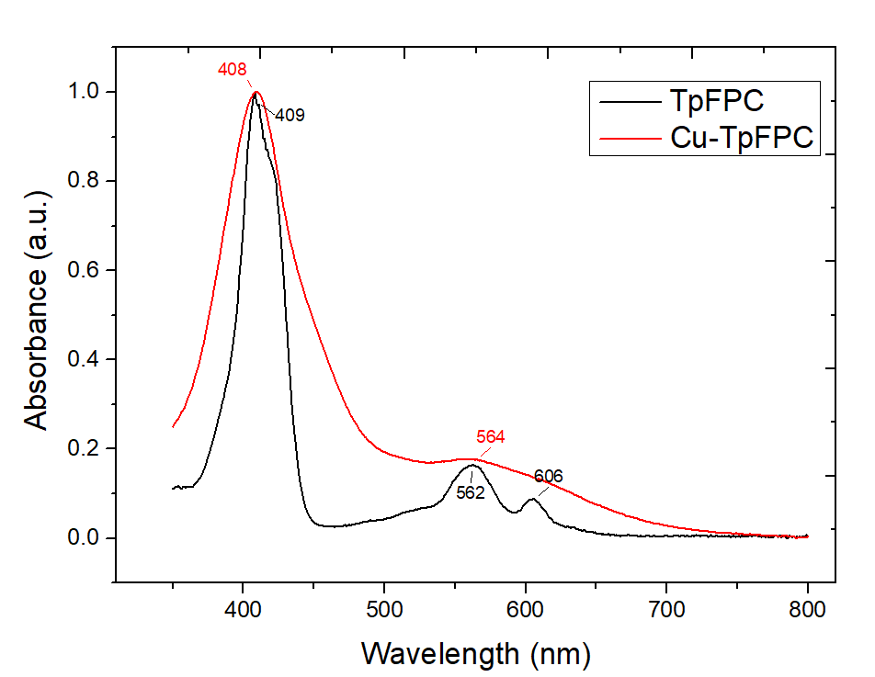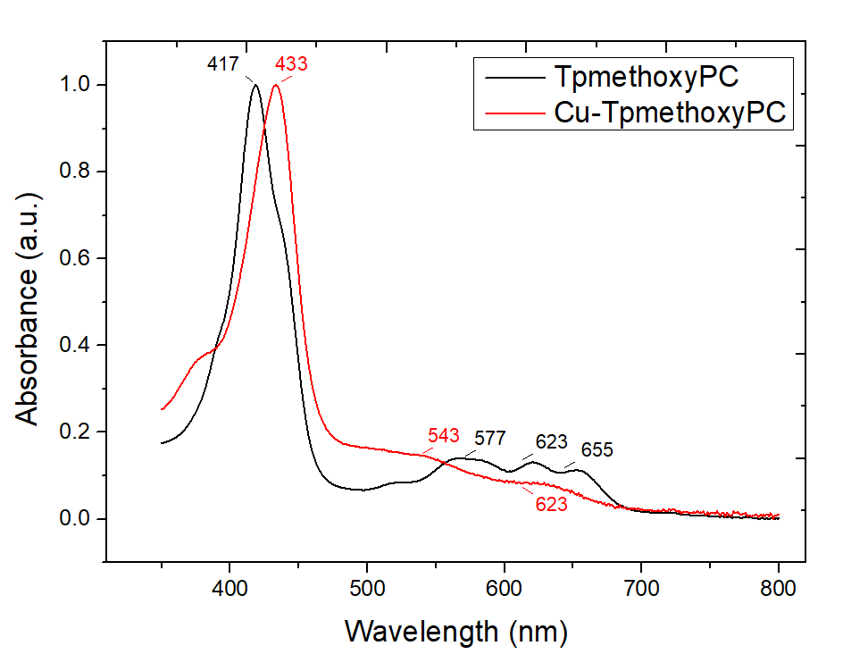
Figure S1. UV-visible electronic absorption spectra of 1 (a) and 2 (b) in CHCl₃ solution (black) compared to the corresponding metal free corroles (red).

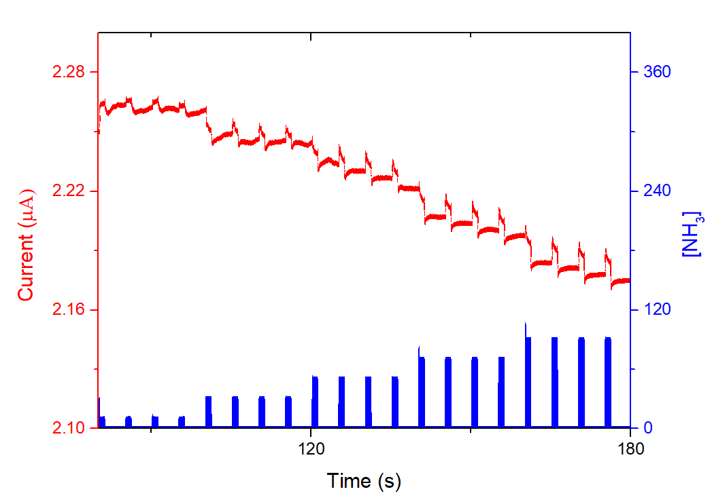

Figure S2. Current variation as a function of time of 1/LuPc₂ heterojunction exposed to NH₃ in the range 10-90 ppm with 1 min/4 min exposure/recovery cycles, at 40% RH and a bias of 3 V.

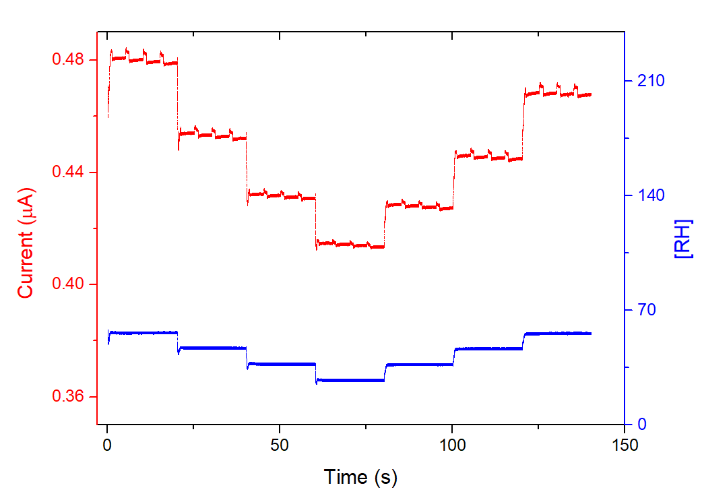
Figure S3. Current variation as a function of time of 1/LuPc₂ heterojunction device exposed to 50 ppm NH₃, with 1 min/4 min exposure/recovery cycles, at RH values in the range 30%-60%, at a bias of 3 V.

References
1. Sharts, C. M.; Gorelik, V. S.; Agoltsov, A. M.; Zlobina, L. I.; Sharts, O. N. Detection of carbon-fluorine bonds in organofluorine compounds by Raman spectroscopy using a copper-vapor laser. Proc. SPIE-Int. Soc. Opt. Eng. 1999, 3537, 317.
2. Menaa, F.; Menaa, B.; Sharts, O. Development of carbon-fluorine spectroscopy for pharmaceutical and biomedical applications. Faraday Discussions 2011, 149, 269.

