Supplementary Information 1 (SI1)
Headspace SPME-GC-MS analysis of fecal VOCs: SPME fiber cleaning was done for 30 minutes at 300 ºC. The fiber was exposed to the stool sample within glass tubes for 30 minutes. It was then injected in the Agilent Single-Quadrupole GC/MS Instrument for 5 minutes, at 280 ºC. GC-MS data processing for metabolome analysis (volatile identification and quantification) is carried out using the Agilent data analysis software. Raw GC-MS data files are automatically transferred to servers for storage and further analysis.
VOCs adsorbed on the 75μm CAR/PDMS SPME fiber were thermally injected into an electron impact (70 eV) quadrupole GC/MS (GC-7890B, MSD-5977B, Agilent Technologies, USA). The compounds were separated using SPB-624 capillary column (60 m x 250 μm, 1.4 μm film thickness) and helium (99.999%, Linde) as carrier gas (flow rate of 1.7 mL/min). The column remained to 35ºC for 5 minutes, then increased to 180ºC (at 4ºC/min) for another 20 minutes. The chromatogram run time was 61.25 minutes. The temperatures of the MS transfer line, quadrupole, and ion source were 250, 150, and 230°C, respectively. Full scan mode with 35-350 amu was selected. The NIST20 spectral library (≥ 80% match factor) allowed compound identification alongside an internal database of VOC standards. Data processing was performed using ChemStation software (Agilent, USA).

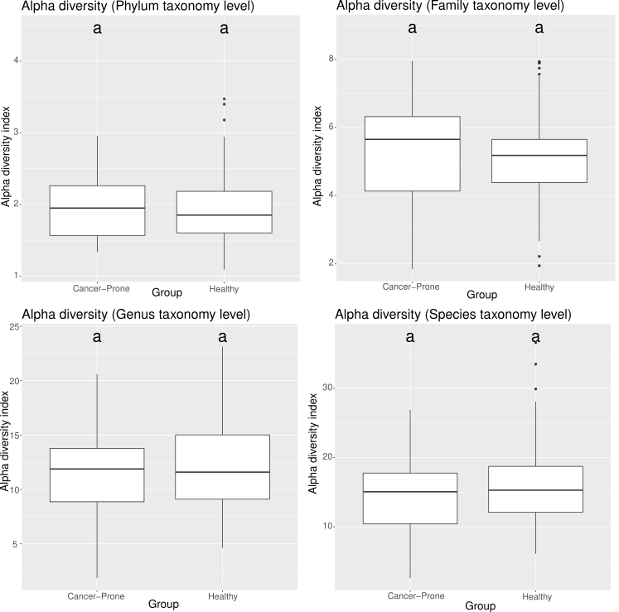
Supplementary Figure 1. Alpha Diversity plot. X-axis indicates the cancer-prone (HRA) and healthy (NA) groups and y-axis shows the alpha diversity index calculated for each taxonomic level with Inverse Simpson. The mean of the alpha diversity found for each group is shown with the black horizontal line within each box. The results from the Tukey’s Honest Significant Difference (HSD) test are shown with the letters above each boxplot. Here the letters are the same (a-a) which indicates that the alpha diversity index between the groups might not differ.
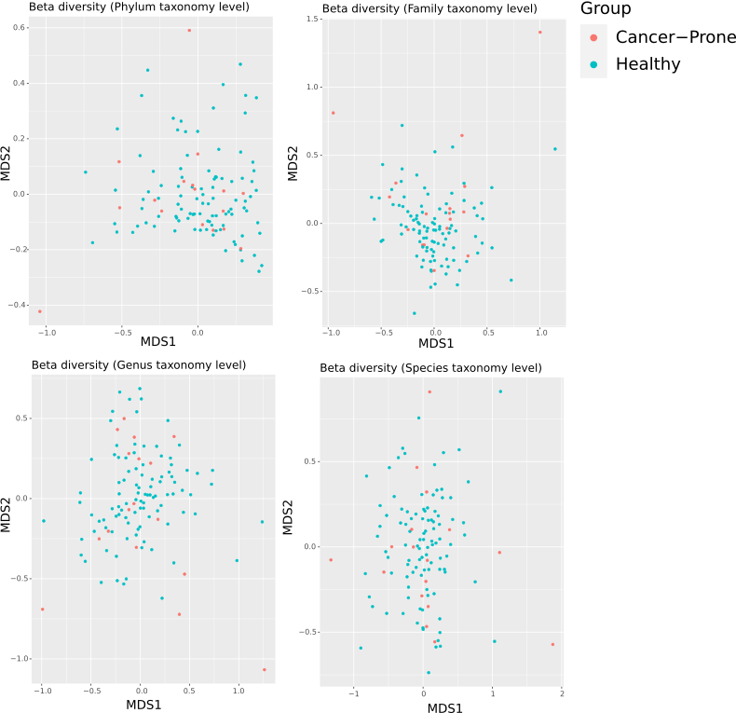Supplementary Figure 2. Multidimensional scaling (MDS) plot using UniFrac index, based on the relative abundance of the bacteria at the taxonomy level of phylum, family, genus and species for samples between 17 NA and 100 HRA individuals after 16S Metagenomic Analysis. Orange and blue dots represent healthy (NA) and cancer prone (HRA) individuals respectively.
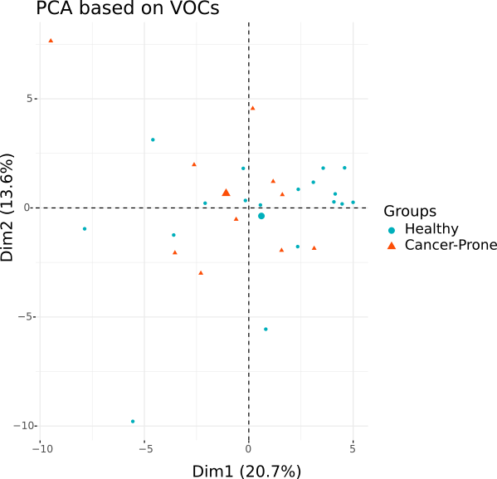
Supplementary Figure 3. Principal Component Analysis (PCA) of fecal samples based on VOC composition. The plot is based on the normalized GC-MS values (Shapiro Wilk normality test) of the 71 emitted volatiles for a total of 28 fecal samples classified in the NA group (18 subjects) and the HRA group (10 subjects). Orange triangles and blue dots represent healthy (NA) and cancer prone (HRA) individuals respectively. The big orange triangle and big blue dot represent the average healthy (NA) and cancer prone (HRA) individuals respectively.

Supplementary Table 1. Statistically significant association between VOCs and subject groups. Information about the p-value, population size and the mean value for each group is shown for all the statistically significant VOCs.
VOCs | P-value | HRA samples | NA samples | HRA mean | NA mean
Methyl propionate | 0,0466 | 10 | 18 | 0,7322 | 0,3475
Methyl butyrate | 0,0370 | 10 | 18 | 2,2473 | 1,2484
Isobutyric acid | 0,0393 | 10 | 18 | 0,0606 | 0,0402
Butyl methyl ketone (2-Hexanone) | 0,0051 | 10 | 18 | 0,0541 | 0,0136
Ethyl acetone (2-Pentanone) | 0,0452 | 10 | 18 | 0,1672 | 0,0956

Supplementary Table 2. Statistically significant interactions between relative abundance of bacteria at the family level and VOCs. P-value, population size, mean relative abundance of FBFs and mean value of VOCs for each group is also shown. The mean values were calculated based on the number of subjects used for the interaction test, that is n=28 (NA=18 and HRA=10).
FAMILY TAXONOMY LEVEL
FBFs | VOC | P-value of interaction | no. | Mean FBF value in HRA | Mean FBF value in NA | Mean VOC value in HRA | Mean VOC value in NA
Acidaminococcaceae | D-Limonene | 0,0333 | 28 | 2,1078 | 2,5298 | 0,0606 | 0,0402
 | Isobutyric acid | 0,0226 | 28 | 2,1078 | 2,5298 | 0,1755 | 0,1447
Bacteroidaceae | Isovaleraldehyde (3-Methylbutanal) | 0,0188 | 28 | 13,6112 | 10,8085 | 0,0265 | 0,0649
 | 2-Methylbutyraldehyde (2-Methylbutanal) | 0,0383 | 28 | 13,6112 | 10,8085 | 0,0561 | 0,0338
 | Acetaldehyde | 0,0097 | 28 | 13,6112 | 10,8085 | 0,1424 | 0,1516
 | Acetic acid | 0,0132 | 28 | 13,6112 | 10,8085 | 0,4298 | 0,2981
 | Butanone | 0,0159 | 28 | 13,6112 | 10,8085 | 0,1973 | 0,2447
 | Isobutyraldehyde | 0,0144 | 28 | 13,6112 | 10,8085 | 0,3416 | 0,2078
 | Isobutyric acid | 0,0314 | 28 | 13,6112 | 10,8085 | 2,2473 | 1,2484
 | Methyl butyrate | 0,0364 | 28 | 13,6112 | 10,8085 | 0,0606 | 0,0402
 | Methyl cyclohexanecarboxylate | 0,0483 | 28 | 13,6112 | 10,8085 | 0,0265 | 0,0265
 | Propyl butyrate | 0,0096 | 28 | 13,6112 | 10,8085 | 0,0860 | 0,0845
Coriobacteriaceae | Acetaldehyde | 0,0230 | 28 | 3,2006 | 3,1246 | 0,0265 | 0,0649
 | Dimethyl disulfide | 0,0324 | 28 | 3,2006 | 3,1246 | 0,0036 | 0,0035
 | Methacrolein | 0,0333 | 28 | 3,2006 | 3,1246 | 0,0054 | 0,0027
 | Methyl 4-methylvalerate | 0,0300 | 28 | 3,2006 | 3,1246 | 0,5838 | 0,6092
 | Propanal | 0,0067 | 28 | 3,2006 | 3,1246 | 0,0462 | 0,0575
Enterobacteriaceae | Acetaldehyde | 0,0486 | 28 | 1,2198 | 1,7108 | 0,0265 | 0,0649
 | Methyl 4-methylvalerate | 0,0126 | 28 | 1,2198 | 1,7108 | 0,0036 | 0,0035
 | Propanal | 0,0459 | 28 | 1,2198 | 1,7108 | 0,0462 | 0,0575
Erysipelotrichaceae | Acetaldehyde | 0,0112 | 28 | 4,6086 | 2,5488 | 0,0265 | 0,0649
 | Acetate | 0,0370 | 28 | 4,6086 | 2,5488 | 0,1973 | 0,2447
 | Dimethyl disulfide | 0,0459 | 28 | 4,6086 | 2,5488 | 0,5838 | 0,6092
 | Isobutyric acid | 0,0286 | 28 | 4,6086 | 2,5488 | 0,0606 | 0,0402
 | Isovalerate (Delphinic acid) | 0,0482 | 28 | 4,6086 | 2,5488 | 0,1436 | 0,0892
 | Styrene | 0,0143 | 28 | 4,6086 | 2,5488 | 0,0045 | 0,0107
Eubacteriaceae | Diacetyl (2,3-Butanedione) | 0,0047 | 28 | 1,7625 | 1,7783 | 0,1214 | 0,1014
 | 2-Methylbutyraldehyde (2-Methylbutanal) | 0,0190 | 28 | 1,7625 | 1,7783 | 0,0561 | 0,0338
 | Acetone | 0,0277 | 28 | 1,7625 | 1,7783 | 0,0054 | 0,0027
 | beta-Pinene | 0,0358 | 28 | 1,7625 | 1,7783 | 0,1135 | 0,1520
 | Ethyl acetone (2-Pentanone) | 0,0277 | 28 | 1,7625 | 1,7783 | 0,4298 | 0,2981
 | Isobutyraldehyde | 0,0139 | 28 | 1,7625 | 1,7783 | 0,3416 | 0,2078
 | Isovalerate (Delphinic acid) | 0,0244 | 28 | 1,7625 | 1,7783 | 0,1672 | 0,0956
 | Methacrolein | 0,0120 | 28 | 1,7625 | 1,7783 | 0,0155 | 0,0197
 | Methyl cyclohexanecarboxylate | 0,0035 | 28 | 1,7625 | 1,7783 | 0,0860 | 0,0845
Lachnospiraceae | Dimethyl trisulfide | 0,0073 | 28 | 26,3654 | 31,9963 | 0,0036 | 0,0035
 | Methacrolein | 0,0425 | 28 | 26,3654 | 31,9963 | 0,0054 | 0,0027
 | Methyl 4-methylvalerate | 0,0288 | 28 | 26,3654 | 31,9963 | 0,0462 | 0,0575
 | Propanal | 0,0362 | 28 | 26,3654 | 31,9963 | 0,2025 | 0,1480
 | Propanal | 0,0295 | 28 | 2,8706 | 0,0839 | 0,0036 | 0,0035
 | Butyl methyl ketone (2-Hexanone) | 0,0391 | 28 | 2,8706 | 0,0839 | 0,0541 | 0,0136
Peptostreptococcaceae | Decane | 0,0280 | 28 | 1,5888 | 1,4099 | 0,0036 | 0,0035
 | Isobutyrate | 0,0437 | 28 | 1,5888 | 1,4099 | 0,0151 | 0,0125
 | Methacrolein | 0,0377 | 28 | 1,5888 | 1,4099 | 0,0054 | 0,0027
 | Methyl cyclohexanecarboxylate | 0,0413 | 28 | 1,5888 | 1,4099 | 0,0606 | 0,0402
 | Propanal | 0,0490 | 28 | 1,5888 | 1,4099 | 0,0034 | 0,0045
 | Thiourea | 0,0215 | 28 | 1,5888 | 1,4099 | 0,0860 | 0,0845
Porphyromonadaceae | Acetaldehyde | 0,0497 | 28 | 1,7777 | 1,5011 | 0,0265 | 0,0649
 | Methacrolein | 0,0460 | 28 | 1,7777 | 1,5011 | 0,0162 | 0,0068
 | Methanethiol (Methyl mercaptan) | 0,0208 | 28 | 1,7777 | 1,5011 | 0,0054 | 0,0027
Prevotellaceae | Isovaleraldehyde (3-Methylbutanal) | 0,0183 | 28 | 7,0502 | 2,8116 | 0,0561 | 0,0338
 | 2-Methylbutyraldehyde (2-Methylbutanal) | 0,0167 | 28 | 7,0502 | 2,8116 | 0,4298 | 0,2981
 | Acetic acid | 0,0339 | 28 | 7,0502 | 2,8116 | 0,1973 | 0,2447
 | Isobutyraldehyde | 0,0104 | 28 | 7,0502 | 2,8116 | 0,3416 | 0,2078
Rikenellaceae | Acetaldehyde | 0,0168 | 28 | 1,2148 | 0,8832 | 0,0265 | 0,0649
Ruminococcaceae | Acetaldehyde | 0,0480 | 28 | 17,9953 | 22,1231 | 0,0265 | 0,0649
 | Isovalerate (Delphinic acid) | 0,0257 | 28 | 17,9953 | 22,1231 | 0,0036 | 0,0035
 | P-Cresol | 0,0392 | 28 | 17,9953 | 22,1231 | 0,1436 | 0,0892
 | Propanal | 0,0358 | 28 | 17,9953 | 22,1231 | 0,4585 | 0,4180
Streptococcaceae | Dimethyl trisulfide | 0,0327 | 28 | 3,9527 | 2,3578 | 0,0162 | 0,0068
 | Methanethiol (Methyl mercaptan) | 0,0110 | 28 | 3,9527 | 2,3578 | 0,0036 | 0,0035
 | Propanal | 0,0160 | 28 | 3,9527 | 2,3578 | 0,2025 | 0,1480
 | Sulcatone (6-Methyl-5-hepten-2-one) | 0,0347 | 28 | 3,9527 | 2,3578 | 0,0286 | 0,0305
Veillonellaceae | D-Limonene | 0,0342 | 28 | 3,7915 | 1,2730 | 0,1755 | 0,1447
Verrucomicrobiaceae | Butyl butyrate | 0,0074 | 28 | 0,9157 | 1,7955 | 0,0265 | 0,0265
 | Methyl cyclohexanecarboxylate | 0,0265 | 28 | 0,9157 | 1,7955 | 0,1840 | 0,2770
 | Propyl butyrate | 0,0363 | 28 | 0,9157 | 1,7955 | 0,0072 | 0,0160
 | Valeric acid (Pentanoic acid) | 0,0089 | 28 | 0,9157 | 1,7955 | 0,0860 | 0,0845

Supplementary Table 3. Statistically significant interactions between relative abundance of bacteria at the genus level and VOCs. P-value, population size, mean relative abundance of FBGs and mean value of VOCs for each group is also shown. The mean values were calculated based on the number of subjects used for the interaction test, that is n=28 (NA=18 and HRA=10).
GENUS TAXONOMY LEVEL
FBGs | VOC | P-value of interaction | no. | Mean FBG value in HRA | Mean FBG value in NA | Mean VOC value in HRA | Mean VOC value in NA
Akkermansia | Butyl butyrate | 0,0497 | 28 | 0,9558 | 1,8369 | 0,5733 | 0,5769
 | Butyrate (Butyric acid) | 0,0075 | 28 | 0,9558 | 1,8369 | 0,0265 | 0,0265
 | Methyl cyclohexanecarboxylate | 0,0257 | 28 | 0,9558 | 1,8369 | 0,1840 | 0,2770
 | Propyl butyrate | 0,0347 | 28 | 0,9558 | 1,8369 | 0,0072 | 0,0160
 | Valeric acid (Pentanoic acid) | 0,0086 | 28 | 0,9558 | 1,8369 | 0,0860 | 0,0845
Alistipes | Acetaldehyde | 0,0160 | 28 | 1,2508 | 0,9132 | 0,0265 | 0,0649
Anaerostipes | Dimethyl trisulfide | 0,0485 | 28 | 1,0840 | 1,4862 | 0,2025 | 0,1480
Bacteroides | Isovaleraldehyde (3-Methylbutanal) | 0,0172 | 28 | 13,8285 | 11,1753 | 0,0265 | 0,0649
 | 2-Methylbutyraldehyde | 0,0362 | 28 | 13,8285 | 11,1753 | 0,0561 | 0,0338
 | Acetaldehyde | 0,0094 | 28 | 13,8285 | 11,1753 | 0,1424 | 0,1516
 | Acetic acid | 0,0117 | 28 | 13,8285 | 11,1753 | 0,4298 | 0,2981
 | Butanone | 0,0159 | 28 | 13,8285 | 11,1753 | 0,1973 | 0,2447
 | Isobutyraldehyde | 0,0128 | 28 | 13,8285 | 11,1753 | 0,3416 | 0,2078
 | Isobutyric acid | 0,0334 | 28 | 13,8285 | 11,1753 | 2,2473 | 1,2484
 | Methyl butyrate | 0,0369 | 28 | 13,8285 | 11,1753 | 0,0606 | 0,0402
 | Methyl cyclohexanecarboxylate | 0,0476 | 28 | 13,8285 | 11,1753 | 0,0265 | 0,0265
 | Propyl butyrate | 0,0104 | 28 | 13,8285 | 11,1753 | 0,0860 | 0,0845
Blautia | Propanal | 0,0018 | 28 | 7,4343 | 8,6688 | 0,0036 | 0,0035
Clostridium IV | Acetic acid | 0,0273 | 28 | 0,6284 | 1,3470 | 0,0054 | 0,0027
 | Methacrolein | 0,0196 | 28 | 0,6284 | 1,3470 | 0,1973 | 0,2447
Clostridium XlVa | Butanal | 0,0012 | 28 | 2,3397 | 1,7719 | 0,0036 | 0,0035
 | Propanal | 0,0078 | 28 | 2,3397 | 1,7719 | 0,0175 | 0,0097
Clostridium XVIII | Decane | 0,0490 | 28 | 1,6754 | 1,0891 | 0,0034 | 0,0045
Collinsella | Acetaldehyde | 0,0409 | 28 | 2,2150 | 1,9674 | 0,0265 | 0,0649
 | Dimethyl disulfide | 0,0227 | 28 | 2,2150 | 1,9674 | 0,0036 | 0,0035
 | Isobutyric acid | 0,0138 | 28 | 2,2150 | 1,9674 | 0,0054 | 0,0027
 | Methacrolein | 0,0374 | 28 | 2,2150 | 1,9674 | 0,5838 | 0,6092
 | Methyl 4-methylvalerate | 0,0461 | 28 | 2,2150 | 1,9674 | 0,0606 | 0,0402
 | Propanal | 0,0165 | 28 | 2,2150 | 1,9674 | 0,0462 | 0,0575
Coprococcus | Acetaldehyde | 0,0445 | 28 | 1,6960 | 1,9782 | 0,0265 | 0,0649
 | Acetic acid | 0,0239 | 28 | 1,6960 | 1,9782 | 0,1973 | 0,2447
 | Active valeric acid (2-Methylbutanoic acid) | 0,0479 | 28 | 1,6960 | 1,9782 | 2,2473 | 1,2484
 | Butyrate (Butyric acid) | 0,0043 | 28 | 1,6960 | 1,9782 | 0,0606 | 0,0402
 | Isobutyric acid | 0,0199 | 28 | 1,6960 | 1,9782 | 1,2991 | 0,7167
 | Isovalerate (Delphinic acid) | 0,0185 | 28 | 1,6960 | 1,9782 | 0,5733 | 0,5769
 | Methyl butyrate | 0,0257 | 28 | 1,6960 | 1,9782 | 0,1436 | 0,0892
 | Methyl cyclohexanecarboxylate | 0,0224 | 28 | 1,6960 | 1,9782 | 0,1151 | 0,0570
 | Methyl valerate | 0,0447 | 28 | 1,6960 | 1,9782 | 0,1840 | 0,2770
 | Valeric acid (Pentanoic acid) | 0,0255 | 28 | 1,6960 | 1,9782 | 0,0860 | 0,0845
Dialister | Propyl butyrate | 0,0177 | 28 | 1,7181 | 0,1671 | 0,0265 | 0,0265
Dorea | Propanal | 0,0154 | 28 | 1,5394 | 2,4240 | 0,0036 | 0,0035
Escherichia Shigella | Propanal | 0,0160 | 28 | 0,4117 | 1,6384 | 0,0036 | 0,0035
Eubacterium | Isovaleraldehyde | 0,0053 | 28 | 1,8049 | 1,8116 | 0,1214 | 0,1014
 | Diacetyl (2,3-Butanedione) | 0,0200 | 28 | 1,8049 | 1,8116 | 0,0561 | 0,0338
 | 2-Methylbutyraldehyde | 0,0288 | 28 | 1,8049 | 1,8116 | 0,0054 | 0,0027
 | Acetone | 0,0389 | 28 | 1,8049 | 1,8116 | 0,1135 | 0,1520
 | beta-Pinene | 0,0306 | 28 | 1,8049 | 1,8116 | 0,4298 | 0,2981
 | Ethyl acetone (2-Pentanone) | 0,0158 | 28 | 1,8049 | 1,8116 | 0,3416 | 0,2078
 | Isobutyraldehyde | 0,0274 | 28 | 1,8049 | 1,8116 | 0,1672 | 0,0956
 | Methacrolein | 0,0124 | 28 | 1,8049 | 1,8116 | 0,0155 | 0,0197
 | Methyl cyclohexanecarboxylate | 0,0034 | 28 | 1,8049 | 1,8116 | 0,0860 | 0,0845
Faecalibacterium | Acetaldehyde | 0,0084 | 28 | 6,2463 | 7,7564 | 0,0265 | 0,0649
 | Dimethyl trisulfide | 0,0417 | 28 | 6,2463 | 7,7564 | 0,0036 | 0,0035
 | Furfural | 0,0174 | 28 | 6,2463 | 7,7564 | 0,0024 | 0,0016
 | P-Cresol | 0,0133 | 28 | 6,2463 | 7,7564 | 0,0032 | 0,0083
 | Propanal | 0,0276 | 28 | 6,2463 | 7,7564 | 0,2025 | 0,1480
 | trans-4-methyl-2-pentene | 0,0256 | 28 | 6,2463 | 7,7564 | 0,4585 | 0,4180
Fusicatenibacter | Indole | 0,0055 | 28 | 0,4490 | 1,3316 | 0,0036 | 0,0035
 | P-Cresol | 0,0340 | 28 | 0,4490 | 1,3316 | 0,4585 | 0,4180
 | Propanal | 0,0497 | 28 | 0,4490 | 1,3316 | 0,0365 | 0,0586
Gemmiger | Heptanal | 0,0352 | 28 | 2,7335 | 3,0464 | 0,0118 | 0,0120
Holdemanella | Isovaleraldehyde | 0,0202 | 28 | 1,2730 | 0,5205 | 0,0561 | 0,0338
 | 2-Heptanone | 0,0305 | 28 | 1,2730 | 0,5205 | 0,4298 | 0,2981
 | 2-Methylbutyraldehyde | 0,0297 | 28 | 1,2730 | 0,5205 | 0,3416 | 0,2078
 | Ethyl acetone (2-Pentanone) | 0,0427 | 28 | 1,2730 | 0,5205 | 0,1672 | 0,0956
 | Isobutyraldehyde | 0,0220 | 28 | 1,2730 | 0,5205 | 0,0462 | 0,0575
 | Methyl 4-methylvalerate | 0,0478 | 28 | 1,2730 | 0,5205 | 0,0182 | 0,0495
Lachnospiraceae incertae sedis | 2-Octanone | 0,0036 | 28 | 4,5114 | 5,1633 | 0,0036 | 0,0035
 | Butanal | 0,0365 | 28 | 4,5114 | 5,1633 | 0,0054 | 0,0027
 | Dimethyl disulfide | 0,0043 | 28 | 4,5114 | 5,1633 | 0,0175 | 0,0097
 | Heptanal | 0,0325 | 28 | 4,5114 | 5,1633 | 0,0185 | 0,0150
 | Hexanal | 0,0064 | 28 | 4,5114 | 5,1633 | 0,5838 | 0,6092
 | Isobutyric acid | 0,0079 | 28 | 4,5114 | 5,1633 | 0,0428 | 0,0223
 | Isopropenyl methyl ketone | 0,0429 | 28 | 4,5114 | 5,1633 | 0,0606 | 0,0402
 | Methacrolein | 0,0364 | 28 | 4,5114 | 5,1633 | 0,0118 | 0,0120
 | Propanal | 0,0103 | 28 | 4,5114 | 5,1633 | 0,0063 | 0,0040
Lactobacillus | Propanal | 0,0316 | 28 | 2,9129 | 0,0861 | 0,0036 | 0,0035
 | Butyl methyl ketone (2-Hexanone) | 0,0381 | 28 | 2,9129 | 0,0861 | 0,0541 | 0,0136
Phascolarctobacterium | Dimethyl disulfide | 0,0288 | 28 | 1,3843 | 2,1504 | 0,5838 | 0,6092
 | D-Limonene | 0,0365 | 28 | 1,3843 | 2,1504 | 0,1755 | 0,1447
Prevotella | Isovaleraldehyde | 0,0160 | 28 | 6,2903 | 2,5045 | 0,0561 | 0,0338
 | 2-Methylbutyraldehyde | 0,0142 | 28 | 6,2903 | 2,5045 | 0,4298 | 0,2981
 | Acetic acid | 0,0230 | 28 | 6,2903 | 2,5045 | 0,1973 | 0,2447
 | Isobutyraldehyde | 0,0102 | 28 | 6,2903 | 2,5045 | 0,3416 | 0,2078
Roseburia | Propanal | 0,0239 | 28 | 2,1586 | 3,9047 | 0,0036 | 0,0035
Ruminococcus | Butyl methyl ketone (2-Hexanone) | 0,0438 | 28 | 5,3763 | 7,3652 | 0,0541 | 0,0136
Ruminococcus2 | Isovaleraldehyde | 0,0007 | 28 | 2,8810 | 2,5121 | 0,0036 | 0,0035
 | Hexanal | 0,0466 | 28 | 2,8810 | 2,5121 | 0,0561 | 0,0338
 | Isobutyraldehyde | 0,0188 | 28 | 2,8810 | 2,5121 | 0,0924 | 0,0599
 | Propanal | 0,0339 | 28 | 2,8810 | 2,5121 | 0,4298 | 0,2981
 | Propanol | 0,0388 | 28 | 2,8810 | 2,5121 | 0,0428 | 0,0223
Streptococcus | Dimethyl trisulfide | 0,0264 | 28 | 3,9984 | 2,2754 | 0,0162 | 0,0068
 | Methanethiol (Methyl mercaptan) | 0,0126 | 28 | 3,9984 | 2,2754 | 0,0036 | 0,0035
 | Propanal | 0,0145 | 28 | 3,9984 | 2,2754 | 0,2025 | 0,1480
 | Sulcatone (6-Methyl-5-hepten-2-one) | 0,0395 | 28 | 3,9984 | 2,2754 | 0,0286 | 0,0305
Veillonella | Propanal | 0,0214 | 28 | 1,8410 | 0,4403 | 0,0036 | 0,0035

