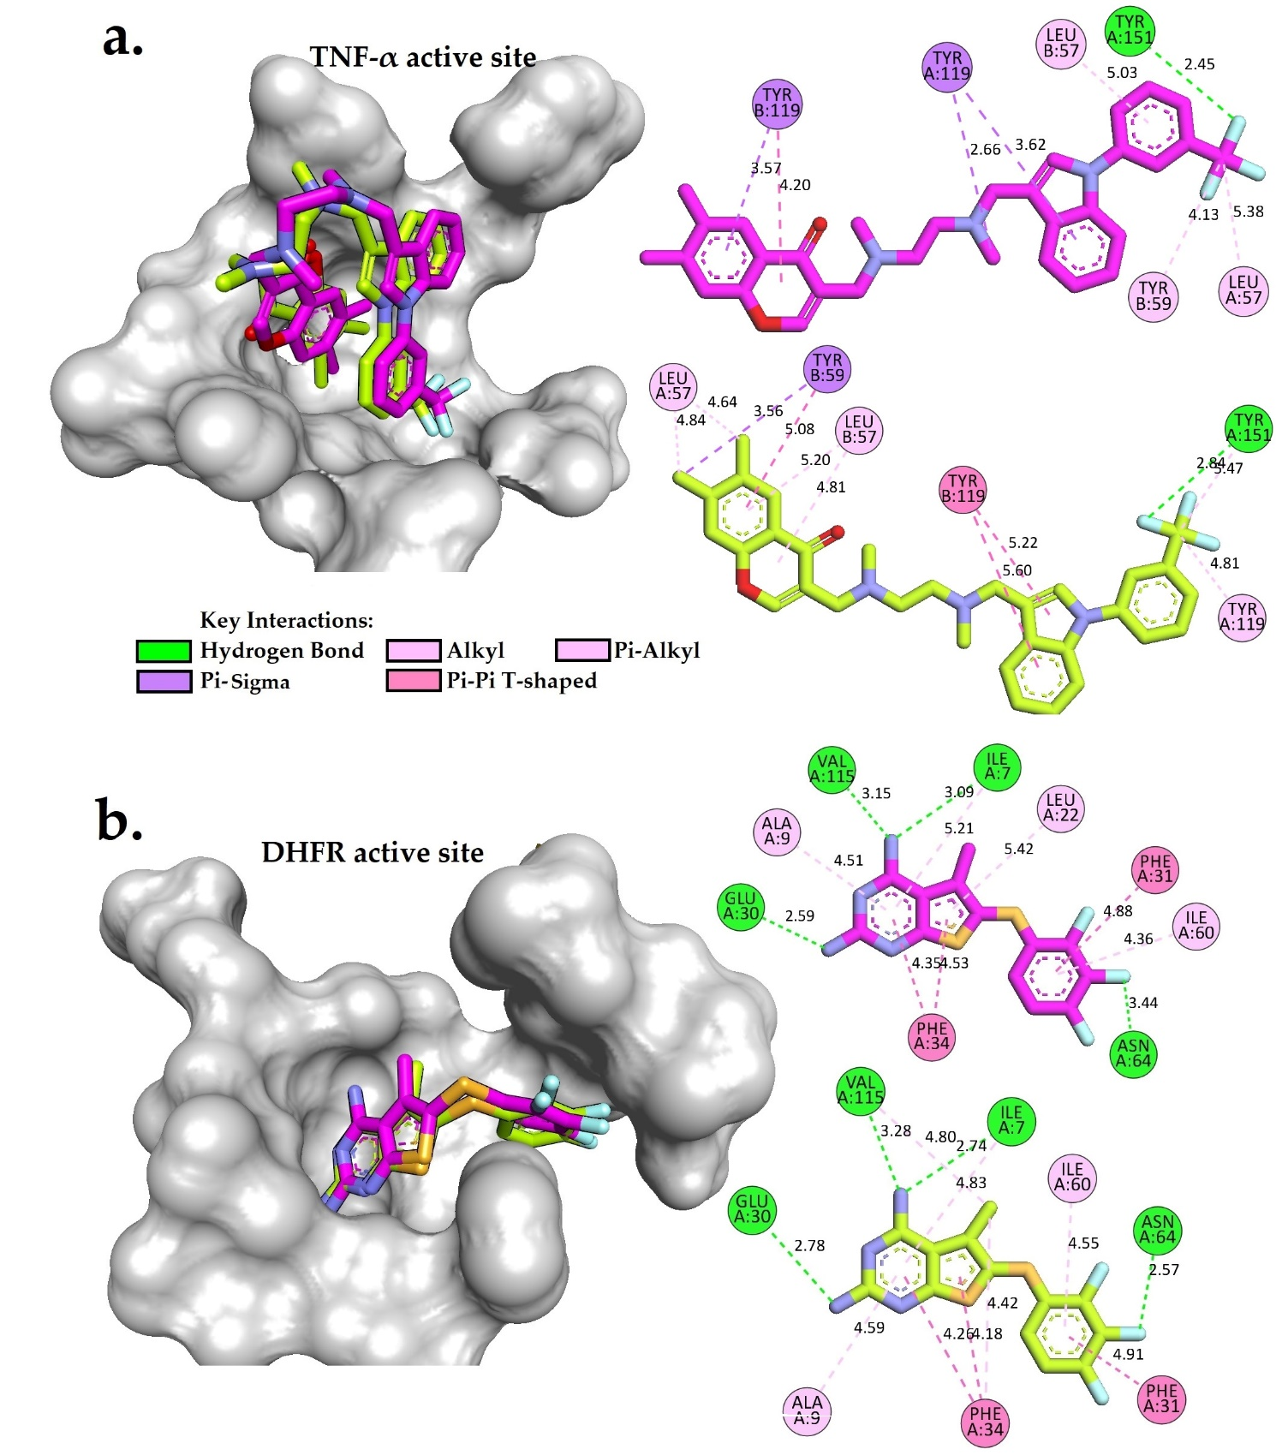
Figure S1. a) Superimposition of the original crystal structure (C pink, O red, F cyan, S orange, and N blue) and docked model (C lime, O red, F cyan, S orange, and N blue) into the active binding site of the Tumor Necrosis Factor Alpha (TNF-α) crystal structure (PDB ID: 2AZ5) and their 2D interactions (RMSD = 0.98 Å). b) Superimposition of the original crystal structure (C pink, O red, F cyan, S orange, and N blue) and the docked model (C lime, O red, F cyan, S orange, and N blue) into the active binding site of dihydrofolate reductase (DHFR) crystal structure (PDB ID: 5HQY) with RMSD = 0.62 Å and their 2D interactions. Some regions of the protein are omitted to facilitate visualization. These models were generated using BIOVIA Discovery Studio Visualizer.

