Supplementary Information

Table S1. Summary Statistics from GWAS result using 154 SNPs
SNP | Chromosome | Position | P value | MAF | Effect
S1_68992917 | 8 | 68992917 | 6.60E-14 | 0.1529 | 0.6401
S1_53208128 | 4 | 53208128 | 3.38E-07 | 0.0537 | -0.4741
S1_24909781 | 6 | 24909781 | 2.80E-05 | 0.0868 | -0.4375
S1_23794794 | 1 | 23794794 | 0.00033228 | 0.0744 | -0.2892
S1_94173819 | 3 | 94173819 | 0.00037769 | 0.0785 | -0.2982

SNP – Single Nucleotide Polymorphism
MAF – Minor Allele Frequency

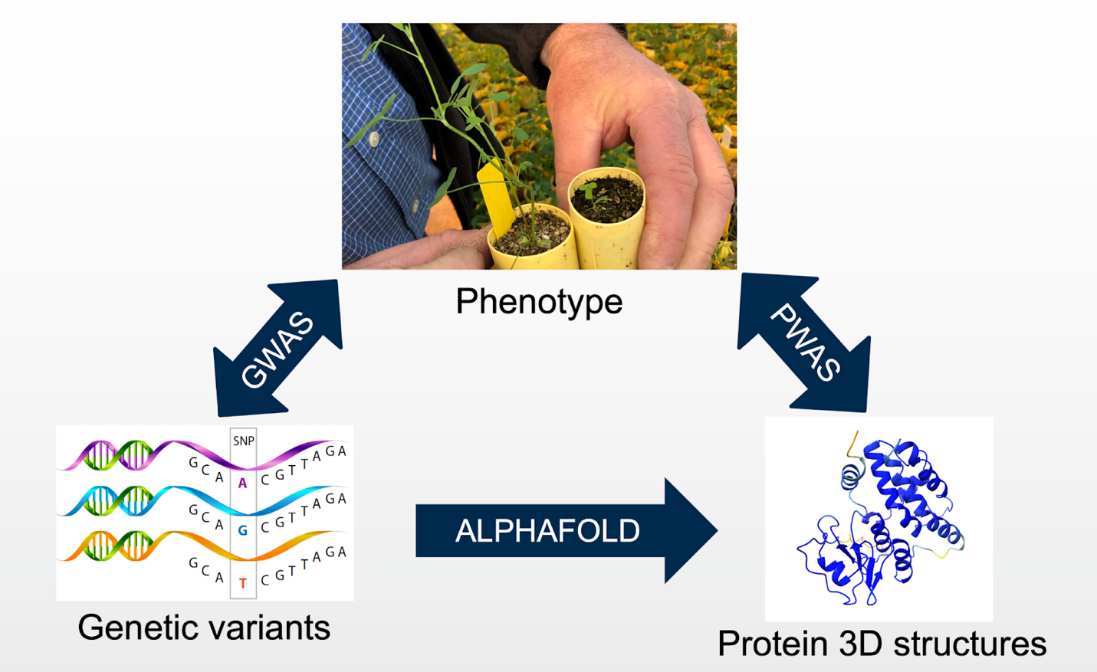
Figure S1: Outline of the proteome-wide association study. Genetic variants represent the variants called through exome capture sequencing. Protein features used as local distance difference test generated using the alphafold through 3D structure of proteins.
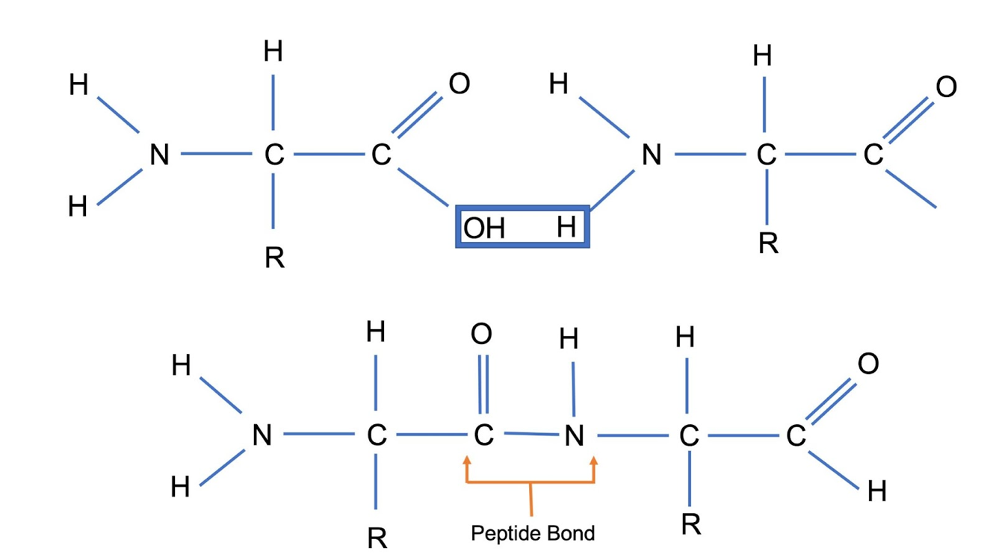
Figure S2. A Peptide bond (orange lines) links the two amino acids together in a protein molecule. Here R represents the alkyl group which can have a different number of residues based on the amino acid type. These residues determine the property of the amino acids to which it is linked.

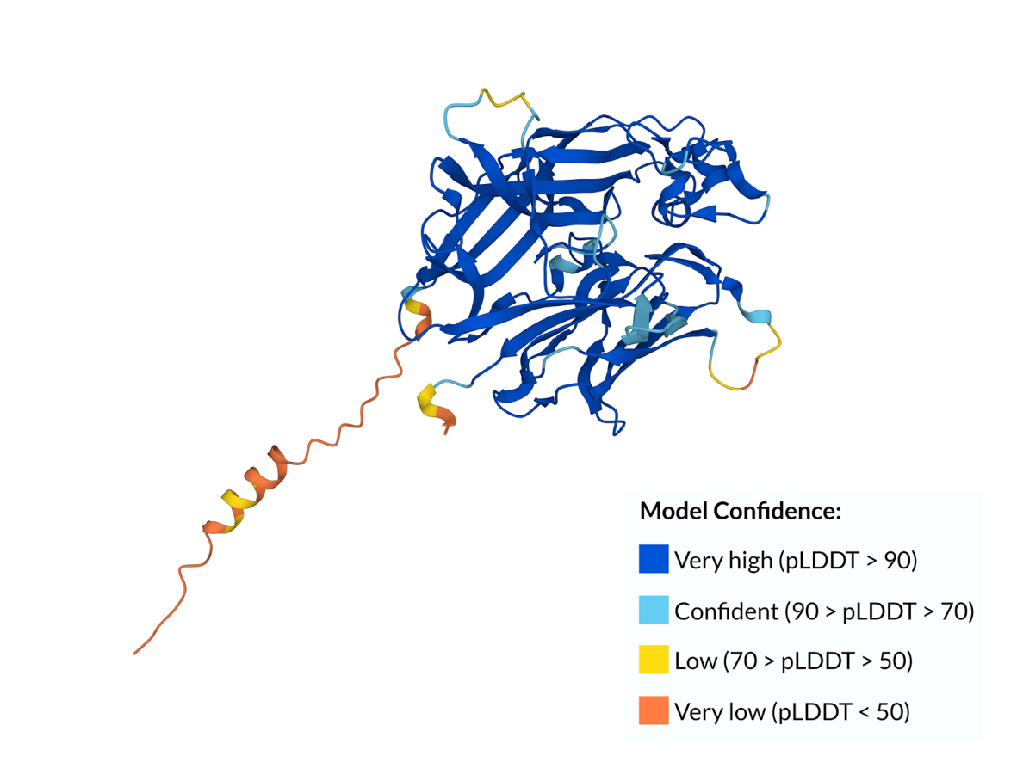
Figure S4.3. 3D Structure of the gene MsG0280007716.01.T01. The confidence scores are color coded from high confidence (dark blue) to low confidence (orange). The prediction accuracy of this protein is high as most of the regions are predicted with high confidence.

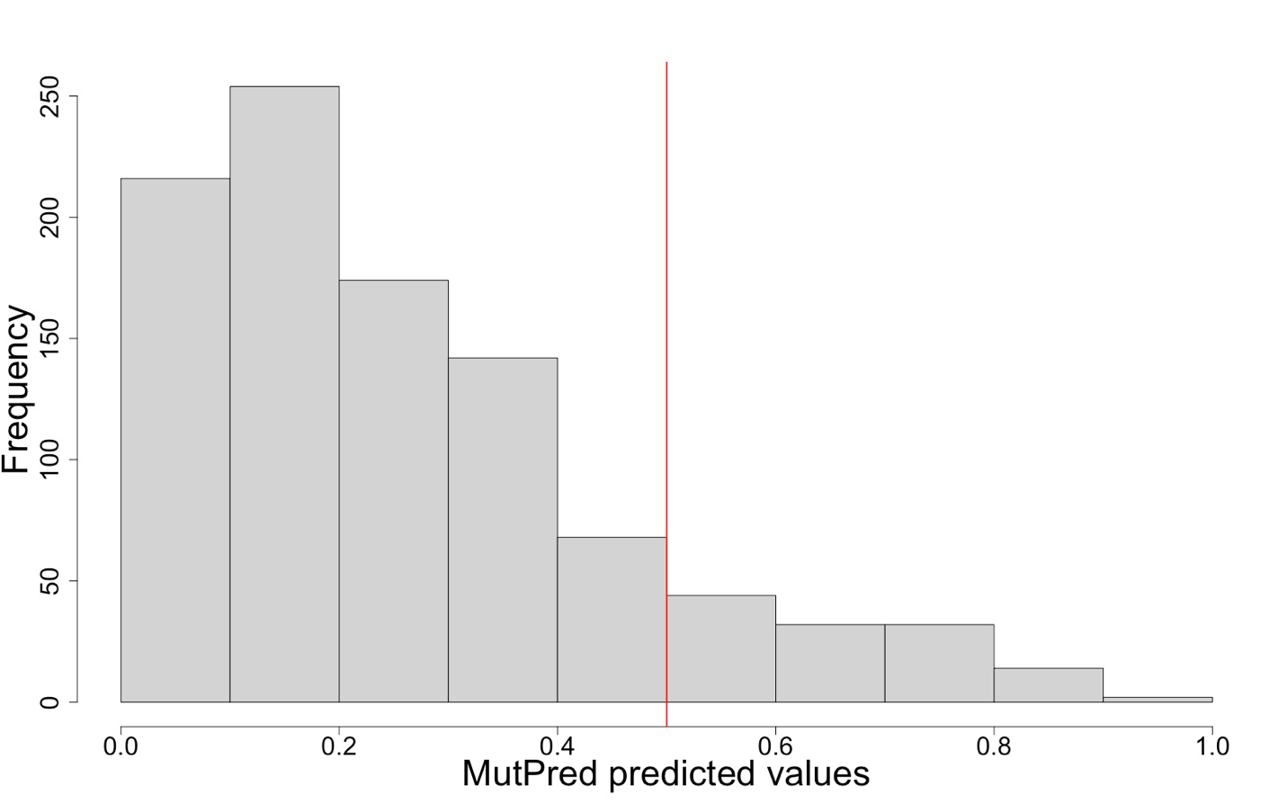
Figure S4.4. Distribution of mutation effect prediction from MutPred2. The mutation's effect value due to the substitution of amino acids lies between 0 and 1. Any prediction effect above 0.5 is considered to have a deleterious effect on the phenotype. While the x-axis represents the effect of amino acid substitution on phenotype and the y-axis their frequency, the red line represents the number of predicted values that are at or above the threshold used for the selection of deleterious mutation for association study.

