Supplementary Material:

A VEGFB-based peptidomimetic inhibits VEGFR2-mediated PI3K/Akt/mTOR and PLCγ/ERK signaling and elicits apoptotic, antiangiogenic, and antitumor activities

Mohadeseh Namjoo¹, Hossein Ghafoori², Elham Assareh², Amir Reza Aref³, Ebrahim Mostafavi⁴, Ali Hamrahi Mohsen⁵, Saeed Balalaei⁶, Sylvain Broussy⁷, S. Mohsen Asghari^{5*}

- Department of Biology, University Campus II, University of Guilan, Rasht, Iran.
- Department of Biology, Faculty of Sciences, University of Guilan, Rasht, Iran.
- Belfer Center for Applied Cancer Science, Dana-Farber Cancer Institute, Harvard Medical School, Boston, MA, USA
- Department of Medicine, Stanford University School of Medicine, Stanford, CA, USA.
- Institute of Biochemistry and Biophysics (IBB), University of Tehran, Tehran, Iran
- Peptide Chemistry Research Center, K. N. Toosi University of Technology, K. N. Toosi University of Technology, Tehran, Iran.
- Faculty of Pharmacy, Université Paris Cité, Paris, France.

Correspondence to S. Mohsen Asghari: Department of Biochemistry, Institute of Biochemistry and Biophysics (IBB), University of Tehran, Iran. Postal Code: 1417614411. sm.asghari@ut.ac.ir

This supporting information file contains:
- Supplementary Figure 1-7
- Supplementary Table 1-3
- Supplementary Methods
- Reference

Supplementary Figures:

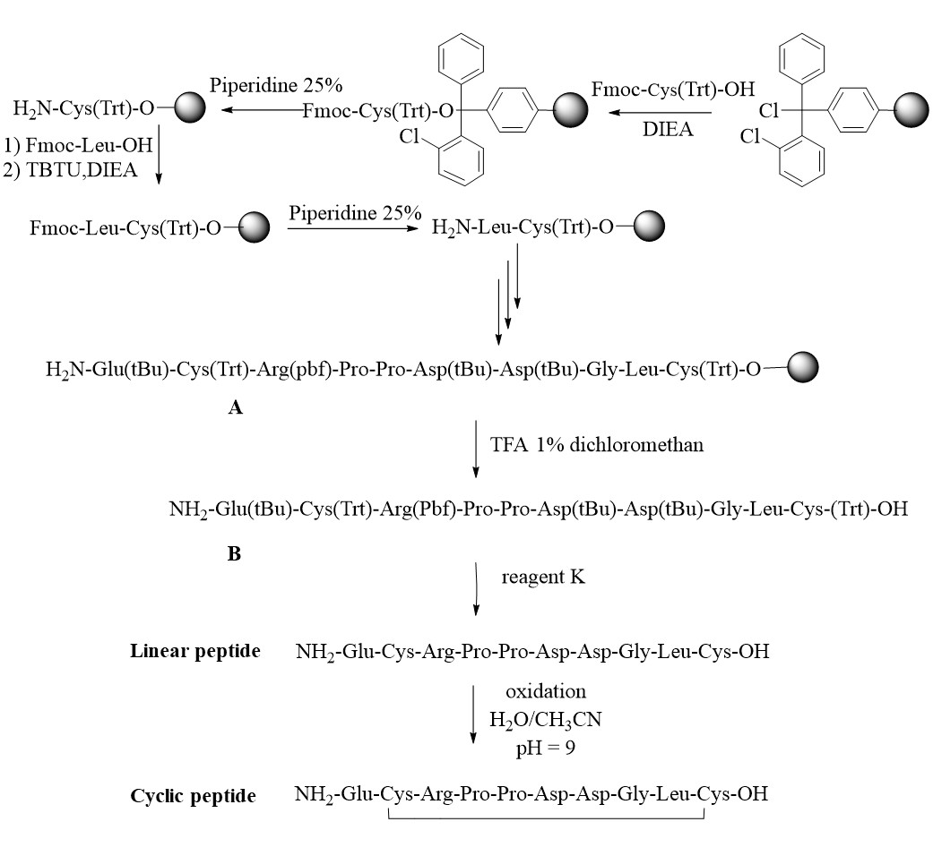
Figure S1. The Synthetic pathway for the synthesis of cyclic peptide sequence. The general method for the synthesis of cyclic peptide based peptide using SPPS.

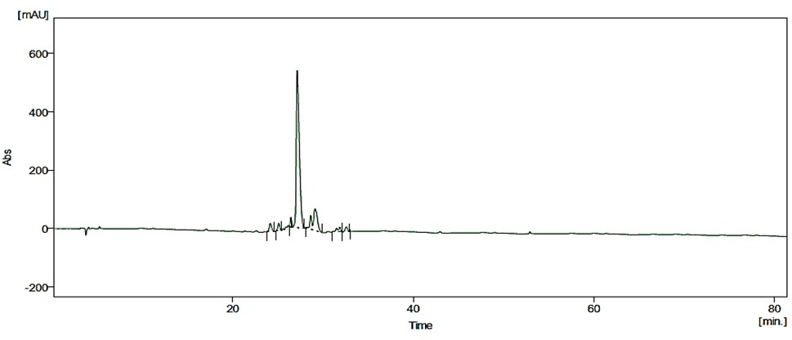
Figure S2. HPLC chromatogram of linear peptide

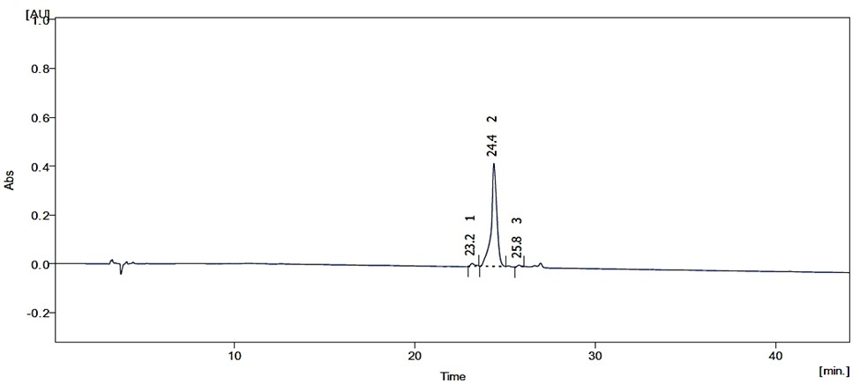
Figure S3. HPLC chromatogram of cyclic peptide

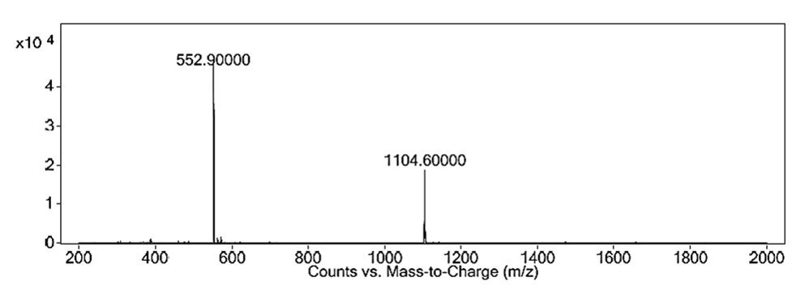
Figure S4. LC-MS of linear peptide

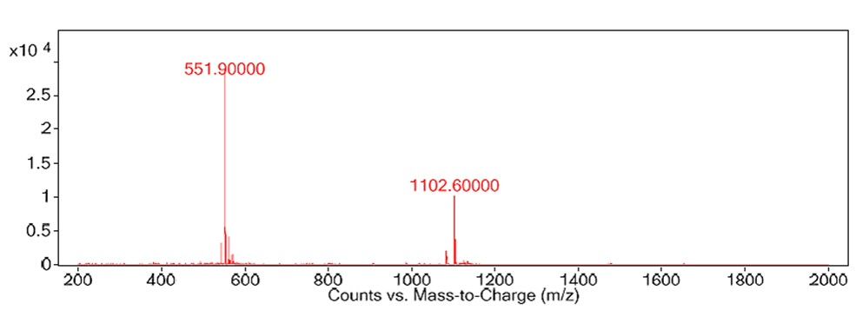
Figure S5. LC-MS of cyclic peptide

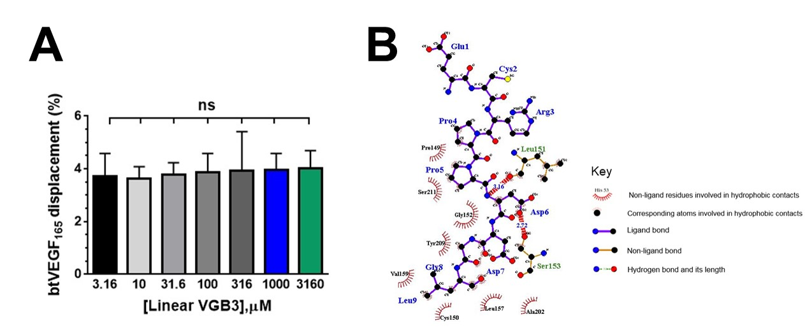
Figure S6. Evaluating the binding capability of the linear VGB3 to VEGFR2
(A) ELISA-based displacement assay. The gradient concentrations of the linear VGB3 (3.16, 10, 31.6, 100, 316, 1000 and 3160 μM) were used in the assay. The linear VGB3 showed no binding to the extracellular domain of VEGFR2 at applied concentrations. (B) Two-dimensional representation of interactions (produced by LigPlot software) in the linear VGB3/VEGFR2 complex.

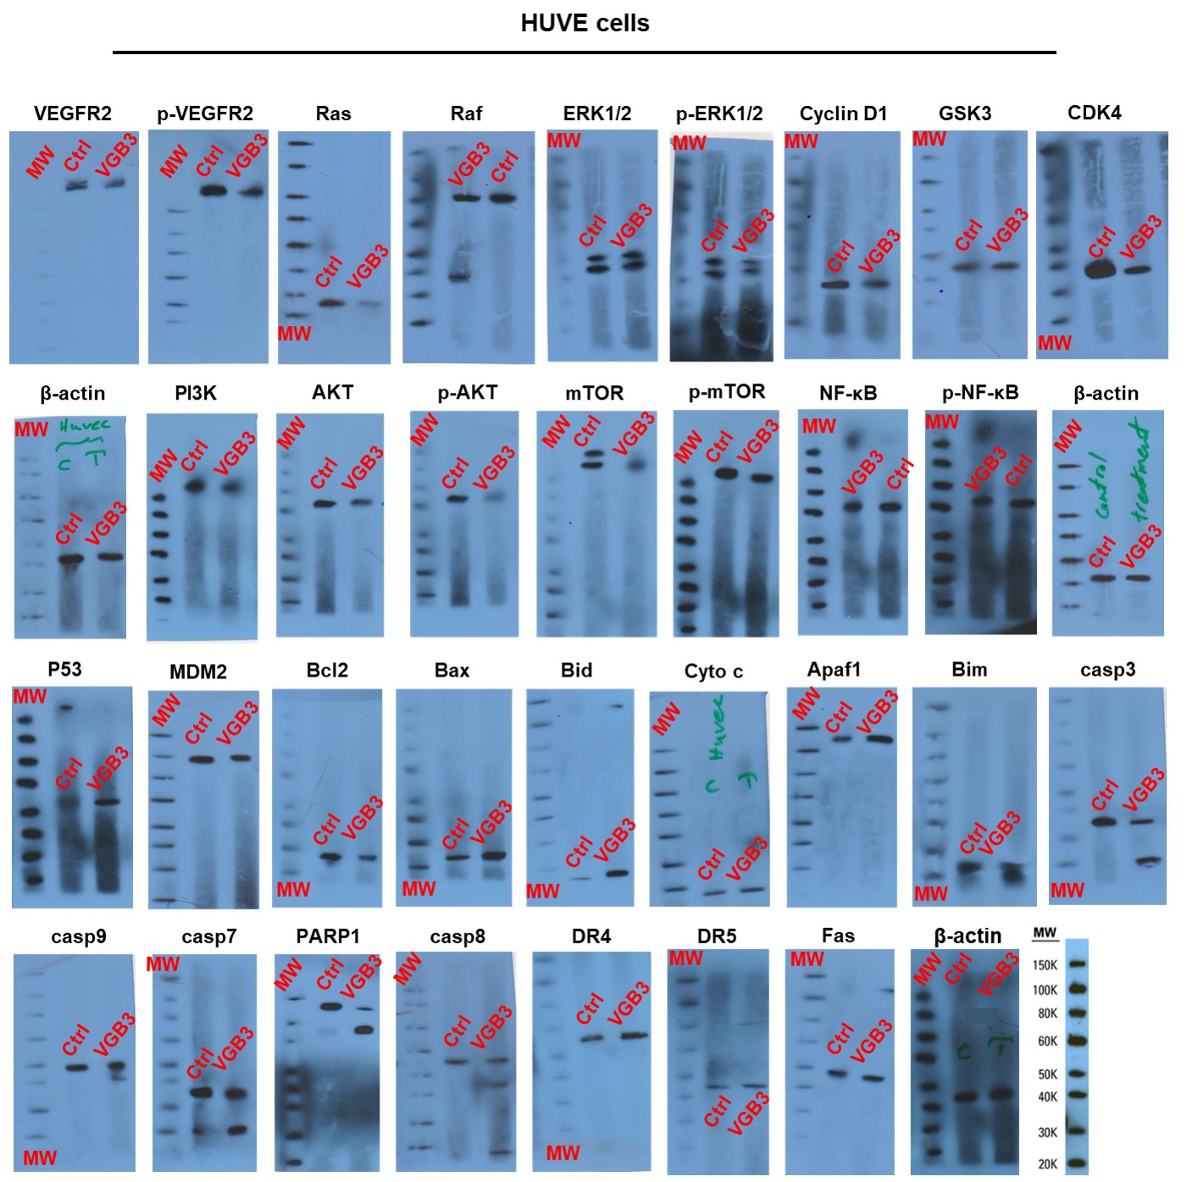
Figure S7

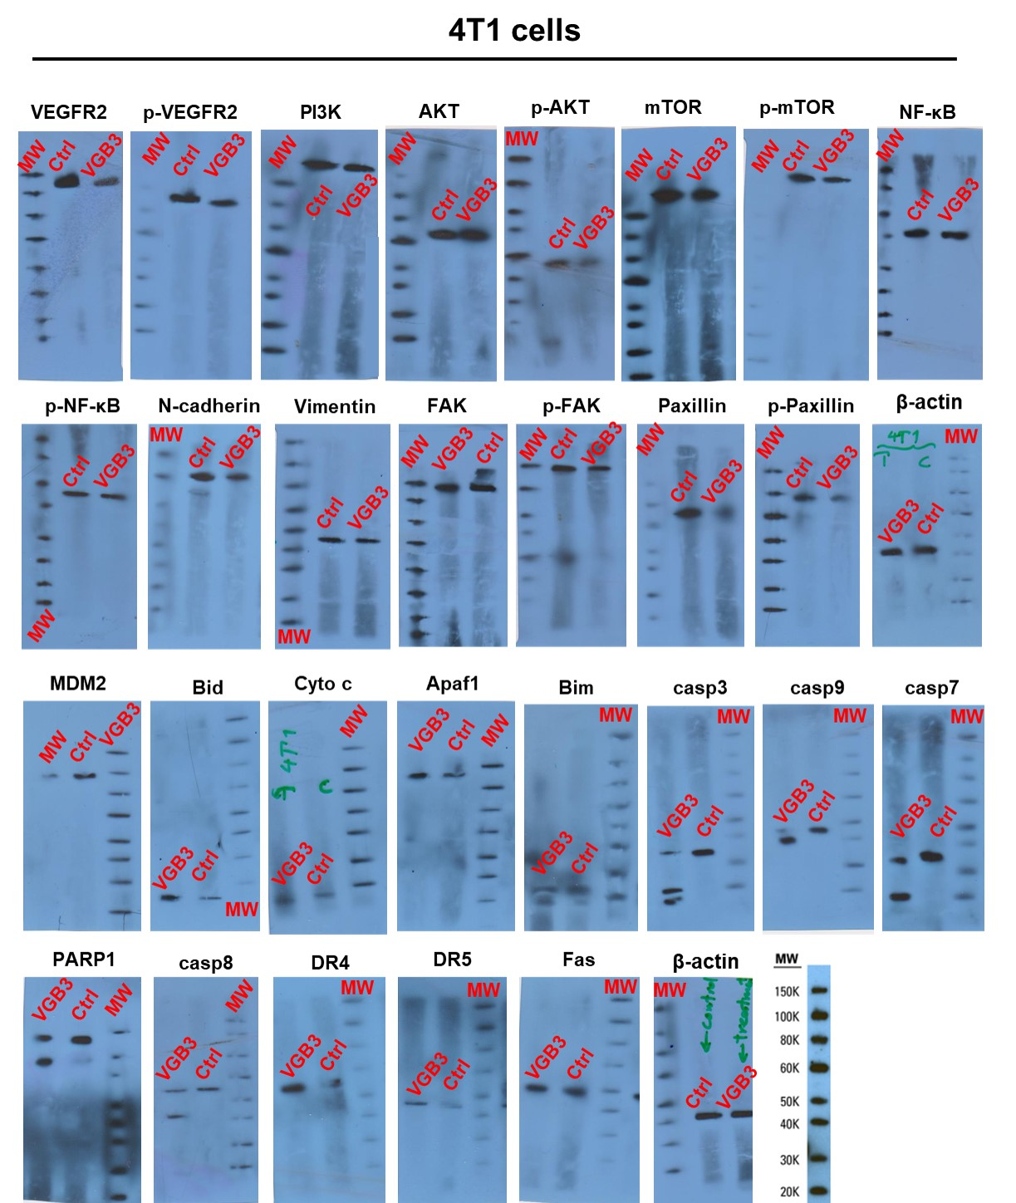
Figure S7. Raw data for western blot analysis.

Supplementary Tables:
Table S1. Interaction of cyclic and linear VGB3 with VEGFR2. The nature of interaction and participating residues are listed.
Complex | Hydrogen bonds  Residue Distance (ͦA) |  | Hydrophobic interactions
Cyclic VGB3/VEGFR2 | C2 with Val135  D6 with Thr145  D6 with Lys144  D7 with Ser189  D7 with Thr145  D7 with Lys144  G8 with Tyr137  L9 with Tyr137  C10 with Val135 | 4.80  3.11  2.67  2.65  3.80  3.35  2.92  3.20  3.30  2.69  3.43 | Ligand  C2, R3, P5, D6, D7, G8, L9, C10  Receptor  Val135, Val136, Tyr137, Ile138, Thr139, Lys142, Lys144, Thr145, Val146,Val147, Pro149
Linear VGB3/VEGFR2 | D6 with Leu151 D6 with Ser153 | 3.16  2.72 | Ligand  P4, P5, D6, D7, G8, L9  Receptor  Pro149, Cys150, Leu151, Gly152, Ser153, Val159, Tyr209, Ser211

Table S2. Peptide purification
Entry | Flow (ml/min) | Time (min) | A% | B%
1 | 10 | 0 | 95 | 5
2 | 10 | 5 | 95 | 5
3 | 10 | 65 | 45 | 55
4 | 10 | 110 | 0 | 100

Table S3. Analytical RP-HPLC separation
Entry | Flow (ml/min) | Time (min) | A% | B%
1 | 1 | 0 | 95 | 5
2 | 1 | 5 | 95 | 5
3 | 1 | 45 | 55 | 45
4 | 1 | 100 | 0 | 100

Supplementary Methods:
- Reagents
Anti-AKT [(B-1): sc-5298], anti-p-AKT [(B-5): sc-271966], anti-PI3K [C2α (H-300): sc-67306], anti-mTOR [(30): sc-517464], anti-p-mTOR [(59.Ser 2448): sc-293133], anti-p-NF-κB [(A-8): sc-166748], anti-E-cadherin [(67A4): sc-21791], anti-P53 [(DO-1): sc-126], anti-MDM2 [(SMP14): sc-965], anti-Bax [(B-9):sc-7480], anti-Bcl2 [(N-19): sc-492], anti-Bim [(H-5): sc-374358], anti-caspase9 [(9CSP01): sc-81663], anti-cytochrome c [(A-8): sc-13156], anti-CD262 [(B-D37): sc-65314], anti-PARP1 [(F-2): sc-8007], anti-ERK 1/2 [(H-72): sc-292838], anti-p-ERK 1/2 [(Thr 177)-R: sc-16981-R], anti-Ras [(259): sc-35], anti-Raf-1 [(E-10): sc-7267], anti-Cdk4 [(DCS-35): sc-23896], anti-GSK-3β [(11B9): sc-81462], anti-Cyclin D1 [(A-12): sc-8396], anti-FAK [(D-1): sc-271126], anti-p-FAK [(2D11): sc-81493], anti-paxillin [(B-2): sc-365379], p-paxillin [(A-5): sc-365020], anti-β-actin [(C4): sc-47778], mouse anti-rabbit IgG-HRP (sc-2357) and m-IgGκ BP-HRP (sc-516102) were purchased from Santa Cruz Biotechnology INC, California, U.S.A. Anti-Vimentin (V9) and phycoerythrin (PE)-secondary anti-goat (P-2771MP) were purchased from Invitrogen, U.S.A. Anti-VEGFR2 (ab39256), anti-p-VEGFR2 (ab5473), anti-Bid (ab10640), anti-NF-κB (ab16502) and anti-CD261 (ab8414) were purchased from Abcam. Anti-Apaf-1 (E-AB-12215) and anti-N-cadherin (E-AB-70061) were purchased from Elabscience ®. Anti-caspase7 (#9492), anti-caspase3 (#14220) and anti-caspase8 (#9746) were purchased from Cell Signaling Technology. Anti-CD95 (AF326) was purchased from R&D Systems. The molecular weight protein ladder (84785) was purchased from Thermo Scientific. Recombinant human VEGFR2/KDR Fc chimera protein (357-KD) was purchased from R&D Systems (Minneapolis, MN, U.S.A). TUNEL assays were done utilizing an in situ Cell Death Detection Kit POD (Roche Diagnostic GmbH, Germany). Amersham™ Protran® Premium nitrocellulose western blotting membranes (Ge10600013) was purchased from Sigma, U.S.A.
- Peptide synthesis
Peptides were synthesized manually using standard Fmoc solid-phase peptide synthesis chemistry. The amino acids Fmoc-Cys(Trt)-OH, Fmoc-Leu-OH, Fmoc-Gly-OH, Fmoc-Asp(tBu)-OH, Fmoc-Pro-OH, Fmoc-Arg(Pbf)-OH, Fmoc-Glu(tBu)-OH were used. The peptide synthesis was carried out using 2-chlorotrityl chloride resin (1.0 mmol/g) following the standard Fmoc strategy. Firstly, the resin was swelled with DCM (3×10 mL) for 30 min. Then, Fmoc-Cys(Trt)-OH (0.586 g, 1.0 mmol) was attached to the 2-CTC resin (1.0 g) with DIPEA (1.36 ml, 8 mmol) in anhydrous DMF (10 mL) at room temperature for 3 h. After filtration, the remaining trityl chloride groups were capped by a solution of DCM/MeOH/DIPEA (20:2.4:1.2, 23.6 mL) for 30 min. The resin was filtered and washed thoroughly with DMF (3× 10 mL). After drying the resin under vacuum, the loading capacity was determined by weight and was 1.0. The resin-bound Fmoc-amino acid was washed with DMF (3× 10 mL) and treated with 25% piperidine in DMF (15 mL) for 30 min, followed by washing with DMF (3× 10 mL). Then, a solution of Fmoc-Leu-OH (0.708 g, 2.0 mmol), TBTU (0.64 g, 2.0 mmol), DIPEA (0.6 ml, 3.5 mmol) in 10 ml DMF was prepared, added to the resin-bound free amine, and shaken for 45 min at room temperature. After completion of the coupling, the resin was washed with DMF (3× 10 mL), followed by the coupling repeat for other amino acids of the sequence as the same method. The coupling was confirmed using Kaiser to detect the presence or absence of free primary amino groups in all cases. Fmoc concentration was determined by employing UV spectroscopy. The resin was washed with DMF (3×10 mL) after completing all couplings, and the constructed linear peptide was cleaved from the resin by treatment with TFA (1%) in DCM (100 mL) and neutralization with pyridine (4%) in MeOH (50 mL). Then, the solvent was evaporated under reduced pressure and precipitated in water. 1 g of dry-protected decapeptide was treated with TFA/TES/H₂O/MeOH (95%: 2%: 1.5%: 1.5%) at room temperature for 2-3 h. The yield was 70% (0.773 g of linear VGB3).
The fully deprotected linear peptide was dissolved in H₂O or H₂O/acetonitrile. Then, the solution was buffered to pH=9 with ammonium acetate 10%, and the mixture was stirred at room temperature for 6 h. Afterward, the mixture was lyophilized and the cyclic peptide was analyzed by HPLC (high-performance liquid chromatography) and Mass (ESI).
The cyclic peptide was synthesized following the standard Fmoc-Solid Phase Peptide Synthesis (SPPS) procedure on 2-chlorotrityl resin and TBTU was used as a coupling reagent (Figure S1). Briefly, (1) Fmoc-Cys(Trt)-OH was loaded to the surface of the resin using diisopropylethylamine (DIEA); (2) after capping with MeOH other Fmoc-protected amino acids were added to the peptide sequence using TBTU as coupling reagent. Coupling reactions were performed utilizing Fmoc-amino acid/TBTU /DIEA/. A 25% piperidine in DMF solution was used to deprotect Fmoc groups. The Kaiser test was performed to confirm the coupling of amino acids. The desired fully protected decapeptide on the surface of resin A was obtained after the successive addition of the 10 amino acids in the sequence. The subsequent steps were performed to access linear decapeptide-based peptide: (1) the protected peptide A was cleaved from the resin surface utilizing 1% TFA, and compound B was formed; (2) the final deprotection was done using reagent K (TFA/TES/H2O/MeOH (95%: 2%: 1.5%: 1.5%); and (3) cyclization of the fully deprotected peptide was performed in 500 ml of H₂O or H₂O/acetonitrile (for 200 mg of linear peptide) with air oxidation to access the desired cyclic peptide. Subsequently, the solution was buffered to pH = 9 by adding ammonium acetate 10%. Cyclization was usually complete within 6 h, as shown by HPLC control. Then, the solvents were evaporated, and the peptides were lyophilized (Yields = 98 d). HPLC (Column C-18, Eurospher 100, 7 μm) was used to purify the peptide.
- High performance liquid chromatography
The samples were dissolved in solvent A for liquid chromatography. The mobile phase for all HPLC purifications consisted of solvent A (Acetonitrile/Water (70/30)) and solvent B (NaH₂PO₄/Water (10 mM)), and separations were performed on an HPLC system (Knauer, Germany) equipped with a pump 1800 (Knauer, Germany), UV detector 2500 (Knauer, Germany) (Table S2). Peptide purification was performed at a preparative scale using the C18 column (120 mm × 20mm, 10 μm). The flow rate was set to 10 mL.min⁻¹ and the employed elution program started at 95 % A and remained at this point for 5 min before changing to 45 % of solvent A over 65 min. The elution profile was monitored via UV absorbance at 210 nm, and peptides were collected manually according to their absorbance at 210 nm.
Analytical RP-HPLC (Rigol, China) separation was carried out using an Agilent C18 column (250 mm × 4.6 mm, 5 μm) at a flow rate of 1 mL.min⁻¹ and the mobile phase consisted of solvent A [TFA/Water (0.1%)] and solvent B [Acetonitrile/Buffer A (80/20)]. Separations were performed on an HPLC system (Rigol, China) equipped with a pump 1000 (Rigol, China), UV detector 2500 (Rigol, China) (Table S3). The employed elution program started at 95 % A and remained at this point for 5 min before changing to 55 % of solvent A over 45 min at 1% min⁻¹. The elution profile was monitored via UV absorbance at 210 nm, and peptides were collected manually according to their absorbance at 210 nm. HPLC analysis found that linear decapeptide (H-Glu-Cys-Arg-Pro-Pro-Asp-Asp-Gly-Leu-Cys-OH) was obtained in 91 % < purity (t_{R}: 27.13 min) (Figure. S2). Also, HPLC analysis found that cyclic peptide was obtained in 96 % < purity (t_{R}: 24.38 min) (Figure S3).
- Mass spectrometry analysis
The linear peptide structure was approved using Mass (ESI). Also, the cyclic peptide structure was approved using Mass (ESI). Mass (ESI): C₄₃H₆₉N₁₃O₁₇S₂ m/z = [M+H]⁺ found 1104 for the linear peptide. Also, mass (ESI): C₄₃H₆₇N₁₃O₁₇S₂ m/z = [M+ H]⁺ found 1102 for the cyclic peptide. LC-MS analyses were performed by an Agilent Triple Quadrupole LC/MS 6410 Diode array detector, ALS, TCC, Bin pump, and Degasser: 1200 series. The MS instrument was operated at the following settings: Drying gas: Nitrogen (300 ºC); source voltage 3.5 kV, nebulizing gas pressure: 50 PSI, Ionization mode: Electrospray. Product ions were then scanned and monitored (Figures S4 and S5).
- Ellman assay
The Ellman assay was performed to confirm the presence of the disulﬁde bond in cyclic VGB3. The procedure includes the addition of the peptide (1.23 µM) into the sodium phosphate (100 mM) reaction buffer at pH 8.0 containing 100 mM EDTA; the addition of DTNB (4 mg.mL⁻¹) to the solution; a mix of the sample solution with an equal volume of the Ellman’s reagent and incubation for 15 min at ambient temperature; and finally, read the absorbance of reaction at 412 nm (ε = 1.36 × 104 M⁻¹ cm⁻¹) vs. a sulfhydryl standard ‘cysteine’ treated in the same manner to estimate the sulfhydryl concentration by a UV-3000 spectrophotometer (Pharmacia Biotech Ultrospect, Cambridge, England).
- Molecular modeling and structural reﬁnement
Models of cyclic and linear VGB3 structures were built using homology modeling in the MODELLER software version 9.18 ¹, and VEGFB (PDB ID: 2C7W) was used as a template. The VEGFB in FASTA format was obtained from the PDB website (http://www.rcsb.org/pdb/). Sequence alignments of each peptide with the template was directed using the multiple sequence alignment online server ClustalW (https://embnet.vital-it.ch/software/ClustalW.html). Ten models were created by MODELLER software, version 9.18, and the quality of the modeled structures was verified on the SWISS-MODEL web server (http://swissmodel.expasy.org/), PROCHECK ² and QMEAN ³. Molecular dynamics (MD) simulations were performed using the GROMACS package version 5.1.4 ⁴, to reﬁne the best structures obtained from homology modeling. The 54A7 force ﬁeld parameters ⁵ were used in the simulations and the interaction time steps during the simulation were set to 2 fs. The Particle-Mesh Ewald (PME) method with maximum Fast Fourier Transforms (FFT) grid spacing of 0.16 nm and an interpolation order of 4 was used to determine the long-range electrostatic interactions. A cutoff radius of 1.0 nm is used for Coulomb interactions and short-range interactions defined as van der Waals interactions ⁶. Periodic boundary conditions were used, and bonds were restrained by applying the LINCS algorithm to their equilibrium position. Initial structures were solvated with three-point model water molecules in a cubic box of 1.0 nm to fully cover the protein system in water, following periodic boundary conditions (PBC). The produced system for each peptide was neutralized through the “genion tool” plugin of the GROMACS package by adding ions Na⁺ and Cl⁻. Then, the system was minimized for 50000 iterations using the steepest descent (SD) algorithm and using velocity rescaling (modiﬁed Berendsen) temperature coupling and Parrinello-Rahman pressure coupling methods, simulated under an isothermal-isobaric ensemble (NPT) for 5 ns at a constant temperature, the pressure of 300 K, and 1 atm, respectively. The NVT and NPT equilibration was carried out for 50000 steps. The minimization and equilibration procedures were executed, and finally, one system of the peptide was subjected to a 200 ns production run of MD simulations utilizing 2 fs as the time step and coordinates of all atoms were recorded in the form of .trr GROMACS trajectory ﬁle every 10 ps.
- TUNEL assay
2 × 10³ HUVE or 4T1 cells were cultured in DMEM and RPMI-1640 media, respectively, supplemented with 10% (v/v) FBS overnight. Then, the cells were incubated in the media supplemented with 5% FBS, with PBS or VGB3 (0.40 μM). The terminal deoxynucleotidyl transferase (TdT) dUTP nick-end labeling (TUNEL) assay was performed on the HUVE and 4T1 cells using TUNEL Assay Kit (FITC or HRP-DAB; E-CK-A332) according to manufacturer instructions. The steps included: (1) washing the cells once with PBS; (2) fixation of the HUVE or 4T1 cells in fixative buffer at room temperature for 15-60 min; (3) washing the HUVE or 4T1 cells with PBS for 5 min (three times); (4) adding blocking buffer on the slides, and incubation at room temperature for 10 min; (5) repeating the step 3; (6) putting the slides into the permeabilization buffer on an ice bath for 2 min, and (7) repeating the step 3. The following steps were performed for TUNEL staining: (1 washing the slides with PBS (2 times, 5 min each time) and wipe drying the liquid on the slides; (2) adding 50 μL TdT enzyme working solution to each slide, and incubating at 37°C (60 min in a wet bow); (3) washing the slide with PBS (3 times, 5 min each time); (4) wipe drying the liquid on the slides with absorbent paper; (5) adding DAPI, and incubating at room temperature for 5 min; (6) washing the slides with PBS (4 times, 5 min each time) and wipe drying the liquid on the slides with absorbent paper; and (7) adding mounting medium (contain Fluorescent Mounting Media) to seal the slides. Fluorescence microscopy was done for detection according to manufacturer instructions. Image analysis was done using ImageJ software.

References
1. Eswar, N., Webb, B., Marti‐Renom, M. A., Madhusudhan, M., Eramian, D., Shen, M. y., Pieper, U. & Sali, A. (2006). Comparative protein structure modeling using Modeller. Curr. Protoc. Bioinformatics 15, 5.6. 1-5.6. 30.
2. Laskowski, R. A., MacArthur, M. W., Moss, D. S. & Thornton, J. M. (1993). PROCHECK: a program to check the stereochemical quality of protein structures. J. Appl. Crystallogr. 26, 283-291.
3. Benkert, P., Tosatto, S. C. & Schomburg, D. (2008). QMEAN: A comprehensive scoring function for model quality assessment. Proteins: Structure, Function, Bioinformatics. 71, 261-277.
4. Abraham, M. J., Murtola, T., Schulz, R., Páll, S., Smith, J. C., Hess, B. & Lindahl, E. (2015). GROMACS: High performance molecular simulations through multi-level parallelism from laptops to supercomputers. SoftwareX. 1, 19-25.
5. Schmid, N., Eichenberger, A. P., Choutko, A., Riniker, S., Winger, M., Mark, A. E. & van Gunsteren, W. F. (2011). Definition and testing of the GROMOS force-field versions 54A7 and 54B7. Eur. Biophys. J. 40, 843.
6. Tao, Y., Rao, Z.-H. & Liu, S.-Q. (2010). Insight derived from molecular dynamics simulation into substrate-induced changes in protein motions of proteinase K. J BIOMOL STRUCT DYN 28, 143-157.

