The Comparative Toxic Impact Assessment of Carbon Nanotubes, Fullerene, Graphene, and Graphene Oxide in Marine microalgae Porphyridium purpureum
Konstantin Pikula ¹, Seyed Ali Johari ², Ralph Santos-Oliveira ^{3,4} and Kirill Golokhvast ^{1,5}
¹ Polytechnical Institute, Far Eastern Federal University, 10 Ajax Bay, Russky Island, 690922 Vladivostok, Russia; pikula_ks@dvfu.ru (K.P.)
² Department of Fisheries, Faculty of Natural Resources, University of Kurdistan, Pasdaran St, Sanandaj 66177-15175, Iran; sajohari@gmail.com (S.A.J.)
³ Laboratory of Nanoradiopharmaceuticals and Synthesis of Novel Radiopharmaceuticals, Nuclear Engineering Institute, Brazilian Nuclear Energy Commission, Rua Hélio de Almeida 75, 21941906 Rio de Janeiro, Brazil; roliveira@ien.gov.br (R.S.O.)
⁴ Laboratory of Nanoradiopharmaceuticals and Radiopharmacy, Rio de Janeiro State University, R. São Francisco Xavier, 524, 23070200 Rio de Janeiro, Brazil
⁵ Siberian Federal Scientific Centre of Agrobiotechnology, Centralnaya Str., Presidium, 633501 Krasnoobsk, Russia; golokhvast@sfsca.ru (K.G.)

* Correspondence: pikula_ks@dvfu.ru

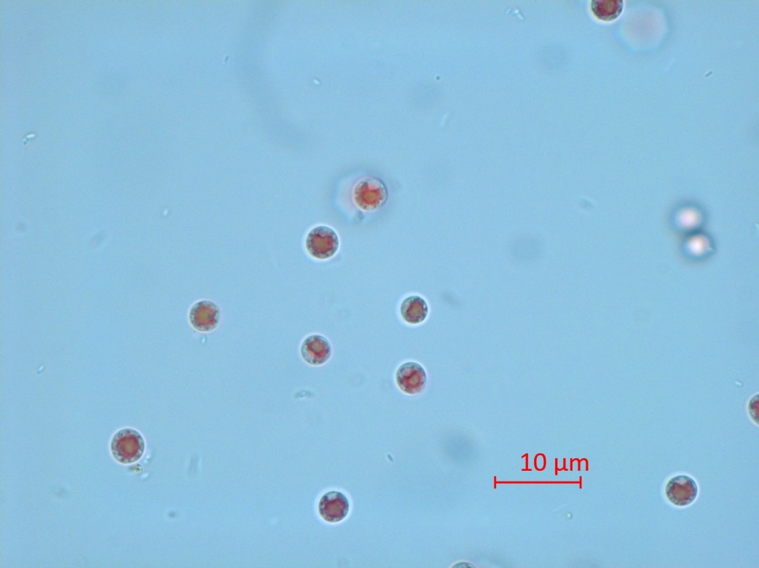
Figure S1. Microscopic picture of P. purpureum from control group.

Table S1: The statistical significance calculation of esterase activity, membrane potential, and ROS generation in P. purpureum cells after 24 h of exposure; Table S2: The statistical significance calculation of the changes in P. purpureum cells after 96 h of exposure.
Table S1. The statistical significance calculation of esterase activity, membrane potential, and ROS generation in P. purpureum cells after 24 h of exposure.
Concentration. mg/L | CNTs |  | C60 |  | Gr |  | GrO
Growth rate
1 | *** | 0.0004 | ns | 0.6562 | ns | 0.4119 | **** | <0.0001
10 | **** | <0.0001 | ns | 0.7143 | ns | 0.0883 | **** | <0.0001
25 | **** | <0.0001 | ns | 0.6845 | ** | 0.0049 | **** | <0.0001
50 | **** | <0.0001 | ns | 0.2042 | **** | <0.0001 | **** | <0.0001
75 | **** | <0.0001 | * | 0.0454 | **** | <0.0001 | **** | <0.0001
100 | n/a | <0.0001 | ** | 0.0057 | **** | <0.0001 | **** | <0.0001
125 | n/a | <0.0001 | * | 0.0118 | **** | <0.0001 | **** | <0.0001
Esterase activity
1 | * | 0.0224 | *** | 0.0007 | ns | 0.2676 | ns | 0.9998
10 | **** | <0.0001 | **** | <0.0001 | ** | 0.0018 | ** | 0.0032
25 | **** | <0.0001 | **** | <0.0001 | **** | <0.0001 | **** | <0.0001
50 | **** | <0.0001 | ns | 0.2647 | **** | <0.0001 | **** | <0.0001
75 | **** | <0.0001 | ns | 0.1285 | **** | <0.0001 | **** | <0.0001
100 | n/a | <0.0001 | **** | <0.0001 | **** | <0.0001 | **** | <0.0001
125 | n/a | <0.0001 | **** | <0.0001 | **** | <0.0001 | **** | <0.0001
Membrane potential
1 | ns | 0.2576 | ns | 0.1437 | ns | 0.1169 | ns | 0.1001
10 | ns | 0.9020 | * | 0.0148 | *** | 0.0004 | ns | 0.0617
25 | ns | 0.1008 | * | 0.0207 | **** | <0.0001 | ns | 0.3921
50 | **** | <0.0001 | ** | 0.0020 | **** | <0.0001 | ns | 0.9951
75 | **** | <0.0001 | **** | <0.0001 | *** | 0.0009 | * | 0.0106
100 | n/a | <0.0001 | **** | <0.0001 | **** | <0.0001 | ** | 0.0024
125 | n/a | <0.0001 | **** | <0.0001 | **** | <0.0001 | ** | 0.0067
ROS generation
1 | ns | 0.6425 | ns | 0.4558 | ns | 0.6279 | ns | 0.0756
10 | ns | 0.9997 | ns | 0.4631 | ns | 0.5122 | ns | 0.1290
25 | *** | 0.0002 | ns | 0.3701 | ns | 0.2023 | ns | 0.1007
50 | *** | 0.0004 | ns | 0.9998 | **** | <0.0001 | ** | 0.0029
75 | *** | 0.0003 | ns | 0.2486 | **** | <0.0001 | **** | <0.0001
100 | n/a | 0.0109 | ns | 0.6707 | **** | <0.0001 | **** | <0.0001
125 | n/a | 0.0337 | ns | 0.9997 | **** | <0.0001 | **** | <0.0001
ROS, Reactive oxygen species; *, p < 0.05; **, p < 0.005; ***, p < 0.0005; ****, p < 0.0001; n/a, not assessed; ns, nonsignificant (p > 0.05).

Table S2. The statistical significance calculation of esterase activity, membrane potential, and ROS generation in P. purpureum cells after 24 h of exposure.
Concentration. mg/L | 4-6 µm |  | 6-10 µm |  | 10-15 µm
CNTs
1 | ns | 0,7792 | ns | 0,7875 | ns | 0,9993
10 | ns | 0,7496 | ns | 0,8065 | ns | 0,3760
25 | *** | 0,0002 | *** | 0,0001 | ns | 0,5322
50 | **** | <0,0001 | *** | 0,0001 | ns | 0,9988
75 | n/a | n/a | n/a | n/a | n/a | n/a
100 | n/a | n/a | n/a | n/a | n/a | n/a
125 | n/a | n/a | n/a | n/a | n/a | n/a
C60
1 | * | 0.0404 | * | 0.0390 | ns | 0.9978
10 | * | 0.0184 | * | 0.0178 | ns | 0.8838
25 | ns | 0.5608 | ns | 0.5615 | ns | 0.8495
50 | ns | 0.9631 | ns | 0.9589 | ns | 0.9137
75 | ns | 0.8700 | ns | 0.8708 | ns | 0.9589
100 | ns | 0.9924 | ns | 0.9919 | ns | 0.9997
125 | ns | 0.4260 | ns | 0.4262 | ns | 0.8115
Gr
1 | ** | 0.0090 | ** | 0.0088 | ns | 0.9999
10 | ns | 0.5525 | ns | 0.5537 | ns | 0.9936
25 | ns | 0.3239 | ns | 0.3188 | ns | 0.9977
50 | ** | 0.0018 | ** | 0.0018 | ns | 0.9977
75 | ** | 0.0029 | ** | 0.0028 | ns | 0.9317
100 | ** | 0.0013 | ** | 0.0013 | ns | 0.9999
125 | **** | <0.0001 | **** | <0.0001 | ns | 0.7740
GrO
1 | ns | 0.1397 | ns | 0.1320 | ns | 0.9999
10 | ns | 0.9784 | ns | 0.9911 | ns | 0.5981
25 | ** | 0.0019 | ** | 0.0028 | * | 0.0183
50 | **** | <0.0001 | **** | <0.0001 | **** | <0.0001
75 | **** | <0.0001 | *** | 0.0001 | **** | <0.0001
100 | *** | 0.0003 | ** | 0.0019 | **** | <0.0001
125 | *** | 0.0003 | ** | 0.0089 | **** | <0.0001
ROS, Reactive oxygen species; *, p < 0.05; **, p < 0.005; ***, p < 0.0005; ****, p < 0.0001; n/a, not assessed; ns, nonsignificant (p > 0.05).

