**Electronic Supporting Information**

**for**

**Development of Blue Phosphorescent Pt(II) Materials using Dibenzofuranyl Imidazole Ligands and their Application in Organic Light-Emitting Diodes**

Hakjo Kim,a Dain Cho,a Haein Kim,a Seung Chan Kim,b Jun Yeob Leeb,* and Youngjin Kanga,*

*aDivision of Science Education, Kangwon National University, Chuncheon 24341, Republic of Korea*

*bSchool of Chemical Engineering, Sungkyunkwan University, 2066 Seobu-ro, Jangan-gu, Suwon, Gyeonggi 16419, Republic of Korea*

# Contents

* Experimental details.
* **Figure S1**. 1H NMR of **1** in CD2Cl2.
* **Figure S2.** 13C NMR of **1** in CD2Cl2.
* **Figure S3**. 1H NMR of **2**in CD2Cl2.
* **Figure S4.** 13C NMR of **2** in CD2Cl2
* **Figure S5.** X-ray structure of **2** using Diamond program.
* **Figure S6.** Decay curve of **1.**
* **Figure S7.** Decay curve of **2** at different wavelngth (black: 482nm, red:435nm).
* **Figure S8.** Oxidation of **1** and **2** (inset: Fc/Fc+ oxidation).
* **Table S1.** Crystal Data and Structure Refinement for **2**.
* **Table S2.** Atomic coordinates (x 104) and equivalent isotropic displacement parameters (Å2x 103) for **2**. U(eq) is defined as one third of the trace of the orthogonalized Uij tensor.
* **Table S3**. Bond lengths [Å] and angles [°] for **2**.
* **Table S4**. Anisotropic displacement parameters (Å2x 103) for **2**. The anisotropic displacement factor exponent takes the form: -22[ h2 a*2U11 + ... + 2 h k a* b* U12 ]
* **Table S5.** Hydrogen coordinates ( x 104) and isotropic displacement parameters (Å2x 10 3) for **2**.
* **Table S6**. Hydrogen bonds for **2** [Å and °].
* **Table S7**. TD-DFT calculation results of **1** and **2**.

**Experimental Details**

*2.1. General Consideration*

All experiments were performed under N2 atmosphere using standard Schlenk technique. Solvents used were dried over suitable drying agents prior to use. All starting materials were commercially purchased and used without further purification. The spectra of NMR were recorded on a 400 or 600 MHz JEOL or Bruker FT-NMR spectrometer. The absorption and emission spectra were obtained using UV/Vis spectrometer Shimadzu UV-1601 and Perkin Elmer Luminescence spectrometer LS 50B, respectively. All solvents for measuring photophysical properties were degassed with nitrogen before use.

*2.2. X-ray crystallographic analysis*

X-ray diffraction data for complex **2** were collected at 173(2) K on a Bruker SMART APEX II ULTRA diffractometer equipped with a graphite monochromated Mo Kα(λ= 0.71073 Å) radiation generated by a rotating anode and a CCD detector. The cell parameters for the compound were obtained from a least-squares refinement of the spots (from 36 collected frames). Data collection, data reduction, and semi-empirical absorption correction (SADABS) were carried out using the software package of APEX2. All of the calculations for the structure determination were carried out using the APEX2 package with the SHELXS-2014 and SHELXL-2014 programs. The non-hydrogen atoms of both compounds were refined anisotropically. All hydrogen atoms were placed in calculated positions and refined isotropically in a riding manner along with their respective parent atoms. The figure was prepared using Diamond program. A summary of the refinement details and resulting factors for the crystal structures of **2** are given in Table S1. CCDC-2259034 contains the supplementary crystallographic data for this paper. These data can be obtained free of charge from The Cambridge Crystallographic Data Centre via [www.ccdc.cam.ac.uk/data_request/cif](http://www.ccdc.cam.ac.uk/data_request/cif).

*2.3. Device Fabrication and Measurement*

The compound **1** phosphor was evaluated by doping in the mixed host, 3,3′-di(9H-carbazol-9-yl)-1,1′-biphenyl(mCBP)/ 9-(3'-Carbazol-9-yl-5-cyano-biphenyl-3-yl) -9H-carbazole-3-carbonitrile (CNmCBP CN) at 3 and 10% using the device configuration of indium tin oxide (50 nm) /poly(3,4-ethylenedioxythiophene) (PEDOT, 40 nm)/4,4′-cyclohexylidenebis[*N*,*N*-bis(4-methylphenyl)benzene amine] (TAPC, 10 nm) / 1,3-bis(*N*-carbazolyl)benzene (mCP, 10 nm) / mCBP:CNmCBPCN dopant(25 nm) / diphenyl[4-(triphenylsilyl)phenyl]phosphine oxide (TSPO1, 5 nm) / 1,3,5–tris (1-phenyl -1*H*-benzo[*d*]imidazol-2-yl)benzene (TPBi, 20 nm) / LiF (1.5 nm) / Al (200 nm).

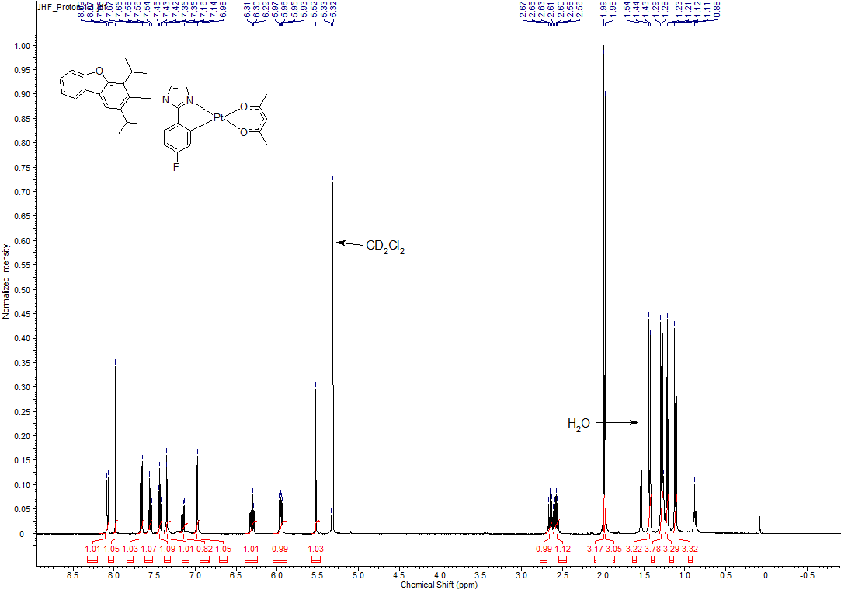

**Figure S1**. 1H NMR of **1** in CD2Cl2.

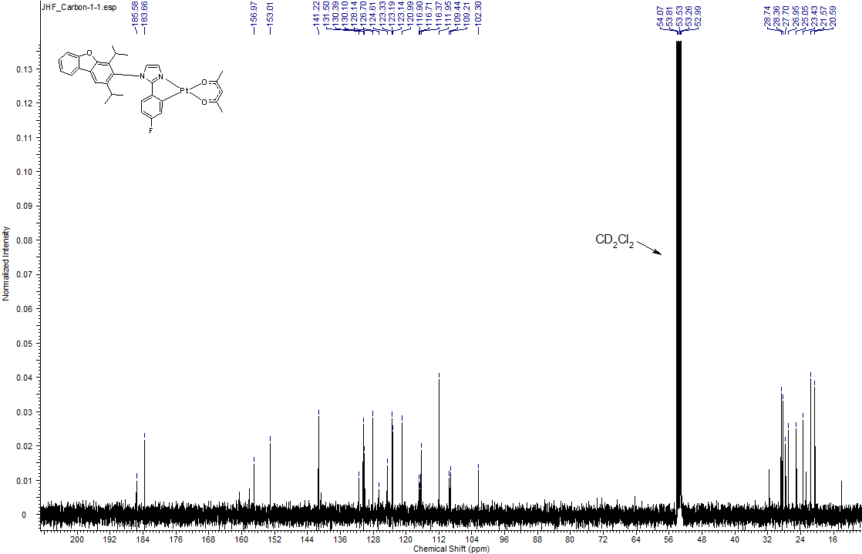

**Figure S2.** 13C NMR of **1** in CD2Cl2**.**

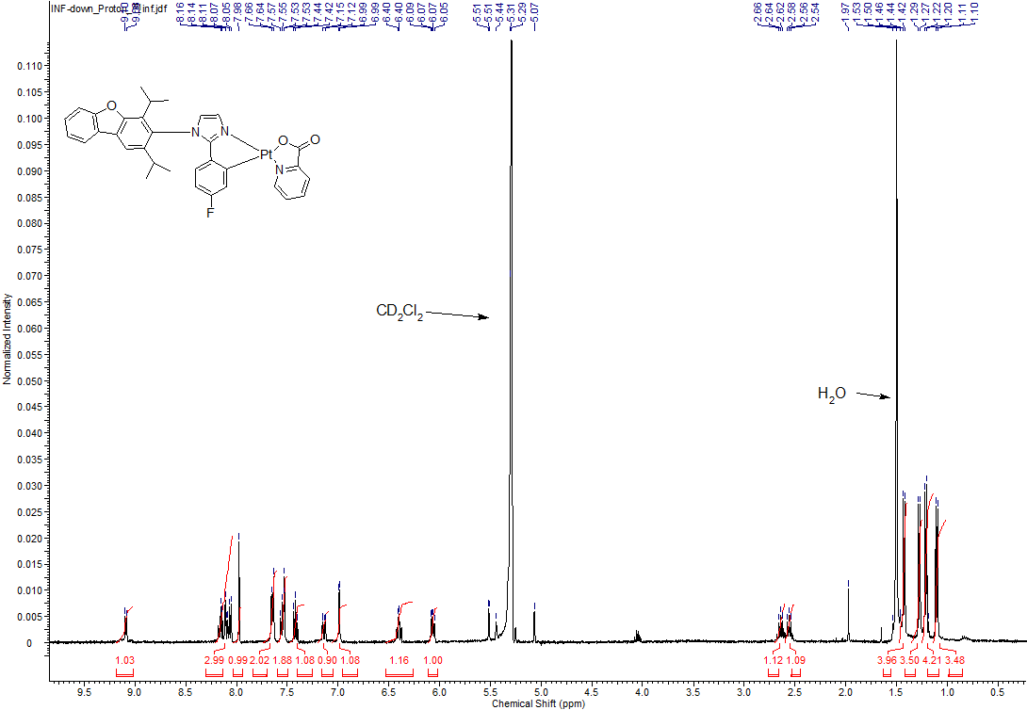

**Figure S3.** 1H NMR of **2**in CD2Cl2.

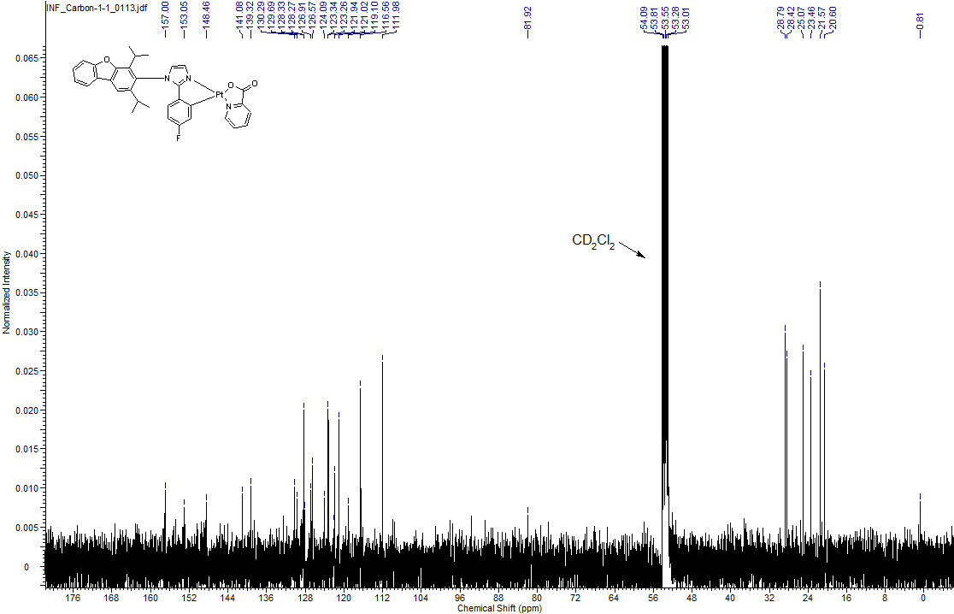

**Figure S4.** 13C NMR of **3** in CD2Cl2

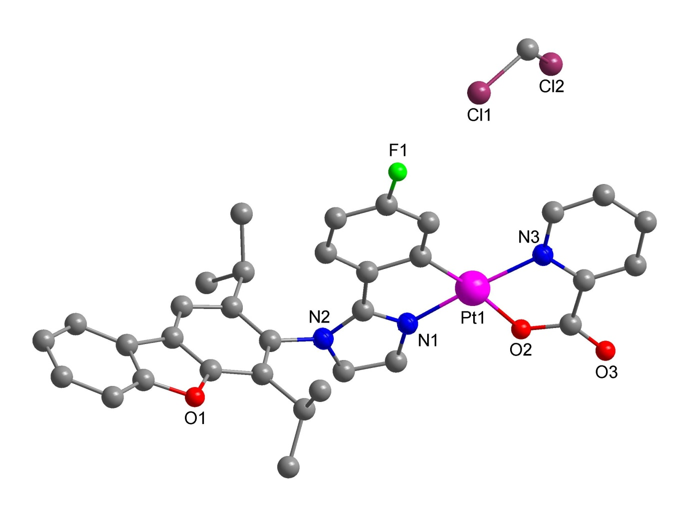

**Figure S5.** X-ray structure of **2** using Diamond program.



**Figure S6.** Decay curve of **1.**



**Figure S7.** Decay curve of **2** at different wavelngth (black: 482nm, red:435nm).

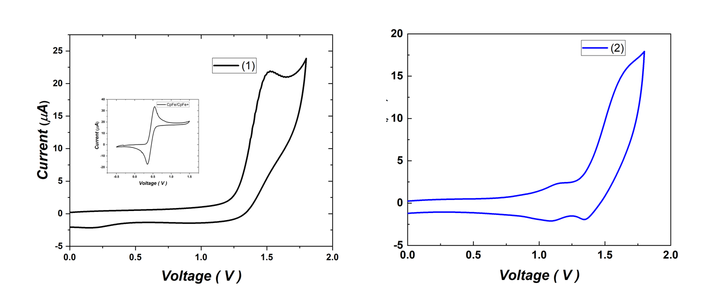

**Figure S8**. Oxidation of **1** (left) and **2** (right)(inset: Fc/Fc+ oxidation).

**Table S1. Crystal Data and Structure Refinement for 2**.

Identification code **2**

Empirical formula C34 H30 Cl2 F N3 O3 Pt

[Pt(C27H24N2OF)(C6H4NO2)]·(CH2Cl2)

Formula weight 813.60

Temperature 173(2) K

Wavelength 0.71073 Å

Crystal system Monoclinic

Space group P2**1**/n

Unit cell dimensions a = 11.3734(3) Å = 90°.

b = 13.4201(4) Å = 101.2050(10)°.

c = 20.8322(6) Å  = 90°.

Volume 3119.05(15) Å3

Z 4

Density (calculated) 1.733 Mg/m3

Absorption coefficient 4.716 mm-1

F(000) 1600

Crystal size 0.298 x 0.222 x 0.093 mm3

Theta range for data collection 1.815 to 28.324°.

Index ranges -15<=h<=15, -17<=k<=17, -27<=l<=27

Reflections collected 82770

Independent reflections 7757 [R(int) = 0.0293]

Completeness to theta = 25.242° 100.0 %

Absorption correction Semi-empirical from equivalents

Max. and min. transmission 0.7457 and 0.5114

Refinement method Full-matrix least-squares on F2

Data / restraints / parameters 7757 / 0 / 397

Goodness-of-fit on F2 1.105

Final R indices [I>2sigma(I)] R1 = 0.0228, wR2 = 0.0547

R indices (all data) R1 = 0.0262, wR2 = 0.0561

Extinction coefficient n/a

Largest diff. peak and hole 1.090 and -0.469 e.Å-3

**Table S2**. Atomic coordinates (x 104) and equivalent isotropic displacement parameters (Å2x 103) for **2**. U(eq) is defined as one third of the trace of the orthogonalized Uij tensor.

________________________________________________________________________________

x y z U(eq)

________________________________________________________________________________

Pt(1) 4718(1) 5950(1) 7676(1) 27(1)

F(1) 5305(2) 3582(2) 5649(1) 64(1)

N(1) 5936(2) 6996(2) 7642(1) 29(1)

N(2) 7339(2) 7684(2) 7212(1) 32(1)

N(3) 3413(2) 4962(2) 7777(1) 29(1)

O(1) 11141(2) 6752(2) 6671(1) 41(1)

O(2) 4272(2) 6497(2) 8529(1) 40(1)

O(3) 3411(3) 5982(2) 9341(1) 67(1)

C(1) 5348(2) 5476(2) 6892(1) 28(1)

C(2) 5078(3) 4622(2) 6519(2) 36(1)

C(3) 5614(3) 4438(2) 5990(2) 40(1)

C(4) 6434(3) 5047(3) 5799(2) 44(1)

C(5) 6751(3) 5899(2) 6165(2) 42(1)

C(6) 6236(3) 6106(2) 6707(1) 32(1)

C(7) 6533(2) 6937(2) 7154(1) 30(1)

C(8) 6367(3) 7800(2) 8023(1) 35(1)

C(9) 7242(3) 8228(2) 7761(2) 34(1)

C(10) 8265(3) 7792(2) 6830(2) 35(1)

C(11) 8032(3) 8422(2) 6273(2) 40(1)

C(12) 8891(3) 8461(2) 5880(2) 41(1)

C(13) 9900(3) 7896(2) 6044(1) 36(1)

C(14) 10100(3) 7299(2) 6596(2) 36(1)

C(15) 9288(3) 7225(2) 7028(2) 36(1)

C(16) 10947(3) 7699(2) 5737(2) 38(1)

C(17) 11317(3) 8041(3) 5170(2) 48(1)

C(18) 12377(3) 7667(3) 5036(2) 50(1)

C(19) 13046(3) 6979(3) 5453(2) 49(1)

C(20) 12678(3) 6626(3) 6010(2) 45(1)

C(21) 11627(3) 7006(2) 6129(2) 40(1)

C(22) 6894(4) 9012(3) 6087(2) 52(1)

C(23) 6125(5) 8628(5) 5450(3) 97(2)

C(24) 7154(5) 10116(3) 6040(3) 91(2)

C(25) 9496(3) 6563(2) 7627(2) 44(1)

C(26) 10646(4) 6821(3) 8106(2) 58(1)

C(27) 9477(4) 5469(3) 7435(2) 60(1)

C(28) 3626(3) 5892(2) 8796(2) 40(1)

C(29) 3074(2) 5042(2) 8363(1) 32(1)

C(30) 2219(3) 4431(3) 8541(2) 40(1)

C(31) 1675(3) 3710(2) 8106(2) 42(1)

C(32) 1992(3) 3643(2) 7505(2) 42(1)

C(33) 2849(3) 4291(2) 7354(2) 39(1)

C(34) 866(4) 3565(3) 5455(2) 67(1)

Cl(1) 2400(1) 3734(1) 5522(1) 90(1)

Cl(2) 222(1) 4472(1) 5892(1) 83(1)

________________________________________________________________________________ **Table S3**. Bond lengths [Å] and angles [°] for **2**.

_____________________________________________________

Pt(1)-N(1) 1.983(2)

Pt(1)-C(1) 2.009(3)

Pt(1)-N(3) 2.032(2)

Pt(1)-O(2) 2.075(2)

F(1)-C(3) 1.360(4)

N(1)-C(7) 1.331(3)

N(1)-C(8) 1.372(4)

N(2)-C(7) 1.347(3)

N(2)-C(9) 1.379(4)

N(2)-C(10) 1.446(3)

N(3)-C(33) 1.334(4)

N(3)-C(29) 1.354(3)

O(1)-C(14) 1.376(4)

O(1)-C(21) 1.393(4)

O(2)-C(28) 1.290(4)

O(3)-C(28) 1.213(4)

C(1)-C(2) 1.385(4)

C(1)-C(6) 1.427(4)

C(2)-C(3) 1.381(4)

C(3)-C(4) 1.357(4)

C(4)-C(5) 1.384(4)

C(5)-C(6) 1.397(4)

C(6)-C(7) 1.450(4)

C(8)-C(9) 1.352(4)

C(10)-C(15) 1.384(4)

C(10)-C(11) 1.420(4)

C(11)-C(12) 1.392(4)

C(11)-C(22) 1.503(5)

C(12)-C(13) 1.362(4)

C(13)-C(14) 1.383(4)

C(13)-C(16) 1.481(4)

C(14)-C(15) 1.413(4)

C(15)-C(25) 1.512(4)

C(16)-C(21) 1.373(5)

C(16)-C(17) 1.407(5)

C(17)-C(18) 1.383(5)

C(18)-C(19) 1.389(5)

C(19)-C(20) 1.391(5)

C(20)-C(21) 1.365(4)

C(22)-C(24) 1.519(6)

C(22)-C(23) 1.531(6)

C(25)-C(27) 1.521(5)

C(25)-C(26) 1.523(5)

C(28)-C(29) 1.514(4)

C(29)-C(30) 1.377(4)

C(30)-C(31) 1.386(5)

C(31)-C(32) 1.373(5)

C(32)-C(33) 1.386(4)

C(34)-Cl(1) 1.737(5)

C(34)-Cl(2) 1.762(5)

N(1)-Pt(1)-C(1) 80.44(10)

N(1)-Pt(1)-N(3) 174.37(9)

C(1)-Pt(1)-N(3) 105.10(10)

N(1)-Pt(1)-O(2) 93.94(9)

C(1)-Pt(1)-O(2) 173.25(10)

N(3)-Pt(1)-O(2) 80.60(9)

C(7)-N(1)-C(8) 108.1(2)

C(7)-N(1)-Pt(1) 116.66(18)

C(8)-N(1)-Pt(1) 135.22(19)

C(7)-N(2)-C(9) 107.8(2)

C(7)-N(2)-C(10) 125.5(2)

C(9)-N(2)-C(10) 126.0(2)

C(33)-N(3)-C(29) 117.7(2)

C(33)-N(3)-Pt(1) 129.8(2)

C(29)-N(3)-Pt(1) 112.55(19)

C(14)-O(1)-C(21) 104.3(2)

C(28)-O(2)-Pt(1) 113.68(19)

C(2)-C(1)-C(6) 115.4(2)

C(2)-C(1)-Pt(1) 130.0(2)

C(6)-C(1)-Pt(1) 114.53(19)

C(3)-C(2)-C(1) 120.8(3)

C(4)-C(3)-F(1) 118.5(3)

C(4)-C(3)-C(2) 124.1(3)

F(1)-C(3)-C(2) 117.3(3)

C(3)-C(4)-C(5) 117.2(3)

C(4)-C(5)-C(6) 120.3(3)

C(5)-C(6)-C(1) 122.1(3)

C(5)-C(6)-C(7) 126.1(3)

C(1)-C(6)-C(7) 111.8(2)

N(1)-C(7)-N(2) 109.0(2)

N(1)-C(7)-C(6) 116.5(2)

N(2)-C(7)-C(6) 134.4(2)

C(9)-C(8)-N(1) 108.0(2)

C(8)-C(9)-N(2) 107.1(2)

C(15)-C(10)-C(11) 125.7(3)

C(15)-C(10)-N(2) 116.2(3)

C(11)-C(10)-N(2) 118.0(3)

C(12)-C(11)-C(10) 117.6(3)

C(12)-C(11)-C(22) 119.8(3)

C(10)-C(11)-C(22) 122.6(3)

C(13)-C(12)-C(11) 118.9(3)

C(12)-C(13)-C(14) 121.8(3)

C(12)-C(13)-C(16) 134.3(3)

C(14)-C(13)-C(16) 103.9(3)

O(1)-C(14)-C(13) 113.7(3)

O(1)-C(14)-C(15) 123.0(3)

C(13)-C(14)-C(15) 123.2(3)

C(10)-C(15)-C(14) 112.8(3)

C(10)-C(15)-C(25) 123.8(3)

C(14)-C(15)-C(25) 123.4(3)

C(21)-C(16)-C(17) 119.6(3)

C(21)-C(16)-C(13) 105.8(3)

C(17)-C(16)-C(13) 134.6(3)

C(18)-C(17)-C(16) 117.7(3)

C(17)-C(18)-C(19) 120.6(3)

C(18)-C(19)-C(20) 122.1(3)

C(21)-C(20)-C(19) 116.1(3)

C(20)-C(21)-C(16) 123.9(3)

C(20)-C(21)-O(1) 123.7(3)

C(16)-C(21)-O(1) 112.4(3)

C(11)-C(22)-C(24) 111.2(3)

C(11)-C(22)-C(23) 111.3(4)

C(24)-C(22)-C(23) 111.0(4)

C(15)-C(25)-C(27) 111.0(3)

C(15)-C(25)-C(26) 112.6(3)

C(27)-C(25)-C(26) 111.0(3)

O(3)-C(28)-O(2) 125.2(3)

O(3)-C(28)-C(29) 119.8(3)

O(2)-C(28)-C(29) 114.9(2)

N(3)-C(29)-C(30) 122.4(3)

N(3)-C(29)-C(28) 116.0(2)

C(30)-C(29)-C(28) 121.4(3)

C(29)-C(30)-C(31) 119.3(3)

C(32)-C(31)-C(30) 118.6(3)

C(31)-C(32)-C(33) 119.1(3)

N(3)-C(33)-C(32) 122.9(3)

Cl(1)-C(34)-Cl(2) 112.3(2)

_____________________________________________________________

Symmetry transformations used to generate equivalent atoms:

**Table S4**. Anisotropic displacement parameters (Å2x 103) for **2**. The anisotropic

displacement factor exponent takes the form: -22[ h2 a*2U11 + ... + 2 h k a* b* U12 ]

______________________________________________________________________________

U11 U22 U33 U23 U13 U12

______________________________________________________________________________

Pt(1) 25(1) 28(1) 28(1) -2(1) 9(1) 0(1)

F(1) 75(2) 54(1) 73(1) -36(1) 45(1) -25(1)

N(1) 28(1) 28(1) 33(1) -4(1) 10(1) -1(1)

N(2) 31(1) 29(1) 38(1) -2(1) 12(1) -2(1)

N(3) 26(1) 30(1) 32(1) 1(1) 9(1) 3(1)

O(1) 39(1) 41(1) 43(1) 4(1) 11(1) 4(1)

O(2) 42(1) 44(1) 38(1) -12(1) 18(1) -8(1)

O(3) 77(2) 93(2) 39(1) -19(1) 29(1) -27(2)

C(1) 27(1) 27(1) 31(1) 0(1) 9(1) 2(1)

C(2) 34(2) 34(1) 42(2) -5(1) 17(1) -2(1)

C(3) 41(2) 37(2) 44(2) -13(1) 16(1) -3(1)

C(4) 52(2) 47(2) 40(2) -12(1) 24(1) -9(2)

C(5) 46(2) 47(2) 40(2) -8(1) 21(1) -11(1)

C(6) 35(2) 32(1) 31(1) -2(1) 10(1) -2(1)

C(7) 29(1) 30(1) 32(1) 0(1) 10(1) -1(1)

C(8) 34(1) 34(1) 38(1) -6(1) 11(1) 1(1)

C(9) 32(1) 28(1) 41(2) -7(1) 8(1) 0(1)

C(10) 34(1) 31(1) 41(2) -4(1) 15(1) -7(1)

C(11) 44(2) 37(2) 42(2) -1(1) 13(1) -7(1)

C(12) 42(2) 41(2) 41(2) 8(1) 8(1) -3(1)

C(13) 36(2) 33(1) 36(1) 1(1) 3(1) -10(1)

C(14) 35(2) 31(1) 40(2) -3(1) 2(1) 1(1)

C(15) 37(2) 29(1) 44(2) -3(1) 12(1) -6(1)

C(16) 33(2) 41(2) 44(2) -12(1) 12(1) -13(1)

C(17) 42(2) 50(2) 51(2) -6(2) 9(2) -8(2)

C(18) 45(2) 58(2) 51(2) -13(2) 22(2) -12(2)

C(19) 40(2) 59(2) 54(2) -16(2) 21(2) -8(2)

C(20) 42(2) 49(2) 47(2) -8(2) 13(1) -3(2)

C(21) 38(2) 45(2) 39(2) -9(1) 12(1) -9(1)

C(22) 51(2) 58(2) 51(2) 15(2) 14(2) 6(2)

C(23) 67(3) 102(4) 106(4) -7(4) -21(3) 11(3)

C(24) 76(3) 48(2) 146(5) 12(3) 12(3) 12(2)

C(25) 40(2) 38(2) 55(2) 5(1) 16(2) 7(1)

C(26) 70(3) 44(2) 53(2) 2(2) -3(2) 10(2)

C(27) 59(2) 37(2) 80(3) 8(2) 3(2) -3(2)

C(28) 38(2) 52(2) 31(1) -7(1) 11(1) -1(1)

C(29) 29(1) 37(2) 31(1) 5(1) 7(1) 4(1)

C(30) 37(2) 48(2) 37(2) 15(1) 11(1) 4(1)

C(31) 32(2) 38(2) 56(2) 16(1) 8(1) -2(1)

C(32) 36(2) 35(2) 57(2) -5(1) 10(1) -2(1)

C(33) 34(2) 41(2) 44(2) -7(1) 13(1) -3(1)

C(34) 79(3) 61(3) 55(2) 0(2) -2(2) -30(2)

Cl(1) 82(1) 124(1) 66(1) -8(1) 23(1) -34(1)

Cl(2) 103(1) 81(1) 71(1) 13(1) 29(1) -4(1)

______________________________________________________________________________ **Table S5.** Hydrogen coordinates ( x 104) and isotropic displacement parameters (Å2x 10 3)

for **2**.

________________________________________________________________________________

x y z U(eq)

________________________________________________________________________________

H(2) 4517 4158 6628 43

H(4) 6775 4895 5429 53

H(5) 7322 6346 6048 51

H(8) 6098 8018 8404 42

H(9) 7703 8796 7925 40

H(12) 8775 8875 5503 50

H(17) 10854 8513 4888 57

H(18) 12650 7883 4656 59

H(19) 13779 6743 5355 59

H(20) 13131 6149 6292 54

H(22) 6424 8922 6442 63

H(23A) 5390 9025 5342 145

H(23B) 6576 8684 5095 145

H(23C) 5916 7928 5503 145

H(24A) 6398 10482 5919 137

H(24B) 7591 10356 6464 137

H(24C) 7642 10223 5707 137

H(25) 8815 6675 7858 52

H(26A) 10740 6373 8484 87

H(26B) 11332 6744 7890 87

H(26C) 10606 7512 8253 87

H(27A) 9614 5056 7830 90

H(27B) 8695 5305 7165 90

H(27C) 10109 5341 7186 90

H(30) 2004 4503 8957 48

H(31) 1094 3272 8222 50

H(32) 1630 3160 7196 51

H(33) 3043 4254 6931 47

H(34A) 717 2896 5623 81

H(34B) 474 3593 4988 81

________________________________________________________________________________ **Table S6**. Hydrogen bonds for **2** [Å and °].

____________________________________________________________________________

D-H...A d(D-H) d(H...A) d(D...A) <(DHA)

____________________________________________________________________________

C(4)-H(4)...Cl(1)#1 0.95 2.99 3.665(3) 129.6

C(33)-H(33)...Cl(1) 0.95 2.97 3.823(3) 150.7

C(34)-H(34A)...O(2)#2 0.99 2.58 3.512(5) 157.6

____________________________________________________________________________

Symmetry transformations used to generate equivalent atoms:

#1 -x+1,-y+1,-z+1 #2 -x+1/2,y-1/2,-z+3/2

**Table S7**. TD-DFT calculation results of **1** and **2**.

|  |  |  |  |  |  |  |  |
| --- | --- | --- | --- | --- | --- | --- | --- |
|  | Transition | λ/E (nm/eV) | f | MO | CI | % | MLCT(%) |
| **1** | S0 → S1 | 355.02/3.4924 | 0.0001 | HOMO → LUMO | 0.6926 | 95.9 | 36.6 |
|  | S0 → T1 | 422.52/2.9344 |  | HOMO → LUMO | 0.6101 | 74.4 |  |
| **2** | S0 → S1 | 414.65/2.9901 | 0.0054 | HOMO → LUMO | 0.6883 | 94.8 | 43.1 |
|  | S0 → T1 | 443.81/2.7937 |  | HOMO → LUMO | 0.6478 | 83.9 |  |