Supporting information

Colloidal Synthesis and Optical Properties of All-inorganic Cs₂CuCl₄ Nanocrystals
Wanying Gu ^{1,†}, Yicheng Zeng ^{1,†}, Yuan Deng ¹, Pan Huang ¹, Geyu Jin ¹, Fangze Liu ², Jing Wei¹, and Hongbo Li ^{1,}*
¹ School of Materials Science and Engineering, Beijing Institute of Technology, Beijing 100081, China
² Advanced Research Institute of Multidisciplinary Sciences, Beijing Institute of Technology, Beijing 100081, China
* Correspondence: hongbo.li@bit.edu.cn (H.L.)
† These authors have contributed equally to this work.

Table 1. Summary of the Optical Performance of the lead and lead free Perovskite NCs.
Emitting materials | PL peak | FHWM | Fabrication technology | PLQY | Ref
CsPb(Cl/Br)₃ | 452 nm | 23 nm | Hot injection | 60% | 8
CsPb(Cl/Br)₃ | 465 nm | 15 nm | Hot injection | 100% | 9
Ni:CsPb(Cl/Br)₃ | 470 nm | — | Modified recrystallization | 89% | 10
Mn:CsPb(Cl/Br)₃ | 466 nm | 17.9 nm | Hot injection | 44% | 11
Cs₃Bi₂Br₉ | 414 nm | 38 nm | Modified recrystallization | 22% | 13
Cs₃Sb₂Br₉ | 408 nm |  | modified supersaturated recrystallization | 51.2% | 15
Cs₃Cu₂I₅ | 445 nm | 63 nm | Hot injection | 87% | 16
Ag：Cs₂CuCl₄ | 434 nm | 58 nm | Hot injection | 42% | This work

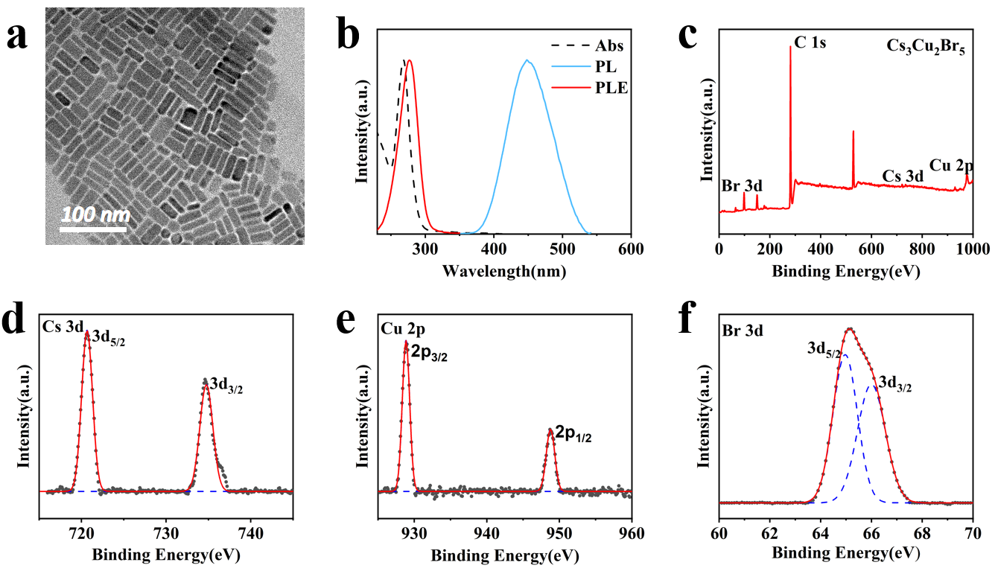
Figure S1. (a) TEM images of the Cs₃Cu₂Br₅ NCs. (b) UV/Vis absorption, PLE, and PL spectra of Cs₃Cu₂Br₅ NCs. (c) XPS survey scan of Cs₃Cu₂Br₅ NCs. (d,e,f) The high-resolution XPS spectra corresponding to Cs 3d, Cu 2p and Br 3d, respectively.

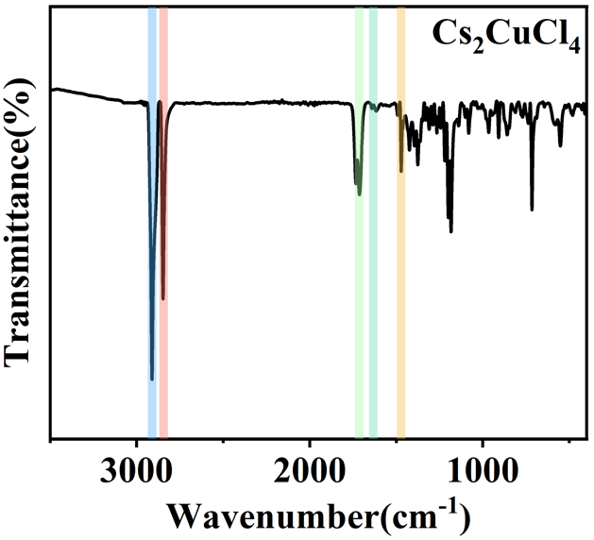
Figure S2. The FITR spectra of Cs₂CuCl₄ NCs.

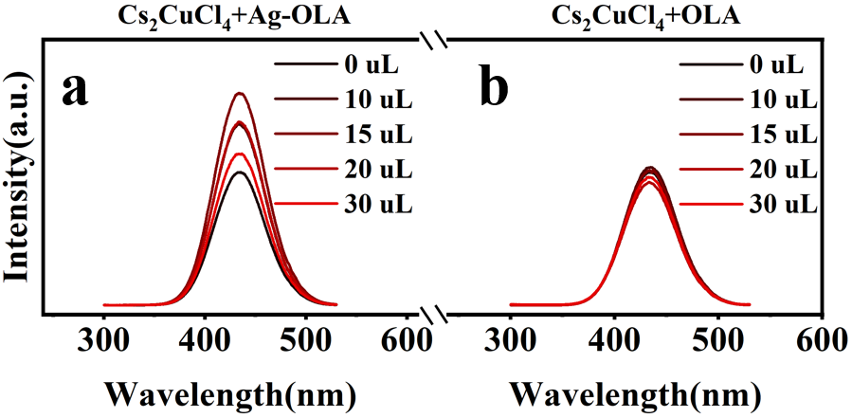
Figure S3. PL spectra for Cs₂CuCl₄ NCs and Ag treated samples. (b) PL spectra for Cs₂CuCl₄ NCs and Cs₂CuCl₄-OLA.

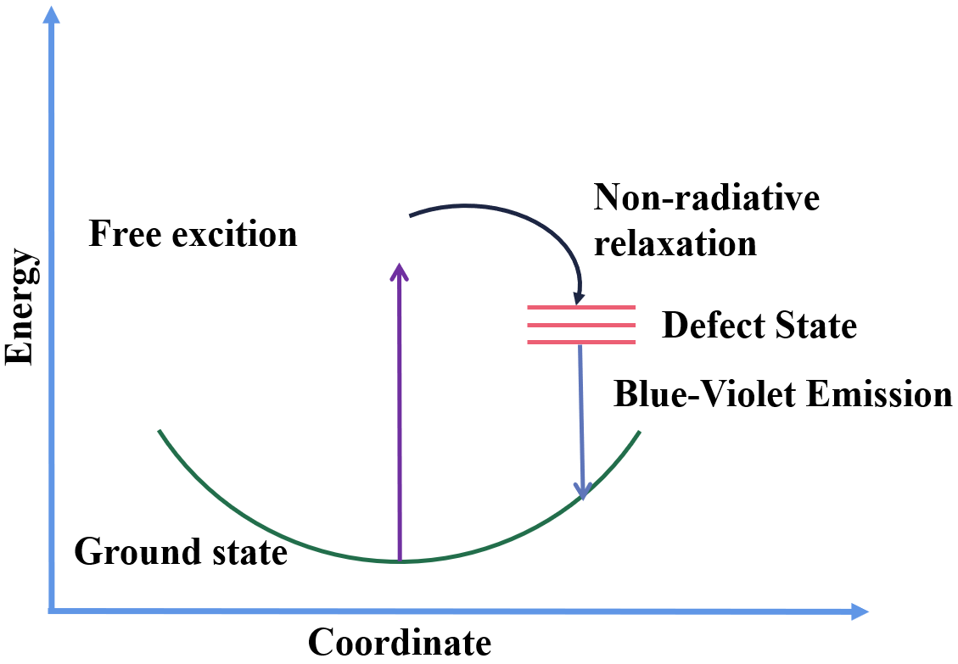
Figure S4. Schematic model representing the emission mechanism.

