Supplementary data for Characterization of Bacterial Transcriptional Regulatory Networks in Escherichia coli through Genome-Wide in vitro Run-Off Transcription/RNA-SEq (ROSE)
Table S1. Technical comparison between the two genome-wide in vitro transcriptome sequencing techniques ROSE and RIViT-seq [1].

 | ROSE | RIViT-seq
Isolation of genomic DNA | - Three different isolation methods tested (Quick-DNA Universal Kit by Zymo, NucleoSpin Microbial DNA Kit by Macherey Nagel and Phenol-Chloroform Isoamyl alcohol DNA extraction) | - GenElute Bacterial Genomic DNA kit (MilliporeSigma)
Digestion of genomic DNA | - Random fragmentation (average size 6 kb) using gTubes (Covaris) | - Enzymatic digestion with EcoRI, HindIII, BamHI and XhoI
RNA purification after in vitro transcription | - RNeasy MinElute Kit (Qiagen) | - RNeasy MinElute Kit (Qiagen)
Primary transcript library generation | - 100 ng RNA input  - Fragmented to an average size of 500 nt  - Digestion of transcripts with 5’ di- and monophosphates by terminator exonuclease (Epicentre)  - Ligation of RNA index adapters  - Treatment with RNA 5’-polyphosphatase (New England Biolabs)  - Ligation of RNA adapters  - Reverse-transcription to cDNA using a sequence-independent loop adapter  - Amplification of cDNA with barcoded primers | - 6 µg RNA input  - /  - /  - /  - Treatment with RNA 5’-polyphosphatase (New England Biolabs)  - Ligation of RNA adapters  - Reverse-transcription to cDNA using a random hexamer with an adaptor sequence  - Amplification of cDNA with barcoded primers
Whole-genome transcriptomics | - / | - Stranded cDNA library generation using TrueSeq Stranded RNA Library Prep Kit (Illumina) and low sample protocol
Sequencing and data processing | - High throughput single-end sequencing (1x75bp)  - Illumina MiSeq  - Trimming using Trimmomatic  - Mapping with Bowtie2 | - High throughput paired-end sequencing (2x150bp)  - Illumina MiSeq  - Trimming using BBDuk  - Mapping with HISAT2
Sequence analysis | - TSS detection and visualization with ReadXplorer, Improbizer, and MEME/Weblogo | - TSS detection manually with read counts of samtools, motif visualization with MEME  - Differential Expression analysis with DESeq2

Table S2. Mapping statistics for all six 5’-end specific ROSE- Eσ⁷⁰ libraries. Mapping statistics for ROSE- Eσ⁷⁰ libraries with the isolation methods by Zymo Research (Z1; Z2), Macherey-Nagel (M1; M2) and with Phenol-Chloroform Isoamyl alcohol (P1; P2).

 |  | Z1 | Z2 | M1 | M2 | P1 | P2
Mappings |  | 2,061,241 | 2,086,867 | 1,618,341 | 2,076,393 | 2,210,864 | 1,737,821
Unique Mappings |  | 2,061,241 | 2,086,867 | 1,618,341 | 2,076,393 | 2,210,864 | 1,737,821
Single Perfect Mappings |  | 1,572,385 | 1,553,410 | 1.240,224 | 1,533,963 | 1,680,056 | 1,305,272

Table S3. Mapping statistics for four 5’-end specific in vivo libraries. Mapping statistics for in vivo libraries of the wildtype strain (WT), the Δfur knockout strain (Δfur), the Δfis knockout strain (Δfis) and of the Δhns knockout strain (Δhns).

 | WT | Δfur | Δfis | Δhns
Mappings | 1,605,710 | 928,706 | 493,254 | 597,949
Unique  Mappings | 1,605,710 | 928,706 | 493,254 | 597,949
Single  Perfect  Mappings | 1,288,944 | 760,574 | 344,796 | 438,708

Table S4. Transcription start site detection parameters for ROSE-Eσ⁷⁰ libraries in ReadXplorer [2,3].
Parameter | Value
Minimum number of read starts: | 7
Minimum percent of coverage increase: | 148
Maximum low coverage read start count: | 0
Minimum low coverage read starts: | 0
Detect novel transcripts? | Yes
Minimum transcript extension coverage: | -
Maximum distance to feature of leaderless transcripts: | 300
Associate nearby neighboring TSS? | Yes
Associate neighboring TSS in a bp window of: | 3
Minimum mapping quality: | 0
Single Perfect Match included: | Yes
Perfect Match included: | No
Single Best Match included: | Yes
Best Match included: | No
Common Match included: | No
Include multiple mapped reads: | Yes
Mapping strand selection: | Feature/analysis strand

Table S5. Transcription start site detection parameters for in vivo libraries in ReadXplorer [2,3].

Parameter | Value
Minimum number of read starts: | 1
Minimum percent of coverage increase: | 32
Maximum low coverage read start count: | 0
Minimum low coverage read starts: | 0
Detect novel transcripts? | Yes
Minimum transcript extension coverage: | 20
Maximum distance to feature of leaderless transcripts: | 300
Associate nearby neighboring TSS? | Yes
Associate neighboring TSS in a bp window of: | 3
Minimum mapping quality: | 0
Single Perfect Match included: | Yes
Perfect Match included: | No
Single Best Match included: | Yes
Best Match included: | No
Common Match included: | No
Include multiple mapped reads: | Yes
Mapping strand selection: | Feature/analysis strand

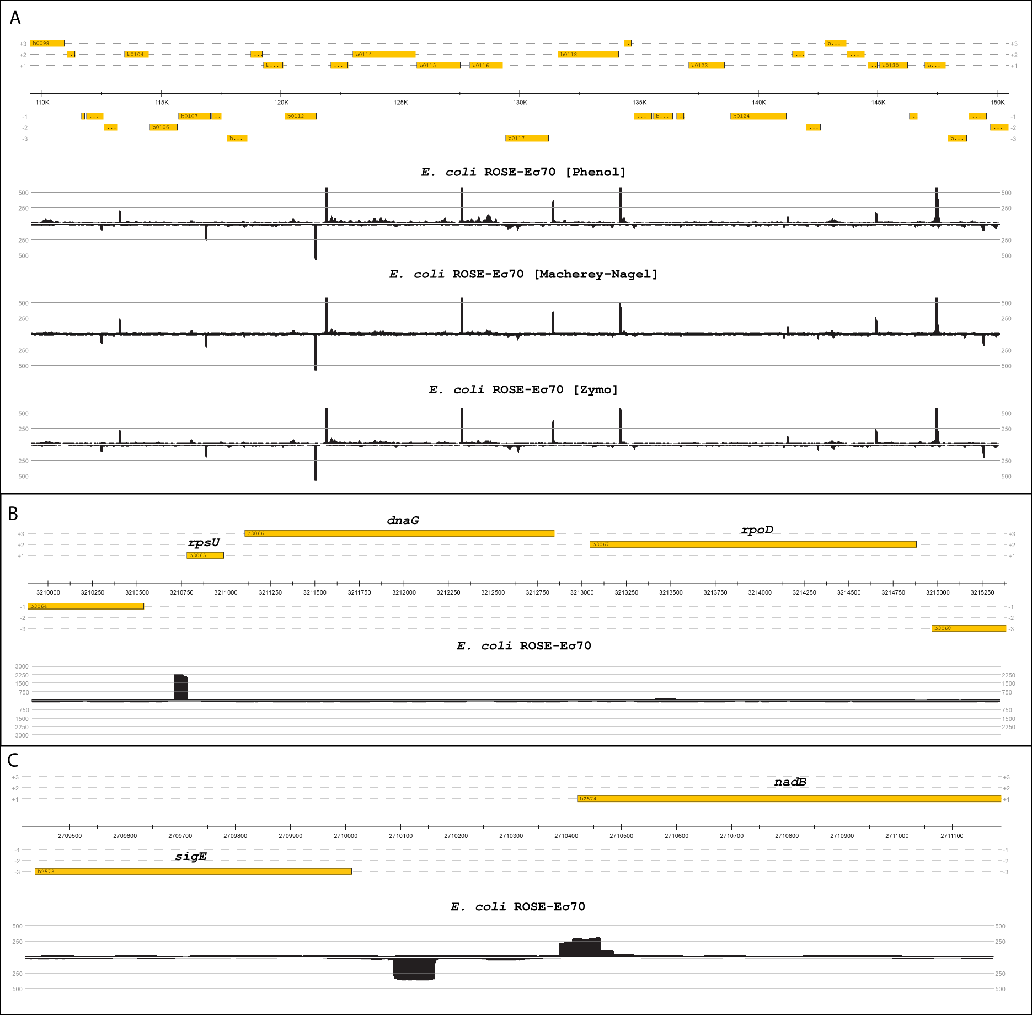
Figure S1. Mapped reads of the 5’-end-specific transcript library in exemplary genomic regions. The reads (black) are filtered and mapped to the reference genome U00096.3. The coverage of the reads associated to their respective location on the genome is visualized with ReadXplorer [2]. (A) Representation of the mapped read distribution in the genomic region 110,000-150,000 bp of the E. coli genome. The genomic DNA for the ROSE-Eσ⁷⁰ experiment was isolated with Phenol-Chloroform Isoamyl alcohol (top), with the NucleoSpin Microbial DNA Kit from Macherey-Nagel (middle) and with the Quick-DNA Universal Kit from Zymo (bottom). (B) Exemplary read stack for the rpsU-dnaG-rpoD operon generated by ROSE-Eσ⁷⁰. (C) Exemplary read stacks for the genes nadB on the sense strand and sigE on the antisense strand generated by ROSE-Eσ⁷⁰.

Figure S2. Distribution of the identified transcription start sites (TSS) by ROSE and by Thomason et al. in relation to their distance to the published TSS in RegulonDB [4].

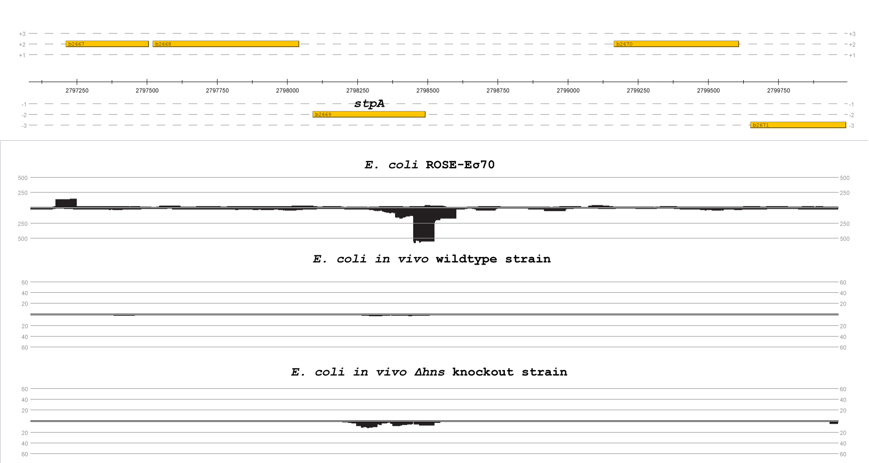
Figure S3. Coverage of mapped reads on the reference genome with an emphasis on gene stpA. Readcount in the promoter region of stpA from the E. coli ROSE-Eσ⁷⁰ (top), E. coli in vivo Wildtype strain (middle) and E. coli in vivo Δhns knockout strain (bottom). The mapping took place on the respective reference genome (U00096.3) and is visualized with ReadXplorer [2].

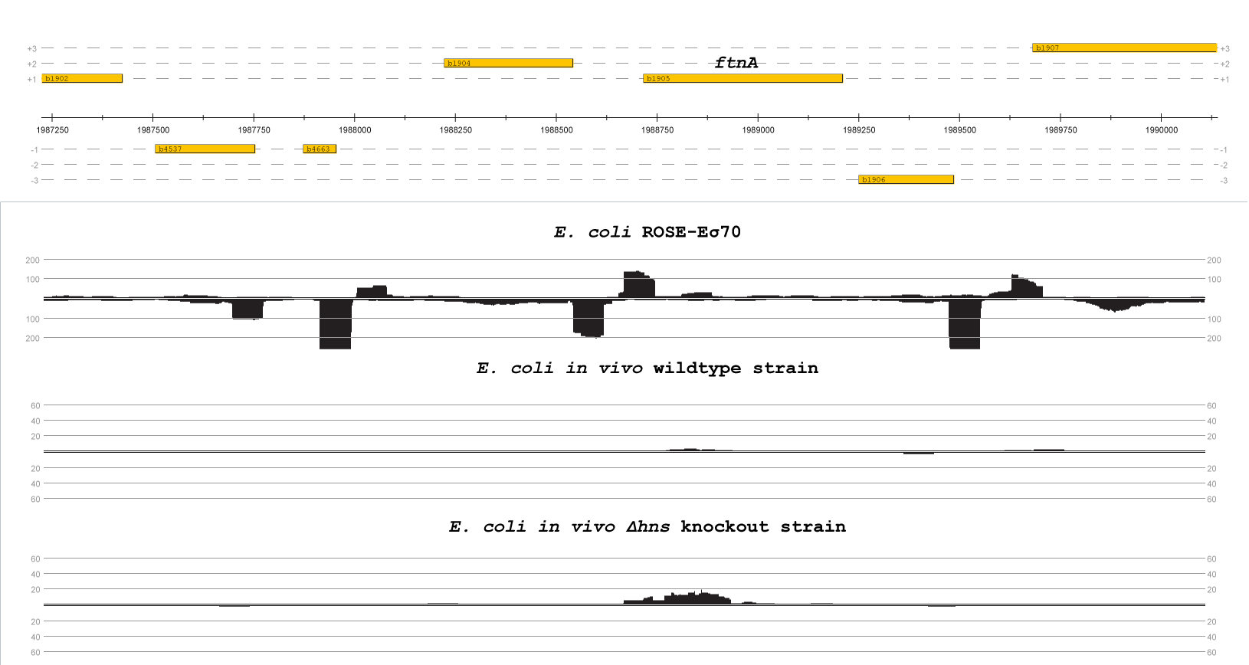
Figure S4. Coverage of mapped reads on the reference genome with an emphasis on gene ftnA. Readcount in the promoter region of ftnA from the E. coli ROSE-Eσ⁷⁰ (top), E. coli in vivo Wildtype strain (middle) and E. coli in vivo Δhns knockout strain (bottom). The mapping took place on the respective reference genome (U00096.3) and is visualized with ReadXplorer [2].
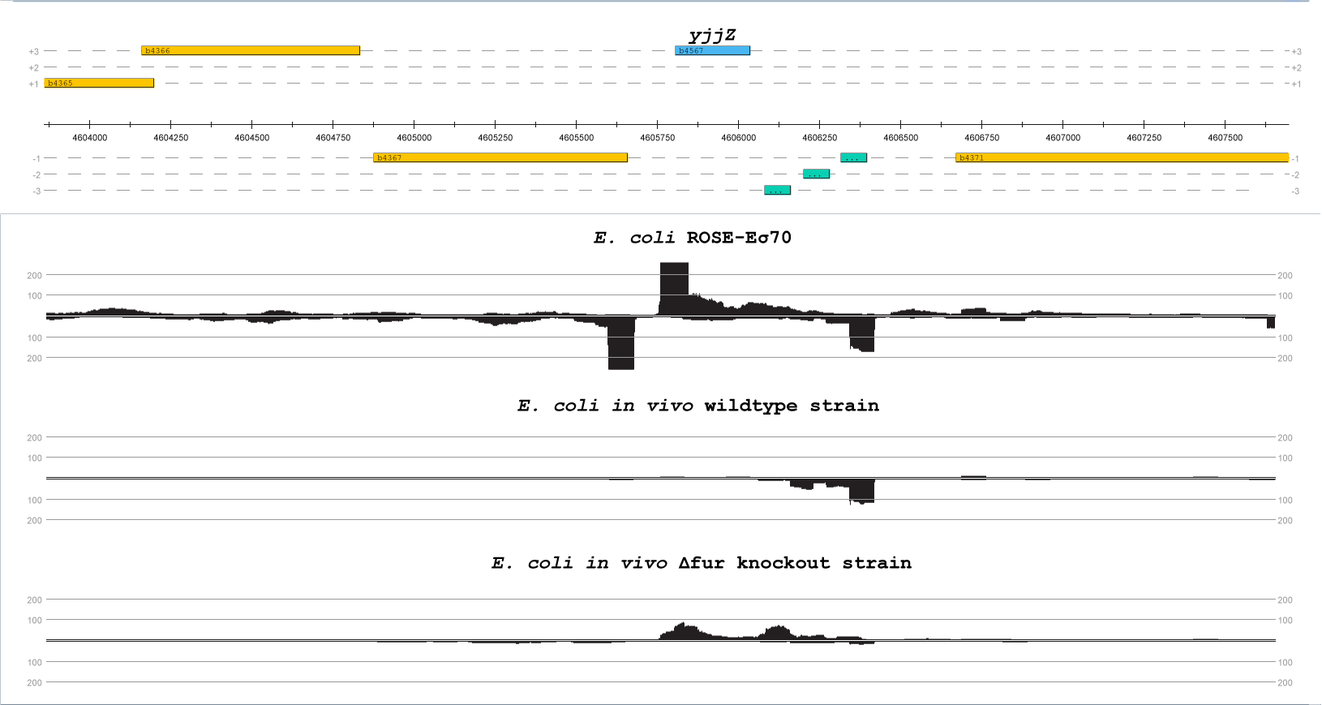
Figure S5. Coverage of mapped reads on the reference genome with an emphasis on gene yjjZ. Readcount in the promoter region of yjjZ from the E. coli ROSE-Eσ⁷⁰ (top), E. coli in vivo Wildtype strain (middle) and E. coli in vivo Δfur knockout strain (bottom). The mapping took place on the respective reference genome (U00096.3) and is visualized with ReadXplorer [2].

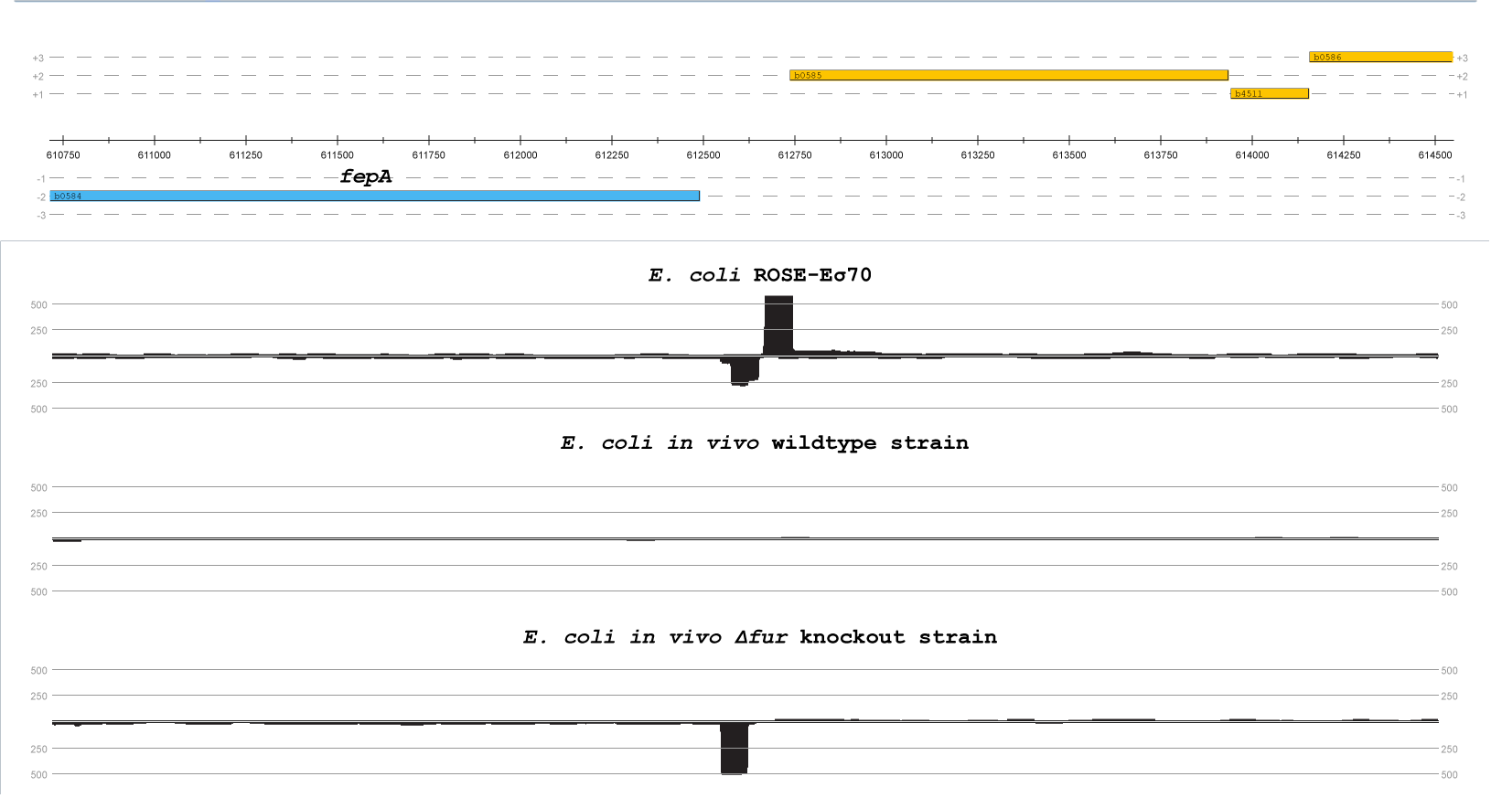
Figure S6. Coverage of mapped reads on the reference genome with an emphasis on gene fepA. Readcount in the promoter region of fepA from the E. coli ROSE-Eσ⁷⁰ (top), E. coli in vivo Wildtype strain (middle) and E. coli in vivo Δfur knockout strain (bottom). The mapping took place on the respective reference genome (U00096.3) and is visualized with ReadXplorer [2].

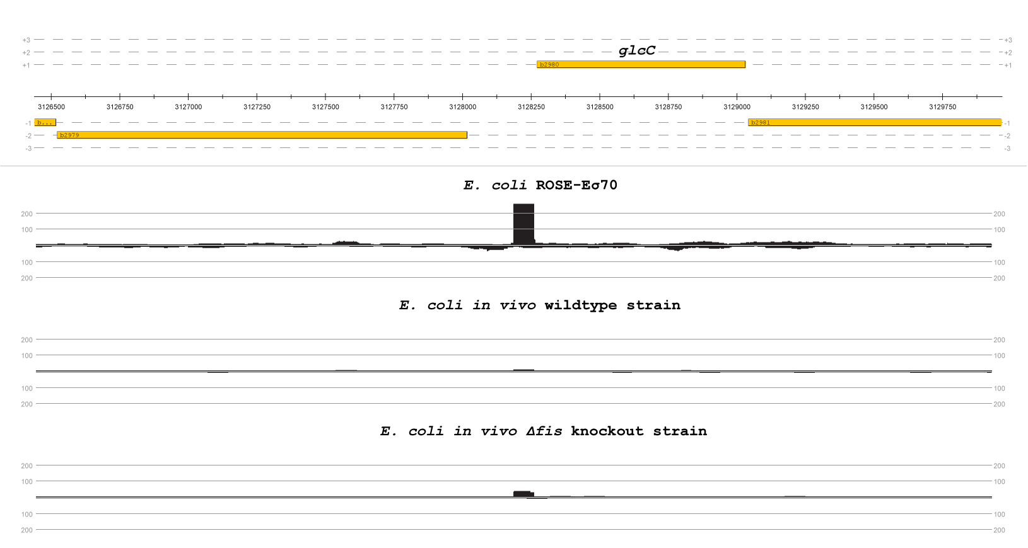
Figure S7. Coverage of mapped reads on the reference genome with an emphasis on gene glcC. Readcount in the promoter region of glcC from the E. coli ROSE-Eσ⁷⁰ (top), E. coli in vivo Wildtype strain (middle) and E. coli in vivo Δfis knockout strain (bottom). The mapping took place on the respective reference genome (U00096.3) and is visualized with ReadXplorer [2].

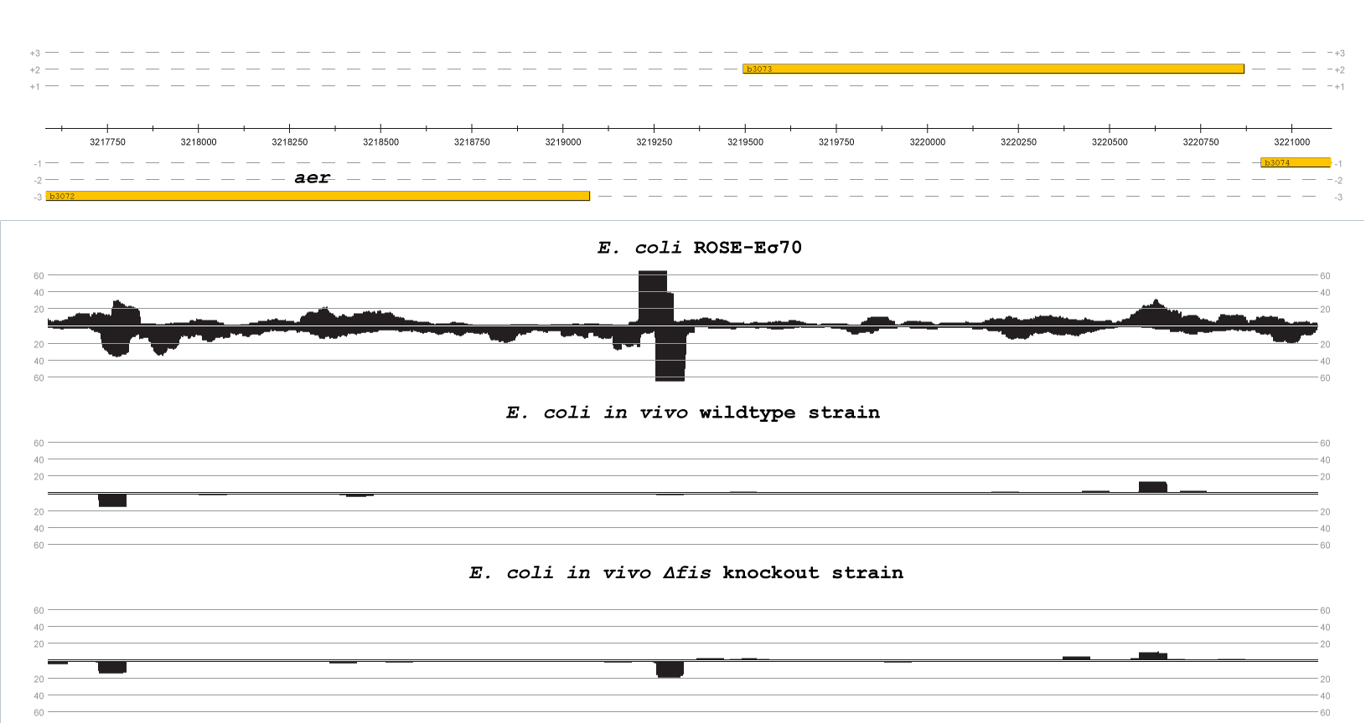
Figure S8. Coverage of mapped reads on the reference genome with an emphasis on gene aer. Readcount in the promoter region of aer from the E. coli ROSE-Eσ⁷⁰ (top), E. coli in vivo Wildtype strain (middle) and E. coli in vivo Δfis knockout strain (bottom). The mapping took place on the respective reference genome (U00096.3) and is visualized with ReadXplorer [2].

References
1. Otani, H.; Mouncey, N.J. RIViT-seq enables systematic identification of regulons of transcriptional machineries. Nat. Commun. 2022, 13, 3502, doi:10.1038/s41467-022-31191-w.
2. Hilker, R.; Stadermann, K.B.; Doppmeier, D.; Kalinowski, J.; Stoye, J.; Straube, J.; Winnebald, J.; Goesmann, A. ReadXplorer--visualization and analysis of mapped sequences. Bioinformatics 2014, 30, 2247–2254, doi:10.1093/bioinformatics/btu205.
3. Hilker, R.; Stadermann, K.B.; Schwengers, O.; Anisiforov, E.; Jaenicke, S.; Weisshaar, B.; Zimmermann, T.; Goesmann, A. ReadXplorer 2-detailed read mapping analysis and visualization from one single source. Bioinformatics 2016, 32, 3702–3708, doi:10.1093/bioinformatics/btw541.
4. Santos-Zavaleta, A.; Salgado, H.; Gama-Castro, S.; Sánchez-Pérez, M.; Gómez-Romero, L.; Ledezma-Tejeida, D.; García-Sotelo, J.S.; Alquicira-Hernández, K.; Muñiz-Rascado, L.J.; Peña-Loredo, P.; et al. RegulonDB v 10.5: tackling challenges to unify classic and high throughput knowledge of gene regulation in E. coli K-12. Nucleic Acids Res. 2019, 47, D212-D220, doi:10.1093/nar/gky1077.

