Table of Contents
Methodological Details 2
Inclusion criteria 2
Exclusion criteria 2
Withdrawal criteria 3
Serious protocol violations 3
Missing Values 3
Results Details 4
VAS scores and glucose analysis 4
Protocol deviations 4
Adverse events 4
Supplementary Table 1: Medications used. 6
Supplementary Table2: Incremental areas under the curve (iAUC) from 0-2, 2-3 and 0-3h for the 5
subjective appetite domains. 7
Supplementary Figure 1: Summary of procedures are each visit. 8
Supplementary Figure 2: Study flow chart 8
Supplementary Figure 3: Desire to eat, prospective consumption and average appetite. 9
Supplementary Figure 4: Chia and glycemic response: literature review 10

Methodological Details

Inclusion criteria
- Non-pregnant, non-lactating, healthy individuals; at least n=45 aged 18-55 years and up to n=5 aged 56-65 years, inclusive
- BMI 18.5 to 34.9 kg/m², inclusive
- No history of diabetes mellitus
- Systolic blood pressure <160 mmHg and diastolic blood pressure <100 mmHg
- No major illness, trauma or surgery requiring hospitalization within 3mo of the screening visit
- Ability to understand the study procedures and willing to provide informed consent to participate in the study
- Subjects must be eligible to receive income in Canada and be covered by a health insurance plan such as OHIP
- Subjects are willing to follow current Covid guidelines with respect to attending study visits
- Subjects are willing to sign the informed consent prior to any procedures conducted

Exclusion criteria
- Participation in another PepsiCo trial in past 6 months
- Failure to meet any one of the inclusion criteria
- High alcohol consumption (>14 drinks per week and >4 drinks per day for males; and >7 drinks per week and >3 drinks per day for females), or history of alcohol or drug abuse.
- Individuals with a history of bariatric surgery, gastrointestinal disease, moderate or severe renal failure, moderate or severe liver disease or any other medical conditions or use of supplements or medications that increase risk to the subject or others or may affect the results, as judged by the Principal Investigator
- Unwillingness or inability to comply with the experimental procedures and to follow INQUIS safety guidelines
- Known intolerance, sensitivity, or allergy to any ingredients in the study test products.
- Subject is currently participating or recently (within 30 days of screening) participated in a clinical trial involving long-term exposure (greater than 24 hours) to an investigational drug, nutritional supplement, or lifestyle modification.
- Reported weight change of > 5kg in the preceding 3 months
- History of an eating disorder (e.g., anorexia, bulimia, binge eating, pica, rumination, avoidant/restrictive food intake disorder)

Withdrawal criteria
- Withdrawal of consent for any reason
- The development, during the study, of an exclusion criterion, injury, illness, or initiation of use of a medication which, in the opinion of the Principal Investigator, makes the subject's continued participation dangerous to the subject or to others, or which may affect the results
- Failure to follow INQUIS safety guidelines
- Failure to attend scheduled visits
- Failure to follow the protocol
- Lost to follow-up (does not respond to repeated requests for contact)
- Principal investigator elects to remove participant from the study for any reason
- Starting new diet or exercise program while participating in the study
- Subject takes longer than the specified time to complete the study

Serious protocol violations
Test results were excluded if any of the following occurred:
- test conducted in the of presence or after the development of any exclusion criterion (which may not have been discovered until after the test had been completed)
- tests during which an event occurred resulting in the subject being withdrawn
- tests occurring after a subject had been withdrawn
- incomplete consumption of the test meal
- vomiting, nausea or fainting before or after consumption of the test meal
- interval between any 2 tests is <2 days or >3 weeks
- time to complete the study is >6 weeks.

Missing Values
Missing values were replaced as follows: a missing value at -5 or 0 min was replaced by the value at 0 or -5 min, respectively; a missing value at the time of the nadir or peak or at 180 min was imputed as Xij = (IXi + JXj – X..)/[(I-1)×(J-1)] where Xij is the missing value in column i and row j, I and J = the number of columns and rows, respectively, Xi and Xj = the sum of existing values in column i and row j, respectively, and X.. = the sum of all existing values (). Other missing values were replaced by the mean of the surrounding values. If there were more than 3 missing values for any 1 test meal, the results were considered to be invalid and excluded.

Results Details

VAS scores and glucose analysis
Of the 7360 individual VAS scores, n=4 at 0 min and n=4 at 15 min were missing (0.1%, described below under protocol deviations). The mean±SD (CV) of the VAS scores at -5 and 0 min (n=183) are as follows: Desire to Eat, 63.1±6.87 mm (10.9%); Hunger, 62.2±7.68 mm (12.3%); Fullness, 24.9±9.31 mm (37.5%); Prospective Consumption, 66.0±5.93 mm (9.0%); and Average Appetite, 66.6±4.40 mm (6.6%).
Of the 1840 planned blood samples n=1 (0.05%) was missing and n=1 was taken at 75min instead of 60min (described below under protocol deviations). The mean±SD plasma glucose concentration for the duplicate analysis of the n=183 0 min blood samples was 5.38±0.039 mmol/L for an analytical CV of 0.7%. The mean±SD plasma glucose concentration in the n=183 -5- and 0-min blood samples was 5.38±0.109 mmol/L for a CV of 2.0%, a value that includes both analytical and minute-to-minute variation.

Protocol deviations
There were 40 protocol deviations (PD). Twenty-one (21, 53%) involved subjects correcting their answers on the VAS after re-reading the question; the numbers of these for treatments CS0, CS3, CS7 and CS5, respectively, were 5, 8, 3 and 5; and the numbers of these for Desire to Eat, Hunger, Fullness and Prospective consumption, respectively were 2, 10, 7 and 2. Six (6) of the PDs were subjects not consuming the test meal within 8-12 min; 4 subjects consumed the test meal too slowly (13-15 min) and 2 too rapidly (3 and 5 min). Six (6) PD’s involved subjects consuming 125 ml water at either 100 min (n=1), 120 min (n=3), 126 min (n=1) or 130 min (n=1).
One subject missed the 60min blood sample and VAS for treatment CS5 but completed them at 75min. The calculations for VAS tAUC and glucose iAUC were adjusted to take the time difference into account. However, the 75 min values were included in the means for the 60 min on the graphs showing the changes in VAS and glucose with time.
One subject missed the 0 min blood sample for treatment CS7, and one did not complete the 0 min VAS for treatment CS3. These missing values were replaced by the value at -5min. One subject missed the 15 min VAS for treatment CS7; the 1 missing value for each of the 4 domains was replaced using the method described in the section on “Missing Values” above.
The other 2 PDs involved: 1) a subject (treatment CS5) accidentally making a mark on the VAS scale on for hunger at -5 min; the subject initialled the mistake to acknowledge it; and 2) a subject being given a 150 min VAS sheet at 120 min; the staff noticed this immediately after the questionnaire was completed and corrected the time point on the sheet.
All the protocol deviations were considered to be minor and not to have any significant impact on the results.

Adverse events
There were 7 adverse events (AE), none were related to the study product, and none were serious. One participant had COVID-19 from 26 April to 4 May and one had menstrual cramps on 2 May; these were of moderate severity, treated with an over the counter (OTC) medication, resulted in the next visit being postponed until their recovery, and resolved. One participant developed mild symptoms of seasonal allergy (runny nose, itchy eyes, red eye; = 3 AEs), treated with an OTC drug, with the symptoms ongoing at the end of the study. One participant developed mild headache and sore throat (=2 AEs) which resolved with no treatment; the next visit was postponed, but the subject later dropped out.

Supplementary Table 1: Medications used.
ID | Medication Name | Dose, Frequency Route* | Start Date  (dd-mm-yy) | Stop Date  (dd-mm-yy) | Indication
2ª | COVID-19 vaccine (Pfizer) | 50mcg 1x SQ | 30-Mar-22 | 30-Mar-22 | COVID-19 booster
5 | vitamin B12 | 1200mcg qd PO | 26-Jan-18 |  | General health
 | vitamin D | 1000IU bid PO | 26-Jan-18 |  | General health
 | Alaskan salmon oil | 1200mg bid PO | 01-Mar-22 |  | General health
 | biotin | 10000mcg qd PO | 01-Mar-22 |  | General health
6 | protein powder (Six Star) | 30gm qd PO | 01-Jan-16 |  | General health
10 | emtricitabine/ tenofovir disoproxil fumarate | 200/300mg qd PO | 01-Jan-14 |  | HIV pre-exposure prophylaxis
13 | vitamin D | 1000IU qd PO | 09-Jan-22 |  | General health
15 | desogestrel/ethinyl estradiol | 0.15/0.03mg qd PO | 01-Jan-21 |  | Birth Control
 | vitamin D | 1000IU qd PO | 01-Oct-21 |  | General health
16 | levothyroxin | 120mg qd PO | 01-Jan-14 |  | Hypothyroidism
 | atenolol | 50mg qd PO | 01-Jan-16 |  | High blood pressure
 | rosuvastatin | 20mg qd PO | 01-Nov-19 |  | High cholesterol
17 | vitamin D | 1000IU qd PO | 01-Jan-10 |  | General health
 | iron | 300mg PRN PO | 01-Jan-19 |  | General health
18 | ramipril | 5mg qd PO | 01-Jan-17 |  | High blood pressure
19 | venlafaxine | 75mg qd PO | 01-Jan-15 |  | Depression
 | naproxen | 220mg PRN PO | 01-May-19 |  | Arthritis
20 | terbutaline | 1mg PRN IH | 01-Jan-95 |  | Asthma
25 | vitamin D | 1000IU Q1W PO | 01-Jan-20 |  | General health
 | Joint Ease Osteo | 1cap PRN PO | 01-Jul-21 |  | General health
27^{b} | acetaminophen | 500mg 2x PO | 26-Apr-22 | 26-Apr-22 | Relief of COVID-19 symptoms
29 | Calcium & magnesium | 333/137mg qd PO | 01-Jan-21 |  | General health
 | vitamin C | 500mg qd PO | 01-Jan-21 |  | General health
30 | vitamin A/D/E | 1000/300/8.9IU qd PO | 01-Jan-22 |  | General health
31 | ibuprofen | 600mg 2x PO | 16-May-22 | 17-May-22 | Relief of pain from tightening braces
32 | fluoxetine | 300mg qd PO | 01-Jan-18 |  | Anxiety
 | mirtazapine | 30mg qd PO | 01-Jan-18 |  | Depression
 | prazosin | 2mg qhs PO | 01-Jan-18 |  | PTSD, nightmares
 | sertraline | 200mg QD po | 01-Jan-18 |  | Anxiety
 | omega 3, 6, 9 | 1200mg qd PO | 01-Jan-19 |  | General health
 | vitamin D3 | 1000IU qd PO | 01-Jan-19 |  | General health
37 | vitamin C | 500mg qd PO | 01-Jan-20 |  | General health
 | iron | 150mg qd PO | 23-Apr-22 |  | General health
43 | omega 3 | 1000IU qd PO | 07-Jan-22 |  | General health
 | vitamin B100 Complex | 1cap qd PO | 07-Jan-22 |  | General health
 | vitamin D | 1000IU qd PO | 07-Jan-22 |  | General health
47 | loratadine | 10mg qd PO | 31-May-22 |  | Seasonal allergies
The lack of a stop date indicates that the medication was taken throughout the study period.
* Frequency: 1x = once, 2x = twice, qd = once daily, bid = twice daily, PRN = as needed, Q1W = once weekly, qhs = four times daily. Route: SQ = subcutaneous; PO = oral.
ª Next study visit on 7 April
^{b} Next study visit on 10 May

Supplementary Table2: Incremental areas under the curve (iAUC) from 0-2, 2-3 and 0-3h for the 5 subjective appetite domains.
Appetite Domain | iAUC (mm×h) | Treatment |  |  |  | ANOVA
 |  | CS0 | CS3 | CS5 | CS7
Desire to Eat | 0-2 h | -38.1±7.0 | -45.0±7.4 | -42.2±6.9 | -34.5±7.1 | 0.29
 | 2-3 h | -5.3±3.7 | -9.1±3.6 | -7.9±3.6 | -4.4±3.5 | 0.39
 | 0-3 h | -43.3±10.2 | -54.1±10.4 | -50.1±10.1 | -38.9±10.1 | 0.30
Hunger | 0-2 h | -39.1±7.6 | -42.8±7.5 | -42.6±7.0 | -34.3±6.5 | 0.47
 | 2-3 h | -4.5±3.5 | -6.3±3.7 | -7.6±3.6 | -2.5±3.4 | 0.38
 | 0-3 h | -43.6±10.5 | -49.1±10.8 | -50.3±10.1 | -36.8±9.4 | 0.41
Fullness | 0-2 h | 44.8±6.9 | 45.7±7.6 | 47.9±6.8 | 44.0±6.2 | 0.91
 | 2-3 h | 5.4±3.1 | 10.4±3.6 | 11.1±3.3 | 9.2±2.8 | 0.25
 | 0-3 h | 50.1±9.4 | 56.0±10.8 | 59.1±9.5 | 53.2±8.4 | 0.74
Prospective Consumption | 0-2 h | -34.6±6.7 | -38.9±7.2 | -38.0±6.4 | -31.6±6.8 | 0.45
 | 2-3 h | -4.1±3.1 | -6.1±3.4 | -6.9±3.2 | -2.8±3.3 | 0.41
 | 0-3 h | -38.7±9.3 | -45.0±10.1 | -44.9±9.3 | -34.4±9.7 | 0.40
Average Appetite | 0-2 h | -39.1±6.7 | -43.1±7.1 | -42.7±6.4 | -36.1±6.3 | 0.45
 | 2-3 h | -43.9±9.3 | -51.0±10.1 | -51.1±9.2 | -40.8±8.9 | 0.29
 | 0-3 h | -43.9±9.3 | -51.0±10.1 | -51.1±9.2 | -40.8±8.9 | 0.38
Values are means±SEM for n=46 subjects after consuming control cookies (CS0) or cookies containing 3g (CS3), 5g (CS5) or 7g (CS7) chia seeds. iAUC = incremental area under the curve; ANOVA shows the significance of the main effect of treatment.

Supplementary Figure 1: Summary of procedures are each visit.
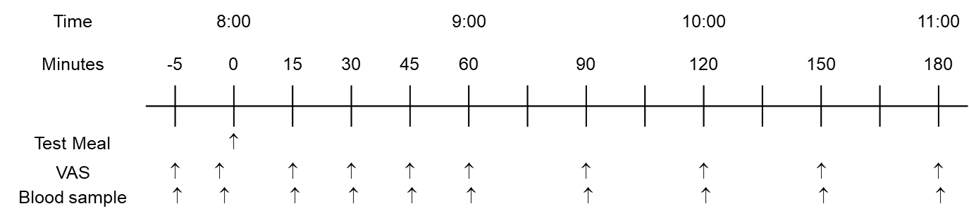
VAS = visual analogue scales: motivation to eat questionnaire.

Supplementary Figure 2: Study flow chart

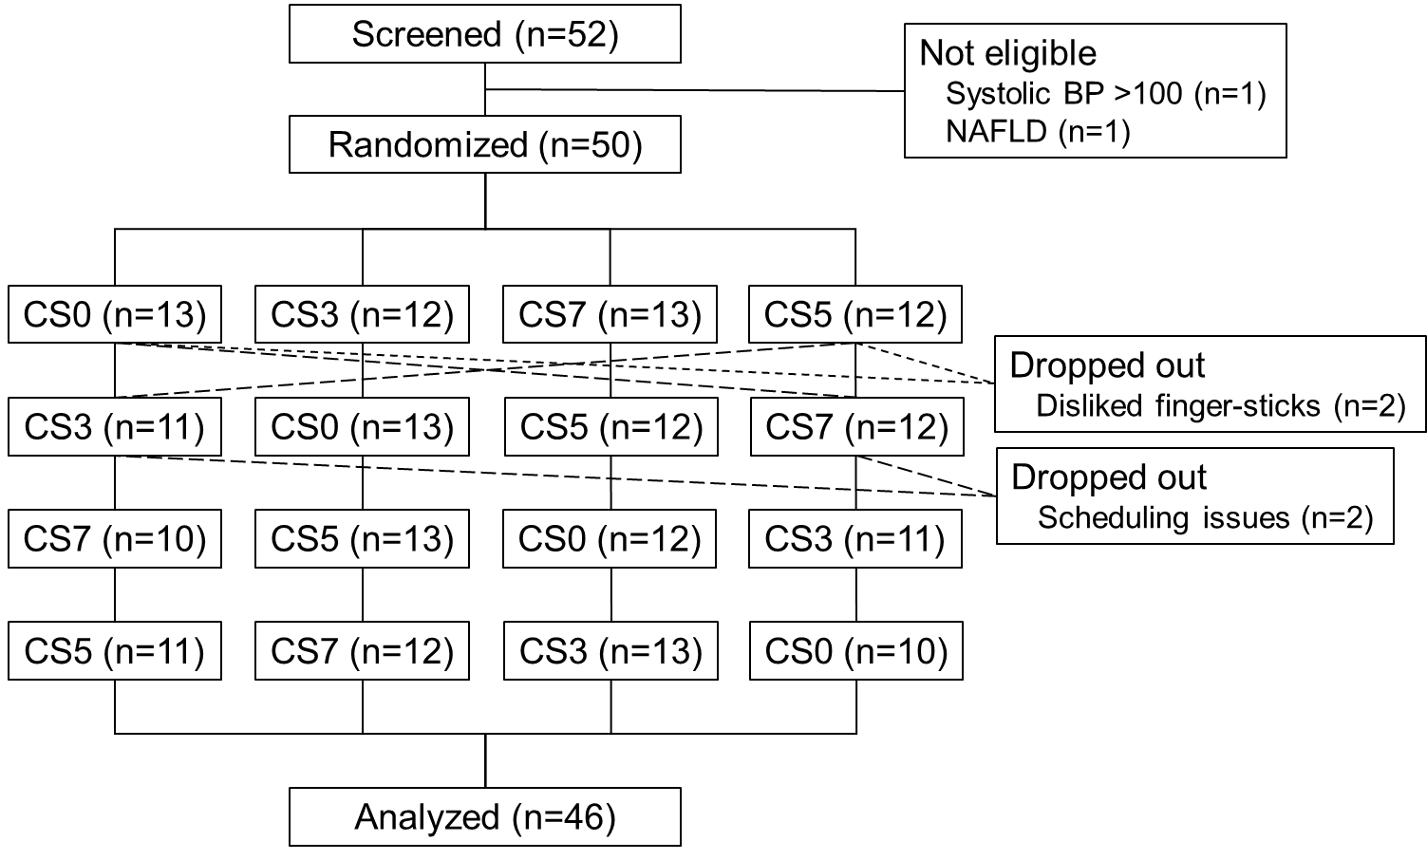

NAFLD = history of non-alcoholic fatty liver disease.
Short, dashed lines indicate the treatments taken by the 2 subjects who dropped-out after the first visit.
Long dashed lines indicate the treatments taken by the 2 subjects who dropped-out after the second visit.

Supplementary Figure 3: Desire to eat, prospective consumption and average appetite.
Values are means±SEM (n=46 subjects) for postprandial Desire to Eat (panel A), Prospective Consumption (panel B) and Average Appetite (Panel C) after consuming control cookies (CS0) or cookies containing 3g (CS3), 5g (CS5) or 7g (CS7) chia seeds. None of the differences between treatments is statistically significant.

Supplementary Figure 4: Chia and glycemic response: literature review
Values are [1+ln(mean RR)]±SEM [ln(mean RR)] where RR (relative response) = T/C where T and C = mean iAUC (incremental areas under the curve) for the Test and Control, respectively. SEM [ln(mean RR)] was estimated as follows:
sqrt([SD²test/(n×mean²test)]+[SD²control/(n×mean²control)]–[2×r×SDtest×SDcontrol/(meantest×meancontrol ×n)]).
Lines are regression lines.
F+P matched means that the chia test-meals contained the same amount of fat and protein as the control.
F+P unmatched means that the chia test meals contained more fat and protein than the control.
Solid blue dots and solid blue line show results for present study (F+P matched); r=-0.94, p=0.063.
Light blue dots and dashed blue line show results form Ho et al, 2013 (F+Pmatched); r=-0.94, p=0.002.
Solid red dots and solid red line show results from Vuksan et al., (F+P unmatched; chia test meals contained 0.034 to 0.118 g protein per g available carbohydrate (g/g) and 0.048 to 0.172 g/g more fat than the control test meals; r=-0.98, p=0.003.
Light red dots and dashed red line show results from Vuksan et al.^{3,4} after adjusting for the effects of fat and protein; r=-0.97, p=0.006.
The effects of fat (-18% per g/g) and protein (-71.5% per g/g) on glucose iAUC was taken to be the mean or their effects from Mogghadam et al. 2006 and Lan-Pidhainy & Wolever 2010.
The slope (±SEM) for Vuksan F+P unmatched (solid red line), -0.97 is significantly greater than that for Ho F+P matched (dashed blue line), -0.49, p=0.043. The are no other significant differences among he slopes.

. Snedecor GW, Cochran WG. Statistical Methods, 7th edition. Iowa State University Press, 1980.
Ho, H.; Lee, A.S.; Jovanovski, E.; Jenkins, A.L.; Desouza, R.; Vuksan, V. Effect of whole and ground Salba seeds (Salvia Hispanica L.) on postprandial glycemia in healthy volunteers: a randomized controlled, dose-response trial. Eur. J. Clin. Nutr. 2013, 67, 786–788.
Vuksan, V.; Jenkins, A.L.; Dias, A.G.; Lee, A.S.; Javanovski, E.; Rogovik, A,L.; Hanna, A. Reduction in postprandial glucose excursion and prolongation of satiety: possible explanation of the long-term effects of whole grain Salba (Salvia Hispanica L.). Eur. J. Clin. Nutr. 2010, 64, 436-438.
Vuksan, V.; Choleva, L.; Jovanovski, E.; Jenkins, A.L.; Au-Yeung, F.; Dias, A.G.; Ho, H.V.T.; Zurbau, A.; Duvnjak, L. Comparison of flax (Linum usitatissimum) and Salba-chia (Salvia hispanica L.) seeds on postprandial glycemia and satiety in healthy individuals: a randomized, controlled, crossover study. Eur. J. Clin. Nutr. 2017, 71, 234-238.
Moghaddam, E.; Vogt, J.A.; Wolever, T.M.S. The effects of fat and protein on glycemic responses in nondiabetic humans vary with waist circumference, fasting plasma insulin and dietary fiber intake. J. Nutr. 2006, 136, 2506-2511.
Lan-Pidhainy, X.; Wolever, T.M.S. The hypoglycemic effect of fat and protein is not attenuated by insulin resistance. Am. J. Clin. Nutr. 2010, 91, 98-105.

