Anti-Adipogenic Activity of Secondary Metabolites Isolated from Smilax sieboldii Miq. on 3T3-L1 Adipocytes

Supplementary Material

List of Figures
Figure S1. ¹H-NMR spectrum (acetone-d₆, 700 MHz) of compound 1
Figure S2. ¹³C-NMR spectrum (acetone-d₆, 175 MHz) of the compound 1
Figure S3. ¹H-NMR spectrum (acetone-d₆, 700 MHz) of the compound 2
Figure S4. ¹³C-NMR spectrum (acetone-d₆, 175 MHz) of the compound 2
Figure S5. ¹H-NMR spectrum (CD₃OD, 700 MHz) of the compound 3
Figure S6. ¹³C-NMR spectrum (CD₃OD, 175 MHz) of the compound 3
Figure S7. ¹H-NMR spectrum (CD₃OD, 700 MHz) of the compound 4
Figure S8. ¹³C-NMR spectrum (CD₃OD, 175 MHz) of the compound 4
Figure S9. ¹H-NMR spectrum (CD₃OD, 700 MHz) of the compound 5
Figure S10. ¹³C-NMR spectrum (CD₃OD, 175 MHz) of the compound 5
Figure S11. ¹H-NMR spectrum (CD₃OD, 700 MHz) of the compound 6
Figure S12. ¹³C-NMR spectrum (CD₃OD, 175 MHz) of the compound 6
Figure S13. ¹H-NMR spectrum (CD₃OD, 700 MHz) of the compound 7
Figure S14. ¹³C-NMR spectrum (CD₃OD, 175 MHz) of the compound 7
Figure S15. ¹H-NMR spectrum (CD₃OD, 700 MHz) of the compound 8
Figure S16. ¹³C-NMR spectrum (CD₃OD, 175 MHz) of the compound 8
Figure S17. ¹H-NMR spectrum (CD₃OD, 700 MHz) of the compound 9
Figure S18. ¹³C-NMR spectrum (CD₃OD, 175 MHz) of the compound 9
Figure S19. ¹H-NMR spectrum (CD₃OD, 700 MHz) of the compound 10
Figure S20. ¹³C-NMR spectrum (CD₃OD, 175 MHz) of the compound 10
Figure S21. ¹H-NMR spectrum (CD₃OD, 700 MHz) of the compound 11
Figure S22. ¹³C-NMR spectrum (CD₃OD, 175 MHz) of the compound 11
Figure S23. ¹H-NMR spectrum (CD₃OD, 700 MHz) of the compound 12
Figure S24. ¹³C-NMR spectrum (CD₃OD, 175 MHz) of the compound 12
Figure S25. ¹H-NMR spectrum (CD₃OD, 700 MHz) of the compound 13
Figure S26. ¹³C-NMR spectrum (CD₃OD, 175 MHz) of the compound 13
Figure S27. ¹H-NMR spectrum (CD₃OD, 700 MHz) of the compound 14
Figure S28. ¹³C-NMR spectrum (CD₃OD, 175 MHz) of the compound 14
Figure S29. ¹H-NMR spectrum (CD₃OD, 700 MHz) of the compound 15
Figure S30. ¹³C-NMR spectrum (CD₃OD, 175 MHz) of the compound 15
Figure S31. ¹H-NMR spectrum (CD₃OD, 700 MHz) of the compound 16
Figure S32. ¹³C-NMR spectrum (CD₃OD, 175 MHz) of the compound 16
Figure S33. DEPT135 spectrum of the compound 16
Figure S34. ¹H-¹H COSY spectrum of the compound 16
Figure S35. HSQC spectrum of the compound 16
Figure S36. HMBC spectrum of the compound 16
Figure S37. Expansion of HMBC spectrum of compound 16
Figure S38. HRESIMS spectrum of the compound 16
Figure S39. ¹H-NMR spectrum (CDCl₃, 700 MHz) of the compound 17
Figure S40. ¹³C-NMR spectrum (CDCl₃, 175 MHz) of the compound 17
Figure S41. DEPT135 spectrum of the compound 17
Figure S42. ¹H-¹H COSY spectrum of the compound 17
Figure S43. HSQC spectrum of the compound 17
Figure S44. HMBC spectrum of the compound 17
Figure S45. ROESY spectrum of compound 17
Figure S46. Specific optical rotation of compound 17
Figure S47. IR spectrum of compound 17
Figure S48. HRESIMS spectrum of the compound 17
Figure S49. ¹H-NMR spectrum (CDCl₃, 700 MHz) of the compound 18
Figure S50. ¹³C-NMR spectrum (CDCl₃, 175 MHz) of the compound 18
Figure S51. DEPT135 spectrum of the compound 18
Figure S52. ¹H-¹H COSY spectrum of the compound 18
Figure S53. HSQC spectrum of the compound 18
Figure S54. HMBC spectrum of the compound 18
Figure S55. ROESY spectrum of compound 18
Figure S56. Specific optical rotation of compound 18
Figure S57. IR spectrum of compound 18
Figure S58. HRESIMS spectrum of the compound 18
Figure S59. ¹H-NMR spectrum (CD₃OD, 700 MHz) of the compound 19
Figure S60. ¹³C-NMR spectrum (CD₃OD, 175 MHz) of the compound 19

1. General Experimental Procedure
Optical rotations were measured using a JASCO P-2000 polarimeter (Tokyo, Japan). UV and FT-IR spectra were measured on a JASCO UV-550 and JASCO Model FT/IR-4100 spectrometer (Tokyo, Japan), respectively. Nuclear magnetic resonance (NMR) spectra were recorded on a Bruker Ascend III 700 spectrometer (Bruker BioSpin GmbH., Rheinstetten, Germany) in acetone-d₆, CDCl₃, and CD₃OD at room temperature. Chemical shifts are in ppm (δ), relative to tetramethylsilane as an internal standard, and coupling constants are in hertz; ¹H, ¹³C, DEPT, COSY, HSQC, and HMBC by using the standard pulse sequences. Electrospray ionization mass (ESI-MS) spectra were acquired on an Agilent 6130 series quadrupole LC/MS System (Agilent Technologies, CA, USA). HRESIMS spectra were recorded by a Triple TOF 5600+ mass spectrometer (AB SCIEX, MA, USA). Open column chromatography was performed using Diaion HP-20 adsorbent resin (Mitsubishi Chemical Corp, Tokyo, Japan). Medium-pressure liquid chromatography (MPLC) was conducted using a CombiFlash Rf flash chromatography system (Teledyne ISCO Inc., NE, USA), and the separations were performed on a RediSep® Rf C₁₈ column with a flow rate of 40 mL/min. Preparative high-performance liquid chromatography (HPLC) was performed on a Thermo Scientifc Dionex Ultimate 3000 UHPLC system (Thermo Fisher Scientific Inc., MA, USA) equipped with an HPG-3200BX biocompatible binary semipreparative pump and a rapid separations PDA detector (Ultimate DAD-3000) controlled by Chromeleon 7.2 software. The separations were carried out on a Kromasil 100-5-C18 column (5 μm, 21.2 × 250 mm, Nouryon Chemicals Finance B.V., Amsterdam, Netherlands). Thin layer chromatography (TLC) was performed using DC-Fertigfolien ALUGRAM® SIL G/UV₂₅₄₊₃₆₆ (0.2 mm, Macherey-Nagel GmbH & Co. KG, Düren, Germany) plates, and spots were visualized by a 10% vanillin−sulfuric acid reagent. All chemicals and solvents were of analytical grade and were used without further purification.

Table S1. In vitro cytotoxicity of compounds 1–19.
Compounds | 1 | 2 | 3 | 4 | 5 | 6 | 7 | 8 | 9 | 10 | 11 | 12 | 13 | 14 | 15 | 16 | 17 | 18 | 19
IC₅₀ (μM) | NC | NC | NC | NC | NC | NC | NC | NC | NC | NC | NC | NC | NC | NC | NC | NC | NC | NC | NC
IC₅₀ values of tested compounds were measured. 3T3-L1 preadipocytes (40% confluence) were treated with different concentrations (25, 50, 100, 200 μM) of tested compounds for 48 h. Statistical analysis was performed by Student’s t-test.
NC, no cytotoxicity.

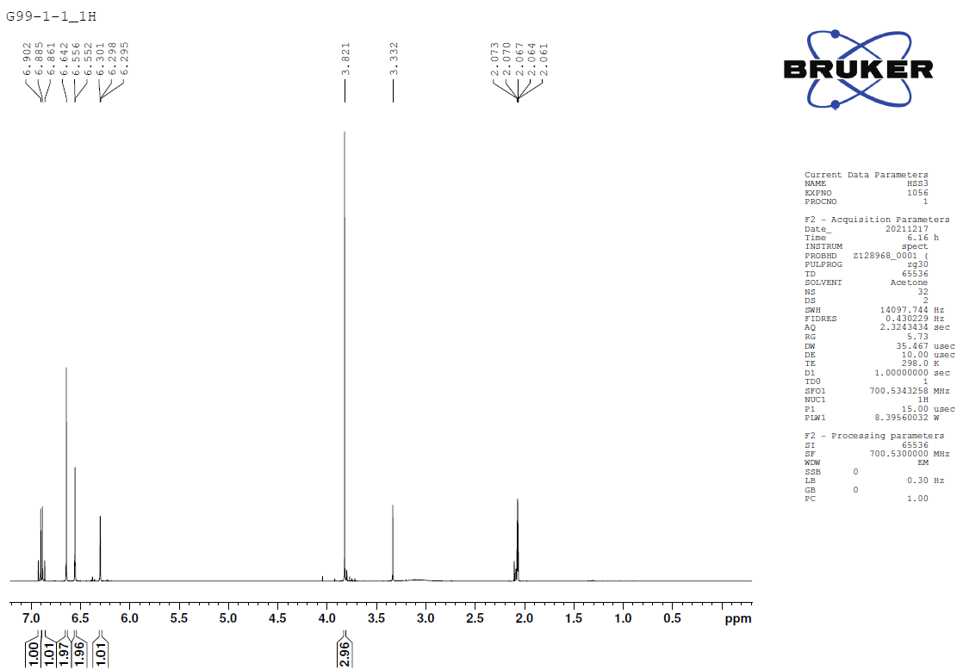
Figure S1. ¹H-NMR spectrum (acetone-d₆, 700 MHz) of compound 1
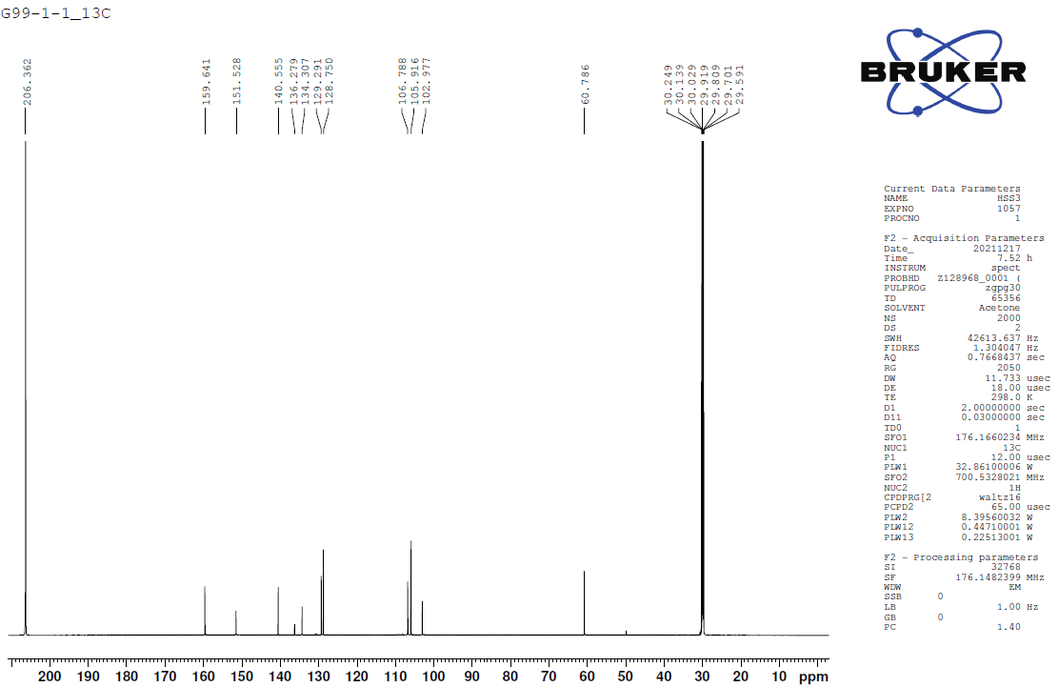
Figure S2. ¹³C-NMR spectrum (acetone-d₆, 175 MHz) of compound 1
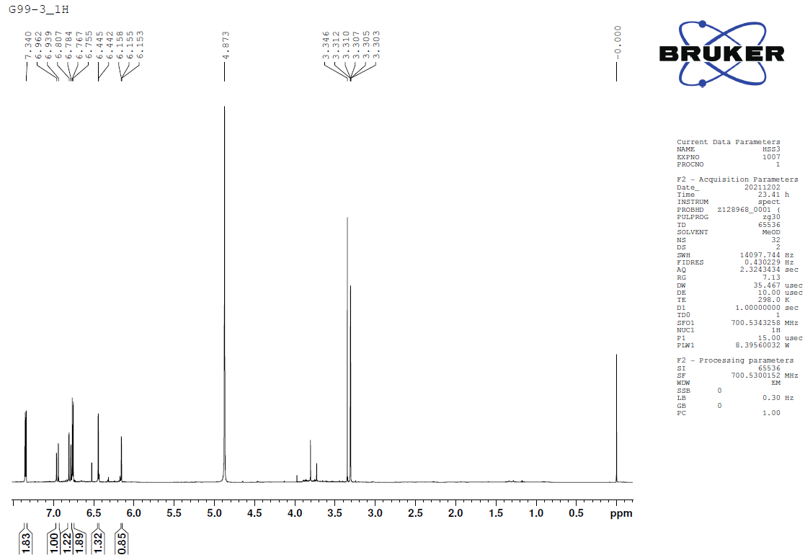
Figure S3. ¹H-NMR spectrum (acetone-d₆, 700 MHz) of compound 2
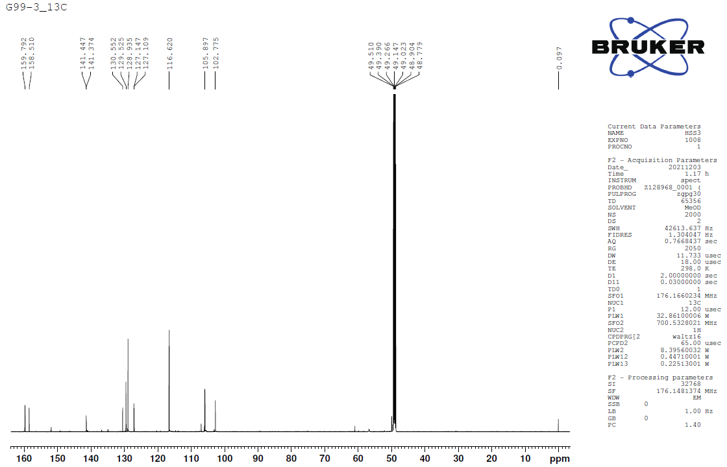
Figure S4. ¹³C-NMR spectrum (acetone-d₆, 175 MHz) of compound 2

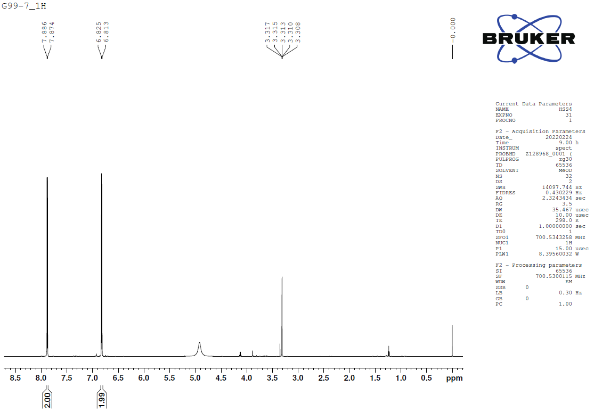
Figure S5. ¹H-NMR spectrum (CD₃OD, 700 MHz) of compound 3
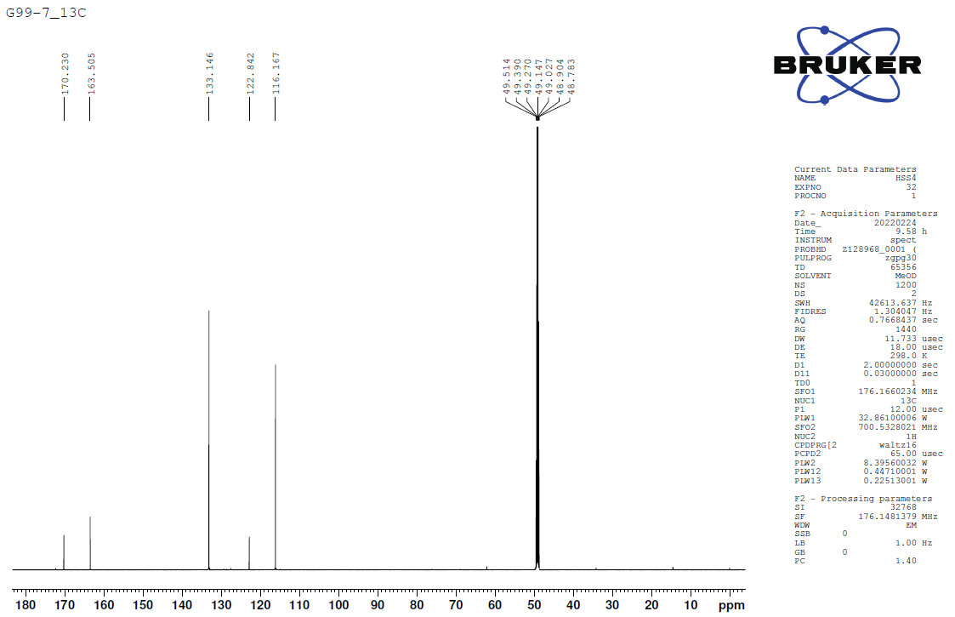
Figure S6. ¹³C-NMR spectrum (CD₃OD, 175 MHz) of compound 3

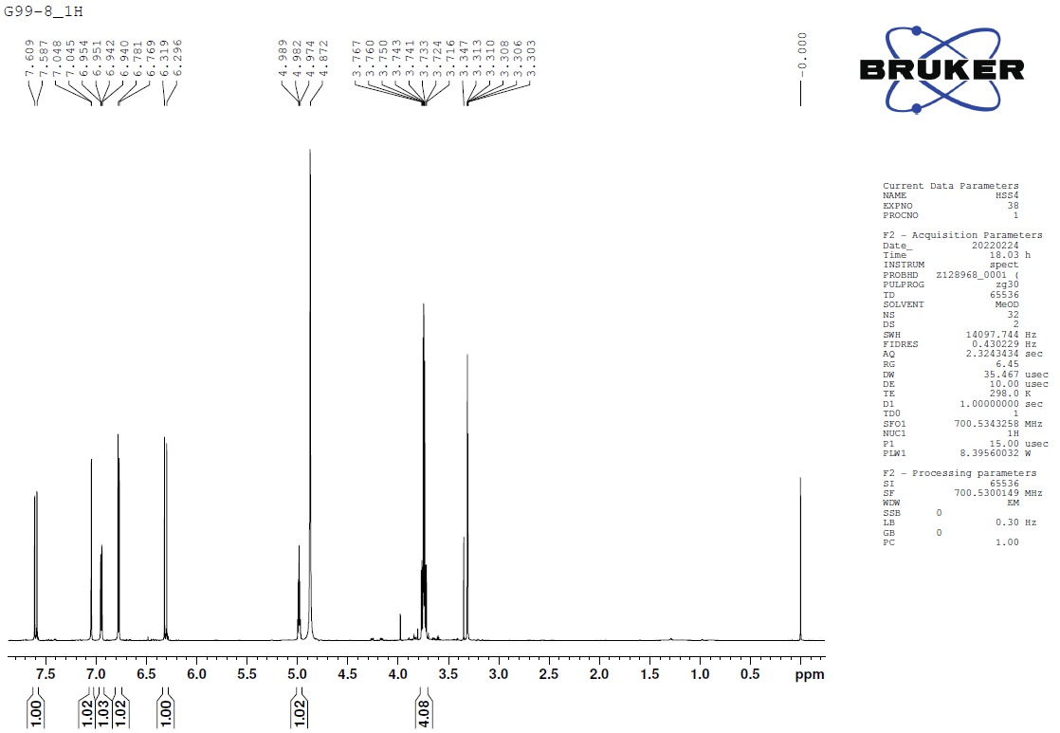
Figure S7. ¹H-NMR spectrum (CD₃OD, 700 MHz) of compound 4
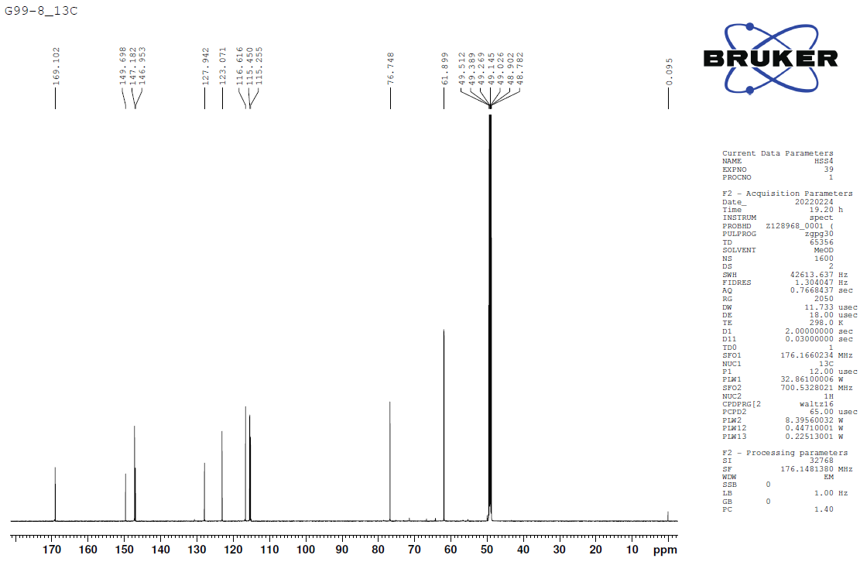
Figure S8. ¹³C-NMR spectrum (CD₃OD, 175 MHz) of compound 4
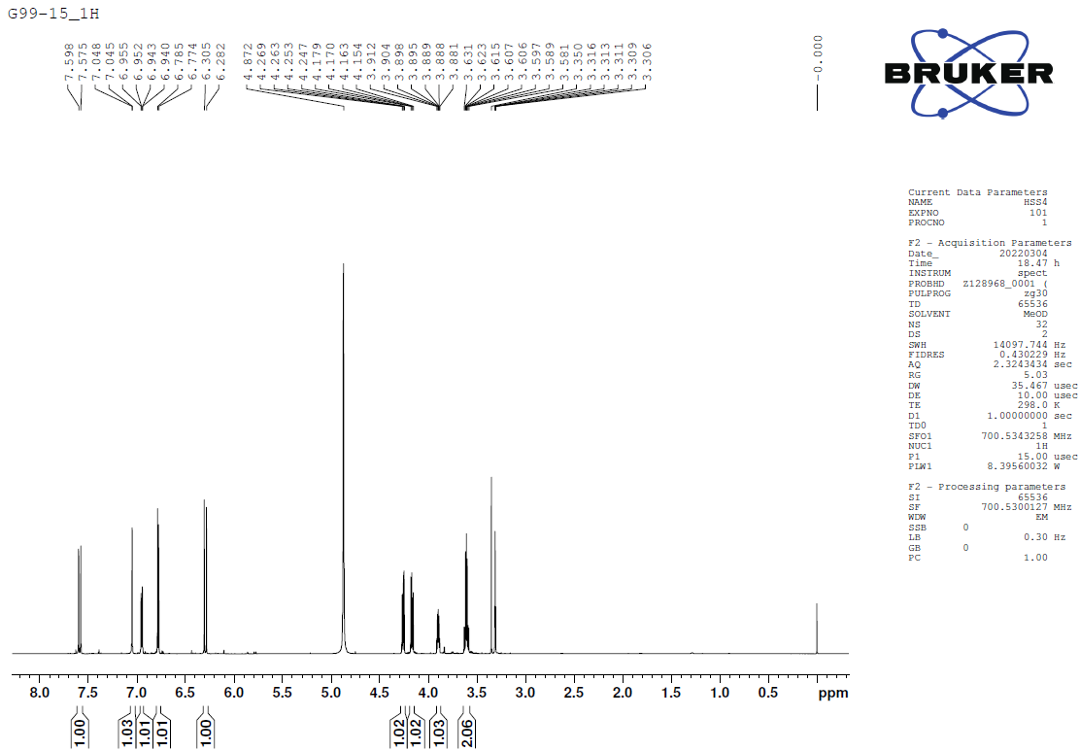
Figure S9. ¹H-NMR spectrum (CD₃OD, 700 MHz) of compound 5
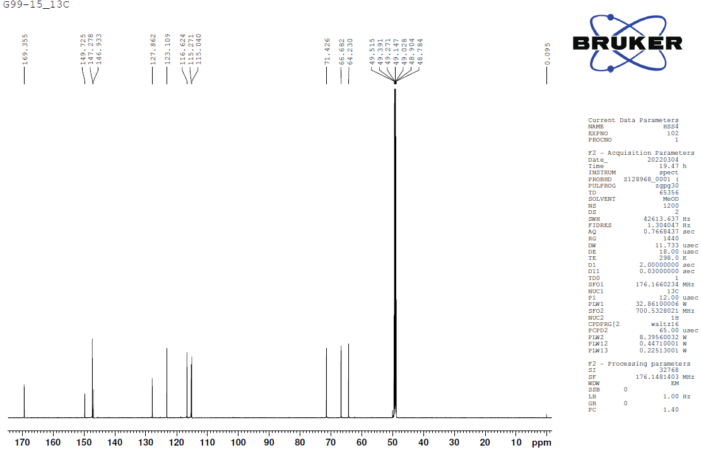
Figure S10. ¹³C-NMR spectrum (CD₃OD, 175 MHz) of compound 5

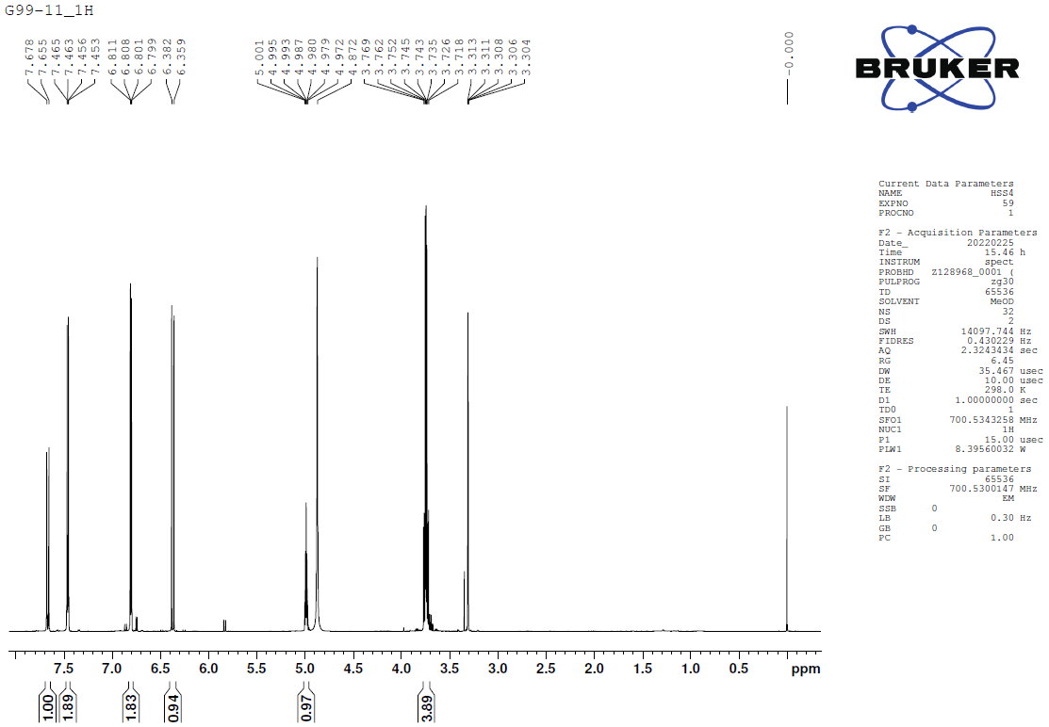
Figure S11. ¹H-NMR spectrum (CD₃OD, 700 MHz) of compound 6
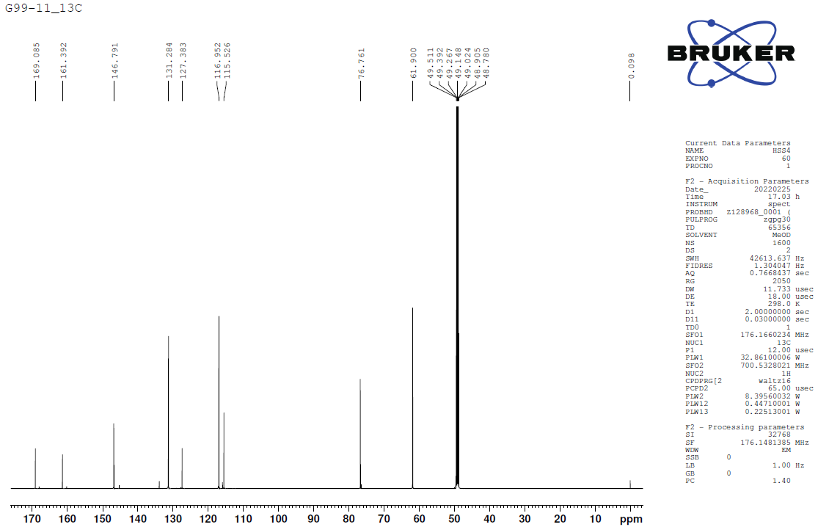
Figure S12. ¹³C-NMR spectrum (CD₃OD, 175 MHz) of compound 6

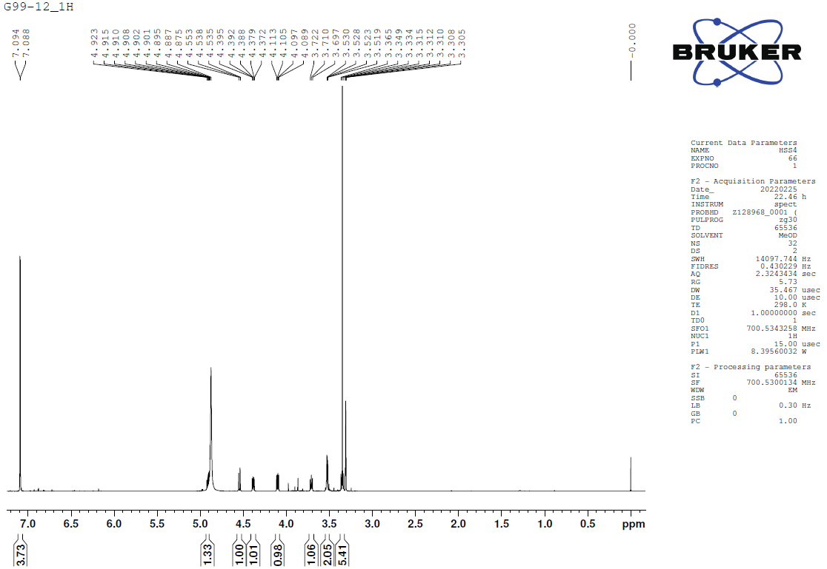
Figure S13. ¹H-NMR spectrum (CD₃OD, 700 MHz) of compound 7
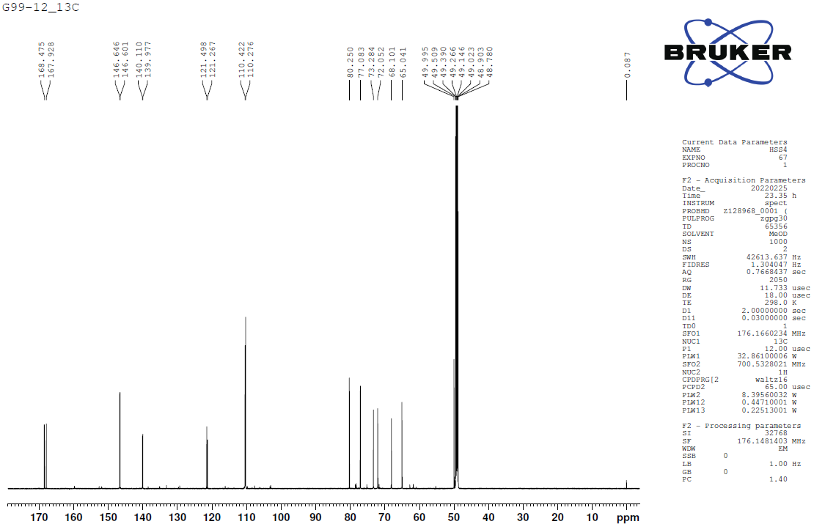
Figure S14. ¹³C-NMR spectrum (CD₃OD, 175 MHz) of compound 7

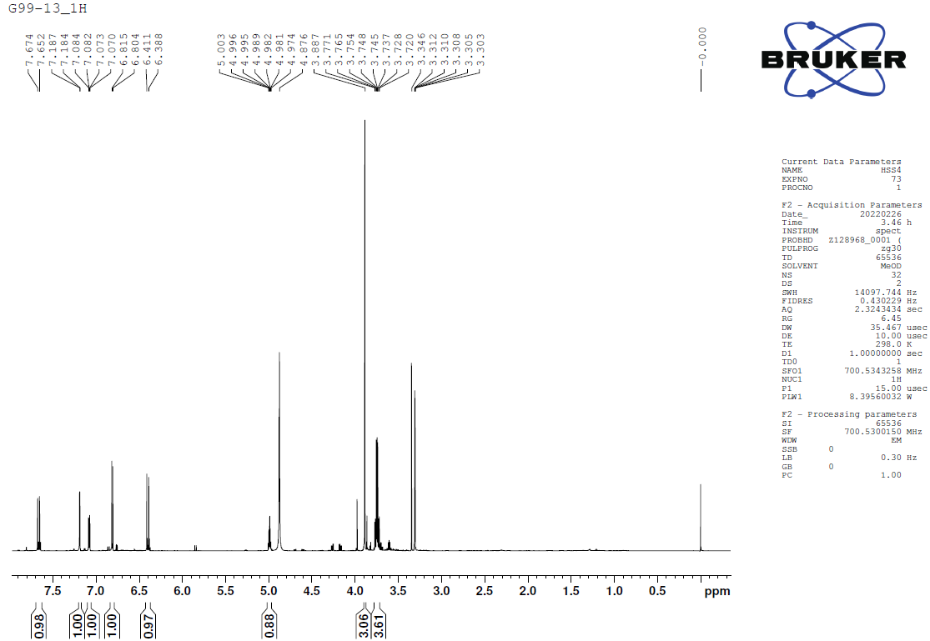
Figure S15. ¹H-NMR spectrum (CD₃OD, 700 MHz) of compound 8
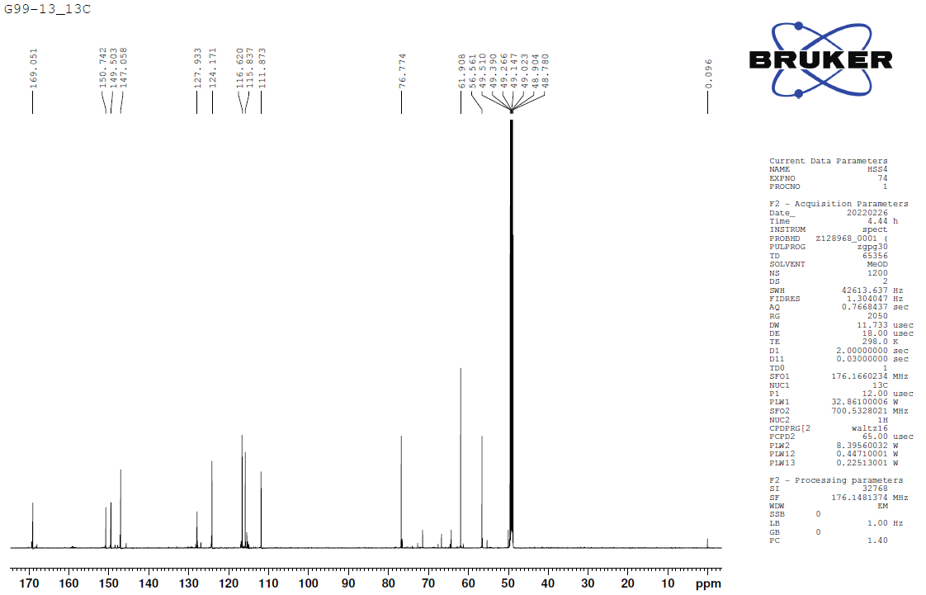
Figure S16. ¹³C-NMR spectrum (CD₃OD, 175 MHz) of compound 8

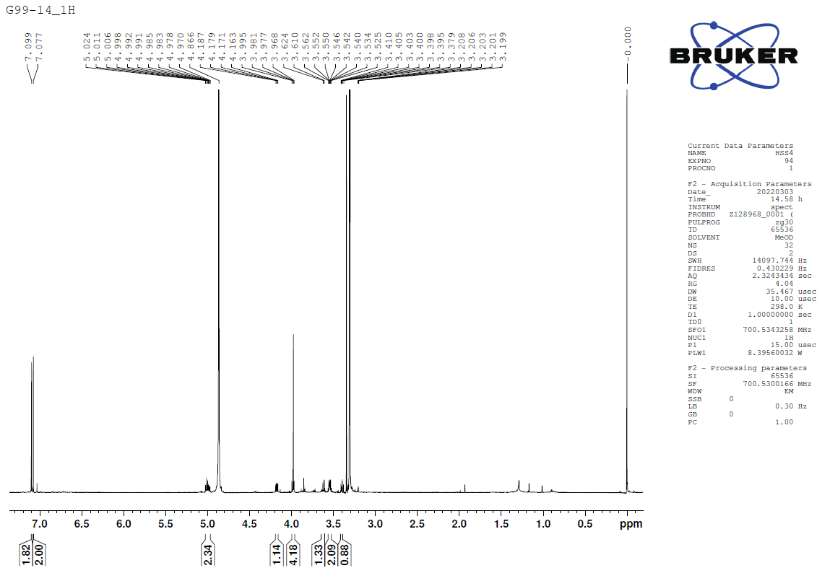
Figure S17. ¹H-NMR spectrum (CD₃OD, 700 MHz) of compound 9
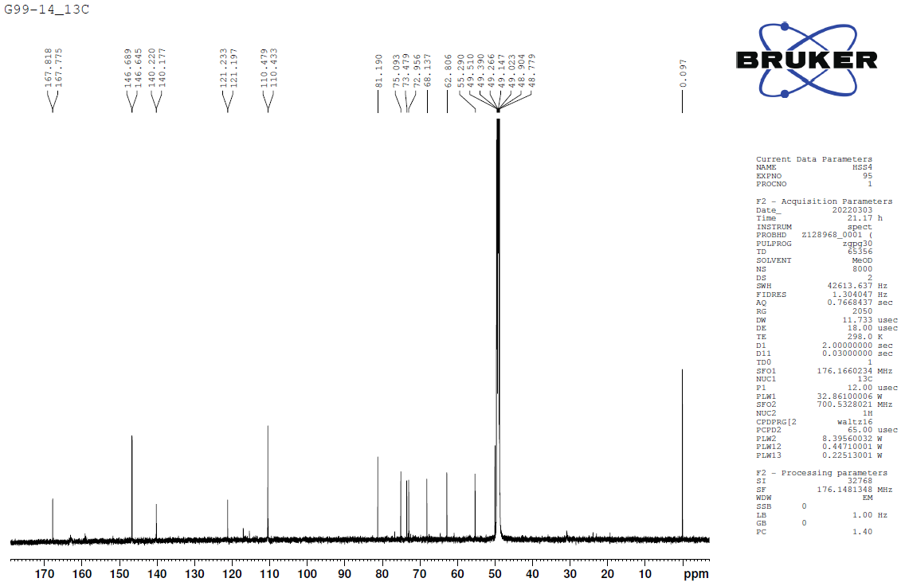
Figure S18. ¹³C-NMR spectrum (CD₃OD, 175 MHz) of compound 9
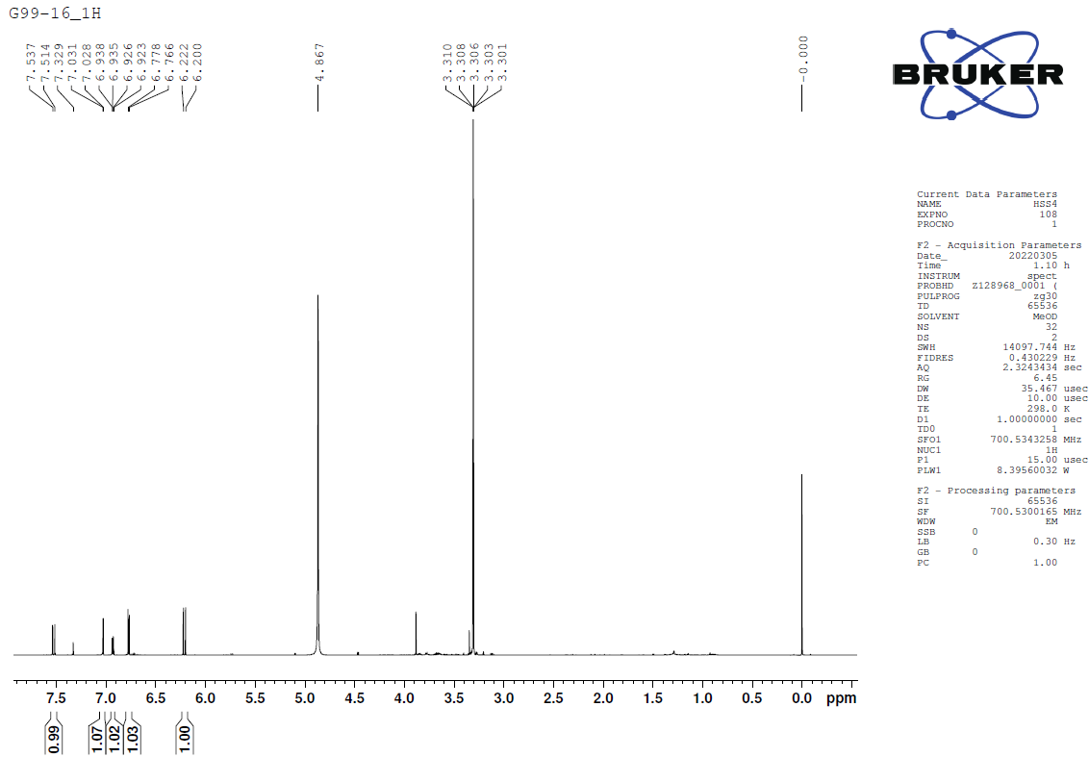
Figure S19. ¹H-NMR spectrum (CD₃OD, 700 MHz) of compound 10
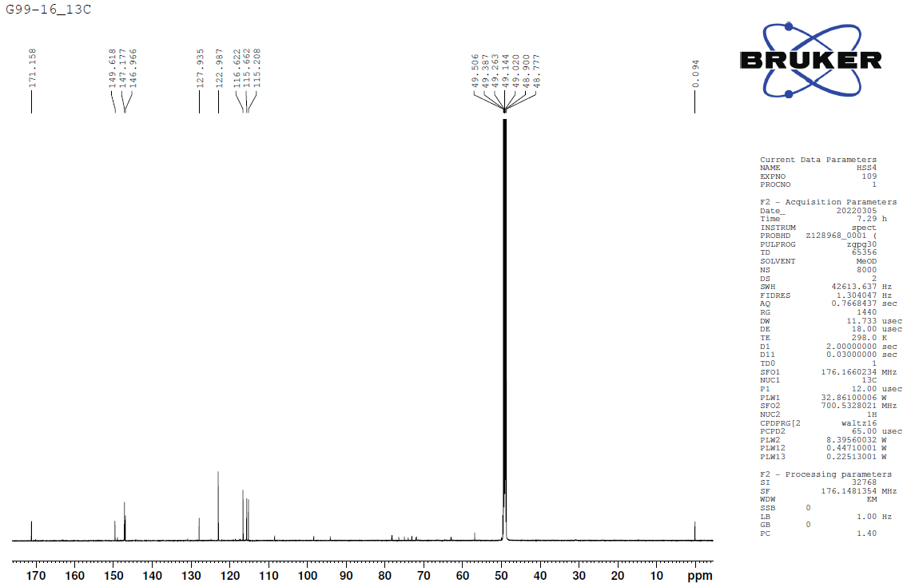
Figure S20. ¹³C-NMR spectrum (CD₃OD, 175 MHz) of compound 10
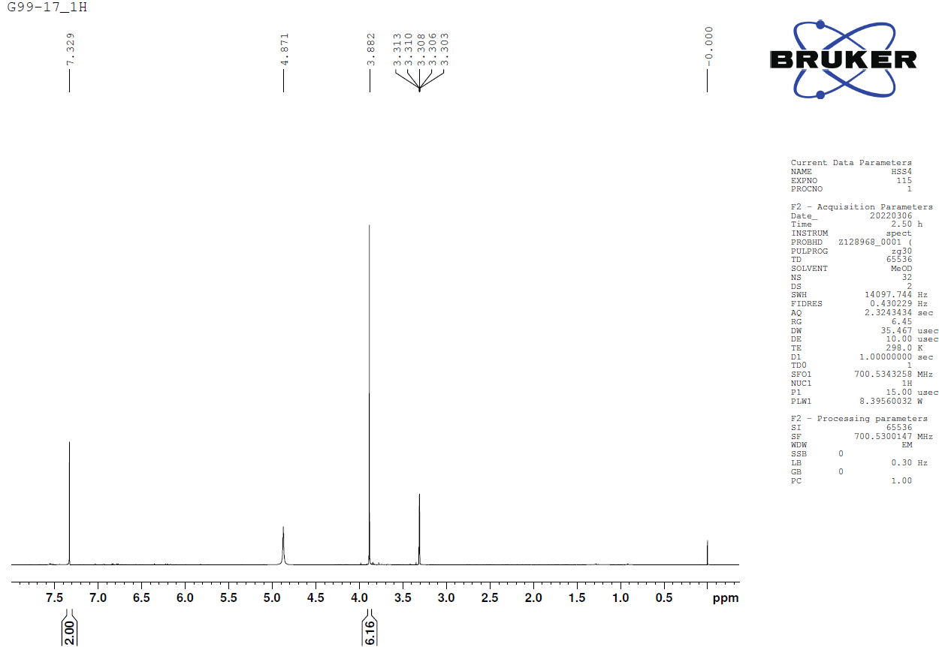
Figure S21. ¹H-NMR spectrum (CD₃OD, 700 MHz) of compound 11
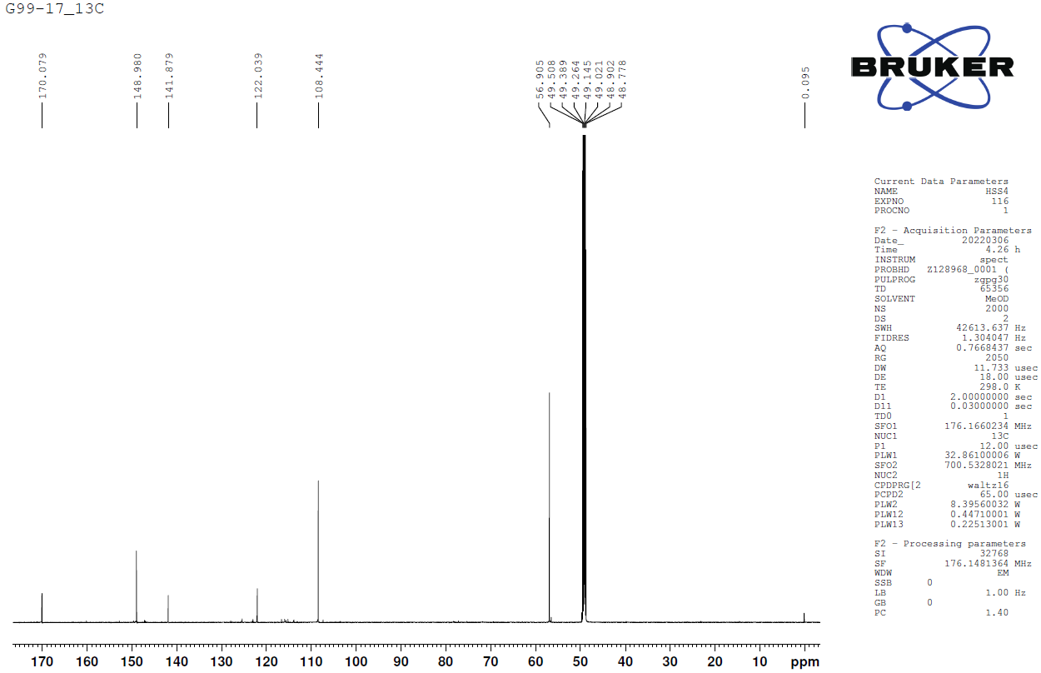
Figure S22. ¹³C-NMR spectrum (CD₃OD, 175 MHz) of compound 11

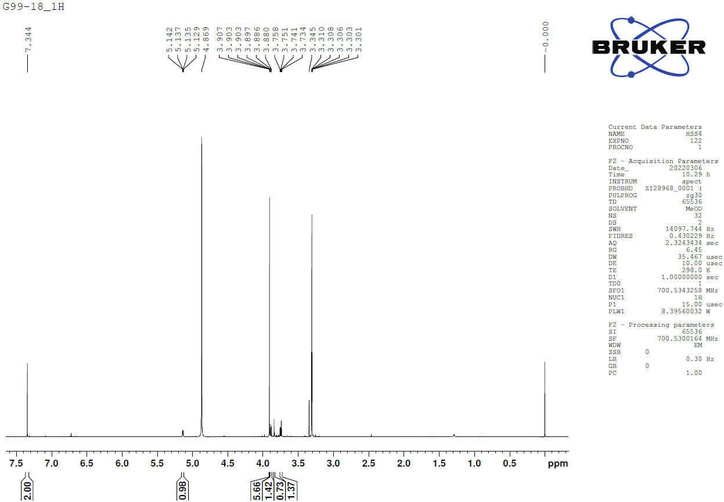
Figure S23. ¹H-NMR spectrum (CD₃OD, 700 MHz) of compound 12
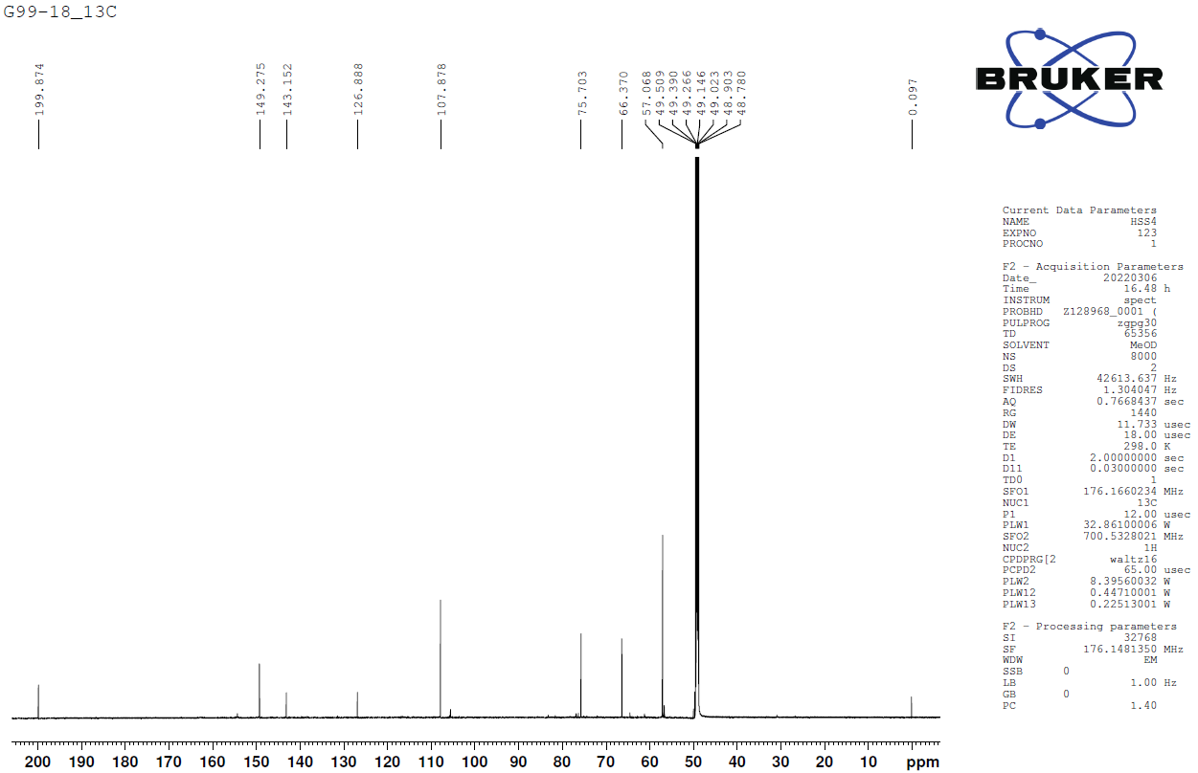
Figure S24. ¹³C-NMR spectrum (CD₃OD, 175 MHz) of compound 12

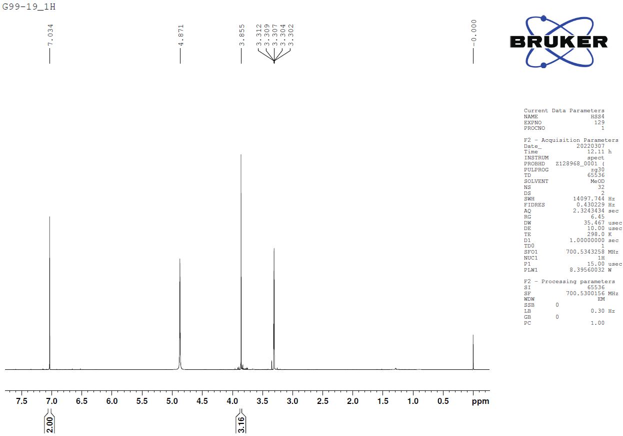
Figure S25. ¹H-NMR spectrum (CD₃OD, 700 MHz) of compound 13
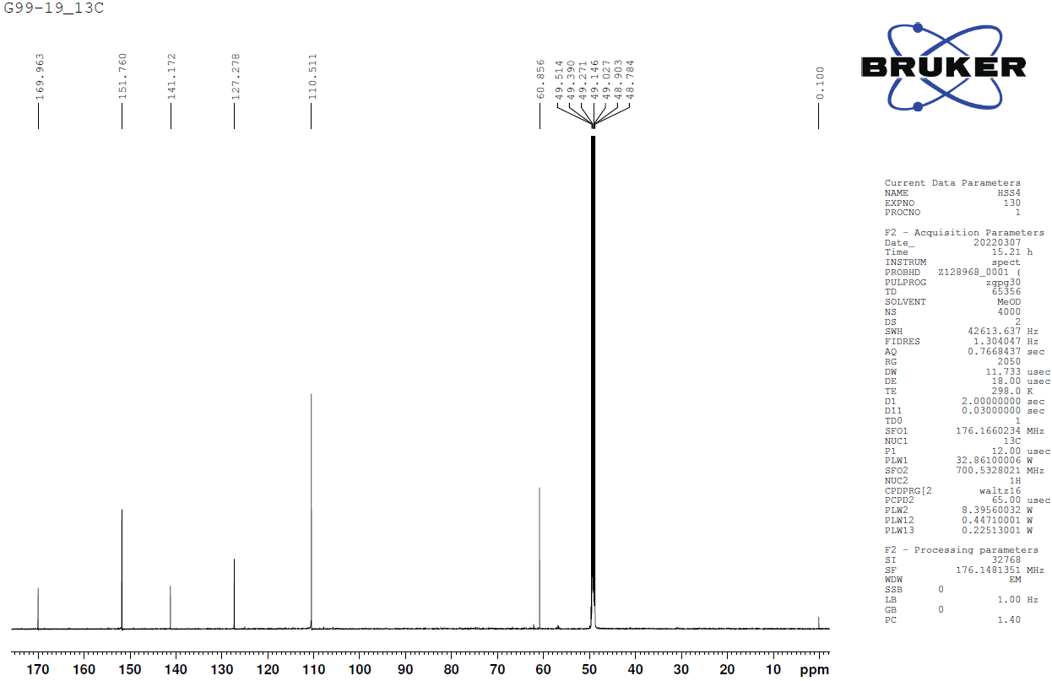
Figure S26. ¹³C-NMR spectrum (CD₃OD, 175 MHz) of compound 13
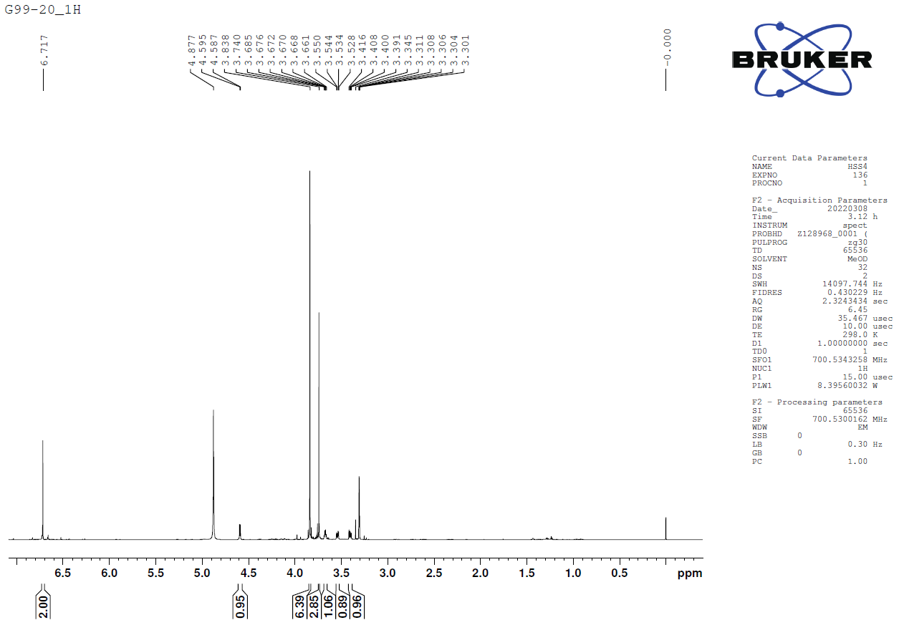
Figure S27. ¹H-NMR spectrum (CD₃OD, 700 MHz) of compound 14
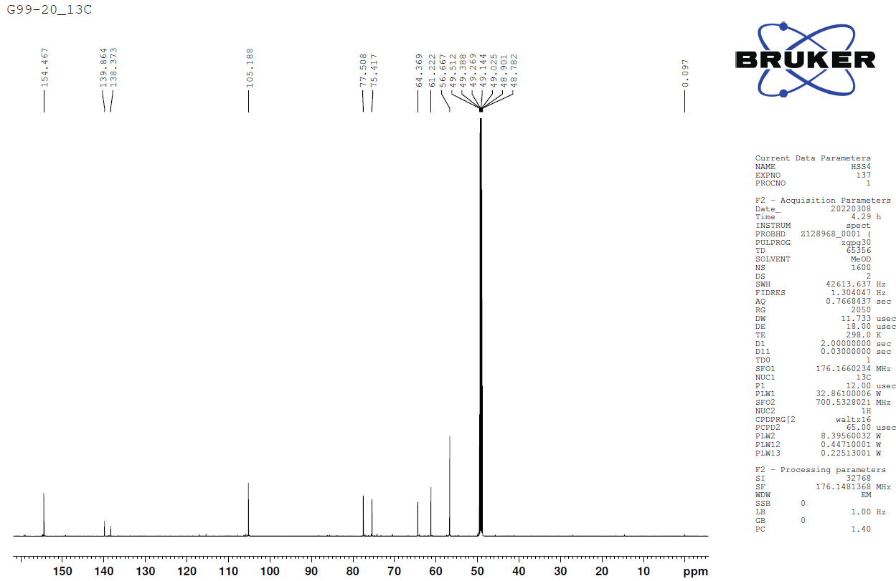
Figure S28. ¹³C-NMR spectrum (CD₃OD, 175 MHz) of compound 14

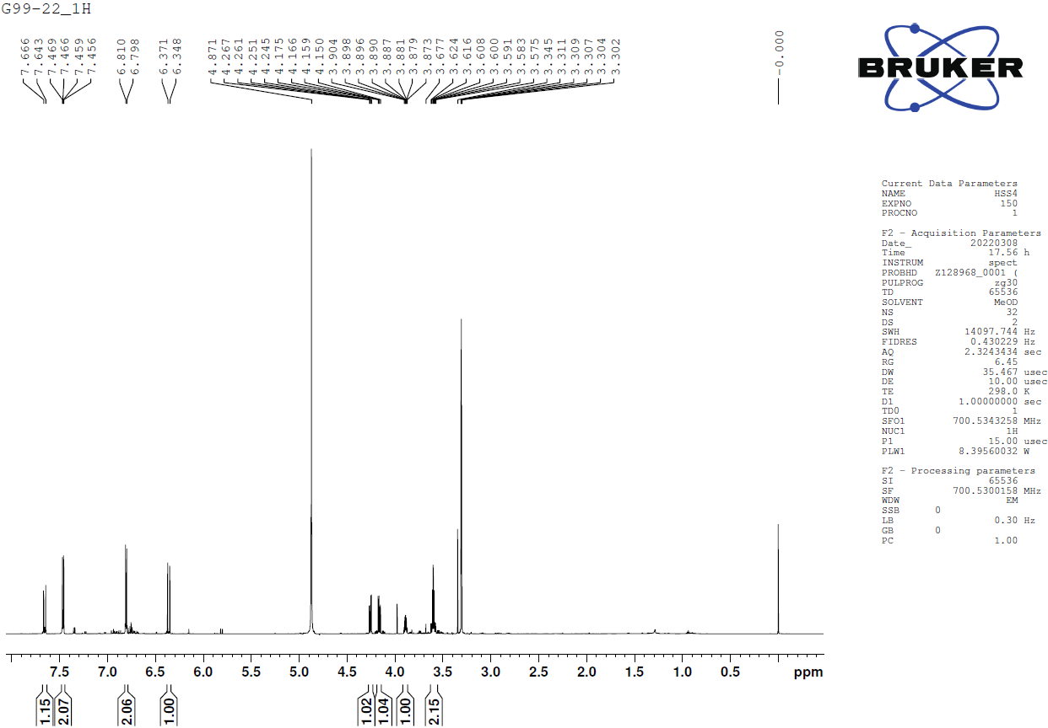
Figure S29. ¹H-NMR spectrum (CD₃OD, 700 MHz) of compound 15
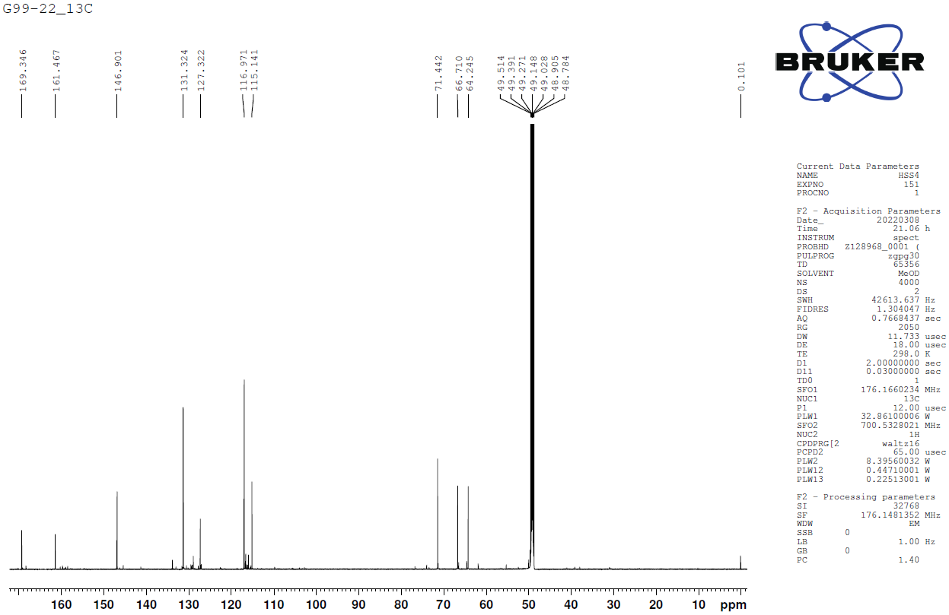
Figure S30. ¹³C-NMR spectrum (CD₃OD, 175 MHz) of compound 15
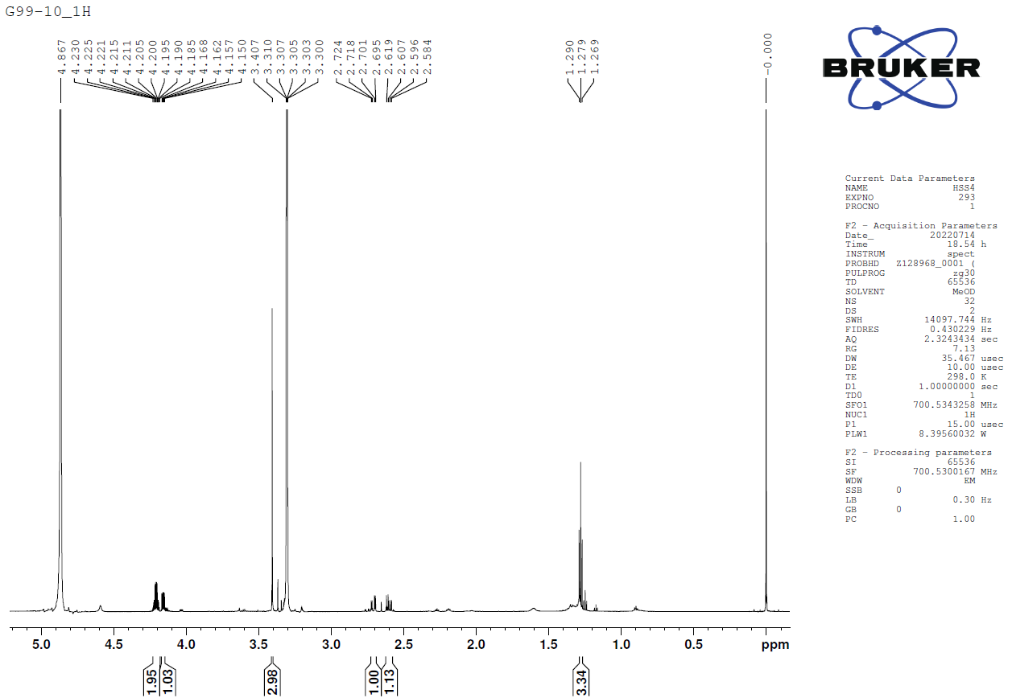
Figure S31. ¹H-NMR spectrum (CD₃OD, 700 MHz) of compound 16
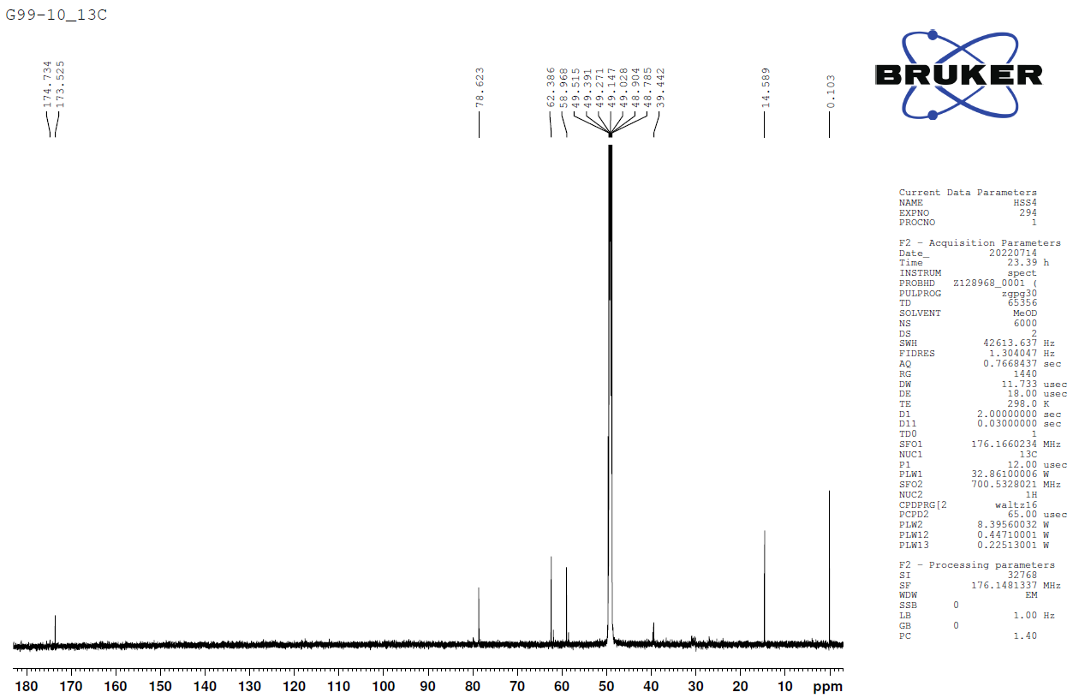
Figure S32. ¹³C-NMR spectrum (CD₃OD, 175 MHz) of compound 16

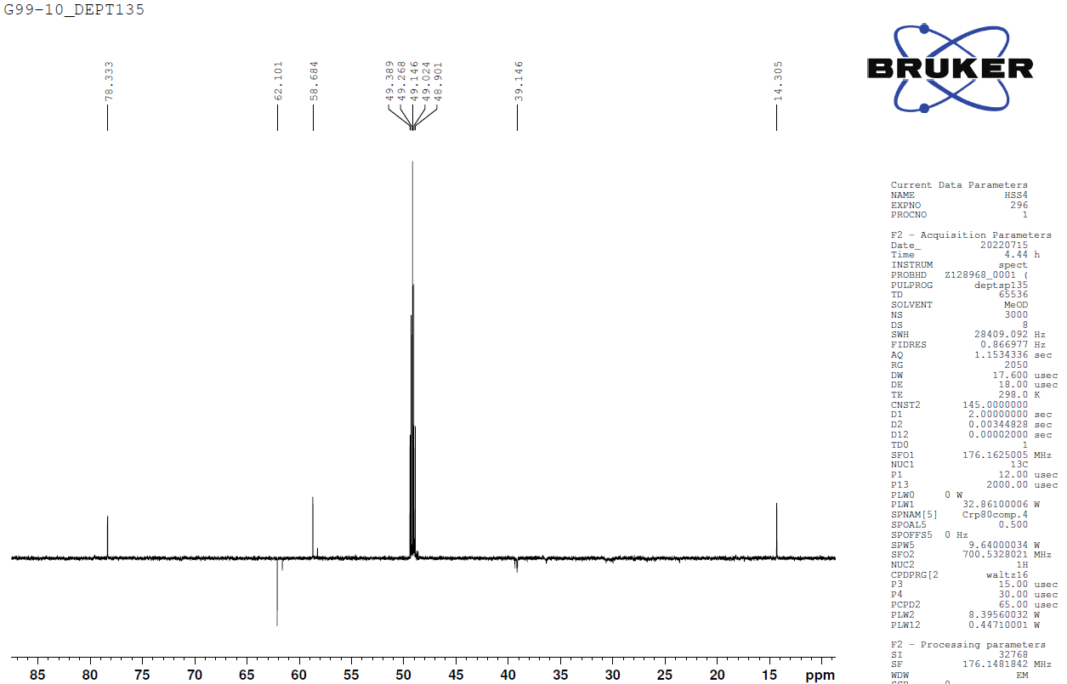
Figure S33. DEPT135 spectrum of compound 16
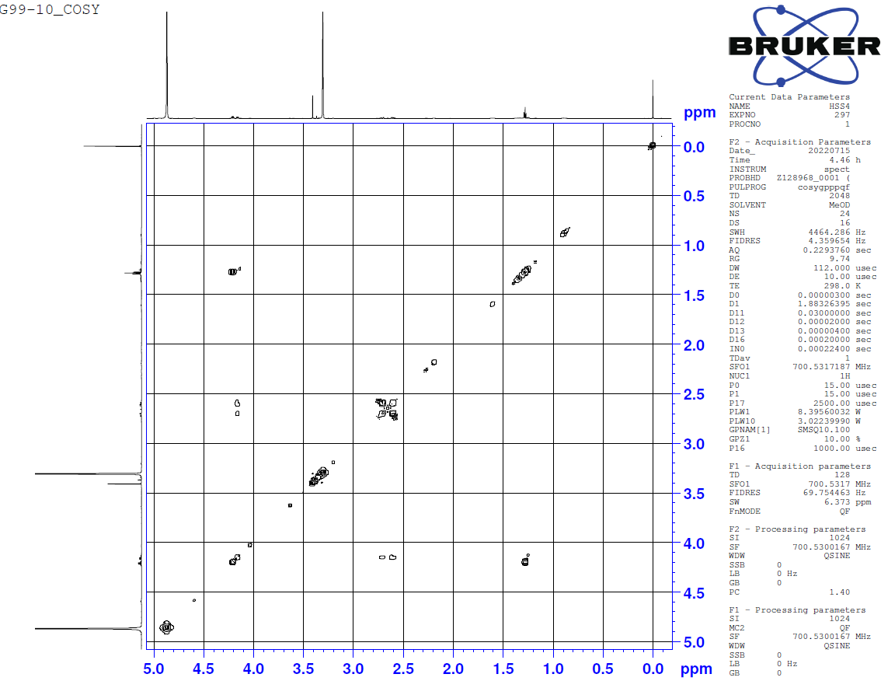
Figure S34. ¹H-¹H COSY spectrum of compound 16
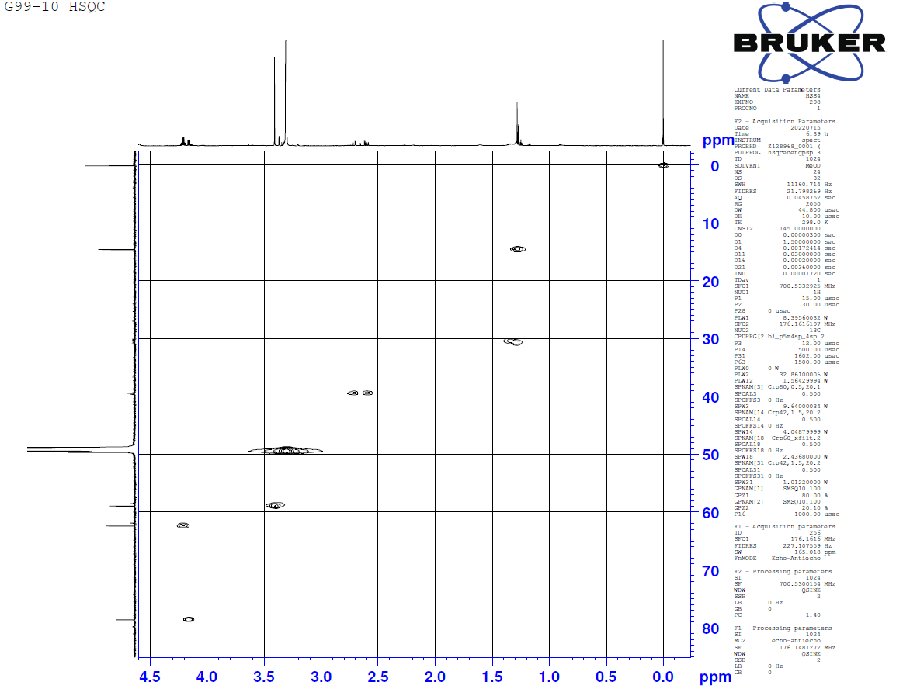
Figure S35. HSQC spectrum of compound 16
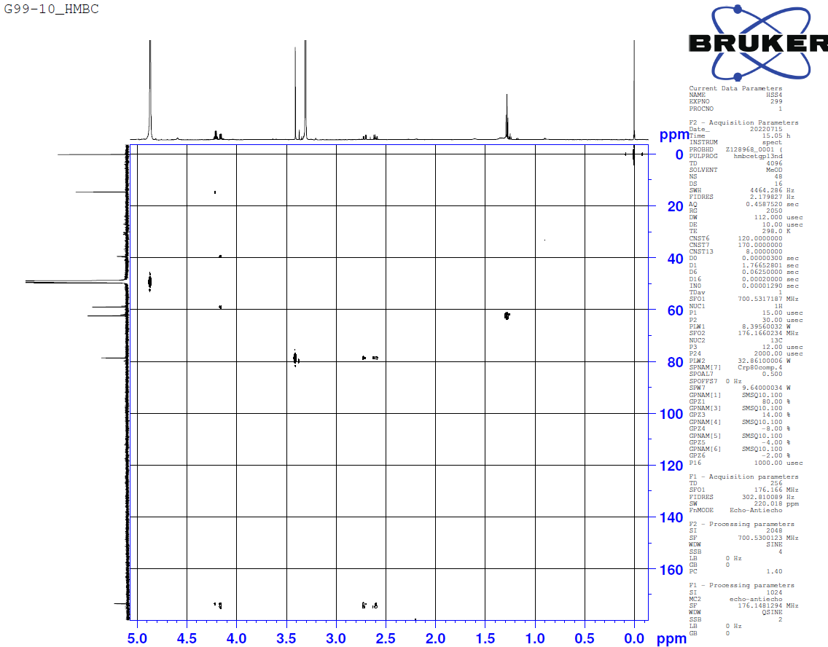
Figure S36. HMBC spectrum of compound 16
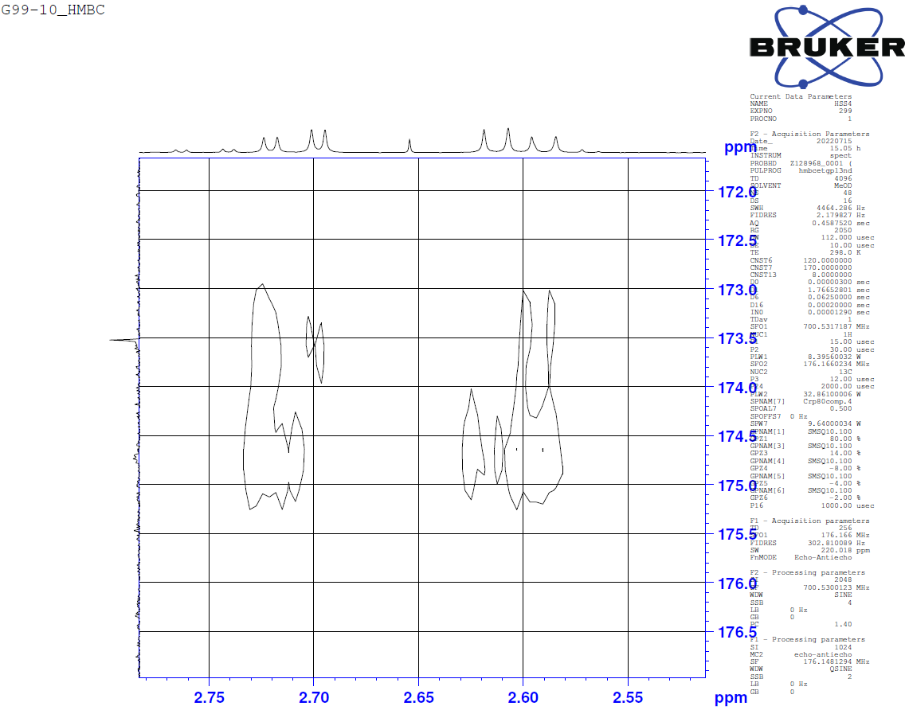
Figure S37. Expansion of HMBC spectrum of compound 16

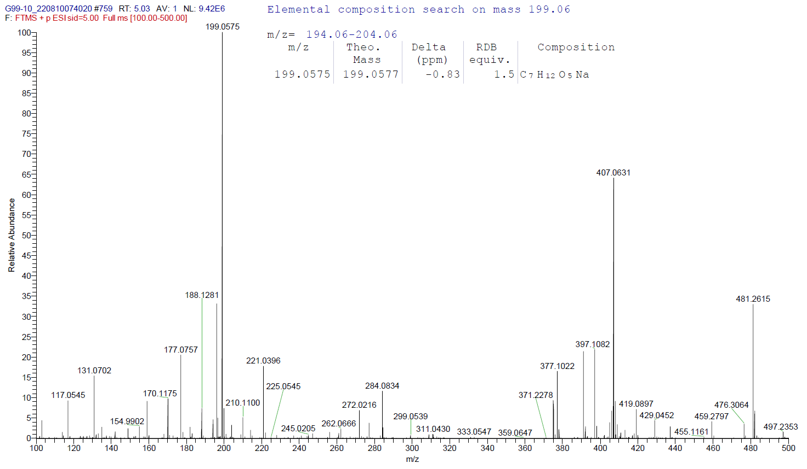
Figure S38. HRESIMS spectrum of compound 16

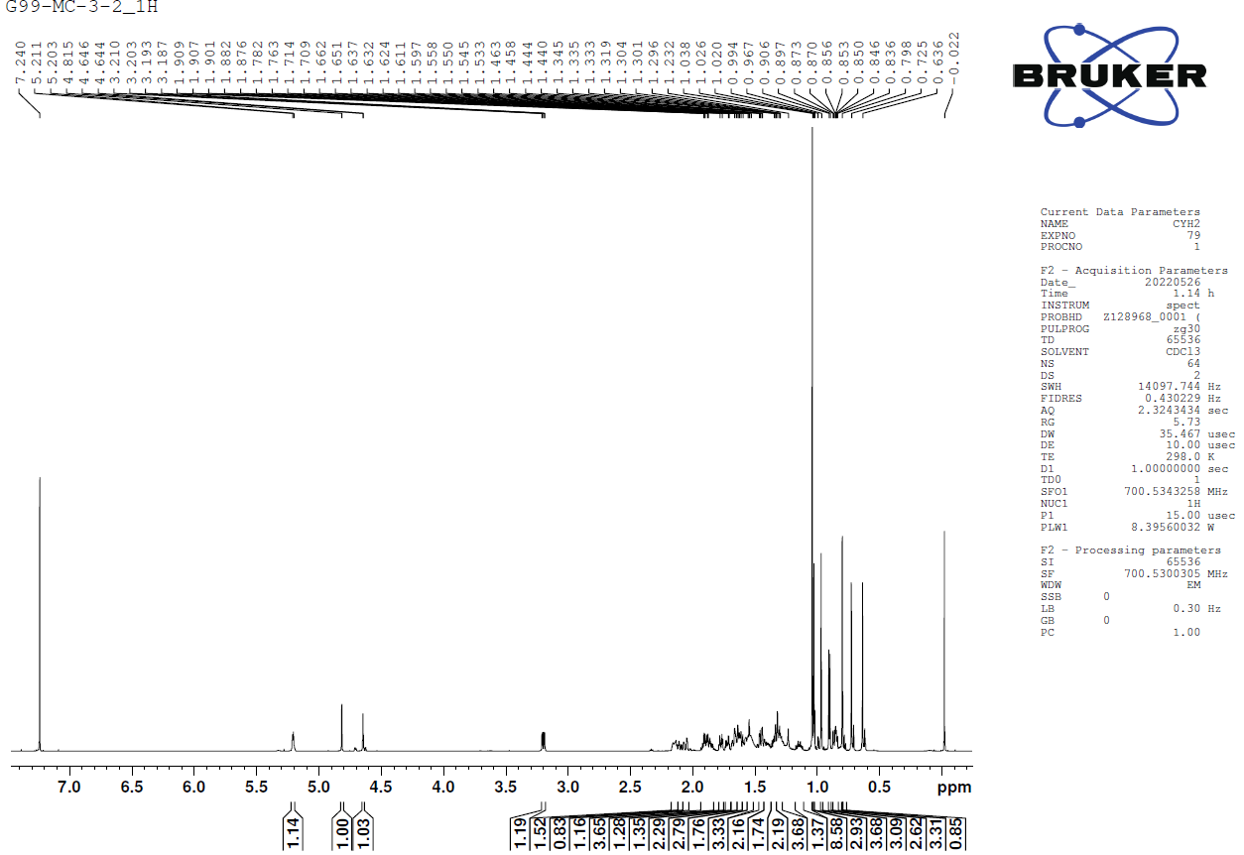
Figure S39. ¹H-NMR spectrum (CDCl₃, 700 MHz) of compound 17
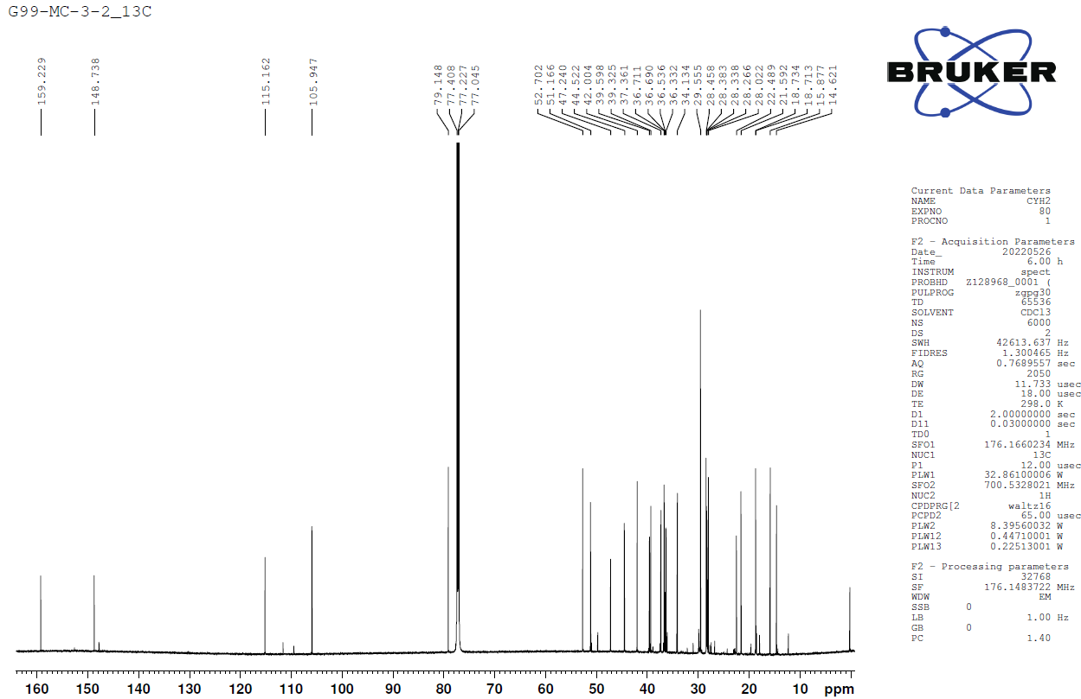
Figure S40. ¹³C-NMR spectrum (CDCl₃, 175 MHz) of compound 17

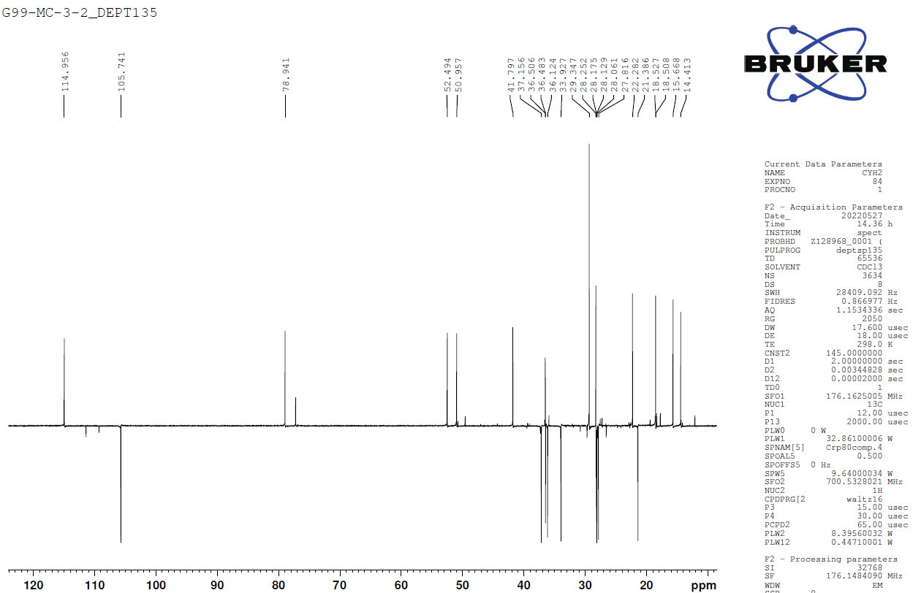
Figure S41. DEPT135 spectrum of compound 17
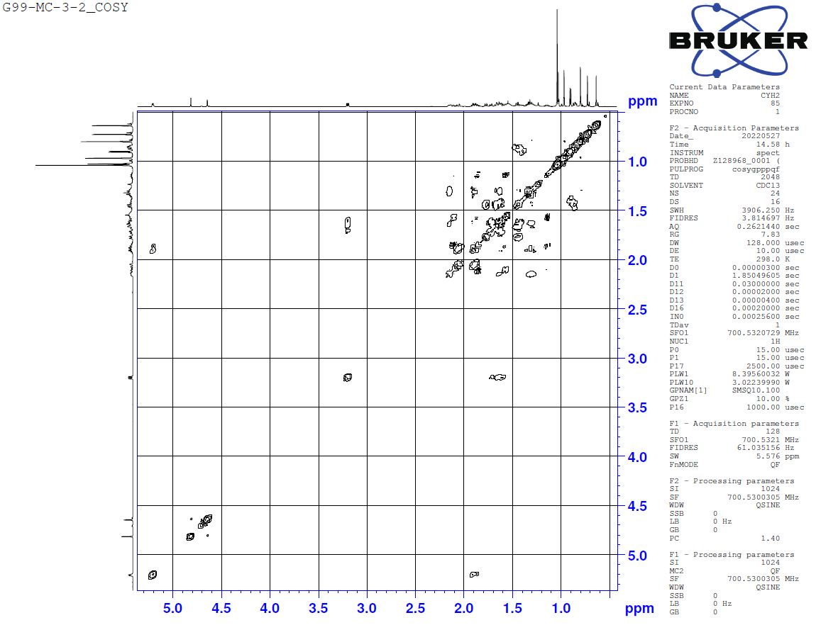
Figure S42. ¹H-¹H COSY spectrum of compound 17
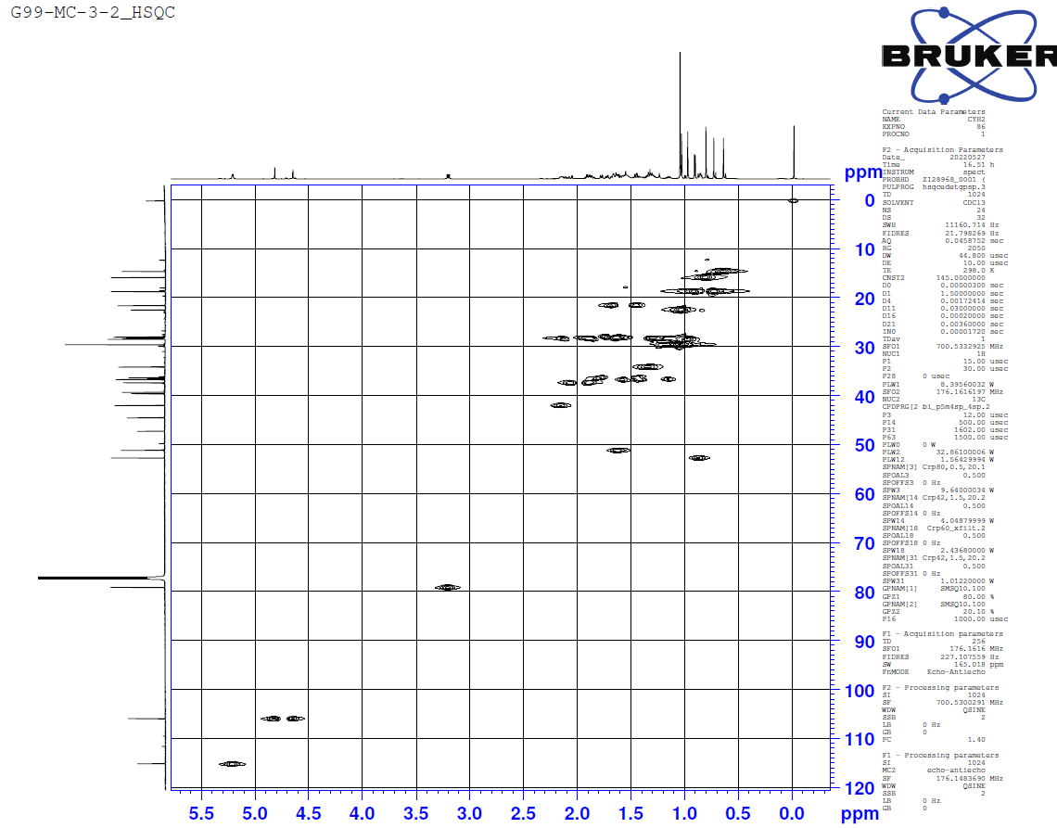
Figure S43. HSQC spectrum of compound 17
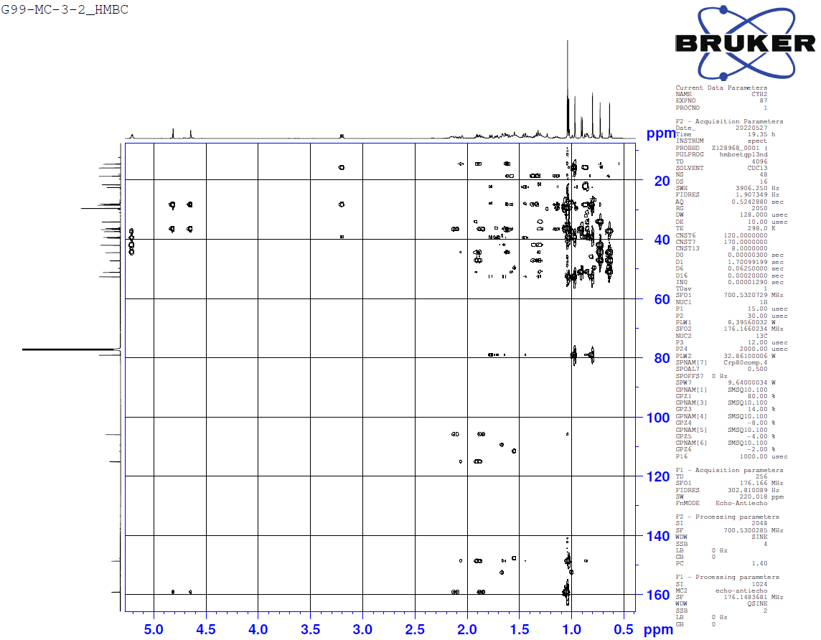
Figure S44. HMBC spectrum of compound 17
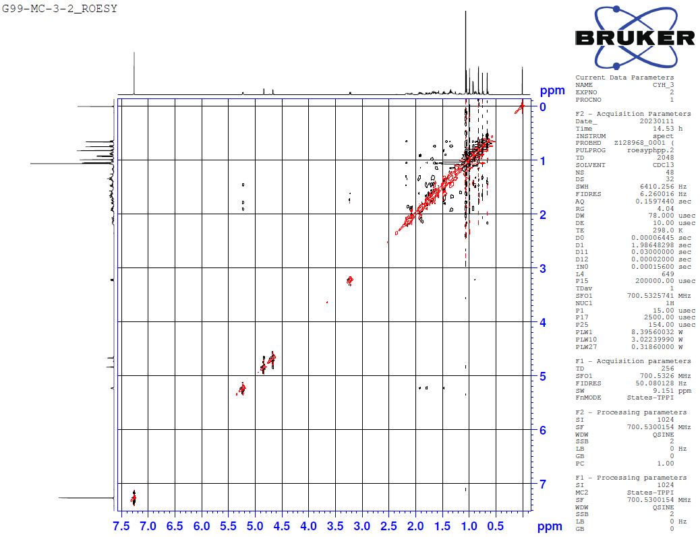
Figure S45. ROESY spectrum of compound 17

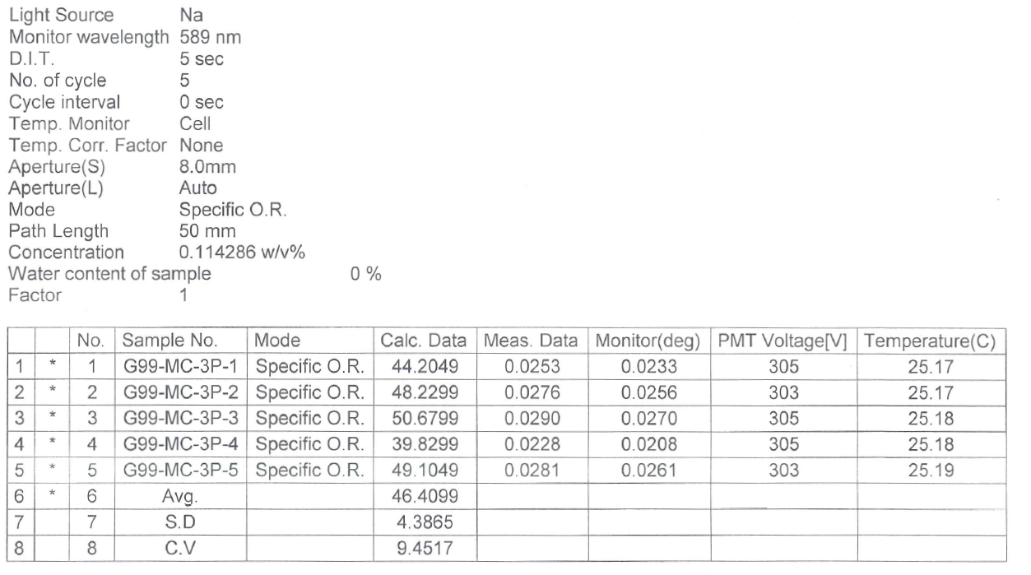
Figure S46. Specific optical rotation of compound 17

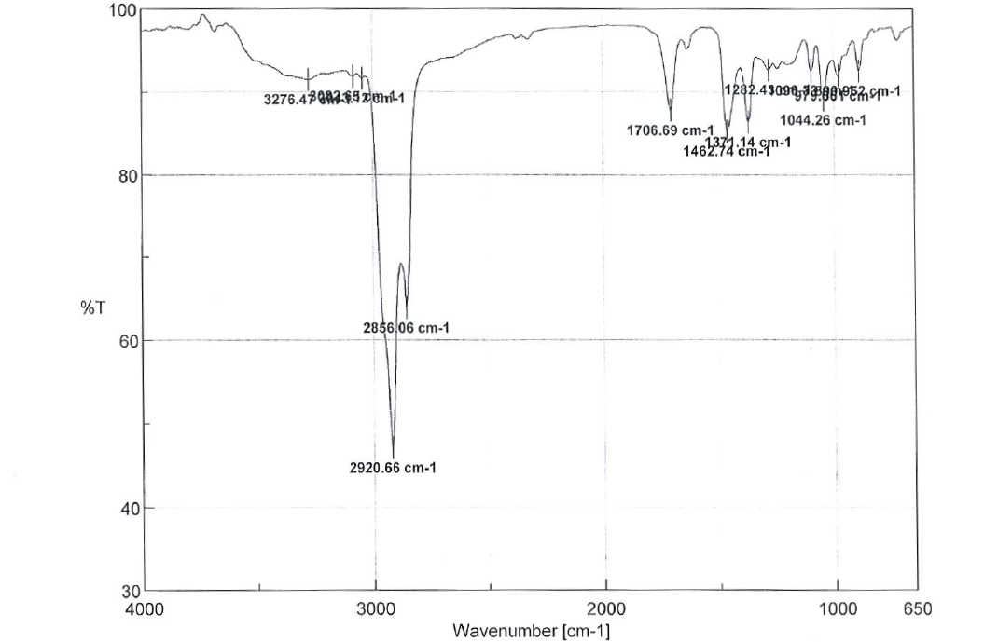
Figure S47. IR spectrum of compound 17

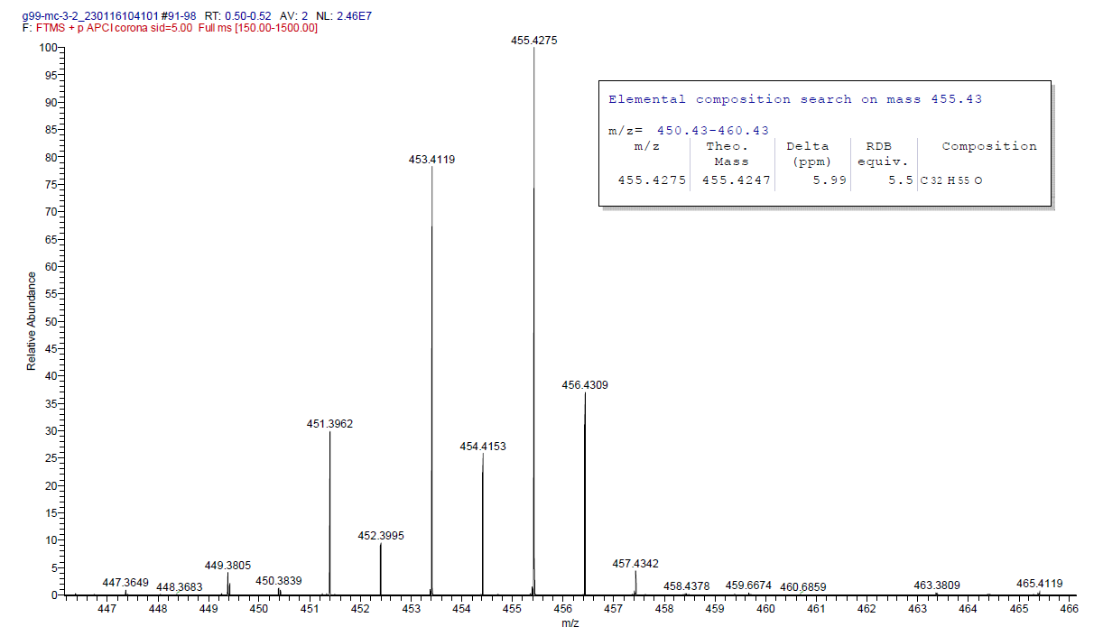
Figure S48. HRESIMS spectrum of compound 17

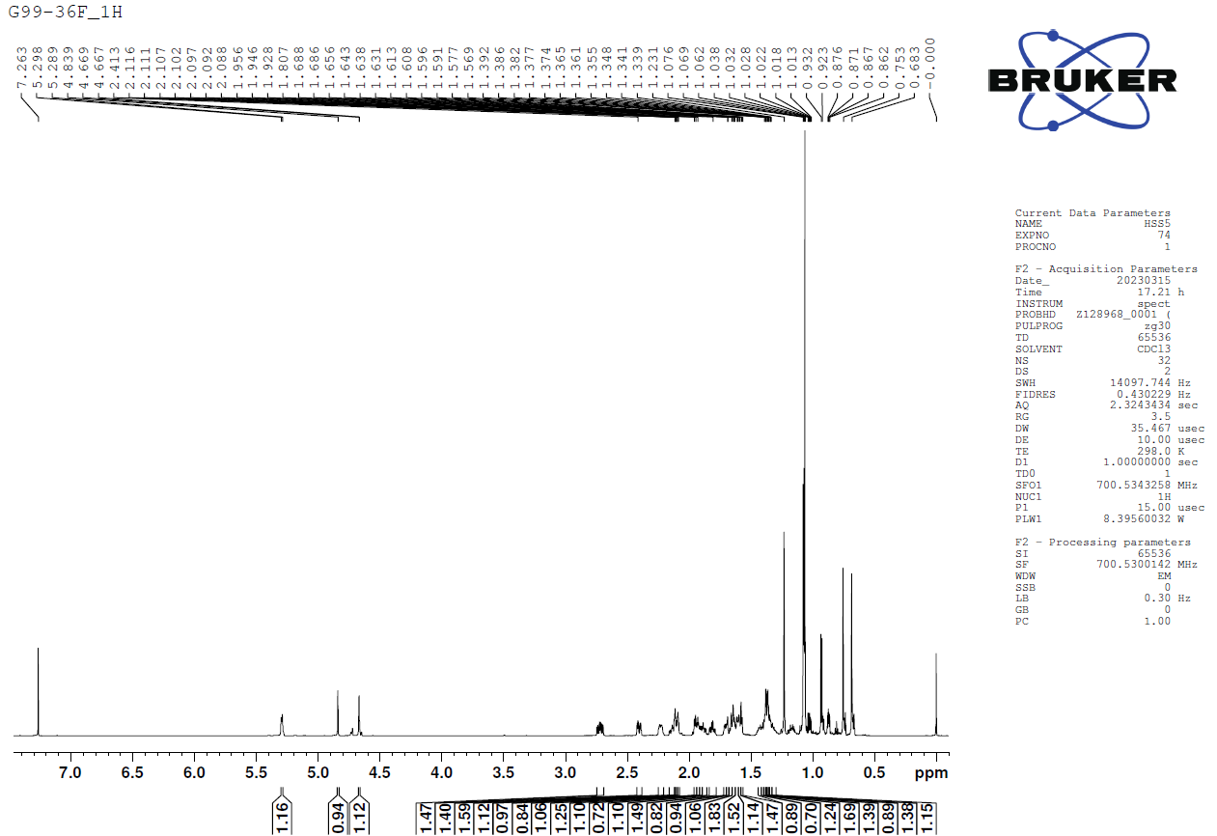
Figure S49. ¹H-NMR spectrum (CDCl₃, 700 MHz) of compound 18
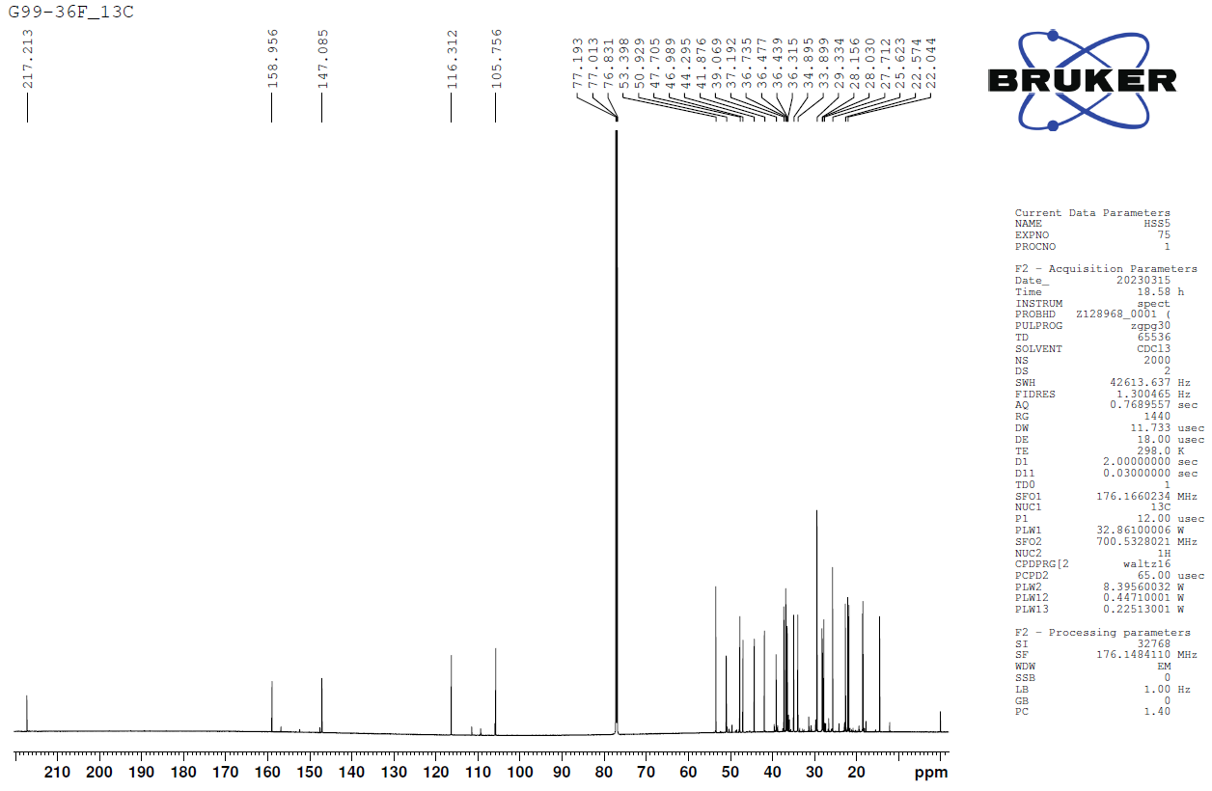
Figure S50. ¹³C-NMR spectrum (CDCl₃, 175 MHz) of compound 18

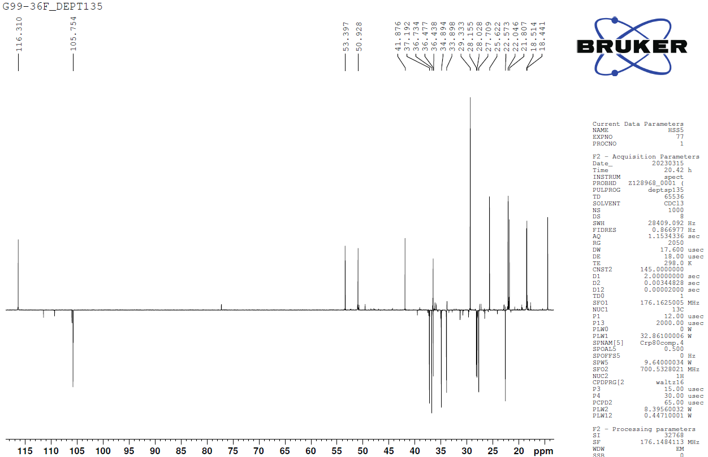
Figure S51. DEPT135 spectrum of compound 18
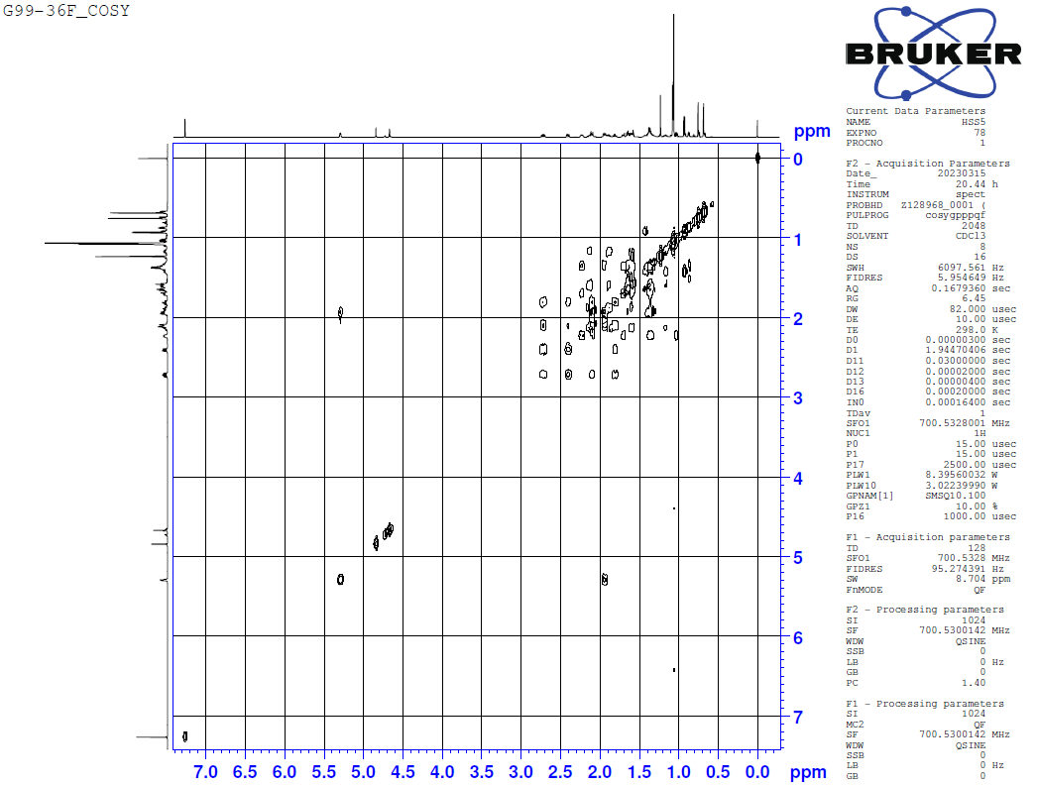
Figure S52. ¹H-¹H COSY spectrum of compound 18

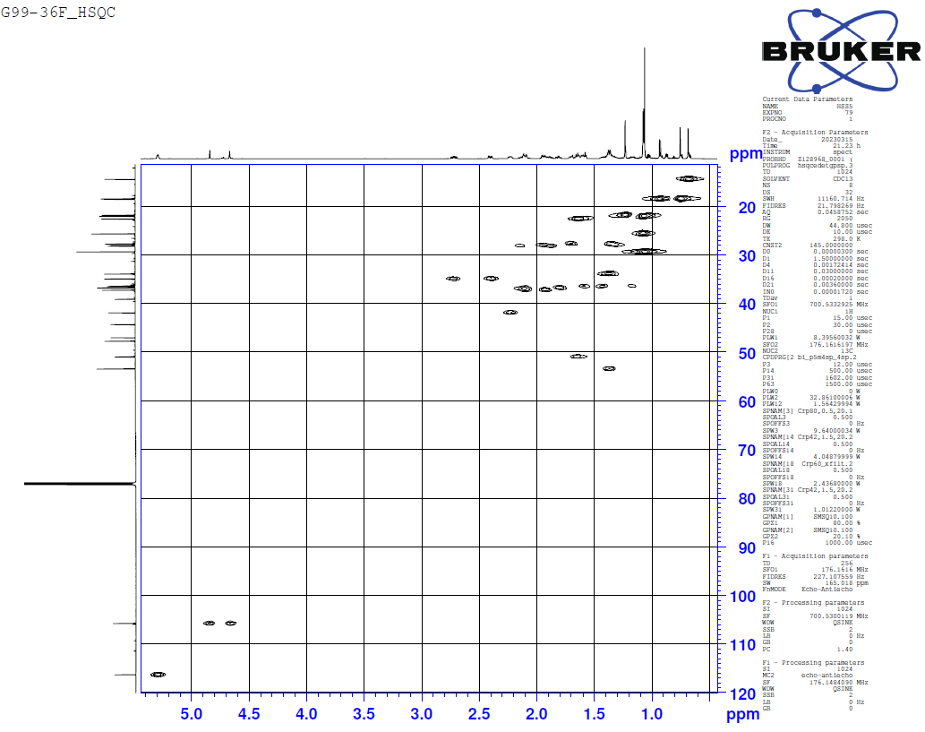
Figure S53. HSQC spectrum of compound 18
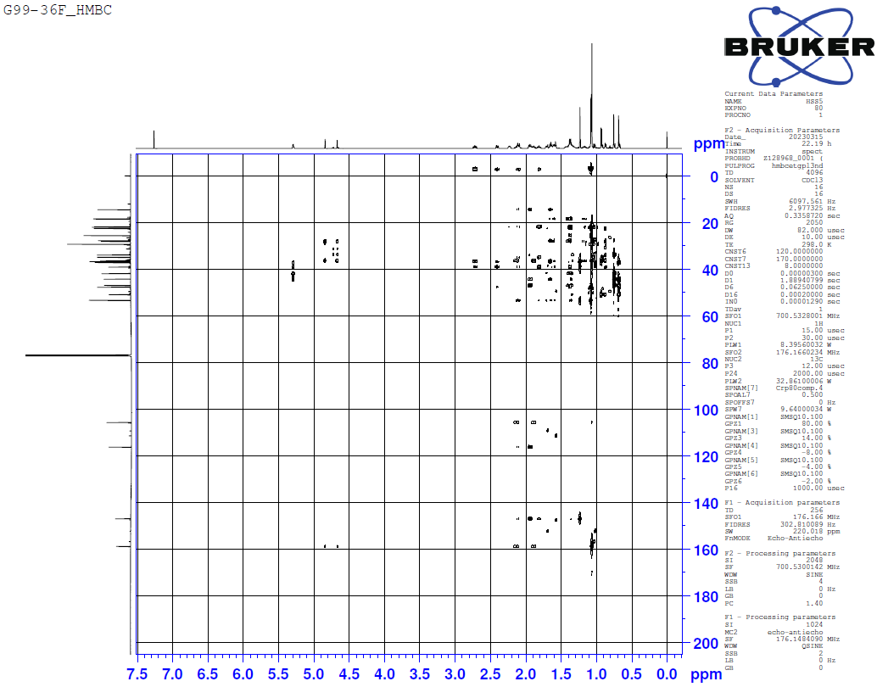
Figure S54. HMBC spectrum of compound 18
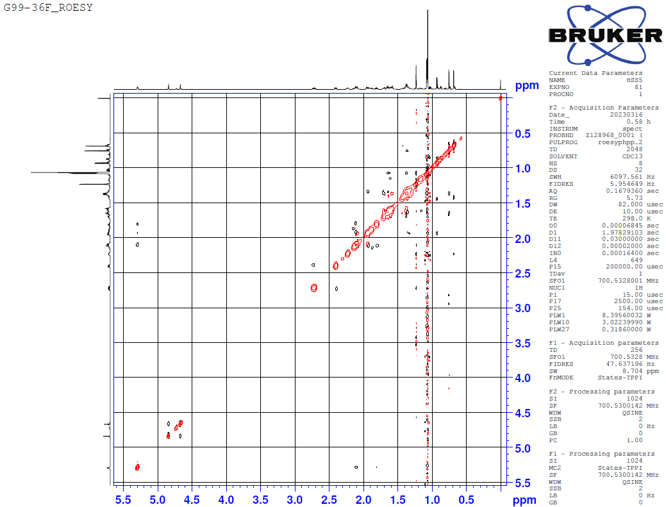
Figure S55. ROESY spectrum of compound 18

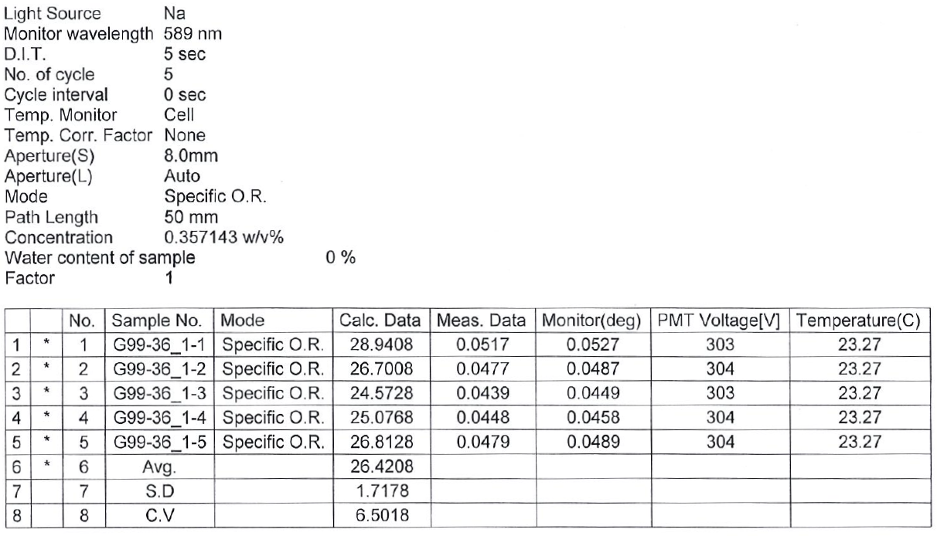
Figure S56. Specific optical rotation of compound 18

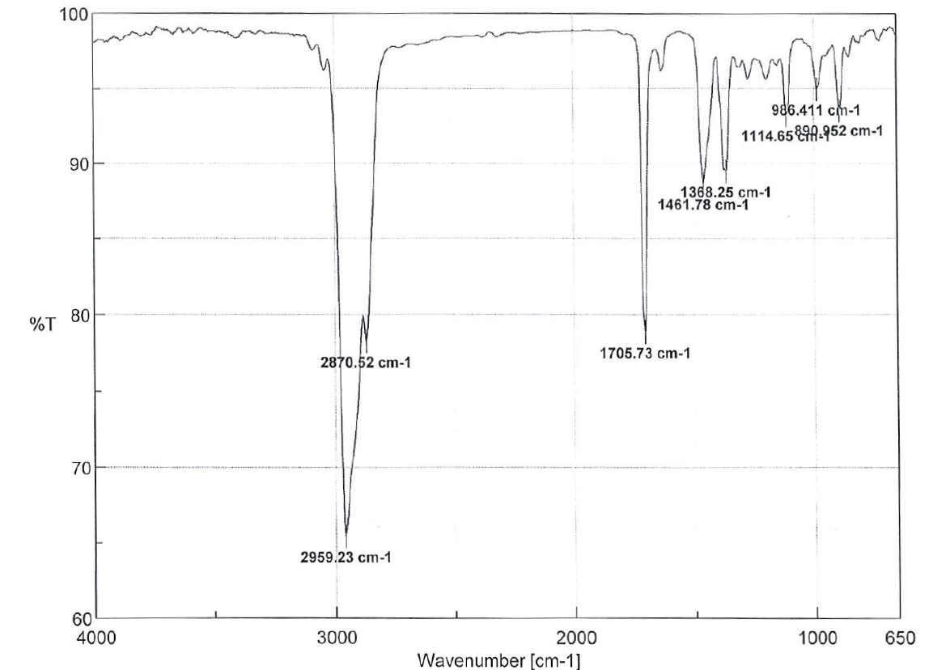
Figure S57. IR spectrum of compound 18

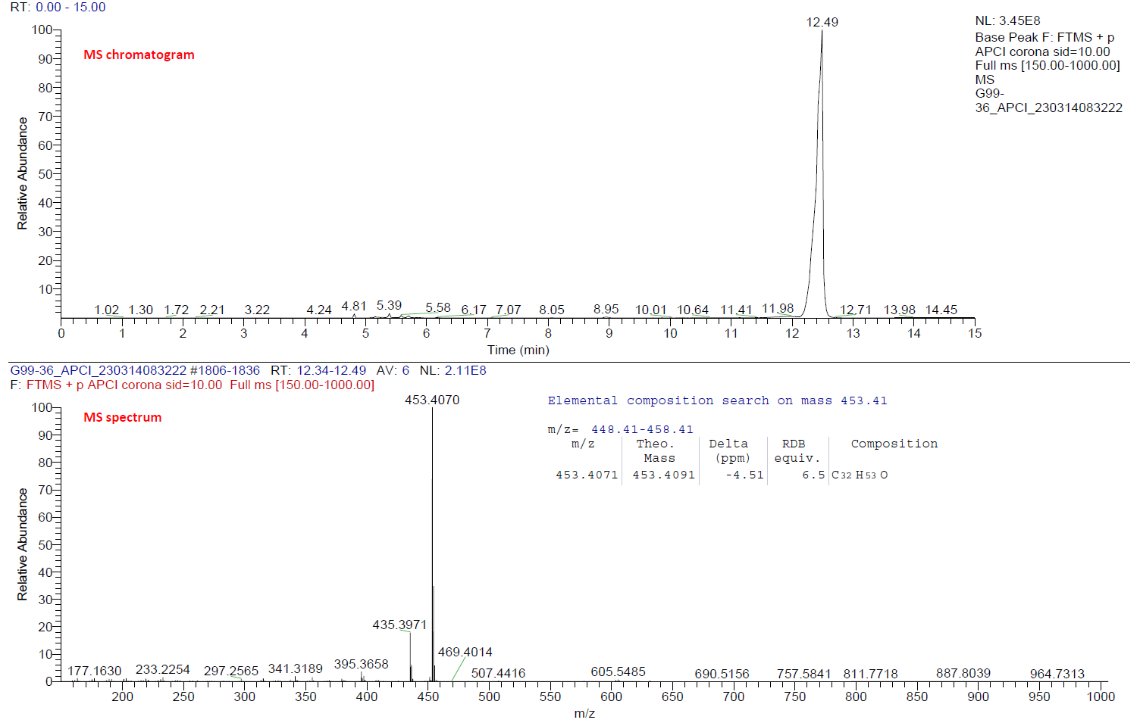
Figure S58. HRESIMS spectrum of compound 18

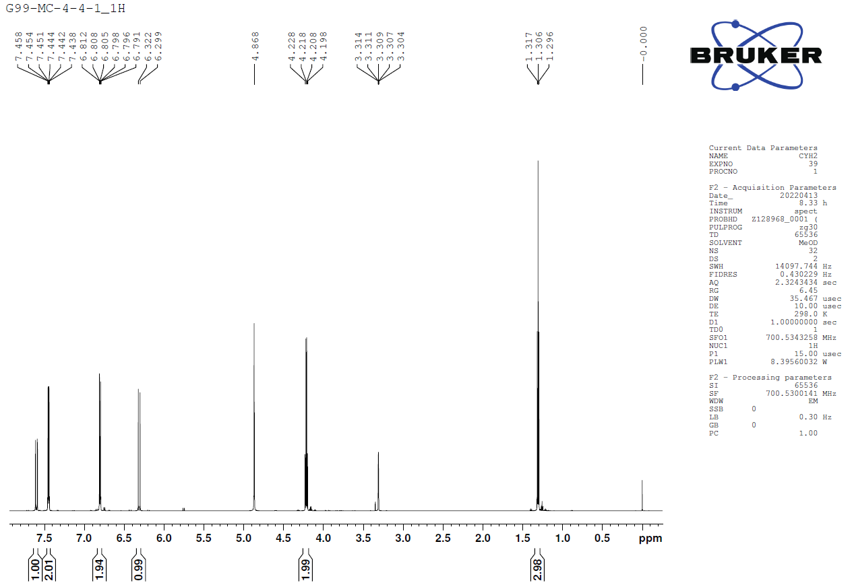
Figure S59. ¹H-NMR spectrum (CD₃OD, 700 MHz) of compound 19
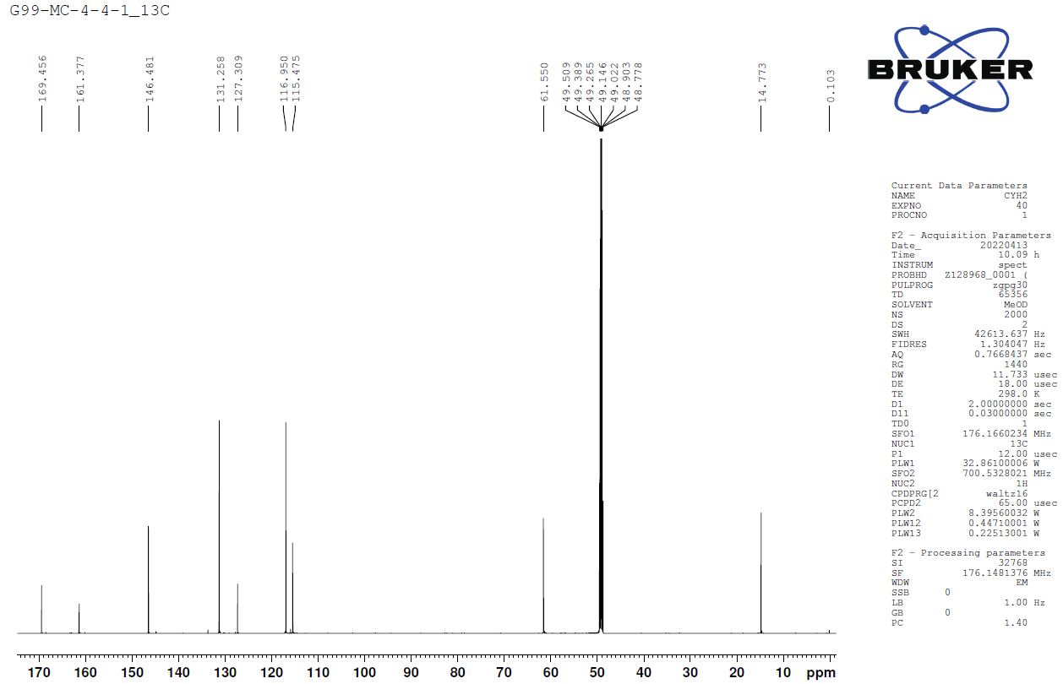
Figure S60. ¹³C-NMR spectrum (CD₃OD, 175 MHz) of compound 19

