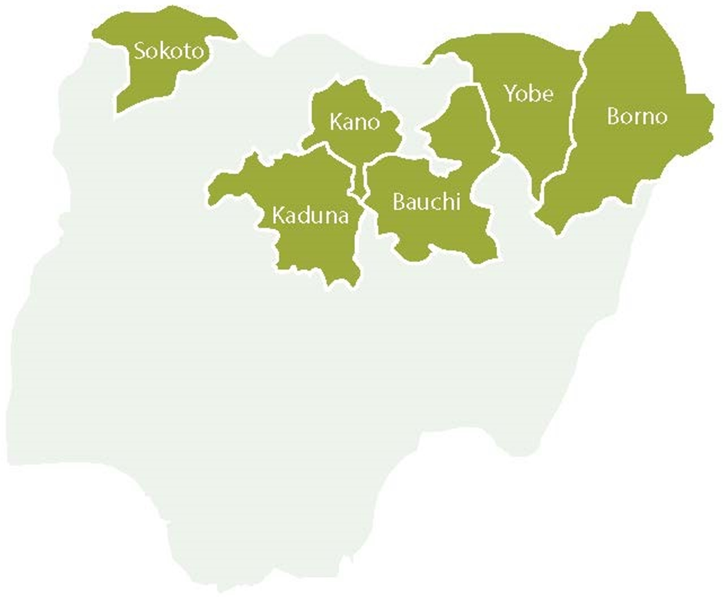
Figure S1: The six (6) Northern states SCIDaR provides RI strengthening support (USAID, 2019)

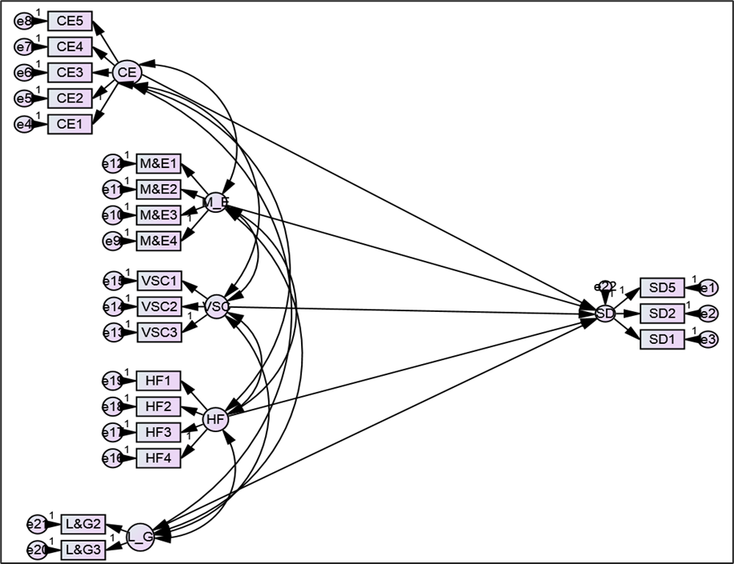
Figure S2: The study model/framework using SEM designed path analysis [Hypothesis H_{2.1} - H_{6.1}]

Table S1: Questionnaire guide for survey
Level | Focus | Participants | Interview method
State | - The perceived effect of COVID-19 on SPHCMB operations and its routine activities  - Impact of the pandemic on the availability of resources and personnel to implement program activities  - The effect on the delivery of essential PHC services across health facilities and LGAs  - Possible strategies to encourage personnel to continue program implementation throughout the pandemic | HCH, ES SPHCMB, Directors, PMs and program officers (2 program officers and directors) | KII
LGA | - The effect of COVID-19 on LGA operations and its routine activities  - The effect on the delivery of essential PHC services across health facilities in LGAs  - The effect of the pandemic on resource availability for PHC services in the LGA | LGHA team (2 respondents per LGA) | KII
Health facility | - The general perspective of community dwellers and health workers on PHC services during the pandemic  - Essential needs of the service providers that will enable continuity of service provision | Service providers, health facility in-charges (2 service providers per HF) | KII
Settlements | - The general perspective of community dwellers on health facility visits during the pandemic  - Possible strategies to motivate community members to access essential services during the pandemic | Traditional leaders, VCMs and caregivers (2 caregivers per settlement/facility) | KII

Table S2: Kaiser-Meyer-Olkin and Bartlett's Test
KMO Measure of Sampling Adequacy. |  | 0.951
Bartlett's Test of Sphericity | Approx. Chi-Square | 5841.294
 | df | 276
 | Sig. | <0.001

Table S3: Initial Eigenvalues and Rotation Sums of Squared Loadings
Comp | Initial Eigenvalues |  |  | Rotation Sums of Squared Loadings
 | Total | % of Variance | Cumulative % | Total | % of Variance | Cumulative %
1 | 13.551 | 56.462 | 56.462 | 6.794 | 28.306 | 28.306
2 | 1.767 | 7.362 | 63.824 | 4.776 | 19.899 | 48.205
3 | 1.185 | 4.938 | 68.762 | 3.483 | 14.513 | 62.718
4 | 1.053 | 4.388 | 73.150 | 2.504 | 10.432 | 73.150
5 | 0.890 | 3.707 | 76.857
6 | 0.634 | 2.641 | 79.498
7 | 0.596 | 2.485 | 81.983
Note: Comp=Component

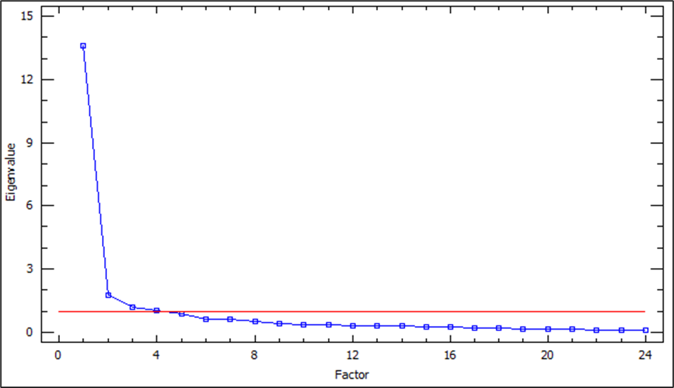
Figure S3: Components with factor loadings matrix

Table S4: Initial Eigenvalues and Rotation Sums of Squared Loadings
Indicators | C1 | Cronbach’s α | C2 | Cronbach’s α | C3 | Cronbach’s α | C4 | Cronbach’s α
SD1 | 0.537 | 0.728
SD2 | 0.678
SD3 | 0.199
SD4 | 0.495
SD5 | 0.643
CE1 | 0.680
CE2 | 0.692
CE3 | 0.766
CE4 | 0.728
CE5 | 0.767
M&E1 | 0.719
M&E2 | 0.659
M&E3 | 0.691
M&E4 | 0.661
VSC1 |  |  |  |  | 0.575 | 0.742
VSC2 |  |  |  |  | 0.543
VSC3 |  |  |  |  | 0.607
HF1 |  |  | 0.787 | 0.861
HF2 |  |  | 0.835
HF3 |  |  | 0.860
HF4 |  |  | 0.784
L&G1 |  |  |  |  |  |  | 0.487 | 0.892
L&G2 |  |  |  |  |  |  | 0.814
L&G3 |  |  |  |  |  |  | 0.837

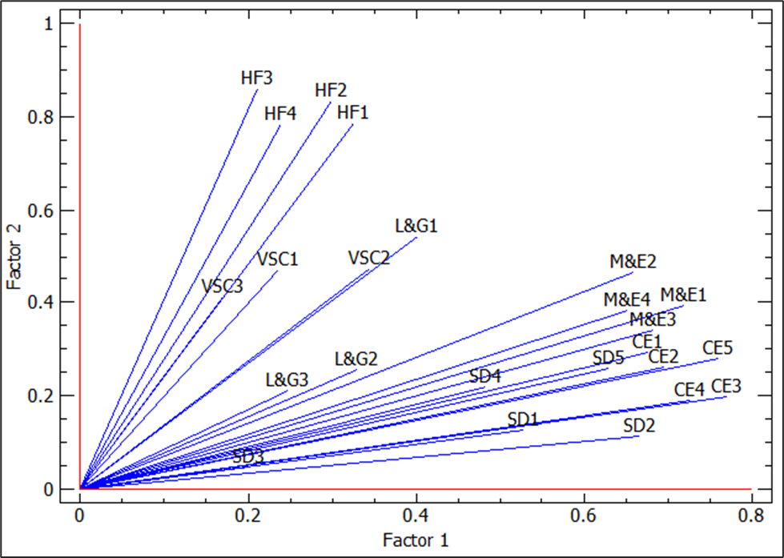
Figure S4: Factor loading in components

