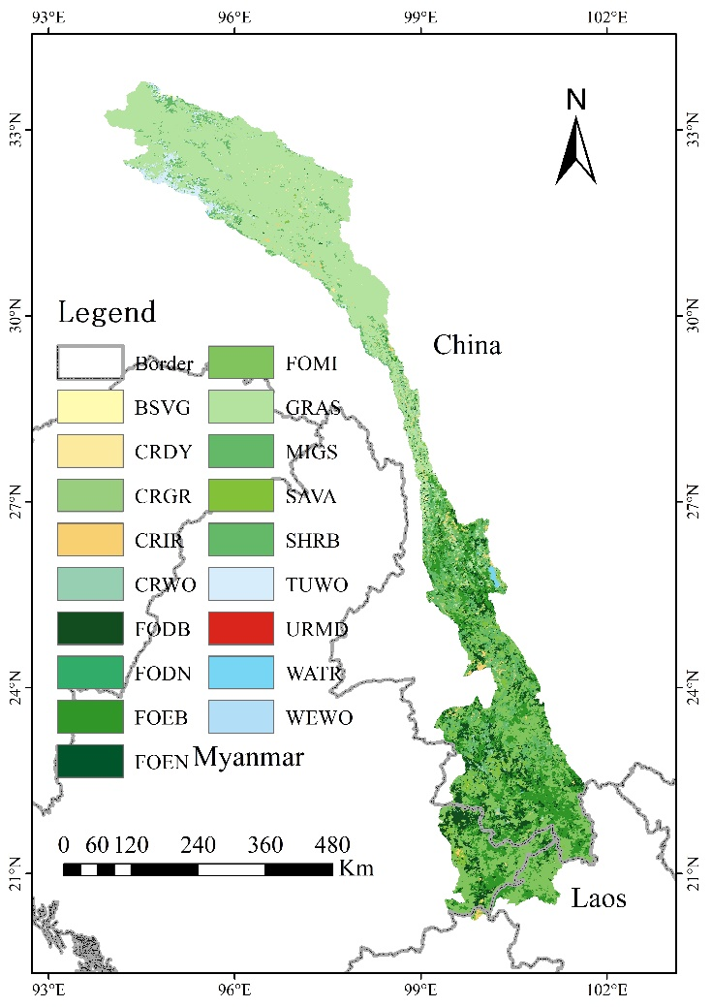
Fig. S1 Map of land use/land cover distribution in the upper Lancang-Mekong River Basin
(Note: BSVG: Barren or Sparsely Vegetated; CRDY: Dryland Cropland and Pasture; CRGR: Cropland/Grassland; CRIR: Irrigated Cropland and Pasture; CRWO: Cropland/Woodland; FODB: Deciduous Broadleaf Forest; FODN: Deciduous Needleleaf Forest; FOEB: Evergreen Broadleaf Forest; FOEN: Evergreen Needleleaf Forest; FOMI: Mixed Forest; GRAS: Grassland; MIGS: Mixed Shrubland/Grassland; SAVA: Savanna; SHRB: Shrubland; TUWO: Wooded Tundra; URMD: Urban and Built-Up Land; WATR: Snow or Ice; WEWO: Wooded Wetland.)

Table S1. Dominant Land Cover Classes in the upper Lancang-Mekong River Basin
Abbreviation | Land Cover Types | Area (% of the basin)
GRAS | Grassland | 38.34%
FOMI | Mixed Forest | 20.70%
FOEB | Evergreen Broadleaf Forest | 15.33%
SHRB | Shrubland | 11.36%
FODB | Deciduous Broadleaf Forest | 8.71%
SAVA | Savanna | 2.42%
TUWO | Wooded Tundra | 1.80%
CRIR | Irrigated Cropland and Pasture | 1.35%

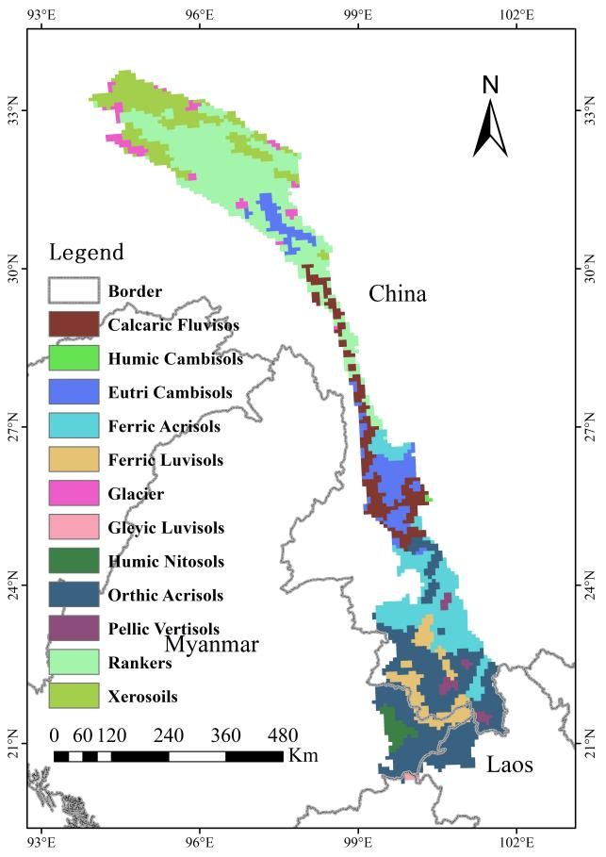
Fig. S2 Map of soil type distribution in the upper Lancang-Mekong River Basin

Table S2. Major Soil Types in the upper Lancang-Mekong River Basin

FAO Soil Name | Area (% of the basin) | Texture | Hydrologic Soil Group* | Moist Bulk Density (g/cm³) | Saturated Hydraulic Conductivity(mm/hr) | Available Water Holding Capacity (mm H₂O/mm soil)
Rankers | 25.07% | LOAM | C | 1.2 | 14.38 | 0.06
Orthic Acrisols | 23.94% | SANDY_CLAY_LOAM | C | 1.3 | 7.27 | 0.06
Ferric Luvisols | 12.98% | SANDY_CLAY_LOAM | C | 1.2 | 14.66 | 0.03
Xerosoils | 11.11% | LOAM | D | 1.4 | 6.24 | 0.07
Calcaric Fluvisols | 7.95% | LOAM | D | 1.4 | 5.21 | 0.17
Eutri Cambisols | 7.89% | LOAM | D | 1.3 | 7.99 | 0.08
Ferric Luvisols | 5.41% | CLAY | C | 1.3 | 9.16 | 0.07
Glacier | 2.34% | UWB | D | 2.5 | 99 | 0.01
Humic Nitosols | 1.83% | CLAY_LOAM | C | 1.2 | 12.6 | 0.17
Pellic Vertisols | 1.39% | CLAY | C | 1.1 | 23.2 | 0.12
Humic Cambisols | 0.09% | LOAM | C | 1.0 | 33.91 | 0.06
(*Note: Hydrologic Soil Group has been divided into four groups (Neitsch et al., 2011): A: (Low runoff potential). The soils have a high infiltration rate even when thoroughly wetted. They chiefly consist of deep, well drained to excessively drained sands or gravels. They have a high rate of water transmission. B: The soils have a moderate infiltration rate when thoroughly wetted. They chiefly are moderately deep to deep, moderately well-drained to well-drained soils that have moderately fine to moderately coarse textures. They have a moderate rate of water transmission. C: The soils have a slow infiltration rate when thoroughly wetted. They chiefly have a layer that impedes downward movement of water or have moderately fine to fine texture. They have a slow rate of water transmission. D: (High runoff potential). The soils have a very slow infiltration rate when thoroughly wetted. They chiefly consist of clay soils that have a high swelling potential, soils that have a permanent water table, soils that have a claypan or clay layer at or near the surface, and shallow soils over nearly impervious material. They have a very slow rate of water transmission.)

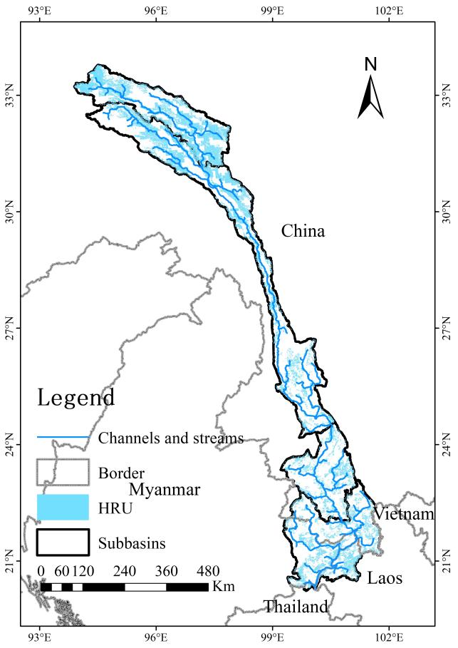
Fig. S3 The channels and streams in the upper Lancang-Mekong River basin

Reference
Neitsch S L, Arnold J G, Kiniry J R, et al. Soil and water assessment tool theoretical documentation version 2009[R]. Texas Water Resources Institute, 2011.

