Supporting Information for:
High-performance wearable Bi₂Te₃-based thermoelectric generator
Yubing Xing¹, Kechen Tang¹, Jiang Wang¹, Kai Hu¹, Yani Xiao¹, Jianan Lyu^{1,2}, Junhao Li¹, Yutian Liu¹, Peng Zhou³, Yonggao Yan^{1*}, Dongwang Yang^{1*}
¹State Key Laboratory of Advanced Technology for Materials Synthesis and Processing, Wuhan University of Technology, Wuhan 430070, China
²Nanostructure Research Center, Wuhan University of Technology, Wuhan 430070, China
³Research Center for Materials Genome Engineering, Wuhan University of Technology, Wuhan 430070, China

* Correspondence and requests for materials should be addressed to Yonggao Yan (yanyonggao@whut.edu.cn) or to Dongwang Yang (ydongwang@whut.edu.cn).

Figure S1. Finite element model of w-TEG.

Table S1. Thermoelectric material properties in the temperature range 303 to 333K.
Materials | Parameters | Value
p-type Bi_{0.5}Sb_{1.5}Te₃ | Electrical conductivity  (10⁴ S m⁻¹)  Thermal conductivity  (W m⁻¹ K⁻¹)  Seebeck coefficient  (μV K⁻¹) | 8.19~9.76  1.53~1.58  223~231
n-type Bi₂Te_{2.7}Se_{0.3} | Electrical conductivity  (10⁴ S m⁻¹)  Thermal conductivity  (W m⁻¹ K⁻¹)  Seebeck coefficient  (μV K⁻¹) | 9.91~11.1  1.76~1.81  -214~-212

Table S2. Material properties used in the simulation.
Materials | Thermal conductivity  (W m⁻¹ K⁻¹) | Electrical resistivity  (ohm·m)
AlN | 195~270 | --
Cu | 401 | 1.55×10⁻⁸~2.78×10⁻⁸
Solder  Skin | 55  11.8~14.2 | 1.14×10⁻⁷  --
Ag | 420 | --

Figure S2. TEG unit and its internal structure.

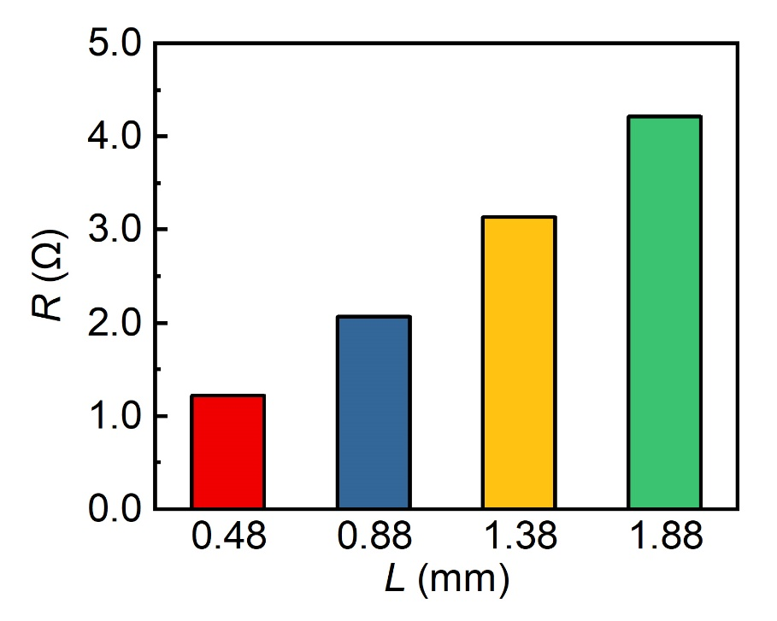
Figure S3. Resistance of TEG with different thermoelectric leg lengths.

