Supplementary Materials

Type of the Paper (Article)
Ultrafast energy transfer dynamics in a cyanobacterial light-harvesting phycobilisome

Chao Xiao ¹, Na Guo ¹, Zidong Liang ¹, Zhencheng Huang ¹, Wenjun Li ^{2, 3}, Mingyuan Xie ^{1,} * and Fuli Zhao ^{1,}*
¹ School of physics, State Key Laboratory of Optoelectronic Materials and Technologies, Sun Yat-sen University, Guangzhou, 510275, China; xiaoch23@mail2.sysu.edu.cn; (C.X.), guon28@mail2.sysu.edu.cn; (N.G.), liangzd@mail2.sysu.edu.cn; (Z.L.), hzhench2@mail.sysu.edu.cn; (Z.H.)
² Yantai Institute of Coastal Zone Research, Chinese Academy of Sciences, Yantai, 264003, China; wjli@yic.ac.cn; (W.L.)
³ Center for Ocean Mega-Science, Chinese Academy of Sciences, Qingdao 266071, China
* Correspondence: xiemy5@mail.sysu.edu.cn; (M.X.), stszfl@mail.sysu.edu.cn; (F.Z.)
Supplementary Figures:

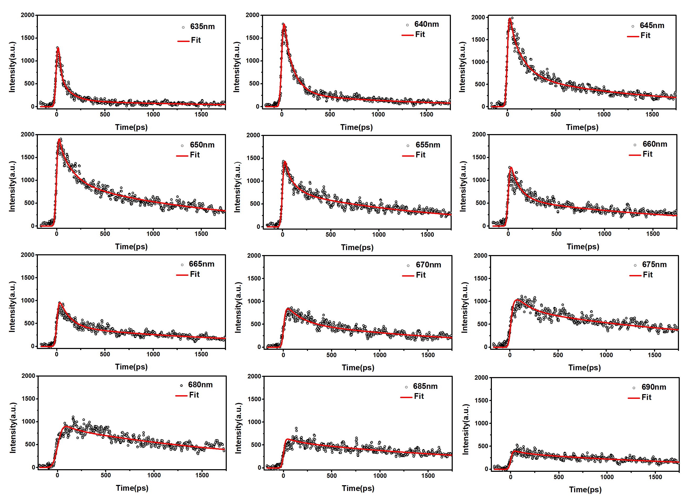
Figure S1. Fluorescence intensity decay curves and fitting results of PBS from T. 2134 at 77K on excitation at 498 nm. The detection wavelengths were 635nm, 640nm, 645nm, 650nm, 655nm, 660nm, 665nm, 670nm, 675nm, 680nm, 685nm, and 690nm. The experiment data is represented by black circles, and the fitting results are represented by red lines.
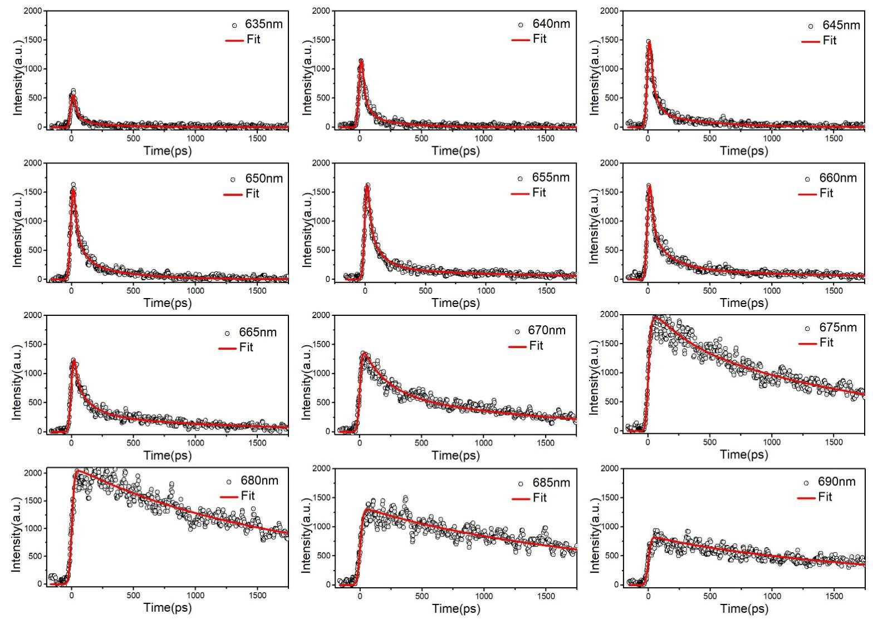
Figure S2. Fluorescence intensity decay curves and fitting results of PBS from T. 2134 at 77K on excitation at 570 nm. The detection wavelengths were 635nm, 640nm, 645nm, 650nm, 655nm, 660nm, 665nm, 670nm, 675nm, 680nm, 685nm, and 690nm. The experiment data is represented by black circles, and the fitting results are represented by red lines.

Supplementary Tables:
Table S1. The deconvolution results of T. 2134 on excitation at 498nm.
E_{em}/nm | τ₁/ps | A₁/% | τ₂/ps | A₂/% | τ₃/ps | A₃/% | τ₄/ps | A₄/% | χ²
630 | 8.9 | 79.4 | 25.7 | 12.9 | 105.1 | 5.6 | 2061 | 2.2 | 2.7
635 | 10 | 60.8 | 24.8 | 17.3 | 111.2 | 18.2 | 1553 | 3.8 | 1.5
640 | 9.8 | 9.8 | 20.8 | 24.4 | 105 | 56.2 | 1317 | 9.6 | 0.9
645 | 6.8 | 3.9 | 17.9 | 30.4 | 140.5 | 42.9 | 1392 | 22.9 | 0.6
650 | 9.9 | -5.1 | 11.8 | 42 | 141 | 28.6 | 1595 | 29.4 | 0.5
655 | 7.9 | -10.5 | 16.3 | 39.3 | 105 | 28.4 | 1636 | 32.3 | 0.7
660 | 9.2 | -13.3 | 21.6 | 20.3 | 104.6 | 47.5 | 1814 | 32.2 | 1
665 | 7.9 | -14.8 | 18.6 | -6.9 | 109.3 | 63.8 | 1893 | 36.2 | 0.9
670 | 7.6 | -23.5 | 25.5 | -22.2 | 146.2 | 45.3 | 1732 | 54.7 | 0.8
675 | 10.5 | -23.2 | 32.7 | -55.6 | 128 | 39.3 | 2178 | 60.8 | 0.7
680 | 6.7 | -5.3 | 21.0 | -14.3 | 108 | 15.1 | 2165 | 84.9 | 0.7
685 | 8.8 | -4 | 19.8 | -2.8 | 127.7 | 13.4 | 2357 | 86.6 | 0.9
690 | 9 | -4.3 | 27.5 | -2.4 | 121.7 | 15.7 | 2078 | 84.3 | 0.9
Average | 9 |  | 23 |  | 120 |  | 1817

Table S2. The deconvolution results of T. 2134 on excitation at 570 nm.
E_{em}/nm | τ₁/ps | A₁/% | τ₂/ps | A₂/% | τ₃/ps | A₃/% | τ₄/ps | A₄/% | χ²
630 | 10 | 91.8 | 59.1 | 8.3 | - | - | - | - | 4.3
635 | 12.4 | 76.4 | 63.3 | 18.2 | 378.3 | 5.4 | - | - | 2.3
640 | 10.5 | 75.8 | 57.1 | 19.3 | 328.5 | 4.9 | - | - | 1.8
645 | 9.7 | 72.6 | 52.5 | 21.8 | 448.7 | 5.6 | - | - | 1.5
650 | 10.6 | 73.2 | 70.9 | 19.8 | 404.5 | 7 | - | - | 1
655 | 16.5 | 65.6 | 66.9 | 18.5 | 167 | 11 | 1754 | 4.8 | 0.9
660 | 12.6 | 65.9 | 46.4 | 15.5 | 189.8 | 14.4 | 1803 | 4.2 | 1.2
665 | 16.4 | 51.4 | 48.4 | 12 | 144.9 | 24.4 | 1306 | 12 | 0.9
670 | 14.4 | -11.4 | 41.3 | 5.2 | 198.3 | 52 | 1542 | 42.7 | 0.6
675 | 17.1 | -15.9 | 47.8 | -14.1 | 252.3 | 26.2 | 1820 | 73.8 | 0.5
680 | 8.1 | -8.2 | 78.2 | -3.2 | 731.3 | 19.5 | 2579 | 80.5 | 0.4
685 | 12 | -2.7 | 41.6 | -2.7 | 462.7 | 7.8 | 2441 | 92.2 | 0.6
690 | 12.5 | -1.6 | 45.1 | -1.3 | 305.5 | 5.9 | 2111 | 94 | 0.7
Average | 13 |  | 55 |  | 334 |  | 1920

