Supplementary Materials

Assessment of the Effect of International Maritime Regulations on Air Quality in the Southern North Sea.
Ward Van Roy*ª, Jean-Baptiste Merveilleª, Kobe Scheldemanª, Annelore Van Nieuwenhoveª, Benjamin Van Roozendaelª, Ronny Schallierª, Frank Maes^{b}
ª Royal Belgian Institute of Natural Sciences, 1000 Brussels, Belgium
^{b} University Ghent, Faculty of Law & Criminology, 9000 Ghent, Belgium

Supplementary Figures

Supplementary Tables

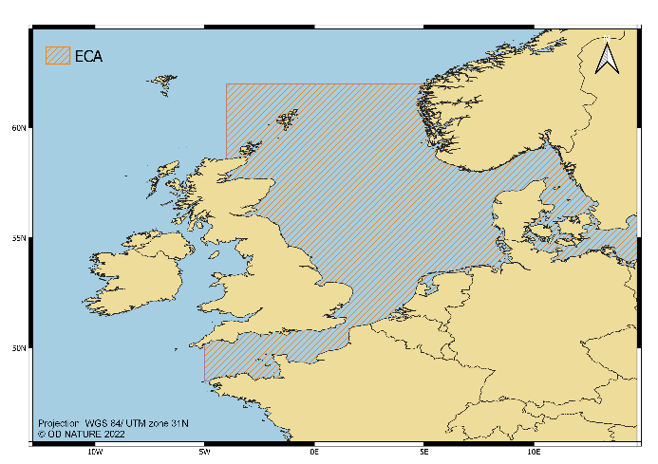
A
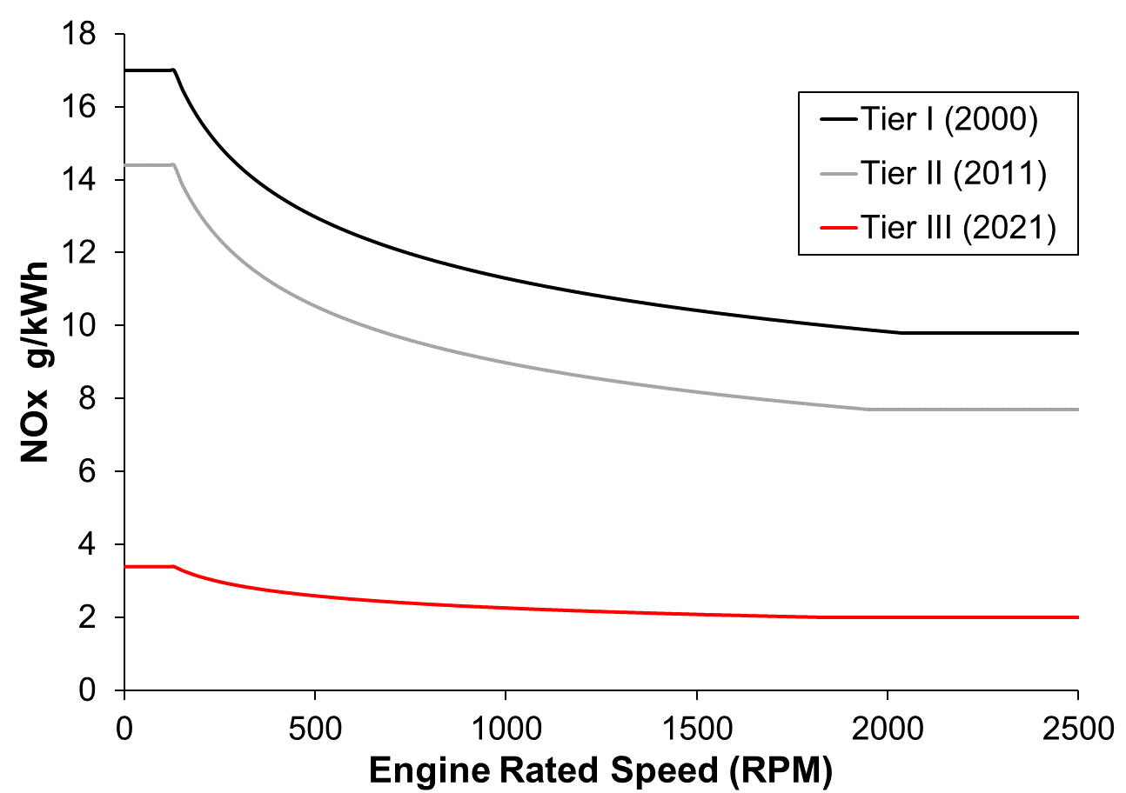
B
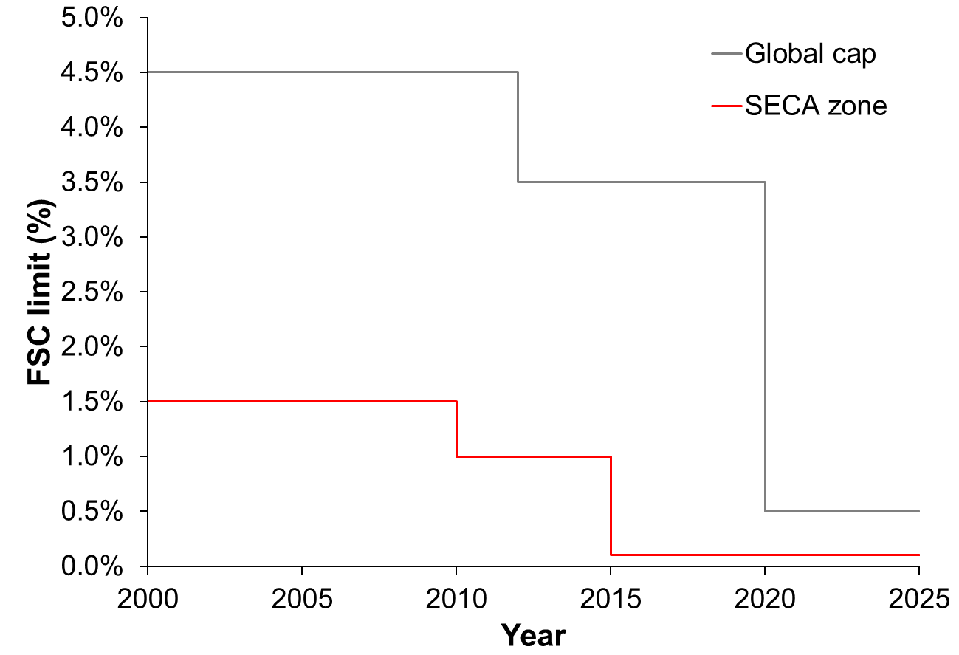
C
Figure S.1. Emission Control Area (ECA) as defined by MARPOL Annex VI (A). Limits on the Fuel Sulfur Content of marine fuels according to the MARPOL Annex VI regulation 14 (B). NOx emission limits according to MARPOL Annex VI Regulation 13 (C).

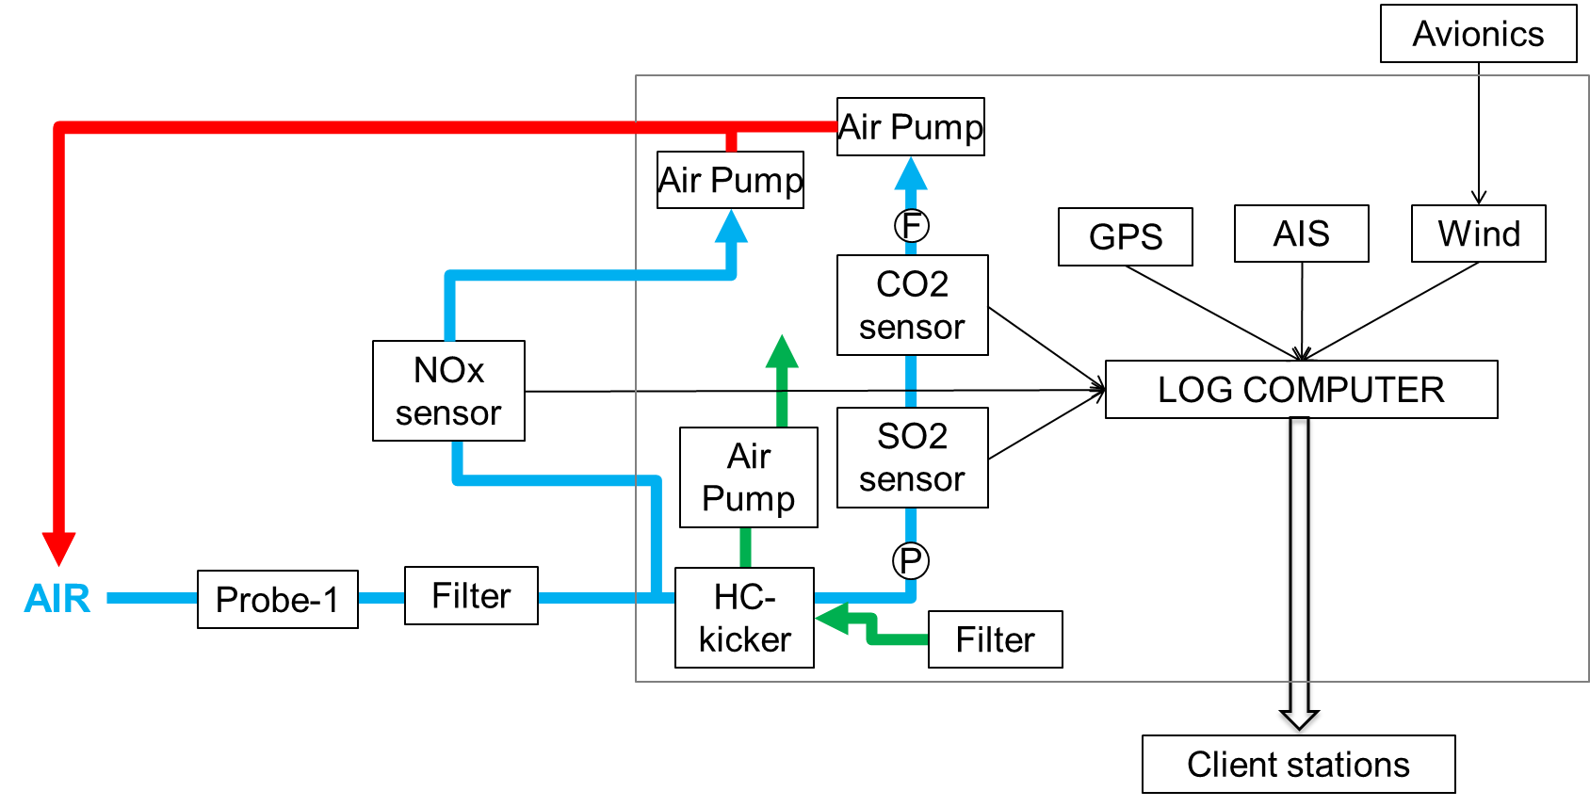
Figure S.2. Schematic overview of the updated sniffer sensor system, with NOx sensor and HC kicker.

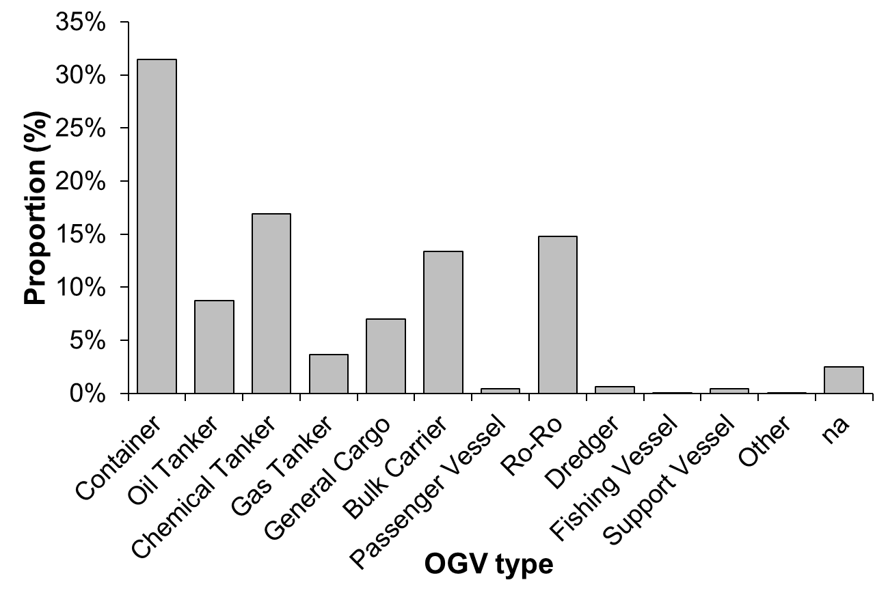
Figure S.3. Distribution of the observed OGVs according to OGV type.

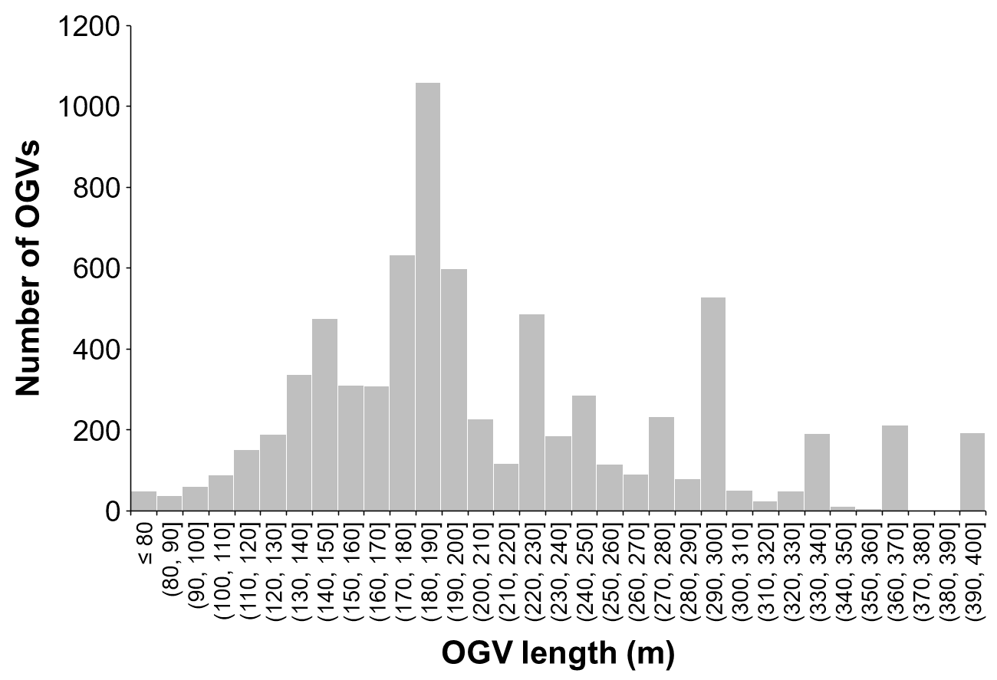
Figure S.4. Distribution of the observed OGVs according to OGV length (m).

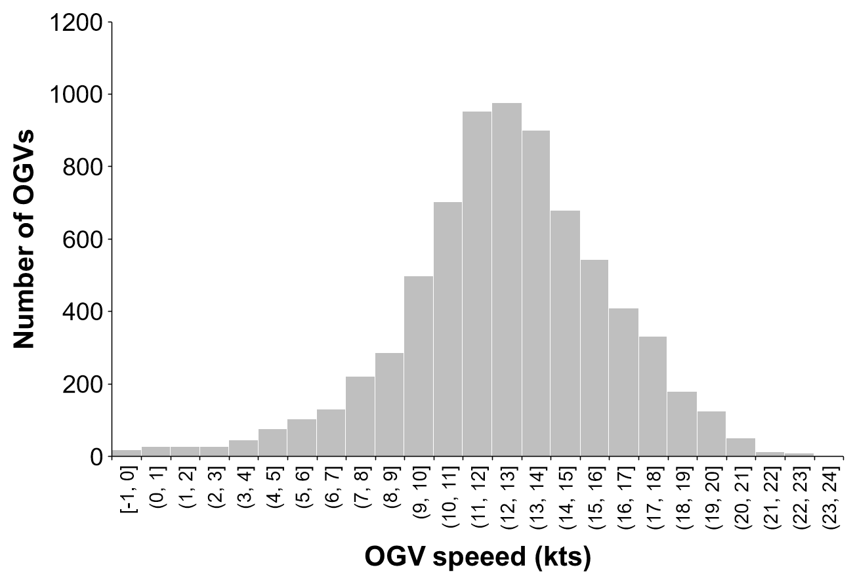
Figure S.5. Distribution of the speed of the observed OGVs.

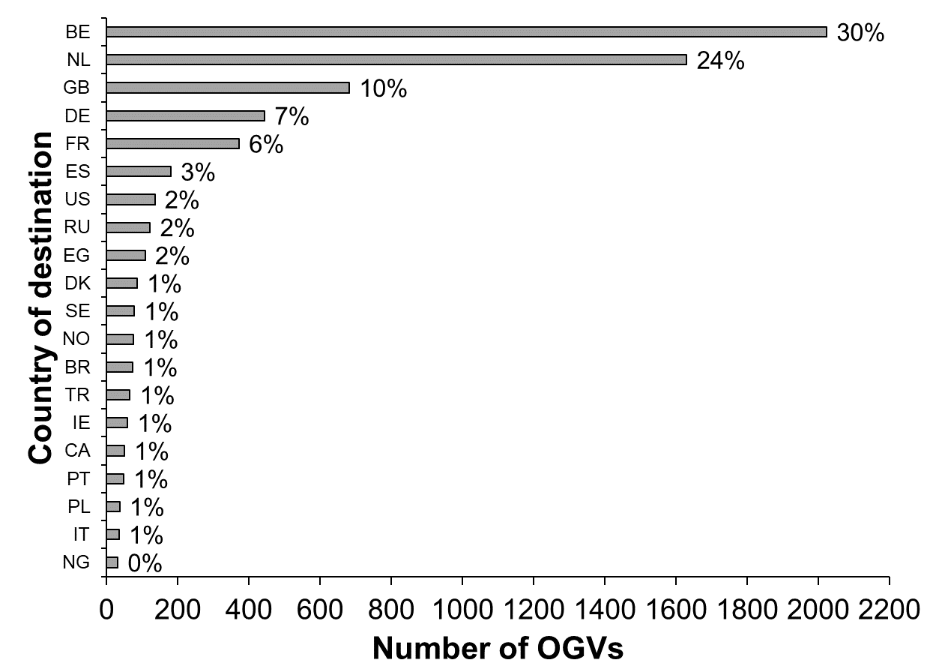
A
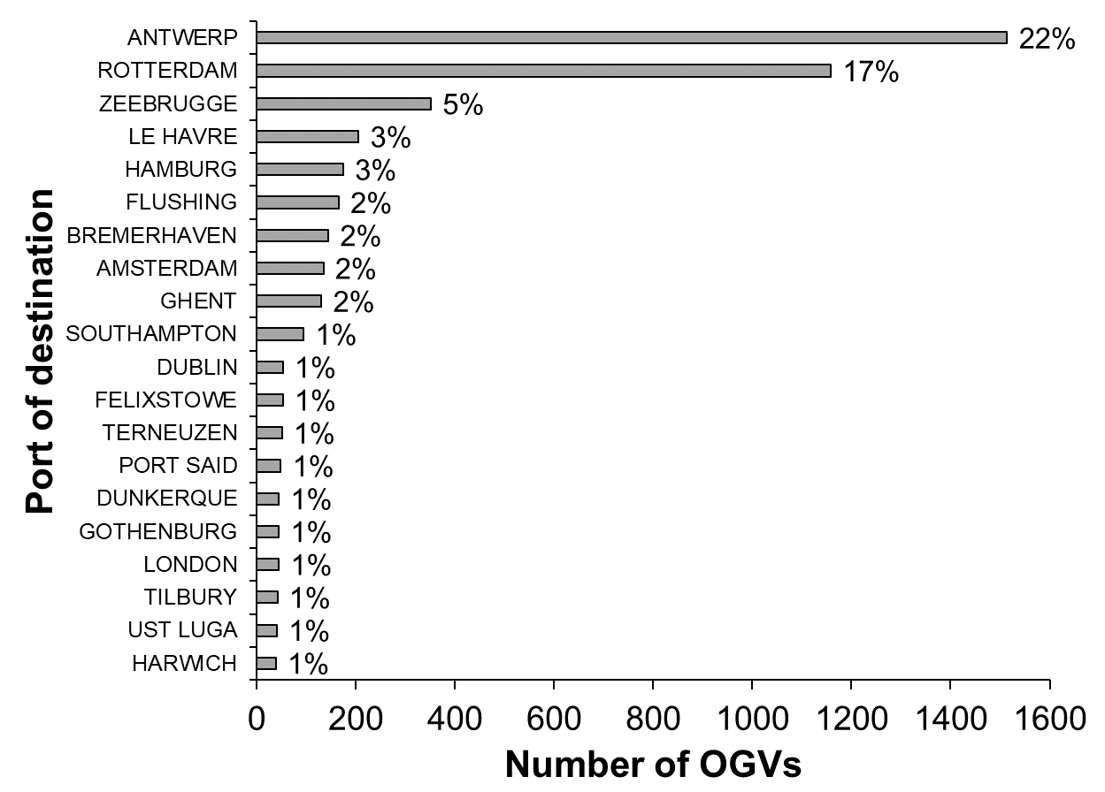
B
Figure S.6. Distribution of 20 most observed countries (A) and ports of destination, based on the AIS information transmitted by the OGVs (B).

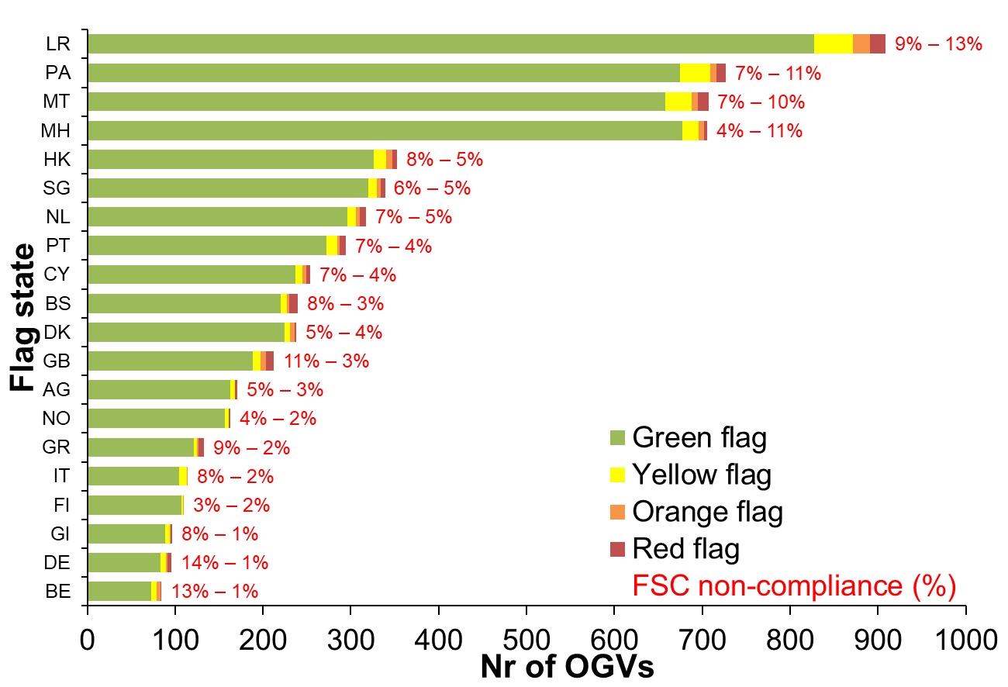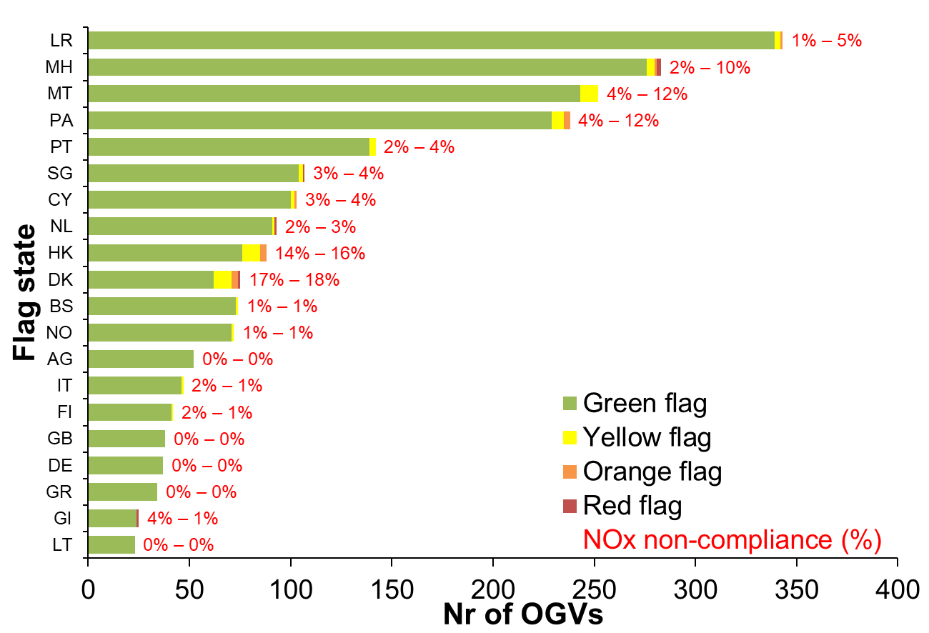
B
A
Figure S.7. Non-compliance for FSC (A) and NO_{x} (B) according to flag state. The left non-compliance rate (%) is based on the non-compliance rate per flag state, the right percentage is the proportion of the number of non-compliant OGVs per flag state compared to the overall number of observed non-compliant OGVs

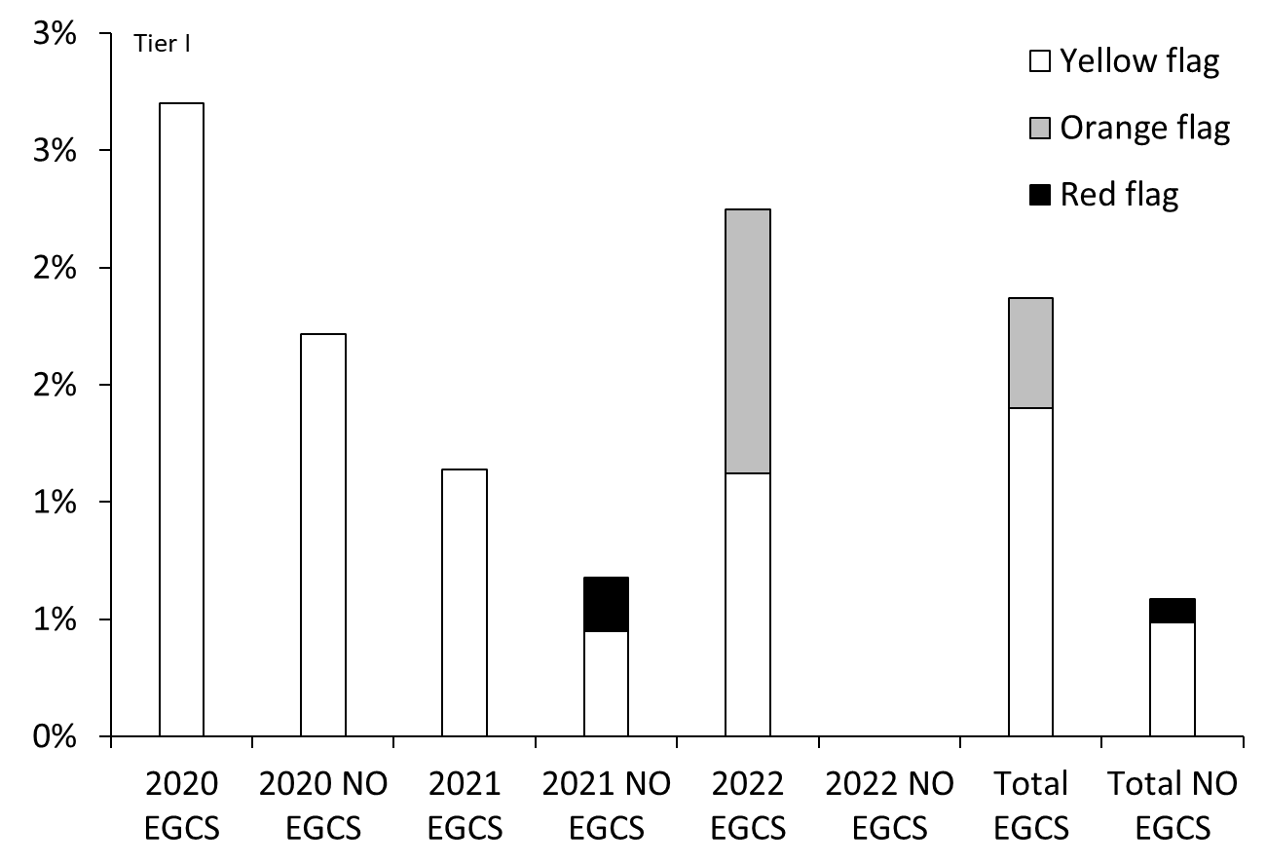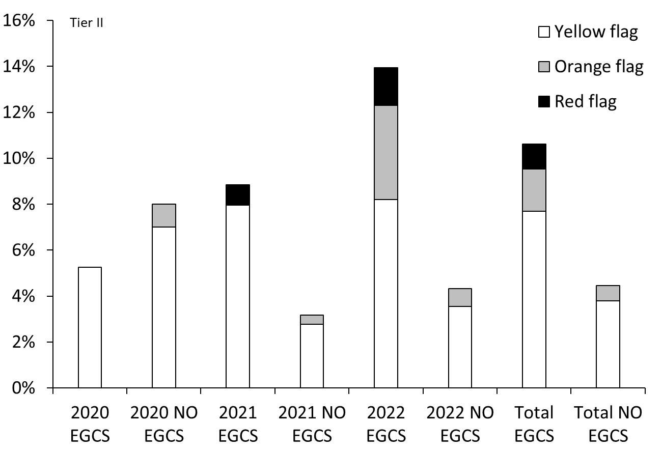
Figure S.8. Difference in compliance levels for OGCS OGVS versus non-EGCS OGVs for Tier I (left) and Tier II (right) OGVS.

Table S.1. Test cycles and weighting factors according to the NOx Technical code.
E2 | Speed | 100% | 100% | 100% | 100%
 | Power | 100% | 75% | 50% | 25%
 | WF | 0.2 | 0.5 | 0.15 | 0.15
E3 | Speed | 100% | 91% | 80% | 63%
 | Power | 100% | 75% | 50% | 25%
 | WF | 0.2 | 0.5 | 0.15 | 0.15

Table S.2. SO₂ and CO₂ concentrations of the ordered plume simulation mixtures and effective FSC value.
Mixture | FSC | SO₂ (ppm) | CO₂ (%)
Low | 0.59 | 25ppm | 1%
Medium | 0.85 | 5ppm | 0.1%
High | 2.38 | 100ppm | 1%

Table S.3. Intra-Assay Coefficient of Variability, freedom of degrees and total uncertainty for FSC and NO_{x}.
 |  | 2020 FSC range (%) |  |  |  | >2020 FSC range (%) |  |  | NO_{x} range (g/kWh)
 |  | <0.2% | 0.2-0.4 | >0.4 |  | 0.13-0.2 | 0.2-0.3 | >0.3 |  | 0-10 | 10-20 | >20
CV_{RW} |  | 18.3% | 11.6% | 13.7% |  | 18.0% | 8.04% | 4.82% |  | 16.1% | 14.9% | 18.6%
n |  | 109 | 49 | 29 |  | 20 | 12 | 14 |  | 24 | 79 | 45
u_{tot} |  | 19% | 13% | 15% |  | 25% | 20% | 18% |  | 21.9% | 21.1% | 23.9%
|b| |  | 4% | 1.33% | 0.66% |  | 15% | 14% | 12% |  | 13.4% | 13.4% | 13.4%
U (σ = 1.96) |  | 42% | 27% | 30% |  | 64% | 52% | 48% |  | 29.6% | 28.0% | 33.4%

