Table S1 The specific primers for the RT-PCR
Gene | Primers | Sequences (5’- 3’)
myh1 | RT-MYH1_F | TCAAGCAGAAGCAGCGTGAGGAG
 | RT-MYH1_R | CGGATAGCACAGAGCCTTCAGCAT
myh4 | RT-MYH4_F | TGATGCCAAGAGTGCCTGCTACG
 | RT-MYH4_R | CTGTCCTCTCCTCCTGAGTGTCCA
gtr12 | RT-GTR12_F | ACCTGCTCATCTCCATGACCTTCC
 | RT-GTR12_R | TATCTCCTCCAGCGTGCGACCT
tri16 | RT-TRI16_F | CGCACAAGCACACTCATCACAAGA
 | RT-TRI16_R | TCATATGGTGGCGGCTTCACTTCT
crem | RT-CREM_F | ATAACGCCAGCTCCAGCCTTCC
 | RT-CREM_R | CGGGCAGCTTCCCTGTTCTTCA
ttc9a | RT-TTC9A_F | TGGAGAATGCAGAGCTGGAGTGTT
 | RT-TTC9A_R | CGGATCGGTACAGAGCCTTGAAGT
jun | RT-JUN_F | CTCTCCTGATGTGGGCTTGCTGAA
 | RT-JUN_R | CTCCTGCTCGTCGGTGACATTCTT
tri65 | RT-TRI65_F | CCAGCAGAGAATCCAGGACAGAGA
 | RT-TRI65_R | TCCATCAGACGGATCAGGTCAGTG
fmo5 | RT-FMO5_F | CGGTGGTTGGAGGAGGAAGTTCAG
 | RT-FMO5_R | AATGCTCGCTCTGTCTGGCTCTG
b3gt2 | RT-B3GT2_F | GGCGGGTGTCTTACTCCAGTTGT
 | RT-B3GT2_R | AGGCGTTGTGCTTGTTGCTCTG
tnni2 | RT-TNNI2_F | CGACAAGGTGGACGAGGAGAGGTA
 | RT-TNNI2_R | AGCATGGAGTCAGCGGACATACG
pprc1 | RT-PPRC1_F | ACCGCTGCTACTGTGTCTGCTC
 | RT-PPRC1_R | GGTGAGGGTTTGGTGGACTTGCTA
ghr | RT-GLIS1_F | GCAGCAAGGATGTCTGTACGGAGA
 | RT-GLIS1_R | AGAGTGAGAGGCGGACGGAGTT
ptgis | RT-PTGIS_F | TCTGGCAGCAGTGAAGAAGGAGTT
 | RT-PTGIS_R | GCAGCGGTGAGTCTGAGTGTCT
sdhb | RT-SDHB_F | GCTGTCCTGTCTGTTCTGTTGTGG
 | RT-SDHB_R | CCGAACCATCACCATCATGCCAGA
stc2 | RT-STC2_F | GAAGTGTGGAGACGAGGTCAGGTT
 | RT-STC2_R | GTGGCTGTGGATTGCTGTGGAAG
nr4a1 | RT-NR4A1_F1 | CCTTGGTGGGAAATGGCTATGTGG
 | RT-NR4A1_R1 | GCTACTGCGTTGTGGCTGAATGAA
nr4a1_1 | RT-NR4A1_1_F2 | AACGCCTCCTGTCAGCACTACG
 | RT-NR4A1_1_R2 | CGATTCCGCCTCCTCTTGTCCA
pde4d | RT-PDE4D_F | CTCCATCTCAGCCGACAAGTTCCA
 | RT-PDE4D_R | TACTGCCACTGTAGCCCTCCTCTT
s41a1 | RT-S41A1_F | CGGAGATCGTGGTGGCATTGGA
 | RT-S41A1_R | TCATCACTCTCGTTGCTCTGGCTT
pdp1 | RT-PDP1_F | CGAGCCAGAGATCACGTACCACAA
 | RT-PDP1_R | CCACGATACGAACCACCTCCTGTC
tutla | RT-TUTLA_F | TGGCTCATCCTCAGCAGCAACAT
 | RT-TUTLA_R | ACATTGACAGACTCGCTCGGTTCA
klf13 | RT-KLF13_F | TGGCAAATCATCCCACCTCAAAGC
 | RT-KLF13_R | CGGAGCGGGCGAACTTCTTACT
htr1a | RT-HTR1A_F | CGGCTGGCATCTCCTTCGCTAT
 | RT-HTR1A_R | CGCTGGAGTGAGAGTCATCATCCT
mxra5 | RT-MXRA5_F | GGCTCCAAGGTAGAGGCACCATAC
 | RT-MXRA5_R | GCAGGACAGCAAGGTCTCCATCA
actb | RT-actb-F | GATCTGGCATCACACCTTCTAC
 | RT-actb-R | CACCGGAGTCCATGACAATAC

Table S2 Summary of transcriptome data generated from the brown-marbled grouper samples.
Sample | Total reads | Unmapped reads | Unique mapped reads | Unique mapped rate | Multiple mapped reads | Multiple mapped ratio | Mapping ratio
H1 | 52,012,402 | 1,527,697 | 50,143,406 | 96.46% | 311,300 | 0.60% | 97.06%
H2 | 63,030,193 | 1,156,861 | 61,217,878 | 97.12% | 655,454 | 1.04% | 98.16%
H3 | 53,917,347 | 1,015,204 | 52,382,921 | 97.15% | 419,222 | 0.78% | 97.93%
L1 | 51,476,226 | 943,598 | 50,292,002 | 97.70% | 240,626 | 0.47% | 98.17%
L2 | 65,202,821 | 1,307,107 | 63,538,208 | 97.45% | 357,506 | 0.55% | 98.00%
L3 | 68,502,049 | 1,377,230 | 66,770,737 | 97.47% | 354,082 | 0.52% | 97.99%

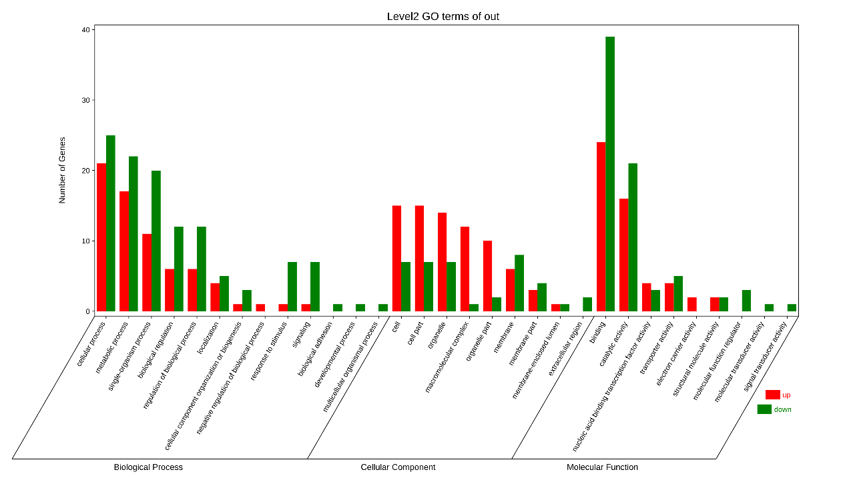
Fig.S1 GO assignment of the differentially expressed genes; red bar indicates up-regulated genes, and green bar indicates down-regulated gene
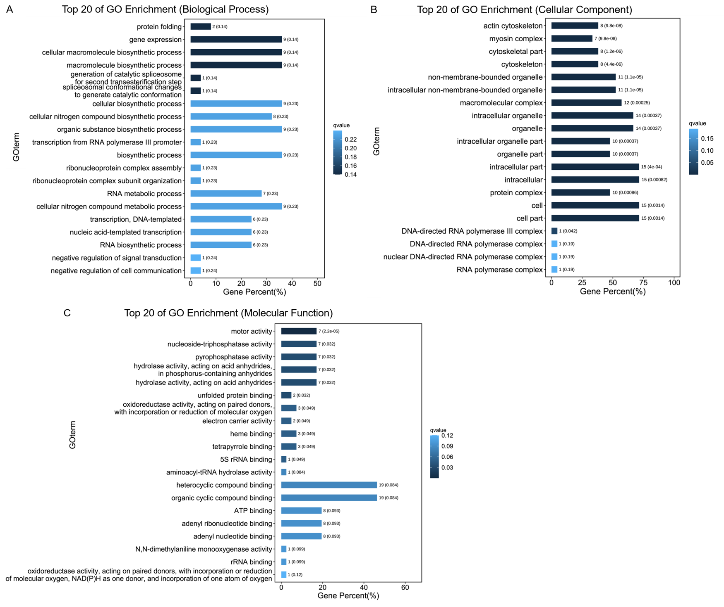
Fig.S2 Bar plots of down-regulated genes in fast-growing grouper of GO functional enrichment analyses. A: Top 20 of GO Enrichment (Biological Process); B: Top 20 of GO Enrichment (Cellular Component); C: Top 20 of GO Enrichment (Molecular Function).
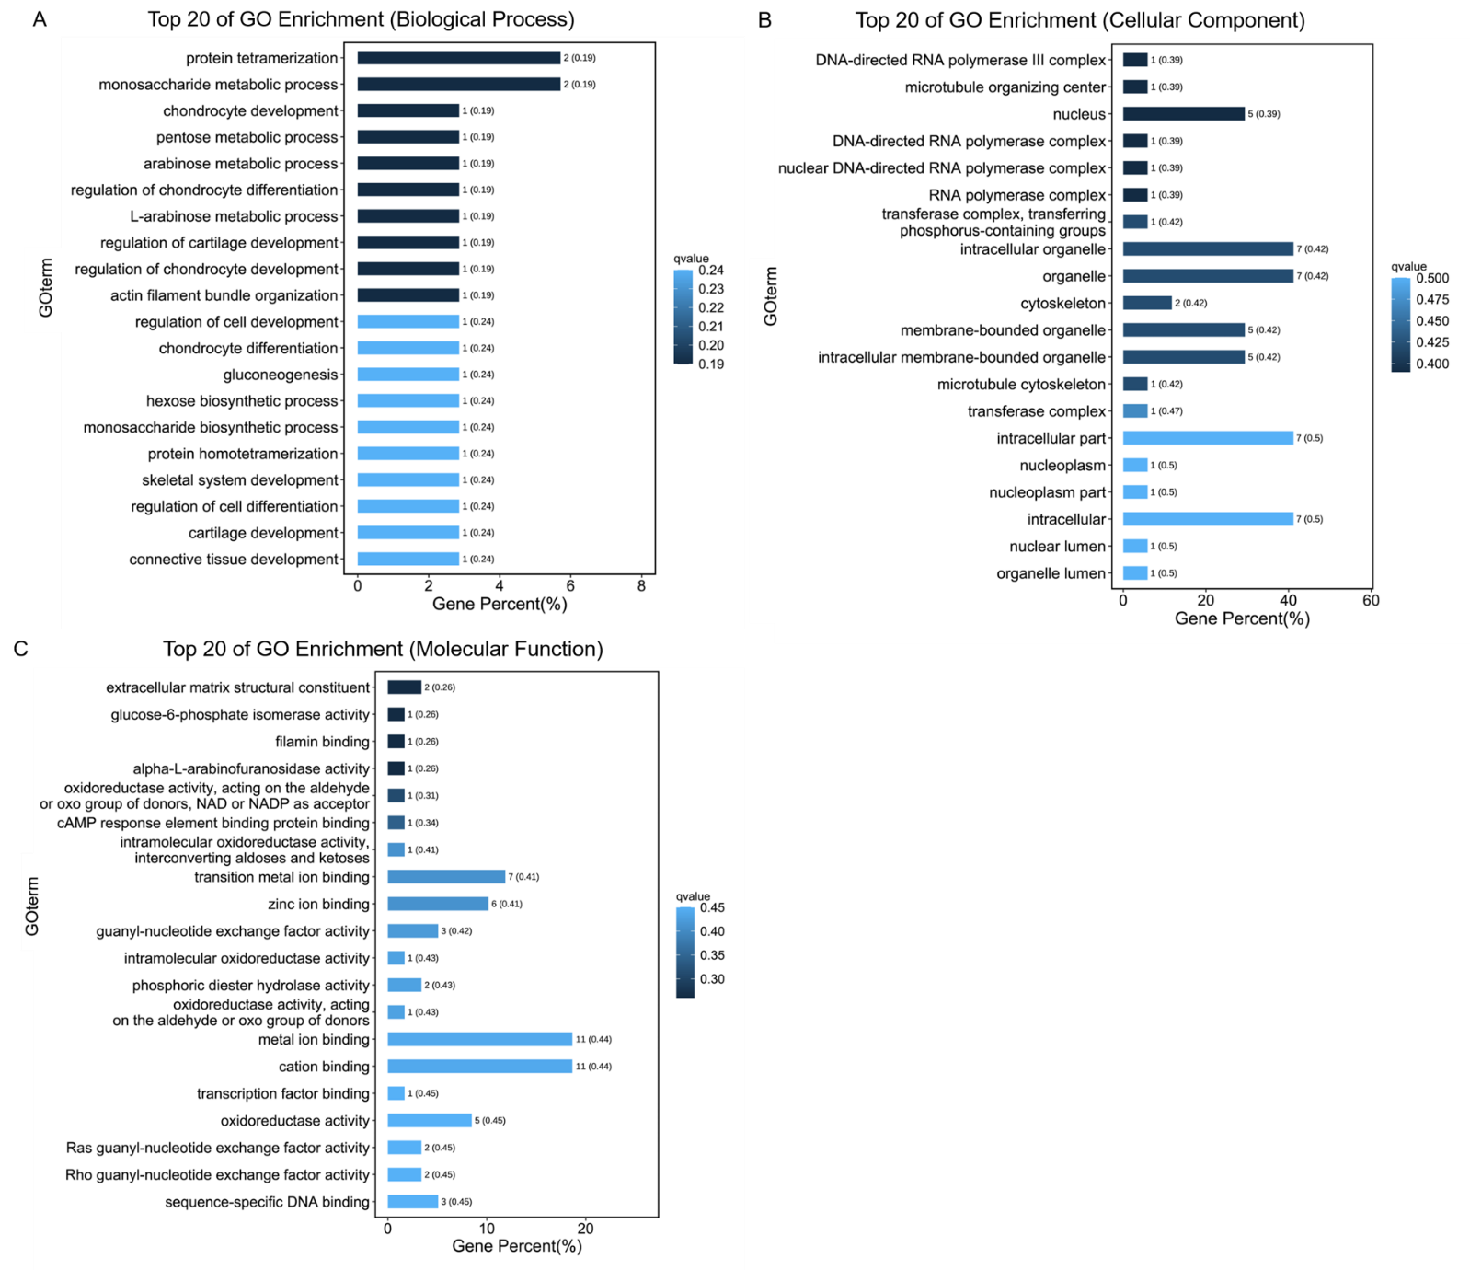
Fig.S3 Bar plots of up-regulated genes in fast-growing grouper of GO functional enrichment analyses. A: Top 20 of GO Enrichment (Biological Process); B: Top 20 of GO Enrichment (Cellular Component); C: Top 20 of GO Enrichment (Molecular Function).
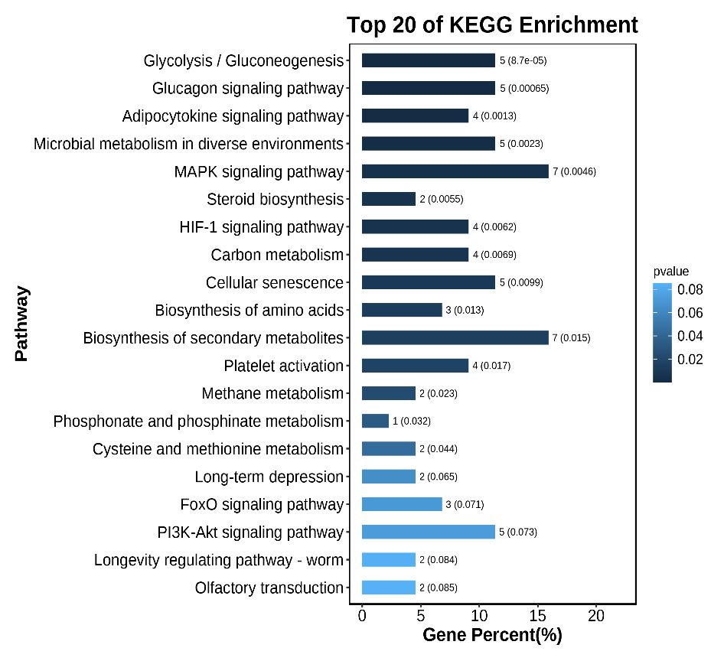
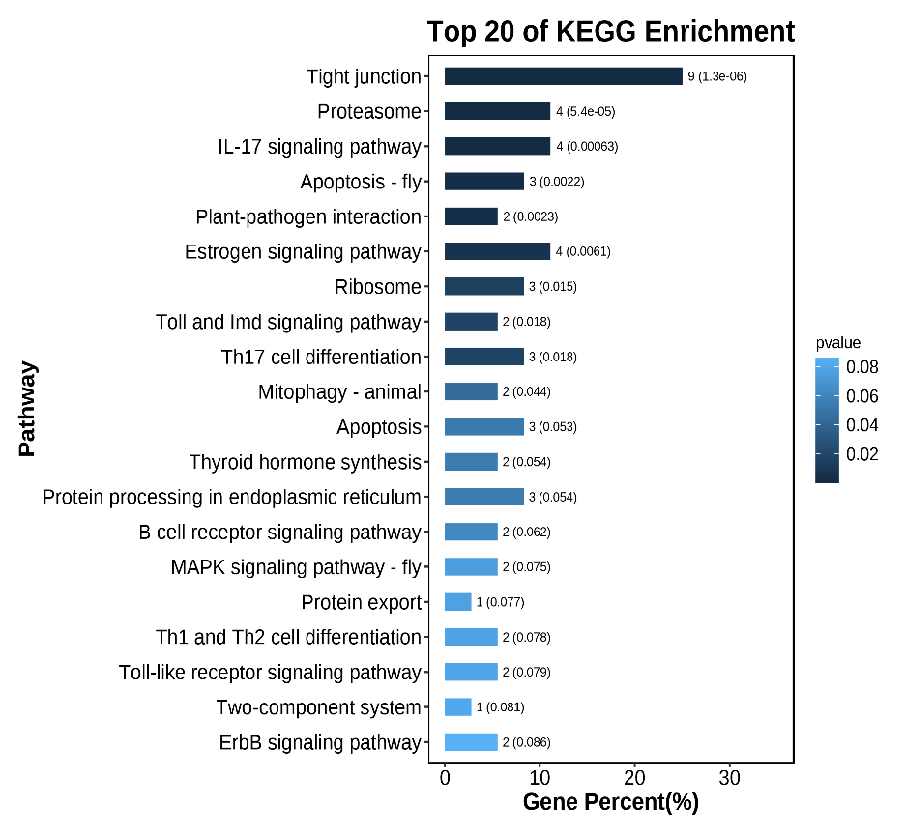
A
B
Fig.S4 A: The bar plot of up-regulated genes in fast-growing grouper of KEGG enrichment analyses. B: The bar plot of down-regulated genes in fast-growing grouper of KEGG enrichment analyses.
+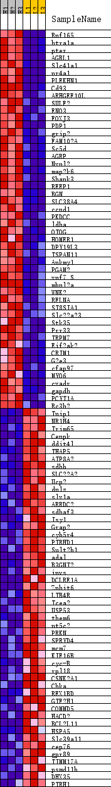
Fig.S5 Heat Map of the top 50 features for each phenotype in GSEA_data. H1, H2, H3: the fast-growing group. L1, L2, L3: the slow-growing group. red indicates upregulated gene, and bule indicates downregulated gene.
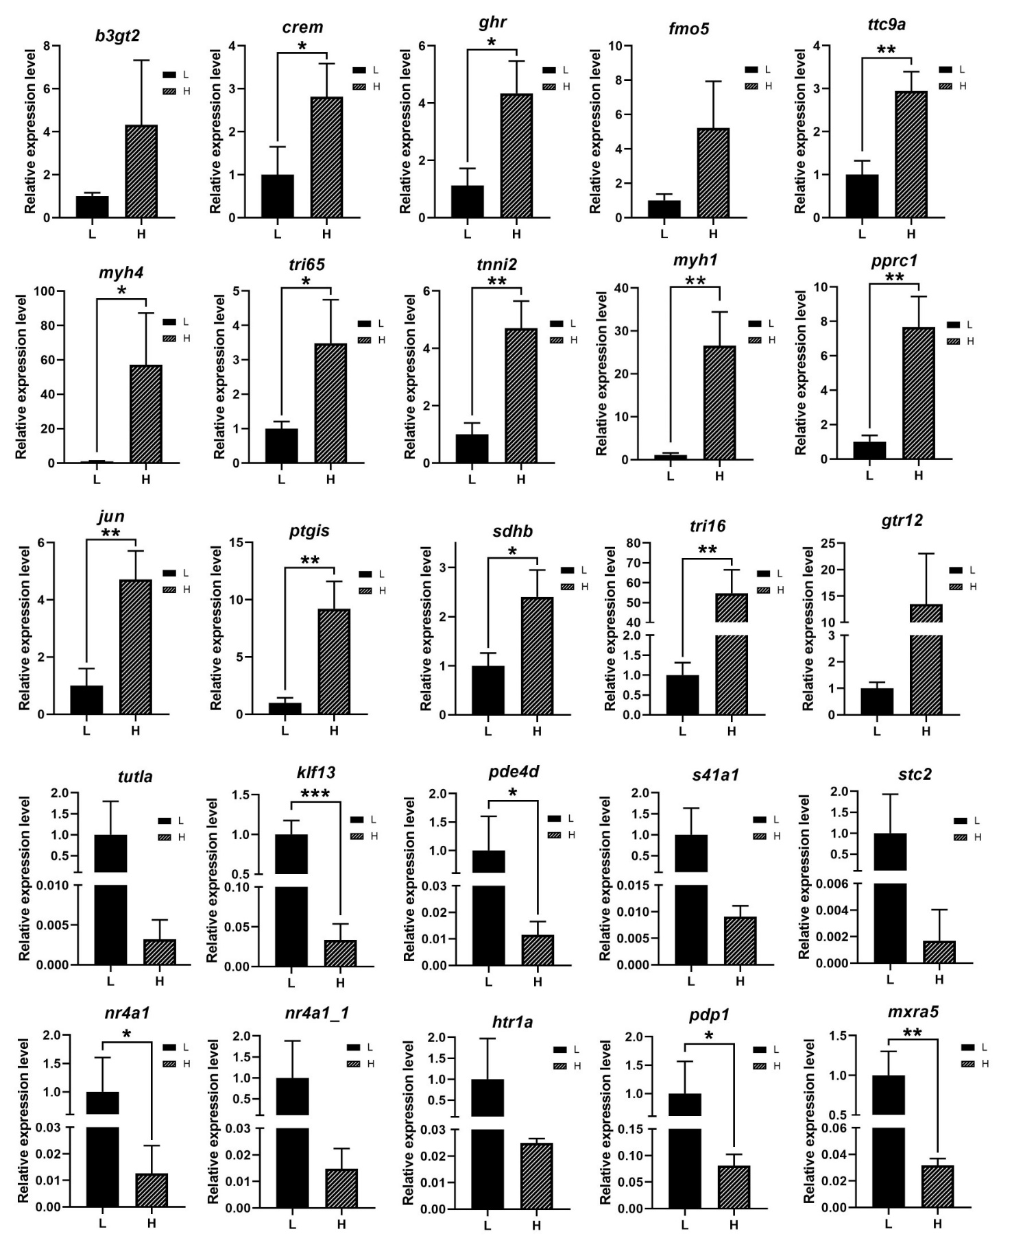
Fig.S6 L represent the slow-growing group; H represent the fast-growing group. The qPCR analysis of gene expression in slow- and fast-growing group. The y-axis indicates relative expression level between the samples of slow- and fast-growing group using the Relative Quantitation. b3gt2, Hexosyltransferase; crem, cAMP-responsive element modulator; ghr, Growth hormone receptor; fmo5, Flavin-containing monooxygenase 5; ttc9a, Tetratricopeptide repeat protein 9A; myh4, Myosin-4; tri65, Tripartite motif-containing protein 65; tnni2, Troponin I, fast skeletal muscle; myh1, Myosin-1; pprc1, Peroxisome proliferator-activated receptor gamma coactivator-related protein 1; jun, Transcription factor Jun; ptgis, Prostacyclin synthase; sdhb, Succinate dehydrogenase [ubiquinone] iron-sulfur subunit, mitochondrial; tri16, Trichothecene 8-O-acetyltransferase; gtr12, Solute carrier family 2, facilitated glucose transporter member 12; tutla, Protein turtle homolog A; klf13, Krueppel-like factor 13; pde4d, cAMP-specific 3',5'-cyclic phosphodiesterase 4D; s41a1, Solute carrier family 41 member 1; stc2, Stanniocalcin-2; nr4a1, Nuclear receptor subfamily 4 group A member 1; htr1a, 5-hydroxytryptamine receptor 1A; pdp1, PWWP domain-containing protein 1; mxra5, Matrix-remodeling-associated protein 5. Significant differences at the P < 0.05, P < 0.01, P < 0.001 level are indicated by *, **, *** above the columns.

