Spectroscopic study of the interaction of reactive dyes with polymeric cationic modifiers of cotton
Konstantinos Papapetros^{1,2}, Labrini Sygellou¹, Charalampos Anastasopoulos³, Konstantinos S. Andrikopoulos^{1,4,*}, Georgios Bokias^{3,*}, George A. Voyiatzis¹

¹Foundation for Research and Technology – Hellas (FORTH), Institute of Chemical Engineering Science (ICE-HT), Stadiou St., GR 265 04 Rio-Patras Greece
²Department of Chemical Engineering, University of Patras, GR-26504, Patras, Greece
³Department of Chemistry, University of Patras, GR-26504, Patras, Greece
⁴Department of Physics, University of Patras, GR-26504, Patras, Greece
*corresponding authors’ email:
kandriko@upatras.gr
bokias@upatras.gr

Supplementary material

S1. Modification procedure
Τhe cotton samples were immersed in an 0.1% aqueous solution of polymeric modifier. The weight ratio of the fabric to the aqueous solution of the polymer, Wtext: V _{(aq)}pol (w / v) is setted as 1:20 w / v. The solution adjusted to alkaline pH using NaOH (0.25M). The modification bath raised to the selected temperature (60ºC) and held at this temperature for 2h. Afterwards, the modified samples were rinsed in water thoroughly at room temperature and dried at 80ºC for 12h.
S2. Dyeing Procedure
S2.1 Dyeing protocol at high and low temperatures without salt
Cotton samples were immersed in an 0.0025% aqueous solution of the dye. The weight ratio of the fabric to the aqueous solution of the dye, Wtext : V dye (w/v) is setted as 1:500 w/v and the Wtext : Wdye ratio is 1g : 12.5mg. The solution adjusted to alkaline pH using NaOH (0.4mg/mL of dye solution) and Na₂CO₃ (5mg/mL of dye solution). The dyeing bath raised to the selected temperature (60ºC or RT) and held at this temperature for 2h. Afterwards, the modified samples were rinsed in water thoroughly at room temperature and dried at 80ºC for 16h.
S2.2 Dyeing protocol at high and low temperatures with salt
Cotton samples were immersed in an 0.0025% aqueous solution of the dye. The weight ratio of the fabric to the aqueous solution of the dye, Wtext : V dye (w/v) is setted as 1:500 w/v and the Wtext : Wdye ratio is 1g : 12.5mg. The solution adjusted to alkaline pH using NaOH (0.4mg/mL of dye solution) and Na₂CO₃ (5mg/mL of dye solution). The NaCl ratio in the bath is 55mg/mL of dye solution. The dyeing bath raised to the selected temperature (60ºC or Room Temperature) and held at this temperature for 2h. Afterwards, the modified samples were rinsed in water thoroughly at room temperature and dried at 80ºC for 16h.

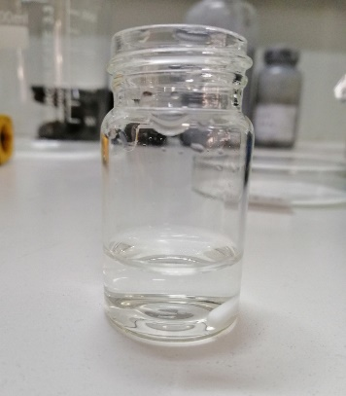 | 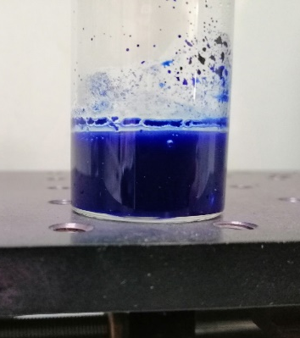
(a) | (b) | (c) | (d)
Fig. S1. Aqueous solutions of (a) polymer modifier PVBCTEAM, (b) Remazol Brilliant Blue R/PVBCTEAM, (c) Novacron Ruby/PVBCTEAM and (d) Remazol Blue/PVBCTEAM binary mixture at stoichiometric charge ratio after 24 h; clearly visible is the phase separation of the insoluble precipitate. Similar result has been observed after 24h for Novacron Ruby also.

Fig. S2. XPS spectra in the N_{1s} spectral region of the precipitates of all binary system at stoichiometric charge ratios. Calculation of the peak integrals of the non-quaternized nitrogen (attributed to the dye) and quaternized nitrogen (attributed to VBCTEAM units), enabled the extraction of ratio value indicating the number of VBCTEAM units per dye molecule.

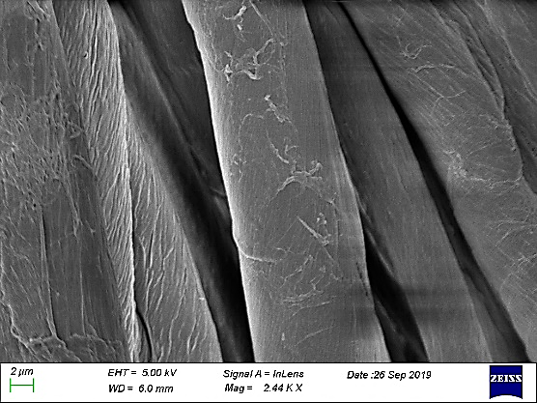 | 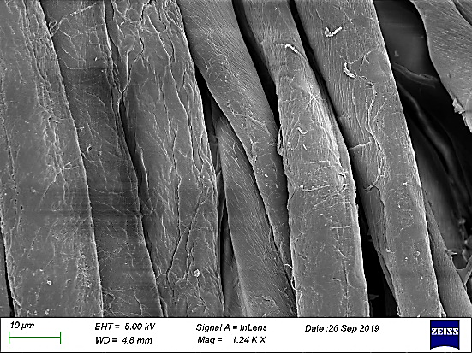 | 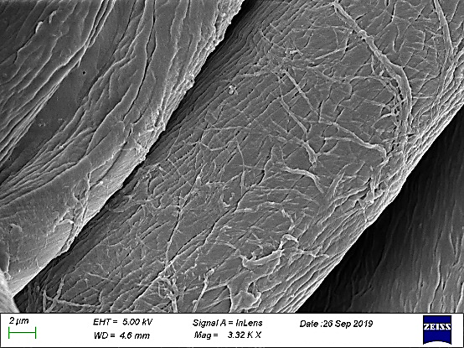
Image S3. SEM images of untreated cotton fibers (left), treated cotton fibers (middle), treated and dyed cotton fibers (right).

