Supplementary Information

A Three-step Process to Isolate Large Quantities of Bioactive Sesquiterpene Lactones from Cichorium intybus L. Roots and Semi-synthesis of Chicory STLs Standards

Francesca Ruggieri ^{(1),†}, Philippe Hance ^{(2),(3),†,*}, Bruna Gioia ⁽¹⁾, Alexandre Biela ⁽¹⁾, Pascal Roussel ⁽⁴⁾, Jean-Louis Hilbert ⁽²⁾, Nicolas Willand ⁽¹⁾
(1) University of Lille, Inserm, Institut Pasteur de Lille, U1177—Drugs and Molecules for Living Systems, F-59000 Lille, France
(2) BioEcoAgro N° 1158, Univ. Lille, INRAE, Univ. Liège, UPJV, YNCREA, Univ. Artois, Univ. Littoral Côte d’Opale, ICV – Institut Charles Viollette, F-59000 Lille, France
(3) Joint Laboratory University of Lille – Florimond-Desprez CHIC41Health, France
(4) Unité de Catalyse et de Chimie du Solide (UCCS), Université de Lille, CNRS, Centrale Lille, Université d’Artois, UMR 8181—UCCS, F-59000 Lille, France

Correspondence: philippe.hance@univ-lille.fr
† These authors contributed equally to this work.

¹H and ¹³C NMR Spectra:
11β,13-dihydrolactucin (DHLc), ¹H NMR (300 MHz, DMSO)
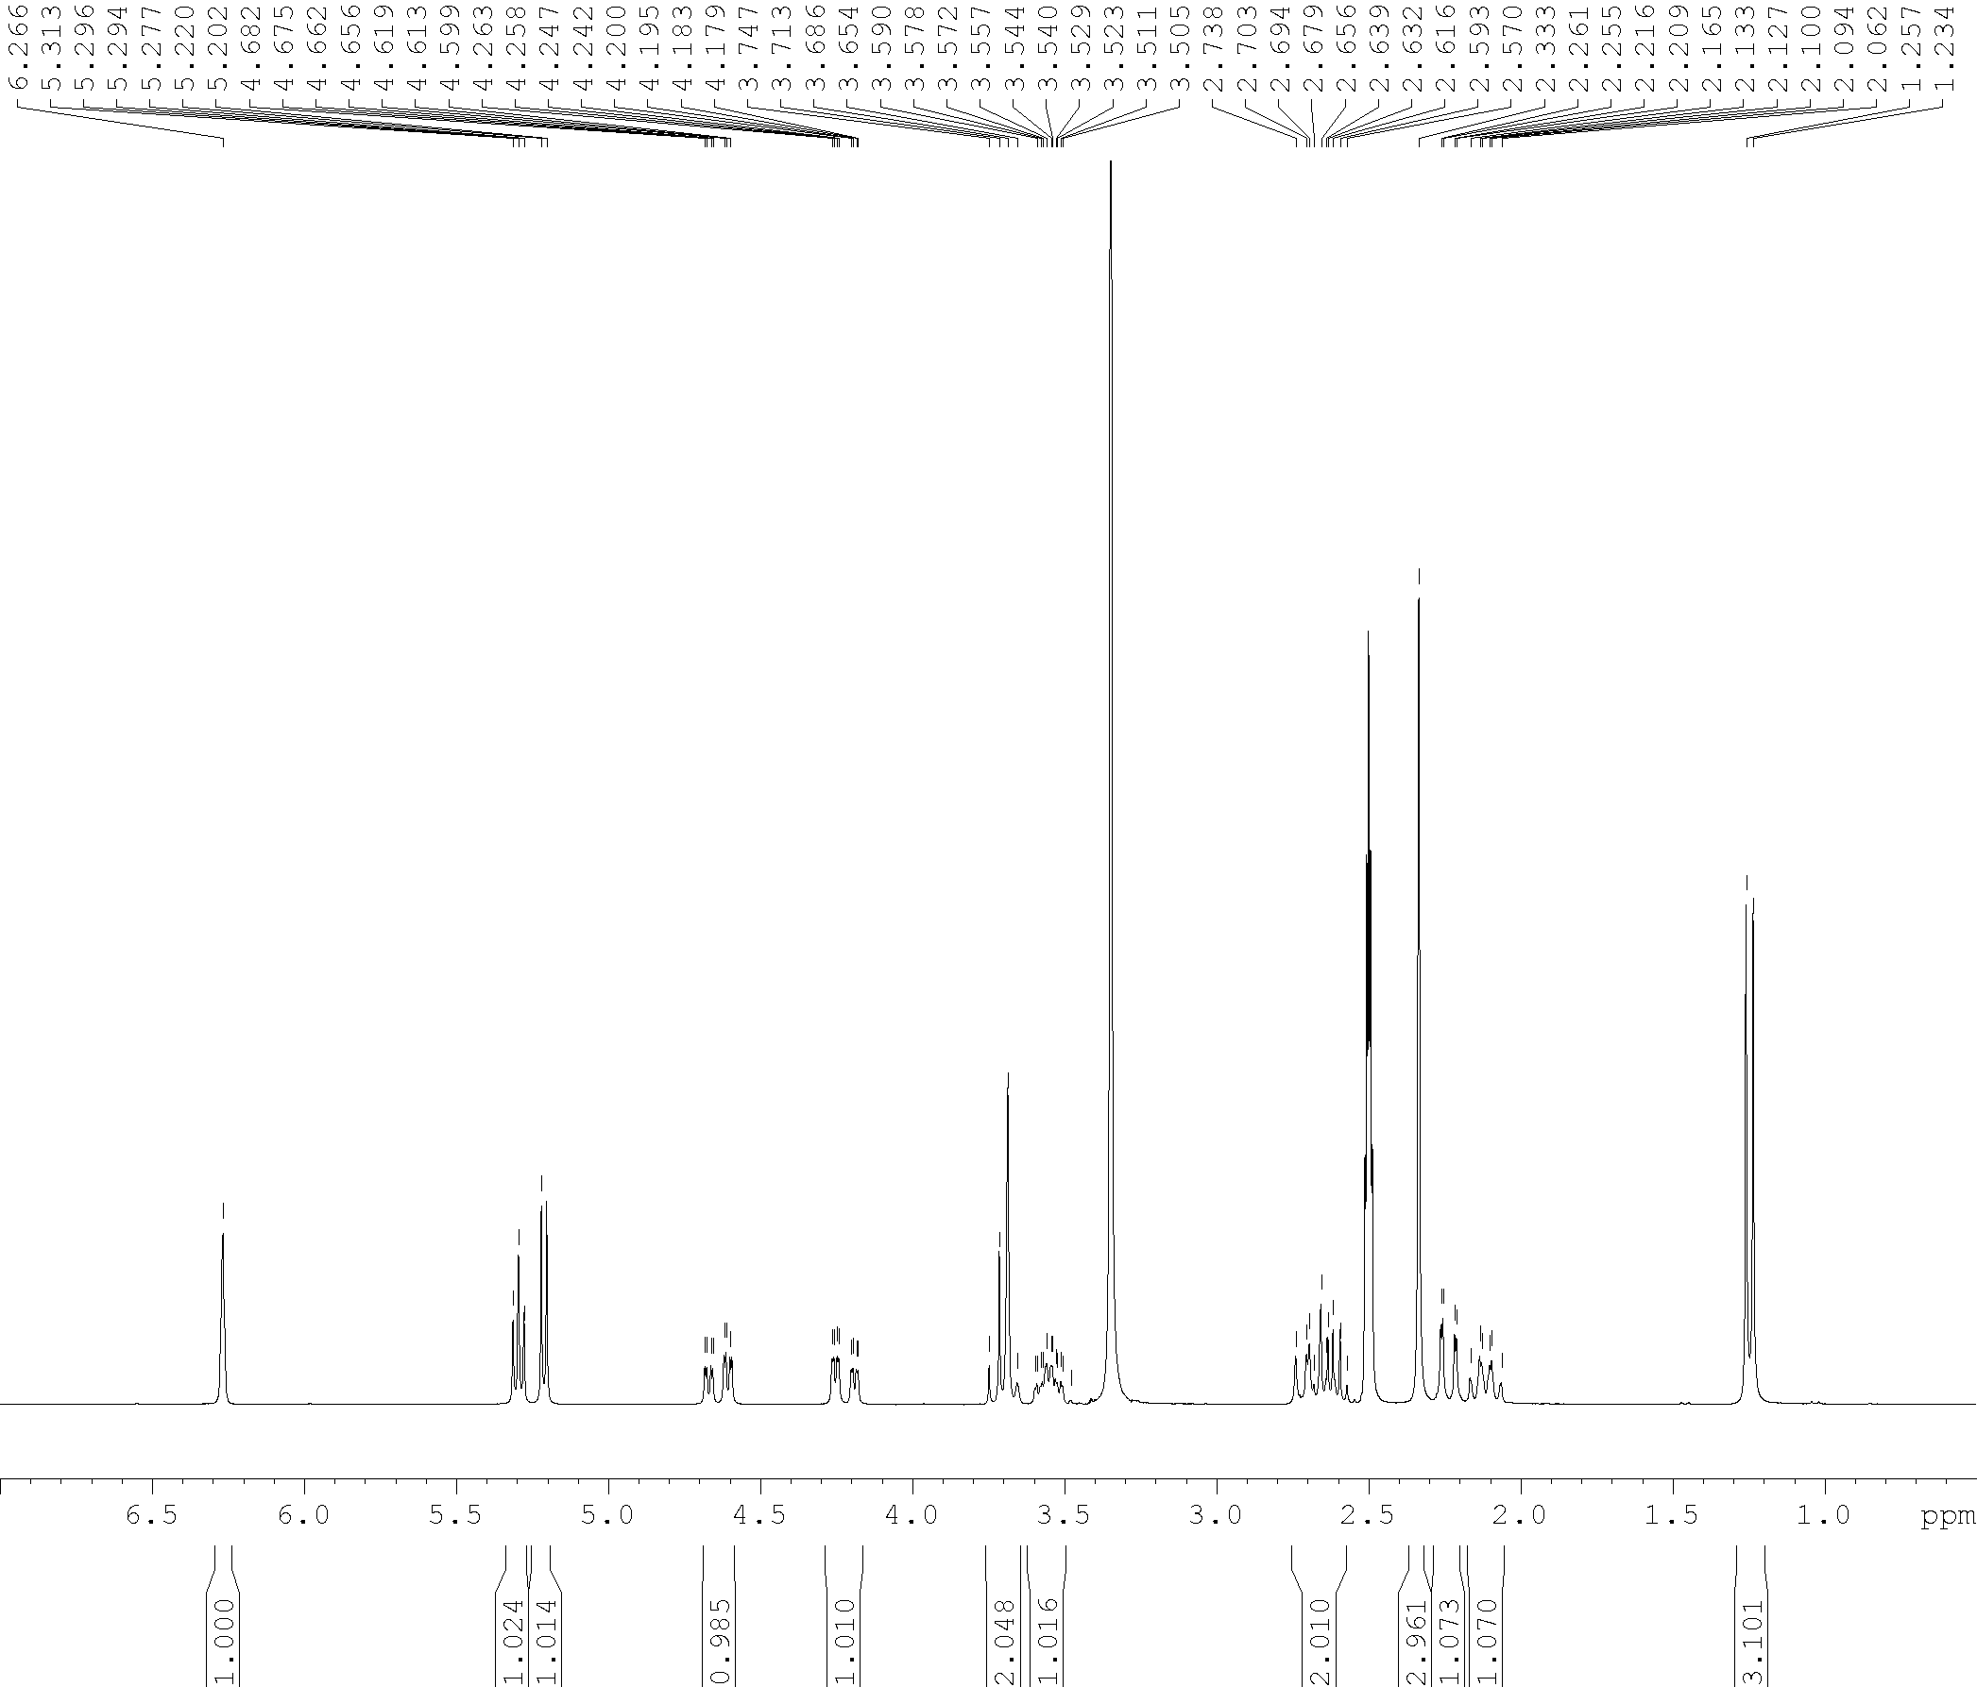

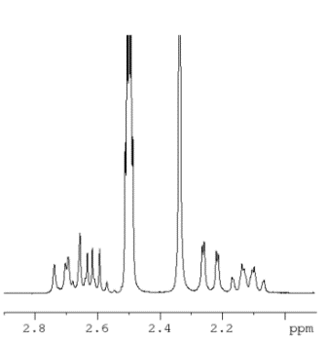

11β,13-dihydrolactucin (DHLc), ¹³C NMR (75 MHz, DMSO)
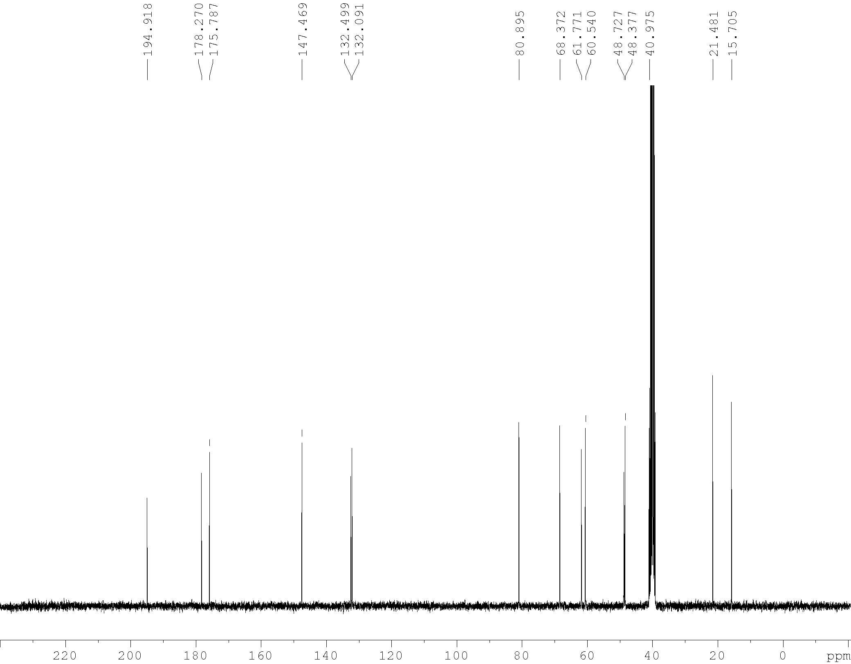

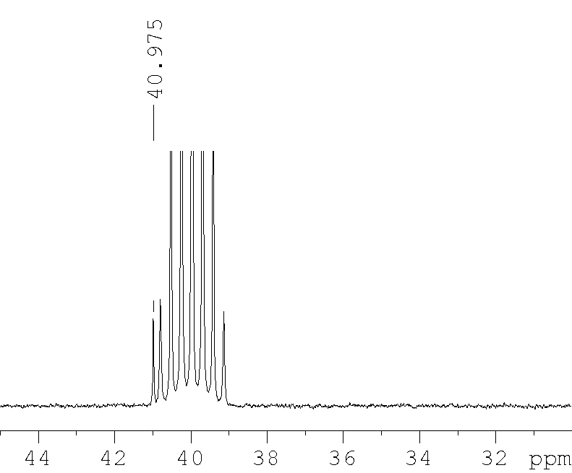

Lactucin (Lc), ¹H NMR (300 MHz, DMSO)
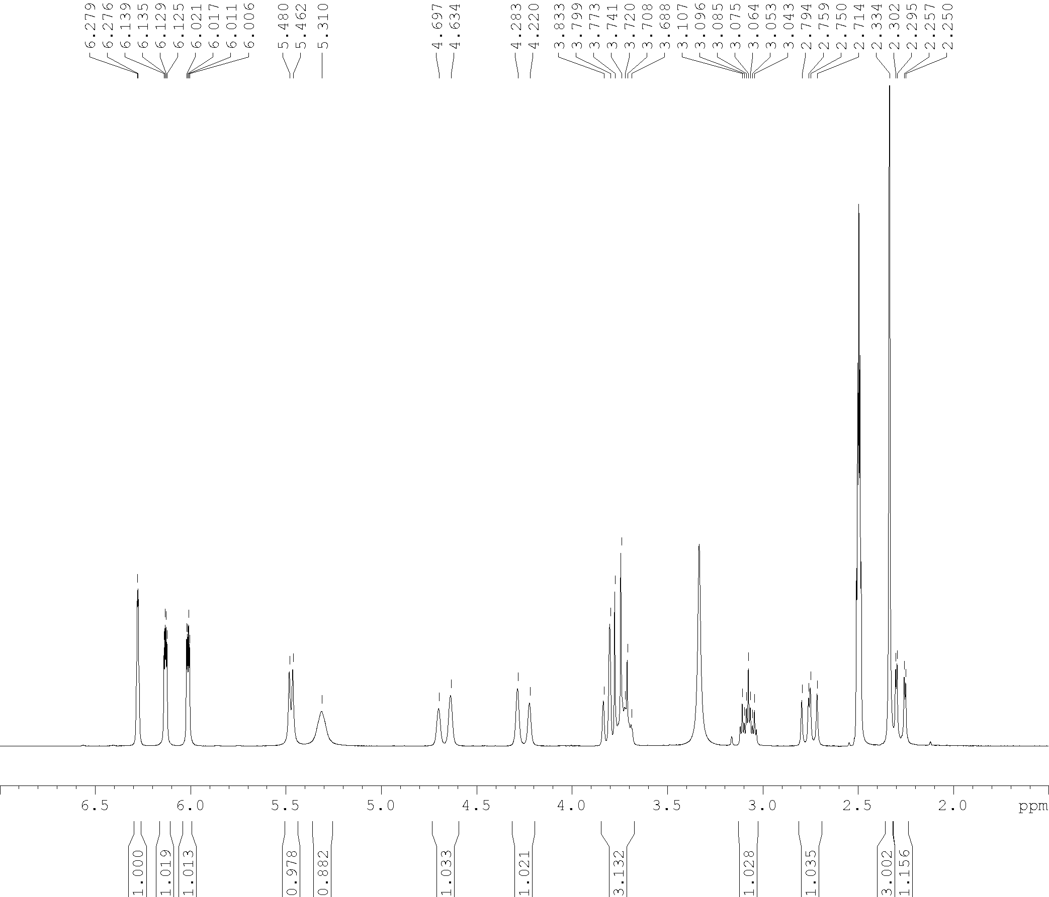

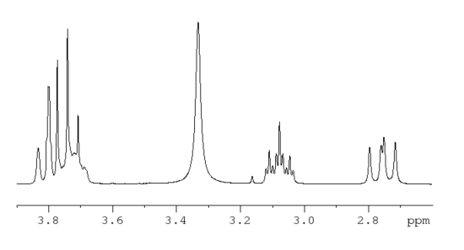

Lactucin (DHLc), ¹³C NMR (75 MHz, DMSO)
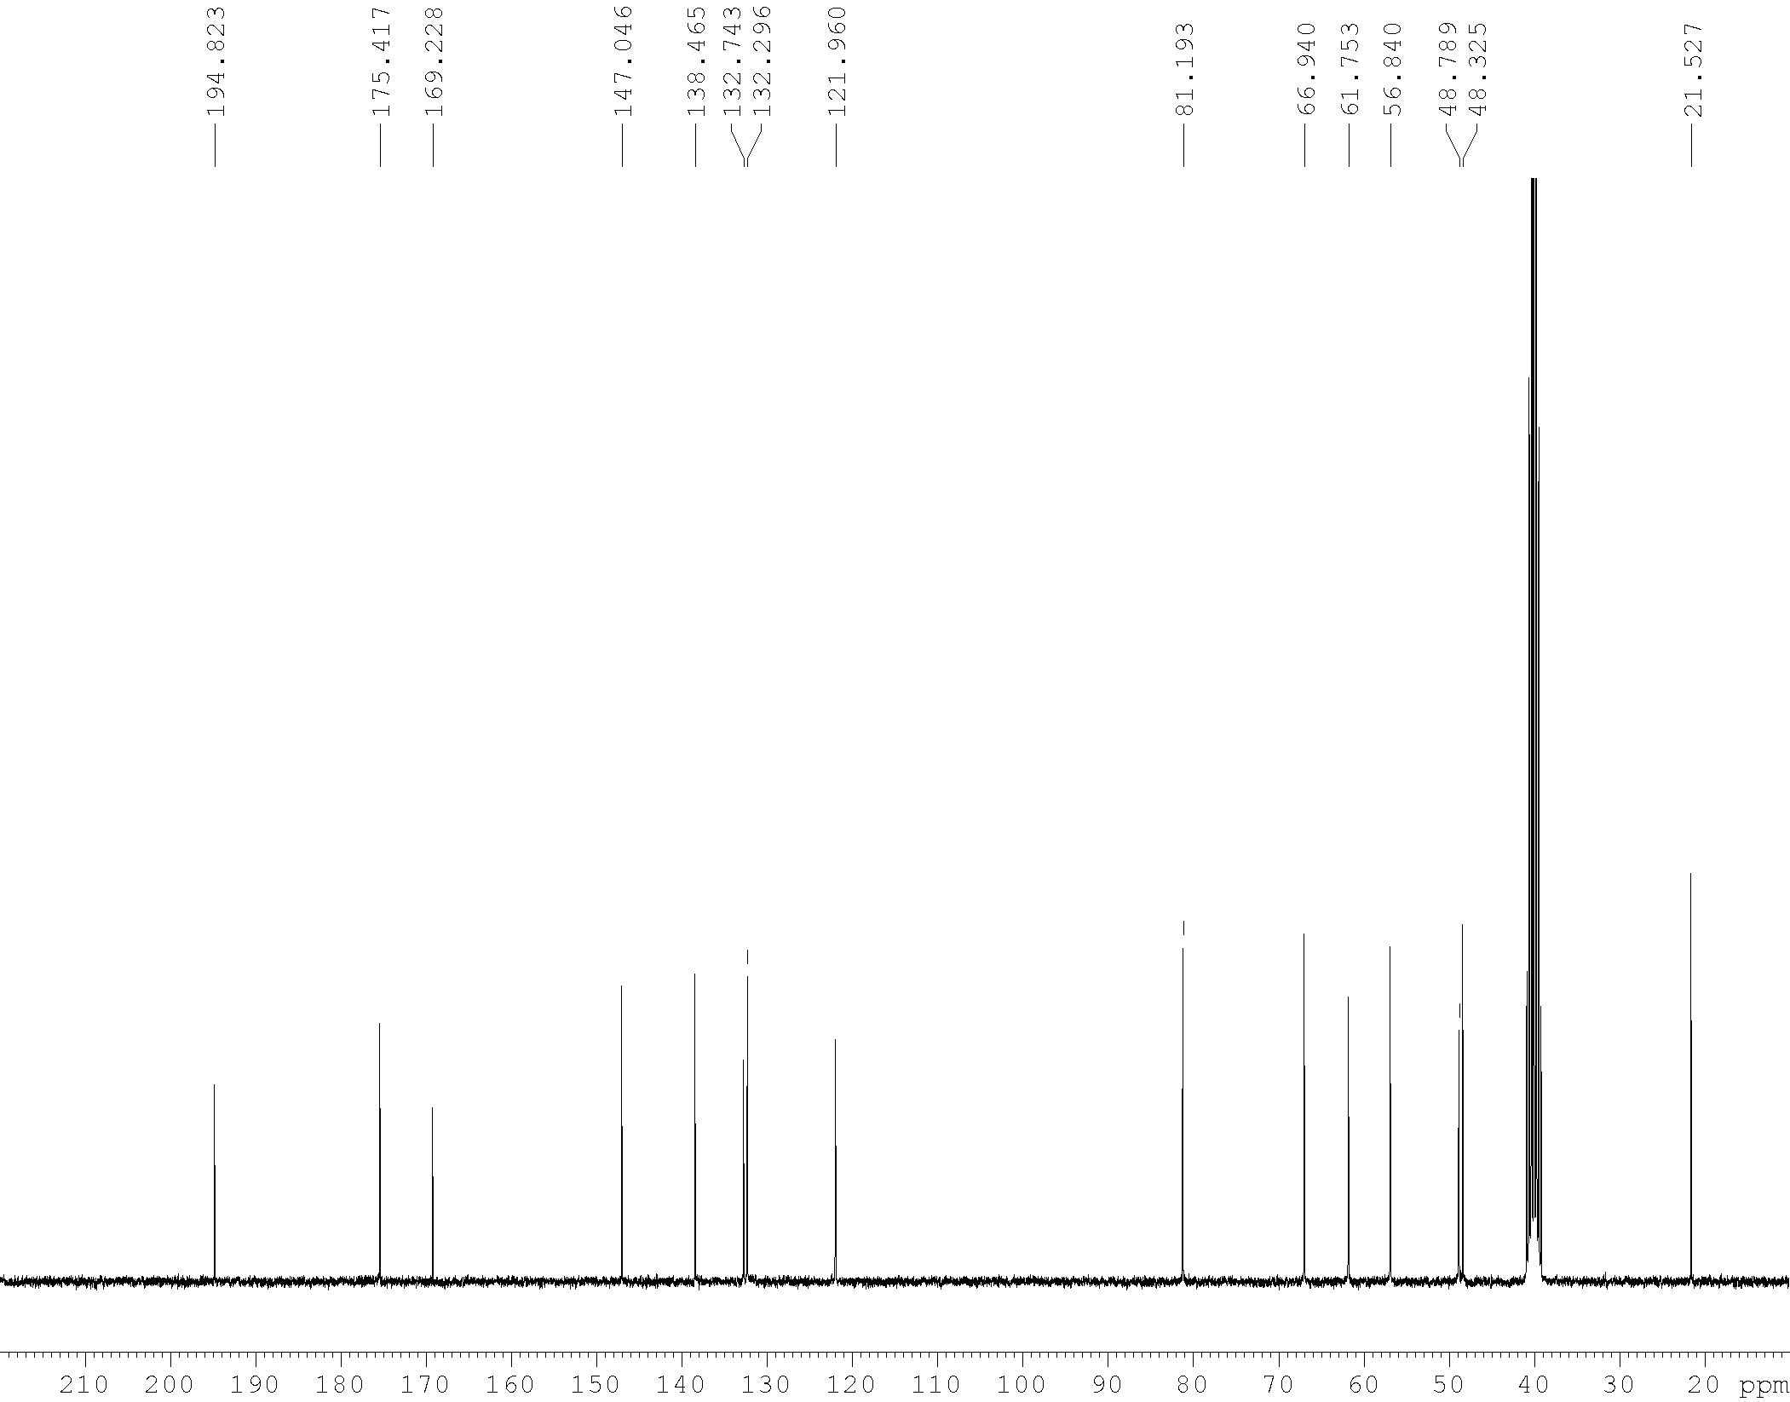

DHLc-Me-oxalate, ¹H NMR (300 MHz, DMSO)
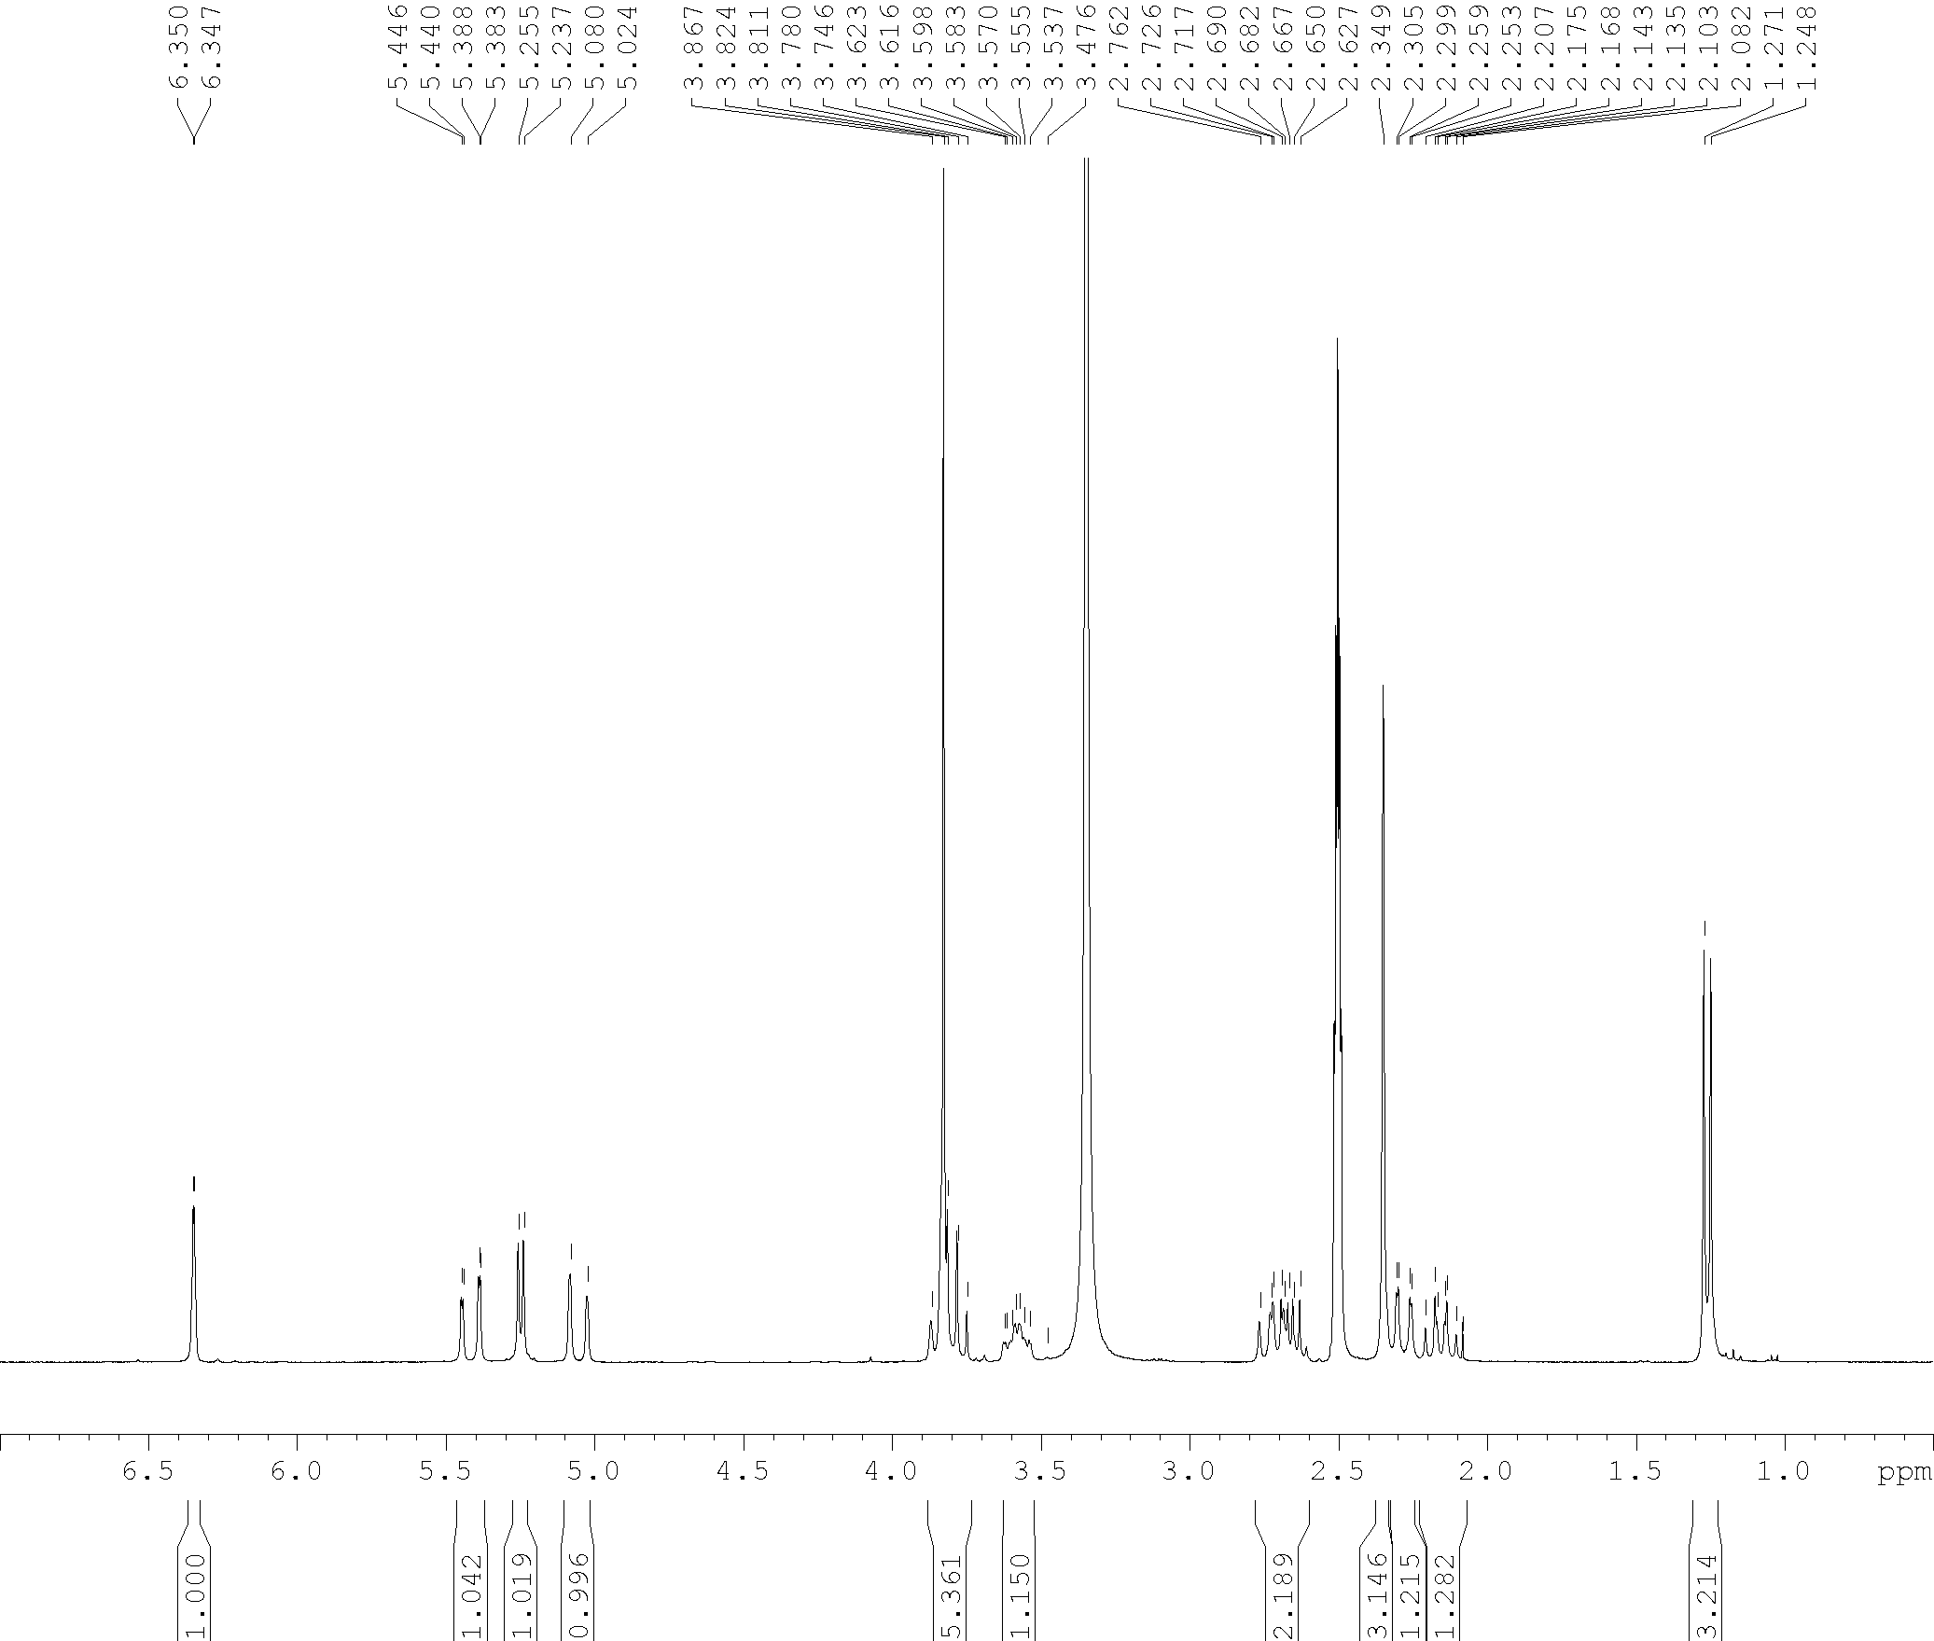

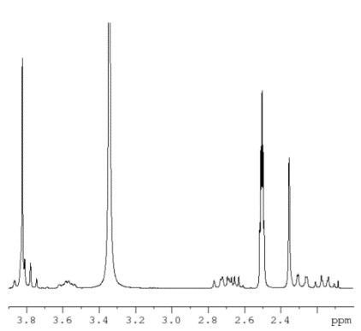

DHLc-Me-oxalate,¹³C NMR (75 MHz, DMSO)

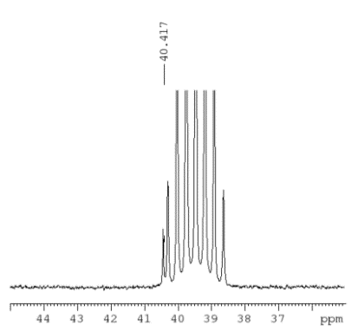
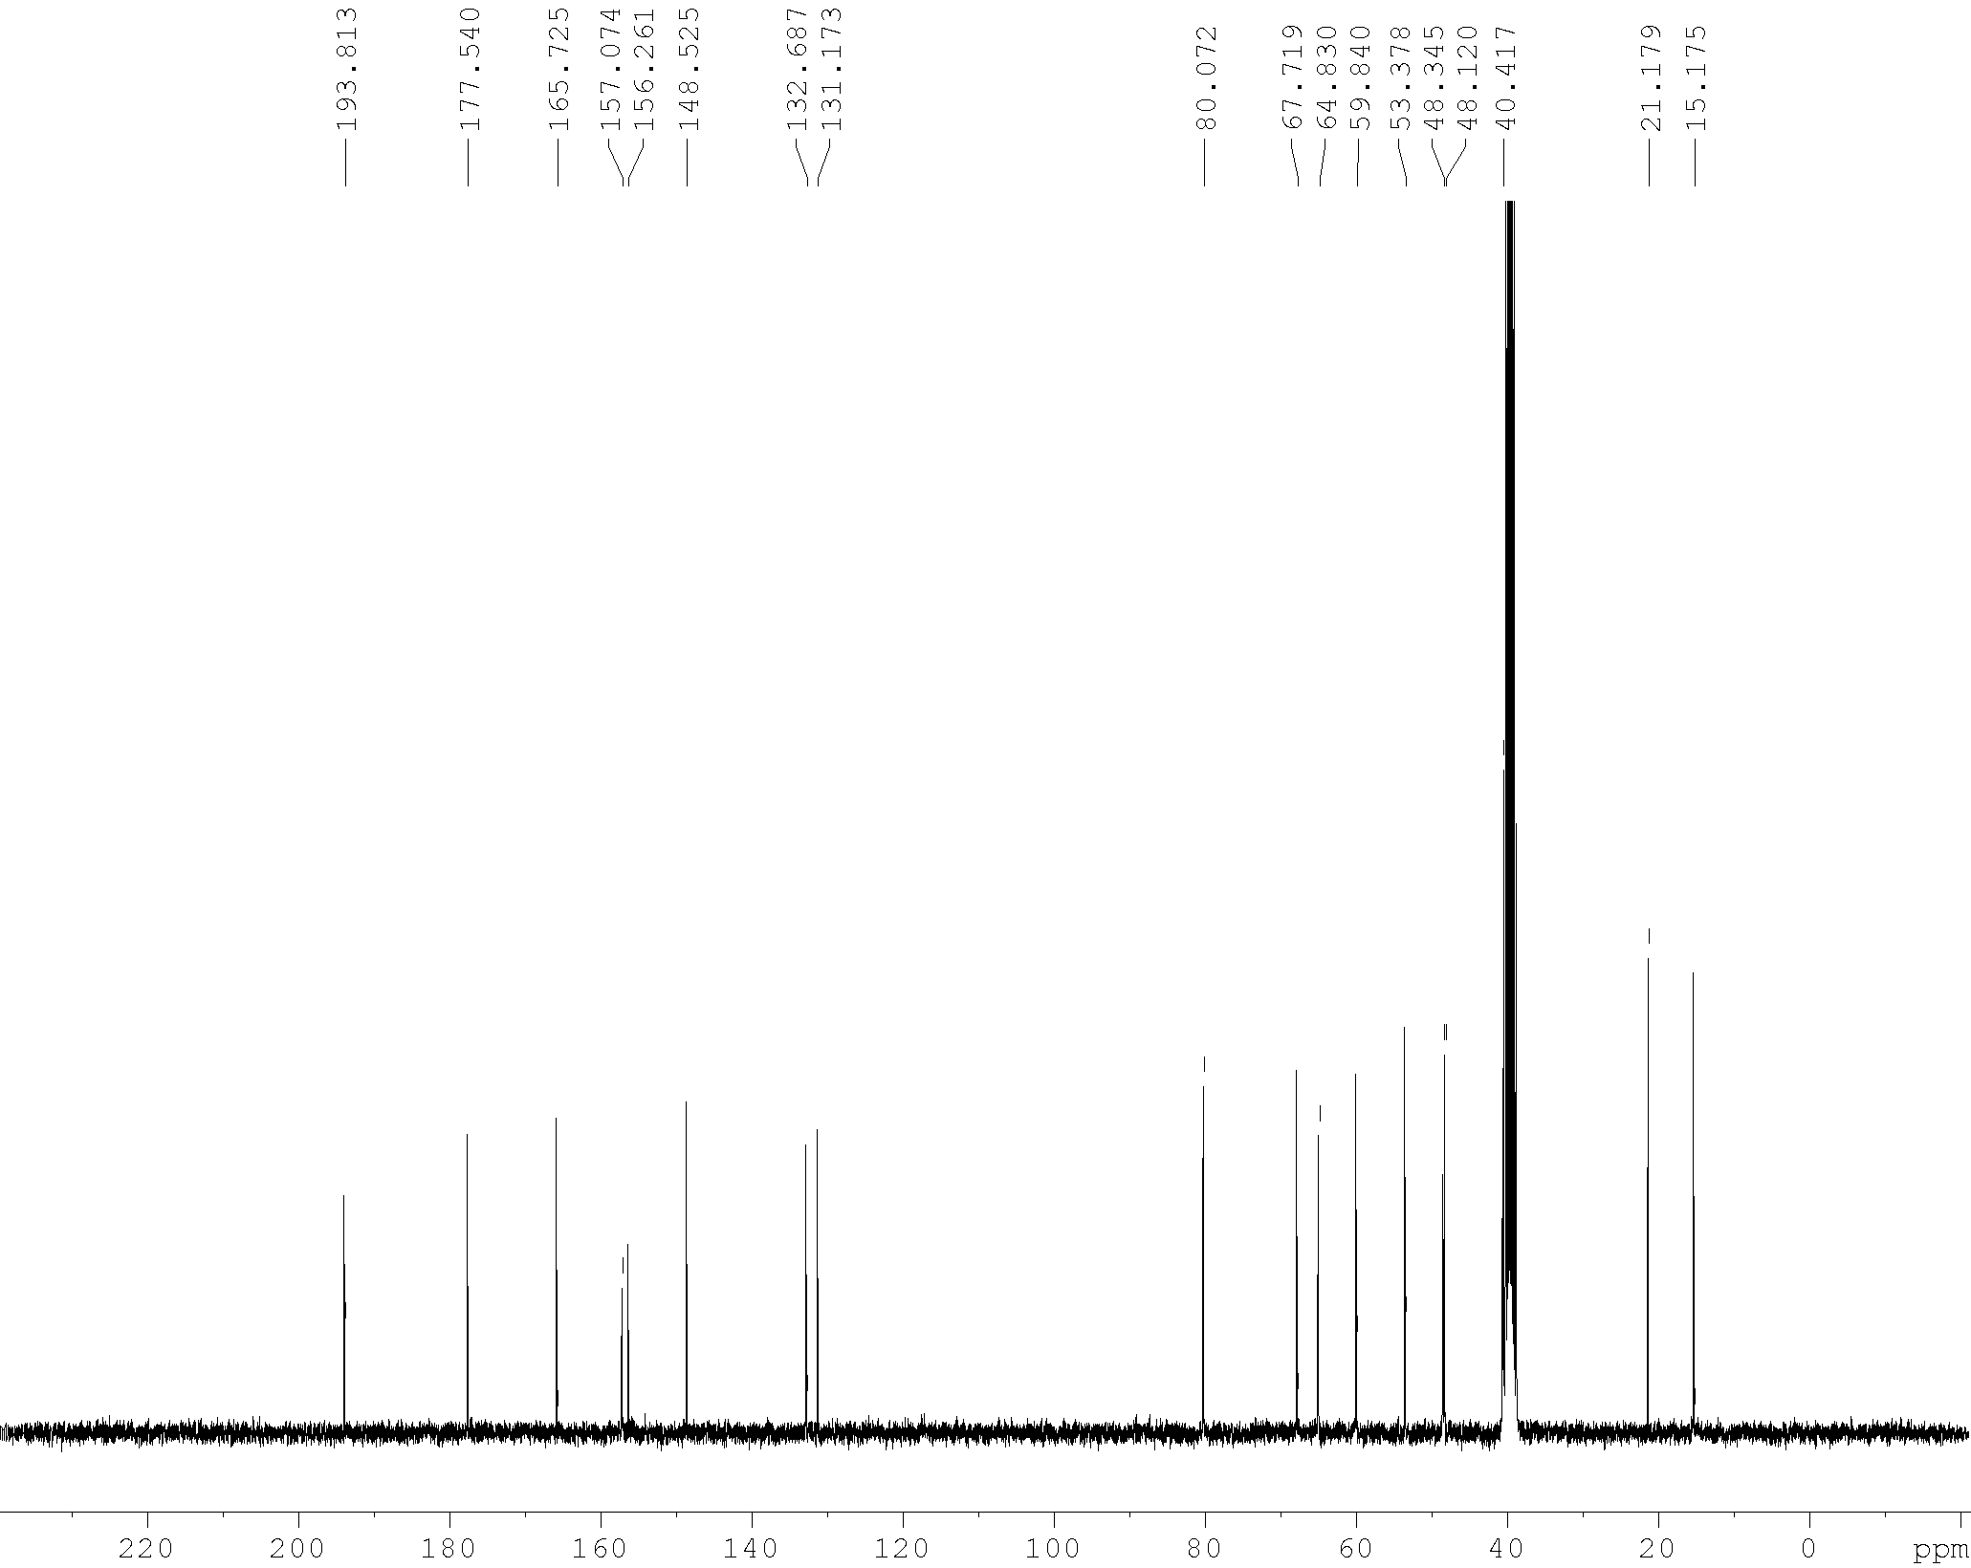

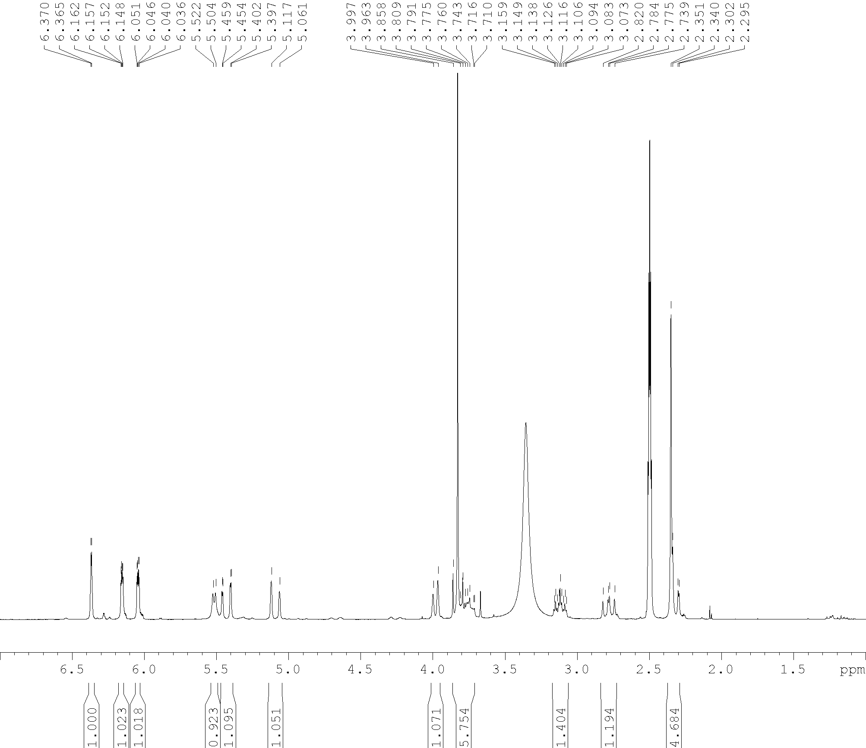
Lc-Me-oxalate, ¹H NMR (300 MHz, DMSO)

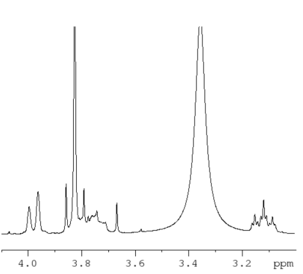

Lc-Me-oxalate,¹³C NMR (75 MHz, DMSO)

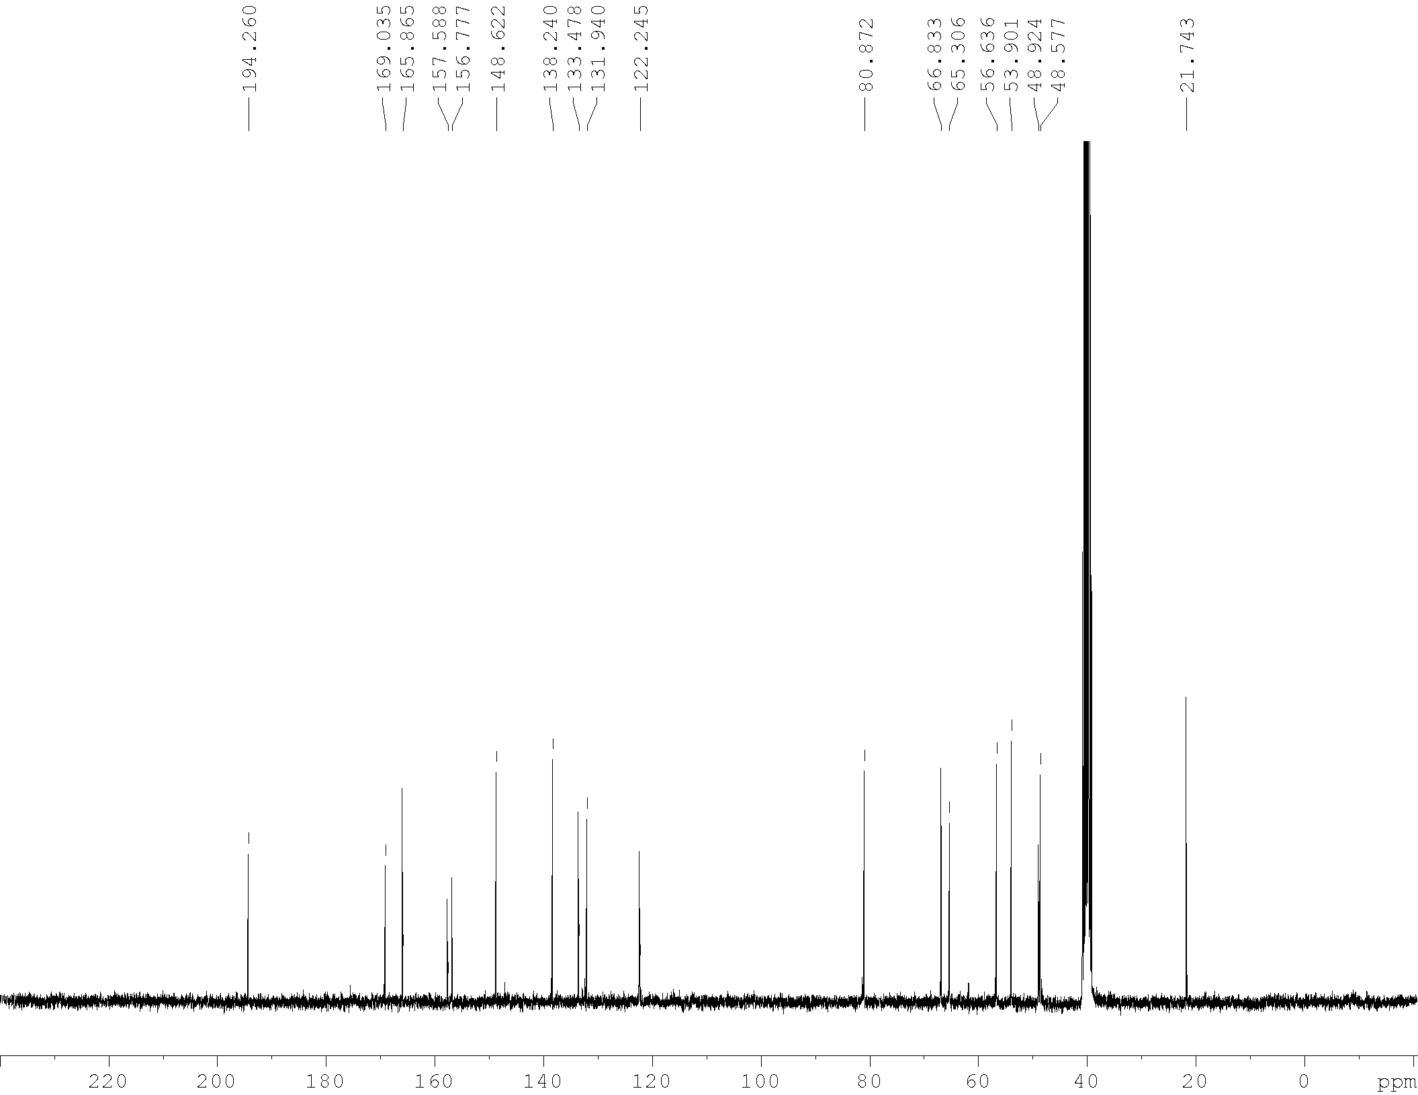

DHLc-oxalate, ¹H NMR (300 MHz, DMSO)
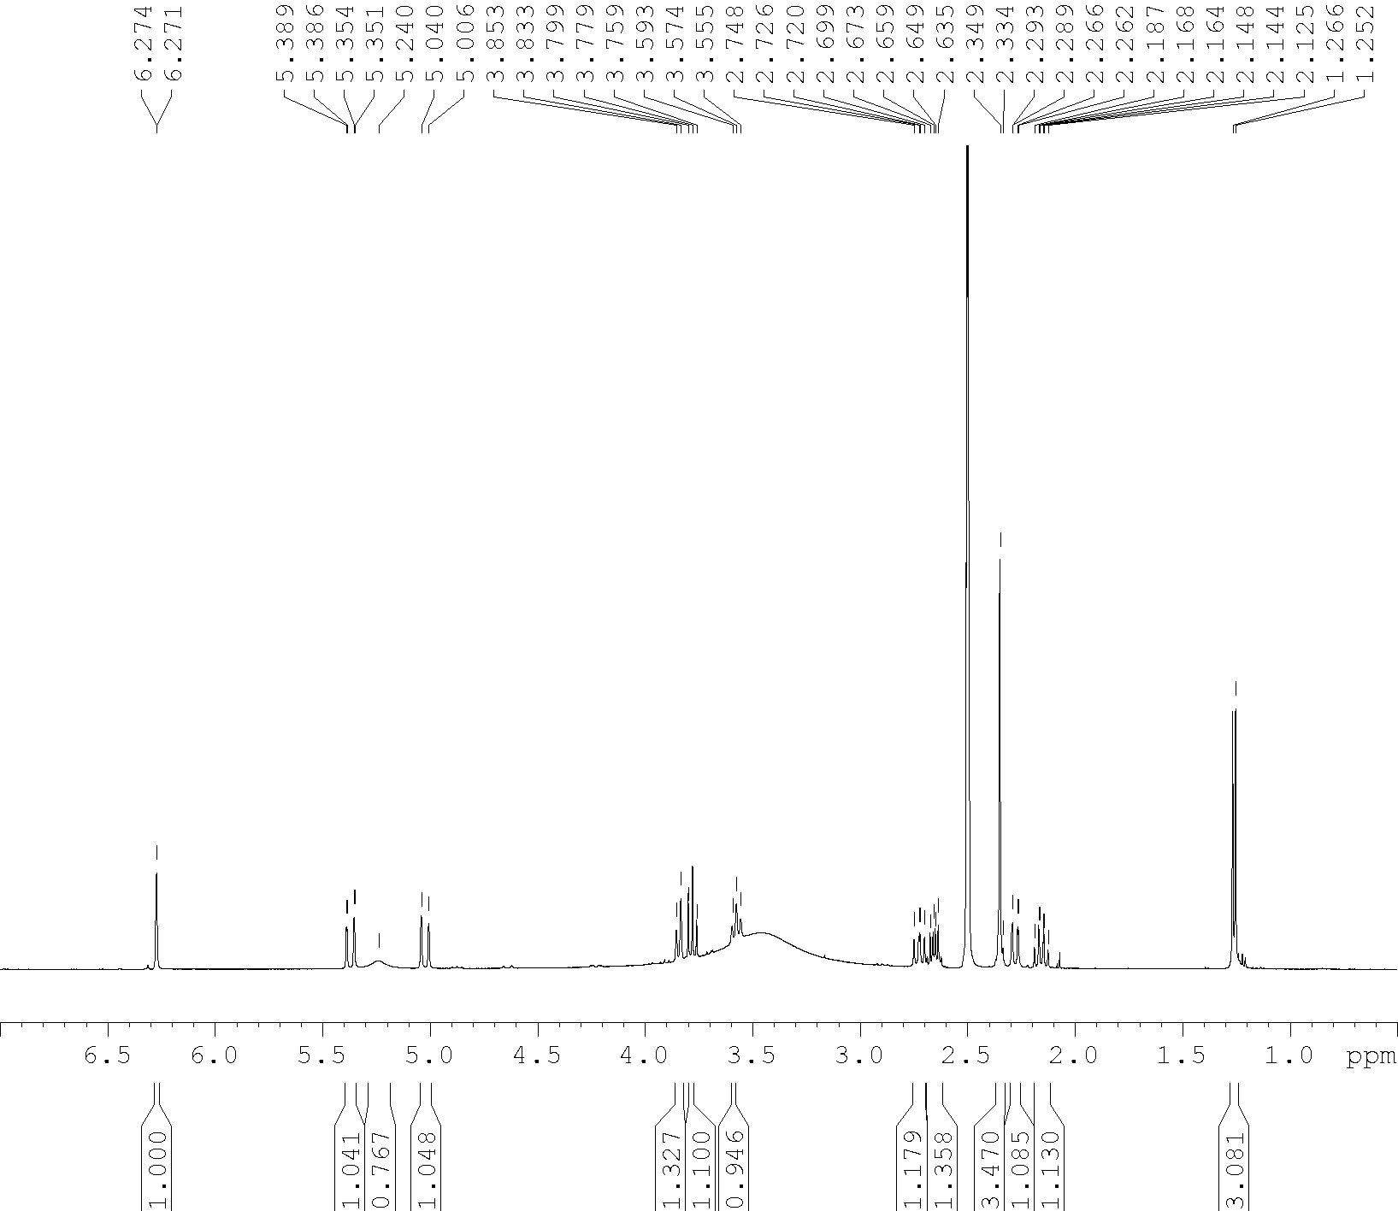

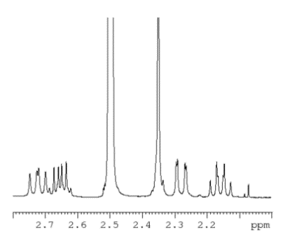

DHLc-oxalate,¹³C NMR (75 MHz, DMSO)

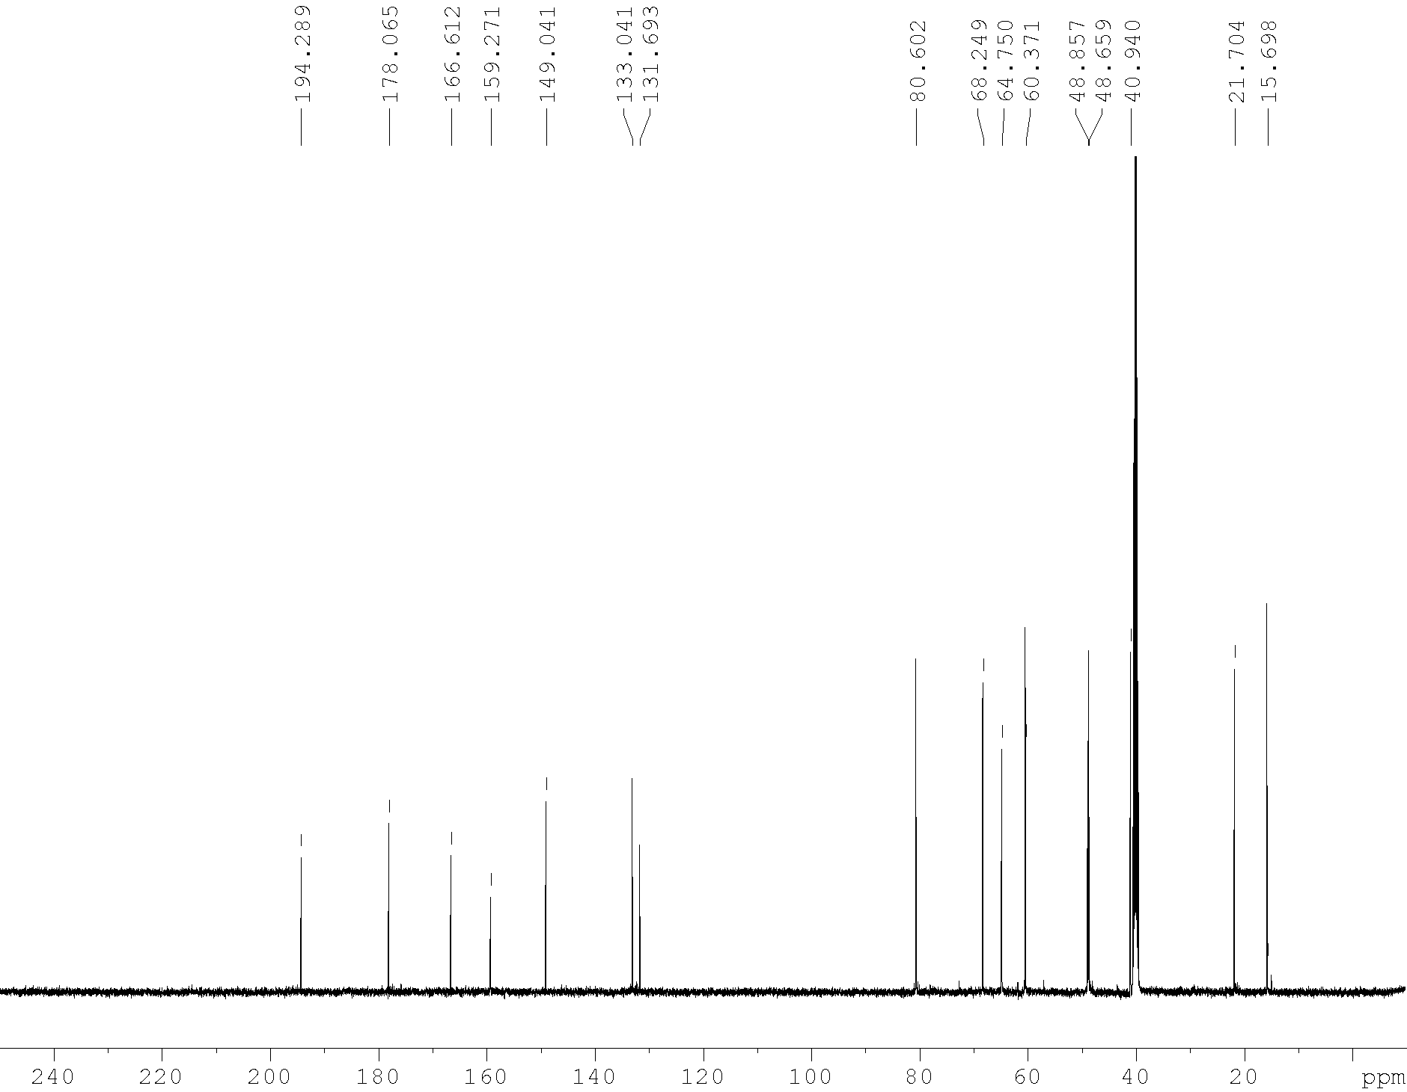

Lc-oxalate, ¹H NMR (300 MHz, DMSO)
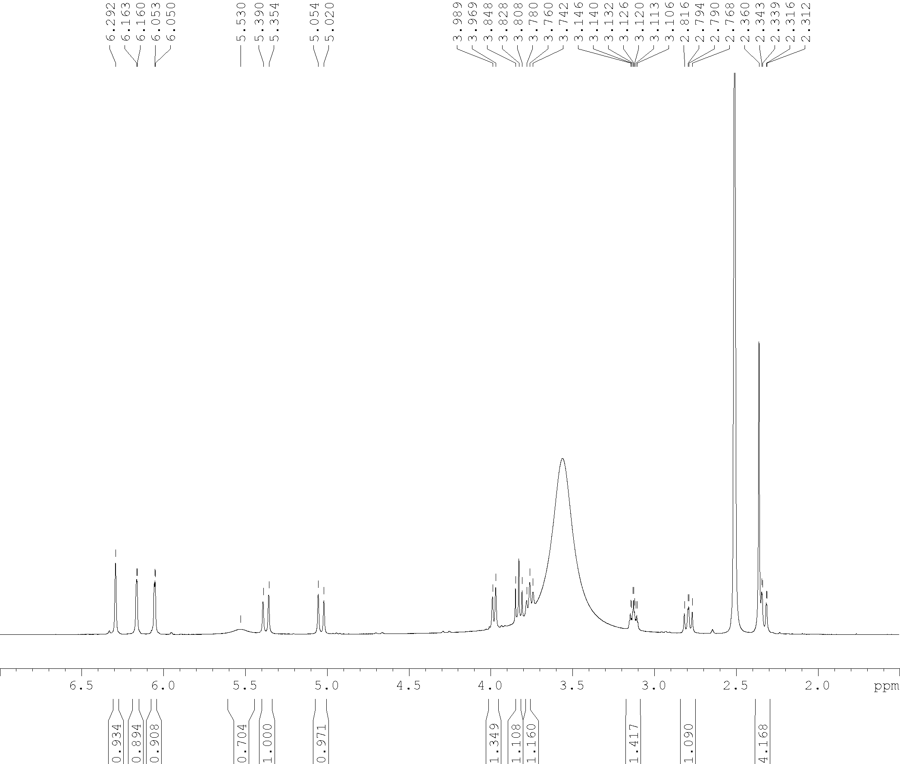

Lc-oxalate, ¹³C NMR (75 MHz, DMSO)

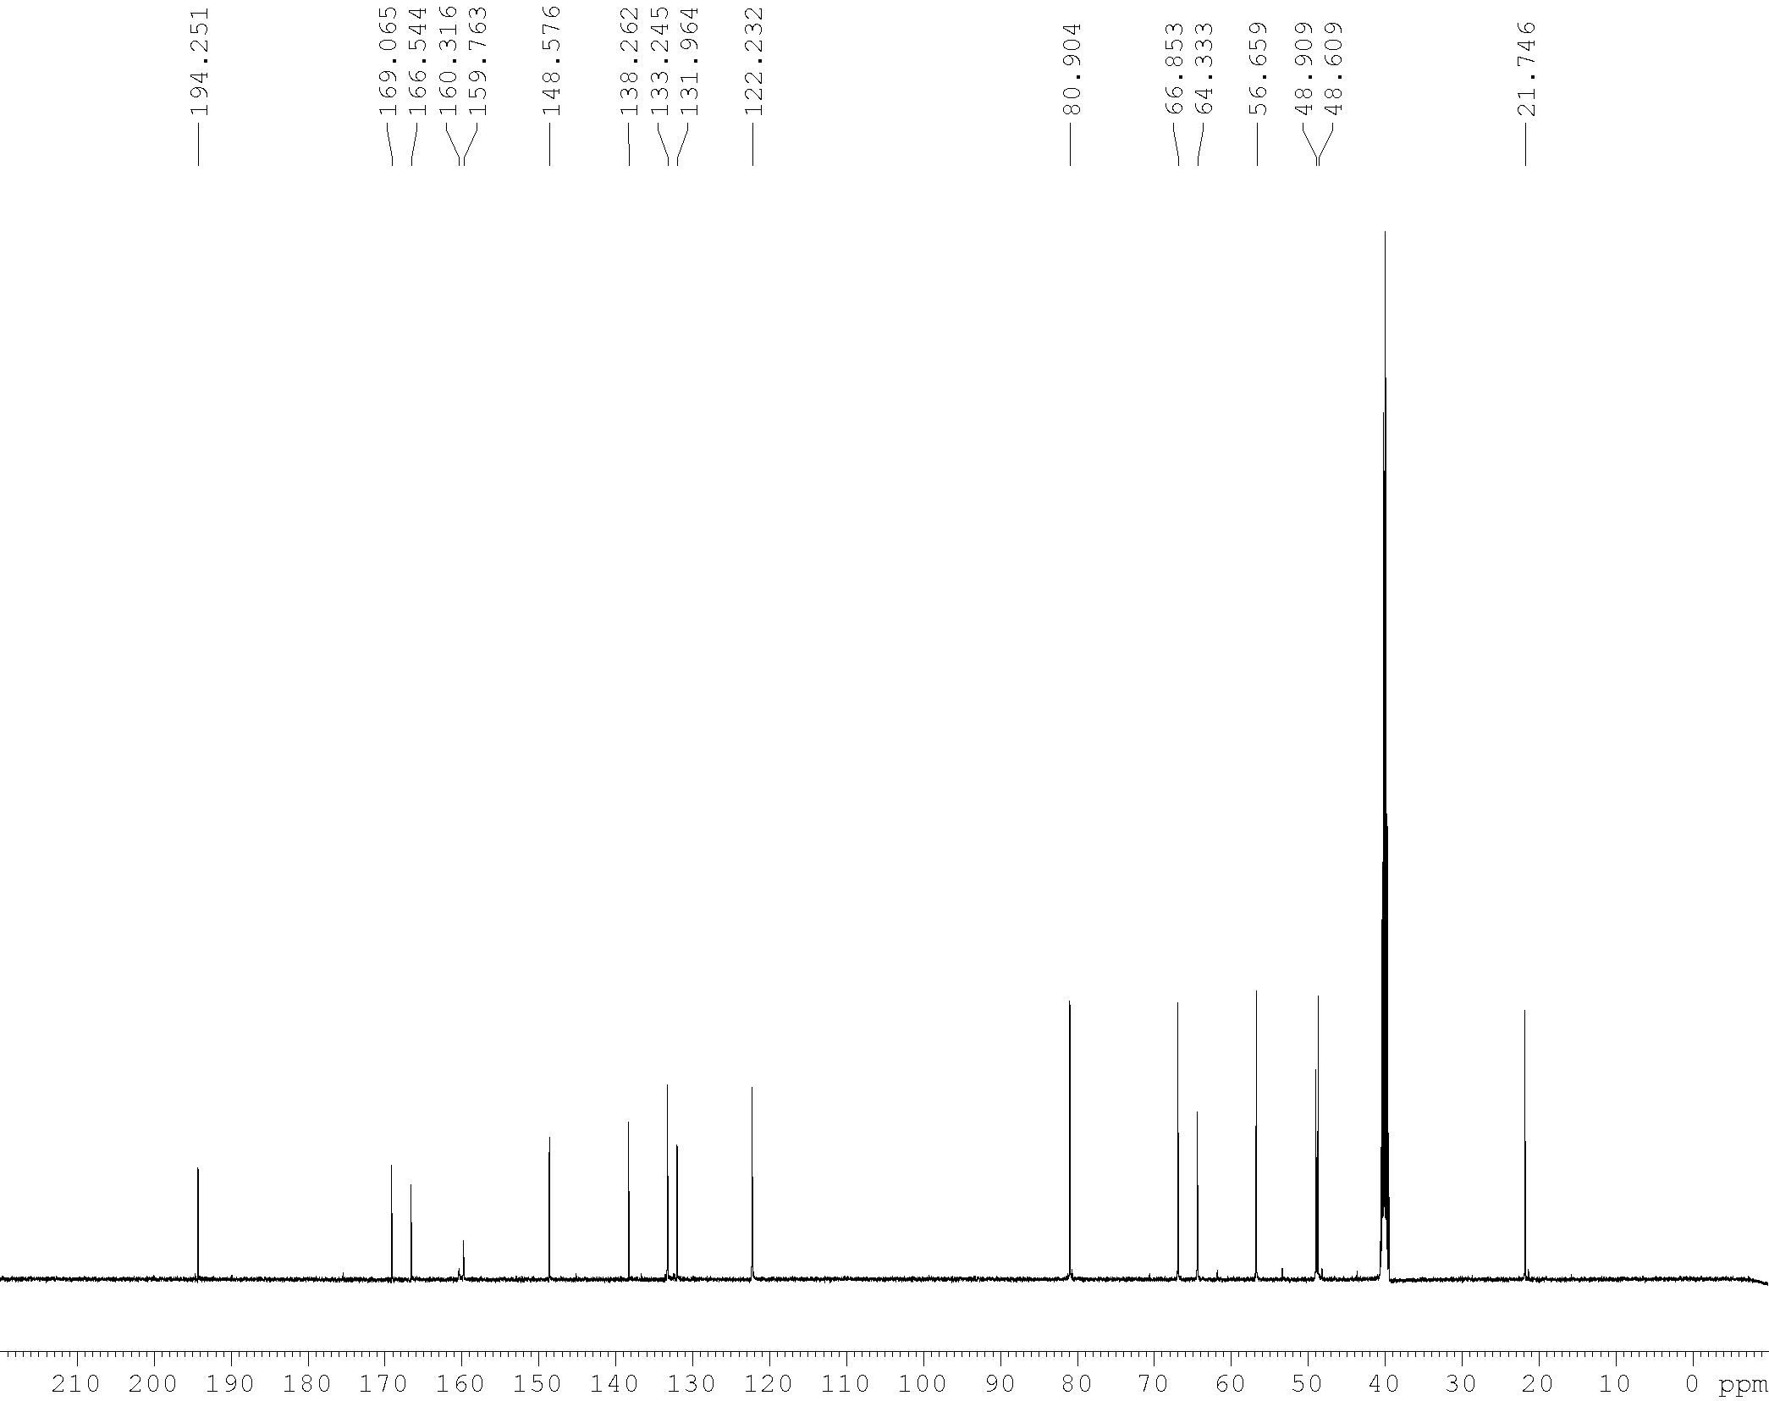

DHLc-glycoside, ¹H NMR (300 MHz, DMSO)
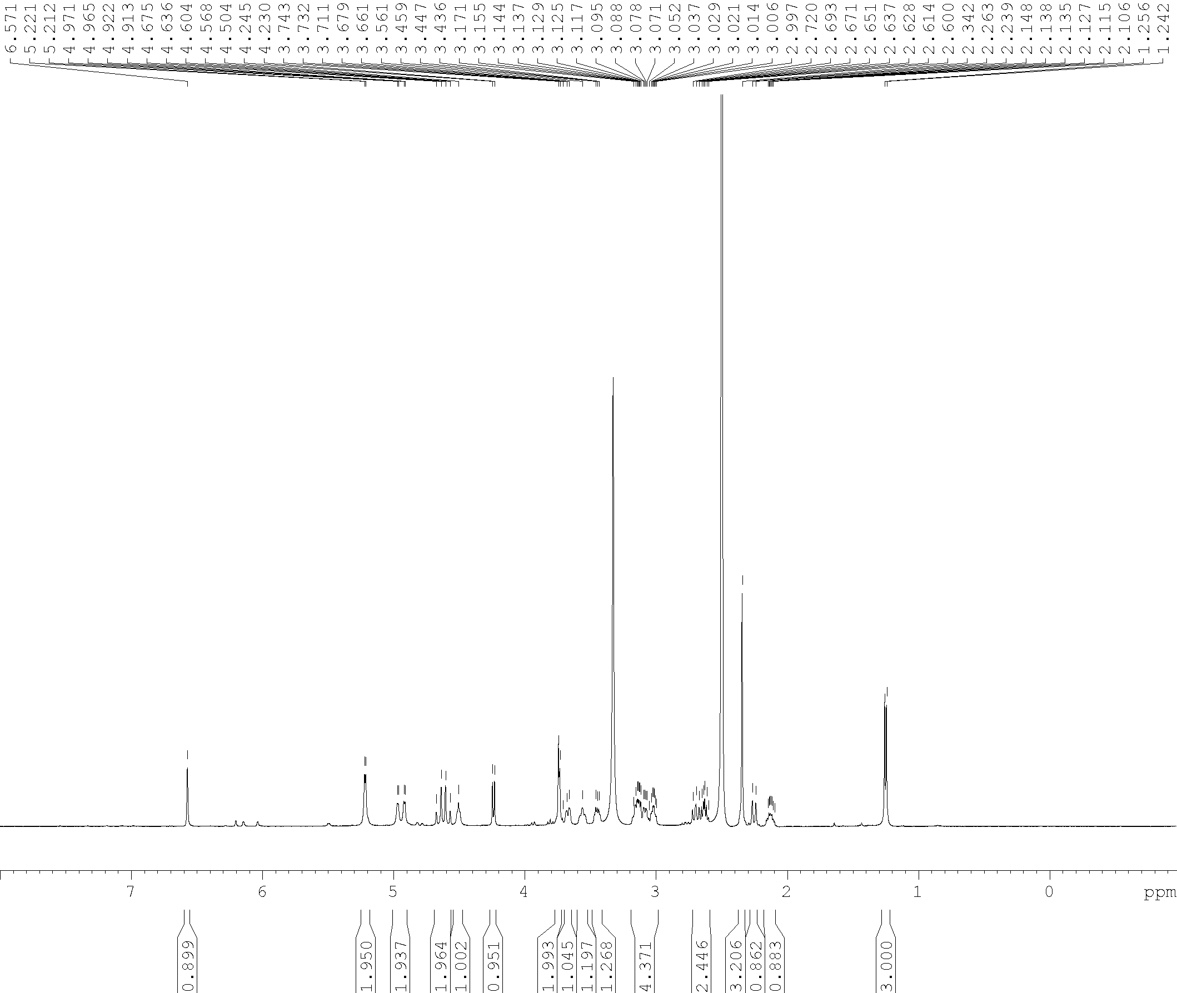

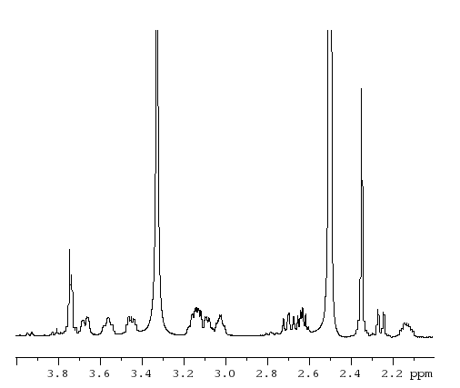

DHLc-glycoside, ¹³C NMR (75 MHz, DMSO)

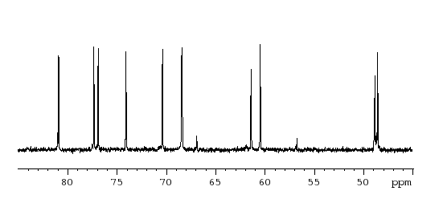
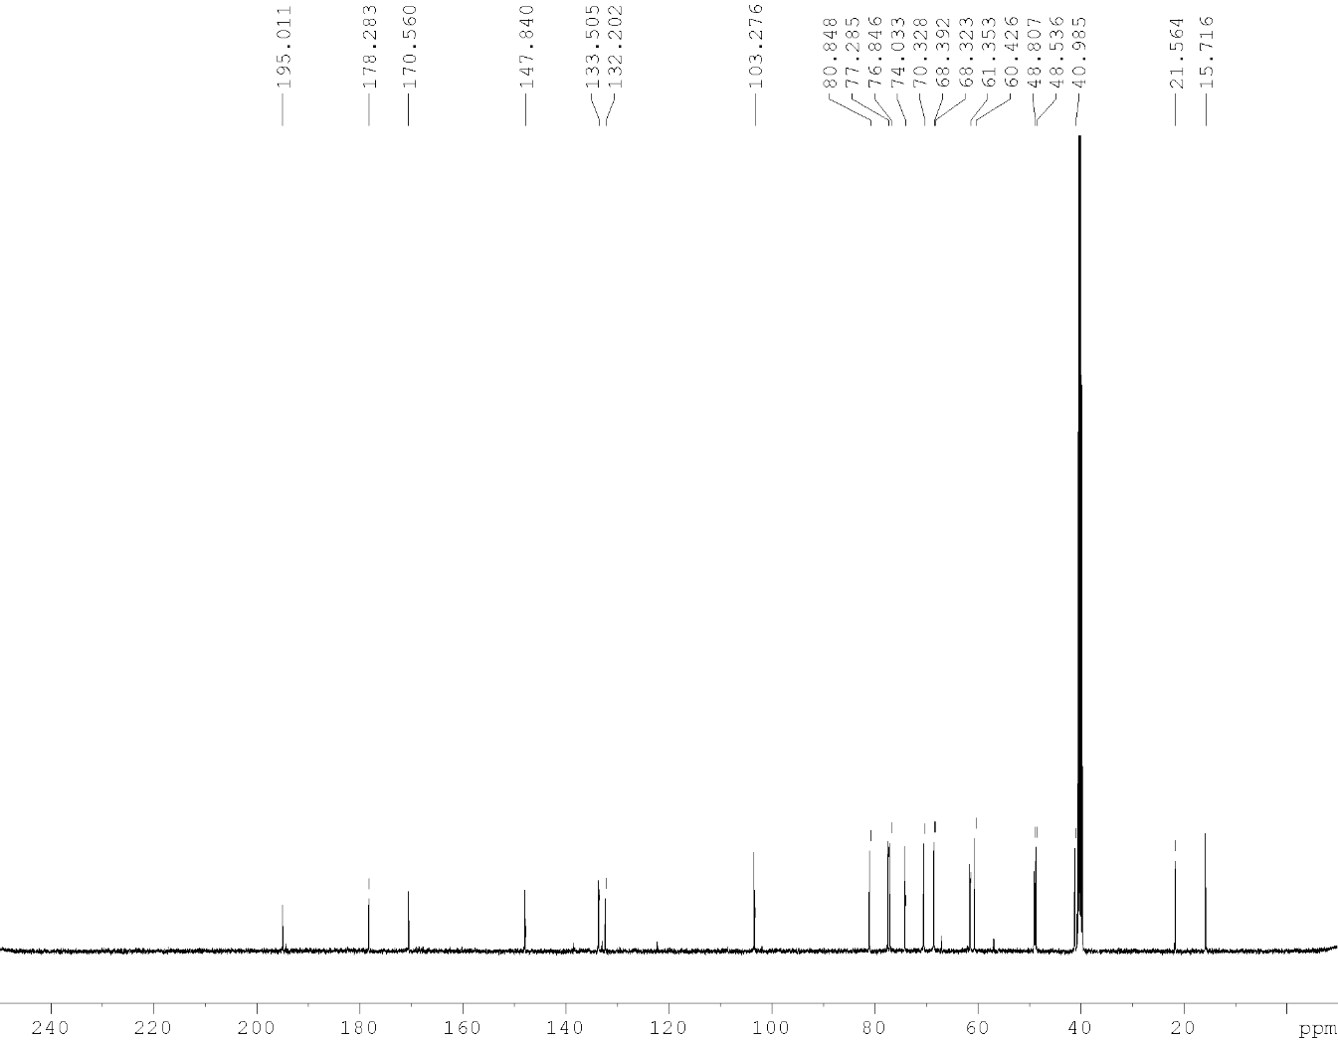

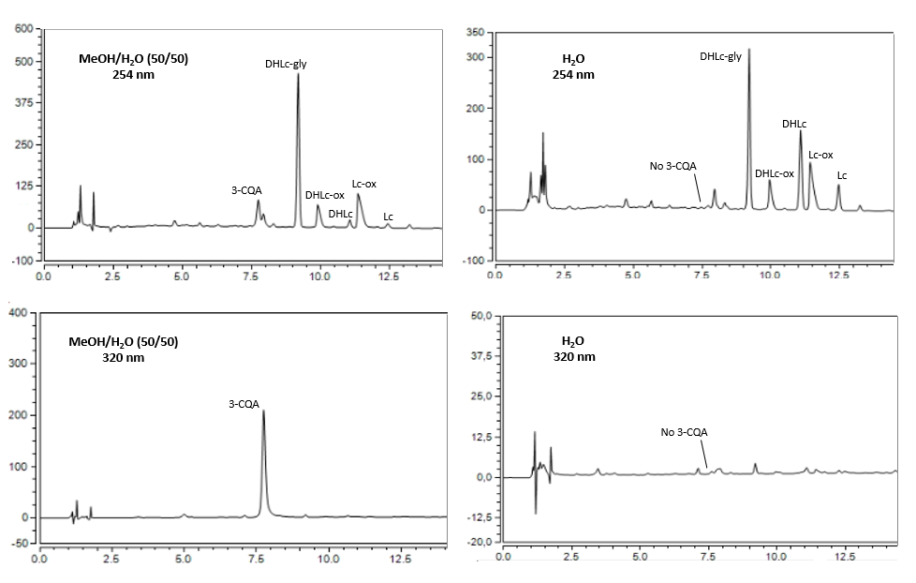
Supplementary Figure S1. HPLC profiles (254 and 320 nm) of a water/methanol 50/50 and pure water extracts and different content in 3-CQA.
DHLc-gly
DHLc-ox
DHLc
Lc-ox
Lc

LC-QTOF-HRMS (+) Analysis of STLs
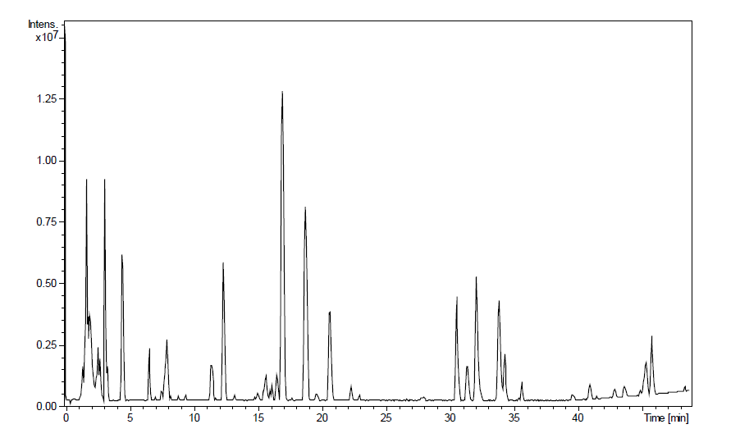
Supplementary Figure S2. Base peak chromatogram (BPC, All − MS) of a water chicory extract obtained in the positive mode.

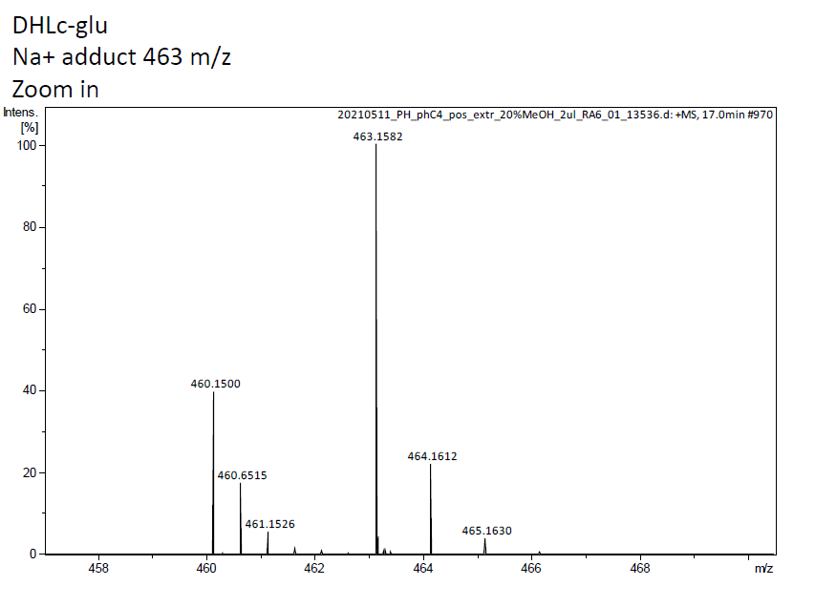
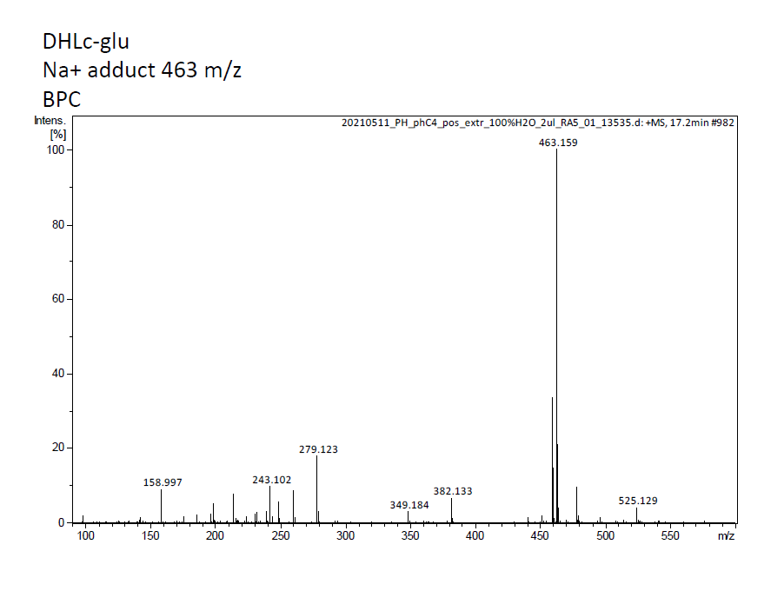
DHLc-gly

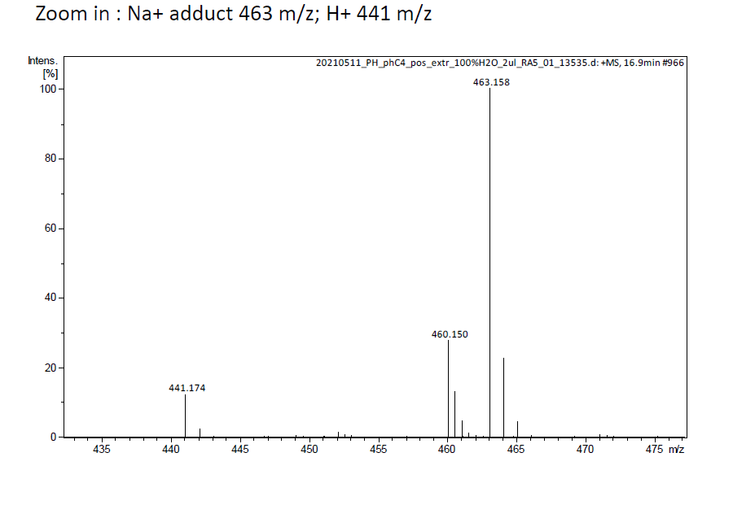

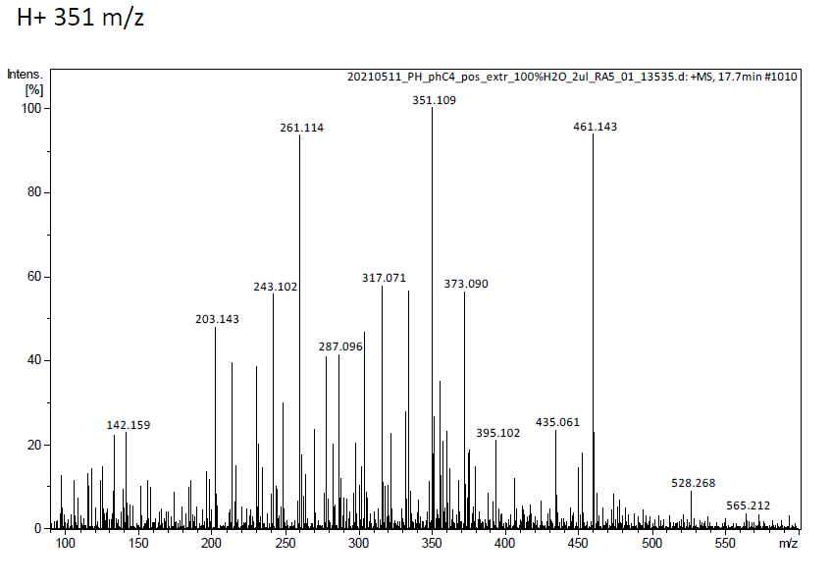
DHLc-ox
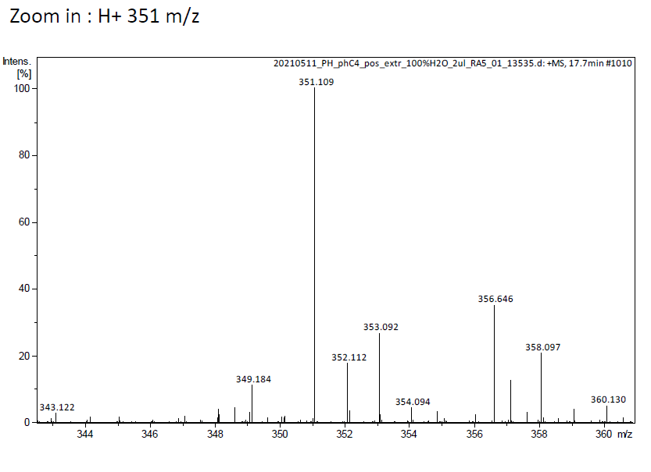
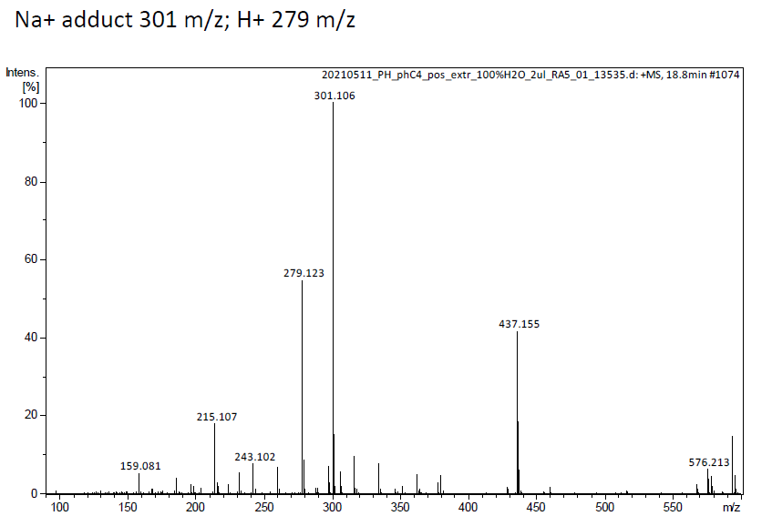
DHLc

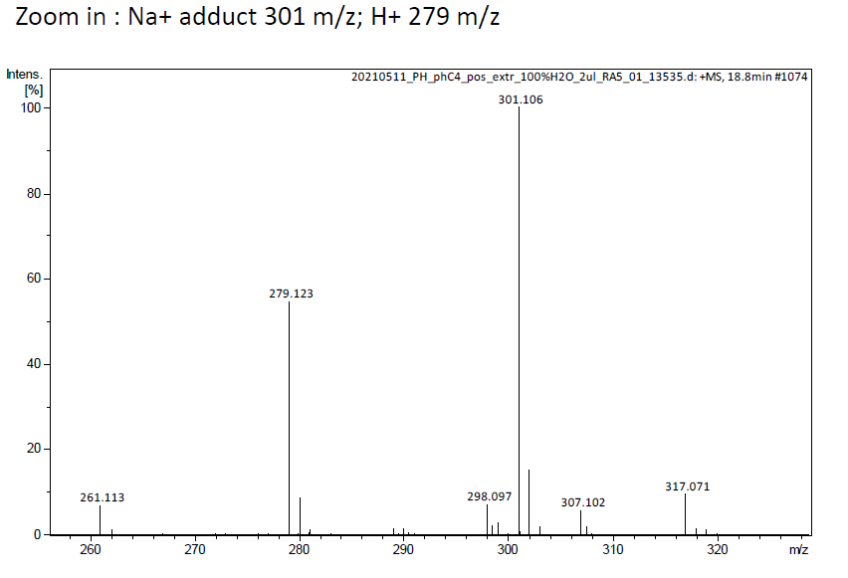
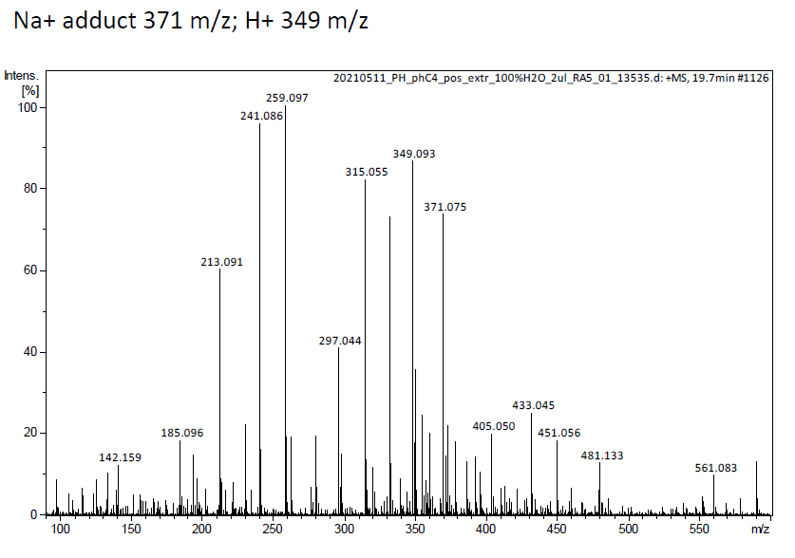
Lc-ox

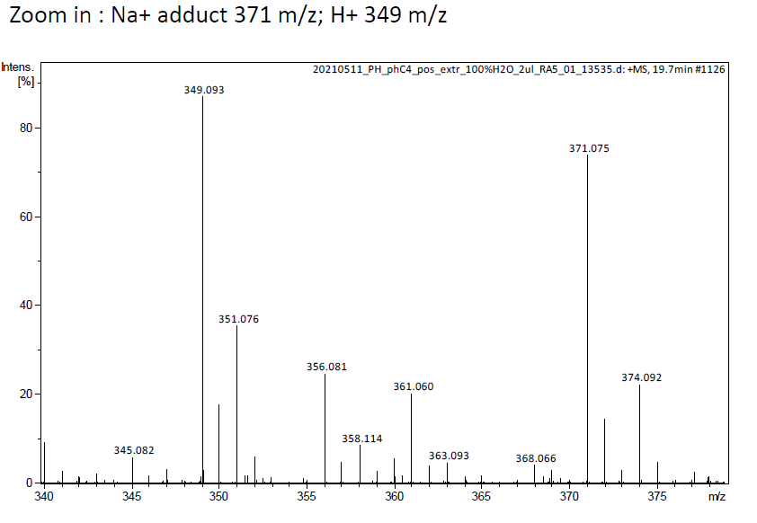

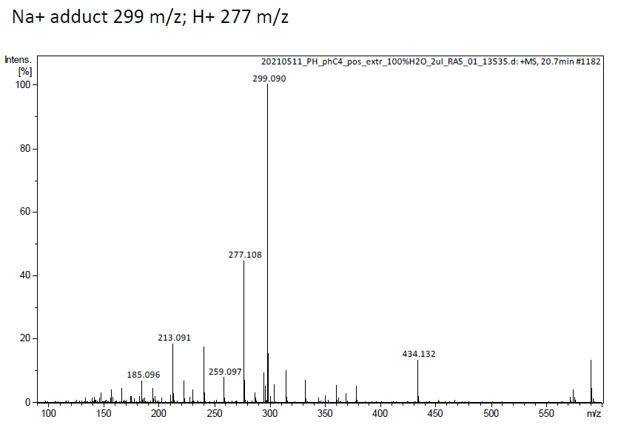
Lc

