Supplementary Materials
Total of all species
Red deer
Ibex
Chamois
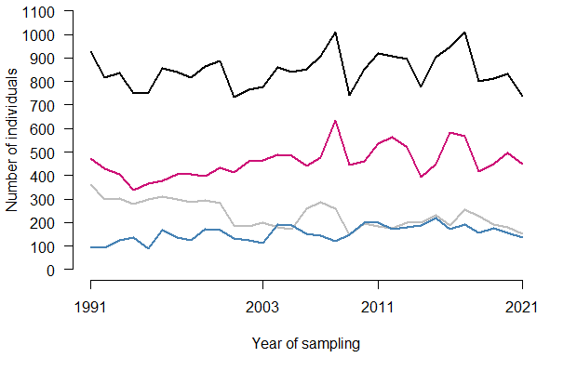
Figure S1. Development of the number of wild ungulates. Annual census counts of red deer (pink), ibex (grey) and chamois (blue) and the total number of all ungulate species (black) in Val Trupchun between 1991 and 2021 (data provided by the Swiss National Park; for a description of methodology, see Anderwald et al. [41]). The four sampling years of the monitoring program are indicated on the x-axis.
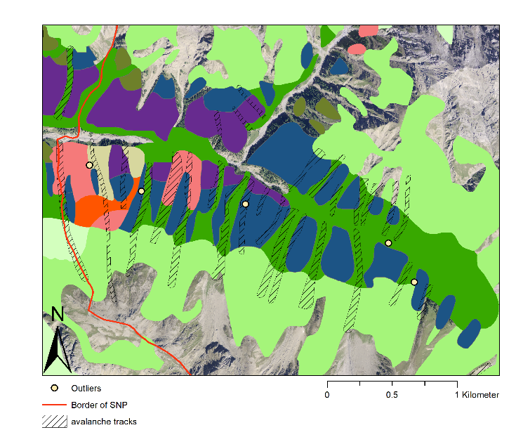
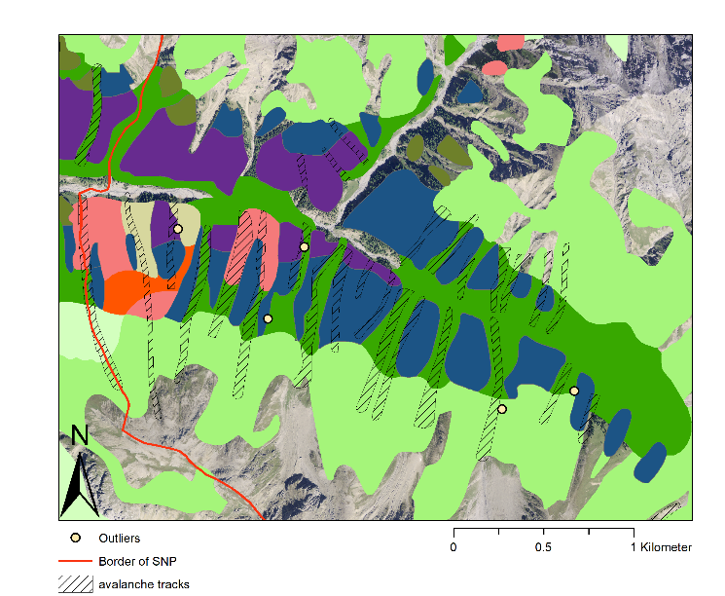
Saplings Young trees

148
144
183
97
110
14
132
8
8
3

Figure S2. Location of outliers (Figure 3) with the highest numbers of saplings (left) and of young trees (right). Outliers are indicated by yellow dots and the corresponding identification number of the sampling plot. Categorizations of forests and meadows are according to the vegetation map of Zoller [20]. The hatched shapes are avalanche tracks (identified and mapped by the SNP in 2009), and the red line shows the border of the SNP.
Figure S3. Heatmap of the annual mean number of ungulates (red deer, chamois, and ibex), based on visual observation data from the SNP between 2012 and 2021 (data provided by the Swiss National Park; for a description of methodology, see Anderwald et al. [41]).

Figure S4. Distribution of sampling plots, numbers of saplings, and proportions of saplings that have been browsed over the four sampling years in Val Trupchun. Pie charts show sampling plots with saplings, dots are sampling plots without saplings, and crosses are plots that were not sampled. Sizes of pie charts represent the number of saplings. Striped patterns of the pie chart indicate saplings that have not been browsed, and pink colored areas indicate saplings that have been browsed.

Figure S5. Distribution of sampling plots, numbers of young trees, and proportions of young trees that show trunk damage by wild ungulates over three sampling years in Val Trupchun. Pie charts show plots with young trees, dots are sampling plots without young trees, and crosses are plots that were not sampled. Sizes of pie charts represent the number of young trees. Striped patterns of the pie chart indicate young trees with no damage to their trunks, and blue colored areas indicate young trees with damaged trunks.

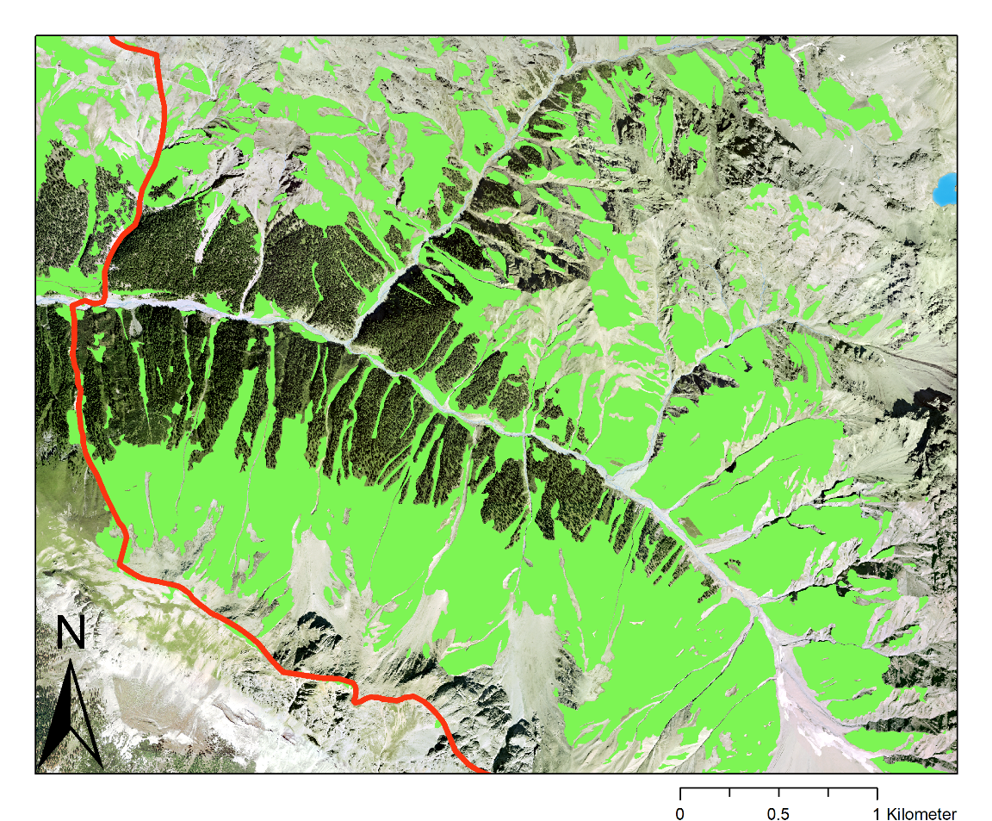
Meadows
Border of SNP

Figure S6. Location of meadows in Val Trupchun [23].

Table S1. Model parameters. The suffix ".z" of the variables indicates that they were centered and scaled, and transformations are indicated with their function. Means, 2.5% and 97.5% quantiles are based on 2000 samples drawn from the joint posterior distribution. The sample size is n = 1808 data points (browsed trees of the same species in the same developmental stage per sampling plot and sampling year; see Figure 7).
Fixed effects
Explanatory variable | Mean | 2.5% quantile | 97.5% quantile
Intercept | -5.13 | -5.86 | -4.44
Spruce | 1.53 | 0.93 | 2.15
Larch | 2.15 | 1.82 | 2.50
Developmental stage 3 | 1.19 | 0.69 | 1.66
Developmental stage 4 | 0.87 | 0.35 | 1.42
Developmental stage 5 | 1.02 | 0.46 | 1.59
Developmental stage 6 | 0.41 | -0.22 | 1.049
log(Number of saplings).z | -0.074 | -0.23 | 0.077
Shannon index.z | -0.17 | -0.34 | 0.0045
Average developmental stage.z | -0.074 | -0.25 | 0.091
Elevation.z | 0.51 | 0.21 | 0.80
Slope.z | -0.10 | -0.28 | 0.085
log(Dist. to next hiking trail).z | 0.16 | -0.11 | 0.44
log(Dist. to next meadow+1).z | -0.064 | -0.25 | 0.12
Eastness.z | 0.24 | 0.075 | 0.40
Norrthness.z | -0.34 | -0.54 | -0.14

Random effects
Variables | Groups | Variance | Standard deviation
Plot ID | 197 | 0.44 | 0.67
Year | 4 | 0.18 | 0.42

Table S2. Point estimates and 95% compatibility intervals of the predictors of the binomial generalized linear mixed-effects model.
Predictor | Point estimate | 95% compatibility interval
 |  | 2.5% quantile | 97.5% quantile
Tree species¹
Larch | 0.15 | 0.096 | 0.22
Spruce | 0.084 | 0.046 | 0.15
Cembra pine | 0.019 | 0.011 | 0.033
Developmental stage²
2 | 0.049 | 0.026 | 0.091
3 | 0.15 | 0.096 | 0.22
4 | 0.11 | 0.070 | 0.17
5 | 0.13 | 0.080 | 0.19
6 | 0.072 | 0.041 | 0.12
Elevation³
min.: 1835 m.a.s.l | 0.049 | 0.021 | 0.12
max.: 2225 m.a.s.l | 0.31 | 0.19 | 0.48
Northness³
-1 (south) | 0.31 | 0.18 | 0.49
1 (north) | 0.12 | 0.079 | 0.19
Eastness³
-1 (west) | 0.087 | 0.048 | 0.15
1 (east) | 0.21 | 0.13 | 0.31
Slope³
min.: 16% | 0.19 | 0.10 | 0.35
max.: 138% | 0.093 | 0.033 | 0.22
Number of saplings³
min.: 1 | 0.15 | 0.098 | 0.23
max.: 112 | 0.092 | 0.032 | 0.25
Average developmental stage³
min.: 1.89 | 0.17 | 0.099 | 0.28
max.: 6 | 0.12 | 0.060 | 0.22
Shannon index³
min.: 0 | 0.18 | 0.12 | 0.28
max.: 1.27 | 0.10 | 0.056 | 0.18
Distance to next hiking trail³
min.: 2 m | 0.12 | 0.068 | 0.20
max.: 583 m | 0.21 | 0.099 | 0.41
Distance to next meadow³
min.: 0 m | 0.15 | 0.098 | 0.23
max.: 166 m | 0.11 | 0.038 | 0.27

¹Point estimates and 95% compatibility intervals refer to developmental stage 3.
²Point estimates and 95% compatibility intervals refer to larch.
³Point estimates and 95% compatibility intervals refer to larch in developmental stage 3.
Table S3. Pearson correlation coefficients of the untransformed model predictors.
 | Tree species | Dev. stage | Elev. | North. | East. | Slope | Num. of saplings | Av. dev. stage | Shannon  index | Dis. to hiking trail | Dis. to meadow
Tree species | 1
Developmental stage | 0.11 | 1
Elevation | -0.041 | 0.017 | 1
Northness | -0.14 | 0.16 | 0.33 | 1
Eastness | -0.050 | 0.084 | 0.069 | 0.11 | 1
Slope | -0.0062 | -0.019 | 0.088 | -0.0065 | -0.0047 | 1
Number of saplings | 0.0062 | 0.0052 | 0.076 | 0.014 | -0.15 | 0.036 | 1
Average developmental stage | 0.013 | 0.54 | 0.029 | 0.23 | 0.14 | -0.064 | -0.073 | 1
Shannon index | -0.032 | 0.024 | -0.097 | 0.29 | 0.16 | 0.064 | 0.20 | -0.025 | 1
Distance to next hiking trail | 0.0053 | -0.078 | 0.74 | 0.045 | -0.15 | 0.052 | 0.19 | -0.12 | -0.11 | 1
Distance to next meadow | 0.061 | -0.14 | -0.39 | -0.26 | -0.26 | -0.040 | -0.17 | -0.20 | -0.11 | -0.12 | 1

Table S4. Total number of saplings and number of saplings being browsed.
Saplings
 |  | Northeast-exposed slope |  | Southwest-exposed slope
Year | Tree species | Total individuals | Browsed  individuals | Total individuals | Browsed  individuals
1991 | Larch | 384 | 52 | 13 | 1
 | Cembra pine | 215 | 5 | 1 | 0
 | Spruce | 51 | 0 | 109 | 13
 | Mountain ash | 21 | 8 | 0 | 0
 | Upright mountain pine | 0 | 0 | 7 | 0
 | Total | 671 | 65 | 130 | 14
 | Ratio of browsed and total individuals in % | 9.7% |  | 10.8%
2003 | Larch | 443 | 44 | 15 | 0
 | Cembra pine | 361 | 8 | 3 | 0
 | Spruce | 42 | 5 | 62 | 0
 | Mountain ash | 4 | 1 | 0 | 0
 | Upright mountain pine | 5 | 0 | 0 | 0
 | Total | 855 | 58 | 80 | 0
 | Ratio of browsed and total individuals in % | 6.8% |  | 0%
2011 | Larch | 623 | 110 | 61 | 26
 | Cembra pine | 594 | 13 | 32 | 2
 | Spruce | 43 | 5 | 192 | 4
 | Mountain ash | 53 | 9 | 0 | 0
 | Upright mountain pine | 2 | 0 | 0 | 0
 | Total | 1315 | 137 | 285 | 32
 | Ratio of browsed and total individuals in % | 10.4% |  | 11.2%
2021 | Larch | 637 | 171 | 84 | 29
 | Cembra pine | 591 | 19 | 15 | 1
 | Spruce | 72 | 3 | 202 | 27
 | Mountain ash | 10 | 0 | 0 | 0
 | Upright mountain pine | 1 | 0 | 1 | 0
 | Total | 1311 | 193 | 302 | 57
 | Ratio of browsed and total individuals in % | 14.7% |  | 18.9%

Table S5. Total number of young trees and number of young trees with damaged trunks.
Young trees
 |  | Northeast-exposed slope |  |  | Southwest-exposed slope
Year | Tree species | Total individuals |  | Individuals with trunk damage | Total individuals |  | Individuals with trunk damage
2003 | Larch | 769 |  | 53 | 125 |  | 12
 | Cembra pine | 171 |  | 19 | 110 |  | 31
 | Spruce | 85 |  | 12 | 228 |  | 11
 | Mountain ash | 1 |  | 0 | 0 |  | 0
 | Upright mountain pine | 2 |  | 0 | 0 |  | 0
 | Total | 1028 |  | 84 | 463 |  | 54
 | Ratio of damaged and total individuals in % | 8.2% |  |  | 11.7%
2011 | Larch | 918 |  | 41 | 103 |  | 8
 | Cembra pine | 198 |  | 37 | 104 |  | 31
 | Spruce | 117 |  | 10 | 241 |  | 14
 | Mountain ash | 1 |  | 0 | 0 |  | 0
 | Upright mountain pine | 3 |  | 0 | 0 |  | 0
 | Total | 1237 |  | 88 | 448 |  | 53
 | Ratio of damaged and total individuals in % | 7.1% |  |  | 11.8%
2021 | Larch | 1195 |  | 103 | 125 |  | 4
 | Cembra pine | 260 |  | 46 | 81 |  | 23
 | Spruce | 116 |  | 13 | 226 |  | 15
 | Mountain ash | 4 |  | 0 | 0 |  | 0
 | Upright mountain pine | 0 |  | 0 | 3 |  | 1
 | Total | 1575 |  | 162 | 435 |  | 43
 | Ratio of damaged and total individuals in % | 10.3% |  |  | 9.9%

