**Supplementary material**

**A multivariate approach to determining and predicting the internal postharvest quality of Hass avocado**

|  |  |
| --- | --- |
| Sample | OC (oil content) (%) |
| EB | 14.30 ± 1.246 |
| N1 | 12.62 ± 0.390 |
| N2 | 11.63 ± 0.255 |
| R1 | 14.13 ± 0.196 |
| R2 | 13.26 ± 0.353 |

**Figure S1.** Variability in the dry matter (DM) content of Hass avocado fruits during harvest cycles. Growing localities: Orchards EB (El Banco), N (Nápoles), and R (Recuerdo). Growing season or harvest cycle: 1 and 2 (2021). Development fruit time R1 (176 days), N1 (162 days), R2 and N2 (173 days), and EB (226 days). Oil content (OC) at harvest (mean ± standard error). * *p*-value with the “*” mean that there is a statistically significant difference between orchards (p < 0.05).

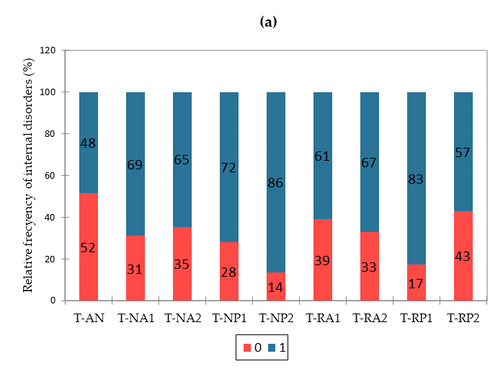

EB

NA1

NA2

NP1

NP2

RA1

RA2

RP1

RP2

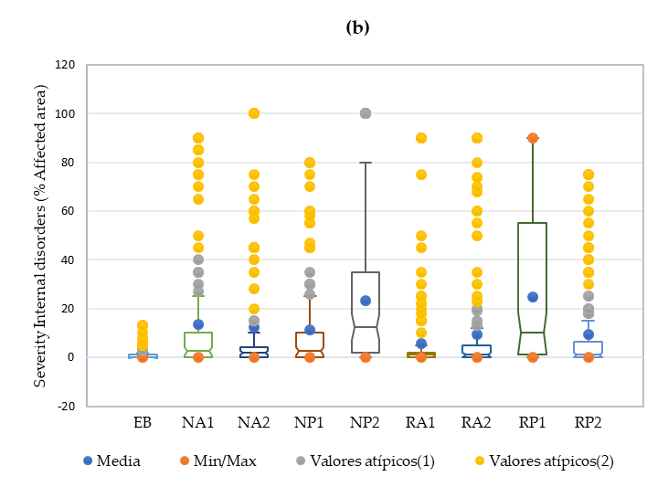

Outliers (1)

Outliers (2)

Mean

Min/Max

**Figure S2.** Percentage of incidence (a) and severity (b) of internal disorders. 0= without disorder, 1= with disorder. Orchards: EB (El Banco), N (Nápoles), and R (Recuerdo). Nutrient management: BIK (A) and grower (P). Growth cycle: main harvest (1) secondary (2).

**Table S1.** K proportion test results regarding the incidence of internal disorders (Marascuilo procedure).

|  |  |
| --- | --- |
| **Sample** | **Proportions \*** |
| EB | 0.485 a |
| RP2 | 0.571 a |
| RA1 | 0.610 a, b |
| NA2 | 0.646 a, b, c |
| RA2 | 0.670 a, b, c |
| NA1 | 0.690 a, b, c |
| NP1 | 0.720 a, b, c |
| RP1 | 0.828 b, c |
| NP2 | 0.865 c |

* Test Chi-square (Observed value) = 46.525 Chi-square (Critical value) = 15.507.

For each column, different letters represent significant differences among the orchards (rows) (Test Chi-square (P < 0.05)).

**Table S2.** Kruskal‒Wallis two-tailed test results regarding disorder severity (multiple pairwise comparisons using Dunn's procedure with Bonferroni correction).

|  |  |  |  |
| --- | --- | --- | --- |
| **Sample** | **Frequency** | **Range sum** | **Mean of ranges** |
| EB | 97 | 28776.500 a | 296.665 a |
| RA1 | 100 | 37362.000 a, b | 373.620 a, b |
| RP2 | 99 | 39105.000 a, b | 395.000 a, b |
| RA2 | 101 | 43175.500 b | 427.480 b |
| NA2 | 100 | 42819.000 b | 428.190 b |
| NP1 | 100 | 47225.500 b, c | 472.255 b, c |
| NA1 | 100 | 47408.000 b, c | 474.080 b, c |
| RP1 | 99 | 57396.000 c | 579.758 c |
| NP2 | 100 | 58588.500 c | 585.885 c |

K (Observed value) = 107.259; K (Critical value) = 15.507.

For each column, different letters represent significant differences among the orchards (rows) (P < 0.05).

**Figure S3.** Logistic regression analysis of internal disorder incidence. Y= internal disorders, X= days to ready to eat (DRTE). **Equation of the model**: Pr (Internal disorders=1) = 1 / (1 + exp(-(-1.769863+0.401484*DRTE)))

EB NA1 NA2 NP1 NP2 RA1 RA2 RP1 RP2

EB NA1 NA2 NP1 NP2 RA1 RA2 RP1 RP2

T-EB

EB NA1 NA2 NP1 NP2 RA1 RA2 RP1 RP2

EB NA1 NA2 NP1 NP2 RA1 RA2 RP1 RP2

**Figure S4.** Incidence of internal disorders in avocado: relative frequency in vascular browning (a), stem end rot (b), flesh discoloration (c), flesh bruising (d), flesh rots (e), and body rots (f). Internal disorders. 0= without disorder, 1= with disorder Orchards: EB (El Banco), N (Nápoles), and R (Recuerdo). Nutrient management: BIK (A) and grower (P). Growth cycle: main harvest (1) secondary (2).

**Table S3.** K proportion test results regarding the incidence of internal disorders (Marascuilo procedure comparison).

|  |  |  |  |  |  |  |
| --- | --- | --- | --- | --- | --- | --- |
| **Sample** | **Vascular browing** | **Stem end rot** | **Flesh discoloration** | **Flesh bruising** | **Flesh rots** | **Body rots** |
| EB | 0.371 a | 0.062 a | 0.000 a | 0.103 a, b | 0.041 a | 0.010 a |
| RP2 | 0.469 a, b | 0.110 a | 0.122 a, b | 0.235 b, c | 0.082 a, b | 0.143 a, b, c |
| NA1 | 0.500 a, b | 0.140 a | 0.130 a, b | 0.090 a, b | 0.260 b | 0.290 c |
| RA1 | 0.530 a, b, c | 0.163 a, b | 0.170 b, c | 0.070 a, b | 0.100 a, b | 0.060 a, b |
| NP1 | 0.570 a b, c | 0.210 a, b, c | 0.130 a, b | 0.090 a, b | 0.260 b | 0.170 b, c |
| NA2 | 0.580 a b, c | 0.380 b, c | 0.032 a, b | 0.021 a | 0.063 a, b | 0.105 a, b, c |
| RA2 | 0.590 a b, c | 0.380 b, c | 0.030 a, b | 0.110 a, b | 0.160 a, b | 0.180 b, c |
| RP1 | 0.667 b, c | 0.414 c | 0.170 c | 0.374 c | 0.232 b | 0.172 b, c |
| NP2 | 0.760 c | 0.460 c | 0.384 a, b | 0.174 a, b, c | 0.174 a, b | 0.128 a, b, c |

For each column**, d**ifferent letters represent significant differences among the orchards (rows) (Test Chi-square (P < 0.05)).

**Figure S5**. Severity of internal disorders through Hass avocado ripening for growing cycle 1 of 2021. Orchard: El Banco (a), Nápoles – grower (b), Nápoles – BIK (c), Recuerdo – grower (d) and Recuerdo – BIK (e).The Red dash line could use as a control limit according to [21] and [22]. The cross and line represent the mean and median, respectively. Days to ready to eat (DRTE).

**Figure S6**. Severity of internal disorders through Hass avocado ripening for growing cycle 2 of 2021. Orchard: El Banco (a), Nápoles – grower (b), Nápoles – BIK (c), Recuerdo – grower (d) and Recuerdo – BIK (e).The Red dash line could use as a control limit according to [21] and [22]. The cross and line represent the mean and median, respectively. Days to ready to eat (DRTE).

**Table S4**. Descriptive statistics of the flesh mineral composition of Hass avocados at the RTE (ready to eat) stage.

| **T** | **Statistics** | **N\*** | **P\*** | **K\*** | **Ca\*** | **Mg\*** | **S\*** | **Fe\*\*** | **Cu\*\*** | **Mn\*\*** | **Zn\*\*** | **B\*\*** |
| --- | --- | --- | --- | --- | --- | --- | --- | --- | --- | --- | --- | --- |
| EB | Min | 0,692 | 0,105 | 1,248 | 0,043 | 0,088 | 0,061 | 27,552 | 5,370 | 7,430 | 15,112 | 49,465 |
| Max | 0,863 | 0,127 | 1,541 | 0,054 | 0,098 | 0,075 | 34,747 | 5,992 | 8,308 | 18,306 | 53,318 |
| Mean | 0,765 | 0,119 | 1,392 | 0,048 | 0,094 | 0,069 | 31,363 | 5,720 | 7,902 | 16,394 | 51,654 |
| SD | 0,066 | 0,009 | 0,114 | 0,004 | 0,004 | 0,005 | 2,915 | 0,264 | 0,384 | 1,127 | 1,403 |
| NA1 | Min | 1,067 | 0,147 | 1,579 | 0,052 | 0,102 | 0,099 | 23,329 | 7,373 | 6,763 | 19,974 | 62,227 |
| Max | 1,337 | 0,209 | 1,976 | 0,069 | 0,117 | 0,121 | 33,027 | 8,531 | 8,088 | 23,211 | 83,096 |
| Mean | 1,197 | 0,179 | 1,788 | 0,059 | 0,112 | 0,110 | 28,874 | 8,099 | 7,618 | 22,237 | 69,135 |
| SD | 0,111 | 0,026 | 0,172 | 0,006 | 0,006 | 0,009 | 3,896 | 0,403 | 0,479 | 1,248 | 7,523 |
| NA2 | Min | 1,224 | 0,162 | 1,788 | 0,050 | 0,105 | 0,106 | 26,735 | 6,501 | 7,150 | 19,242 | 37,354 |
| Max | 1,335 | 0,193 | 1,940 | 0,056 | 0,115 | 0,122 | 33,134 | 8,348 | 7,906 | 26,306 | 46,420 |
| Mean | 1,277 | 0,177 | 1,863 | 0,054 | 0,110 | 0,112 | 28,631 | 7,127 | 7,687 | 23,856 | 42,993 |
| SD | 0,045 | 0,010 | 0,063 | 0,002 | 0,004 | 0,006 | 2,454 | 0,748 | 0,280 | 2,667 | 3,701 |
| NP1 | Min | 0,940 | 0,138 | 1,440 | 0,053 | 0,086 | 0,084 | 18,215 | 6,029 | 5,019 | 15,072 | 53,871 |
| Max | 1,146 | 0,186 | 1,788 | 0,069 | 0,112 | 0,110 | 20,860 | 7,594 | 7,041 | 20,208 | 62,736 |
| Mean | 1,049 | 0,166 | 1,625 | 0,062 | 0,098 | 0,097 | 19,793 | 7,011 | 6,121 | 17,368 | 56,951 |
| SD | 0,094 | 0,021 | 0,131 | 0,006 | 0,011 | 0,012 | 0,941 | 0,567 | 0,851 | 1,857 | 3,567 |
| NP2 | Min | 1,010 | 0,160 | 1,650 | 0,065 | 0,104 | 0,105 | 37,227 | 7,632 | 6,993 | 18,960 | 49,245 |
| Max | 1,100 | 0,194 | 1,886 | 0,072 | 0,125 | 0,126 | 44,311 | 9,932 | 8,981 | 22,460 | 52,445 |
| Mean | 1,071 | 0,179 | 1,781 | 0,069 | 0,114 | 0,115 | 39,634 | 8,897 | 8,049 | 21,287 | 51,116 |
| SD | 0,035 | 0,014 | 0,086 | 0,003 | 0,008 | 0,008 | 2,973 | 0,847 | 0,896 | 1,576 | 1,377 |
| RA1 | Min | 0,892 | 0,114 | 1,355 | 0,038 | 0,070 | 0,086 | 17,433 | 7,344 | 5,480 | 16,231 | 20,725 |
| Max | 0,997 | 0,146 | 1,648 | 0,050 | 0,089 | 0,111 | 19,961 | 8,601 | 6,407 | 19,844 | 29,794 |
| Mean | 0,943 | 0,125 | 1,458 | 0,044 | 0,080 | 0,094 | 18,543 | 8,032 | 6,101 | 18,211 | 24,462 |
| SD | 0,041 | 0,011 | 0,118 | 0,004 | 0,008 | 0,009 | 1,015 | 0,480 | 0,330 | 1,349 | 3,391 |
| RA2 | Min | 0,941 | 0,153 | 1,517 | 0,055 | 0,103 | 0,102 | 23,463 | 9,398 | 8,351 | 17,161 | 16,219 |
| Max | 1,038 | 0,180 | 1,716 | 0,064 | 0,120 | 0,120 | 30,843 | 11,594 | 9,961 | 23,220 | 18,061 |
| Mean | 0,987 | 0,165 | 1,647 | 0,059 | 0,111 | 0,110 | 27,698 | 10,656 | 9,171 | 20,682 | 17,147 |
| SD | 0,042 | 0,012 | 0,073 | 0,004 | 0,006 | 0,007 | 2,645 | 0,838 | 0,669 | 2,203 | 0,746 |
| RP1 | Min | 0,883 | 0,103 | 1,179 | 0,041 | 0,070 | 0,085 | 20,719 | 6,415 | 4,768 | 15,698 | 15,491 |
| Max | 0,940 | 0,126 | 1,510 | 0,055 | 0,088 | 0,092 | 28,219 | 8,667 | 6,881 | 19,165 | 24,962 |
| Mean | 0,904 | 0,110 | 1,371 | 0,046 | 0,079 | 0,087 | 23,903 | 7,709 | 5,670 | 17,784 | 20,412 |
| SD | 0,021 | 0,009 | 0,116 | 0,005 | 0,007 | 0,003 | 3,322 | 0,889 | 0,925 | 1,328 | 3,220 |
| RP2 | Min | 0,955 | 0,144 | 1,397 | 0,059 | 0,103 | 0,086 | 24,193 | 7,482 | 7,290 | 17,002 | 13,086 |
| Max | 1,038 | 0,167 | 1,495 | 0,073 | 0,130 | 0,112 | 31,845 | 8,967 | 9,194 | 20,606 | 14,453 |
| Mean | 1,006 | 0,152 | 1,450 | 0,065 | 0,114 | 0,096 | 27,513 | 8,250 | 8,152 | 19,009 | 13,981 |
| SD | 0,033 | 0,009 | 0,042 | 0,006 | 0,010 | 0,009 | 3,525 | 0,617 | 0,876 | 1,616 | 0,528 |

(SD) Standard deviation, (Max) Maximum, (Min) Minimum. T: treatments. N (nitrogen), P (phosphorus), K (potassium), Ca (calcium), Mg (magnesium), S (sulfur), Fe (iron), Cu (copper), Mn (manganese), Zn (zinc), B (boron). * (%), ** (mg/Kg).