Supplementary material
Adapted Business Model Canvas Template and Primary Market Research for Project-Based Learning on Management of Slurry
Alejandro Moure Abelenda^{a,*}, Farid Aiouacheª, and Daniel Moreno-Mediavilla^{b}
ªSchool of Engineering, Lancaster University, Lancaster, LA1 4YW, UK
^{b}Faculty of Education, Universidad Internacional de La Rioja (UNIR), Avenida de la Paz 137, 26004 Logroño, Spain
*Corresponding author: a.moureabelenda@lancaster.ac.uk

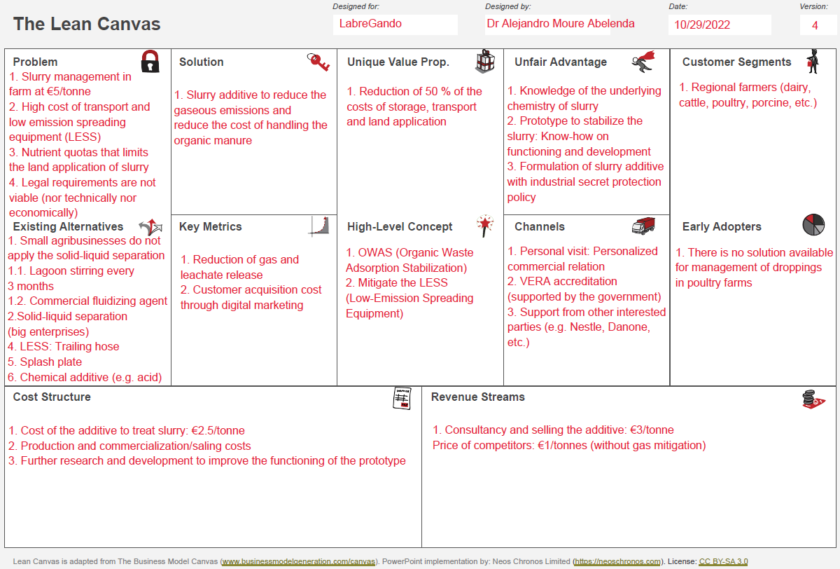
Fig. S.1. Lean BMC templated filled for the LabreGando project.
Table. S.1. Rubric for assessing the artifact developed in the PBL (Make it happen!). Elaborated with Rubistar (ALTEC at University of Kansas, 2008). (1/3)
CATEGORY | 4 | 3 | 2 | 1
Modification/Testing: Modifications applied to the prototype. | Clear evidence of troubleshooting, testing, and refinements based on data or scientific principles. | Clear evidence of troubleshooting, testing and refinements. | Some evidence of troubleshooting, testing and refinements. | Little evidence of troubleshooting, testing or refinement.
Function: Justification for all the components of the artifact. | Structure functions extraordinarily well, holding up under atypical stresses. | Structure functions well, holding up under typical stresses. | Structure functions pretty well but deteriorates under typical stresses. | Fatal flaws in function with complete failure under typical stresses.
Scientific Knowledge: Based on the content of the curriculum. | Explanations by all group members indicate a clear and accurate understanding of scientific principles underlying the construction and modifications. | Explanations by all group members indicate a relatively accurate understanding of scientific principles underlying the construction and modifications. | Explanations by most group members indicate relatively accurate understanding of scientific principles underlying the construction and modifications. | Explanations by several members of the group do not illustrate much understanding of scientific principles underlying the construction and modifications.

Table. S.1. Rubric for assessing the artifact developed in the PBL (Make it happen!). Elaborated with Rubistar (ALTEC at University of Kansas, 2008). (2/3)
CATEGORY | 4 | 3 | 2 | 1
Information Gathering: Primary Market Research. | Accurate information taken from several sources in a systematic manner. | Accurate information taken from a couple of sources in a systematic manner. | Accurate information taken from a couple of sources but not systematically. | Information taken from only one source and/or information not accurate.
Plan: Adapted BMC Template (both paper-based and online). | Plan is neat with clear measurements and labeling for all components. | Plan is neat with clear measurements and labeling for most components. | Plan provides clear measurements and labeling for most components. | Plan does not show measurements clearly or is otherwise inadequately labeled.
Data Collection: Throughout the whole PBL. | Data taken several times in a careful, reliable manner. | Data taken twice in a careful, reliable manner. | Data taken once in a careful, reliable manner. | Data not taken carefully OR not taken in a reliable manner.
Construction -Materials: Request for special components. | Appropriate materials were selected and creatively modified in ways that made them even better. | Appropriate materials were selected and there was an attempt at creative modification to make them even better. | Appropriate materials were selected. | Inappropriate materials were selected and contributed to a product that performed poorly.

Table. S.1. Rubric for assessing the artifact developed in the PBL (Make it happen!). Elaborated with Rubistar (ALTEC at University of Kansas, 2008). (3/3)
CATEGORY | 4 | 3 | 2 | 1
Construction - Care Taken: Request for special consumables. | Great care taken in construction process so that the structure is neat, attractive and follows plans accurately. | Construction was careful and accurate for the most part, but 1-2 details could have been refined for a more attractive product. | Construction accurately followed the plans, but 3-4 details could have been refined for a more attractive product. | Construction appears careless or haphazard. Many details need refinement for a strong or attractive product.
Journal/Log - Content: Student's notebook. | Journal provides a complete record of planning, construction, testing, modifications, reasons for modifications, and some reflection about the strategies used and the results. | Journal provides a complete record of planning, construction, testing, modifications, and reasons for modifications. | Journal provides quite a bit of detail about planning, construction, testing, modifications, and reasons for modifications. | Journal provides very little detail about several aspects of the planning, construction, and testing process.
Journal/Log - Appearance: Student's notebook. | Several entries made and all are dated and neatly. | Several entries are made and most of the entries are dated and neatly entered. | Several entries are made and most of the entries are dated and legible. | Few entries are made AND/OR many entries are not dated or very difficult to read.
Fig. S.2. Process flow diagram for the commercialization of the technology on improving the management of organic slurry.

Reference
ALTEC at University of Kansas, 2008. Create Rubrics for your Project-Based Learning Activities [WWW Document]. Rubistar. URL http://rubistar.4teachers.org/index.php?screen=CustomizeTemplate&bank_rubric_id=6&section_id=4& (accessed 2.26.23).

