Supplementary Tables and Figures
Table S1. Demographic characteristics of patients prescribed non-repeat antibiotics
Characteristic | January 2020 (pre-pandemic) cohort |  |  | January 2021 (pandemic) cohort
 | Population  (n = 19,375,208) | Prescribed non-repeated antibiotics  (n = 1,095,824) | Prescribing per 1000 | Population  (n = 19,545,285) | Prescribed non-repeated antibiotics  (n = 835,065) | Prescribing per 1000 | Percent change vs 2020
Age and sex
18-29, Female | 1,789,887 (9.24) | 134,634 (12.29) | 75.22 | 1,768,295 (9.05) | 109,661 (13.13) | 62.02 | -17.55
18-29, Male | 1,801,657 (9.3) | 56,958 (5.2) | 31.61 | 1,787,078 (9.14) | 40,384 (4.84) | 22.60 | -28.52
30-39, Female | 1,683,962 (8.69) | 114,373 (10.44) | 67.92 | 1,707,559 (8.74) | 91,425 (10.95) | 53.54 | -21.17
30-39, Male | 1,732,184 (8.94) | 46,449 (4.24) | 26.82 | 1,756,215 (8.99) | 33,553 (4.02) | 19.11 | -28.75
40-49, Female | 1,526,149 (7.88) | 95,049 (8.67) | 62.28 | 1,530,997 (7.83) | 75,587 (9.05) | 49.37 | -20.73
40-49, Male | 1,620,217 (8.36) | 46,172 (4.21) | 28.50 | 1,629,425 (8.34) | 33,876 (4.06) | 20.79 | -27.05
50-59, Female | 1,635,345 (8.44) | 106,195 (9.69) | 64.94 | 1,654,637 (8.47) | 81,680 (9.78) | 49.36 | -23.98
50-59, Male | 1,686,327 (8.7) | 56,306 (5.14) | 33.39 | 1,705,162 (8.72) | 42,531 (5.09) | 24.94 | -25.30
60-69, Female | 1,305,184 (6.74) | 95,640 (8.73) | 73.28 | 1,331,364 (6.81) | 69,702 (8.35) | 52.35 | -28.55
60-69, Male | 1,281,804 (6.62) | 59,760 (5.45) | 46.62 | 1,310,721 (6.71) | 43,580 (5.22) | 33.25 | -28.68
70-79, Female | 1,090,670 (5.63) | 94,663 (8.64) | 86.79 | 1,116,918 (5.71) | 69,294 (8.3) | 62.04 | -28.52
70-79, Male | 992,394 (5.12) | 63,573 (5.8) | 64.06 | 1,014,499 (5.19) | 45,823 (5.49) | 45.17 | -29.49
80-120, Female | 725,149 (3.74) | 80,839 (7.38) | 111.48 | 725,407 (3.71) | 63,746 (7.63) | 87.88 | -21.17
80-120, Male | 504,279 (2.6) | 45,213 (4.13) | 89.66 | 507,008 (2.59) | 34,223 (4.1) | 67.50 | -24.71
Residence
Private home | 19,102,126 (98.59) | 1,066,974 (97.37) | 55.86 | 19,276,300 (98.62) | 811,003 (97.12) | 42.07 | -24.68
Care home | 56,979 (0.29) | 10,339 (0.94) | 181.45 | 56,385 (0.29) | 9,105 (1.09) | 161.48 | -11.01
Care or nursing home | 2,505 (0.01) | 454 (0.04) | 181.24 | 2,322 (0.01) | 375 (0.04) | 161.50 | -10.89
Nursing home | 48,843 (0.25) | 8,827 (0.81) | 180.72 | 47,447 (0.24) | 7,734 (0.93) | 163.00 | -9.80
Missing | 164,755 (0.85) | 9,230 (0.84) | 56.02 | 162,831 (0.83) | 6,848 (0.82) | 42.06 | -24.93
Ethnicity
British | 13,336,088 (68.83) | 874,819 (79.83) | 65.60 | 13,424,038 (68.68) | 674,871 (80.82) | 50.27 | -23.36
African | 237,664 (1.23) | 9,023 (0.82) | 37.97 | 248,818 (1.27) | 6,745 (0.81) | 27.11 | -28.60
Any other Asian background | 280,197 (1.45) | 10,930 (1) | 39.01 | 290,504 (1.49) | 8,201 (0.98) | 28.23 | -27.63
Any other Black background | 88,421 (0.46) | 3,829 (0.35) | 43.30 | 93,335 (0.48) | 3,087 (0.37) | 33.07 | -23.62
Any other Mixed background | 90,785 (0.47) | 3,923 (0.36) | 43.21 | 94,187 (0.48) | 3,122 (0.37) | 33.15 | -23.29
Any other White background | 1,671,589 (8.63) | 64,806 (5.91) | 38.77 | 1,718,196 (8.79) | 46,065 (5.52) | 26.81 | -30.85
Any other ethnic group | 304,982 (1.57) | 11,563 (1.06) | 37.91 | 320,839 (1.64) | 9,087 (1.09) | 28.32 | -25.30
Bangladeshi | 85,337 (0.44) | 4,645 (0.42) | 54.43 | 89,091 (0.46) | 3,488 (0.42) | 39.15 | -28.07
Caribbean | 105,798 (0.55) | 4,936 (0.45) | 46.65 | 106,382 (0.54) | 4,054 (0.49) | 38.11 | -18.32
Chinese | 133,388 (0.69) | 2,325 (0.21) | 17.43 | 134,678 (0.69) | 1,403 (0.17) | 10.42 | -40.23
Indian | 528,449 (2.73) | 23,344 (2.13) | 44.17 | 547,831 (2.8) | 16,128 (1.93) | 29.44 | -33.36
Irish | 102,020 (0.53) | 6,488 (0.59) | 63.60 | 102,812 (0.53) | 5,029 (0.6) | 48.91 | -23.08
Pakistani | 372,857 (1.92) | 23,068 (2.11) | 61.87 | 385,318 (1.97) | 17,869 (2.14) | 46.37 | -25.04
White and Asian | 45,869 (0.24) | 2,119 (0.19) | 46.20 | 48,185 (0.25) | 1,643 (0.2) | 34.10 | -26.19
White and Black African | 42,435 (0.22) | 1,840 (0.17) | 43.36 | 44,412 (0.23) | 1,423 (0.17) | 32.04 | -26.11
White and Black Caribbean | 53,562 (0.28) | 3,014 (0.28) | 56.27 | 55,520 (0.28) | 2,628 (0.31) | 47.33 | -15.88
Missing | 1,895,767 (9.78) | 45,152 (4.12) | 23.82 | 1,841,139 (9.42) | 30,222 (3.62) | 16.41 | -31.08
Index of Multiple Deprivation (IMD) quintile
1 | 3,688,616 (19.04) | 224,189 (20.46) | 60.78 | 3,708,065 (18.97) | 175,373 (21) | 47.30 | -22.18
2 | 3,806,589 (19.65) | 216,195 (19.73) | 56.79 | 3,827,052 (19.58) | 166,545 (19.94) | 43.52 | -23.38
3 | 4,113,190 (21.23) | 229,326 (20.93) | 55.75 | 4,133,488 (21.15) | 173,933 (20.83) | 42.08 | -24.53
4 | 3,861,551 (19.93) | 213,073 (19.44) | 55.18 | 3,883,672 (19.87) | 158,955 (19.04) | 40.93 | -25.82
5 | 3,529,411 (18.22) | 190,812 (17.41) | 54.06 | 3,548,646 (18.16) | 139,983 (16.76) | 39.45 | -27.04
Missing | 375,851 (1.94) | 22,229 (2.03) | 59.14 | 444,362 (2.27) | 20,276 (2.43) | 45.63 | -22.85
Region
London | 1,370,757 (7.07) | 49,413 (4.51) | 36.05 | 1,401,485 (7.17) | 38,806 (4.65) | 27.69 | -23.19
East | 4,473,416 (23.09) | 261,134 (23.83) | 58.37 | 4,524,344 (23.15) | 195,634 (23.43) | 43.24 | -25.93
East Midlands | 3,346,011 (17.27) | 190,942 (17.42) | 57.07 | 3,368,011 (17.23) | 141,999 (17) | 42.16 | -26.12
North East | 924,774 (4.77) | 54,707 (4.99) | 59.16 | 928,030 (4.75) | 39,970 (4.79) | 43.07 | -27.19
North West | 1,695,187 (8.75) | 104,227 (9.51) | 61.48 | 1,706,464 (8.73) | 83,188 (9.96) | 48.75 | -20.71
South East | 1,316,373 (6.79) | 74,325 (6.78) | 56.46 | 1,323,206 (6.77) | 56,771 (6.8) | 42.90 | -24.01
South West | 2,701,539 (13.94) | 149,984 (13.69) | 55.52 | 2,726,547 (13.95) | 114,471 (13.71) | 41.98 | -24.38
West Midlands | 777,478 (4.01) | 42,906 (3.92) | 55.19 | 778,032 (3.98) | 32,810 (3.93) | 42.17 | -23.58
Yorkshire and The Humber | 2,760,064 (14.25) | 167,543 (15.29) | 60.70 | 2,778,667 (14.22) | 130,883 (15.67) | 47.10 | -22.40
Missing | 9,609 (0.05) | 643 (0.06) | 66.92 | 10,499 (0.05) | 533 (0.06) | 50.77 | -24.13
Table shows N (%) for total population, population prescribed repeat antibiotics, population prescribed non-repeat antibiotics, in January 2020 and January 2021. The rate of antibiotic prescribing is calculated per 1000, and percent change in the rate of antibiotic prescribing is calculated for January 2021 vs January 2020

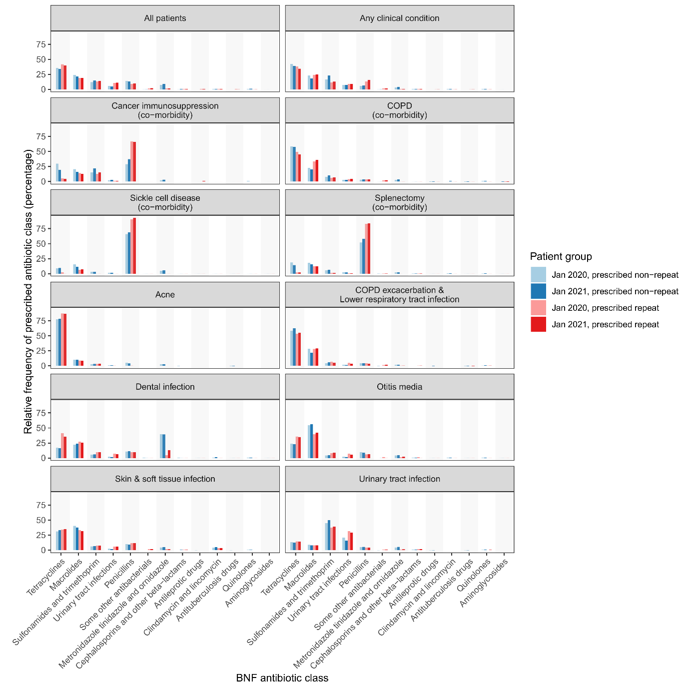
Figure S1. The relative frequency of prescribed antibiotic classes is shown as a percentage of total patients within each patient group, broken down by patient clinical condition. Patient groups represent repeated and non-repeated prescribing of a given antibiotic class in January 2020 and 2021 cohorts. Antibiotic classes are ordered by frequency of prescribing among the January 2021 repeated prescribed group, among ‘All patients’ (from most frequent [tetracyclines] to least frequent [aminoglycosides]).

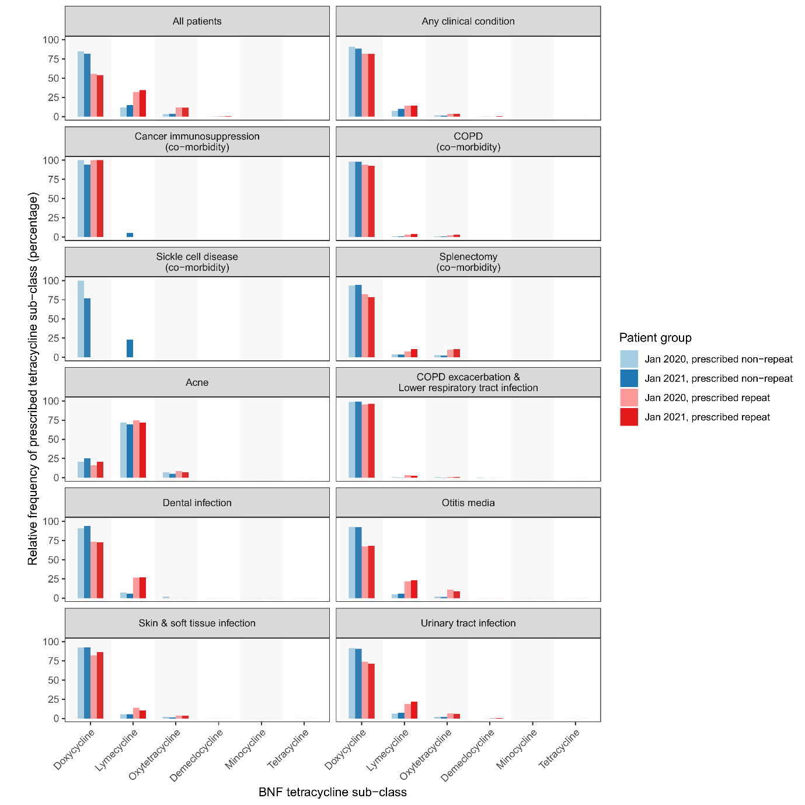
Figure S2. The relative frequency of prescribed tetracycline sub-classes is shown as a percentage of total patients within each patient group, broken down by patient clinical condition. Patient groups represent repeated and non-repeated prescribing of a given antibiotic class in January 2020 and 2021 cohorts. Tetracycline sub-classes are ordered by frequency of prescribing among the January 2021 repeated prescribed group, among ‘All patients’ (from most frequent [doxycycline] to least frequent [tetracycline]).

