SUPPLEMENTARY DATA
Integrating AI/ML Models for Patient Stratification Leveraging Omics Dataset and Clinical Biomarkers from COVID-19 Patients: A Promising Approach to Personalized Medicine
Babatunde Bello, Yogesh N. Bundey, Roshan Bhave, Maksim Khotimchenko, Szczepan W. Baran, Kaushik Chakravarty and Jyotika Varshney

Table 1. Clinical data columns for ML workflow
Column Group | Column Group Definitions | Columns
Basic Profile | Basic profile data for patient | Age, Height (cm), Weight (kg), BMI
Comorbidities | Presence of external comorbidity | Alcoholic Nonalcoholic Liver Disease present, Asthma present, Atrial Fibrillation present, Cancer Flag present, Chronic Kidney Disease present, Chronic Viral Hepatitis present, COPD present, Coronary Artery Disease present, Crohn’s Disease present, Diabetes present, Heart Failure present, Hypertension present, Obstructive Sleep Apnea present, Ulcerative Colitis present
Medications | Whether medication was given to patient | Apixaban given, Argatroban given, Azithromycin given, Dexamethasone given, Dobutamine given, Dopamine given, Eculizumab given, Enoxaparin given, Epinephrine given, Famotidine given, Gimisilumab given, Heparin given, Hydrocortisone given, Hydroxychloroquine given, Methotrexate given, Methylprednisolone given, Milrinone given, Norepinephrine Levophed given, No Ppm given, Phenylephrine given, Prednisone given, Remdesivir given, Rituximab given, Rivaroxaban given, Sarilumab given, Tissue Plasminogen Activator given, Tocilizumab given, Vasopressin Vasostrict given, Warfarin Coumadin given
Lab Results | Lab value of selected biomarker | Median Albumin lab value, Median Alt lab value, Median Anion Gap lab value, Median Ast lab value, Median Base Excess Arterial lab value, Median Base Excess Venous lab value, Median Basophil Number lab value, Median Basophil Percent lab value, Median Brain Natriuretic Protein lab value, Median Bun lab value, Median Calcium lab value, Median Carboxyhemoglobin Arterial lab value, Median Chloride lab value, Median Co2 Total lab value, Median Creatine Kinase Mb lab value, Median Creatine Kinase lab value, Median C Reactive Protein lab value, Median C Reative Protein Hs lab value, Median Deoxyhemoglobin Arterial lab value, Median D Dimer lab value, Median Egfr lab value, Median Eosinophil Number lab value, Median Eosinophil Percent lab value, Median Esr lab value, Median Ferritin lab value, Median Fibrinogen lab value, Median Glucose lab value, Median Haptoglobin lab value, Median Hco3 Arterial lab value, Median Hco3 Venous lab value, Median Hematocrit lab value, Median Hemoglobin A1C lab value, Median Hemoglobin Arterial lab value, Median Hemoglobin lab value, Median Inr lab value, Median Interleukin 1 Beta lab value, Median Interleukin 6 lab value, Median Interleukin 8 lab value, Median Lactate Arterial lab value, Median Ldh lab value, Median Lymphocyte Number lab value, Median Lymphocyte Percent lab value, Median Mchc lab value, Median Mch lab value, Median Mcv lab value, Median Mean Platelet Volume lab value, Median Methemoglobin Arterial lab value, Median Monocyte Number lab value, Median Monocyte Percent lab value, Median Neutrophil Number lab value, Median Neutrophil Percent lab value, Median O2 Saturation Arterial lab value, Median O2 Saturation Venous lab value, Median Oxyhemoglobin Arterial lab value, Median Pc02 Venous lab value, Median Pco2 Arterial lab value, Median Ph Arterial lab value, Median Ph Venous lab value, Median Platelet lab value, Median Po2 Arterial lab value, Median Po2 Venous lab value, Median Potassium lab value, Median Procalcitonin lab value, Median Prothrombin Time lab value, Median Ptt lab value, Median Rbc Count lab value, Median Serum Creatinine lab value, Median Sodium lab value, Median Tnf Alpha lab value, Median Total Bilirubin lab value, Median Total Protein lab value, Median Troponin I lab value, Median Uric Acid lab value, Median Wbc lab value, Maximum C Reactive Protein lab value, Maximum D Dimer lab value, Interquartile Range C Reactive Protein lab value, Interquartile Range D Dimer lab value, Minimum C Reactive Protein lab value, Minimum D Dimer lab value, Minimum Serum Creatinine lab value, Standard Deviation C Reactive Protein lab value, Standard Deviation D Dimer lab value, Mean C Reactive Protein lab value, Mean D Dimer lab value, Mean Mean Platelet Volume Median lab value, Number of C Reactive Protein observed - lab value, Number of D Dimer observed - lab value
Others | Maximum sequential organ failure assessment (SOFA) score recorded during the 24-hour period | SOFA Score

Table 2. Modeling Results for Severity and Outcome predictive models
 | Severity | Survival
Balanced Accuracy | 91.6% | 99.1%
ROC-AUC | 98.1% | 99.9%
ROC Curve | 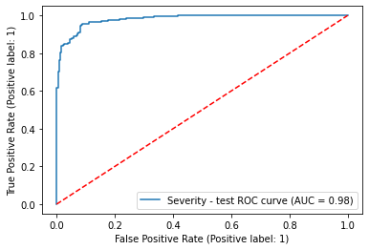 | 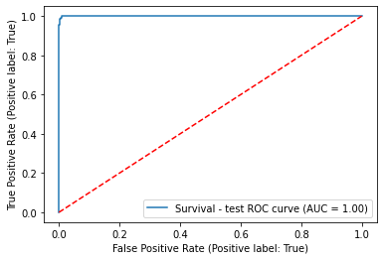

Table 3. Modeling Results for Severity and Outcome predictive models without comorbidities in the training set
 | Severity | Survival
Balanced Accuracy | 85.4% | 69.8%
ROC-AUC | 93.5% | 87.8%
ROC Curve | 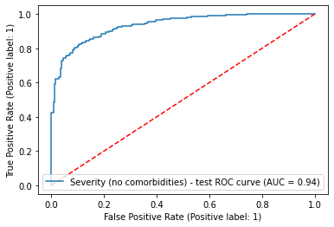 | 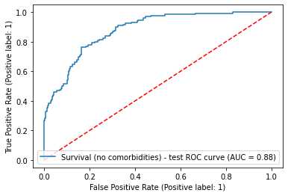

Table 4. Percentage of missing values per column within clinical biomarker training data
Column | Percent Missing (%)
Age | 0
BMI | 0.67
Alcoholic Nonalcoholic Liver Disease present | 0
Asthma present | 0
Atrial Fibrillation present | 0
Cancer Flag present | 0
Chronic Kidney Disease present | 0
Chronic Viral Hepatitis present | 0
Copd present | 0
Coronary Artery Disease present | 0
Crohns Disease present | 0
Diabetes present | 0
Heart Failure present | 0
Htn present | 0
Obstructive Sleep Apnea present | 0
Ulcerative Colitis present | 0
Height (cm) | 2.5
Median Albumin lab value | 23.99
Median Alt lab value | 25.13
Median Anion Gap lab value | 11.33
Median Ast lab value | 25.6
Median Base Excess Arterial lab value | 97.4
Median Base Excess Venous lab value | 68.47
Median Basophil Number lab value | 35.24
Median Basophil Percent lab value | 20.09
Median Brain Natriuretic Protein lab value | 91.86
Median Bun lab value | 12
Median Calcium lab value | 11.74
Median Carboxyhemoglobin Arterial lab value | 83.5
Median Chloride lab value | 10.87
Median Co2 Total lab value | 11.72
Median Creatine Kinase Mb lab value | 98.31
Median Creatine Kinase lab value | 91.23
Interquartile Range C Reactive Protein lab value | 39.96
Maximum C Reactive Protein lab value | 39.96
Mean C Reactive Protein lab value | 39.96
Median C Reactive Protein lab value | 39.96
Minimum C Reactive Protein lab value | 39.96
Number of C Reactive Protein observed - lab value | 39.96
Standard Deviation C Reactive Protein lab value | 94.68
Median C Reative Protein Hs lab value | 98.7
Median Deoxyhemoglobin Arterial lab value | 83.5
Interquartile Range D Dimer lab value | 44.05
Maximum D Dimer lab value | 44.05
Mean D Dimer lab value | 44.05
Median D Dimer lab value | 44.05
Minimum D Dimer lab value | 44.05
Number of D Dimer observed - lab value | 44.05
Standard Deviation D Dimer lab value | 94.9
Median Egfr lab value | 54.52
Median Eosinophil Number lab value | 35.24
Median Eosinophil Percent lab value | 20.09
Median Esr lab value | 93.34
Median Ferritin lab value | 42.01
Median Fibrinogen lab value | 74
Median Glucose lab value | 7.29
Median Haptoglobin lab value | 97.87
Median Hco3 Arterial lab value | 78.73
Median Hco3 Venous lab value | 63.41
Median Hematocrit lab value | 29.31
Median Hemoglobin A1C lab value | 97.03
Median Hemoglobin Arterial lab value | 80.91
Median Hemoglobin lab value | 13.47
Median Inr lab value | 47.76
Median Interleukin 1 Beta lab value | 95.54
Median Interleukin 6 lab value | 89.97
Median Interleukin 8 lab value | 92.98
Median Lactate Arterial lab value | 78.53
Median Ldh lab value | 46.07
Median Lymphocyte Number lab value | 35.24
Median Lymphocyte Percent lab value | 20.06
Median Mchc lab value | 13.49
Median Mch lab value | 13.49
Median Mcv lab value | 13.49
Mean Value lab value | 13.87
Median Methemoglobin Arterial lab value | 85.09
Median Monocyte Number lab value | 35.24
Median Monocyte Percent lab value | 20.06
Median Neutrophil Number lab value | 18.93
Median Neutrophil Percent lab value | 20.06
Median O2 Saturation Arterial lab value | 78.86
Median O2 Saturation Venous lab value | 62.93
Median Oxyhemoglobin Arterial lab value | 79.69
Median Pc02 Venous lab value | 60.26
Median Pco2 Arterial lab value | 76.57
Median Ph Arterial lab value | 76.59
Median Ph Venous lab value | 60.27
Median Platelet lab value | 14.58
Median Po2 Arterial lab value | 76.58
Median Po2 Venous lab value | 60.62
Median Potassium lab value | 11.69
Median Procalcitonin lab value | 58.49
Median Prothrombin Time lab value | 47.76
Median Ptt lab value | 48.68
Median Rbc Count lab value | 13.49
Median Serum Creatinine lab value | 11.79
Minimum Serum Creatinine lab value | 11.79
Median Sodium lab value | 25.47
Median Tnf Alpha lab value | 92.98
Median Total Bilirubin lab value | 24.28
Median Total Protein lab value | 24.5
Median Troponin I lab value | 87.67
Median Uric Acid lab value | 95.5
Median Wbc lab value | 13.7
Apixaban given | 0
Argatroban given | 0
Azithromycin given | 0
Dexamethasone given | 0
Dobutamine given | 0
Dopamine given | 0
Eculizumab given | 0
Enoxaparin given | 0
Epinephrine given | 0
Famotidine given | 0
Gimisilumab given | 0
Heparin given | 0
Hydrocortisone given | 0
Hydroxychloroquine given | 0
Methotrexate given | 0
Methylprednisolone given | 0
Milrinone given | 0
Norepinephrine Levophed given | 0
No Ppm given | 0
Phenylephrine given | 0
Prednisone given | 0
Remdesivir given | 0
Rituximab given | 0
Rivaroxaban given | 0
Sarilumab given | 0
Tissue Plasminogen Activator given | 0
Tocilizumab given | 0
Vasopressin Vasostrict given | 0
Warfarin Coumadin given | 0
SOFA Score | 2
Weight (kg) | 1.75

Table 7. Clusters of patients with percent of severe patients per cluster and cluster biomarker observations. Clusters were generated through K-Means clustering where optimal number of clusters were determined through the Elbow Method. The data used as the input for clustering was SHAP values (feature impact scores) for the overall clinical feature set.
Cluster | Percent Severe (%) | Observations
1 | 89.3 | - Patients with higher weight
2 | 10.9 | - Patients with lower weight
3 | 94.6 | - Patients with high SOFA score, BUN, and Serum Creatinine levels
4 | 7.3 | - Patients with low SOFA score, BUN, and Serum Creatinine levels
5 | 93.1 | - No real indicator  - Interesting group of patients
6 | 4.9 | - Patients with high BUN, Serum Creatinine, LDH  - Low PCO2 arterial
7 | 6.2 | - Patients with low values overall
8 | 93.4 | - Patients with high LDH
9 | 92.8 | - Patients with high potassium
10 | 1.7 | - Patients with high lymphocyte percent
11 | 95.1 | - Patients with high SOFA score, BUN, and Serum Creatinine levels
12 | 96.5 | - Low BUN, Serum Creatinine  - High CO2 total
13 | 98.6 | - High SOFA score, BUN  - Low Albumin  - Normal Serum Creatinine
14 | 11.1 | - Low PCO2 Arterial  - Low SOFA score
15 | 96.0 | - Normal SOFA score  - High BUN
Table 8. Results for predicting COVID severity in comorbidity specific patients trained on non-comorbidity patient data.
 |  | Trained on data without specific comorbidity |  | Trained on data without any comorbidity
Comorbidity | Percentage of overall data | Balanced Accuracy | ROC-AUC | Balanced Accuracy | ROC-AUC
Alcoholic Nonalcoholic Liver Disease | 3.56% | 88.95% | 95.21% | 81.92% | 92.60%
Asthma | 5.9% | 78.23% | 87.22% | 76.44% | 83.21%
Atrial Fibrillation | 10.86% | 79.05% | 87.57% | 75.73% | 84.34%
Cancer Flag | 8.3% | 79.43% | 86.80% | 72.29% | 82.24%
Chronic Kidney Disease | 12.61% | 78.09% | 86.58% | 72.73% | 84.59%
Chronic Viral Hepatitis | 1.1% | 92.48% | 98.35% | 91.21% | 97.05%
Copd | 7.29% | 84.33% | 90.09% | 79.13% | 84.20%
Coronary Artery Disease | 13.93% | 83.93% | 91.92% | 82.35% | 90.79%
Crohns Disease | 8.82% | 72.66% | 79.69% | 82.81% | 91.80%
Diabetes | 29.8% | 79.70% | 89.65% | 75.97% | 86.56%
Heart Failure | 10.9% | 76.81% | 84.15% | 73.68% | 80.73%
Htn | 38.45% | 77.65% | 86.70% | 75.89% | 84.58%
Obstructive Sleep Apnea | 6.1% | 77.90% | 85.65% | 67.98% | 78.36%
Ulcerative Colitis | 0.31% | 100.00% | 100.00% | 100.00% | 100.00%

Table 9. Common significant genes ( at GS>0.3 & MM>0.8) in MEcyan module across traits - EOD, SOFA, BUN

CSL1 | DYSF | LRRC4 | RN7SL731P
ACTN1 | EXOC6 | MANSC1 | RNF24
ADAM9 | F5 | MAP2K6 | RNU7-45P
ADGRG3 | FAM53C | MAPK14 | ROPN1L
ALOX5 | FCAR | MCTP2 | RPL11P3
ALPK1 | FGR | MEGF9 | RPL26P5
ANO10 | FLOT1 | MGAM | RPS2P14
ANXA3 | FLOT2 | MIR3605 | RTEL1P1
ATP11A | GCA | MIR4802 | SEMA4A
ATXN1 | GLT1D1 | MIR7848 | SIPA1L2
B4GALT5 | HRH2 | MKNK1 | SIRPA
BASP1 | HYCC2 | MTCO3P23 | SLC22A4
BASP1-AS1 | IL17RA | MTCYBP23 | SLC25A44
BAZ1A | ITGAM | MTMR3 | SLC2A3
BCL6 | JAK3 | MTND3P12 | SLC37A3
C3orf86P | KIF1B | MTND4LP23 | SLC9A8
CAMKK2 | KLHL2 | MTND5P32 | SLED1
CARD6 | LILRA6 | NABP1 | SRPK1
CFLAR | LILRB3 | NEAT1 | SSH1
CR1 | LRG1 | NQO2 | STAT5B
CRISPLD2 | PIK3CD-AS1 | PFKFB3 | STX11
DRAM1 | PLXNC1 | PGS1 | STX3
RALB | PPP1R3D | PHF21A | TGFA
RASGRP4 | PRKCD | PHTF1 | TLR5
RN7SL552P | PYGL | UPP1 | TLR8
WDFY3 | TRIM25 | USB1 | TMCO3
XPO6 | UBXN2B | ZNF415P1

Table 10. Common significant genes ( at GS>0.2 & MM>0.8)in MEdarkred module across traits - EOD, SOFA, BUN, and heart failure, alcohol liver disease, kidney disease selected ( at GS>0.1 & MM>0.8, since these set are only moderately significant)

ACSL1 | LOT1 | MTCYBP23 | SEMA4A
ACTN1 | FLOT2 | MTMR3 | SIPA1L2
ADAM9 | GCA | MTND3P12 | SIRPA
ADGRG3 | GLT1D1 | MTND4LP23 | SLC22A4
ALOX5 | HRH2 | MTND5P32 | SLC25A44
ALPK1 | HYCC2 | NABP1 | SLC2A3
ANO10 | IL17RA | NEAT1 | SLC37A3
ANXA3 | ITGAM | NQO2 | SLC9A8
ATP11A | JAK3 | FGR | SLED1
ATXN1 | KIF1B | PFKFB3 | SRPK1
B4GALT5 | KLHL2 | PGS1 | SSH1
BASP1 | LILRA6 | PHF21A | STAT5B
BASP1-AS1 | LILRB3 | PHTF1 | STX11
BAZ1A | LRG1 | PIK3CD-AS1 | STX3
BCL6 | LRRC4 | PLXNC1 | TGFA
C3orf86P | MANSC1 | PPP1R3D | TLR5
CAMKK2 | MAP2K6 | PRKCD | TLR8
CARD6 | MAPK14 | PYGL | TMCO3
CFLAR | MCTP2 | RALB | TRIM25
CR1 | MEGF9 | RASGRP4 | UBXN2B
CRISPLD2 | MGAM | RN7SL552P | UPP1
DRAM1 | MIR3605 | RN7SL731P | USB1
DYSF | MIR4802 | RNF24 | WDFY3
EXOC6 | MIR7848 | RNU7-45P | XPO6
F5 | MKNK1 | ROPN1L | ZNF415P1
FAM53C | MTCO3P23 | RPL11P3 | RPS2P14
FCAR | TEL1P1 | RPL26P5

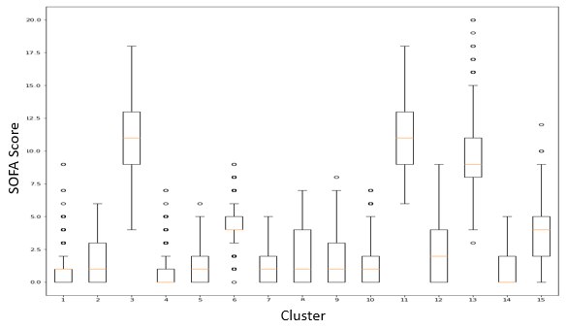
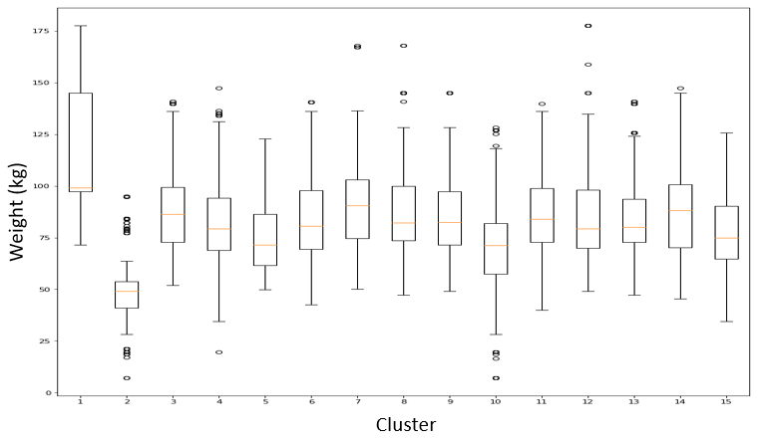
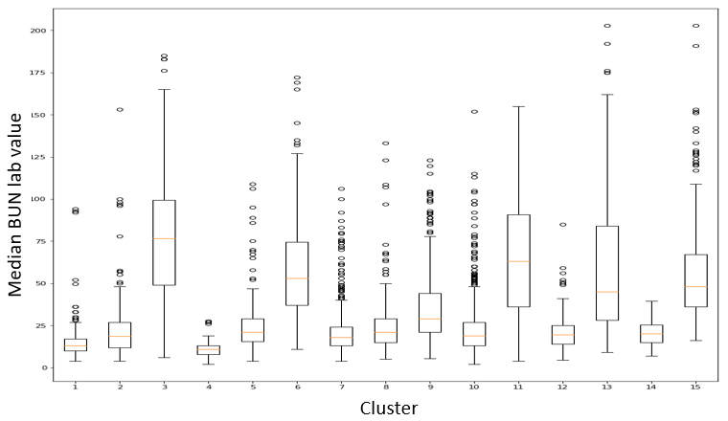
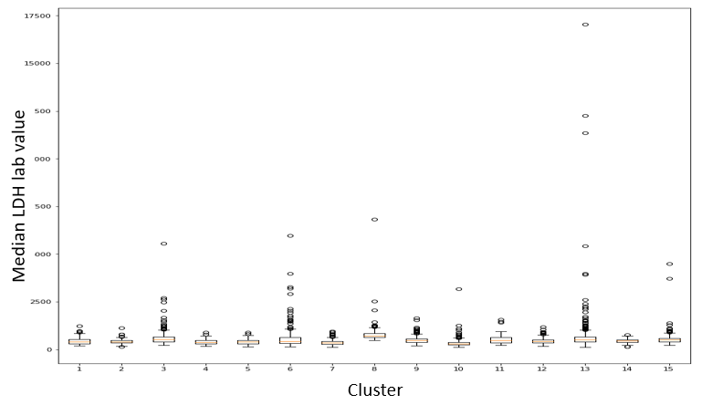
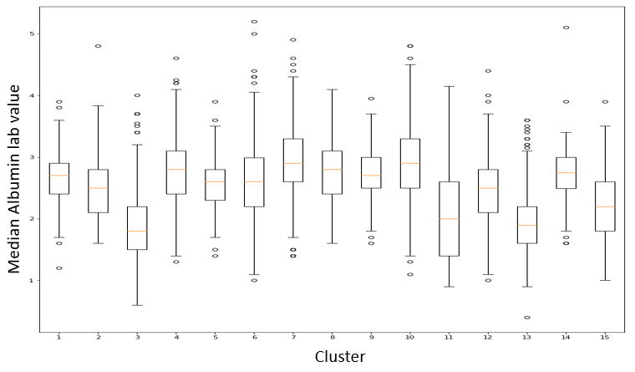
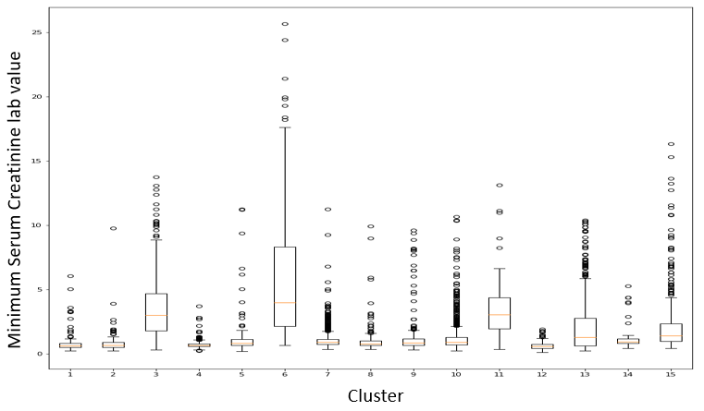
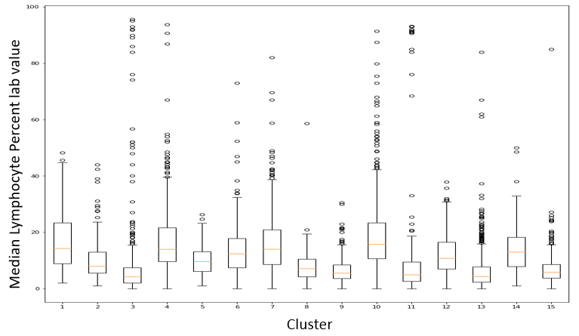
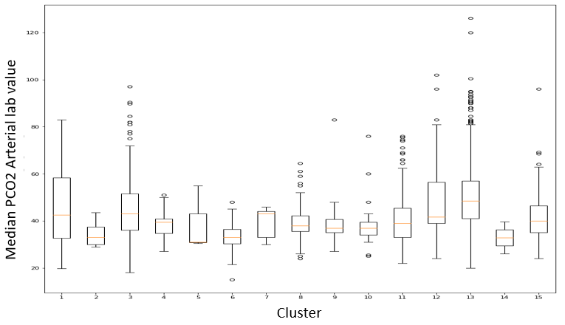
Figure 1. Biomarker value boxplots per cluster. Varying biomarker value thresholds can be clearly correlated with percentage of severe patients for many of the clusters. Cluster 5 did not have a clearly observed correlation between biomarker values and percent of severe patients. Much of the clusters that had high percent of severe patients had distinct levels of BUN, Serum Creatinine, and SOFA score.
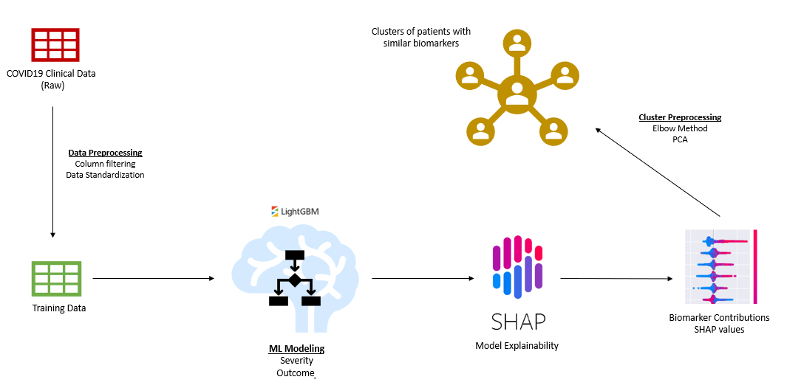
Figure 2. Clinical biomarker ML workflow

Raw Clinical Data
Data Cleaning
Clinical Biomarker Data
Data Preprocessing and Transformation

Model Training

Severity Classification Model

Model Explainability

Feature Impact Scores
Clustering
Patient Clusters
Figure 3. ML Clustering Methodology overview. Raw clinical data was cleaned and preprocessed to include relevant columns and appropriate value standardization. Clinical biomarker data was used in ML modeling for predicting COVID-19 case severity. Model explainability with SHAP was applied on the trained severity model and clinical biomarker data was transformed into feature impact scores, which was the input for clustering.

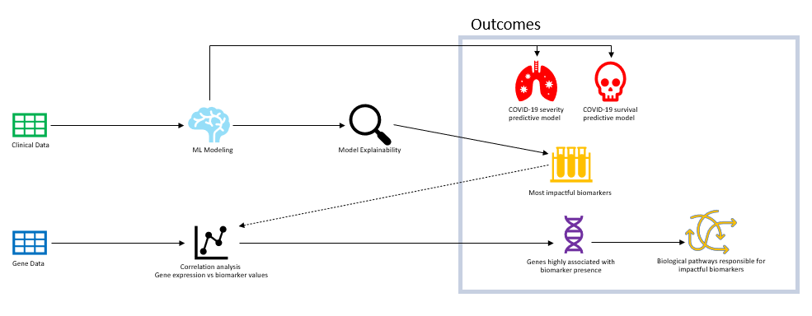
Figure 4. Overall Bioanalysis / ML workflow

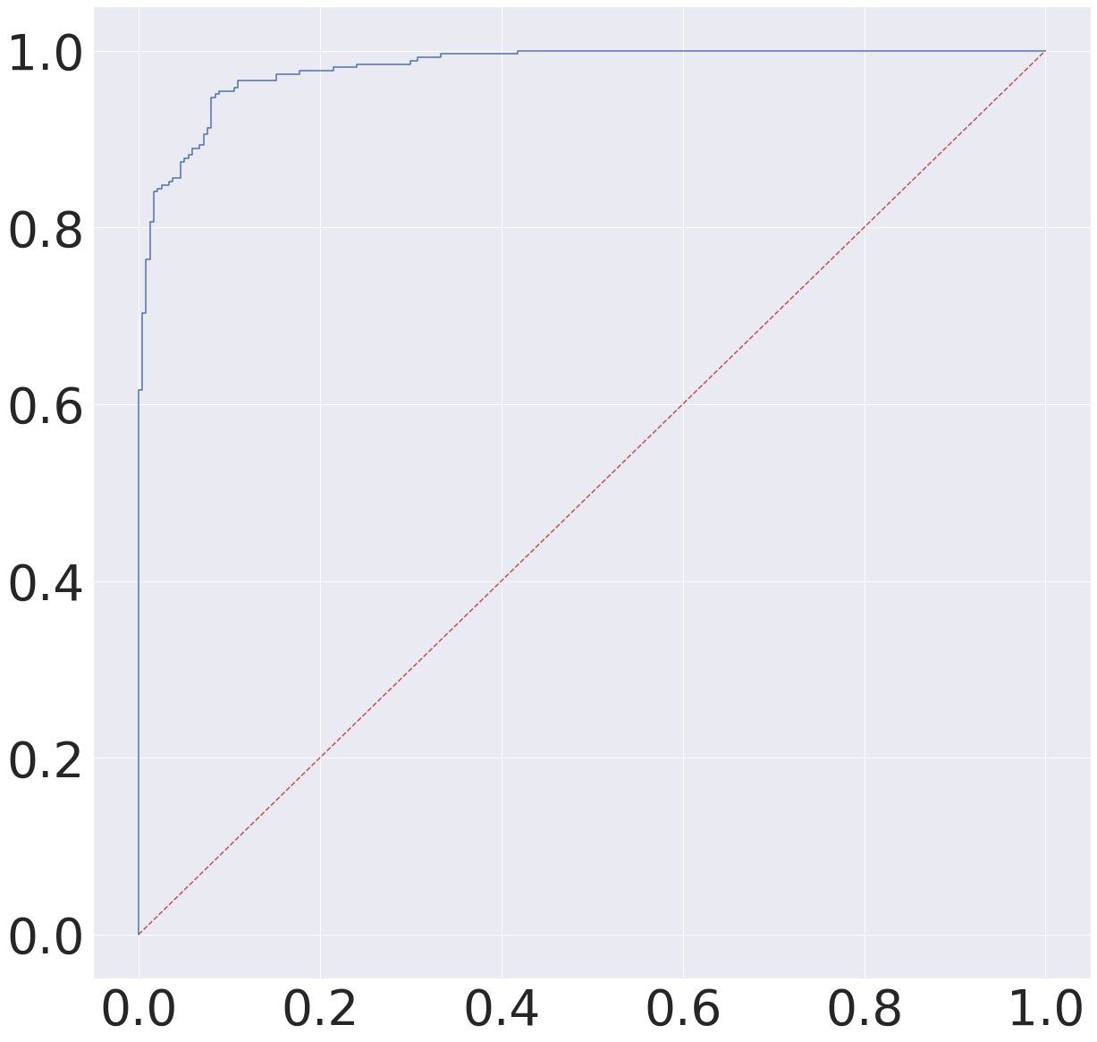
Figure 4. ROC curve for severity classification model (98.1%)

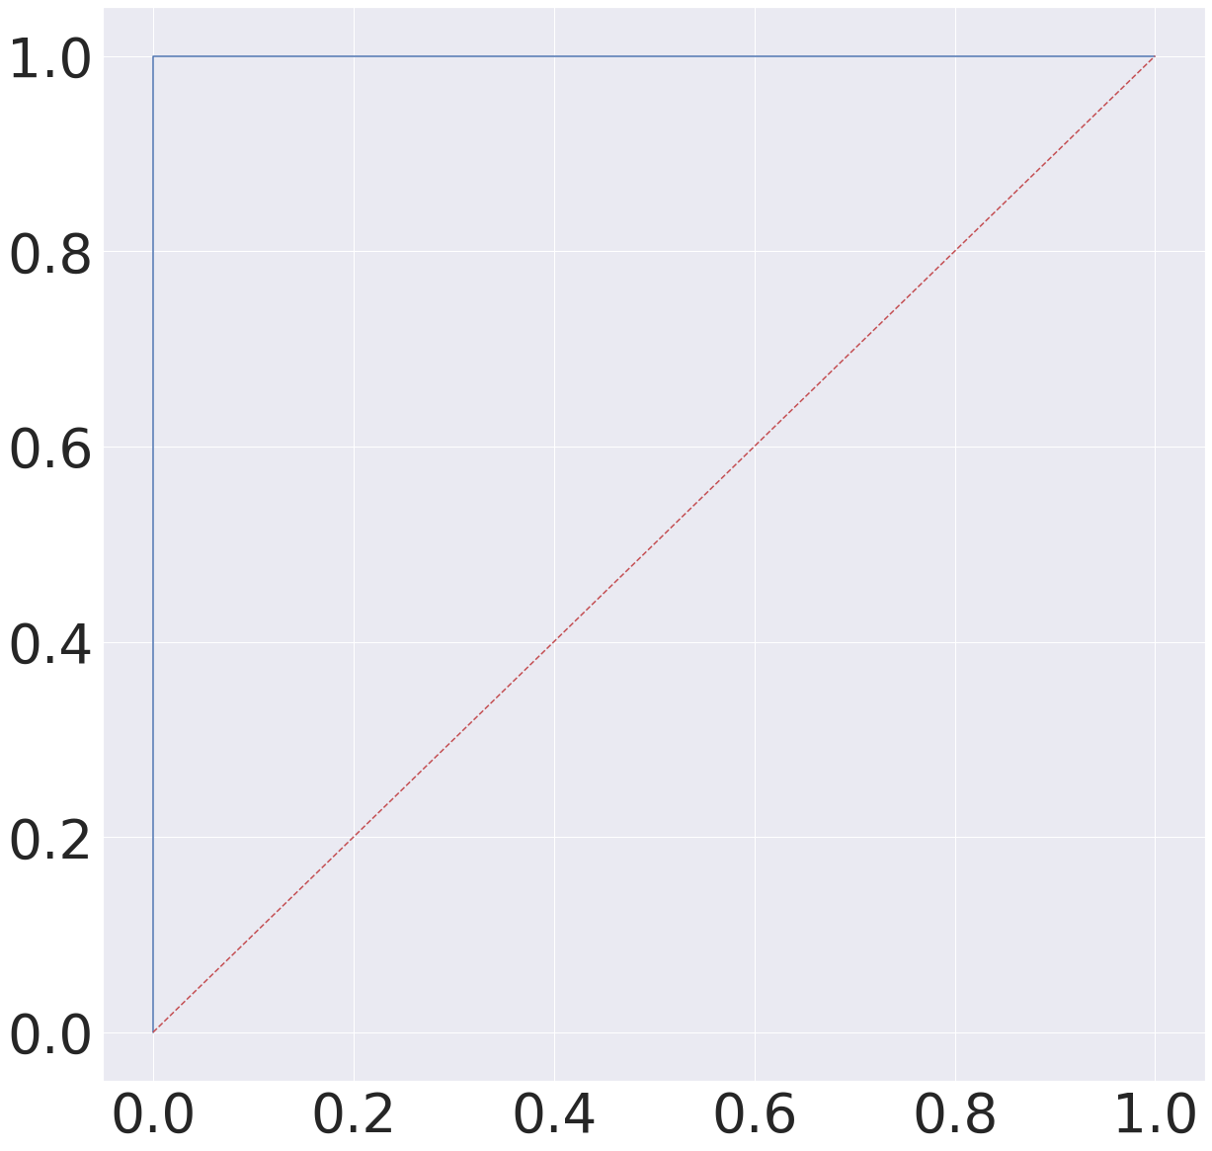
Figure5. ROC curve for outcome/survivability classification model (99.9%)

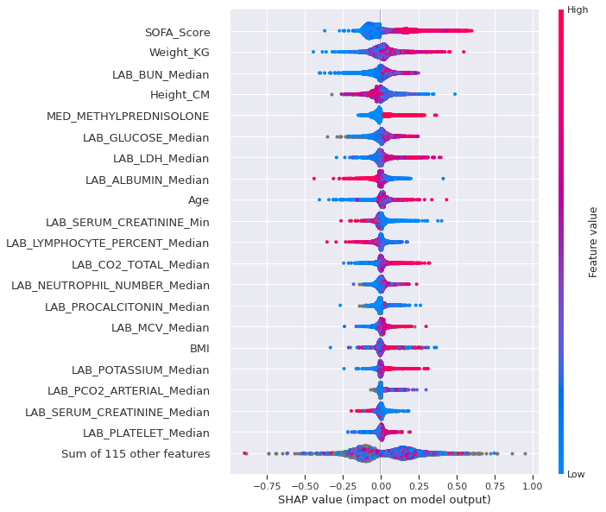
Figure 6.
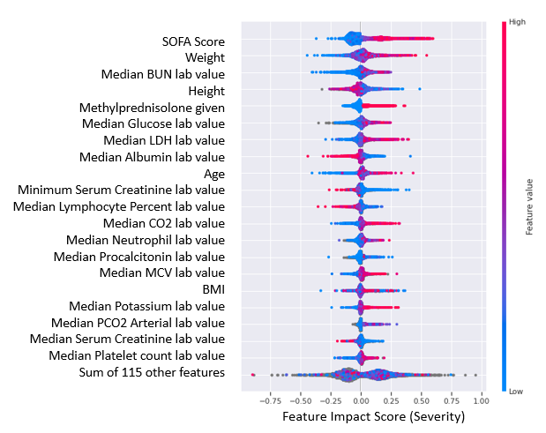
Figure 7. Top 20 clinical features for severe COVID cases

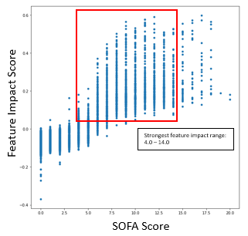 | 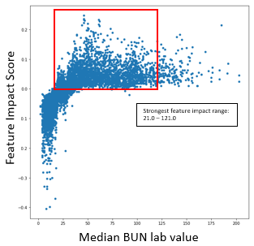
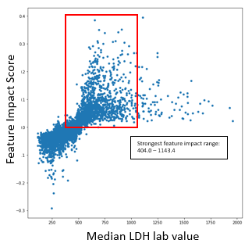 | 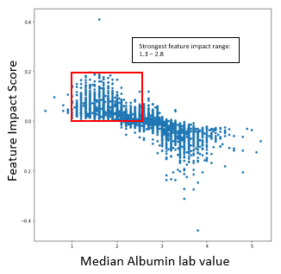
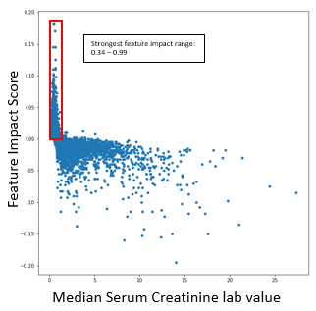 | 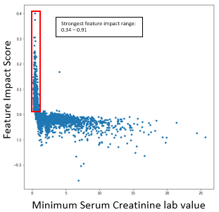

Figure 8. Biomarker value vs SHAP value scatter plots for Severity models.
SOFA Score severe range (normal distribution): 4 - 14
BUN median severe range (normal distribution): 21 -121
Glucose median severe range (normal distribution): 109 - 297
LDH median severe range (normal distribution): 404 - 1193
Albumin median severe range (normal distribution): 1.3 - 2.8
Serum Creatinine minimum severe range (normal distribution): 0.34 - 0.91

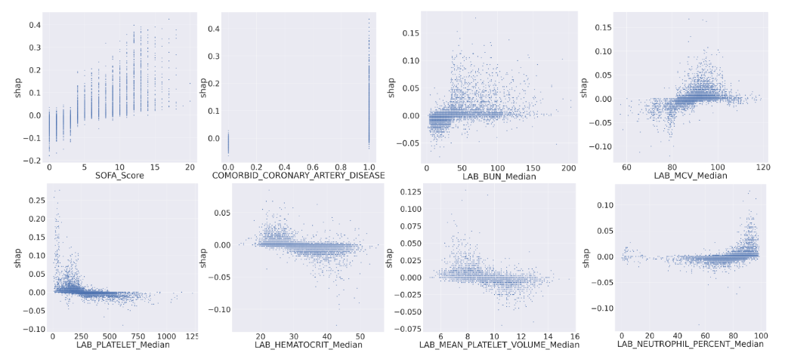
Figure 9. Biomarker value vs SHAP value scatter plots for Outcome models

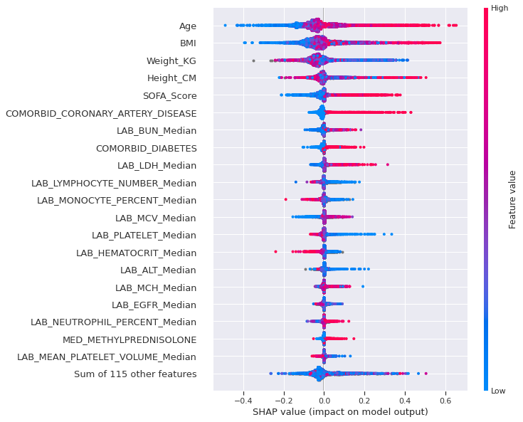
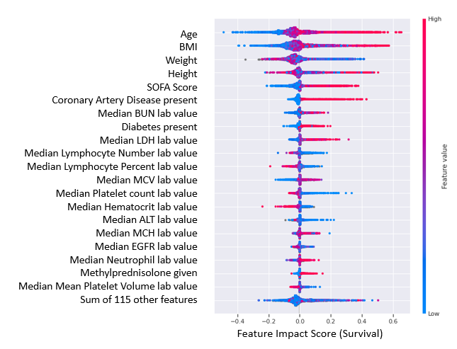
Figure 10. Top 20 clinical features for outcome/survivability model seen via SHAP value beeswarm

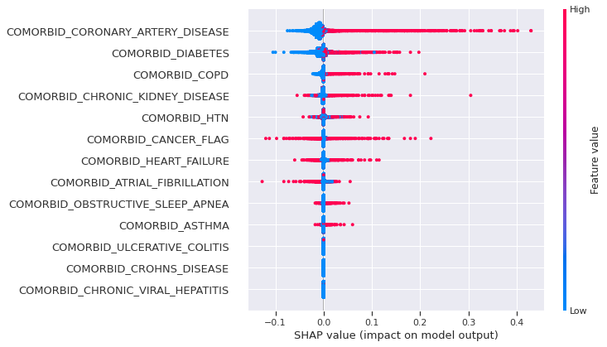
Figure 11. Comorbidity based inferences for outcome/survivability models seen via SHAP value beeswarm

Note
The bioinformatics analysis is to identify gene networks that show significant differences associated with COVID-19 severity, patient disease comorbidities, clinical biomarker measure during the patient stay in the clinic. The enrichment analysis is done on the significant gene network list using the GO ( biological processes) and KEGG pathway for gene annotation.

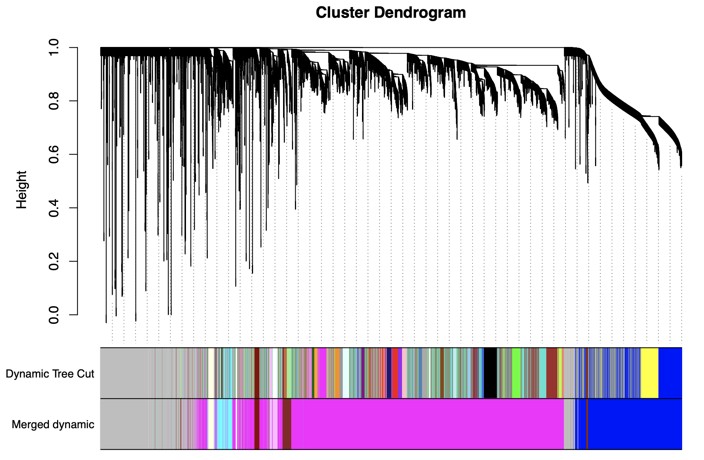
Figure 12. Gene Cluster Dendrogram for. The blocks in Dynamic Tree Cuts are different modules or clusters of gene network, and Merged dynamic blocks modules merged together based on module similarity from Dynamic Tree Cut blocks

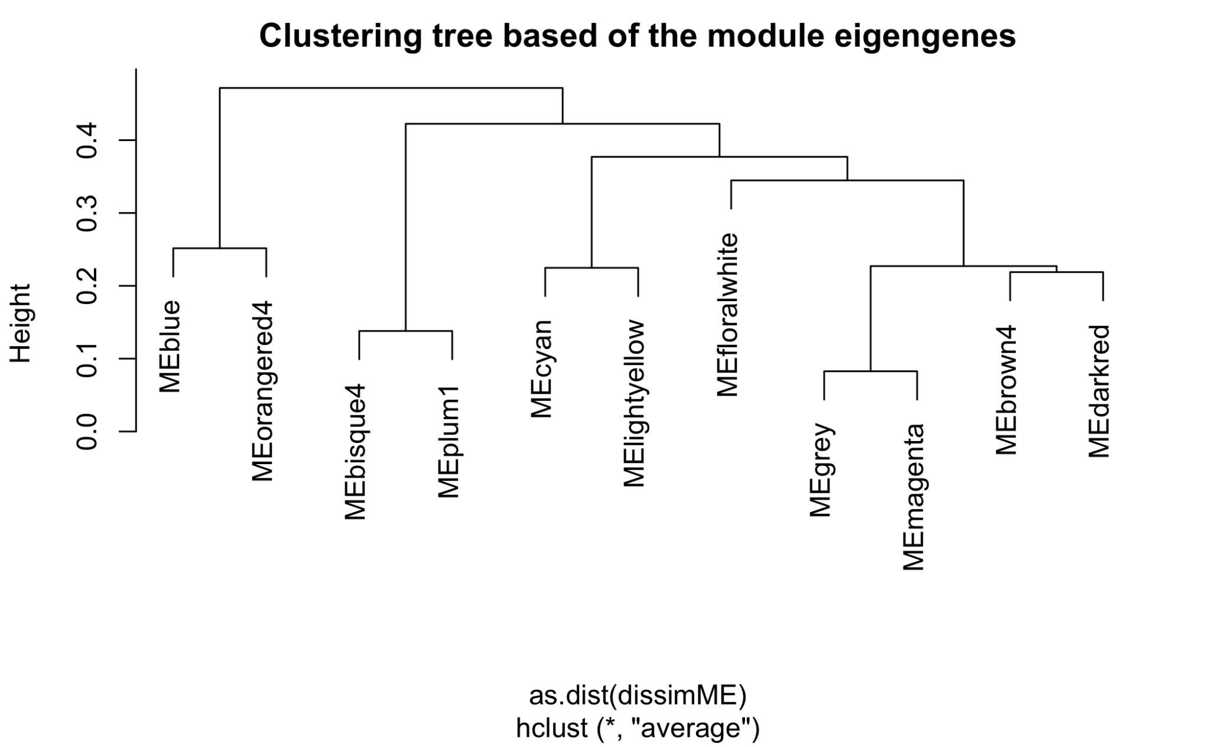
Figure 13. Cluster Tree of gene module eigengenes based on the merge dynamic blocks

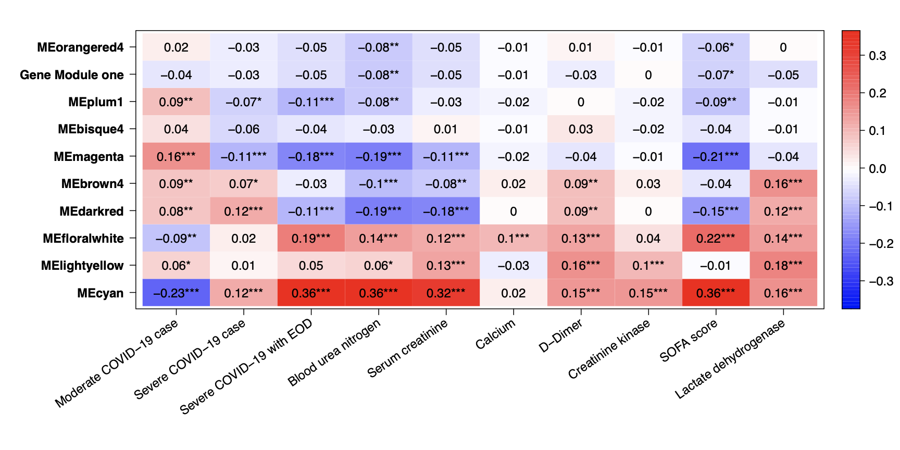
Figure 14. Heatmaps of module traits for severity and clinical biomarkers. The boxes indicate the correlation based on module eigengenes in the rows and traits in the column. The color legend – blue (negative correlation) and red (positive correlation) - and p-values represented by asterisk where (***) indication very significant.

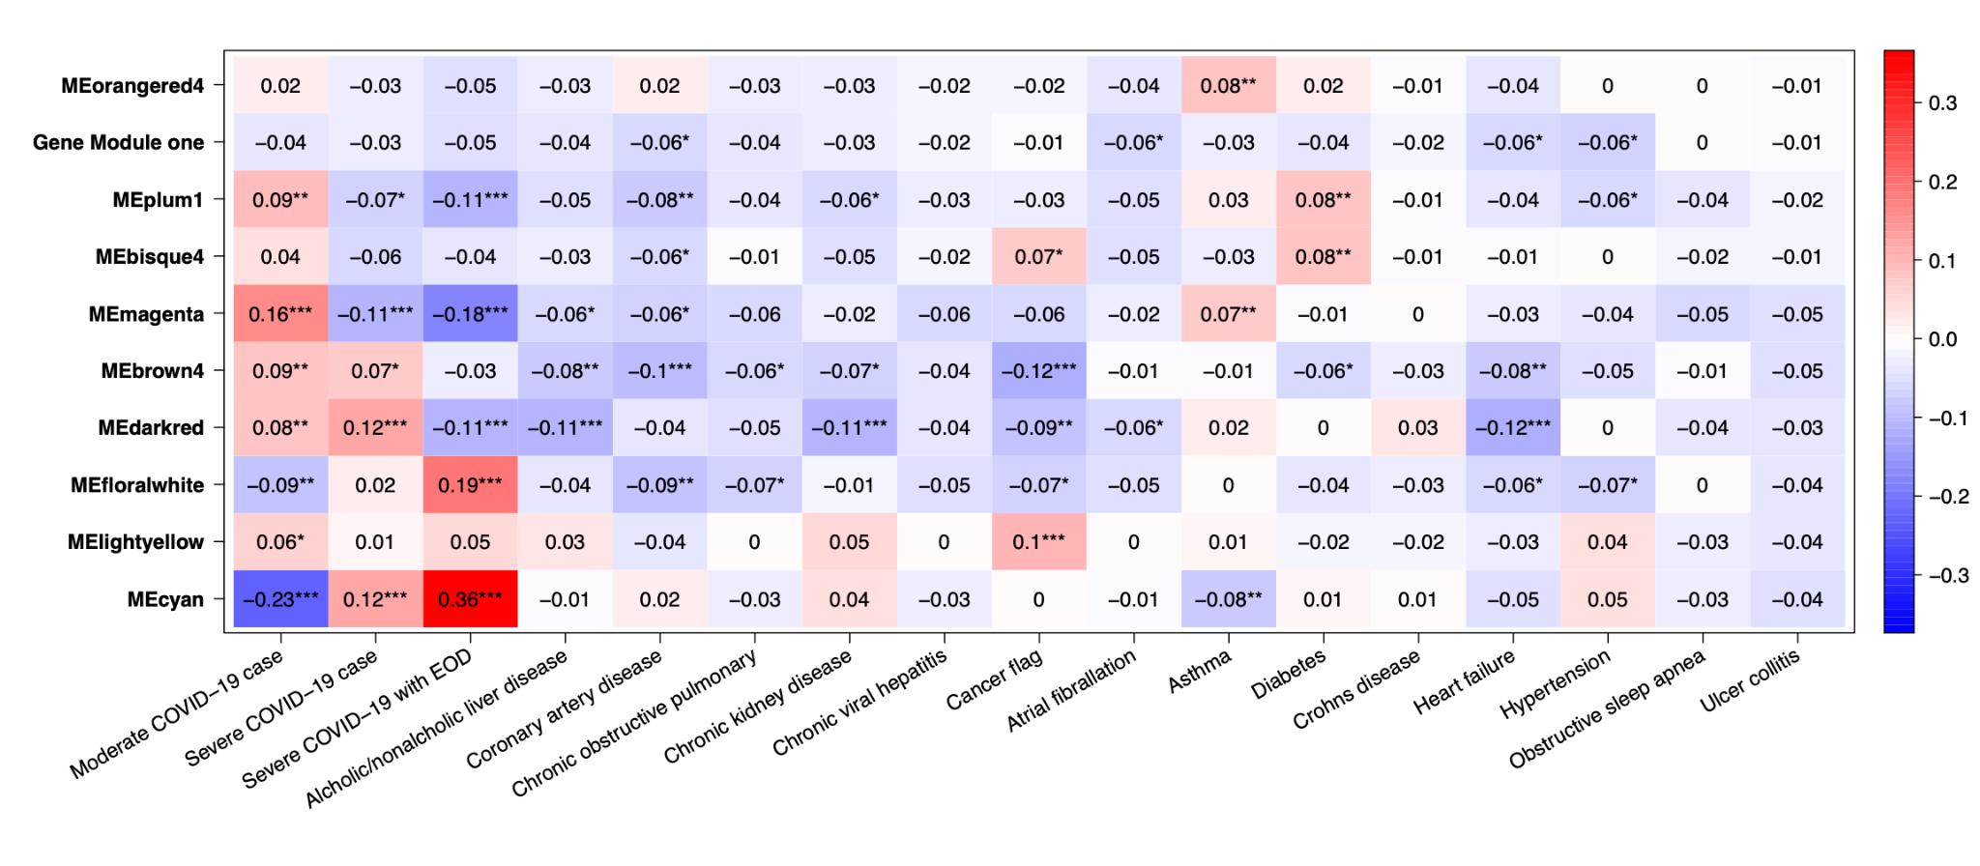
Figure 15. Heatmaps of module traits for severity and disease comorbidity. The boxes indicate the correlation based on module eigengenes in the rows and traits in the column. The color legend – blue (negative correlation) and red (positive correlation) - and p-values represented by asterisk where (***) indication very significant.

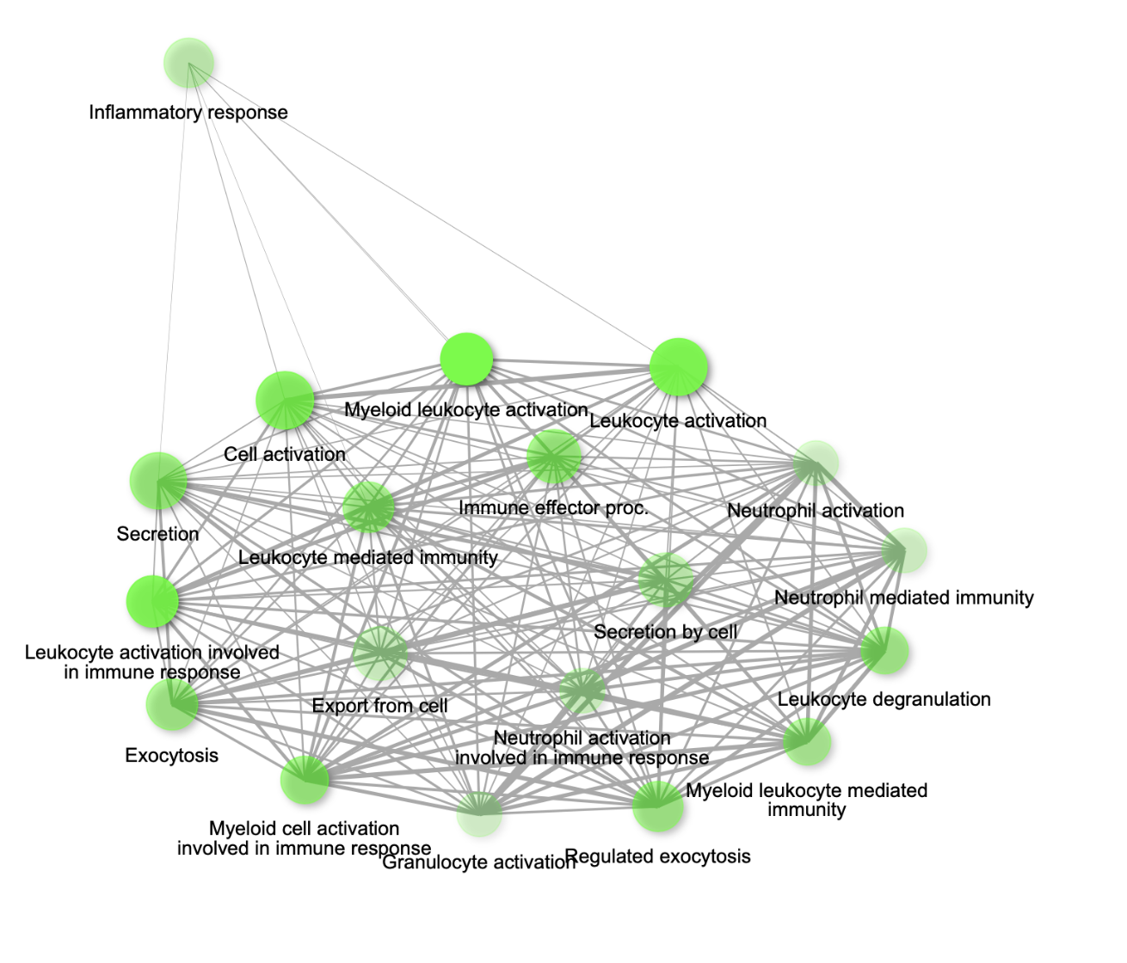
Figure 16. Gene network for top 20 enriched pathways for genes module, MEcyan based on GO biological process annotation.

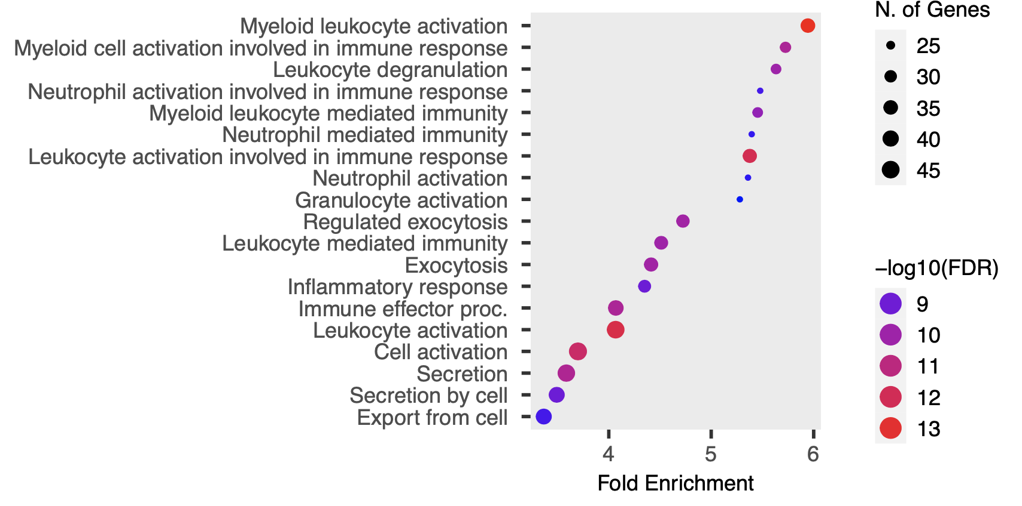
Figure 17. Dot plot for top 20 enriched pathways based for gene module, MEcyan based on GO annotation

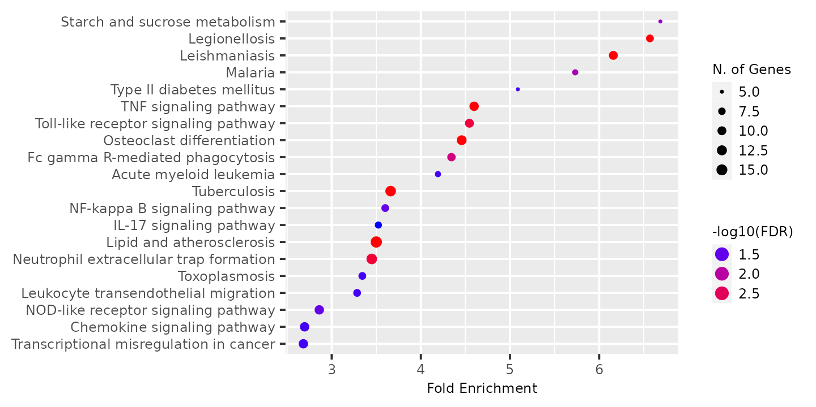
Figure 18. Dot plot for top 20 most enriched pathways based for gene module, MEcyan based on KEGG

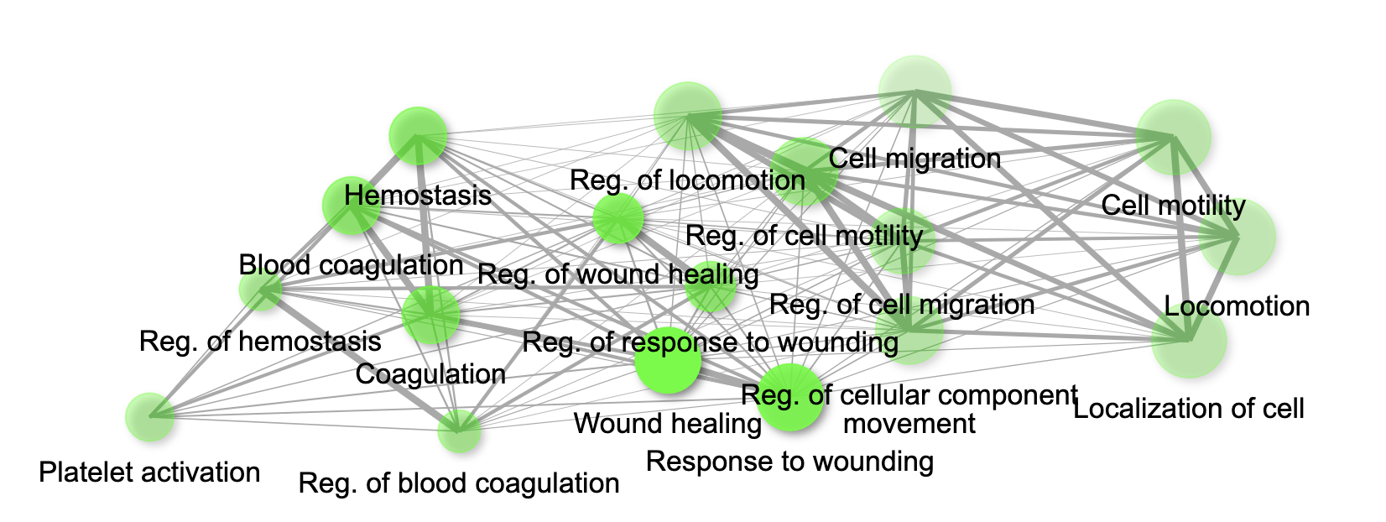
Figure 19. Gene network for top 20 enriched pathways for genes module, MEdarkred based on GO biological process annotation.

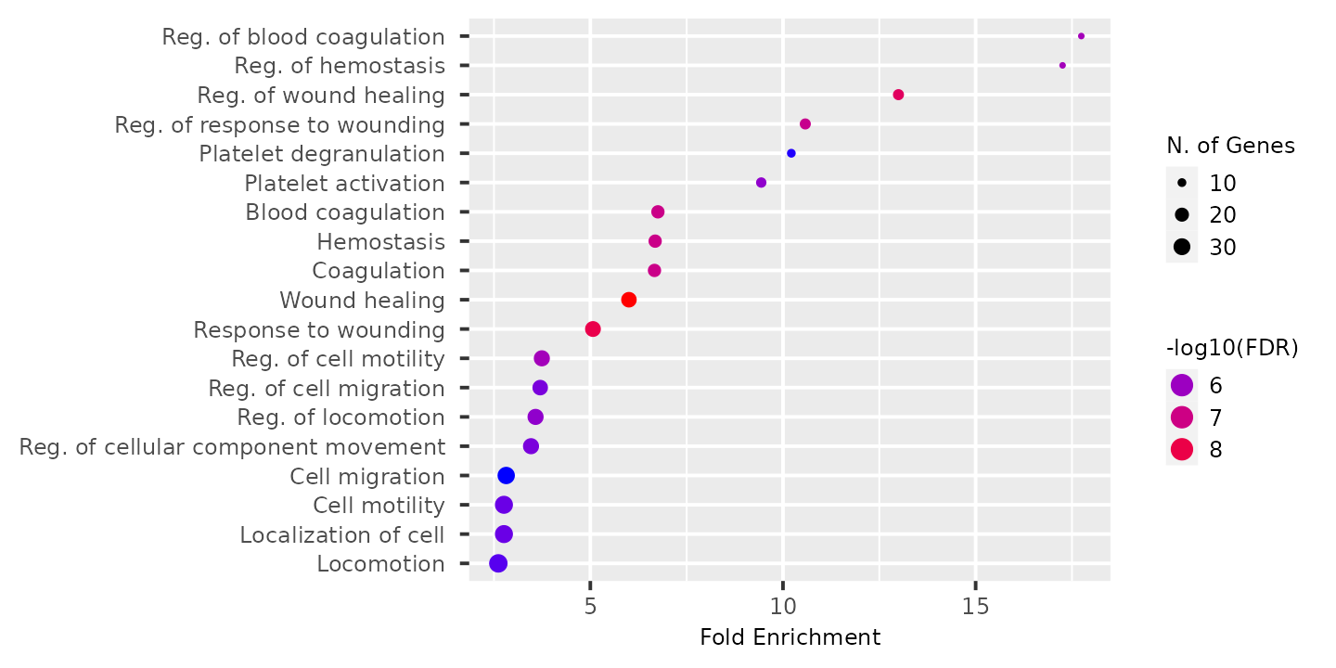
Figure 20. Dot plot for top 20 enriched pathways based for gene module, MEdarkred based on GO annotation

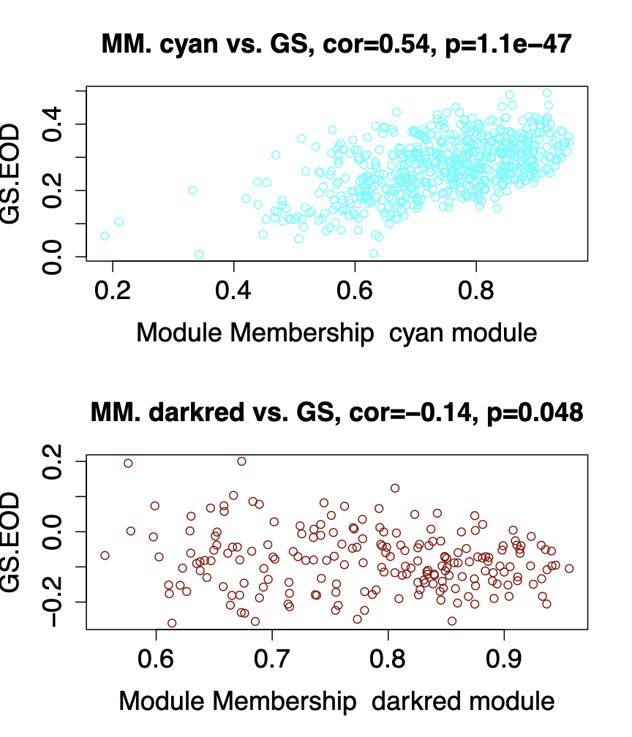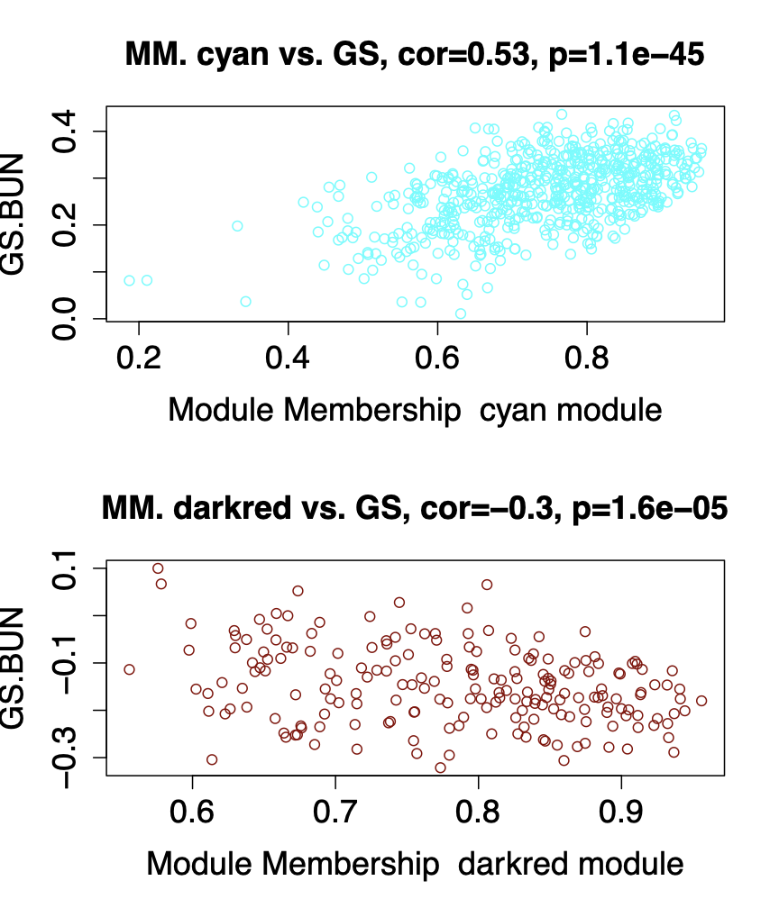

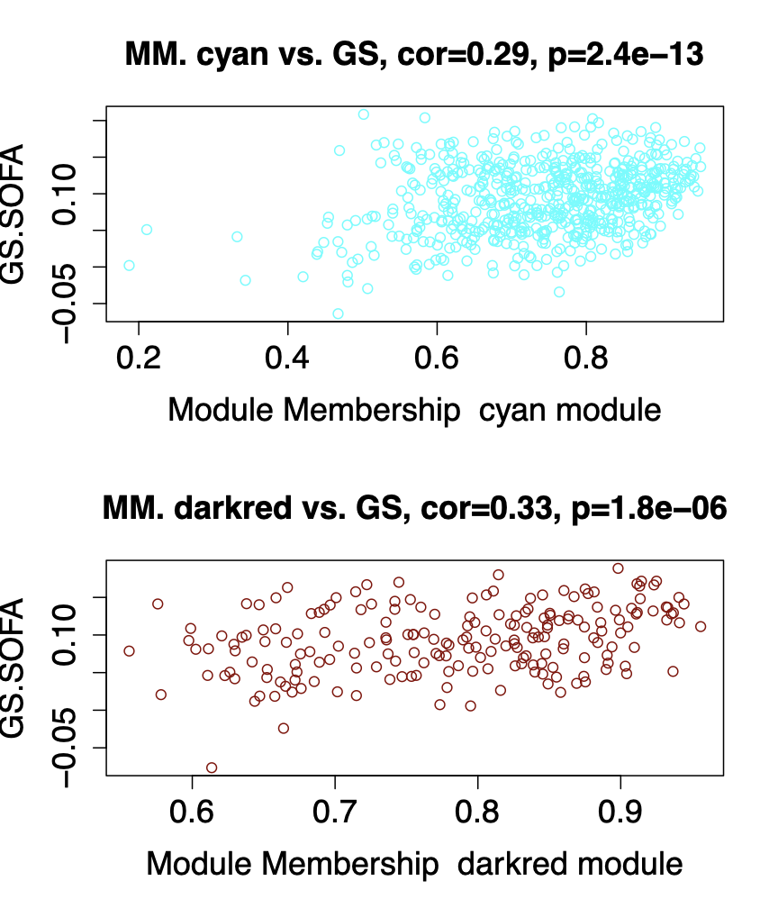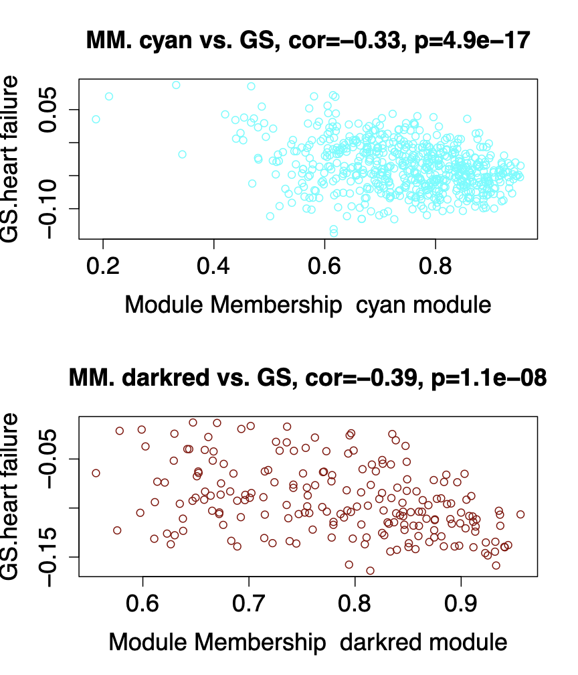
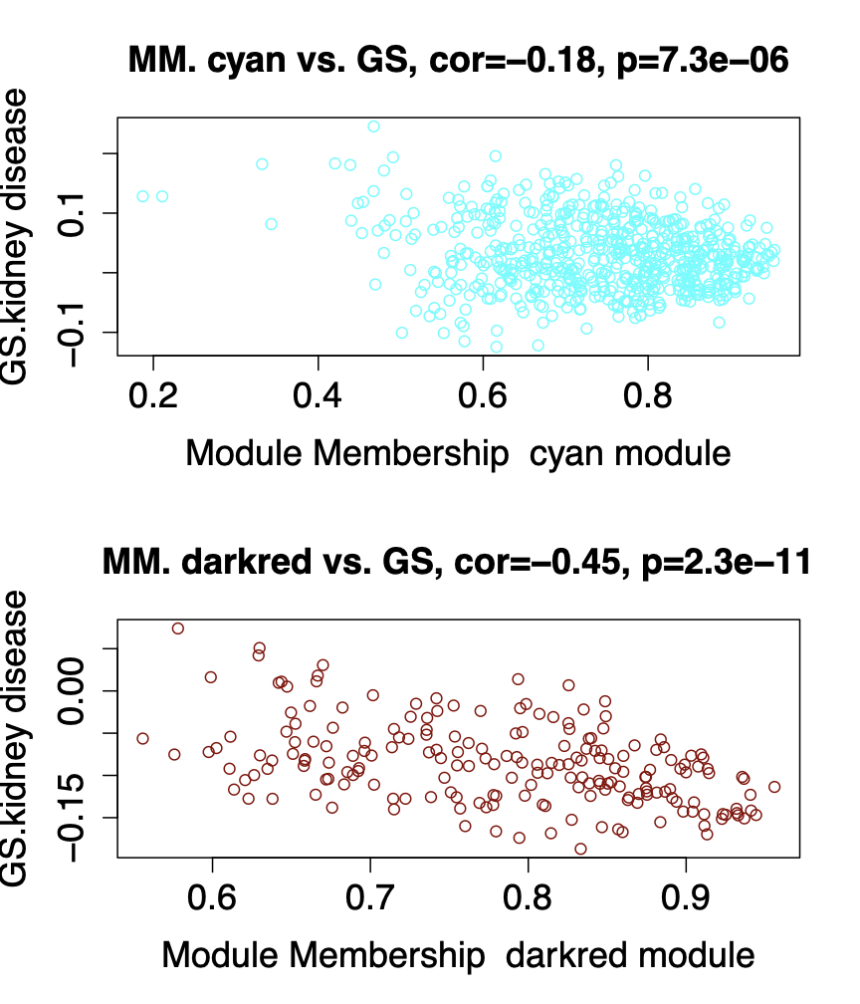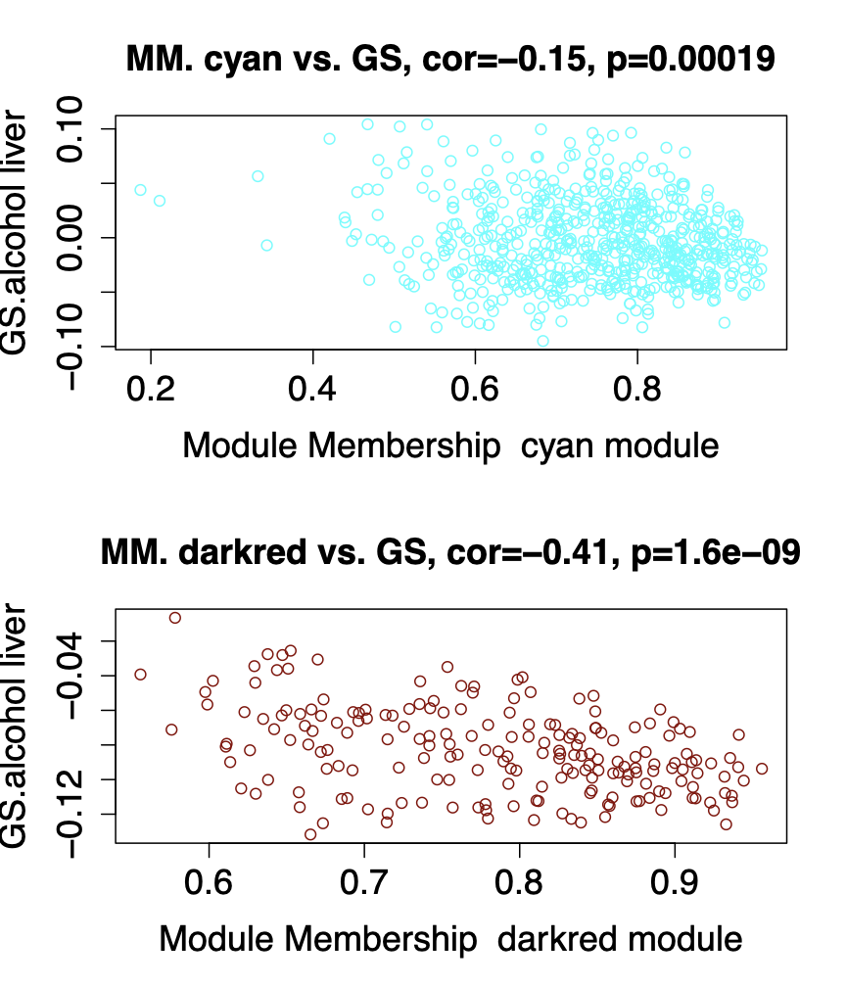
Figure 21. Scatterplots of gene significance for EOD, SOFA score, BUN, LDH, Alcohol/non-alcohol liver disease, heart failure and chronic artery disease versus module membership in MEcyan and MEdarkred modules. Gene Significance (GS) indicate how significance the gene in the modules are significant to the trait and Module Membership(MM)

