Supplementary Materials
Article
Endothelial function and Hypoxic-hyperoxic preconditioning in coronary surgery with a cardiopulmonary bypass: Randomized Clinical Trial
Irina A. Mandel ^{1,2*}, Yuriy K. Podoksenov ^{3,4}, Sergey L. Mikheev ^{3,5}, Irina V. Suhodolo ⁴, Yulia S. Svirko ³, Vladimir M. Shipulin ^{3,4}, Andrey G. Yavorovskiy¹, Andrey I. Yaroshetskiy ¹
- Correspondence: Irina A. Mandel, e-mail: irina.a.mandel@gmail.com;

1. The intraoperative anaerobic threshold measurement technique

The determination of the anaerobic threshold at the beginning of the operation in the background of anesthesia, mechanical ventilation, and myoplegia was carried out according to a specially developed method (RF Patent for Invention No. 2432114) [METHOD FOR EVALUATING DEGREE OF METABOLIC AND CARDIORESPIRATORY ADAPTATION OF PATIENT. RU 2432114 C1; 27.10.2011 Bull. 30; https://worldwide.espacenet.com/publicationDetails/biblio?CC=RU&NR=2432114C1&KC=C1&FT=D]. The data obtained were compared with the classical method of measuring the anaerobic threshold during ergospirometry carried out 72 hours before the operation.
The developed method does not require the use of complex expensive equipment (ergospirometer, device for preparing a hypoxic gas mixture) and allows you to determine the anaerobic threshold during surgery.
A method for assessing the degree of metabolic and cardiorespiratory adaptation of cardio surgical patients by the power of the anaerobic threshold, including sequential inhalation of a gas mixture with 51% (FiO2 = 0.51) and 21% (FiO2 = 0.21) oxygen content. At the same time, they make sure that the parameters of mechanical ventilation, indicators of homeostasis, and therapeutic measures remained unchanged throughout all measurements. At the inhalation of a gas mixture with a 51% oxygen content, the percentage of oxygen and the partial tension of carbon dioxide in the exhaled air are measured using the gas module of the Primus (Dräger) anesthesia respiratory apparatus. After stabilization of indicators (usually after 3-5 minutes), their values ​​​​are recorded and oxygen consumption is determined according to formula 1:
VО2–0.51 = (51 – О2 exp.- 0.51) × MV, | (1)

where
VО2–0.51 - (ml/min) oxygen consumption by inhaling a gas mixture with FiO2 = 0.51;
51 – (%) percentage of inspiratory oxygen when inhaling a gas mixture with FiO2= 0.51;
О2 exp. - 0.51 - (%) percentage of expiratory oxygen when inhaling a gas mixture with FiO2 = 0.51;
MV – (ml/min) minute ventilation.

The release of carbon dioxide was determined by formula 2:
VCO2-0.51 = etCO2-0.51 × MV : BP, | (2)

where
VCO2-0.51 - (ml/min) release of CO2 upon inhalation of a gas mixture with FiO2 = 0.51;
etCO2-0.51 (mm Hg) partial pressure of CO2 at the end of exhalation (end tidal) when inhaling a gas mixture with FiO2 = 0.51;
MV – (ml/min) minute ventilation;
BP - (mm Hg) - Atmospheric pressure (barometric pressure).

After the measurements are completed, proceed to the inhalation of a gas mixture with a 21% oxygen content and the percentage of oxygen and the partial pressure of carbon dioxide in the exhaled air are measured. According to the formulas below after stabilization (usually after 3-5 minutes), oxygen consumption and carbon dioxide emission are determined after stabilization.
Formula 3:
VО2–0.21 = (21 – О2 exp.-0.21) × MV, | (3)

where
VО2–0.21 - (ml/min) oxygen consumption by inhaling a gas mixture with FiO2 = 0.21;
21 – (%) п percentage of inspiratory oxygen when inhaling a gas mixture with FiO2 = 0.21;
О2 exp. - 0.21 - (%) percentage of expiratory oxygen when inhaling a gas mixture with FiO2 = 0.21;
MV – (ml/min) minute ventilation.

Formula 4:
VCO2-0.21 = etCO2-0.21 × MV / BP, | (4)

where
VCO2 - (ml/min) release of CO2 upon inhalation of a gas mixture with FiO2 = 0.21;
etCO2-0.21 (mm Hg) partial pressure of CO2 at the end of exhalation (end tidal) when inhaling a gas mixture with FiO2 = 0.21;
MV – (ml/min) minute ventilation;
BP - (mm Hg) - Atmospheric pressure (barometric pressure).

Since the anaerobic threshold is determined at the moment of the intersection of the curves of oxygen consumption and carbon dioxide emission, i.e. when the value of oxygen consumption corresponding to the moment of reaching the anaerobic threshold (VO2–AT) is equal to VCO2 and if the carbon dioxide emission did not change during the measurement stages (which almost always takes place) the determination of the anaerobic threshold power is carried out according to formula 5:
PAT = 0.21 – (VО2–0.21 – VCO2) × 0.3 : (VО2–0.51 - VО2–0.21), | (5)

where
PAT – (FiO2) power of anaerobic threshold;
0.21 – FiO2 in the room air;
VО2–0.21 – (ml/min) oxygen consumption by inhaling a gas mixture with FiO2 = 0.21;
VCO2 - (ml/min) release of CO2;
0.3 - Δ FiO2 = 0.51 – 0.21;
VО2–0.51 - (ml/min) oxygen consumption by inhaling a gas mixture with FiO2 = 0.51.

The calculation principle is shown in figure 1. The values of VO2 and VCO2 found during measurements 1, 2 (at FiO2 = 0.51), and 3, 4 (at FiO2 = 0.21) were plotted on a graph, then the points VO2–0.51 and VO2-0.21 were connected with a straight line, and continue the line until it intersects with the VCO2 line, which built in the same way.

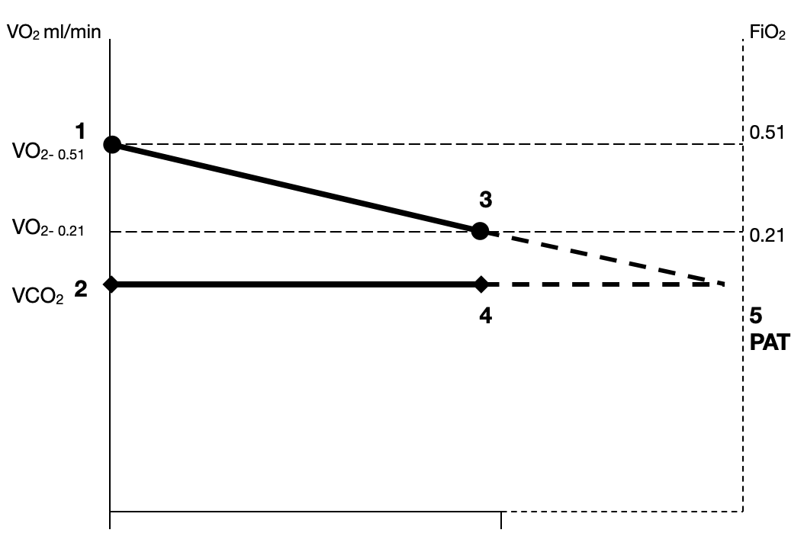

Supplementary Figure 1. Scheme for calculating the power of the anaerobic threshold. Numbers indicate the formulas numbers from text. FiO2 - oxygen fraction in the inhaled gas mixture, PAT - the power of the anaerobic threshold, VO2 - oxygen consumption, VCO2 - carbon dioxide release.
The values of VO2 and VCO2 found during measurements 1, 2 (at FiO2 = 0.51), and 3, 4 (at FiO2 = 0.21) were plotted on a graph, then the points VO2–0.51 and VO2-0.21 were connected with a straight line, and continue the line until it intersects with the VCO2 line, which built in the same way.

- Supplementary Data
Supplementary Table 1. Dynamics of oxygen balance characteristics during hypoxic-hyperoxic preconditioning.
Parameter | Baseline | Hypoxic phase, n=60 | Hyperoxic phase, n=60
 |  | 10 min | 10 min | 20 min | 30 min
СI, l/min/m² | 2.7  [2.4; 2.9] | 2.75  [2.1; 2.95] | 2.75  [2.1; 2.9] | 2.75  [2.1; 2.9] | 2.75  [2.1; 2.9]
раО₂, mm Hg | 108.2 [104; 120] | 47.7 [46.5; 49]* | 342.0 [299.3; 366]* | 329.4 [290; 379.6]* | 330 [305.5; 377.6]*
рvО₂, mm Hg | 46.2 [44.8; 47.4] | 35.6 [32.7; 38.8]* | 62.5 [56.1; 70]* | 63.7 [57; 69.1]* | 62.5 [57; 67]*
раСО₂, mm Hg | 38.7 [34.73; 42.18] | 39 [36; 43.2] | 41.2 [37.2; 47] | 41.4 [38.5; 43] | 40 [38.9; 45]
рvCO₂, mm Hg | 44 [38.8; 48] | 43.0 [41.5; 46.5] | 45 [40.7; 49.9] | 44 [42.2; 47.5] | 47.6 [43; 52]
ΔPCO₂, mm Hg | 6 [2.9; 6.9] | 3.7 [2.7; 6.75]* | 3.0 [1.3; 5.1]* | 4.0 [2.8; 5.5]* | 5.7 [5.0; 7.0]
CaO2, ml/L | 170.5 [161; 185.2] | 146 [128.3; 162]* | 173.1 [162; 185.7] | 173.4 [162; 185.7] | 173.4 [162; 185.7]
CvO2, ml/L | 134.8 [122; 144.9] | 106.6 [93.3; 115.5]* | 148.2 [138.9; 160.1]* | 151.1 [139.8; 164.6]* | 147.9 [138.3; 160.5]*
C(a-v)O2, ml/L | 35.46 [29.68; 43.38] | 40.15 [32.56; 48.3]* | 23 [15.9; 26.02]* | 20.11 [14.78; 29.7]* | 20.81 [17.72; 26.36]*
ΔPCO₂/ C(a-v)O₂ | 1.56 [0.89; 1.89] | 0.97 [0.67; 1.70]* | 1.43 [0.73; 2.38] | 2.20 [0.92; 3.12]* | 2.49 [2.04; 3.53]*
SaO_{2,} % | 98.8 [97.6; 99.4] | 85 [82.6; 86.6]* | 99.9 [99.7; 99.9] | 99.9 [99.8; 99.9] | 99.9 [99.4; 99.9]
SvO_{2,} % | 77.4 [73.6; 80.7] | 59.1 [57; 64.2]* | 86 [84.4; 88.7]* | 87.4 [81.7; 90.6]* | 88 [83.5; 88.9]*
IVO₂, ml/min/m² | 88.43 [72.09; 110] | 106 [87.8; 117.2]* | 59.7 [38.55; 74.14]* | 55.3 [39.8; 71]* | 55.5 [38; 72.1]*
IDO₂, ml/min/m² | 440.7 [398.4; 507.1] | 367.8 [324.1; 451.2]* | 464.6 [390.8; 532] | 463.2 [390.8; 532.4] | 464.4 [390.8; 532]
IEО₂, % | 21.4 [17.24; 25.33] | 27.6  [25.02; 32.6]* | 13.9  [10.45; 15]* | 12.2  [8.21; 18.22]* | 11.9  [ 10.26; 15.74]*
Lac, mM/l | 1.45 [1.3; 1.95] | 1.8 [1.43; 2.3] | 1.65 [1.0; 2.0] | 1.7 [1.3; 2.1] | 1.9 [1.5; 2.3]
Glu, mM/l | 6.1 [5.0; 7.2] | 5.8 [5.0; 6.5] | 6 [5.1; 6.4] | 5.7 [5.3; 7.0] | 6 [5.5; 6.8]
rSO2 left | 62 [57; 64] | 51 [44; 57] | 72 [66; 75]
rSO2 right | 62 [56; 65] | 53 [42; 58] | 72 [67; 78]
CI—cardiac index; paO2— arterial oxygen tension; pvO2— mixed venous oxygen tension; рaCO₂ ₋ arterial carbon dioxide tension; рvCO₂ ₋ venous carbon dioxide tension; ΔPCO₂ - venous-to-arterial carbon dioxide difference; CaO2 - arterial oxygen content; CvO2 - venous oxygen content; Ca-vO2 - arterial–venous oxygen content; ΔPCO₂/Ca-vO2—venous-to-arterial carbon dioxide difference/arterial–venous oxygen content difference ratio; SaO2— arterial oxygen saturation; SvO2— mixed venous oxygen saturation; IEO2—oxygen extraction index; IVO2 – oxygen consumption index; IDO2 – oxygen delivery index; Lac - lactate; Glu - glucose; rSO2 - regional cerebral saturation. Values are shown as median and [25; 75 quartile]. Wilcocson test, *—p < 0.05 comparing to the baseline.

