Supplementary Materials: Dual-Extended State Observer-Based Feedback Linearizing Control for a Nonlinear System with Mismatched Disturbances and Uncertainties
Ravi Gandhi ¹, Dipak Adhyaru ², Gulshan Sharma ^{3,}* and Pitshou N. Bokoro ³
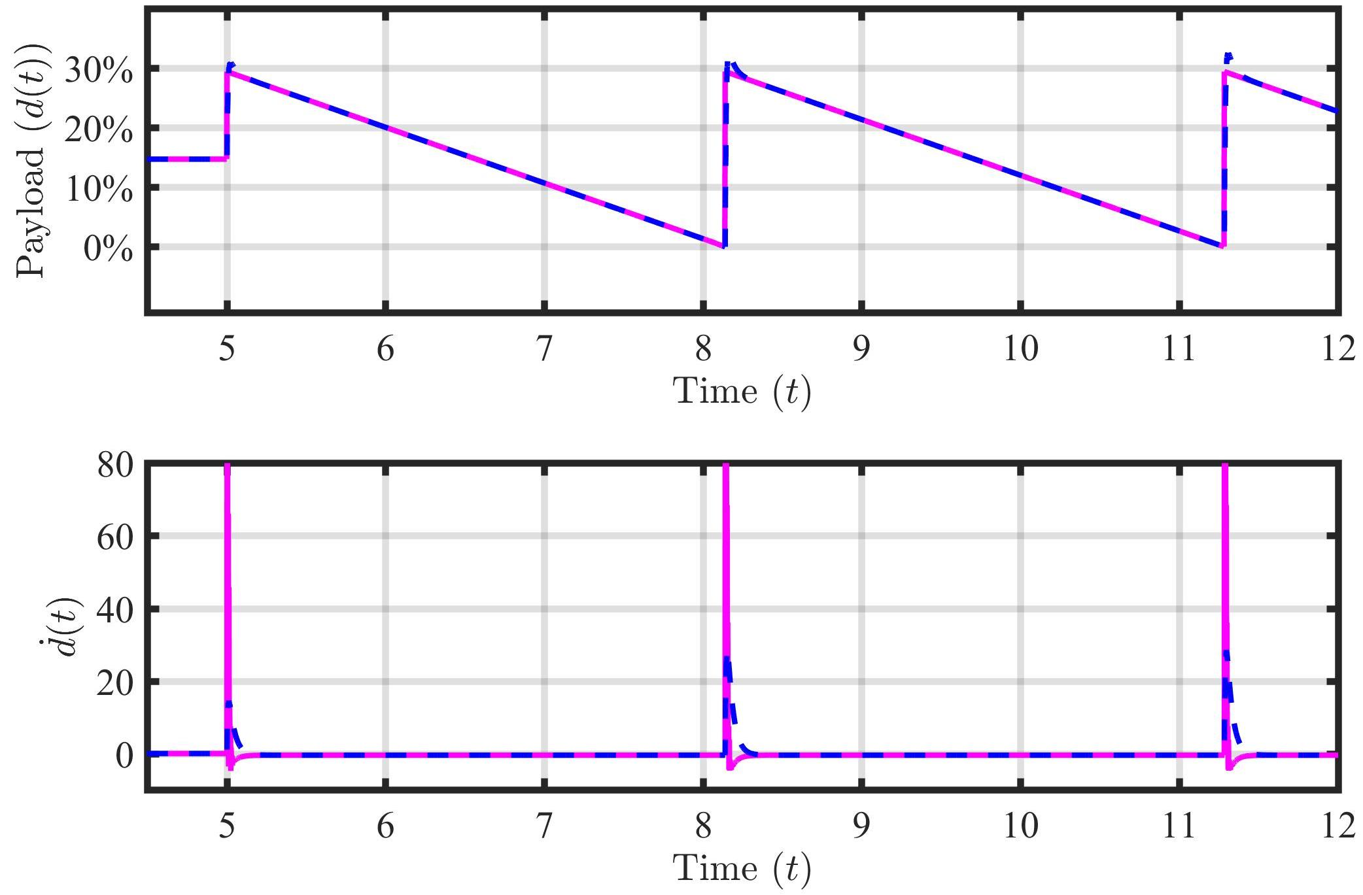
Figure S1. DESO based estimation of square-wave payload disturbance and its first-order derivative.
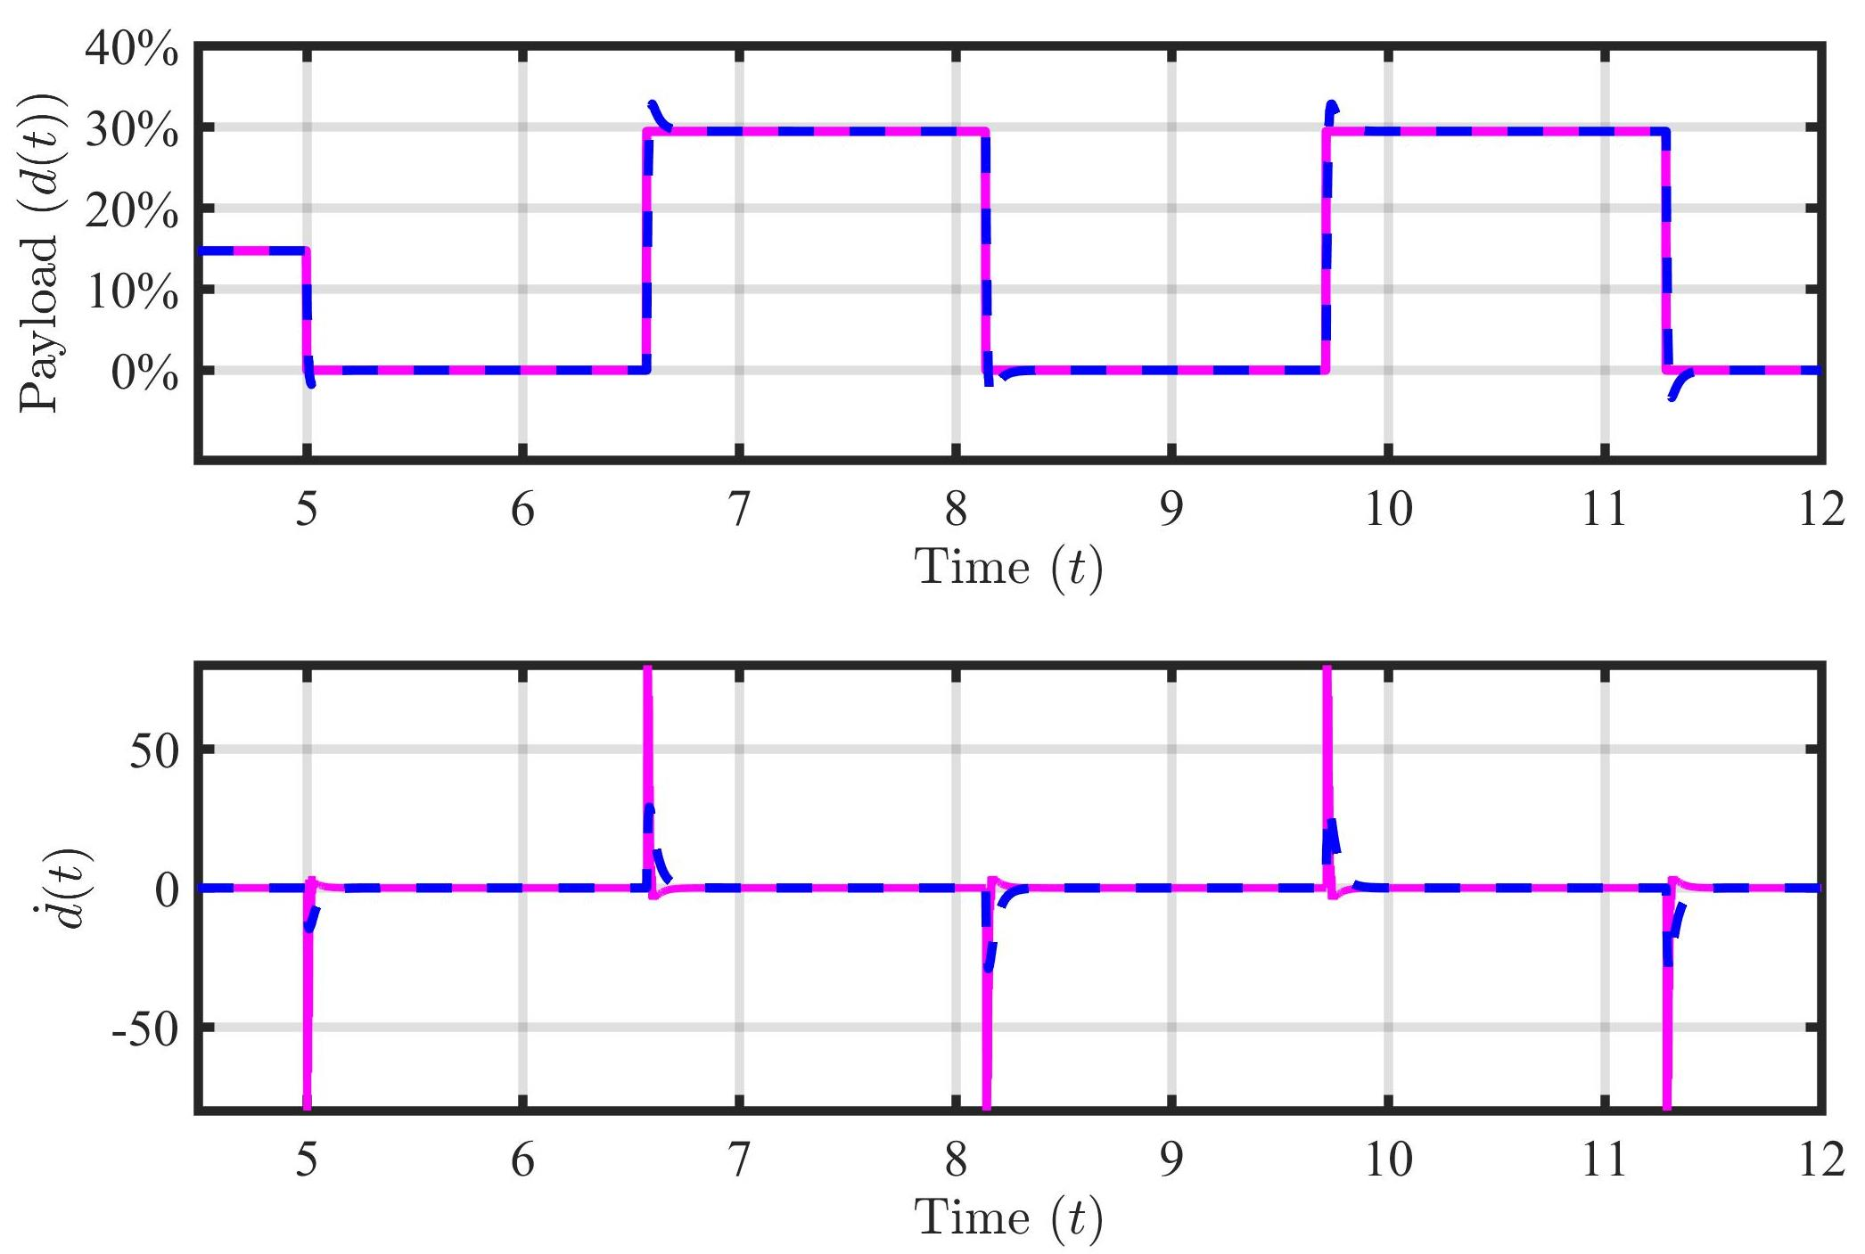
Figure S2. DESO based estimation of sawtooth-wave payload disturbance and its first-order derivative.

