Supplementary Material

Supplement Table. A1 Statistical analysis of TA
year/site | phenotype | Variability | Mean | SD | CV (%) | Kurt | skewness
2018 liuyang | TA | 9.63°-55.66° | 27.86a | 6.75 | 24.23% | 1.42 | 0.84
2019 liuyang |  | 14.59°-47.76° | 25.82a | 6.56 | 25.43% | 0.67 | 0.85

Supplement Table. A2 Primer for RT–qPCR
Gene ID | Primer sequence (5'to3')
LOC_Os01g67770 | F | AATGAAGGTCTTGTGTTGCATC
 | R | GCTTTGGTTTTGTAAGCTCTGA
LOC_Os02g35180 | F | CCTCCTCTTTCAAATACTCCCA
 | R | CTCCCATCCTCTCAGGTCT
LOC_Os09g38130 | F | TTAGCTGGAATGATTCAGCTCA
 | R | ATTATAGTTATCTACGCGGGCC
OsActin | F | CAGCCACACTGTCCCCATCTA
 | R | AGCAAGGTCGAGACGAAGGA

Supplement Table. A3 Comparison of GWAS results with previously reported results of TA
QTL | Chr | Marker interval | LOD score | P value | R2(%) | Ref
QTa1 | 1 | RG173/RG532 | 2.6 | - | 2.7 | Li.et al (1999)
qTA1.1 | 1 | 1297448 | - | 1.64E-07 | - | Bai.et al (2022)
qTA1.2 | 1 | 12048457 | - | 1.64E-07 | - | Bai.et al (2022)
QTa2 | 2 | RG171-RG437 | 3.6 | - | 5.2 | Li.et al (1999)
qTA-2 | 2 | C777-R1989 | 7.56 | - | 19.05 | Yu.et al (2005)
qTA2 | 2 | RM13594–RM3512 | 4.26 | - | 39 | Zhao.et al (2022)
qTA2.1 | 2 | 30414101 | - | 1.47E-12 | - | Bai.et al (2022)
qTA6 | 6 | RM528–RM3343 | 3.12 | - | 37 | Zhao.et al (2022)
qTA6.1 | 6 | 3234165 | - | 5.85E-08 | - | Bai.et al (2022)
Ta | 9 | RZ228-RG667 | 32.3 | - | 47.5 | Li.et al (1999)
qTA-9a | 9 | RG662-CT100 | 5.51 | - | 22.7 | Qian.et al (2001)
qTA-9b | 9 | G295-RG451 | 3.05 | - | 11.9 | Qian.et al (2001)
qTA9-2 | 9 | RM107-RG667 | 22 | - | 19.5 | Shen.et al (2005)
qTA -9 | 9 | XNpb108 -C570 | 10.5 | - | 32. 83 | Yu.et al (2005)
TAC1 | 9 | P4-P5 | - |  | - | Yu.et al (2007)
qTAC9 | 9 | RM201-RM7306 | 9.31 | - | 17.4 | He.et al (2017)
qTA9 | 9 | RM6235–RM24288 | 4.27 | - | 27 | Zhao.et al (2022)
qTA9-1 | 9 | RM3700–RM24288 | 7.08 | - | 37 | Zhao.et al (2022)
qTA-12 | 12 | RG461-G148 | 5.71 | - | 20.9 | Qian.et al (2001)

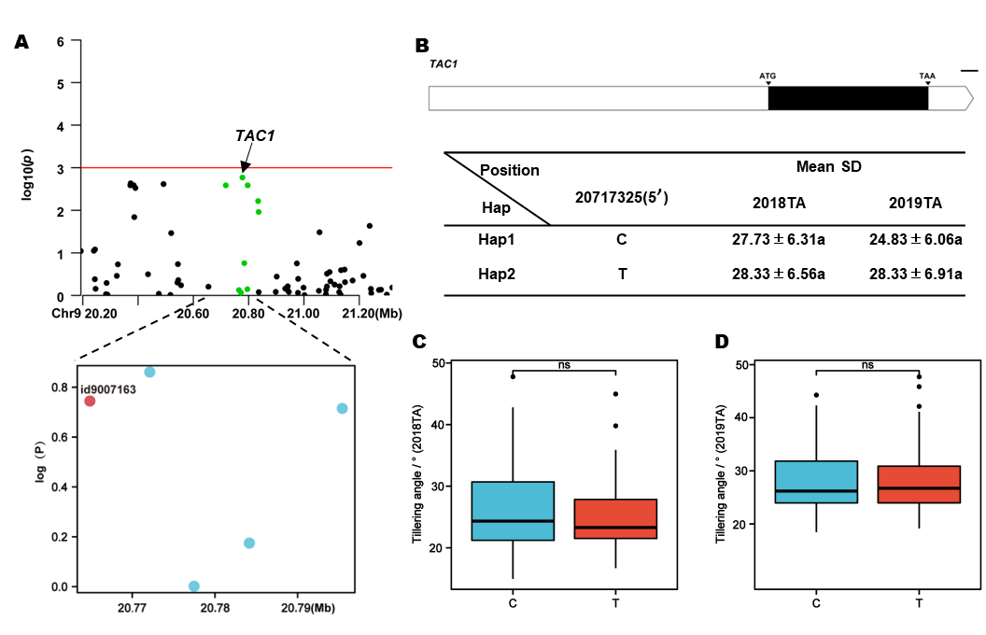
Supplement Figure. A3 TAC1 haplotype significance analysis. (A) Partial Manhattan map of TAC1 on Chr.9; (B) Schematic representation of TAC1 structure and the positions of 1 SNPs used for haplotype analysis, bar = 100bp; (C) and (D) Comparisons of TA values among accessions with different haplotypes in2018 and 2019. *p ≤ 0.05, **p ≤ 0.01.

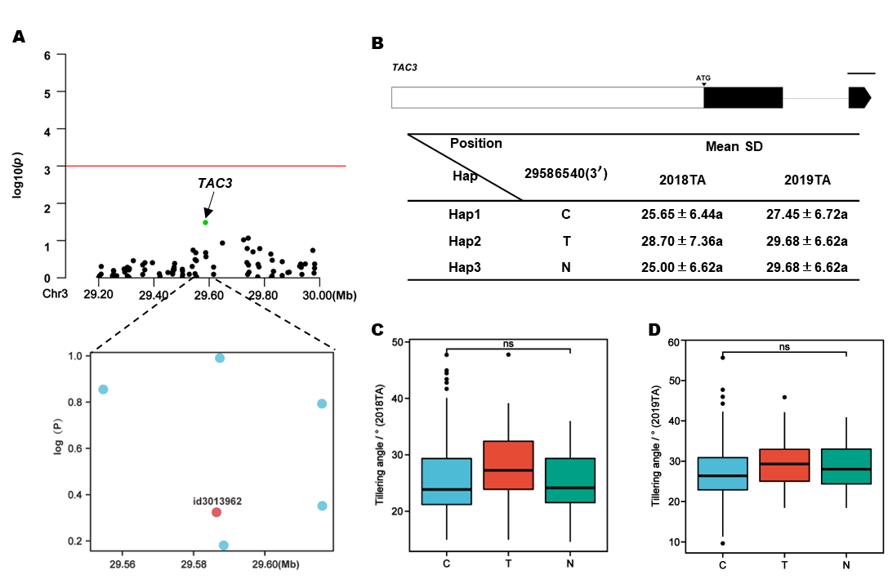
Supplement Figure. A4 TAC3 haplotype significance analysis. (A) Partial Manhattan map of TAC3 on Chr.3; (B) Schematic representation of TAC3 structure and the positions of 1 SNPs used for haplotype analysis, bar = 100bp; (C) and (D) Comparisons of TA values among accessions with different haplotypes in2018 and 2019. *p ≤ 0.05, **p ≤ 0.01.

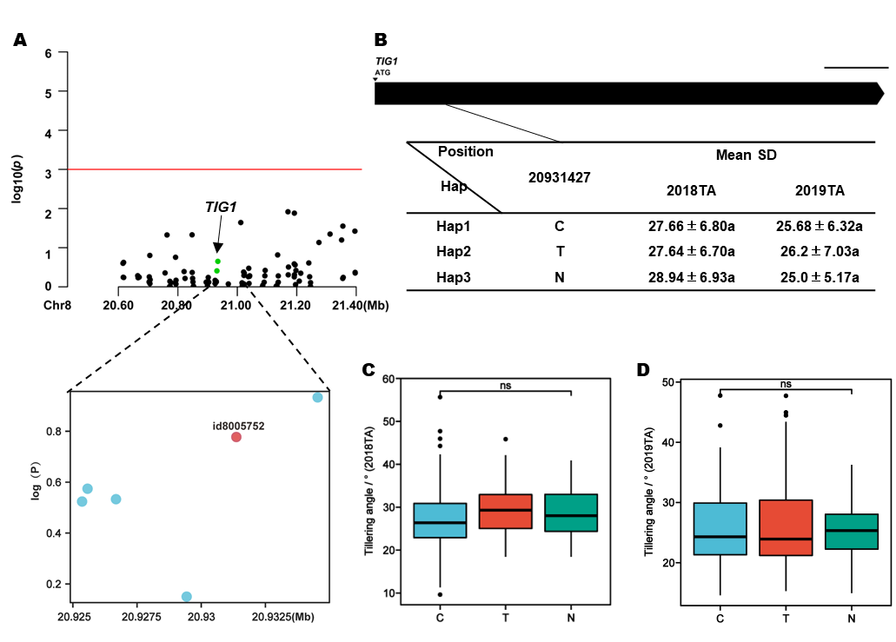
Supplement Figure. A5 TIG1 haplotype significance analysis. (A) Partial Manhattan map of TIG1 on Chr.8; (B) Schematic representation of TIG1 structure and the positions of 1 SNPs used for haplotype analysis, bar = 100bp; (C) and (D) Comparisons of TA values among accessions with different haplotypes in2018 and 2019. *p ≤ 0.05, **p ≤ 0.01.

