

**Figure S1:** The bi-dimensional representation of environmental and biotic variables associated with larval habitat distribution on the factorial plan of the two first MCA dimensions (38.4% of explained inertia). The wide segregation of variable on the factorial plan translates a good correlation of these variables with the species composition variability among larval habitats.

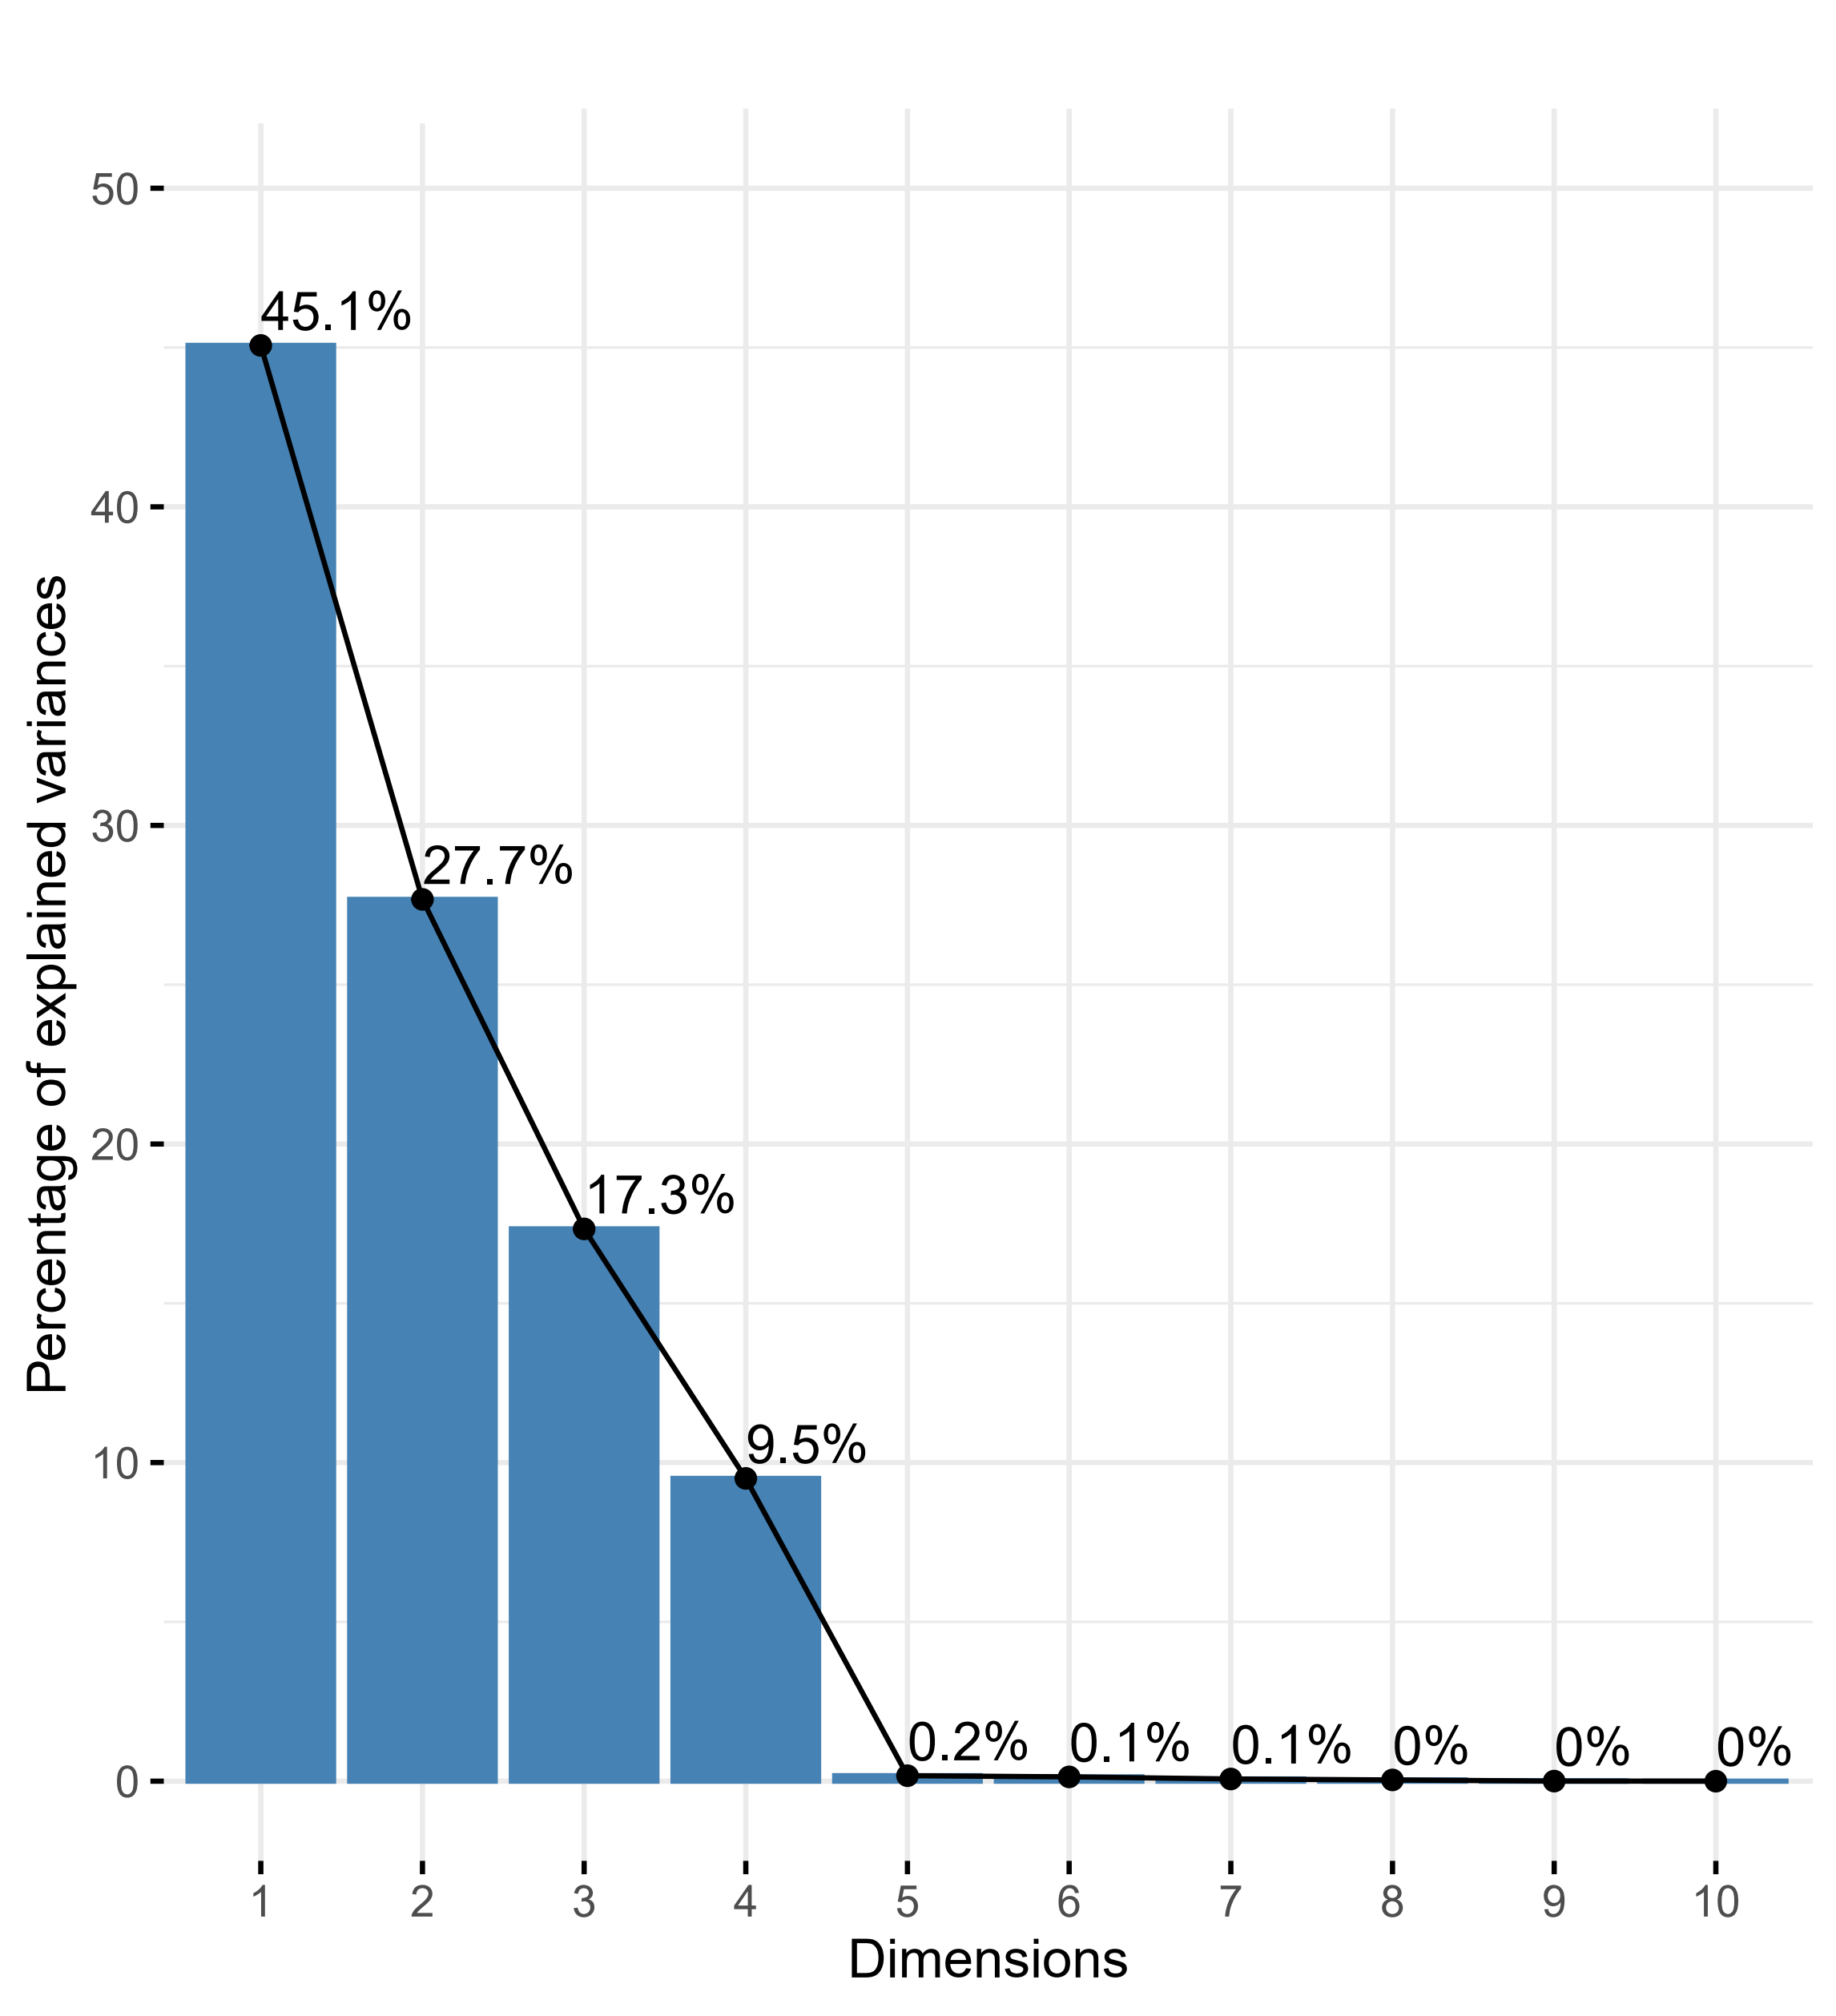

**Figure S2:** PAC’s percentage of explained variances of data following the dimensions. The first two dimensions (1 & 2) refer to an explained variance of 72.8%.