Supplementary Figures
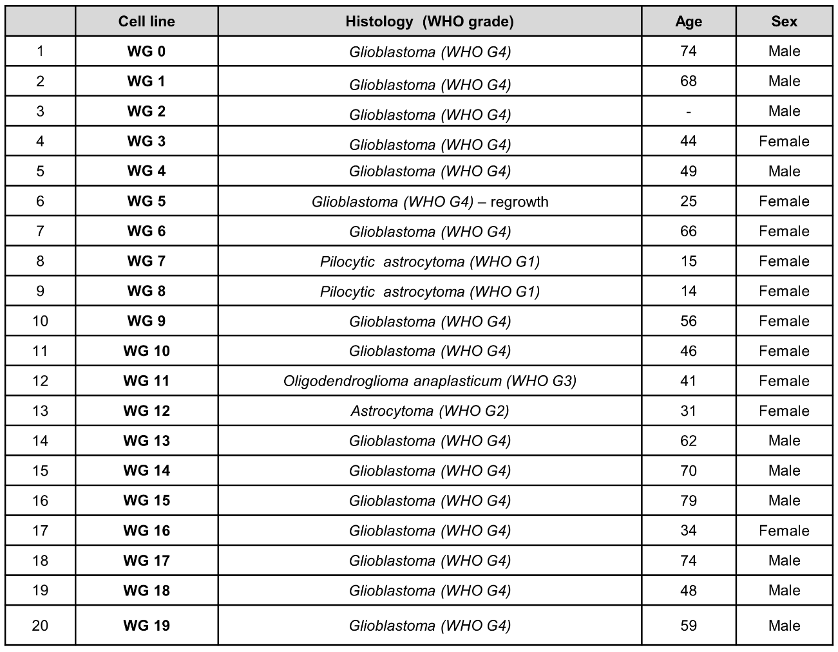
Supplementary Figure 1. Information about patient cohort and corresponding primary cell cultures. Clinical data included histological type, age, gender of patients with corresponding primary glioma cell cultures.

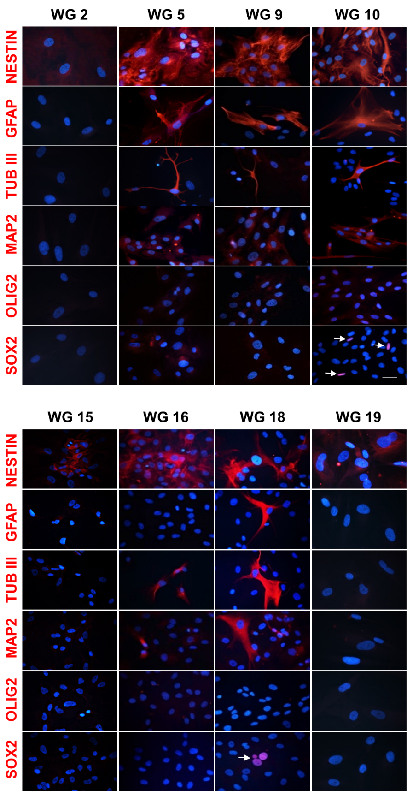
Supplementary Figure 2. Immunofluorescent staining of selected proteins in primary cell cultures. Representative immunofluorescent staining of the stemness (NESTIN, SOX2, OLIG2) and differentiation (GFAP, β-TUB III, MAP2) markers in WG2, WG5, WG9, WG10, WG15, WG16, WG18 and WG19 cells. White arrows indicate SOX2 nuclear staining. Scale bar: 100 µm.

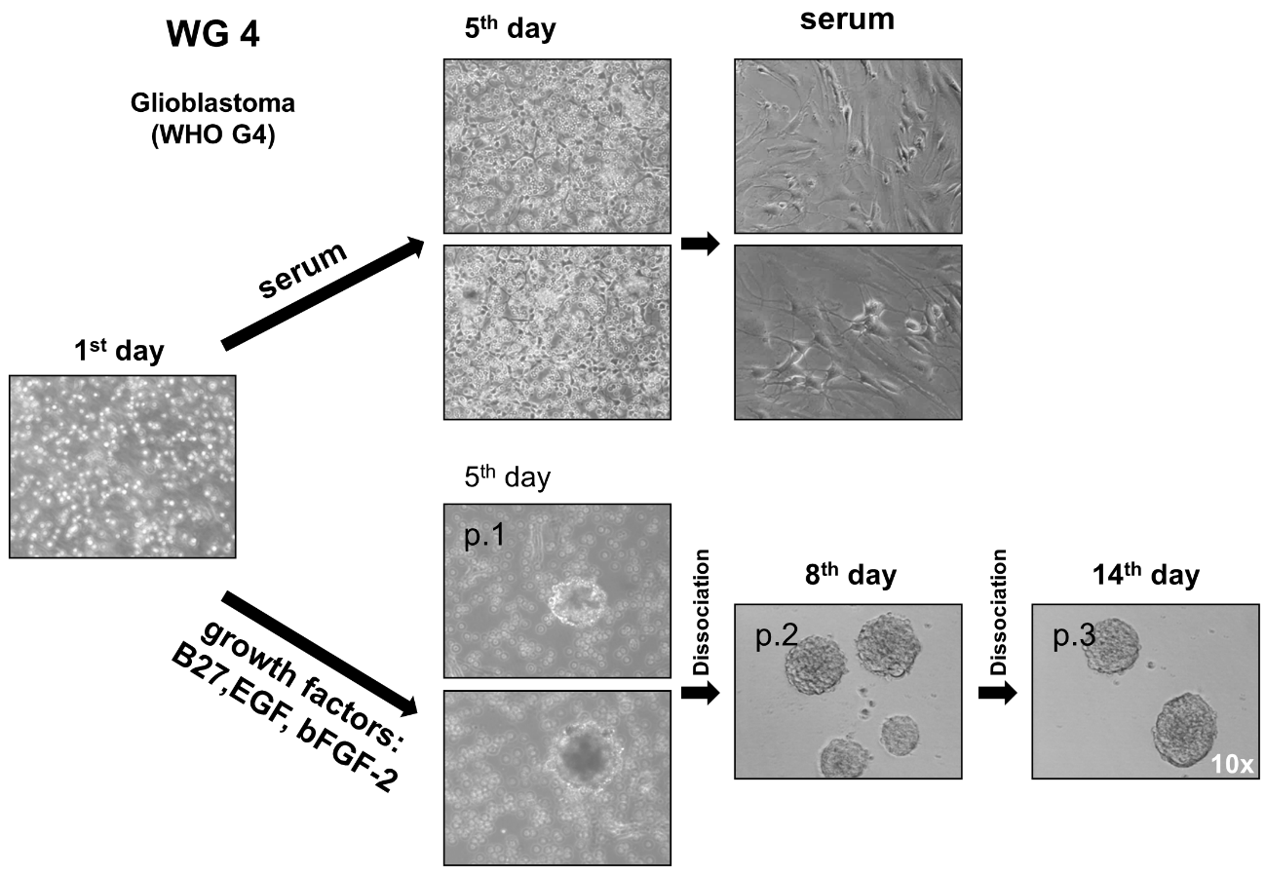
Supplementary Figure 3. Establishment of primary cell culture and passaging. Light microscopy images of dissociated WG4 cells 1 day after tissue dissection, and after 5 days in the presence of serum (FBS) or under sphere conditions (growth factors). Morphology of adherent WG4 cells growing in the presence of serum, and second and tertiary generation of WG4 neurospheres growing in a medium supplemented with B27 and growth factors.

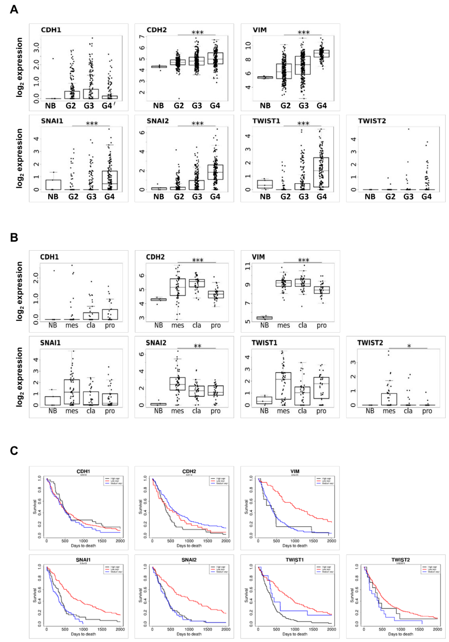
Supplementary Figure 4. Expression of EMT-related genes in TCGA gliomas and the survival analysis of GBM-patients with different expression of EMT-related genes. (A) Expression of key EMT-related genes in glioma of different grades. Boxplots show the expression of CDH1, CDH2, VIM, SNAIs, TWISTs in normal brain samples (NB) compared to human gliomas of different grades (G2-G4) in the TCGA dataset. (B) Expression of key EMT genes in different subtypes of GBM. Boxplots show the expression of CDH1, CDH2, VIM, SNAIs, TWISTs in normal brain samples (NB) compared to different subtypes of GBM (mes-mesenchymal, cla-classical, pro-proneural). (C) Survival analysis of glioma patients with different expression of key EMT genes in the TCGA dataset. Association of CDH1, CDH2, VIM, SNAIs and TWISTs expression with overall survival in all grades gliomas in the TCGA dataset (red line - low expression, black line – high expression, blue line - medium expression).
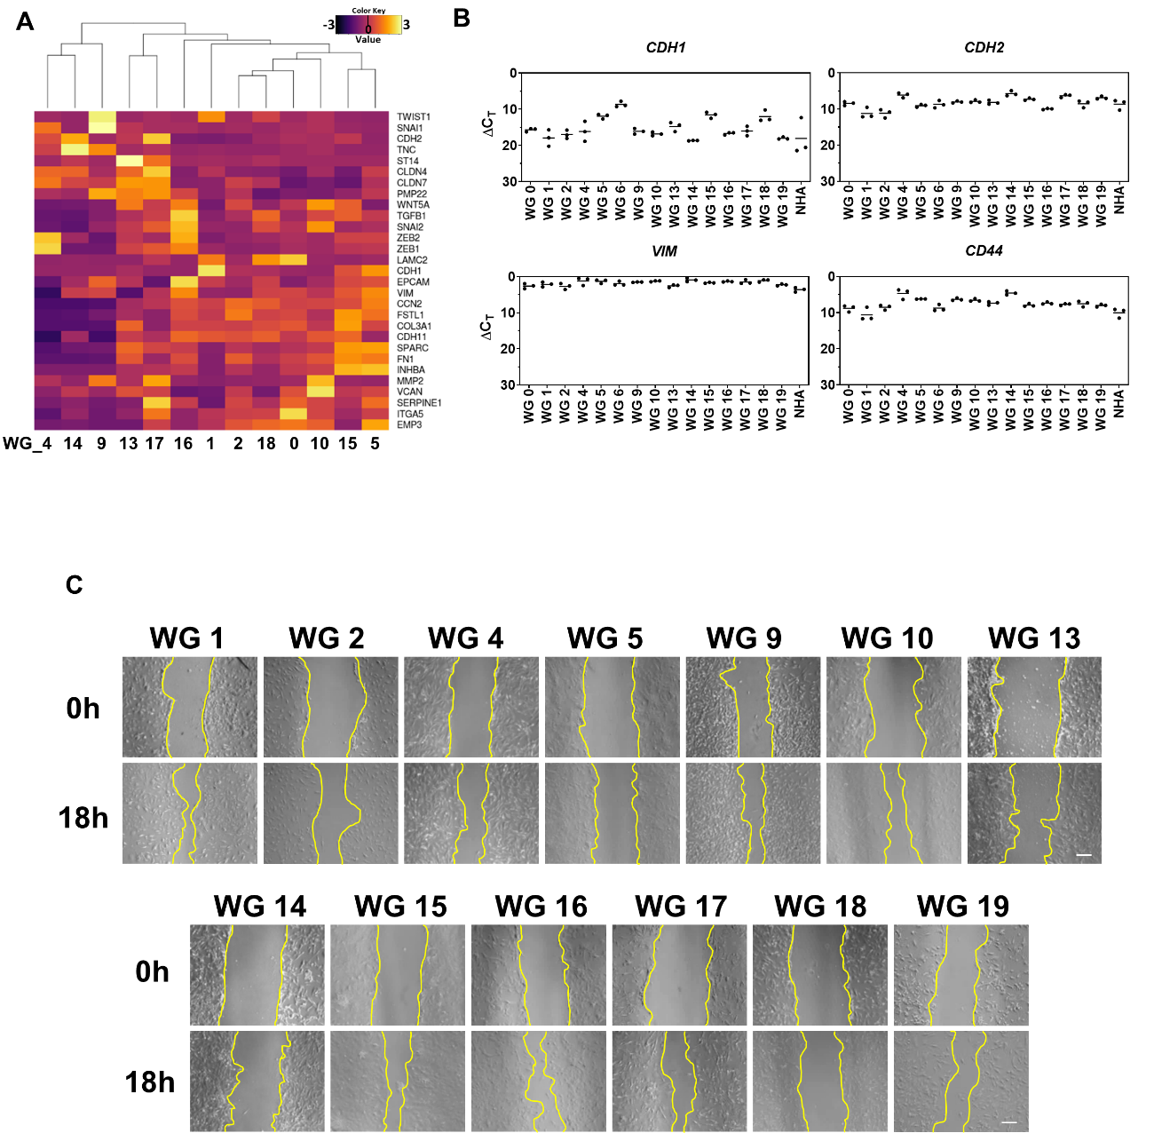
Supplementary Figure 5. Characterization of the mesenchymal phenotype of primary glioma cell cultures. (A) RNAseq of primary cell lines represented as a heatmap of EMT genes across primary glioma cell cultures. (B) Expression of chosen EMT-related genes (CDH1, CDH2, VIM, CD44). The RT-qPCR data are shown as delta Ct values relative to the 18S expression. Statistical analysis was performed using t-test (*p<0.05, **p<0.01, ***p<0.001), n=3, mean ± SD. (C) The migratory ability of different primary glioma cells was analyzed by scratch assay. Photos represent wound closure after 0 h and 18 h. Scale bar: 200 µm.

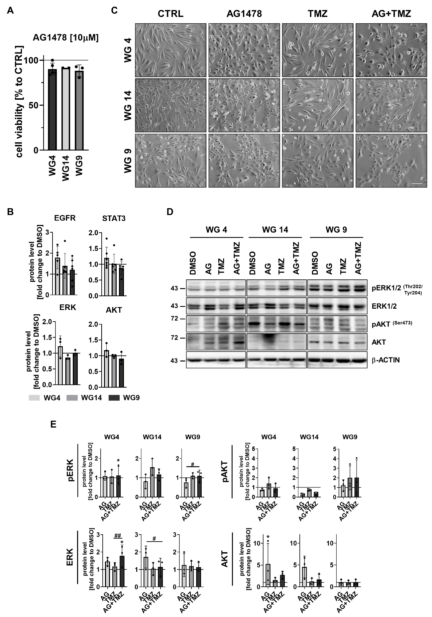
Supplementary Figure 6. The effect of AG1478 alone or in combination with TMZ (A) Cell viability of WG4, WG14 and WG9 cells after treatment with 10 µM AG for 6 h, determined by PrestoBlue test. Viability of the control group was set as 100% and marked by a black solid line. Statistical significance was calculated on raw data by t-test in comparison to untreated cells (not significant). (B) The densitometric quantification of total: EGFR, STAT3, ERK and AKT in cells exposed to AG (10 µM) for 6 h. The level of a protein of interest in control cells equals 1 and is marked by a solid black line. β-ACTIN was used as a loading control. Statistical significance was determined by t-test in comparison to control conditions (without AG), (not significant), n≥3, mean ± SD. (C) Representative images of WG4, WG14 and WG9 cells after 10 µM AG, 1 mM TMZ and combined AG+TMZ treatment for 72 h. Scale bar: 100 µm. (D) Representative immunoblots of proteins involved in EGFR signaling pathways in WG4, WG14 and WG9 cells treated with 10 µM AG, 1 mM TMZ or with combination of AG+TMZ for 72 h with (E) the densitometric quantification. The level of a protein of interest in control cells equals 1 and is marked by a solid black line. β-ACTIN was used as a loading control. Statistical significance was determined by one-way ANOVA followed by Dunnett’s post hoc test in comparison to untreated control cells (*p<0.05, **p<0.01, ***p<0.001) or by one-way ANOVA followed by uncorrected Fisher’s LSD test between the groups: AG or TMZ vs AG+TMZ (#p<0.05, ##p<0.01, ###p<0.001), n=3, mean ± SD.
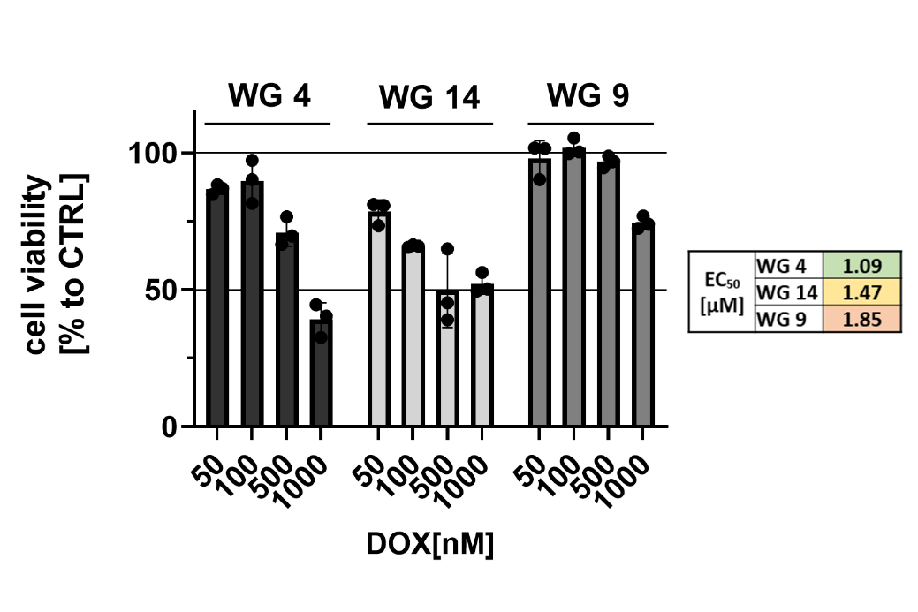
Supplementary Figure 7. Impact of DOX treatment to primary glioma cell cultures. (A) Cell viability of WG4, WG14 and WG9 cells after DOX treatment for 48 h, determined by MTT cell metabolism test. The viability of untreated control cells was set as 100% and marked with a black solid line. EC50 was calculated using a linear relationship between the dose and cell viability. n=3, mean ± SD.

