Supplementary Information:
Genome analysis of three bacteriophages targeting Multi Drug Resistant clinical isolate of E. coli, host receptor prediction using machine learning tools and the evaluation of monophages and cocktail in vitro and in vivo
Niranjana Sri Sundaramoorthy^{a,b}, Vineetha KUª, Veena Nair, Kavi Bharathi, Jean Sophy Royª, Malarvizhi R, Sneha Srinath^{c}, Santhosh Kumar S^{c}, Prakash Sankaran, Suma Mohan S*^{c} and Saisubramanian Nagarajan^{a,d}*
ª Center for Research on Infectious Diseases (CRID), School of Chemical and Biotechnology, SASTRA Deemed University, Tamil Nadu, India
^{b} Translational Health Sciences Technology Institute, Faridabad
^{c} Department of Bioinformatics, School of Chemical and Biotechnology, SASTRA Deemed University, Tamil Nadu, India
^{d} Antimicrobial Resistance Lab, ASK-I-312, School of Chemical and Biotechnology, SASTRA Deemed University, Tamil Nadu, India
*Jointly Communicated
Communicating Authors
Dr. Saisubramanian Nagarajan
Mail id: sai@scbt.sastra.edu
Dr. Suma Mohan S
Mail id: sumamohan@scbt.sastra.edu

Supplementary Figure 1: Spot assay showing the presence of bacteriophages specific to U1007. 1- Water sample from Madurai Pond 1, 2- Cow’s urine sample from Madurai, 3- Water sample from Madurai pond 2, 4 – Urine sample from cow shed at Perambalur, 5 – Dung sample from cow shed at Perambalur, 6 – Water sample from Cauvery river, 7 – Urine sample from SASTRA cow shed, 8 – Dung sample from SASTRA cow shed, 9 – Soil sample from a corn farm, 10 – Soil sample from a onion farm, 11 – Water sample from Ganges river 12- Hospital sewage sample, 13- cuvam river, 14- sewage sample from Taramani area, 15- Railway station area.
A) U3790
B) U1007
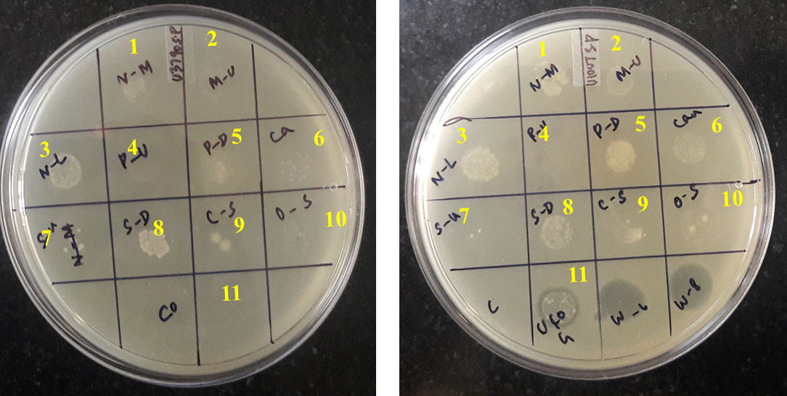

B) U1007
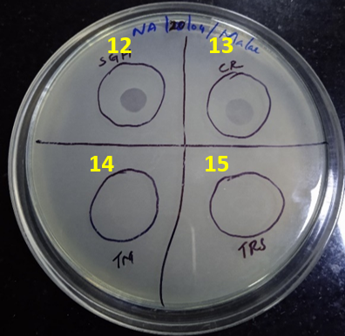

Supplementary Figure 2: Genome alignment of the close homologs of Escherichia phage (A)U1G, (B) CR and M with Mauve.
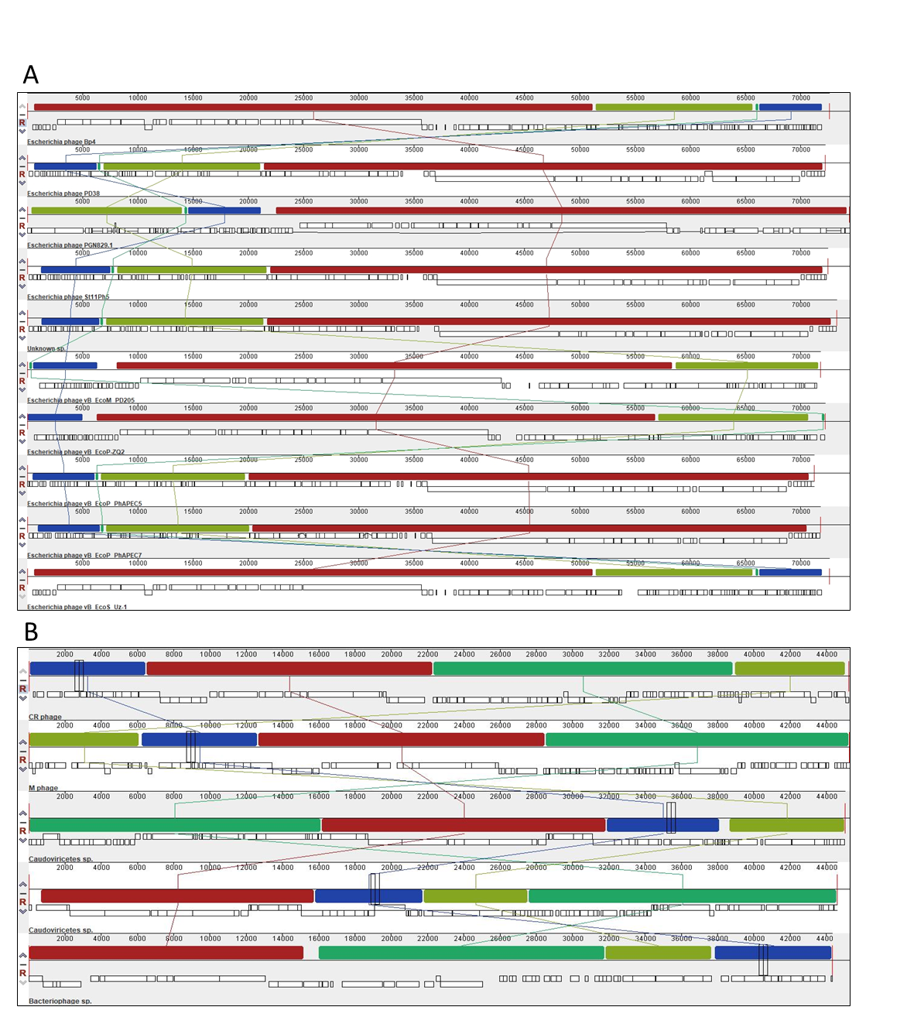

Supplementary Figure 3: Phylogenetic tree of the potential RBP proteins identified from (A) U1G, (B) CR and (C) M phage. Phylogenetic tree of the RBP protein constructed with the Maximum Likelihood method with 500 bootstrap values using MEGA11. The homologs of the RBP proteins of U1G, CR and M phages from other bacteriophages were obtained using BLASTp search.

A
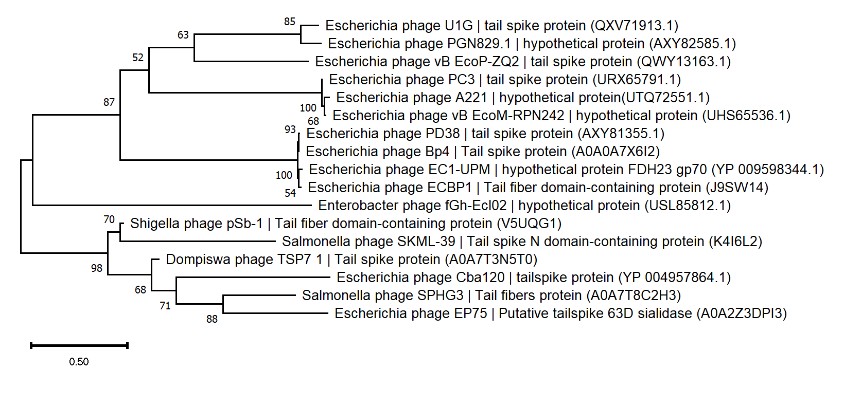

B
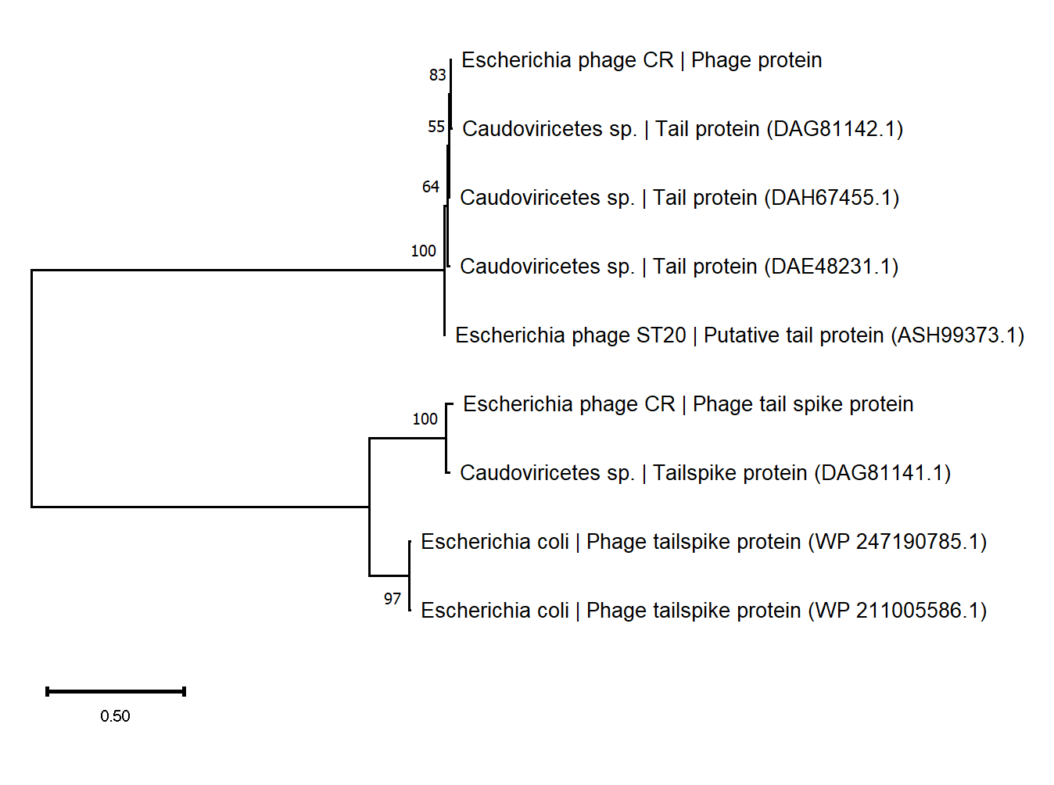

C

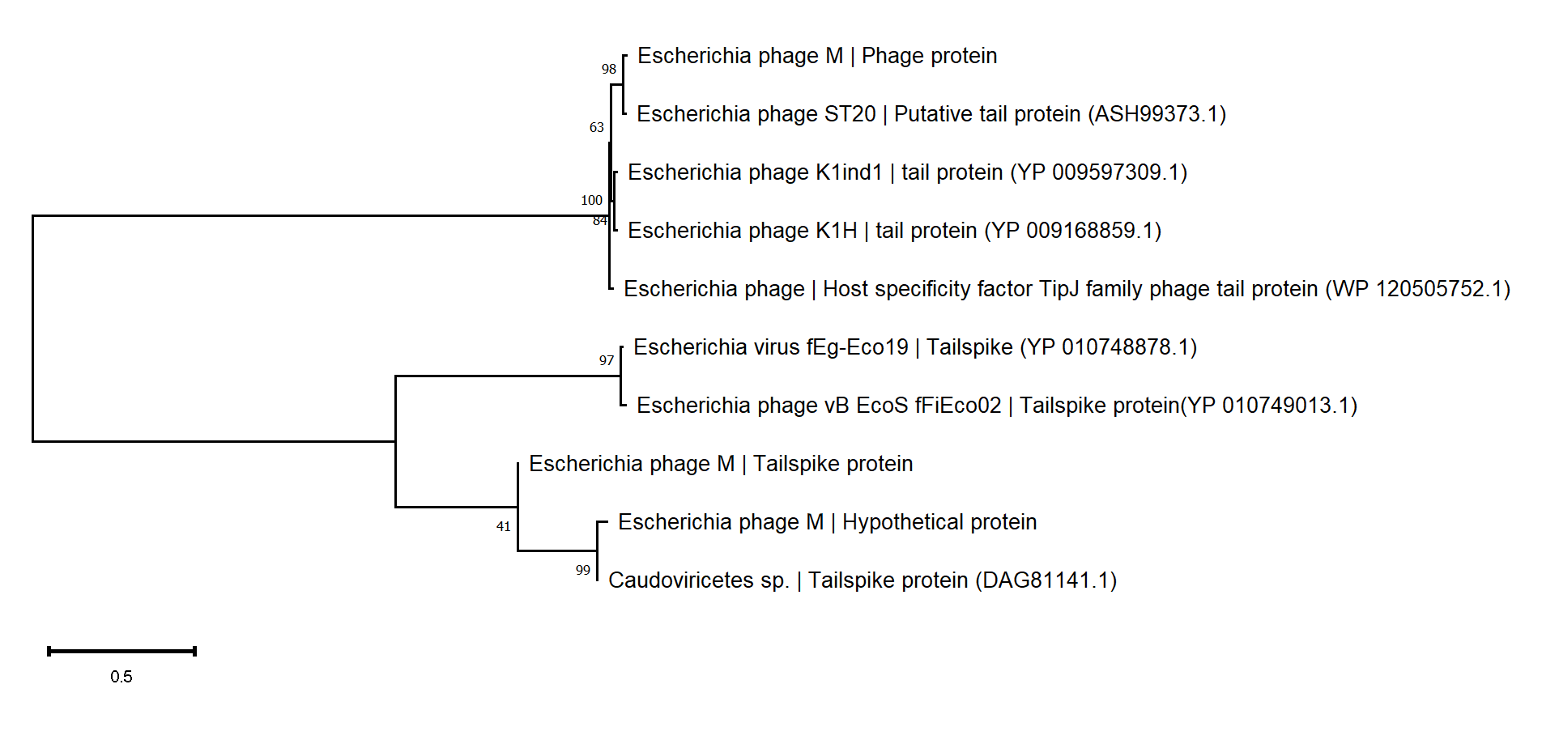
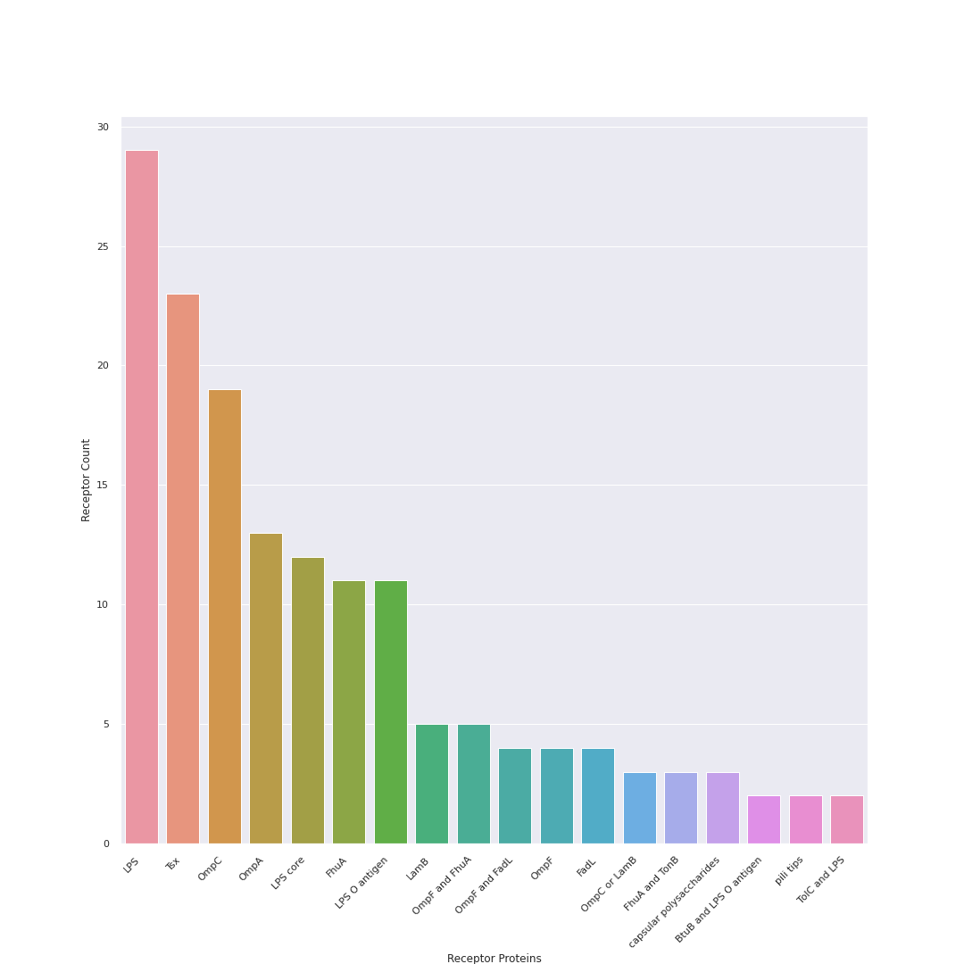
Supplementary figure 4: The receptor label distribution in the dataset with multiple entries.
Supplementary Figure 5: One-step growth curve of U1G, CR and M phages
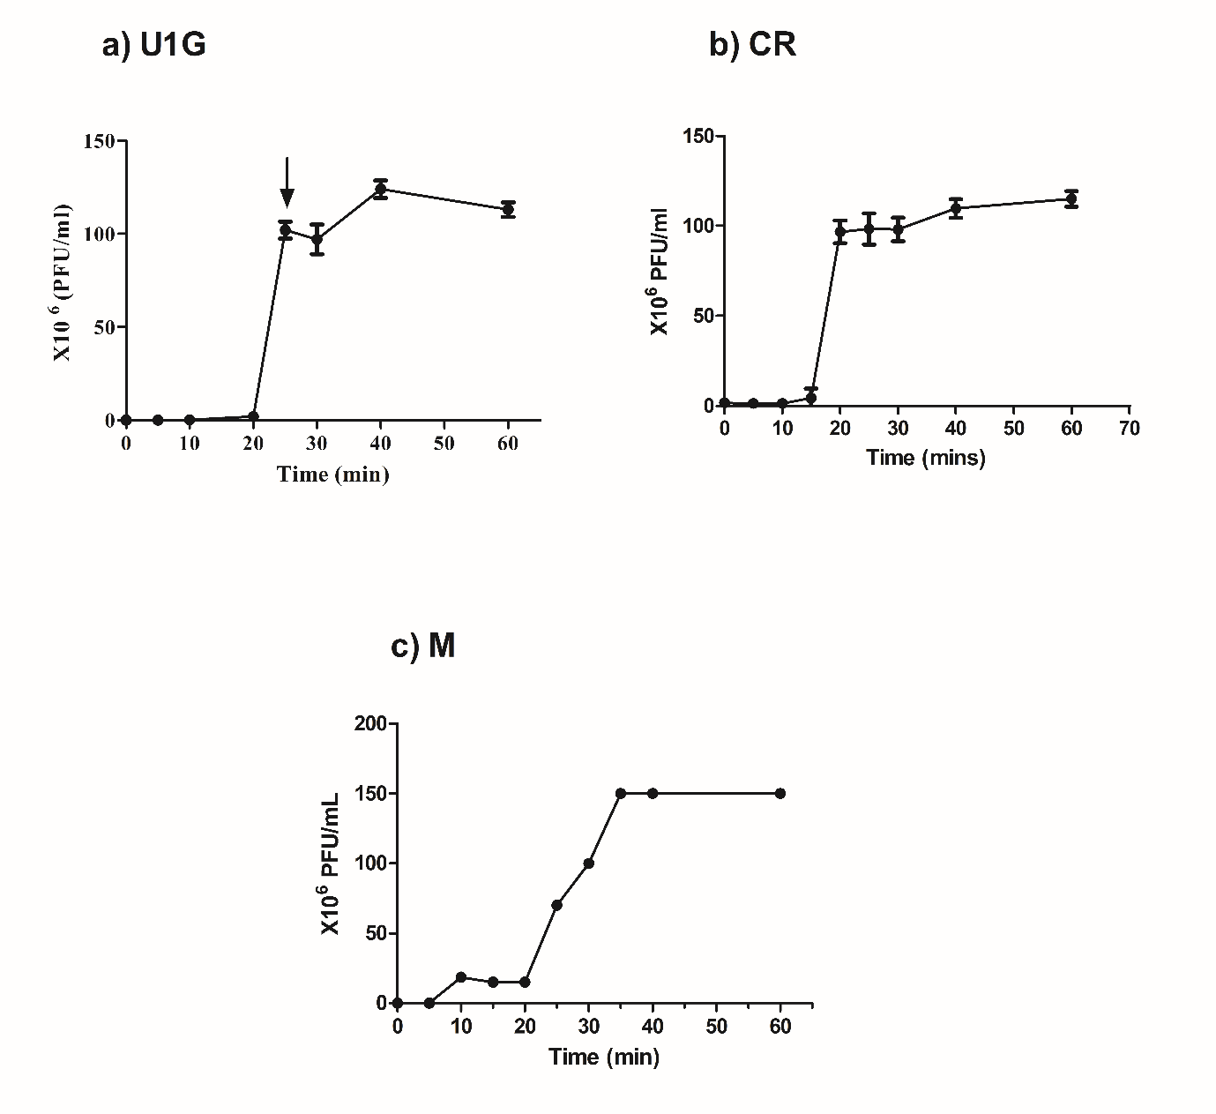
Supplementary Figure 6a: U1G is highly specific to U1007, with a slight lysis against U3790.
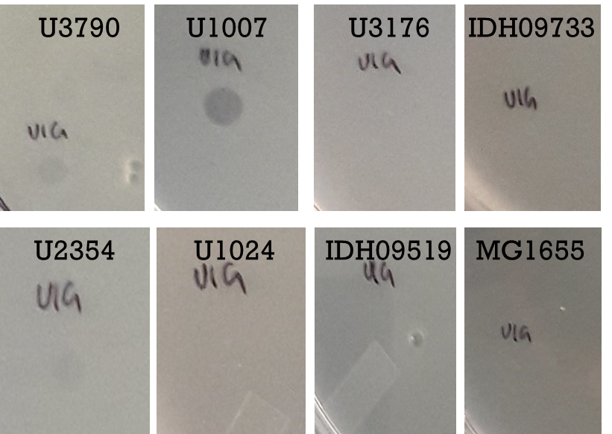
Figure 6b: M is highly specific to U1007, with a slight lysis against U2354.
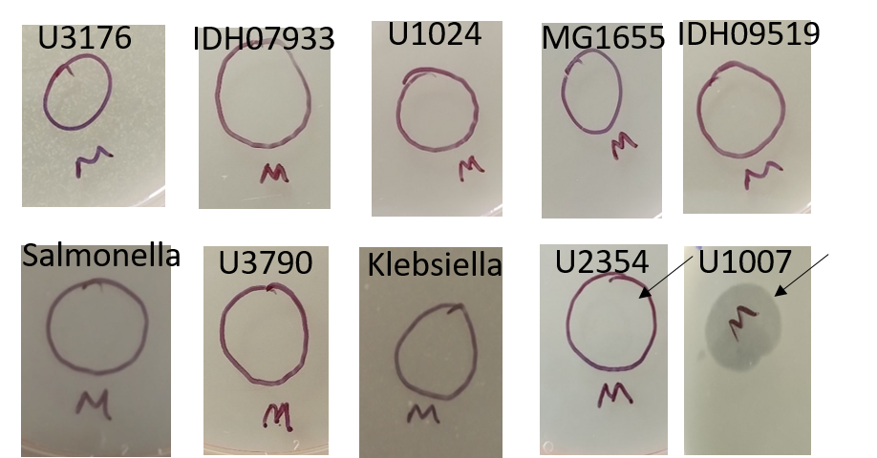

Figure 6c. CR is highly specific to U1007, with lysis against U2354.
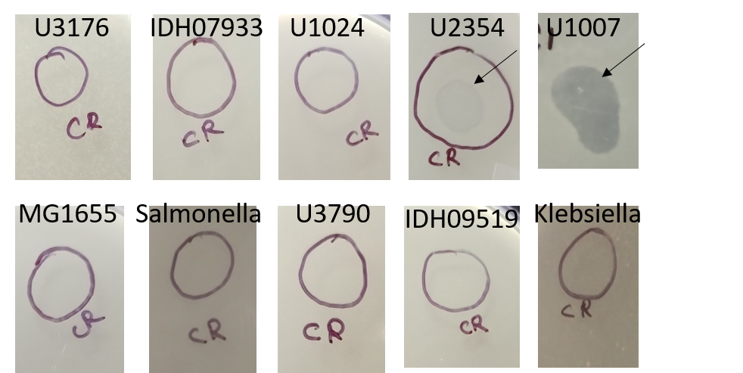

Supplementary Figure 7: Representative Temperature stability data of U1G, CR and M phages
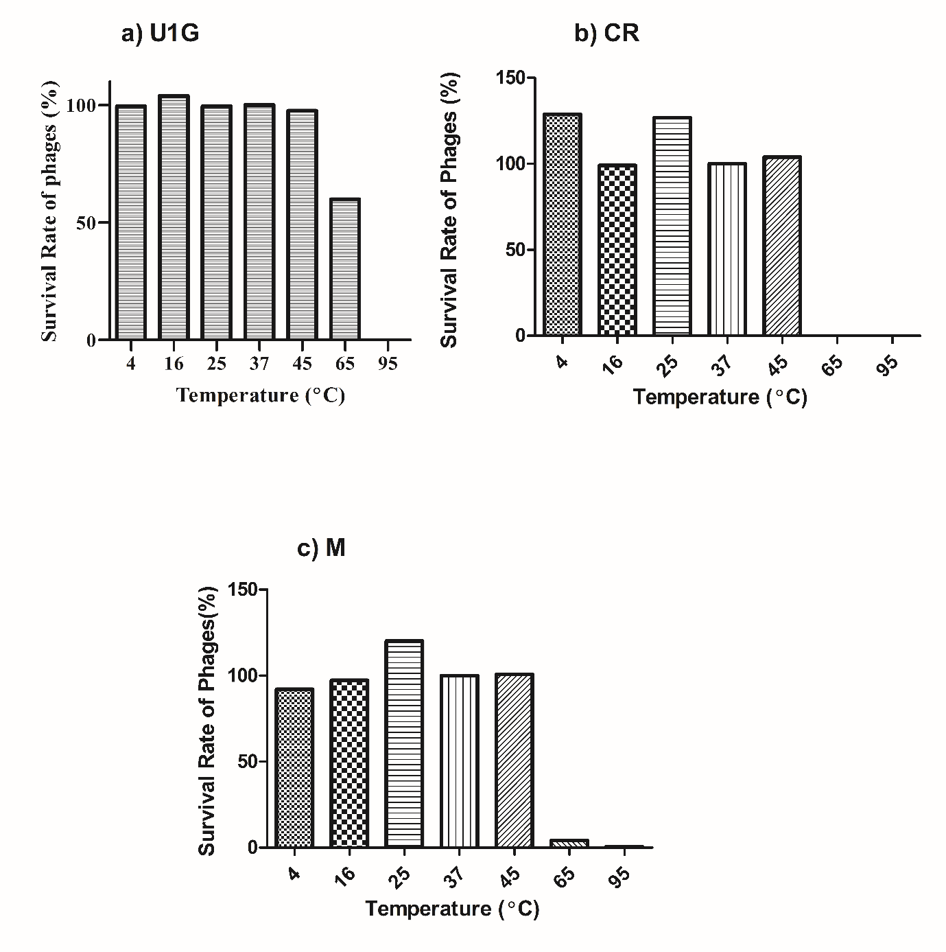

Supplementary Figure 8: Representative pH stability data of U1G, CR and M phages
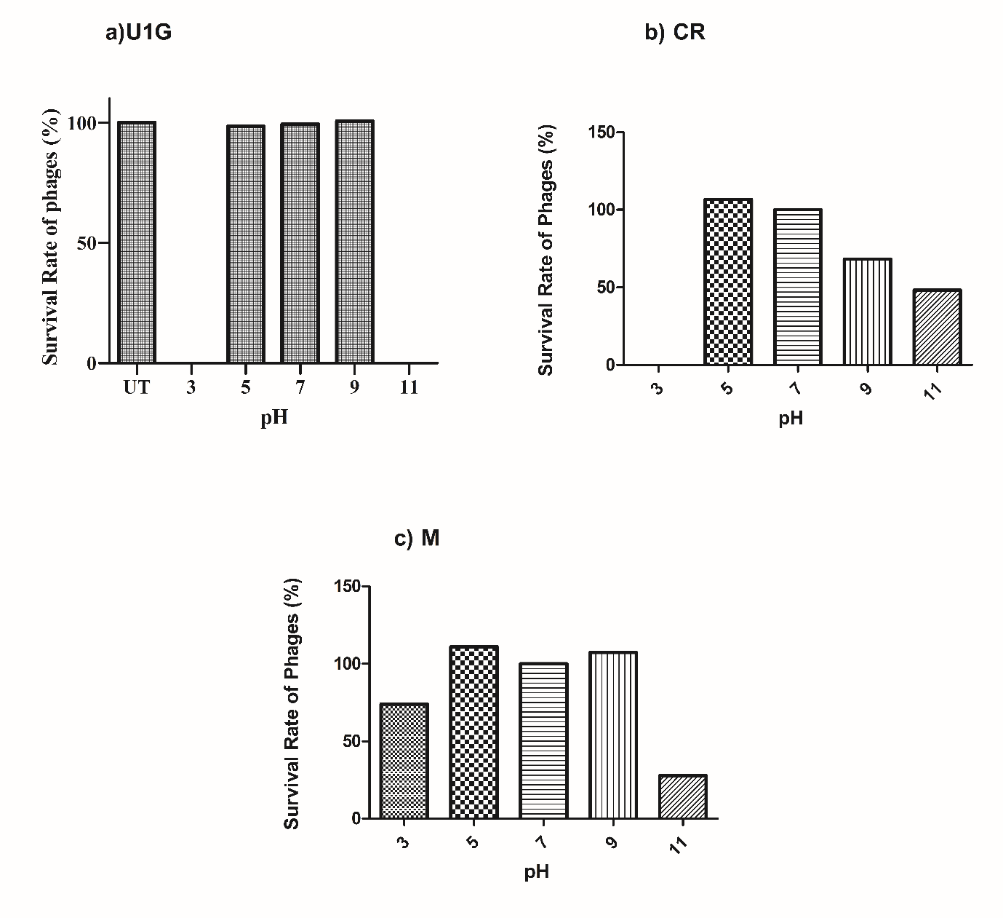

Supplementary Figure 9: Representative toxicity testing of phages on zebrafish. Phages were injected in muscle tissue and 48h post injection, liver and brain were dissected

Supplementary Figure 10: In vivo infection study with monophages
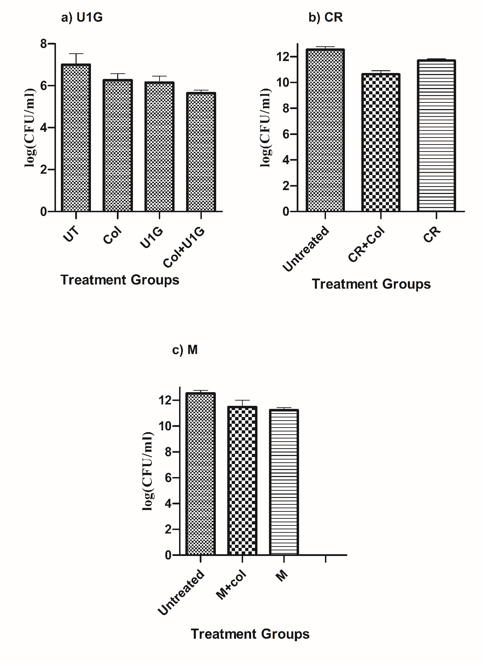

Supplementary Figure 11: A) Strain U1007 is heteroresistant to colistin B) U1007 is ESBL positive

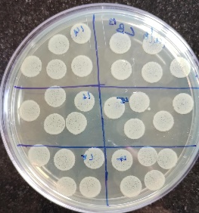
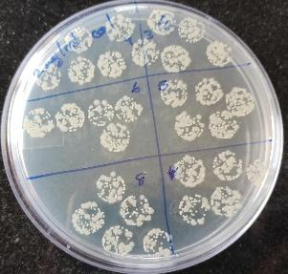
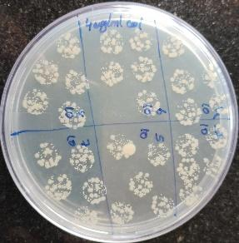
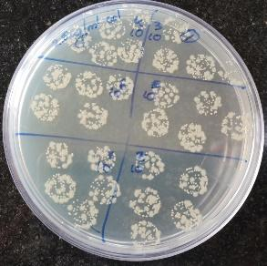

Colistin :0 µg/ml 2 µg/ml 2.5 µg/ml 4 µg/ml

Heteroresistance Calculation
No.of colonies on colistin plate * Dilution factor
No. of colonies on antibiotic free plate * Dilution factor
= 30* 10⁸/ 609*10¹⁰ =0.000492

B) ESBL test was performed using Hexa G-minus 23 and Hexa G-plus 1 rings.
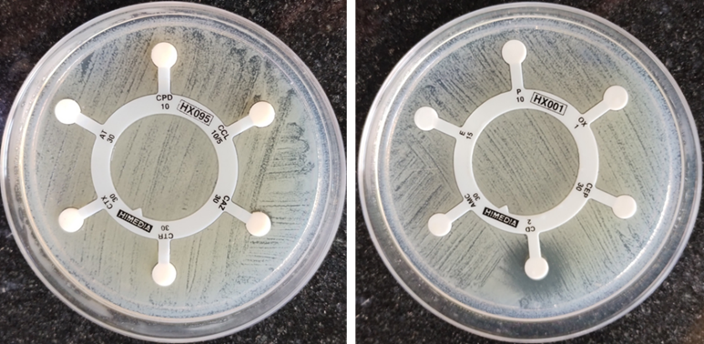
Hexa G-minus 23- Aztreonam(AT)-30mcg, Cefpodoxime(CPD)-10 mcg, Cefpodoxime/Clavulanic acid(CCL)-10/5 mcg, Ceftazidime(CAZ)- 30 mcg, Ceftriaxone(CTR)-30 mcg, Cefotaxime(CTX)-30 mcg,
Hexa G-plus 1- Penicillin G(P)-10units, Oxacillin(OX)-1mcg, Cephalothin(CEP)-30mcg, Clindamycin(CD)-2mcg, Erythromycin(E)-15mcg, Amoxyclav(AMC)- 30mcg
Table S1: Antimicrobial Resistant Genes in Genome of E. coli Clinical isolate U1007 using ResFinder.

Antimicrobial | Class | Genetic Background
amikacin | aminoglycoside | aac(6')-Ib-cr (aac(6')-Ib-cr_DQ303918), rmtB (rmtB_AB103506)
tobramycin | aminoglycoside | aac(6')-Ib-cr (aac(6')-Ib-cr_DQ303918), rmtB (rmtB_AB103506)
cefepime | beta-lactam | blaOXA-1 (blaOXA-1_HQ170510), blaNDM-5 (blaNDM-5_JN104597), blaCTX-M-15 (blaCTX-M-15_AY044436)
chloramphenicol | amphenicol | catB3 (catB3_U13880), catB3 (catB3_AJ009818)
piperacillin+tazobactam | beta-lactam | blaOXA-1 (blaOXA-1_HQ170510), blaNDM-5 (blaNDM-5_JN104597)
cefoxitin | beta-lactam | blaNDM-5 (blaNDM-5_JN104597)
ampicillin | beta-lactam | blaOXA-1 (blaOXA-1_HQ170510), blaTEM-1B (blaTEM-1B_AY458016), blaNDM-5 (blaNDM-5_JN104597), blaCTX-M-15 (blaCTX-M-15_AY044436)
ampicillin+clavulanic acid | beta-lactam | blaOXA-1 (blaOXA-1_HQ170510), blaNDM-5 (blaNDM-5_JN104597)
cefotaxime | beta-lactam | blaNDM-5 (blaNDM-5_JN104597), blaCTX-M-15 (blaCTX-M-15_AY044436)
ciprofloxacin | quinolone | aac(6')-Ib-cr (aac(6')-Ib-cr_DQ303918) gyrA (p.S83L)
sulfamethoxazole | folate pathway antagonist | sul1 (sul1_U12338), sul2 (sul2_AY034138)
imipenem | beta-lactam | blaNDM-5 (blaNDM-5_JN104597)
trimethoprim | folate pathway antagonist | dfrA17 (dfrA17_FJ460238)
nalidixic acid | quinolone | gyrA (p.S83L), gyrA (p.D87N)
ertapenem | beta-lactam | blaNDM-5 (blaNDM-5_JN104597)
tetracycline | tetracycline | tet(A) (tet(A)_AJ517790)
ceftazidime | beta-lactam | blaNDM-5 (blaNDM-5_JN104597), blaCTX-M-15 (blaCTX-M-15_AY044436)
temocillin | beta-lactam | blaNDM-5 (blaNDM-5_JN104597)
gentamicin | aminoglycoside | rmtB (rmtB_AB103506)
meropenem | beta-lactam | blaNDM-5 (blaNDM-5_JN104597)
azithromycin | macrolide | mph(A) (mph(A)_D16251)
isepamicin | aminoglycoside | rmtB (rmtB_AB103506)
hydrogen peroxide | peroxide | sitABCD (sitABCD_AY598030)
fluoroquinolone | quinolone | aac(6')-Ib-cr (aac(6')-Ib-cr_DQ303918)
cephalothin | beta-lactam | blaTEM-1B (blaTEM-1B_AY458016)
amoxicillin+clavulanic acid | beta-lactam | blaOXA-1 (blaOXA-1_HQ170510), blaNDM-5 (blaNDM-5_JN104597)
erythromycin | macrolide | mph(A) (mph(A)_D16251)
kanamycin | aminoglycoside | rmtB (rmtB_AB103506)
piperacillin | beta-lactam | blaOXA-1 (blaOXA-1_HQ170510), blaTEM-1B (blaTEM-1B_AY458016), blaNDM-5 (blaNDM-5_JN104597), blaCTX-M-15 (blaCTX-M-15_AY044436)
amoxicillin | beta-lactam | blaOXA-1 (blaOXA-1_HQ170510), blaTEM-1B (blaTEM-1B_AY458016), blaNDM-5 (blaNDM-5_JN104597), blaCTX-M-15 (blaCTX-M-15_AY044436)
ethidium bromide | quaternary ammonium compound | qacE (qacE_X68232)
sisomicin | aminoglycoside | aac(6')-Ib-cr (aac(6')-Ib-cr_DQ303918), rmtB (rmtB_AB103506)
spectinomycin | aminocyclitol | aadA5 (aadA5_AF137361)
doxycycline | tetracycline | tet(A) (tet(A)_AJ517790)
arbekacin | aminoglycoside | rmtB (rmtB_AB103506)
cefixime | beta-lactam | blaNDM-5 (blaNDM-5_JN104597)
benzylkonium chloride | quaternary ammonium compound | qacE (qacE_X68232)
ceftriaxone | beta-lactam | blaCTX-M-15 (blaCTX-M-15_AY044436)
telithromycin | macrolide | mph(A) (mph(A)_D16251)
ticarcillin | beta-lactam | blaTEM-1B (blaTEM-1B_AY458016), blaCTX-M-15 (blaCTX-M-15_AY044436)
chlorhexidine | quaternary ammonium compound | qacE (qacE_X68232)
cetylpyridinium chloride | quaternary ammonium compound | qacE (qacE_X68232)
spiramycin | macrolide | mph(A) (mph(A)_D16251)
dibekacin | aminoglycoside | aac(6')-Ib-cr (aac(6')-Ib-cr_DQ303918)
netilmicin | aminoglycoside | aac(6')-Ib-cr (aac(6')-Ib-cr_DQ303918)
aztreonam | beta-lactam | blaCTX-M-15 (blaCTX-M-15_AY044436)
streptomycin | aminoglycoside | aadA5 (aadA5_AF137361), aph(3'')-Ib (aph(3'')-Ib_AF321551), aph(6)-Id (aph(6)-Id_CP000971)
colistin * | polymyxin | emrA_2, emrB_2
* genes identified using Roary.

Table S2: Antimicrobial profile of E. coli clinical isolate U1007 determined by two fold microbroth dilution assay
Class | Antibiotics | MIC(µg/mL)
Cephalosporin | Ceftriaxone | >128
Carbapenem | Meropenem | >128
Fluoroquinolones | Ciprofloxacin | >128
 | Levofloxacin | 32
 | Norfloxacin | >128
Aminoglycosides | Gentamicin | >128
 | Tobramycin | >128
 | Streptomycin | 128
 | Kanamycin | >128
Antimycobacterial | Rifampicin | 32
Macrolides | Erythromycin | >128
Tetracycline | Minocycline | 8
Polymyxin | Colistin | 4

Table S3: Features of U1G, genome annotated by RAST
Start | Stop | RAST
170 | 493 | Phage protein
584 | 943 | hypothetical protein
997 | 1203 | hypothetical protein
1330 | 1713 | Phage integrase
1857 | 2156 | hypothetical protein
2159 | 2377 | hypothetical protein
2374 | 2547 | hypothetical protein
2571 | 3044 | Phage HNH homing endonuclease (ACLAME 27)
3049 | 3180 | hypothetical protein
3314 | 3622 | hypothetical protein
3619 | 3840 | hypothetical protein
3837 | 4094 | hypothetical protein
4091 | 4411 | Phage antirepressor protein
4414 | 4596 | hypothetical protein
4593 | 4973 | hypothetical protein
5027 | 5845 | hypothetical protein
5835 | 5996 | hypothetical protein
6043 | 7260 | hypothetical protein
7318 | 7500 | hypothetical protein
7575 | 8408 | Phage fibritin (wac) protein
8474 | 8788 | Superinfection exclusion protein (Protein gp17)
8893 | 9081 | hypothetical protein
9078 | 9338 | hypothetical protein
9335 | 9520 | hypothetical protein
9521 | 9847 | hypothetical protein
9882 | 10202 | Phage protein
10313 | 10882 | HNH homing endonuclease # Phage intron
11142 | 11816 | Phage protein
11824 | 12327 | hypothetical protein
12324 | 12998 | hypothetical protein
12998 | 13504 | Phage protein
13514 | 13723 | hypothetical protein
13797 | 14039 | hypothetical protein
14055 | 14387 | hypothetical protein
14554 | 14997 | hypothetical protein
14997 | 15941 | Phage protein
16009 | 16221 | hypothetical protein
16214 | 16543 | Phage protein
16536 | 16730 | hypothetical protein
16774 | 19341 | Phage rIIA lysis inhibitor
19346 | 21406 | hypothetical protein
21469 | 21864 | hypothetical protein
21911 | 22045 | hypothetical protein
22108 | 22233 | Phage protein
22725 | 24077 | Phage DNA helicase
24088 | 24618 | hypothetical protein
24628 | 26442 | DNA polymerase I (EC 2.7.7.7), phage-associated
26439 | 27095 | Phage protein (ACLAME 141)
27076 | 28047 | DNA polymerase I (EC 2.7.7.7), phage-associated
28044 | 28349 | hypothetical protein
28349 | 28822 | hypothetical protein
28822 | 29799 | hypothetical protein
29796 | 30233 | Phage-associated homing endonuclease
30276 | 32426 | Phage-associated DNA primase
32483 | 32884 | Phage protein
32950 | 33234 | Phage protein
33430 | 34071 | hypothetical protein
34071 | 34625 | hypothetical protein
34627 | 35067 | hypothetical protein
35299 | 35412 | hypothetical protein
36836 | 37216 | hypothetical protein
48080 | 37326 | DNA polymerase, phage-associated
49890 | 48175 | hypothetical protein
50138 | 49884 | hypothetical protein
50594 | 50151 | hypothetical protein
53262 | 50608 | hypothetical protein
54100 | 53264 | hypothetical protein
54809 | 54177 | hypothetical protein
56085 | 54883 | hypothetical protein
57322 | 56102 | Phage tape measure protein
57686 | 57342 | Phage protein
59970 | 57700 | Phage portal (connector) protein
60479 | 59973 | hypothetical protein
60891 | 60460 | Phage protein
61094 | 60996 | hypothetical protein
61657 | 61328 | Phage tail length tape-measure protein T
62449 | 61916 | hypothetical protein
63285 | 62485 | hypothetical protein
63800 | 63477 | Phage tailspike protein
65447 | 64050 | hypothetical protein
67642 | 65492 | hypothetical protein
68349 | 67639 | hypothetical protein
69945 | 68356 | Phage terminase, large subunit
70627 | 69938 | hypothetical protein
70811 | 71089 | hypothetical protein
71654 | 71968 | hypothetical protein
71972 | 72292 | hypothetical protein
72292 | 72576 | hypothetical protein
72573 | 72887 | hypothetical protein
72877 | 73215 | hypothetical protein

Table S4: Features of CR phage genome annotated by RAST
start | stop | strand | function
229 | 351 | + | hypothetical protein
433 | 819 | + | Phage protein
1010 | 1711 | + | Phage protein
1714 | 1824 | + | Phage major capsid protein of Caudovirales
1977 | 2762 | + | Phage major capsid protein of Caudovirales
2824 | 3165 | + | Phage fibritin (wac) protein
3202 | 3381 | + | hypothetical protein
3385 | 3537 | + | hypothetical protein
3531 | 3758 | + | Phage protein (ACLAME 313)
3761 | 4039 | + | Phage protein
4042 | 4656 | + | Phage protein
4656 | 4787 | + | hypothetical protein
4784 | 5143 | + | Phage protein
5140 | 5640 | + | Phage protein
5640 | 6053 | + | Phage protein
6056 | 7222 | + | Phage protein
7804 | 7250 | - | hypothetical protein
8289 | 7804 | - | 3'-phosphatase, 5'-polynucleotide kinase, phage-associated
8975 | 8286 | - | hypothetical protein
9466 | 8972 | - | Phage protein
9807 | 9481 | - | hypothetical protein
9972 | 10388 | + | Phage protein
10487 | 10750 | + | hypothetical protein
10743 | 12587 | + | Phage tail tape measure
12692 | 13054 | + | Phage tail tape measure
13054 | 14001 | + | Phage protein
14133 | 14444 | + | hypothetical protein
14448 | 14963 | + | Phage protein
14960 | 15325 | + | Phage protein
15388 | 17874 | + | Phage protein
17887 | 19332 | + | Phage tailspike
19345 | 19461 | + | hypothetical protein
19533 | 19721 | + | hypothetical protein
19887 | 19750 | - | Phage protein
20399 | 19884 | - | hypothetical protein
21820 | 20396 | - | Phage DNA helicase
22501 | 22310 | - | Phage protein
22831 | 22532 | - | Phage protein
23006 | 22812 | - | hypothetical protein
23220 | 23089 | - | hypothetical protein
23614 | 23210 | - | DNA polymerase I (EC 2.7.7.7), phage-associated
23976 | 23659 | - | DNA polymerase I (EC 2.7.7.7), phage-associated
25409 | 24006 | - | DNA polymerase I (EC 2.7.7.7), phage-associated
26095 | 25469 | - | Phage protein
26430 | 26179 | - | hypothetical protein
27533 | 26427 | - | Phage protein
27667 | 27527 | - | Phage protein
28011 | 27664 | - | Phage protein
28280 | 28008 | - | hypothetical protein
28591 | 28277 | - | hypothetical protein
29153 | 28635 | - | 13.88 kDa late protein
29403 | 29176 | - | hypothetical protein
29526 | 29741 | + | hypothetical protein
30390 | 29758 | - | Phage replicative DNA helicase, repA
30635 | 30381 | - | hypothetical protein
32014 | 30644 | - | Phage replicative DNA helicase, repA
32235 | 32074 | - | Phage protein
32473 | 32303 | - | Phage protein
32940 | 32590 | - | hypothetical protein
32971 | 33189 | + | hypothetical protein
33208 | 33393 | + | hypothetical protein
33393 | 33632 | + | hypothetical protein
33899 | 34090 | + | hypothetical protein
34094 | 34285 | + | hypothetical protein
34289 | 34432 | + | hypothetical protein
34436 | 34636 | + | hypothetical protein
34772 | 35002 | + | hypothetical protein
35072 | 35449 | + | hypothetical protein
35446 | 35649 | + | Phage protein
35652 | 35855 | + | hypothetical protein
35855 | 36148 | + | hypothetical protein
36145 | 36585 | + | Phage protein
36645 | 36953 | + | hypothetical protein
36946 | 37218 | + | gp55
37196 | 37681 | + | Phage lysin (EC 3.2.1.17)
38028 | 38177 | + | Phage protein
38174 | 38371 | + | hypothetical protein
38368 | 38523 | + | Phage protein
38520 | 38717 | + | hypothetical protein
38698 | 38886 | + | hypothetical protein
38974 | 39141 | + | hypothetical protein
39313 | 39161 | - | hypothetical protein
39332 | 39568 | + | Phage protein
39565 | 39714 | + | hypothetical protein
39841 | 40386 | + | Phage protein
40383 | 40832 | + | Putative phage terminase
40919 | 41413 | + | Phage terminase, large subunit
41416 | 41631 | + | Phage terminase, large subunit
41644 | 42798 | + | 62kDa structural protein
42774 | 43112 | + | 62kDa structural protein
43427 | 43146 | - | hypothetical protein
43536 | 44288 | + | Putative head protein (ACLAME 50)
44435 | 44578 | + | Putative head protein (ACLAME 50)
44581 | 45039 | + | Phage fibritin (wac) protein
45235 | 45068 | - | hypothetical protein

Table S5: Features of M phage genome annotated by RAST
start | stop | strand | function
1 | 180 | + | hypothetical protein
352 | 200 | - | hypothetical protein
371 | 607 | + | Phage protein
604 | 753 | + | hypothetical protein
930 | 1046 | + | hypothetical protein
1080 | 1427 | + | Phage protein
1424 | 2017 | + | Phage terminase
2383 | 2676 | + | Phage terminase, large subunit
2689 | 3357 | + | 62kDa structural protein
3350 | 4159 | + | 62kDa structural protein
4475 | 4194 | - | hypothetical protein
4584 | 5474 | + | Phage protein
5488 | 5631 | + | Putative head protein (ACLAME 50)
5714 | 6091 | + | Phage fibritin (wac) protein
6088 | 6192 | + | hypothetical protein
6398 | 6514 | + | hypothetical protein
6792 | 6574 | - | hypothetical protein
7191 | 7892 | + | Phage protein
7895 | 8347 | + | Phage major capsid protein of Caudovirales
8344 | 8946 | + | Phage major capsid protein of Caudovirales
9009 | 9128 | + | hypothetical protein
9148 | 9351 | + | Phage fibritin (wac) protein
9389 | 9568 | + | hypothetical protein
9572 | 9724 | + | hypothetical protein
9718 | 10227 | + | Phage protein
10230 | 10844 | + | Phage protein
10844 | 10975 | + | hypothetical protein
10972 | 11331 | + | Phage protein
11328 | 11828 | + | Phage protein
11828 | 12241 | + | Phage protein
12244 | 13410 | + | Phage protein
13993 | 13439 | - | hypothetical protein
14478 | 13993 | - | 3'-phosphatase, 5'-polynucleotide kinase, phage-associated
14753 | 14475 | - | Phage transcriptional regulator
15608 | 14754 | - | Phage protein
16000 | 15674 | - | hypothetical protein
16165 | 16581 | + | Phage protein
16680 | 16943 | + | hypothetical protein
16936 | 19248 | + | Phage tail tape measure
19285 | 19941 | + | Phage protein
20330 | 20641 | + | hypothetical protein
20645 | 21160 | + | Phage protein
21157 | 21522 | + | Phage protein
21513 | 24071 | + | Phage protein
24084 | 24416 | + | Phage tailspike
24422 | 25735 | + | hypothetical protein
25732 | 25920 | + | hypothetical protein
26086 | 25949 | - | Phage protein
26238 | 26083 | - | hypothetical protein
26600 | 26319 | - | hypothetical protein
26779 | 26597 | - | Phage DNA helicase
27005 | 26889 | - | Phage DNA helicase
28023 | 26965 | - | Phage DNA helicase
28516 | 28397 | - | Phage-associated homing endonuclease
28704 | 28513 | - | Phage protein
29034 | 28735 | - | Phage protein
29209 | 29015 | - | hypothetical protein
29424 | 29293 | - | hypothetical protein
29603 | 29418 | - | DNA polymerase I (EC 2.7.7.7), phage-associated
29830 | 29600 | - | DNA polymerase I (EC 2.7.7.7), phage-associated
30194 | 29868 | - | DNA polymerase I (EC 2.7.7.7), phage-associated
30352 | 30224 | - | DNA polymerase I (EC 2.7.7.7), phage-associated
31274 | 30378 | - | DNA polymerase I (EC 2.7.7.7), phage-associated
31628 | 31455 | - | DNA polymerase I (EC 2.7.7.7), phage-associated
32315 | 31689 | - | Phage protein
32654 | 32436 | - | hypothetical protein
32989 | 32651 | - | Phage protein
33404 | 33051 | - | Phage protein
33663 | 33472 | - | Phage protein
33830 | 33684 | - | Phage protein
34029 | 33895 | - | Phage protein
34243 | 34040 | - | Phage protein
34512 | 34240 | - | hypothetical protein
34823 | 34509 | - | hypothetical protein
35087 | 34866 | - | 13.88 kDa late protein
35356 | 35114 | - | hypothetical protein
35540 | 35391 | - | hypothetical protein
35647 | 35862 | + | hypothetical protein
36512 | 35880 | - | Phage replicative DNA helicase, repA
38122 | 36503 | - | Phage replicative DNA helicase, repA
38342 | 38181 | - | Phage protein
38580 | 38410 | - | Phage protein
39038 | 38751 | - | hypothetical protein
39094 | 39312 | + | hypothetical protein
39331 | 39516 | + | hypothetical protein
39857 | 39985 | + | hypothetical protein
40048 | 40239 | + | hypothetical protein
40243 | 40434 | + | hypothetical protein
40438 | 40581 | + | hypothetical protein
40585 | 40785 | + | hypothetical protein
40921 | 41151 | + | hypothetical protein
41218 | 41754 | + | hypothetical protein
41751 | 41954 | + | Phage protein
41955 | 42350 | + | hypothetical protein
42595 | 42909 | + | hypothetical protein
42969 | 43274 | + | hypothetical protein
43271 | 43543 | + | hypothetical protein
43580 | 43966 | + | Phage lysin (EC 3.2.1.17)
44006 | 44122 | + | hypothetical protein
44446 | 44595 | + | Phage protein
44592 | 44789 | + | hypothetical protein
44786 | 44941 | + | Phage protein
44938 | 45135 | + | hypothetical protein
45116 | 45292 | + | hypothetical protein

Table S6: The dataset with RBP and host receptor information used for building the ML models.
https://docs.google.com/spreadsheets/d/13BCVyxdjq-PVnH3MuY0T2RAiINW6wk5L/edit#gid=230086930

