**Supplementary Information**

**Insights into the Phytopathogenicity of *Alternaria alternata* Isolated from Infected Pears (*Pyrus communis*) in Italy: Enzymatic Activity and Production of Non-Host Toxins**

Stefany Castaldi 1,a, Jesús G. Zorrilla 2,3,a, Claudia Petrillo 1, Maria Teresa Russo 2, Patrizia Ambrosino 4, Marco Masi 2,5, Alessio Cimmino 2,5 and Rachele Isticato 1,5,6*

|  |
| --- |
|  |

1 Department of Biology, University of Naples Federico II, Complesso Universitario Monte S. Angelo, Via Cinthia 4, 80126 Naples, Italy

2 Department of Chemical Sciences, University of Naples Federico II, Complesso Universitario Monte S. Angelo, Via Cinthia 4, 80126 Naples, Italy

3 Allelopathy Group, Department of Organic Chemistry, Facultad de Ciencias, Institute of Biomolecules (INBIO), University of Cadiz, C/Avenida República Saharaui, s/n, 11510 Puerto Real, Spain

4 AGRIGES srl, 82035 San Salvatore Telesino, Italy

5 Interuniversity Center for Studies on Bioinspired Agro-Environmental Technology (BAT Center), Portici (NA), Italy

6 National Biodiversity Future Center (NBFC), Palermo, 90133, Italy

a These authors equally contributed to this work.

**\*** Correspondence: rachele.isticato@unina.it

**Figure S1.** 1H NMR spectrum (400 MHz) of altertoxin I (**1**) in CDCl3 2

**Figure S2.** ESI MS spectrum of altertoxin I (**1**) recorded in positive mode 2

**Figure S3.** 1H NMR spectrum (400 MHz) of alteichin (**2**) in CDCl3  3

**Figure S4.** ESI MS spectrum of alteichin (**2**) recorded in positive mode 3

**Figure S5.** 1H NMR spectrum (400 MHz) of alternariol (**3**) in CD3OD 4

**Figure S6.** ESI MS spectrum of alternariol (**3**) recorded in positive mode 4

**Figure S7.** 1H NMR spectrum (400 MHz) of alternariol 4-methyl ether (**4**) in (CD3)2CO 5

**Figure S8.** ESI MS spectrum of alternariol 4-methyl ether (**4**) recorded in positive mode 5



**Figure S1.** 1H NMR spectrum (400 MHz) of altertoxin I (**1**) in CDCl3



**Figure S2.** ESI MS spectrum of altertoxin I (**1**) recorded in positive mode



**Figure S3.** 1H NMR spectrum (400 MHz) of alteichin (**2**) in CDCl3



**Figure S4.** ESI MS spectrum of alteichin (**2**) recorded in positive mode



**Figure S5.** 1H NMR spectrum (400 MHz) of alternariol (**3**) in CD3OD

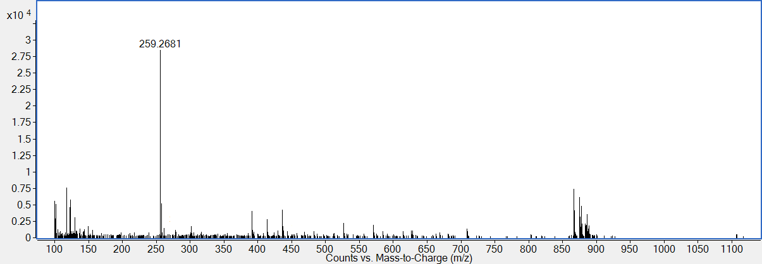

**Figure S6.** ESI MS spectrum of alternariol (**3**) recorded in positive mode



**Figure S7.** 1H NMR spectrum (400 MHz) of alternariol 4-methyl ether (**4**) in (CD3)2CO

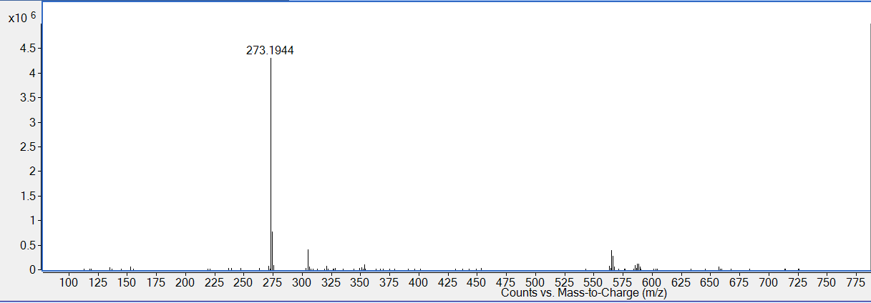

**Figure S8.** ESI MS spectrum of alternariol 4-methyl ether (**4**) recorded in positive mode