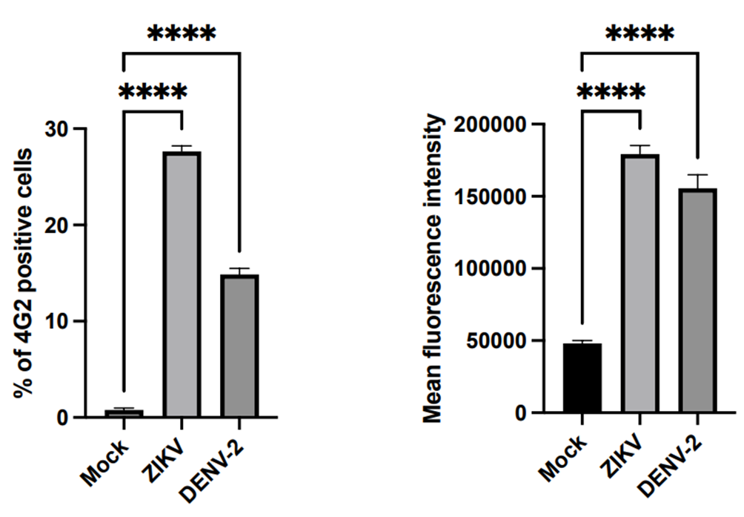
Figure S1 – Infection with both zika and dengue viruses was verified by flow cytometry. A549 cells were infected with ZIKV and DENV2 at moi5 for 48 and 72 hours respectively. Cell infection was assessed by flow cytometry. Ordinary one-Way ANOVA test was performed for statistical analysis. **** p < 0.0001; *** p < 0.001; * p < 0.05.

