Case Report
A fatal case of native valve endocarditis with multiple embolic phenomena and invasive methicillin-resistant Staphylococcus aureus bacteremia: a case report from the Maldives.
Ali Shafeeq¹, Hisham Ahmed Imad^{2,3,4}*, Ahmed Azhad¹, Migdhaadh Shareef¹, Mohamed Shaneez Najmy¹, Mohamed Mausool Siraj¹, Mohamed Sunil¹, Rimsha Rafeeu⁵, Aishath Sofa Moosa⁵, Ahmed Shaheed⁶, Thundon Ngamprasertchai^{3,7}, Wasin Matsee^{3,7}, Pyae Linn Aung² , Wang Nguitragool^{2,8} and Tatsuo Shioda⁴
¹ National Cardiac Center, Indira Gandhi Memorial Hospital, Malé, Maldives; dr.shafeeq@igmh.gov.mv (A.S.); dr.azhad@igmh.gov.mv (A.A.); dr.miqdhaadh@igmh.gov.mv (M.S.); dr.mohmedshaneeznajmy@igmh.gov.mv (M.S.N); dr.mausool@igmh.gov.mv (M.M.S); dr.mohamedsunil@ighmh.gov.mv (M.S.);
² Mahidol Vivax Research Unit, Faculty of Tropical Medicine, Mahidol University, Bangkok 10400, Thailand; pyaelinn.aun@mahidol.ac.th (P.L.A.); wang.ngu@mahidol.edu (W.N.)
³ Thai Travel Clinic, Hospital for Tropical Diseases, Bangkok 10400, Thailand; thundon.nga@mahidol.ac.th (T.N.); wasin.mat@mahidol.edu (W.M.)
⁴ Center for Infectious Disease Education and Research, Department of Viral Infections, Research Institute for Microbial Diseases, Osaka University, Suita 565-0871, Osaka, Japan; shioda@biken.osaka-u.ac.jp (T.S.)
⁵ Trauma and Emergency, Indhira Gandhi Memorial Hospital, Malé 2002, Maldives; dr.rimsharafeeu@igmh.gov.mv (R.R.); dr.aishathsofamoosa@igmh.gov.mv (A.S.M.)
⁶ Department of Medicine, Indhira Gandhi Memorial Hospital, Malé 2002, Maldives; ahmedshaheed@igmh.gov.mv (A.S.)
⁷ Department of Clinical Tropical Medicine, Faculty of Tropical Medicine, Mahidol University,
Bangkok 10400, Thailand
⁸ Department of Molecular Tropical Medicine and Genetics, Faculty of Tropical Medicine, Mahidol
University, Bangkok 10400, Thailand

* Correspondence: hishamahmed.ima@mahidolac.th or imad@biken.osaka-u.ac.jp

Table S1 Antibiotic sensitivity pattern of S. aureus isolated from blood culture after 72 hours of incubation.

Organism | Antibiotic Class | Antibiotics | MIC (µg/mL) | Interpretation
Staphylococcus aureus | Beta-lactam | Oxacillin | ≥ 4.0 | Resistant
Staphylococcus aureus | Beta-lactam | Benzylpenicillin | ≥ 0.5 | Resistant
Staphylococcus aureus | Aminoglycoside | Gentamicin | ≤ 0.5 | Sensitive
Staphylococcus aureus | Quinolone | Ciprofloxacin | ≤ 0.5 | Sensitive
Staphylococcus aureus | Fluoroquinolone | Levofloxacin | 0.25 | Sensitive
Staphylococcus aureus | Glycopeptide | Vancomycin | 1.0 | Sensitive
Staphylococcus aureus | Oxazolidinones | Linezolid | 2.0 | Sensitive
Staphylococcus aureus | Antimycobacterials | Rifampicin | ≤ 0.03 | Sensitive
Staphylococcus aureus | Glycycline | Tigecycline | ≤ 0.12 | Sensitive
Staphylococcus aureus | Lipopeptide | Daptomycin | ≤ 1.0 | Sensitive
Staphylococcus aureus | Tetracycline | Tetracyclines | ≤ 1.0 | Sensitive
Staphylococcus aureus | Lincosamide | Clindamycin | ≤ 0.5 | Sensitive
MIC: Minimal inhibitory concentration

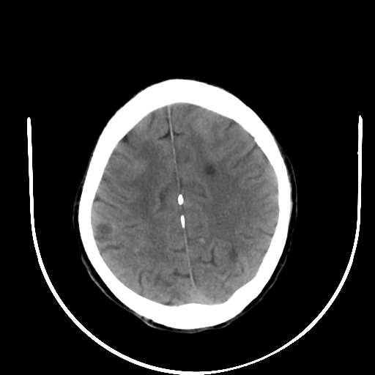 | 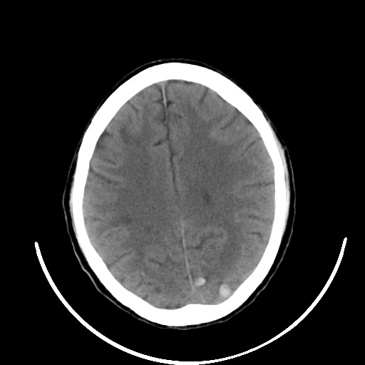
(a) | (b)

Figure S1. Computed tomography images depicting the coronal view of the brain (a) Bilateral multiple subcortical hypodense foci representing infarctions (b) Unilateral hyperdense foci consistent with hemorrhagic transformation.

