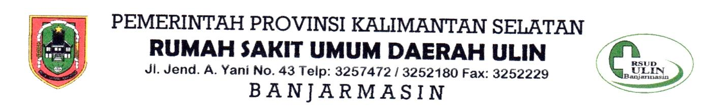

CERTIFICATE OF RESEARCH ETHICS FEASIBILITY
No.421 /VIII- RegRiset /RSUDU/21

With Sincerely ,
With this commission ethics study House Sick General of Ulin Banjarmasin Region has study application appropriateness ethics proposed research _ by :

Researcher Name :
- Siti Norkhalisa
- Ruwaida Ruwaida
- Aldrianto Aldrianto
- Candra Kusuma Negara

agency | : | Cahaya Bangsa Univercity
Title | : | “THE EFFECT OF GIVING A CONTRAST BATH WITH AN ELEVATION OF 30 ° ON DECREASING THE DEGREE OF EDEMA IN PATIENTS WITH CONGESTIVE HEART FAILURE AT ULIN GENERAL HOSPITAL BANJARMASIN”
On Date | : | 3 August 2021

Results Ethics :

- Worthy ethics
- Worthy no with suggestion repair
- Not worthy ethics

Thereby Letter description this given for could used as should .

Banjarmasin, 4 August 2021
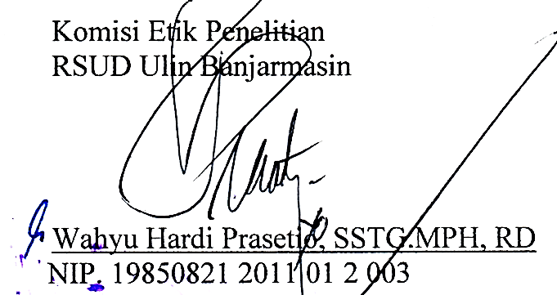

Lampiran

INFORMED CONSENT

Title | : | THE EFFECT OF GIVING A CONTRAST BATH WITH AN ELEVATION OF 30 ° ON DECREASING THE DEGREE OF EDEMA IN PATIENTS WITH CONGESTIVE HEART FAILURE AT ULIN GENERAL HOSPITAL BANJARMASIN
Name Researcher | : | - Siti Norkhalisa  - Ruwaida Ruwaida  - Aldrianto Aldrianto  - Candra Kusuma Negara
We Undergraduate Science Study Program Students Nursing Cahaya Bangsa University To do study at the Ulin Hospital in Banjarmasin. Study this aim for knowing effect of contrast bath with elevation 30 ° to decrease in edema fail heart congestive at the Ulin Hospital in Banjarmasin.
We Expect participation father / mother in give answer on Interview in accordance with agree father / mother without influenced someone else. I will ensure secrecy identity and answer sir / madam , the answer given only for needs research .
Participation father / mother in study this characteristic voluntarily , sir / madam entitled accept and reject Becomes respondent without penalty whatever . If father / mother ready Becomes respondent . Please sign letter agreement this on space provided _ as proof father / mother ready Becomes respondent on study this . Accept love on attention father / mother for study this .

Banjarmasin, 24 September 2021

Nurhayati

