Supporting Information for

Inhibition of Zinc Dendrites Realized by a β-P(VDF-TrFE) Nanofiber Layer in Aqueous Zn-Ion Batteries

Geumyong Park,1,#Hyeonghun Park,1,# WooJun Seol,2 Seokho Suh,1 Ji Young Jo,2 Santosh Kumar,1,3,* and Hyeong-Jin Kim,1,*

1 Graduate School of Energy Convergence, Institute of Integrated Technology, Gwangju Institute of Science and Technology (GIST), 123 Cheomdangwagi-ro, Buk-gu, Gwangju, 61005, Republic of Korea

2 School of Materials Science and Engineering, Gwangju Institute of Science and Technology (GIST), 123 Cheomdangwagi-ro, Buk-gu, Gwangju, 61005, Republic of Korea

3 Research Institute for Solar and Sustainable Energies (RISE), Gwangju Institute of Science and Technology (GIST), 123 Cheomdangwagi-ro, Buk-gu, Gwangju, 61005, Republic of Korea

* Author to whom correspondence should be addressed.

# These authors have contributed equally to this work.

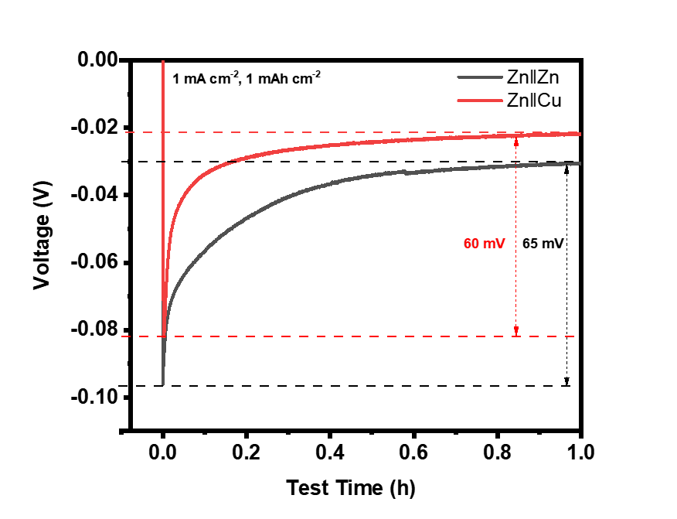

**Figure S1**. The voltage-time curves during Zinc nucleation at 1 mA cm-2 on Zn and Cu substrate.



**Figure S2.** Ionic resistivity measurement of the bare Cu and PNF-Cu symmetric cells with the glass fiber as a separator. Nyquist plots were tested at open circuit voltage (OCV) over the frequency range of 100 kHz to 0.1 Hz.

Formula used for calculating the conductivity,

*σ $=\frac{L}{RbS}$*

Where,

*L*glass fiber = 0.211 mm

*S* = 0.7854 cm2

*R*b (glass fiber) = 0.4868 Ω

*σ*glass fiber = 5.5×10-2 S cm-1

*Rb*(PVDF-TrFE) = Rb-Rb (glass fiber) = 0.04921 Ω

*L*P(VDF-TrFE) = 5 μm × 2 = 10 μm

*σ*P(VDF-TrFE) = 2.59×10-2 S cm-1



**Figure S3.** XRD data of the bare Zn and PNF-Zn after immersion in the electrolyte for 7 days.

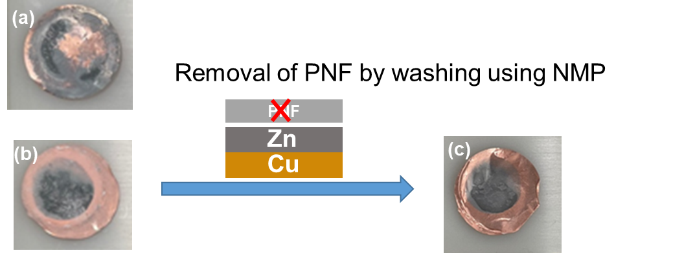

**Figure S4.** Digital images of Zn deposition on the (a) bare Cu and PNF-Cu (b) before removal and (c) after removal of the PNF layer.

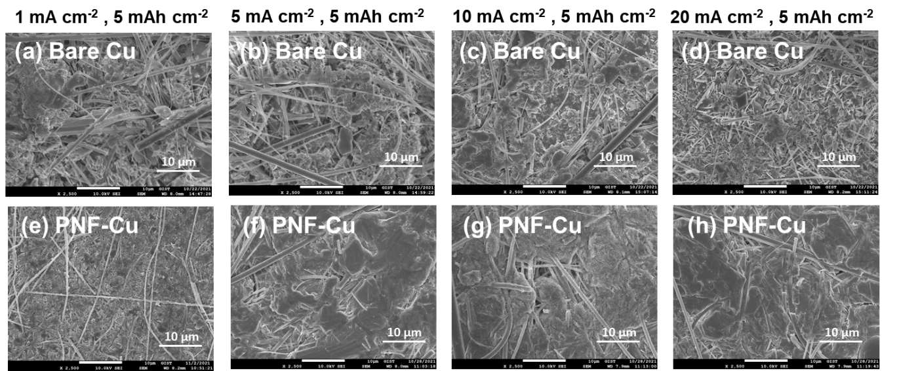

**Figure S5.** Top-view SEM images of Zn deposition morphology on (a-d) bare Cu electrode and (e-h) PNF-Cu under various current densities.

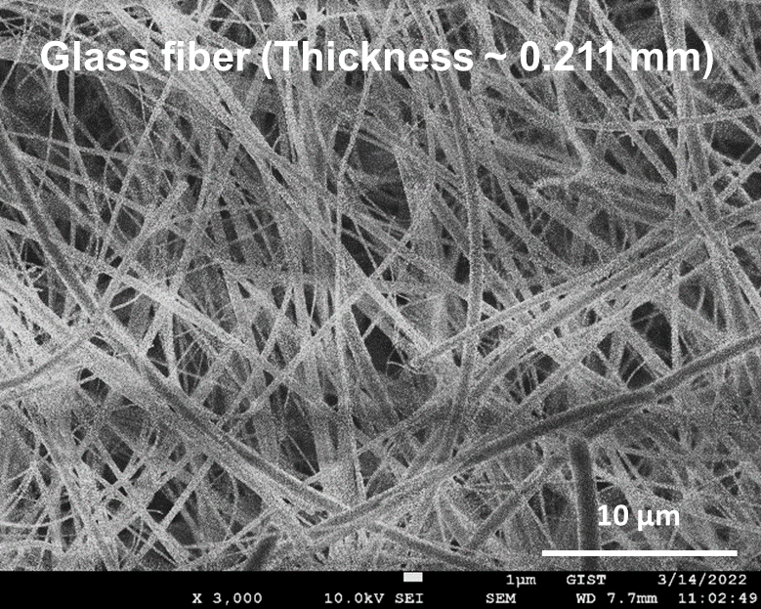

**Figure S6.** Top-view SEM image of glass fiber.

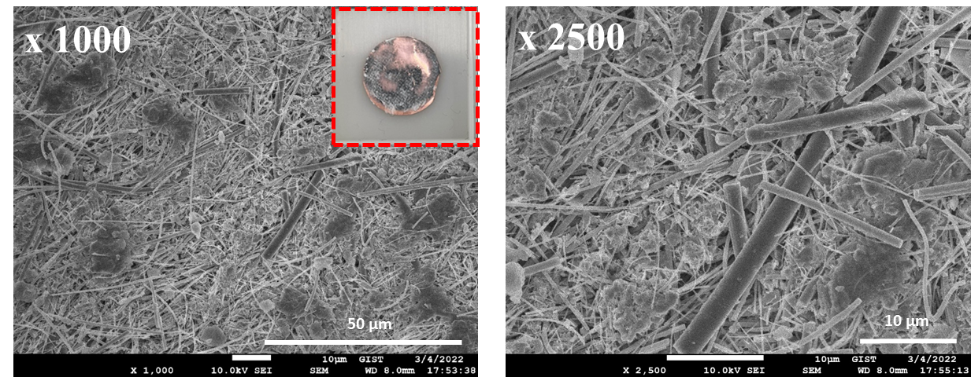

**Figure S7.** Top-view SEM images of Zn deposition morphology of Zn‖Cu cell using two glass fibers as a separator.

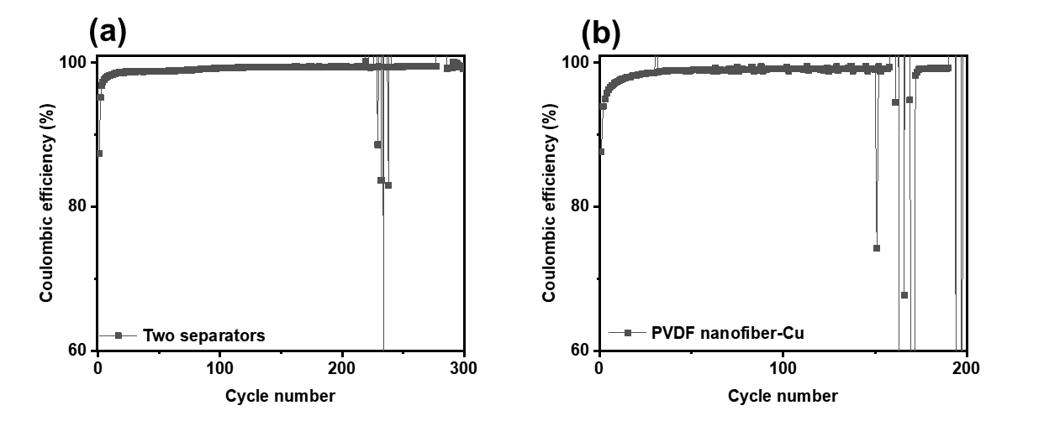

**Figure S8.** Coulombic efficiencies of long-term cycles at 1 mA cm-2 of the (a) Zn‖Cu half cell using 2 separators and (b) Zn‖PVDF-Cu half cell.

**Table S1.** Comparison table for the electrochemical performances by various materials used for surface modification of Zn anode.

|  |  |  |  |  |  |
| --- | --- | --- | --- | --- | --- |
| **Materials** | **Areal capacity**  **(mA h cm−2)** | **Current density**  **(mA cm−2)** | **Coulombic**  **Efficiency**  **(%)** | **Cycle number** | **Reference** |
| PNF | 1 | 1 | 99.2 | 300 | Present work |
| Nafion Zn-X | 2 | 0.2 | 97 | 130 | 1 |
| nanoAu | 0.5 | 0.5 | 97.1 | 60 | 2 |
| PA layera | 0.4 | 0.4 | 97.43 | 300 | 3 |
| Cu/Zn | 0.5 | 5 | 91.8 | 100 | 4 |
| β-PVDF | 0.18 | 0.36 | ~ 96.5 | 200 | 5 |
| Sc2O3 | 0.56 | 1.13 | 99.85 | 260 | 6 |
| ZnO | 0.5 | 2 | 99.55 | 300 | 7 |
| 502 glue | 1 | 2 | 99.74 | 200 | 8 |
| ZnF2 | 1 | 5 | 99.5 | 1000 | 9 |
| Sn | 1 | 1 | ~ 99 | 250 | 10 |
| NCLTib | 1 | 2 | 99.0 | ~700 | 11 |
| Mg-Al LDHc | 1 | 10 | 99.2 | 2000 | 12 |
| PDMS/TiO2-xd | 0.5 | 0.5 | ~ 99.4 | 450 | 13 |
| CG separatore | 1 | 1 | 98.68 | 100 | 14 |
| N-Cf | 2 | 2 | 98.76 | 120 | 15 |
| BaTiO3 | 1 | 1 | / | 120 | 16 |
| ZnP | 0.5 | 2 | 99.5 | 200 | 17 |
| ZnS | 1 | 2 | 99.2 | 200 | 18 |
| CNGg | 1 | 0.5 | 99.4 | 300 | 19 |

*aPolyamide (PA), bNiCo layered double hydroxides (NCLTi), cMg-Al layered double hydroxide (Mg-Al layered double hydroxide), dPoly(dimethylsiloxane) (PDMS), eCellulose nanofibers and graphene oxide (CG), fConductive and defective N-doped carbon (N-C), gCelluose nanowhisker-graphene (CNG).*

**References**

1. Cui, Y.; Zhao, Q.; Wu, X.; Chen, X.; Yang, J.; Wang, Y.; Qin, R.; Ding, S.; Song, Y.; Wu, J.; Yang, K.; Wang, Z.; Mei, Z.; Song, Z.; Wu, H.; Jiang, Z.; Qian, G.; Yang, L.; Pan, F. An Interface‐Bridged Organic–Inorganic Layer That Suppresses Dendrite Formation and Side Reactions for Ultra‐Long‐Life Aqueous Zinc Metal Anodes. *Angew. Chem.* **2020**, 16737-16744.

2. Cui, M.; Xiao, Y.; Kang, L.; Du, W.; Gao, Y.; Sun, X.; Zhou, Y.; Li, X.; Li, H.; Jiang, F.; Zhi, C. Quasi-Isolated Au Particles as Heterogeneous Seeds to Guide Uniform Zn Deposition for Aqueous Zinc-Ion Batteries. *ACS Appl. Energy Mater.* **2019**, *2*, 6490–6496.

3. Zhao, Z.; Zhao, J.; Hu, Z.; Li, J.; Li, J.; Zhang, Y.; Wang, C.; Cui, G. Long-Life and Deeply Rechargeable Aqueous Zn Anodes Enabled by a Multifunctional Brightener-Inspired Interphase. *Energy Environ. Sci.* **2019**, *12*, 1938–1949.

4. Cai, Z.; Ou, Y.; Wang, J.; Xiao, R.; Fu, L.; Yuan, Z.; Zhan, R.; Sun, Y. Chemically Resistant Cu–Zn/Zn Composite Anode for Long Cycling Aqueous Batteries. *Energy Storage Mater.* **2020**, *27*, 205–211.

5. Hieu, L. T.; So, S.; Kim, I. T.; Hur, J. Zn Anode with Flexible β-PVDF Coating for Aqueous Zn-Ion Batteries with Long Cycle Life. *Chem. Eng. J.* **2021**, *411*, 128584.

6. Zhou, M.; Guo, S.; Fang, G.; Sun, H.; Cao, X.; Zhou, J.; Pan, A.; Liang, S. Suppressing by-Product via Stratified Adsorption Effect to Assist Highly Reversible Zinc Anode in Aqueous *Electrolyte*. *J. Energy Chem.* **2021**, *55*, 549–556.

7. Xie, X.; Liang, S.; Gao, J.; Guo, S.; Guo, J.; Wang, C.; Xu, G.; Wu, X.; Chen, G.; Zhou, J. Manipulating the Ion-Transfer Kinetics and Interface Stability for High-Performance Zinc Metal Anodes. *Energy Environ. Sci.* **2020**, *13*, 503–510.

8. Cao, Z.; Zhu, X.; Xu, D.; Dong, P.; Chee, M. O.; Li, X.; Zhu, K.; Ye, M.; Shen, J. Eliminating Zn Dendrites by Commercial Cyanoacrylate Adhesive for Zinc Ion Battery. *Energy Storage Mater.* **2021**, *36*, 132–138.

9. Yang, Y.; Liu, C.; Lv, Z.; Yang, H.; Zhang, Y.; Ye, M.; Chen, L.; Zhao, J.; Li, C. C. Synergistic Manipulation of Zn2+ Ion Flux and Desolvation Effect Enabled by Anodic Growth of a 3D ZnF2 Matrix for Long‐Lifespan and Dendrite‐Free Zn Metal Anodes. *Adv. Mater.* **2021**, *33*, 2007388.

10. Miao, Z.; Du, M.; Li, H.; Zhang, F.; Jiang, H.; Sang, Y.; Li, Q.; Liu, H.; Wang, S. Constructing Nano‐Channeled Tin Layer on Metal Zinc for High‐Performance Zinc‐Ion Batteries Anode. *EcoMat* **2021**, *3*, e12125.

11. Ma, C.; Wang, X.; Lu, W.; Wang, C.; Yue, H.; Sun, G.; Zhang, D.; Du, F. Achieving Stable Zn Metal Anode via a Simple Nico Layered Double Hydroxides Artificial Coating for High Performance Aqueous Zn-Ion Batteries. *Chem. Eng. J.* **2022**, *429*, 132576.

12. Yang, Y.; Liu, C.; Lv, Z.; Yang, H.; Cheng, X.; Zhang, S.; Ye, M.; Zhang, Y.; Chen, L.; Zhao, J.; Li, C. C. Redistributing Zn-Ion Flux by Interlayer Ion Channels in MG-Al Layered Double Hydroxide-Based Artificial Solid Electrolyte Interface for Ultra-Stable and Dendrite-Free Zn Metal Anodes. *Energy Storage Mater.* **2021**, *41*, 230–239.

13. Guo, Z.; Fan, L.; Zhao, C.; Chen, A.; Liu, N.; Zhang, Y.; Zhang, N. A Dynamic and Self‐Adapting Interface Coating for Stable Zn‐Metal Anodes. *Adv. Mater.* **2021**, *34*, 2105133.

14.  Cao, J.; Zhang, D.; Gu, C.; Wang, X.; Wang, S.; Zhang, X.; Qin, J.; Wu, Z. S. Manipulating Crystallographic Orientation of Zinc Deposition for Dendrite‐Free Zinc Ion Batteries. *Adv. Energy Mater.* **2021**, *11*, 2101299.

15. Wu, C.; Xie, K.; Ren, K.; Yang, S.; Wang, Q. Dendrite-Free Zn Anodes Enabled by Functional Nitrogen-Doped Carbon Protective Layers for Aqueous Zinc-Ion Batteries. *Dalton Trans.* **2020**, *49*, 17629–17634.

16. Zou, P.; Zhang, R.; Yao, L.; Qin, J.; Kisslinger, K.; Zhuang, H.; Xin, H. L. Ultrahigh‐Rate and Long‐Life Zinc–Metal Anodes Enabled by Self‐Accelerated Cation Migration. *Adv. Energy Mater.* **2021**, *11*, 2100982.

17. Cao, P.; Zhou, X.; Wei, A.; Meng, Q.; Ye, H.; Liu, W.; Tang, J.; Yang, J. Fast‐Charging and Ultrahigh‐Capacity Zinc Metal Anode for High‐Performance Aqueous Zinc‐Ion Batteries. *Adv. Funct. Mater.* **2021**, *31*, 2100398.

18. Hao, J.; Li, B.; Li, X.; Zeng, X.; Zhang, S.; Yang, F.; Liu, S.; Li, D.; Wu, C.; Guo, Z. An in‐Depth Study of Zn Metal Surface Chemistry for Advanced Aqueous Zn‐Ion Batteries. *Adv. Mater.* **2020**, *32*, 2003021.

19. Zhang, X.; Li, J.; Liu, D.; Liu, M.; Zhou, T.; Qi, K.; Shi, L.; Zhu, Y.; Qian, Y. Ultra-Long-Life and Highly Reversible Zn Metal Anodes Enabled by a desolvation and deanionization Interface Layer. *Energy Environ. Sci.* **2021**, *14*, 3120–3129.