A new albomycin-producing strain of Streptomyces globisporus may provides protection for ants Messor structor
Supplementary Materials
Yuliya Zakalyukina^{1,2*}, Nikolay Pavlov³, Dmitrii Lukianov^{3,4}, Mikhail Biryukov^{1,3,5}, Valeria Marina^{3,4}, Olga Belozerova⁶, Vadim Tashlitsky⁴, Elena Guglya^{6,7}, and Ilya Osterman^{1,3,4}
¹ Center for Translational Medicine, Sirius University of Science and Technology, Olympic Avenue 1, 354340 Sochi, Russia
² Department of Soil Science, Lomonosov Moscow State University, Leninskie Gory 1, 119991 Moscow, Russia
³ Center of Life Sciences, Skolkovo Institute of Science and Technology, Bolshoy Boulevard 30, bld. 1, 121205 Moscow, Russia
⁴ Department of Chemistry, Lomonosov Moscow State University, Leninskie Gory 1, 119991 Moscow, Russia
⁵ Department of Biology, Lomonosov Moscow State University, Leninskie Gory 1, 119991 Moscow, Russia
⁶ Shemyakin-Ovchinnikov Institute of Bioorganic Chemistry of the Russian Academy of Sciences, Moscow, 117997, Russia
⁷ Pirogov Russian National Research Medical University, Moscow, 117997, Russia
* Correspondence: juline@soil.msu.ru (Y.V.Z.); Tel.: +79175548004 (Y.V.Z)

Content

Table S1. The isolation of Gram-positive bacteria strains from Messor structor individuals 2
Table S2. General features of the genome of strain 4-3 and its closely related strains of Streptomyces globisporus 3
Figure S1. Neighbour-joining phylogenetic tree of strain 4-3, related Streptomyces globisporus subsp. globisporus and some actinobacteria species, firstly isolated from insects 4
Figure S2. Maximum-parsimony phylogenetic tree based on almost complete 16S rRNA gene sequences (1445 positions in the final dataset) showing the position of 4-3 among the related strains of the genus Streptomyces and type actinobacterial species isolated from insects 5
Figure S3. Maximum-likelihood phylogenetic tree of strain 4-3 and comparison with related strains of the genus Streptomyces and type actinobacterial species isolated from insects, based on almost complete 16S rRNA gene sequences 6
Table S3. Morphological, physiological and biochemical characteristics of strain 4-3 and closest Streptomyces globisporus subsp. globisporus strains 7
Figure S4. Cultural properties of 4-3 on ISP media after 14 days at 28℃ 8
Figure S5. Utilization of different sugars (1.0%, w/v) as sole carbon source by strain 4-3 9
Figure S6. RP HPLC of an active fraction and UV spectrum of an active metabolite peak 10
Figure S7. LC-MS data for albomycin δ2 11
Table S4. Some of the secondary metabolite gene clusters in Streptomyces globisporus subsp. globisporus 4-3 12
Table S5. Antimicrobial activity of Streptomyces globisporus subsp. globisporus 4-3 13
Table S1. The isolation of Gram-positive bacteria strains from Messor structor individuals
Caste | Isolated strains | Frequency of occurrence¹,% | Identified as
Solders | M1, S1, S3, S4, S5, S51, Mdom1, Mdom2, Mdom3 (4-3) | 89 | Streptomyces globisporus subsp. globisporus strain 4-3²
 | Am1, Am2, Mr | 44 | Staphylococcus gallinarum L1³
Workers | M1, S1, S3, S4, S5, S51, Mdom1, Mdom2 | 50 | Streptomyces globisporus subsp. globisporus strain 4-3
 | Am1, Am2, Mr | 88 | Staphylococcus gallinarum L1
Larvae | MdomX1 | 7 | Streptomyces globisporus subsp. globisporus strain 4-3
 | L1 | 85 | Staphylococcus gallinarum L1
Pupae | MdomX1, MdomX2 | 21 | Streptomyces globisporus subsp. globisporus strain 4-3
 | L1 | 85 | Staphylococcus gallinarum L1
¹ -- the proportion of individuals of the studied caste in which this strain was isolated,
² -- GenBank accession number for 16S rRNA gene sequence is ON326616,
³ -- GenBank accession number is ON326604

Table S2. General features of the genome of strain 4-3 and its closely related strains of Streptomyces globisporus
Genomic features | 1 | 2 | 3 | 4 | 5
Size (Mbp) | 7,941,828 | 8,246,570 | 7,237,318 | 7,548,572 | 7,332,794
Total gene | 7,449 | 7,410 | 6,729 | 6,822 | 6,762
Contigs | 139 | 59 | 594 | 54 | 51
G +C content (%) | 71.6 | 71.4 | 71.4 | 71.7 | 71.7
No. of rRNA clusters | 3 | 1 | 5 | 3 | 5
No. of tRNA clusters | 65 | 68 | 63 | 65 | 63
Contig N50 | 375,468 | 434,455 | 22,344 | 268,800 | 459,850
Contig L50 | 9 | 6 | 100 | 7 | 5
No. proteins | 7,142 | 7,495 | 6,258 | 6,622 | 6,593
Completeness of genome*, % | 99.1 | 99.1 | 95.3 | 99.1 | 97.2
Quality of genome*, % | 56.6 | 47.1 | 62.3 | 52.1 | 54.7
Strains, (GenBank assembly accessions are indicated in parentheses): 1, 4-3 (SAMEA13759927); 2, Streptomyces globisporus subsp. globisporus DSM 40199^{T} (GCA_014649555.1); 3, Streptomyces globisporus subsp. globisporus DSM 40136 (GCA_002154385.1); 4, Streptomyces rubiginosohelvolus DSM 40176^{T} (GCA_014649875.1); 5, Streptomyces pluricolorescens DSM 40019^{T} (GCA_014650395.1).

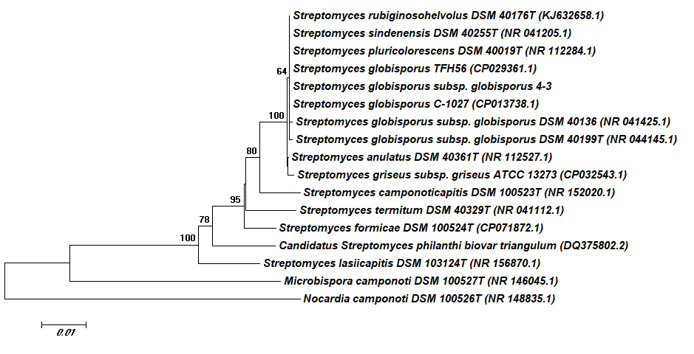
Figure S1. Neighbour-joining phylogenetic tree of strain 4-3, related Streptomyces globisporus subsp. globisporus and some actinobacteria species, firstly isolated from insects. The evolutionary distances were computed from 16S rRNA full-length sequences using the Tamura-Nei method. Bootstrap values for n=1,000 are given at the branching points in percentages for values higher than 60. Bar, 0,01 nucleotide substitutions per site. The analysis involved 17 nucleotide sequences with a total of 1472 positions in the final dataset. Nocardia camponoti DSM 100526^{T} was used as the outgroup.

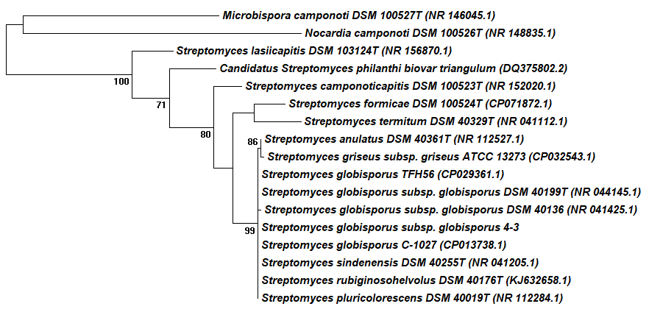
Figure S2. Maximum-parsimony phylogenetic tree based on almost complete 16S rRNA gene sequences (1445 positions in the final dataset) showing the position of 4-3 among the related strains of the genus Streptomyces and type actinobacterial species isolated from insects. Tree #1 out of 2 most parsimonious trees (length = 353) is shown. The consistency index is (0,661765), the retention index is (0,634921), and the composite index is 0,510814 (0,420168) for all sites and parsimony-informative sites. The percentage of replicate trees in which the associated taxa clustered together in the bootstrap test (1000 replicates) are shown next to the branches. The MP tree was obtained using the Subtree-Pruning-Regrafting (SPR) algorithm with search level 1 in which the initial trees were obtained by the random addition of sequences (10 replicates). The tree is drawn to scale , with branch lengths calculated using the average pathway method and are in the units of the number of changes over the whole sequence. Codon positions included were 1st+2nd+3rd+Noncoding. All positions containing gaps and missing data were eliminated.

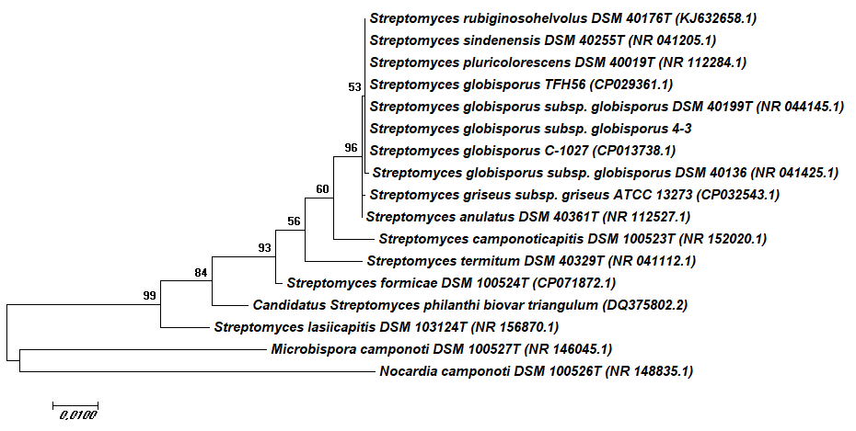
Figure S3. Maximum-likelihood phylogenetic tree of strain 4-3 and comparison with related strains of the genus Streptomyces and type actinobacterial species isolated from insects, based on almost complete 16S rRNA gene sequences. Maximum Likelihood method based on the Tamura-Nei model. The tree with the highest log likelihood (-3854,6731) is shown. The percentage of trees in which the associated taxa clustered together is shown next to the branches. Initial tree(s) for the heuristic search were obtained automatically by applying Neighbor-Join and BioNJ algorithms to a matrix of pairwise distances estimated using the Maximum Composite Likelihood (MCL) approach, and then selecting the topology with superior log likelihood value. The tree is drawn to scale, with branch lengths measured in the number of substitutions per site. The analysis involved 17 nucleotide sequences. Codon positions included were 1st+2nd+3rd+Noncoding. All positions containing gaps and missing data were eliminated. There were a total of 1445 positions in the final dataset.

Table S3. Morphological, physiological and biochemical characteristics of strain 4-3 and closest Streptomyces globisporus subsp. globisporus strains
Properties | 1 | 2¹ | 3¹
Morphological and physiological characteristics
Spore surface | Smooth | Smooth | Smooth
Spore chains morphology | RF | RF | RF
Temperature-range and optimum (°C) | 8-37 (28) | (28) | (28)
NaCl tolerance (%) | 5 | n/d² | n/d
Acid from carbohydrates
Arabinose | + | + | +
Dulcite | ﹣ | n/d | n/d
Fructose | + | + | +
Galactose | + | n/d | n/d
Glucose | + | ﹣ | +
Inositol | ﹣ | ﹣ | ﹣
Lactose | ﹣ | n/d | n/d
Maltose | + | n/d | n/d
Mannitol | + | + | +
Raffinose | ﹣ | ﹣ | ﹣
Rhamnose | + | + | +
Sorbitol | ﹣ | n/d | n/d
Sucrose | ﹣ | ﹣ | ﹣
Xylose | + | ﹣ | ﹣
Degradation of and enzymes
Starch | + | + | +
Gelatin | + | + | +
Cellulose | ﹣ | + | +
Urea | + | + | +
Citrate | + | + | +
β-glucosidase | + | + | +
L-ornithine decarboxylase | ﹣ | + | +
L-arginine decarboxylase | ﹣ | + | +
L-lysine decarboxylase | + | + | +

¹ Data for Streptomyces globisporus subsp. globisporus DSM 40199^{T} (2) and Streptomyces globisporus subsp. globisporus DSM 40136^{T} (3) are from https://bacdive.dsmz.de/
² n/d, not determined

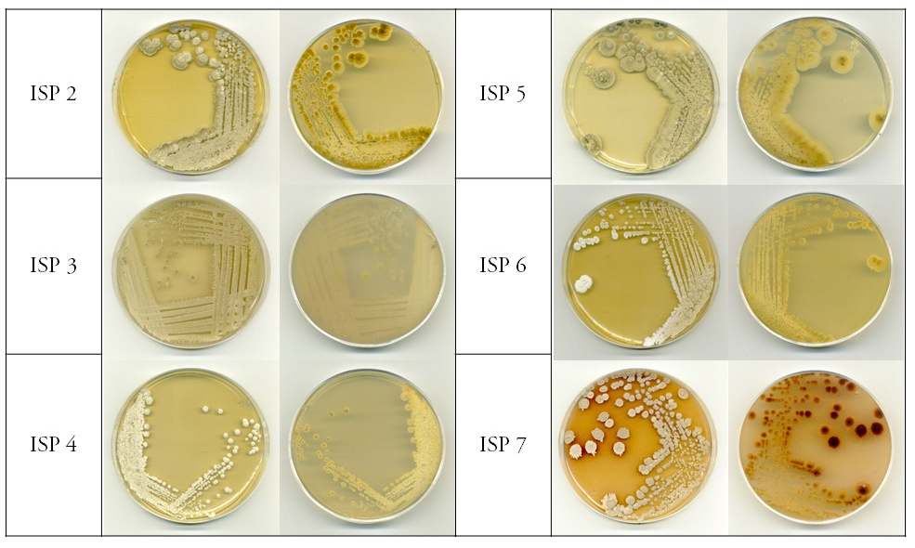

Figure S4. Cultural properties of 4-3 on ISP media after 14 days at 28℃.

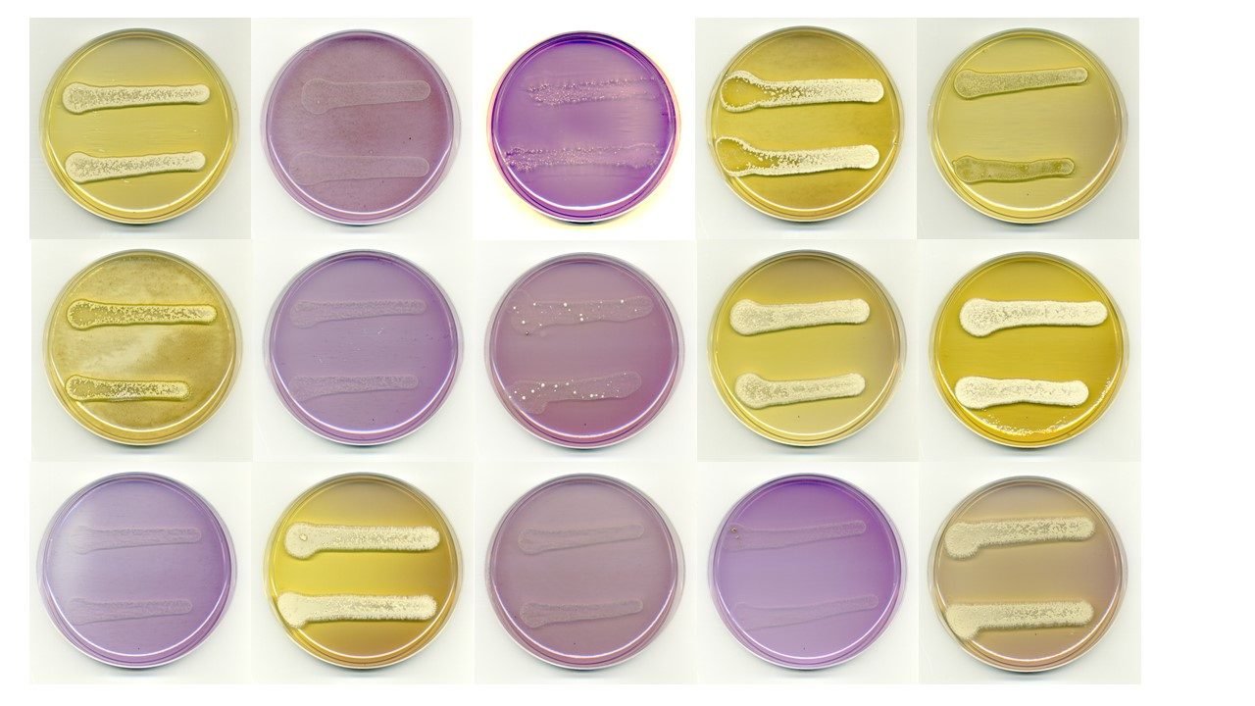
Figure S5. Utilization of different sugars (1.0%, w/v) as sole carbon source by strain 4-3.
Top row: arabinose, base agar without sugar, cellulose, fructose, galactose;
middle row: glucose, inositol, lactose, mannitol, mannose;
bottom row: raffinose, rhamnose, sorbitol, sucrose, xylose.

Figure S6. RP HPLC of an active fraction of culture liquid eluted from the LPS500H sorbent and UV spectrum of an active metabolite peak at 11.5 min. Column: Phenomenex Luna 5 μm C18 (2) 100 Å 4.6*250 mm; eluent: 4% of MeCN, 10 mM AcONH4, Flow rate 1ml/min, Temperature 25C, UV260 nm

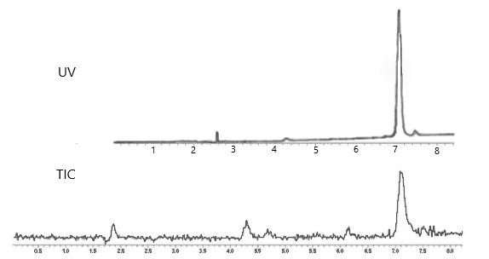
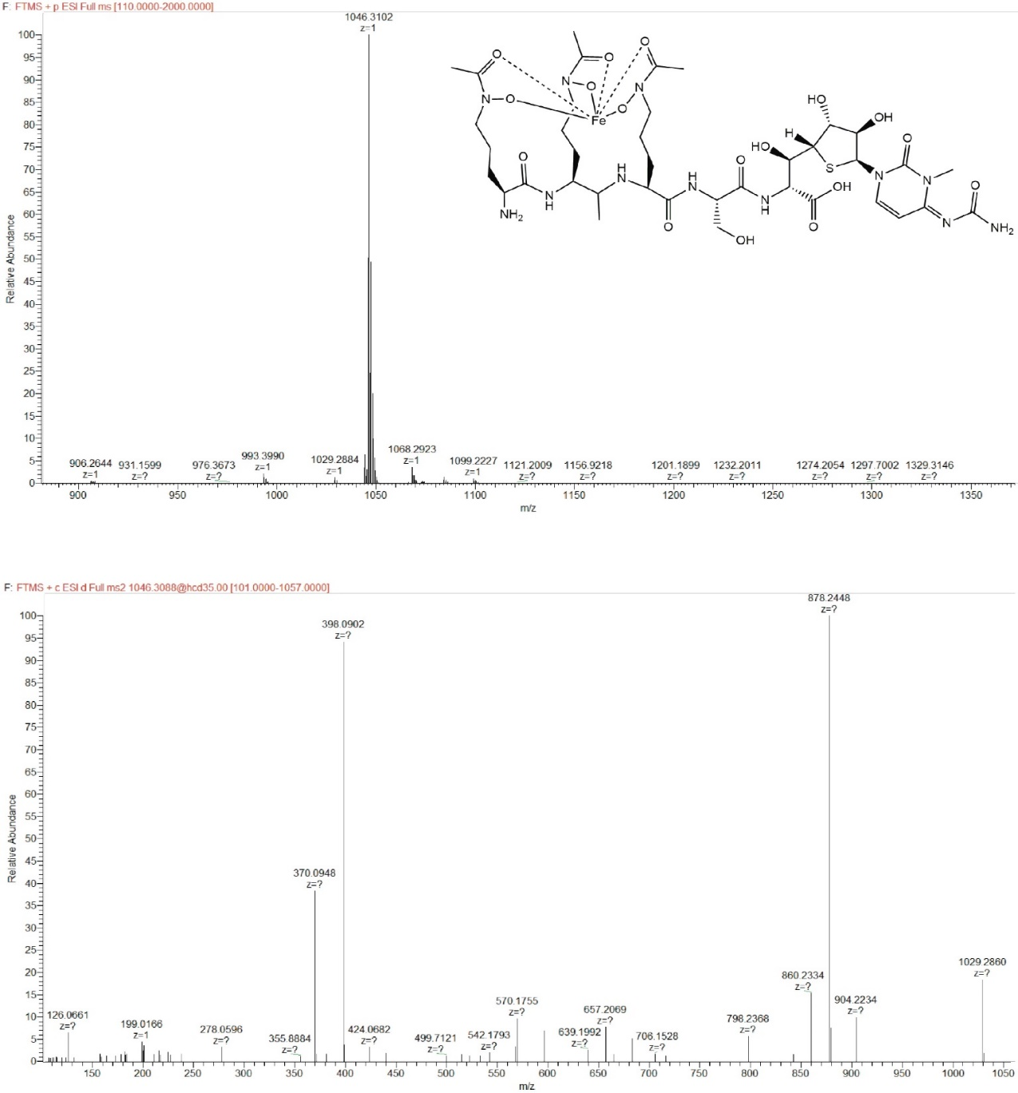
Figure S7. LC-MS data for albomycin δ2 (top down): UV profile at 287 nm; TIC collected at positive ion mode, MS1 and MS2 for the peak at 7.2 min.

Table S4. Some of the secondary metabolite gene clusters in Streptomyces globisporus subsp. globisporus 4-3
Region | Type | From (bp) | To (bp) | Most similar known cluster | Similarity, %
1.1 | NRP | 287,765 | 324,504 | Streptophenazines B/C/E/H/G biosynthesis gene cluster | 100
 | Polyketide | 324,738 | 347,987 | Mayamycin biosynthesis gene cluster | 100
2.1 | RiPP:Lanthipeptide | 58,226 | 81,129 | Labyrinthopeptins A2/A1/A3 biosynthetic gene cluster | 40
4.1 | Polyketide | 277,202 | 399,632 | Viguiepinol biosynthetic gene cluster | 73
7.2 | Siderophore | 84,661 | 96,439 | Desferrioxamine B biosynthetic gene cluster | 100
8.1 | Terpene | 301,258 | 327,831 | Hopene biosynthetic gene cluster | 69
9.1 | RiPP: Lassopeptide | 350,361 | 373,055 | Keywimysin biosynthetic gene cluster | 100
10.1 | Other: Melanin | 81,003 | 91,476 | Melanin biosynthetic gene cluster | 100
10.2 | Polyketide | 129,829 | 170,881 | Alkylresorcinol biosynthetic gene cluster | 100
14.1 | Terpene | 23,415 | 48,421 | Isorenieratene biosynthetic gene cluster | 100
14.3 | Terpene | 128,324 | 174,416 | Geosmin biosynthetic gene cluster | 100
14.4 | NRPS: Siderophore | 211,154 | 258,557 | Streptobactin biosynthetic gene cluster | 100
21.1 | RiPP:Lanthipeptide | 148,549 | 166,688 | Lanthipeptide(s) Putative Class III | 100
24.1 | NRPS: Siderophore | 1 | 36,289 | Coelichelin biosynthetic gene cluster | 81

Table S5. Antimicrobial activity of Streptomyces globisporus subsp. globisporus 4-3, isolated from Messor structor ants
Test organisms | Zones of growth inhibition*, mm
Bacillus subtilis ATCC 6633 | 5±0,6
Staphylococcus aureus ATCC 25923 | 10±2,0
Aspergillus niger INA 00760 | 5±0,8
Candida albicans CBS 8836 | 0
Paenibacillus alvei VKM B-502 | 20±1,6
Bacillus thuringiensis VKM B-6650 | 15±2,4
Beauveria bassiana VKM F-1357 | 12±1,4
Entomophthora coronata VKM F-1359 | 15±3,6
* Data are means ± standard error over five replicates.

