Supplementary Material of Home-range size and space use of territorial Bonelli’s eagles (Aquila fasciata) tracked by high resolution GPS/GSM telemetry.

Sara Morollón, Vicente Urios and Pascual López-López.

Table S1. Summary information of the 50 Bonelli’s eagles tracked by GPS/GSM satellite telemetry in eastern Spain.
Individual | Territory | Sex | Tagging date | End day of data transmission | No. locations
Abel | 1 | Male | 19/05/2015 | 02/09/2016 | 70,070
Adan | 1 | Male | 31/01/2017 | 16/06/2020 | 202,346
Aura | 1 | Female | 19/05/2015 | 21/05/2021 | 233,314
Berta | 2 | Female | 10/06/2015 | 04/07/2015 | 4,366
Blas | 2 | Male | 10/06/2015 | 27/06/2016 | 60,636
Boira | 2 | Female | 06/11/2015 | 28/06/2016 | 26,501
Boj | 2 | Male | 11/04/2017 | 19/06/2017 | 11,235
Bruma | 2 | Female | 11/04/2017 | 21/05/2021 | 228,029
Carbo | 3 | Male | 28/10/2015 | 25/03/2020 | 194,875
Carla | 3 | Female | 28/10/2015 | 30/11/2018 | 105,168
Dino | 4 | Male | 29/10/2015 | 21/03/2018 | 123,451
Dora | 4 | Female | 29/10/2015 | 21/03/2018 | 135,077
Enebro | 5 | Male | 07/06/2016 | 06/07/2020 | 219,785
Faig | 6 | Male | 08/06/2016 | 21/05/2021 | 257,640
Fauna | 6 | Female | 18/05/2017 | 21/05/2021 | 134,853
Flora | 6 | Female | 08/06/2016 | 14/12/2016 | 26,633
Garra | 7 | Female | 07/10/2016 | 24/02/2019 | 128,447
Gel | 7 | Male | 07/10/2016 | 21/05/2021 | 234,500
Haeckel | 8 | Male | 20/04/2017 | 01/04/2018 | 53,850
Helios | 8 | Male | 06/10/2016 | 26/01/2017 | 14,033
Hydra | 8 | Female | 06/10/2016 | 07/03/2018 | 74,598
Iris | 9 | Female | 09/12/2016 | 27/03/2017 | 11,567
Isis | 9 | Male | 09/12/2016 | 20/01/2017 | 4,352
Jara | 10 | Female | 14/06/2017 | 21/05/2021 | 215,518
Juan | 10 | Male | 05/06/2017 | 13/11/2020 | 164,822
Karma | 11 | Female | 06/06/2017 | 29/03/2018 | 42,589
Koko | 11 | Male | 13/09/2017 | 29/03/2018 | 26,490
Linneo | 12 | Male | 11/07/2017 | 21/05/2021 | 217,907
Lucy | 12 | Female | 11/07/2017 | 31/12/2019 | 108,127
Margulis | 13 | Female | 06/06/2018 | 21/05/2021 | 156,689
Mendel | 13 | Male | 06/06/2018 | 21/05/2021 | 173,427
Newton | 14 | Male | 07/06/2018 | 31/03/2019 | 46,076
Nube | 14 | Female | 06/06/2018 | 31/12/2018 | 34,708
Ochoa | 15 | Male | 08/06/2018 | 21/05/2021 | 169,997
Olympia | 15 | Female | 11/06/2018 | 21/05/2021 | 181,436
Pino | 16 | Male | 23/06/2020 | 06/07/2020 | 1,016
Pluma | 16 | Female | 28/01/2019 | 21/05/2021 | 55,635
Popper | 16 | Male | 28/01/2019 | 16/10/2019 | 24,800
Rosalind | 17 | Female | 03/06/2019 | 21/05/2021 | 43,955
Rutherford | 17 | Male | 03/06/2019 | 21/05/2021 | 47,904
Sabina | 18 | Female | 13/06/2019 | 21/02/2020 | 17,333
Salvia | 18 | Female | 09/06/2020 | 21/05/2021 | 16,543
Sauce | 18 | Male | 12/06/2019 | 21/05/2021 | 46,935
Taiga | 19 | Female | 21/06/2019 | 21/05/2021 | 37,701
Tejo | 19 | Male | 15/06/2019 | 21/05/2021 | 46,985
Ulex | 20 | Male | 08/10/2019 | 31/12/2020 | 18,147
Uva | 20 | Female | 08/10/2019 | 01/01/2021 | 17,727
Vera | 21 | Female | 07/11/2019 | 21/05/2021 | 33,424
Verdi | 21 | Male | 07/11/2019 | 21/05/2021 | 43,456
VillenaFemale | 22 | Female | 17/05/2018 | 31/12/2019 | 77,923
VillenaMale | 22 | Male | 17/05/2018 | 21/05/2021 | 168,484

Table S2. Summary statistics of daily home-range (K95%, K75% and K50%) size (km²) per individual.
Individual | Territory | Count | K95 % |  | K75 % |  | K50 %
 |  |  | Mean | sd | Mean | sd | Mean | sd
Abel | 1 | 471 | 43.395 | 47.510 | 18.422 | 16.327 | 8.307 | 7.536
Adan | 1 | 1233 | 66.091 | 30.852 | 30.946 | 15.362 | 14.370 | 7.661
Aura | 1 | 2091 | 54.255 | 45.832 | 24.498 | 20.482 | 11.120 | 9.712
Berta | 2 | 26 | 51.02 | 31.939 | 21.986 | 13.934 | 10.076 | 6.526
Blas | 2 | 384 | 40.174 | 37.932 | 16.358 | 14.764 | 7.269 | 6.587
Boira | 2 | 225 | 28.576 | 32.807 | 11.777 | 14.767 | 5.237 | 6.896
Boj | 2 | 64 | 43.774 | 34.008 | 18.767 | 14.162 | 8.693 | 6.657
Bruma | 2 | 1417 | 44.546 | 52.184 | 17.804 | 18.223 | 7.882 | 7.858
Carbo | 3 | 1608 | 54.514 | 42.297 | 23.610 | 17.820 | 10.672 | 8.344
Carla | 3 | 777 | 50.018 | 37.346 | 21.694 | 17.278 | 9.686 | 8.016
Dino | 4 | 805 | 49.670 | 22.164 | 22.639 | 11.500 | 10.248 | 5.654
Dora | 4 | 875 | 41.344 | 26.916 | 18.191 | 13.391 | 8.159 | 6.377
Enebro | 5 | 1491 | 55.802 | 55.802 | 24.064 | 18.623 | 10.906 | 8.783
Faig | 6 | 1728 | 74.152 | 45.246 | 33.396 | 22.319 | 15.288 | 10.918
Fauna | 6 | 1353 | 88.845 | 55.017 | 40.668 | 27.495 | 18.715 | 13.665
Flora | 6 | 190 | 57.079 | 40.610 | 26.090 | 19.470 | 12.194 | 9.417
Garra | 7 | 870 | 46.310 | 37.288 | 19.439 | 16.658 | 8.654 | 7.750
Gel | 7 | 1623 | 51.922 | 35.989 | 22.026 | 16.558 | 9.786 | 7.808
Haeckel | 8 | 346 | 33.634 | 23.892 | 13.803 | 9.263 | 6.235 | 4.260
Helios | 8 | 113 | 28.549 | 18.421 | 12.796 | 8.739 | 5.789 | 4.096
Hydra | 8 | 518 | 26.092 | 19.678 | 10.452 | 8.312 | 4.592 | 3.859
Iris | 9 | 109 | 25.638 | 39.296 | 10.284 | 16.874 | 4.671 | 7.774
Isis | 9 | 46 | 22.436 | 38.279 | 10.140 | 18.755 | 4.714 | 8.941
Jara | 10 | 1347 | 35.313 | 22.431 | 15.239 | 9.698 | 6.898 | 4.604
Juan | 10 | 1104 | 45.310 | 43.165 | 19.222 | 16.269 | 8.795 | 7.645
Karma | 11 | 297 | 51.317 | 47.636 | 22.593 | 21.574 | 10.533 | 10.382
Koko | 11 | 198 | 56.860 | 63.937 | 25.366 | 30.092 | 11.881 | 14.785
Linneo | 12 | 1343 | 83.835 | 53.175 | 36.635 | 24.242 | 16.388 | 11.573
Lucy | 12 | 839 | 84.428 | 121.653 | 37.260 | 60.360 | 16.644 | 28.069
Margulis | 13 | 951 | 53.009 | 39.655 | 23.524 | 18.337 | 10.849 | 8.931
Mendel | 13 | 1013 | 56.498 | 30.099 | 25.371 | 14.804 | 11.646 | 7.247
Newton | 14 | 298 | 88.771 | 80.323 | 38.958 | 36.567 | 17.869 | 17.141
Nube | 14 | 208 | 78.713 | 76.146 | 33.419 | 36.339 | 15.053 | 17.484
Ochoa | 15 | 1018 | 59.204 | 75.709 | 25.779 | 35.131 | 11.934 | 16.729
Olympia | 15 | 1011 | 62.806 | 142.687 | 26.971 | 65.035 | 12.343 | 30.213
Pino | 16 | 14 | 80.206 | 30.202 | 41.094 | 17.422 | 20.742 | 9.572
Pluma | 16 | 691 | 35.723 | 32.428 | 16.015 | 14.322 | 7.432 | 6.948
Popper | 16 | 232 | 51.428 | 41.383 | 22.711 | 18.865 | 10.429 | 8.685
Rosalind | 17 | 560 | 25.524 | 22.142 | 11.085 | 9.299 | 5.124 | 4.427
Rutherford | 17 | 559 | 27.298 | 20.835 | 12.183 | 9.805 | 5.659 | 4.866
Sabina | 18 | 227 | 63.970 | 66.833 | 28.629 | 29.228 | 13.258 | 14.231
Salvia | 18 | 220 | 71.536 | 63.769 | 32.325 | 30.010 | 15.094 | 14.423
Sauce | 18 | 593 | 82.029 | 65.745 | 38.277 | 31.558 | 17.797 | 15.206
Taiga | 19 | 572 | 35.502 | 57.337 | 14.893 | 17.241 | 6.810 | 7.697
Tejo | 19 | 589 | 46.890 | 217.078 | 20.872 | 102.214 | 9.661 | 48.038
Ulex | 20 | 396 | 116.106 | 214.752 | 56.422 | 108.062 | 27.323 | 54.364
Uva | 20 | 396 | 95.413 | 181.324 | 47.788 | 99.890 | 23.093 | 50.092
Vera | 21 | 385 | 45.181 | 37.823 | 19.846 | 16.618 | 9.064 | 7.937
Verdi | 21 | 431 | 56.519 | 74.680 | 25.067 | 31.749 | 11.399 | 13.448
YHembra | 22 | 535 | 57.245 | 56.452 | 21.720 | 22.900 | 9.250 | 10.257
YMacho | 22 | 1050 | 73.442 | 381.809 | 30.025 | 188.364 | 13.243 | 90.580

Figure S1: General boxplot of the monthly average of the daily home range size at three different levels (K95%, K75% and K50%).

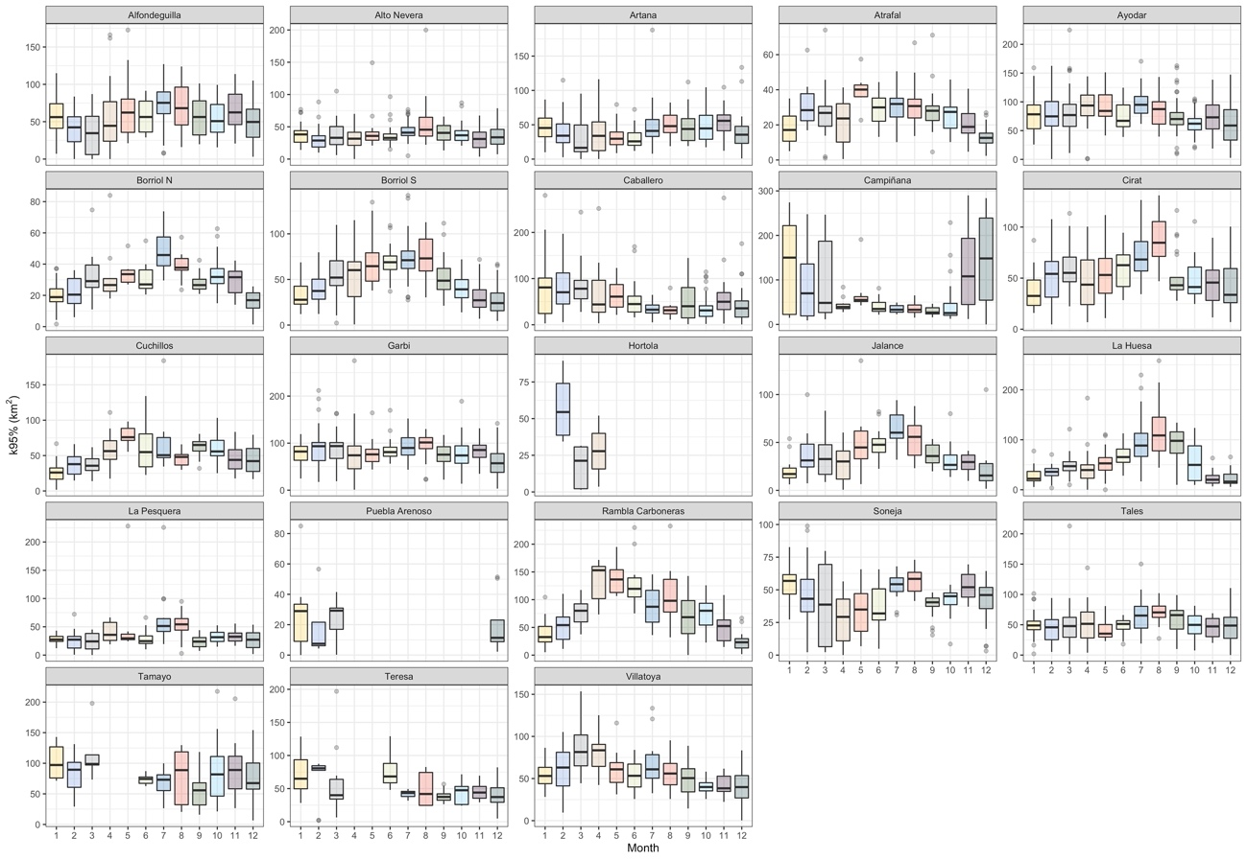
Figure S2: Boxplot of the monthly average of the daily home range size (K95%) per territory.

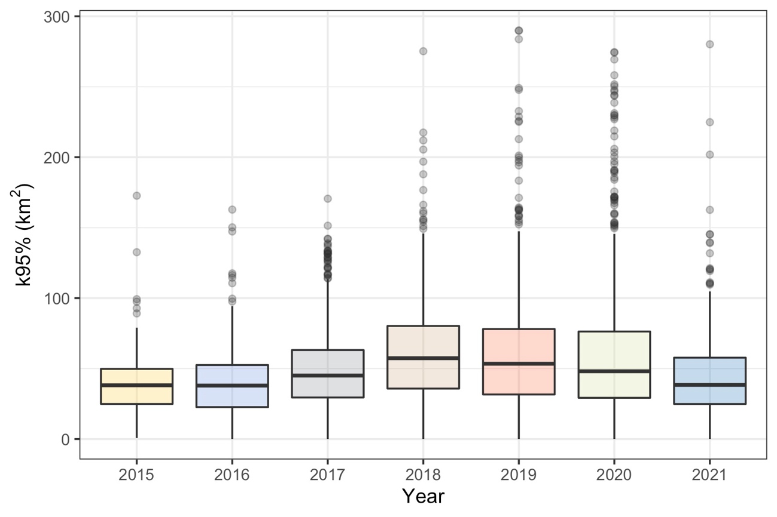
Figure S3: Differences in daily home range size (K95%) among years.

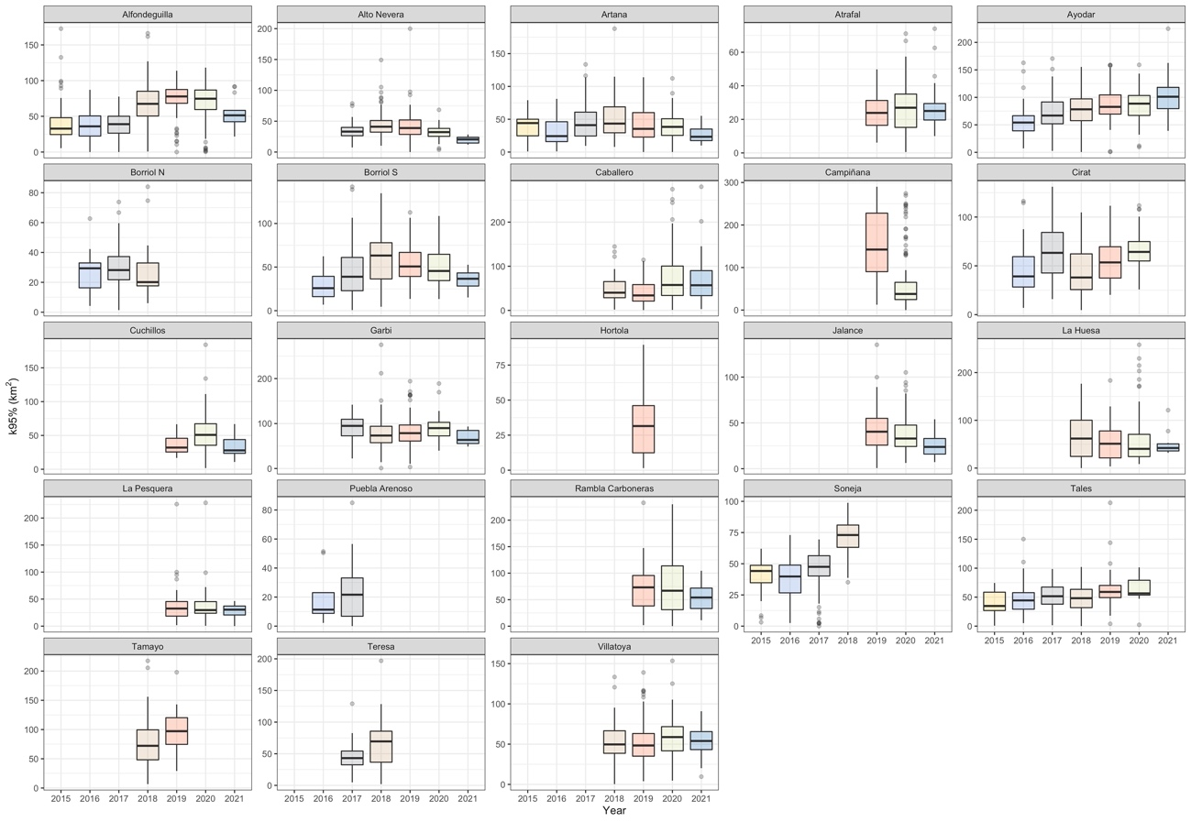
Figure S4: Differences in daily home range size (K95%) among years and territories.

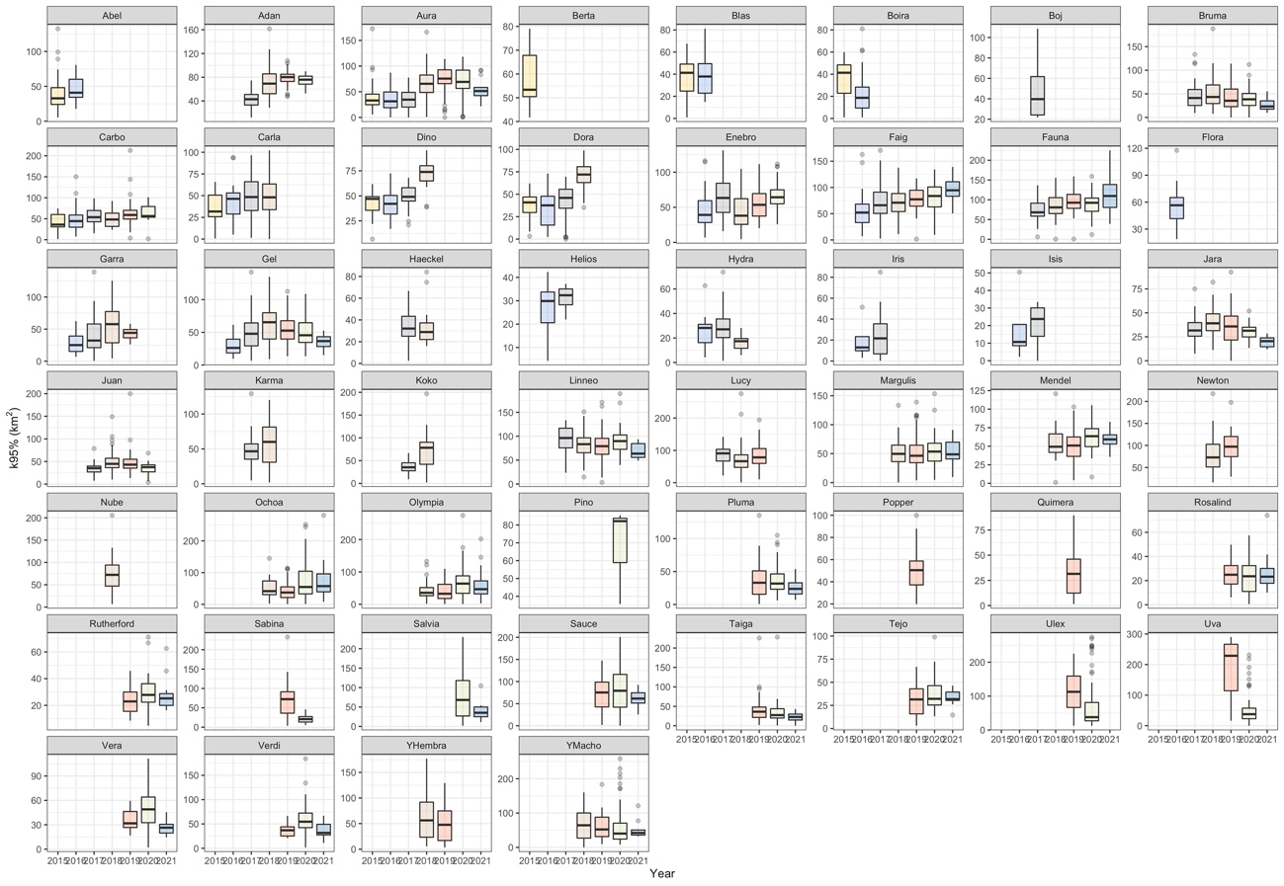
Figure S5: Differences in daily home range size (K95%) among years per individual.

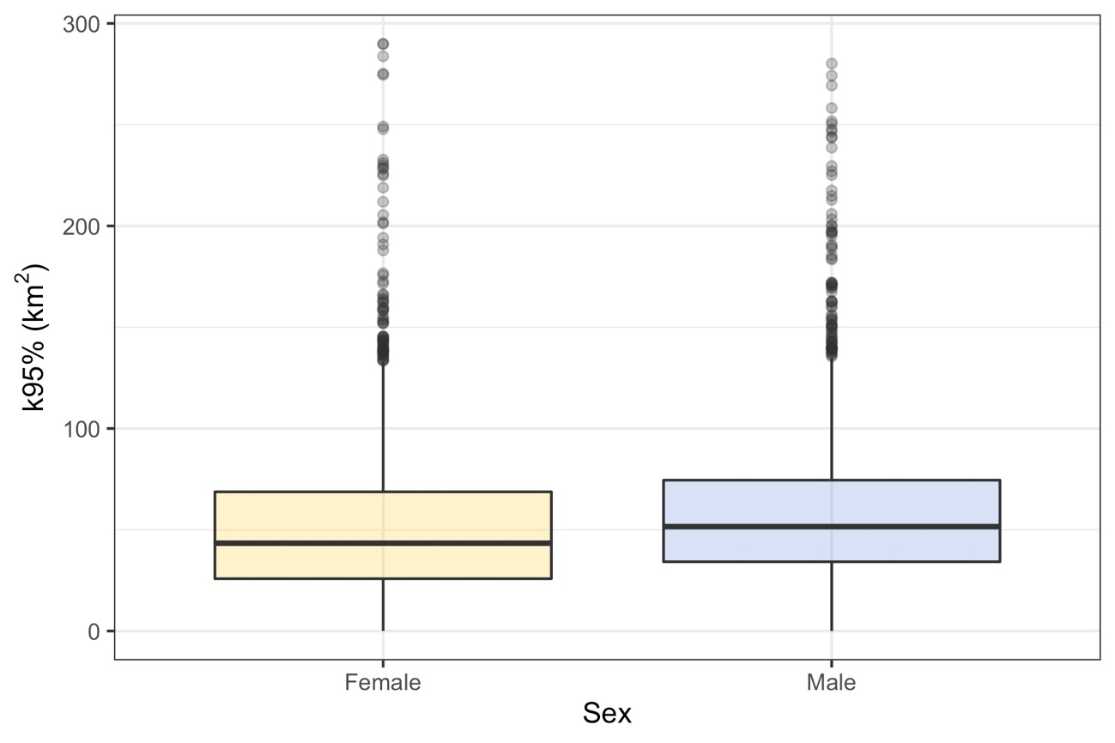
Figure S6: Differences in the daily home range size (K95%) between sexes.

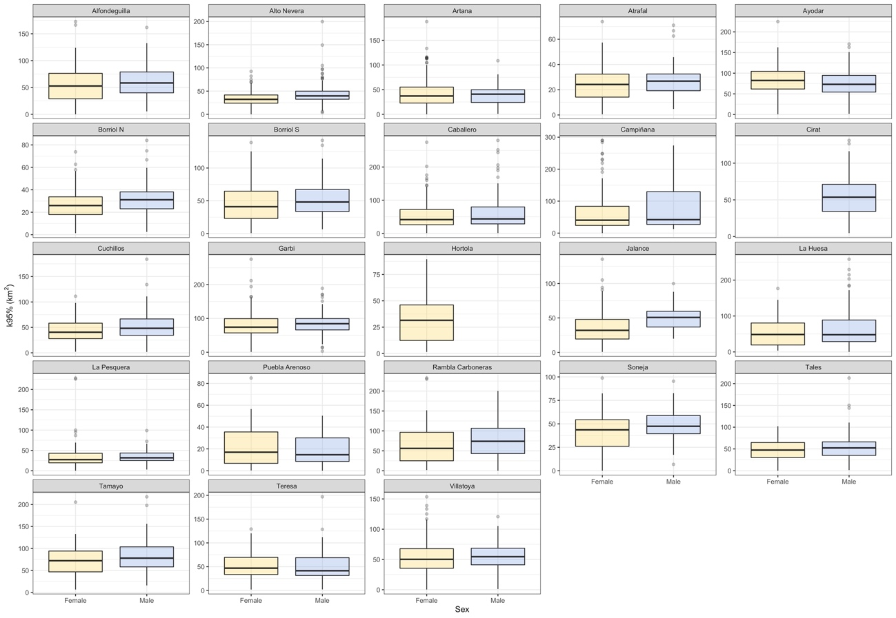
Figure S7: Differences in daily home range size (K95%) between sexes and territories.

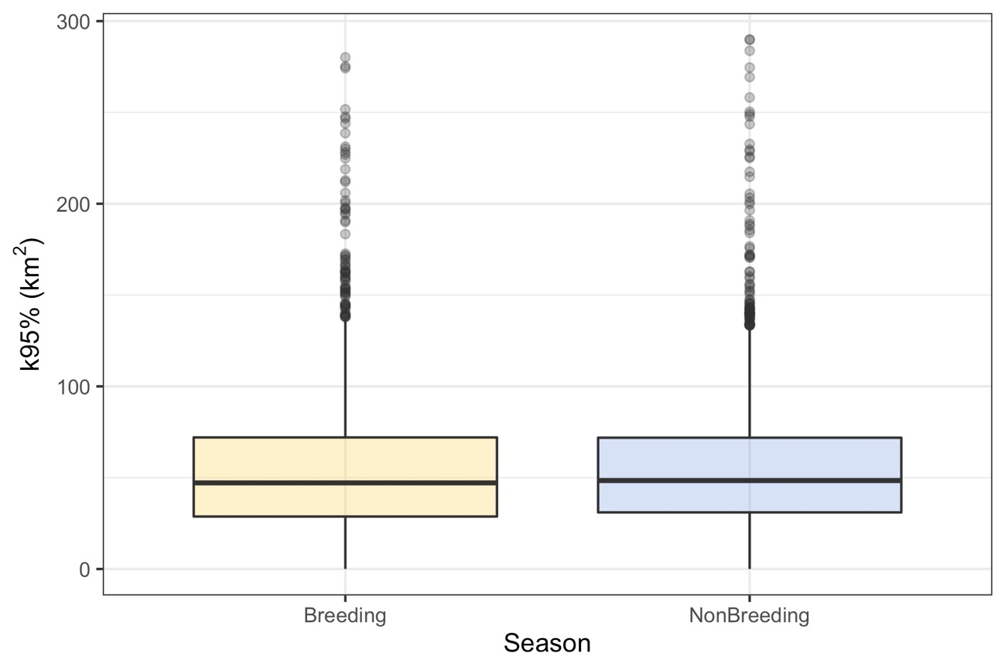
Figure S8: Differences in the daily home range size (K95%) between seasons.

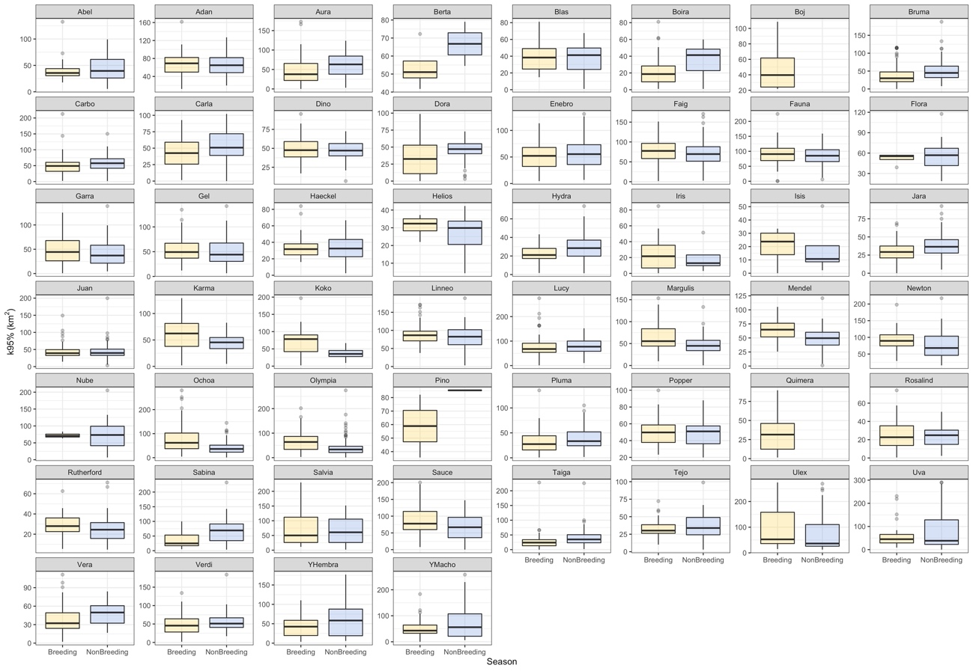
Figure S9: Differences in daily home range size (K95%) between seasons and territories.

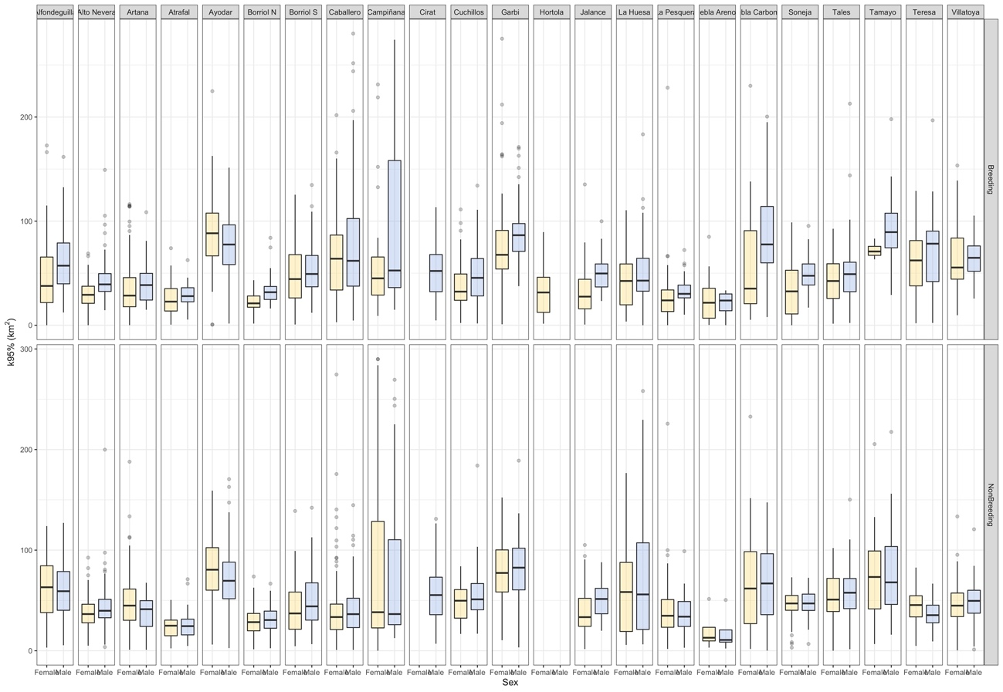 Figure S10: Differences in daily home range size (K95%) between sexes, season and territories.

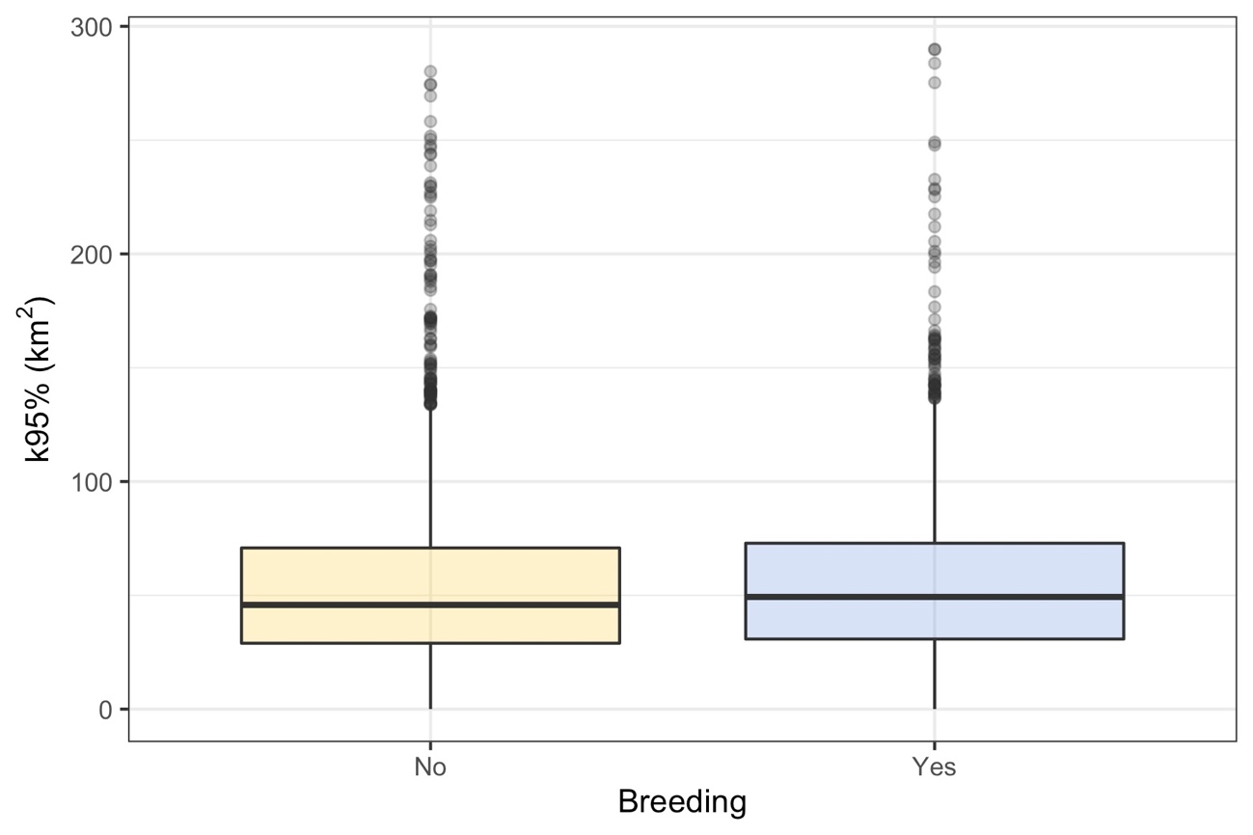

Figure S11: Differences in daily home range size (K95%) between breeding status.

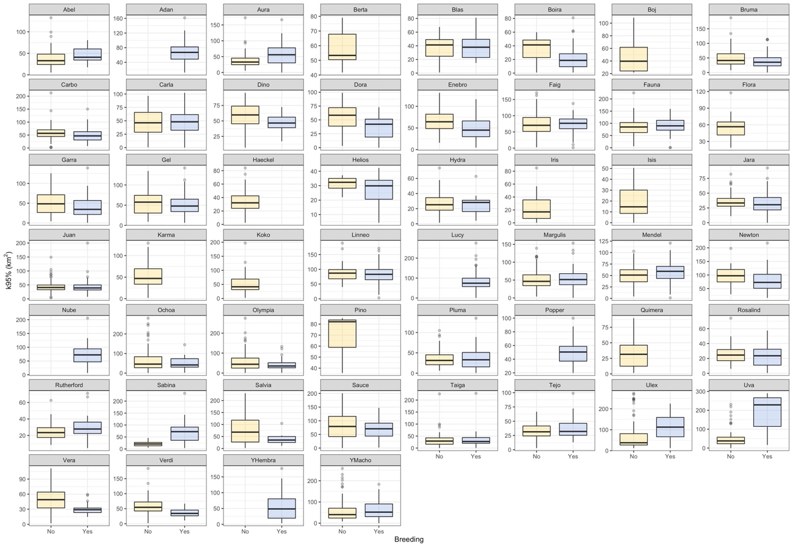
Figure S12: Differences in daily home range size (K95%) between breeding status and individuals.

