Silicon-rich materials detoxify multiple heavy metals in wheat by regulating oxidative stress and heavy metal subcellular distribution

Zheyong Li^{a,b}, Yajun Yuan^{c}, Luojing Xiang^{a,b}, Qu Su^{a,b}, Zhenyan Liu^{a,b}, Wenguang Wu^{a,b}, Yihao Huang^{a,b}, Shuxin Tu^{d,e,*}

ªHubei Provincial Academy of Eco-Environmental Sciences, Wuhan 430072, China
^{b}State Key Laboratory of Soil Health Diagnosis and Green Remediation for Environmental Protection, Wuhan, 430072, China
^{c}Department of Environmental Engineering Design, Hubei Urban Construction Design Institute Co., Ltd., Wuhan 430051, China
^{d}College of Resources and Environment, Huazhong Agricultural University, Wuhan, 430070, China
^{e}Hubei Research Centre for Environment Pollution and Remediation, Wuhan 430070, China

Corresponding Author
Dr. Shuxin Tu, Professor
College of Resources and Environment, Huazhong Agricultural University
Wuhan (430070), P.R. China
E-mail: stu@mail.hzau.edu.cn

Table S1 Basic physicochemical properties of the experimental topsoils before application of amendments
Soils | pH | N_{total} | P_{total} | Organic matter | K_{available} | P_{available} | N_{available} | ^{b}As | ^{b}Cd | ^{b}Pb | ^{b}Zn
 |  | g/kg |  |  | mg/kg
ªYB | 6.09 | 0.86 | 0.55 | 12.12 | 112.2 | 26.21 | 57.91 | 2.52 | 11.99 | 152.67 | 234.22
ªCA | 7.14 | 2.21 | 0.89 | 10.22 | 56.57 | 41.98 | 41.25 | 5.23 | 12.79 | 155.41 | 300.55
ª YB, yellow brown soil; CA, calcareous alluvial soil.
^{b} DTPA-extractable fraction

Table S2 Physicochemical properties of RHB and bentonite used in this experiment
Parameters | RHB | bentonite
pH | 10.52±0.2 | 9.06±0.3
Grain size (mm) | 0.15 | 0.15
Total N (g/kg) | 6.86±0.4 | –
Total P (g/kg) | 3.52±0.1 | –
Total K (g/kg) | 14.21±2.5 | –
Total Cd (mg/kg) | – | 1.11±0.4
Total Zn (mg/kg) | 33.74±2.9 | 67.12±3.3
Total Pb (mg/kg) | 3.01±0.2 | 25.67±0.9
Total As (mg/kg) | – | 0.33±0.01
–: Not measured.

Table S3 Effects of Si-rich amendments on growth and yield characters of wheat. Values are the mean ±SD (n = 4). Different letters in the same column indicate a significant difference at p < 0.05.
Treatment | Seedling stage |  | Maturity stage
 | Shoot length (cm/plant) | Shoot dry weight (g/plant) | Shoot dry weight (g/plant) | Grain dry weight (g/pot)
YB soil
Control | 61.22±0.81d | 0.52±0.02c | 1.12±0.05c | 3.98±0.51c
T1 | 62.71±1.19d | 0.54±0.05c | 1.24±0.12b | 4.32±0.32b
T2 | 64.48±1.08c | 0.62±0.01b | 1.22±0.04b | 4.41±0.21b
T3 | 65.52±2.77b | 0.63±0.06a | 1.26±0.08b | 4.62±0.49b
T4 | 68.84±3.12a | 0.66±0.03a | 1.31±0.21a | 5.05±0.32a
CA soil
Control | 57.12±2.10b | 0.45±0.02c | 0.92±0.09c | 4.15±0.31d
T1 | 56.21±1.92b | 0.44±0.03c | 0.98±0.14b | 4.21±0.56c
T2 | 57.33±1.13b | 0.49±0.05b | 0.96±0.11b | 4.28±0.33b
T3 | 58.21±4.71a | 0.49±0.02b | 1.02±0.21a | 4.31±0.47b
T4 | 58.39±5.12a | 0.52±0.08a | 1.05±0.04a | 4.58±0.27a

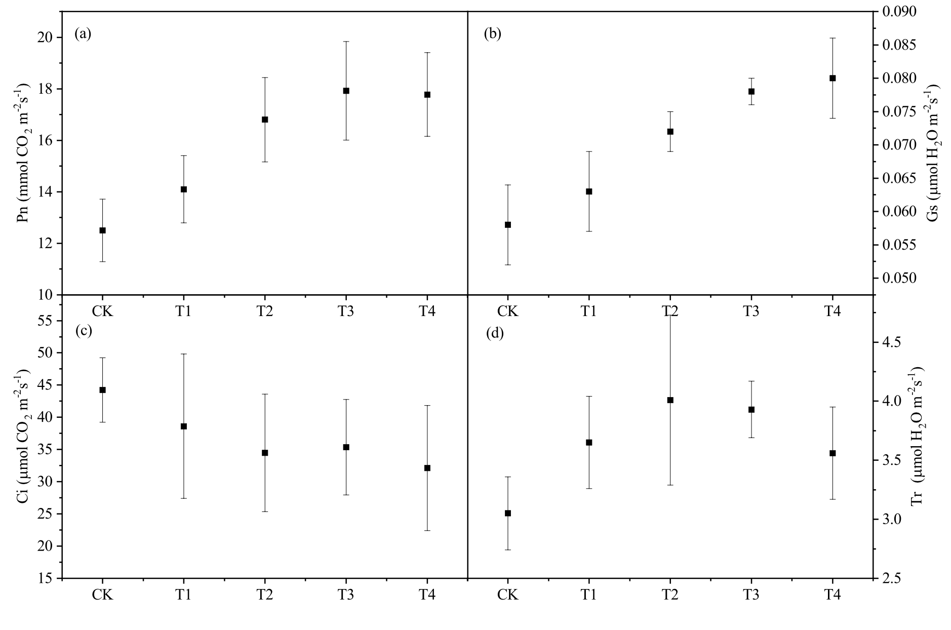Figure S1 Effects of Si-rich amendments (T1-T4) on wheat leaf photosynthetic parameters under multi-heavy metal stress in yellow brown soil (YB).

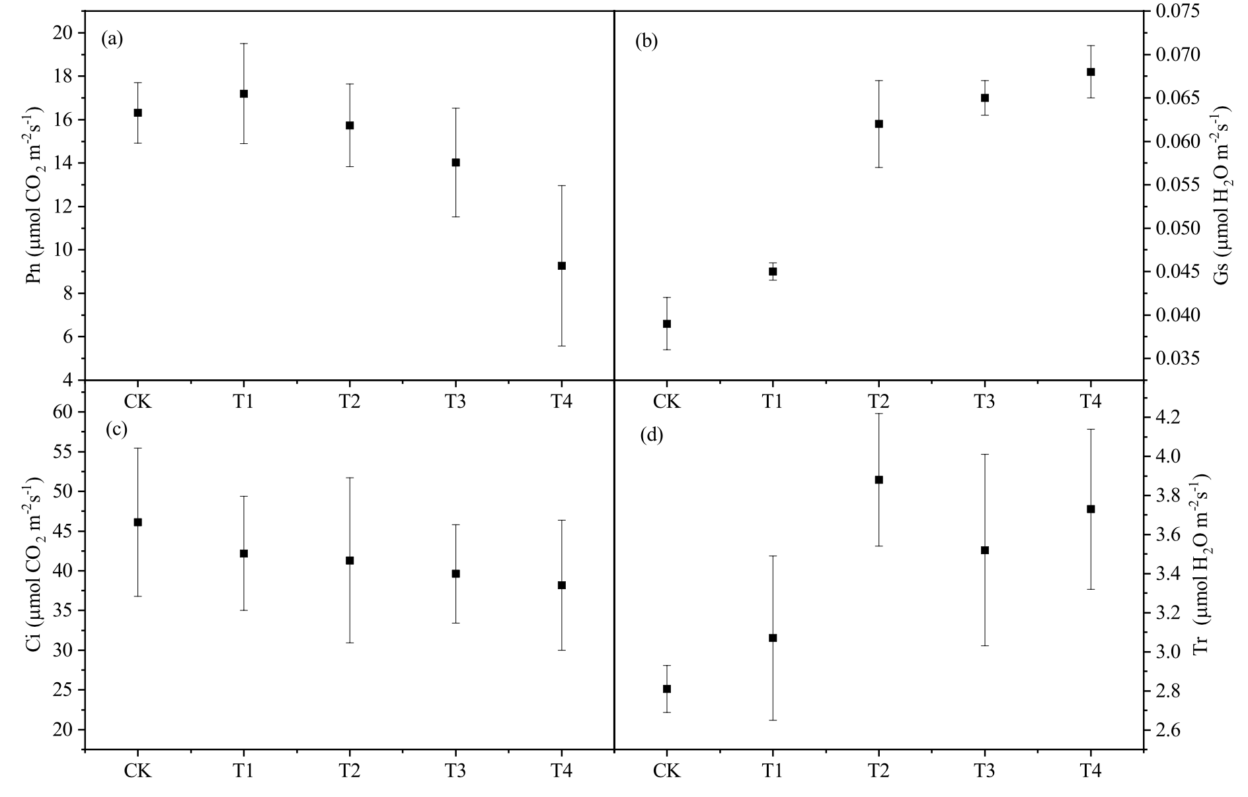Figure S2 Effects of Si-rich amendments on wheat leaf photosynthetic parameters under multi-heavy metal stress in calcareous alluvial soil (CA).

