Supplementary Material

Table 1. Frequency of cows diagnosed with disease for parity
 |  | Parity
Disease |  | Primiparous | Multiparous
Metritis |  | 22 (37.3) | 37 (62.7)
Retained Placenta |  | 8 (40.0) | 12 (60.0)
Mastitis |  | 13 (31.7) | 28 (68.3)
Ketosis |  | 11 (24.4) | 34 (75.6)
Laminitis |  | 4 (18.2) | 18 (81.8)
Healthy |  | 22 (71.0) | 9 (29.0)

Supplementary milk composition data

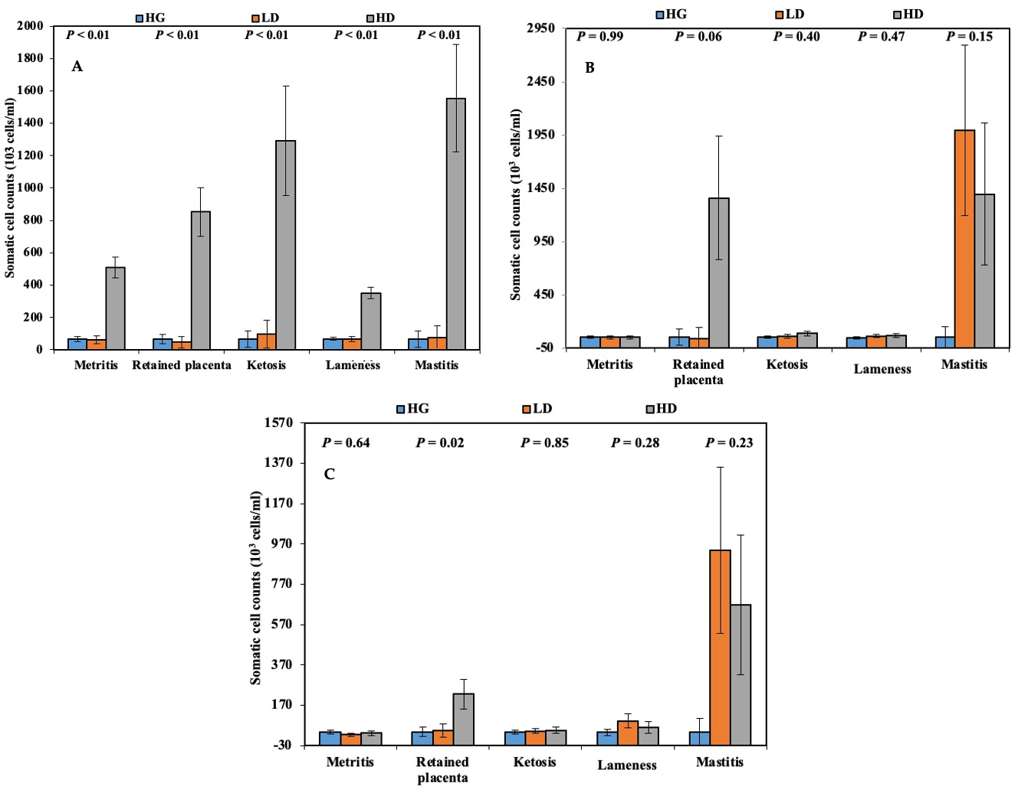

Figure 1. Comparisons of somatic cell counts (10³ cells/mL) between healthy group (HG, blue), low disease (LD, orange), and high disease (HD, grey) for cows diagnosed with metritis, retained placenta, ketosis, lameness, and mastitis at A) Prior to dry off (~1 week before date of dry off); B) 1 week after parturition; C) 2 weeks after parturition.

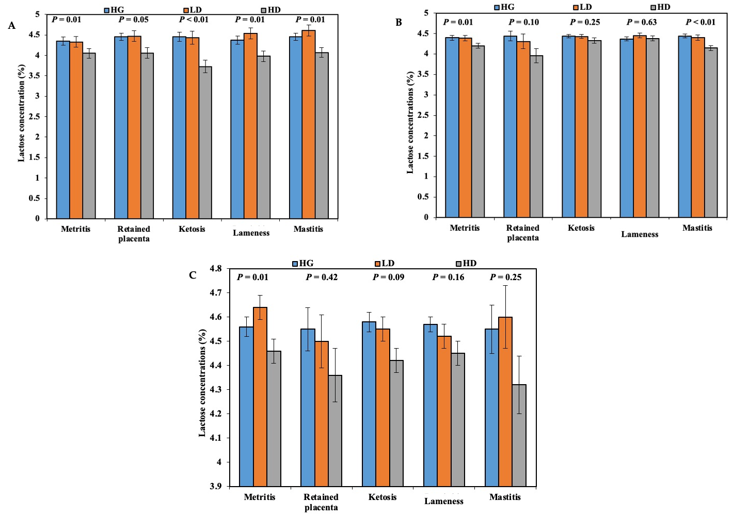

Figure 2. Comparisons of lactose concentrations (%) between healthy group (HG, blue bar), low disease (LD, orange bar), and high disease (HD, grey bar) for cows diagnosed with metritis, retained placenta, ketosis, lameness, and mastitis at A) Prior to dry off (~1 week before date of dry off); B) 1 weeks after parturition; C) 2 weeks after parturition.

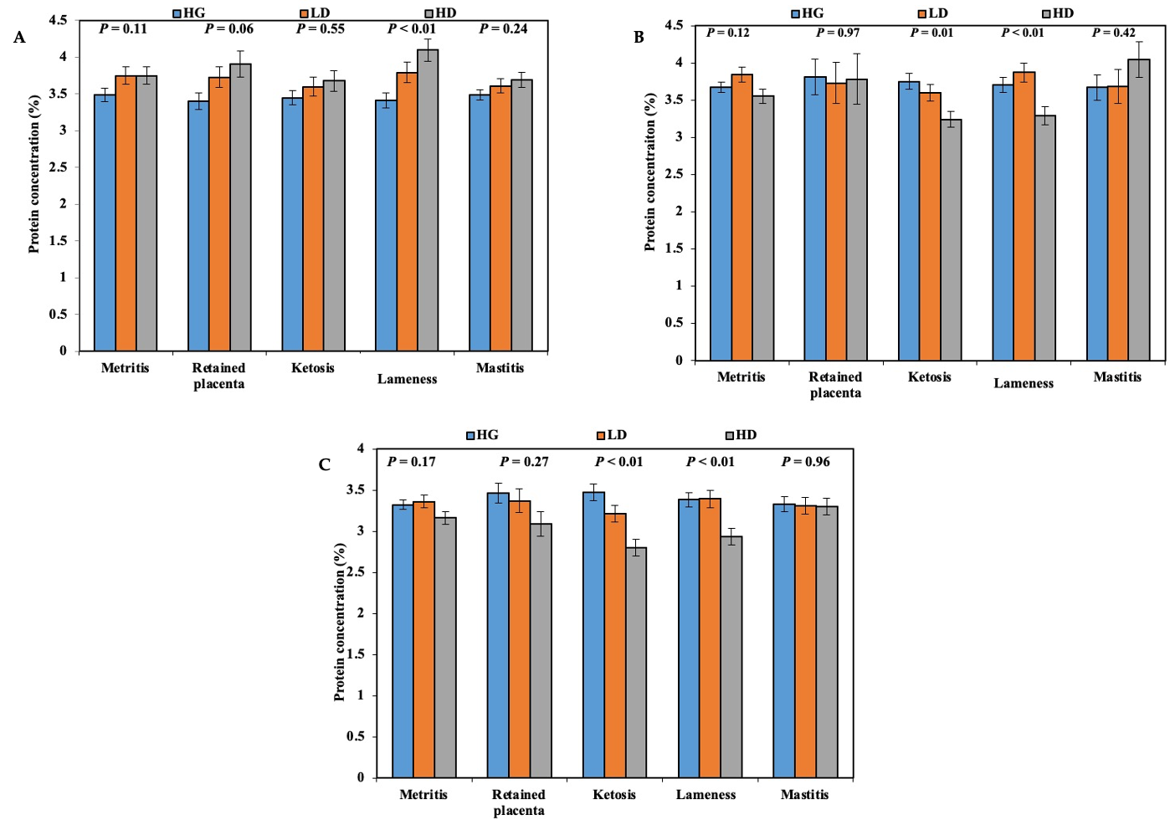
Figure 3. Comparisons of protein concentrations (%) between healthy group (HG, blue bar), low disease (LD, orange bar), and high disease (HD, grey bar) for cows diagnosed with metritis, retained placenta, ketosis, lameness, and mastitis at A) Prior to dry off (~1 week before date of dry off); B) 1 weeks after parturition; C) 2 weeks after parturition.

Milk composition data throughout experimental period

Figure 4. Concentrations of somatic cell counts with A) metritis, B) retained placenta, C) ketosis, D) lameness, and E) mastitis between healthy, low-disease, and high-disease (LSM+SEM; HS = effect of health status; Wk = effect of week; Wk x HS = week x health status interaction).

Figure 5. Concentrations of lactose in the milk of cows with A) metritis, B) retained placenta, C) ketosis, D) lameness, and E) mastitis between healthy, low-disease, and high-disease (LSM+SEM; HS = effect of health status; Wk = effect of week).

Figure 6. Concentrations of protein in the milk of cows with A) metritis, B) retained placenta, C) ketosis, D) lameness, and E) mastitis between healthy, low-disease, and high-disease (LSM+SEM; HS = effect of health status; Wk = effect of week; Wk*P = effect of sampling week and parity interaction).

Figure 7. Concentrations of fat in the milk of cows with a) metritis, B) retained placenta, C) ketosis, D) lameness, and E) mastitis between healthy, low-disease, and high-disease (LSM+SEM; HS = effect of health status; Wk = effect of week).

Figure 8. Concentrations of milk urea nitrogen (Milk urea N) for a) metritis, B) retained placenta, C) ketosis, D) lameness, and E) mastitis between healthy, low-disease, and high-disease (LSM+SEM; HS = effect of health status; Wk = effect of week; Wk*P = effect of week * parity interaction).

Figure 9. Concentrations of total solids for a) metritis, B) retained placenta, C) ketosis, D) lameness, and E) mastitis between healthy, low-disease, and high-disease (LSM+SEM; HS = effect of health status; Wk = effect of week).

