Supplementary Table 1: Pubmed example search strategy

Search term validation | The food assistance search terms were taken from Martin et al. The machine learning terms were taken from Wang et al.
#1 | "Food Assistance"[Mesh] OR "Food Supply"[Mesh]
#2 | (food*[tw] OR meal*[tw] OR nutrition[tw] OR dietary[tw] OR diet[tw] OR "infant formula"[tw] OR "baby formula"[tw]) AND (access*[tw] OR suppl*[tw] OR assist*[tw] OR aid[tw] OR secure[tw] OR securit*[tw] OR insecure[tw] OR insecurit*[tw] OR pantr*[tw] OR bank*[tw] OR distribut*[tw] OR desert*[tw] OR system*[tw] OR relief[tw] OR rescue*[tw] OR redistribut*[tw] OR response*[tw] OR responder*[tw] OR resilienc*[tw])
#3 | foodbank*[tw] OR SNAP[tw] OR "food stamp*"[tw] OR "Women Infants and Children Program"[tw] OR WIC[tw] OR "food first responder*"[tw] OR "feed the hungry"[tw] OR "emergency kitchen*"[tw] OR "free meal*"[tw] OR "free food*"[tw] OR "community pantr*"[tw] OR "food service*"[tw] OR "meal service*"[tw] OR "soup kitchen*"[tw] OR "community meal*"[tw]
#4 | #1 or #2 or #3
#5 | ("Machine Learning"[Mesh] OR "Artificial Intelligence"[Mesh] OR "Natural Language Processing"[Mesh] OR "Neural Networks(Computer)"[Mesh] OR "Support Vector Machine"[Mesh] OR Machine learning[Title/Abstract] OR Artificial Intelligence[Title/Abstract] OR Naive Bayes[Title/Abstract] OR bayesian learning[Title/Abstract] OR Neural network[Title/Abstract] OR Neural networks[Title/Abstract] OR Natural language processing[Title/Abstract] OR support vector*[Title/Abstract] OR random forest*[Title/Abstract] OR boosting[Title/Abstract] OR deep learning[Title/Abstract] OR machine intelligence[Title/Abstract] OR computational intelligence[Title/Abstract] OR computer reasoning[Title/Abstract])
#6 | ((sentiment[Title/Abstract] OR sentiments[Title] OR opinion[Title] OR opinions[Title] OR emotion[Title] OR emotions[Title] OR emotive[Title] OR affect[Title] OR affects[Title] OR affective[Title]) AND (“sentiment classification” OR “opinion mining” OR “natural language processing” OR NLP OR “text analytics” OR “text mining” OR “F-measure” OR “emotion classification”)) OR “sentiment analysis”
#7 | (“social network analysis”[All Fields] OR “network analysis”[All Fields]) OR “social media network analysis” OR “Twitter”)
#8 | #5 or # 6 or #7
#12 | #4 and #8
#13 | Date Limit: 2010 to Current

Supplementary Figure 1: Model hyperparameter selection of topic number, alpha, and beta
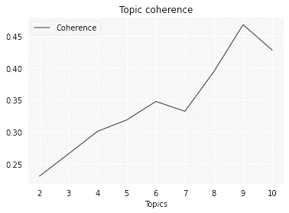

Caption: In order to select the optimal number of topics to analyze from the corpus, the coherence score, alpha, and beta model hyperparameters were calculated on 75% of the corpus as described by Kapadia.⁶¹ Using Matplotlib⁹⁹ package in Python, coherence values are plotted on the y axis versus number of topics on the x axis. 9 topics had the highest coherence score.
Supplementary Figure 2: Intertopic distance map (via multidimensional scaling)
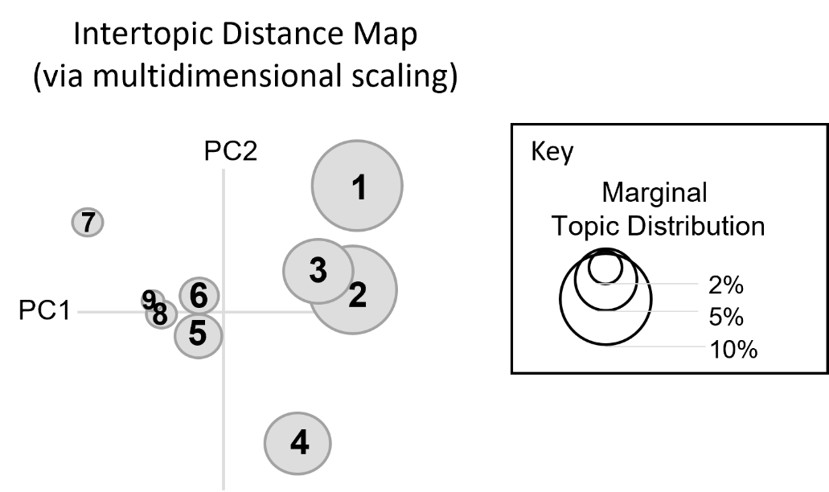

Caption: The pyLDAvis⁶² algorithm package in Python was used to produce a dynamic intertopic distance map (via multidimensional scaling). Each circle represents a topic. The size of the circle relates to that topic’s relative dominance within the corpus. The ideal map has little overlap between each topic. This map acts, therefore, as a visual check of the coherence value and topic number presented in Supplementary Figure 1.
Supplementary Table 2: Results of LDA model: Topics with percent contribution
# | Topics | Percent Contribution
1 | 0.037*"churn" + 0.015*"client" + 0.015*"benefit" + 0.014*"state" + '  '0.012*"cost" + 0.012*"government" + 0.010*"recertification" + '  '0.010*"program" + 0.009*"agency" + 0.008*"fraud"' | 0.6359
2 | 0.020*"snap" + 0.019*"household" + 0.009*"new" + 0.009*"recipient" + ''0.007*"topic" + 0.007*"program" + 0.006*"exist" + 0.006*"insecurity" + ''0.006*"include" + 0.005*"level"' | 0.9996
3 | 0.011*"amount" + 0.010*"supermarket" + 0.009*"receive" + 0.008*"bank" + ''0.006*"warehouse" + 0.006*"layer" + 0.006*"event" + 0.005*"method" + ''0.005*"approximation" + 0.005*"regional"' | NA
4 | 0.000*"security" + 0.000*"blockchain" + 0.000*"level" + 0.000*"measure" + ''0.000*"household" + 0.000*"insecurity" + 0.000*"drone" + 0.000*"grateful" + ''0.000*"coordinator" + 0.000*"relentlessly"' | NA
5 | 0.034*"tweet" + 0.016*"classifier" + 0.011*"sentiment" + 0.010*"word" + ''0.009*"feature" + 0.007*"trend" + 0.006*"propose" + 0.006*"dataset" + ''0.006*"negative" + 0.006*"positive"' | 0.9995
6 | 0.020*"demand" + 0.014*"change" + 0.011*"country" + 0.011*"product" + ''0.007*"increase" + 0.007*"structure" + 0.007*"consumer" + 0.005*"value" + ''0.005*"pandemic" + 0.004*"flour"' | 0.9087
7 | '0.010*"system" + 0.009*"rescue" + 0.007*"value" + 0.007*"volunteer" + ''0.007*"network" + 0.007*"donation" + 0.006*"forecast" + 0.006*"give" + ''0.005*"problem" + 0.005*"expert"' | 0.9996
8 | 0.024*"security" + 0.013*"household" + 0.007*"level" + 0.007*"measure" + ' '0.006*"class" + 0.006*"crisis" + 0.006*"insecurity" + 0.005*"country" + ' '0.005*"access" + 0.005*"prediction"' | 0.9996
9 | '0.016*"mention" + 0.010*"hurricane" + 0.008*"twitter" + 0.008*"healthy" + ' '0.008*"tweet" + 0.006*"category" + 0.006*"list" + 0.006*"day" + ' '0.006*"group" + 0.006*"examine"' | 0.9995

Supplementary Figure 3: Importance of topic key words: representative dominant (Topics 1, 2, 7) and non-dominant (Topic 3) topics
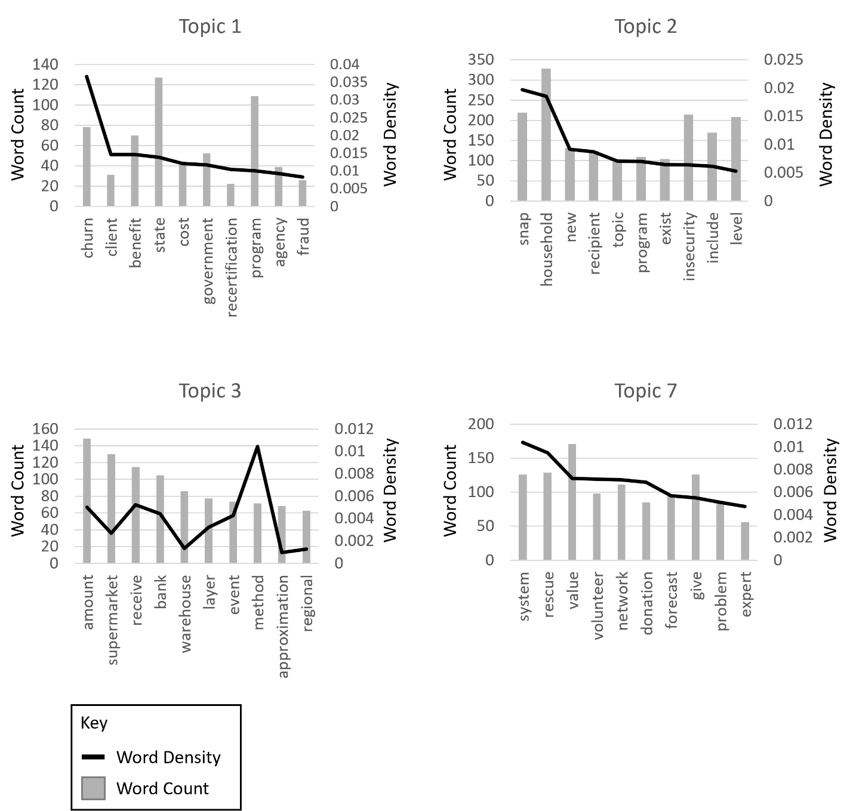
Caption: The frequency and density of keywords in the topics were calculated using TextBlob¹⁰⁰ package in Python, shown in Supplementary Figure 3. These graphs show word count (left axes) versus word density (right axes) for three representative dominant topics (topics 1, 2, and 7) and one representative non-dominant topic (topic 3). Words that had lower word density than word count across multiple topics were removed from the analysis. This included, for example, food, data, and model.

Supplementary Figure 4: Top 10 word frequencies related to disasters and emergencies

Using Textblob package in Python, word frequencies related to disasters and emergencies were calculated. ¹⁰⁰ The top ten words and their word counts were plotted in a bar graph using Matplotlib⁹⁹ package in Python.

